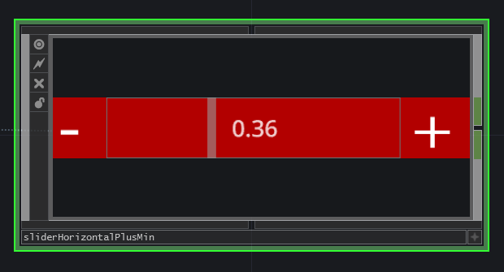 | 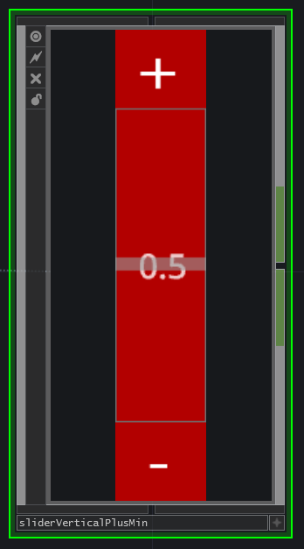

A slider with a plus and minus button. The value of the slider is displayed on the slider itself. When the – button is pressed, the value of the slider is decreased with 0.02. When the + button is pressed, the value of the slider is increased with 0.02.

When the + and – button are pressed at the same time (possible on multi-touch touchscreens), the slider resets to it’s centre value (0.5). The same can be achieved by right clicking on the slider.

The slider comes in a vertical and horizontal configuration.

