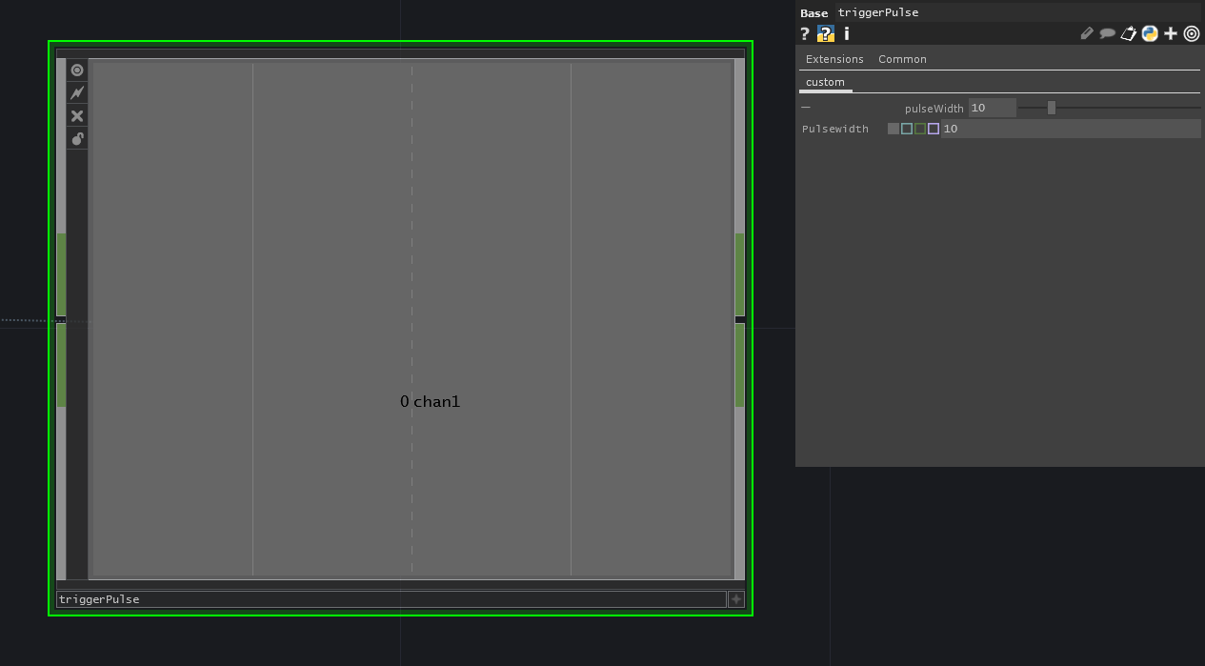

The trigger pulse block is a block that takes a signal input and generates a block signal output. The output of this block is 0, but when a change on the input is detected, the signal output is 1 for the amount of seconds that is set in the parameters.

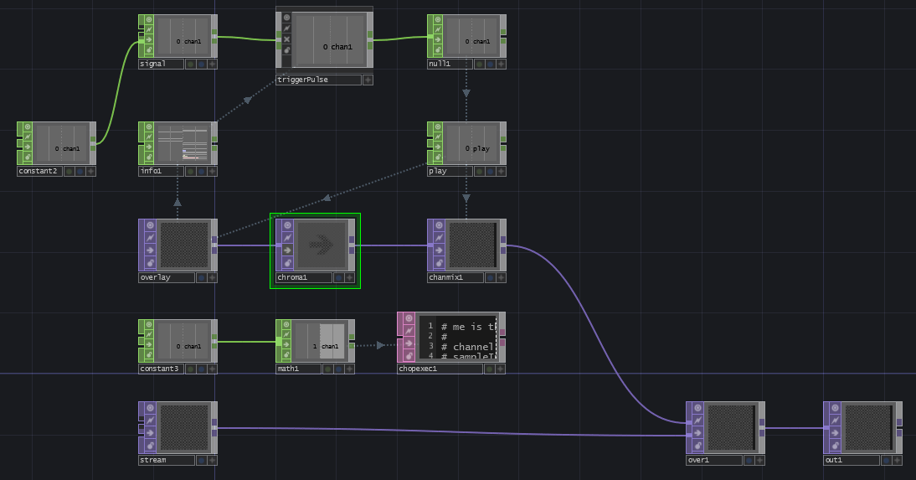

A use case example is the video transition block. Here we monitor if the video that is selected changes. When the video source changes, a transition video is played in the mean time. The transition video’s should only be a couple of seconds.

