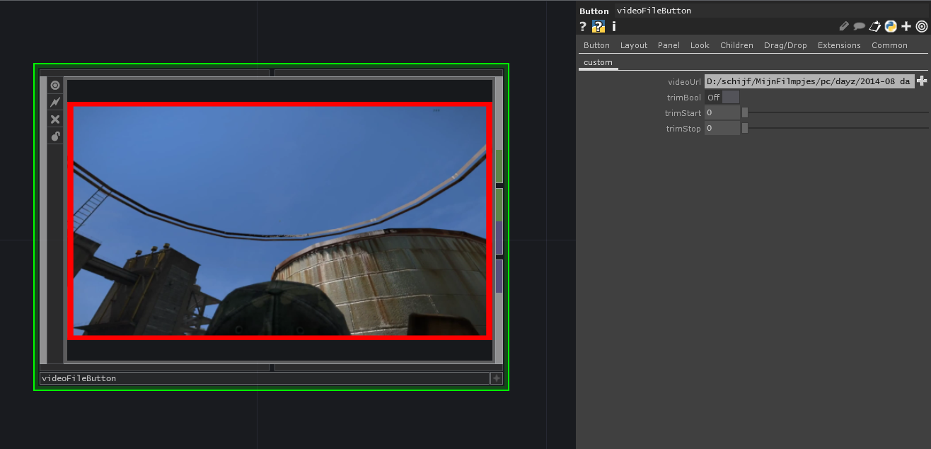
The video file button is a basic button block used to play video files. In the parameters you have to choose which video file to play. Here you can also choose to trim the video clip and by how many seconds.

The video starts playing from the start (or trimmed seconds) when the button is pressed, this ensures the video is always ready to go.

The block outputs a 1 and the video signal when the block is live. When the block is not live, it outputs a 0 and black video signal. When the video is live, the borders are red.

The videoFileButton is similar to the videoButton and thus makes it compatible.

