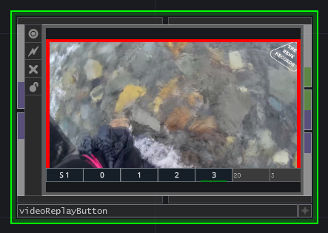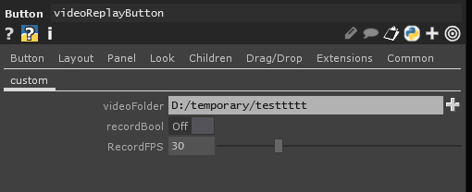

The videoReplayButton is a live replay function. The block needs a video input for which to record. In the parameters you have to setup the folder it can use, the fps in which to record and you have to enable the playback function by enabling recordBool.

By clicking on the video, you make it go live. The block outputs a 1 and the video signal when the block is live. When the block is not live, it outputs a 0 and black video signal. When the video is live, the borders are red. When you make the video go live, it will automatically play from the start of the recording.

Now we need to discuss the extra buttons at the bottom of the screen.
The first button is the “S”. This button will save the current video to the number that is also on this button. In the video example above, it will save the video to preset 1 when pressed. The number automatically loops through the 4 presets when you save video’s. So when saving 5 video’s, preset 0 will be used for video file 5 and save 1 will be lost.

The number buttons 0 to 3 are the available presets. When you have saved a clip with the S button, you can play it back in these presets. In the example above we are replaying clip with ID 3.

The last important setting is the video frame you want to play. In the example above we can see that the first field reads “20” and the second reads “5”. This means that we will play from 20 seconds away from the end of the video, up until 5 seconds away from the end of the video. This design was chosen because you probably want to play the end of the save you just made.

The videoFileButton is similar to the videoButton and videoFileButotn and thus makes it compatible.

