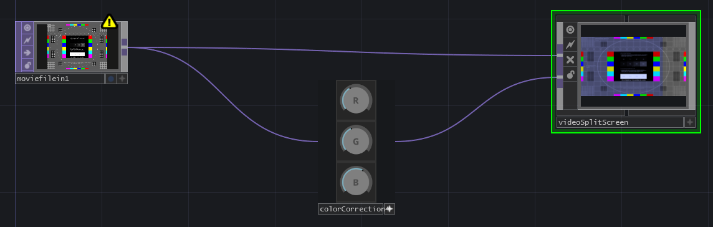
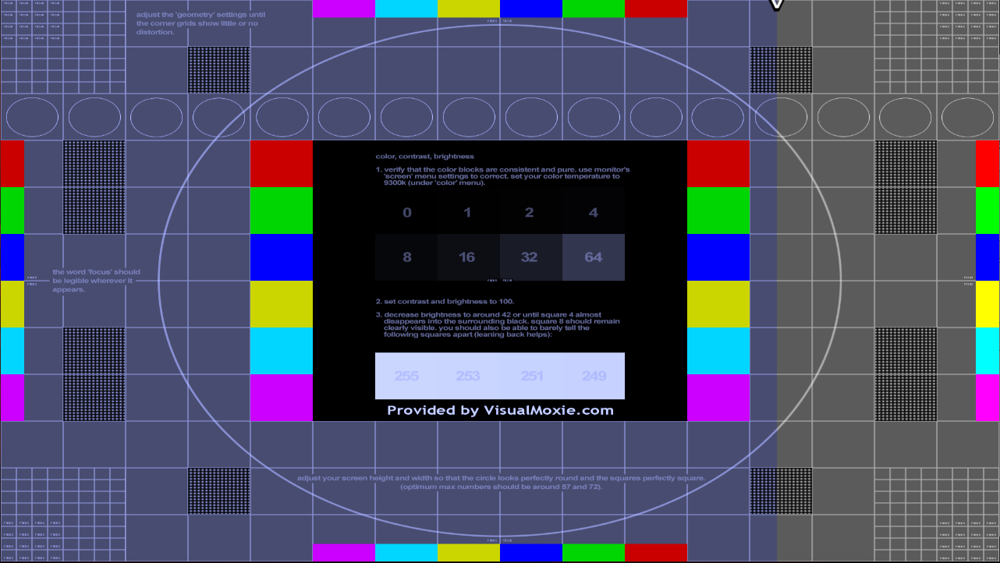
The VideoSplitScreen block is designed to compare 2 separate video signals. This can, as demonstrated in the example, be used to compare a pre- and post-edit video signal. The block has a horizontal slider which is indicated by a small black and white arrow on the top of the screen. By clicking on the screen and dragging, you can change the point where the video is split between the 2 different inputs.
In the example, we see that the blue color has been boosted compared to the original signal. With this block we can easily compare the 2 video signals, and choose where the vertical comparison line is positioned by dragging it to another point.

