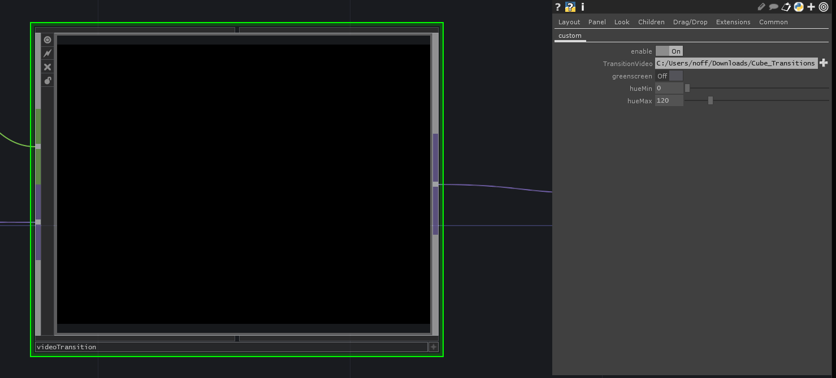

The video transition block takes a video stream and select signal as inputs, and outputs a video signal. Each time the value on the select signal changes, a transition video is played. The specific video to play has to be set in the parameters, here you can also set the green screen settings.

An example is a transition between multiple video sources. Each time a new source is selected, the transition effect will be played. The transition effect could be the logo of the organisation of an event for example.

