VMware Player
Download and install the latest version of VMware player for windows version 4.0 from http://www.vmware.com/products/player on the host computer.

Copy the Virtual Network Editor executable “vmnetcfg.exe” into the installation folder of VMware Player located at
“C:\Program Files (x86)\VMware\VMware Player” or
“C:\Program Files\VMware\VMware Player” for Windows XP

Right click on the VMware Player shortcut (created on the Desktop) and select Properties. Under the Shortcut tab ensure that the command Run is set to Maximized.

Run the VMware Player by double clicking on the shortcut located on the Desktop. Go to File -> Player Preferences … and set up the Preferences as per screenshot below.

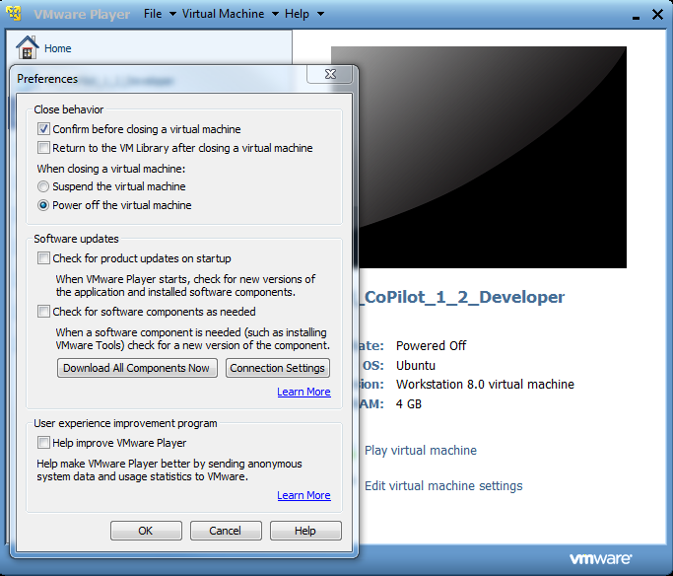

Note: If the following message “Error while powering on: The VMware Authorization Service is not running” displayed during launching of the virtual machine, make sure that the VMware Player runs with Administrator privilege. Do right click on the VMware Player shortcut and select Properties. Check the “Run this program as an administrator” as shown in the screenshot below.

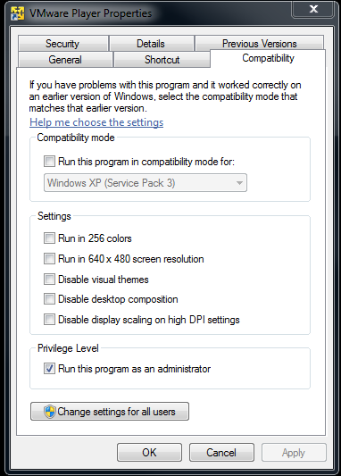

Configuring the network
The VMware player automatically installs two network adapters usually named Vmnet1 (Host-only) and Vmnet8 (NAT-CoPilot). It also installs additional bridging protocols on existing network interfaces.

Run the Virtual Network Editor by double clicking on “vmnetcfg.exe” into the installation folder of VMware Player to set up the network settings.

Set the wired ethernet device to a static IP address of 192.168.1.3/24 (i.e. /24 = mask of 255.255.255.0). This is the host computer IP address.

Any Blueview sonar can be used with the system using its default IP address being 192.168.1.45.

The Vmnet1 (Host-only) Ethernet device is set to DHCP by default. This does not need changing.

The Vmnet8 (NAT-CoPilot) Ethernet device is to be configured with subnet set to 192.168.107.0 as shown below:

Note: make sure to press the Apply button to save all the settings.

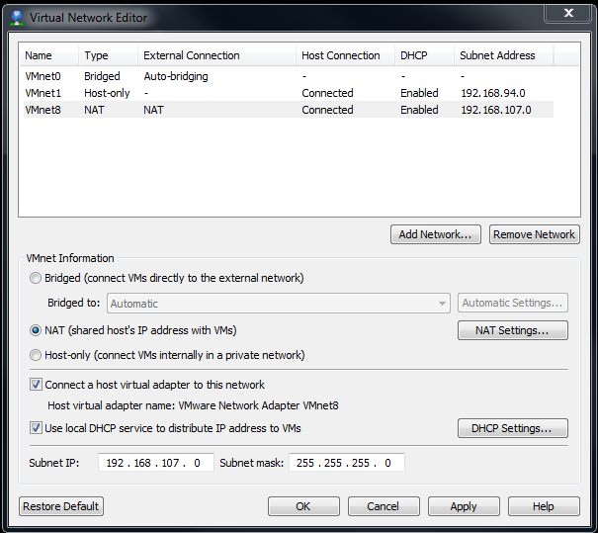

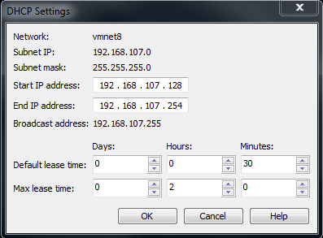

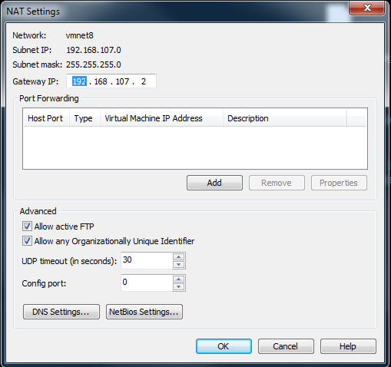

Note: There is nothing to do in the virtual machine. The explanations below are for reference only.

In the Virtual Machine the network is set up as follow:

- /etc/network/interfaces
# The loopback network interface
auto lo
iface lo inet loopback
up route add -host 255.255.255.255 dev lo

# The primary network interface
auto eth0
iface eth0 inet static
address 192.168.107.100
netmask 255.255.255.0
gateway 192.168.107.2

- /etc/resolv.conf
nameserver 192.168.107.2

On the host system the following file CockpitSeeByteOverride.config should contain the following IP addresses:

<CopilotIPAddressString>192.168.107.100</CopilotIPAddressString>
<LocalIPAddressString>192.168.107.1</LocalIPAddressString>

Configuring Virtual Machine
Copy the CoPilot virtual machine folder to “C:\CoPilot” on the host computer. Run VMware Player by double-clicking on the shortcut located on the Desktop. Select “Open a Virtual Machine” in order to add it to the list on the left hand side.

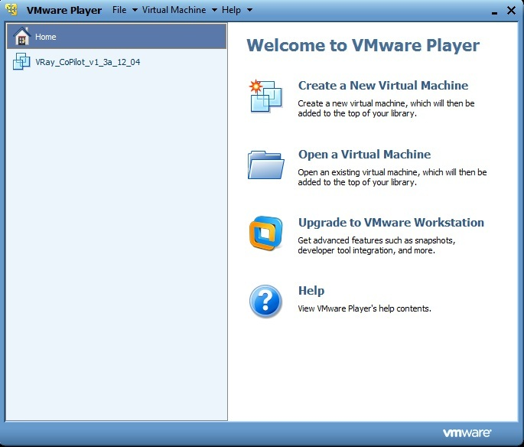

Note: The Virtual Machine is already configured by SeeByte. The explanations below are for information only.

In order to view the virtual machine settings select the virtual machine and then click on the option “Edit virtual machine settings”.

The virtual machine settings should match the following screenshot.

Hardware tab:

- Memory -> at least 2GB
- Processors -> at least 2 cores
- Network Adapter -> NAT
- Serial Ports -> see Serial Ports section

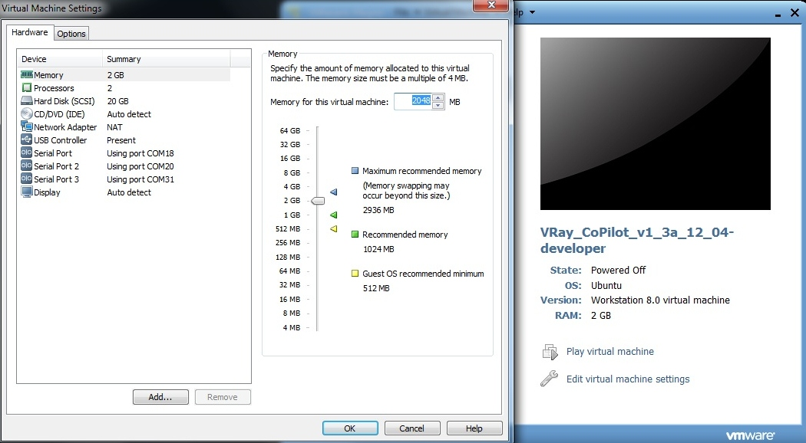

Option tab:

- Shared Folders -> see Shared folder section

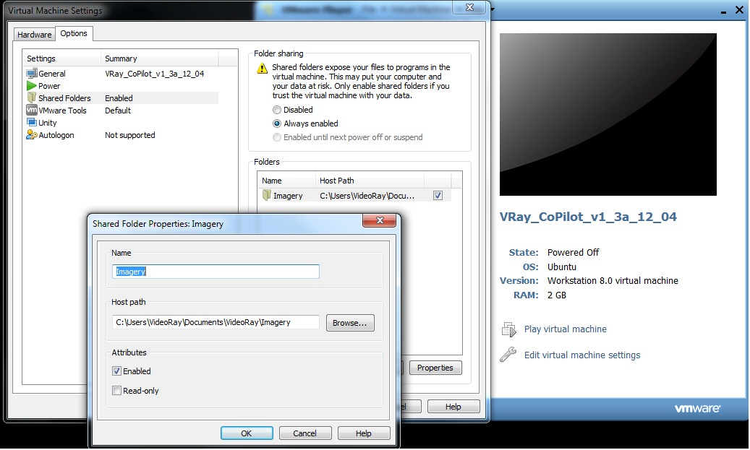

Shared folder
The virtual machine will log sonar and telemetry data to a shared folder on the host system. This allows the user to retrieve data easily and makes sure the virtual machine does not run out of disk space.
The shared folder in the virtual machine is set to “C:\Users\VideoRay\Documents\VideoRay\Imagery” (common folder where Video Ray data is also saved) and its name is “Imagery”.

Note: In the virtual machine the shared folder can be found in /home/seebyte/share.

5 additional folders are created in the shared folder (“C:\Users\VideoRay\Documents\VideoRay\Imagery” ) to store data such as marker files, mission files, sonar files, screenshot files and navigation files from the virtual machine

- marker
- mission
- sonar
- screenshot
- navigation
- update

Note: The folders can be created in the factory but if there are not present and the permissions are right CoPilot will create these folders. The folder shall be named as described (lower case only).

Serial ports
At the moment the virtual port has 3 serial ports configured as follow:

- VMserial 0 (ttyS0) set to DVL COM17 (to be moved to UDP socket)
- VMserial 1 (ttyS1) set to GPS COM19 (to be moved to UDP socket)
- VMserial 2 (ttyS2) set to Telemetry COM31 (to be moved to COM19)

Starting the virtual machine
The virtual machine can be launched from Cockpit by clicking on the SeeByte icon. The virtual machine will start maximized on whichever screen it was last used.

When the virtual machine has booted it will automatically log into the pilot account.

Note: When running the virtual machine for the first time it will ask if it was moved or copied, answer “I copied it”.

Stopping the virtual machine
Click the power icon on the toolbar at the top of the screen in the virtual machine and selected “shut down”. The host system will not allow a shut down to take place until the virtual machine has been shut down.

Starting CoPilot DVL, CoPilot Blueview and CoPilot DVLandBlueview versions
All systems can be started from the icons on the pilot desktop. Only one system may be run at a time. Attempting to start a system will terminate any currently running instance. Running the same system again will close the current instance and create a fresh instance.

