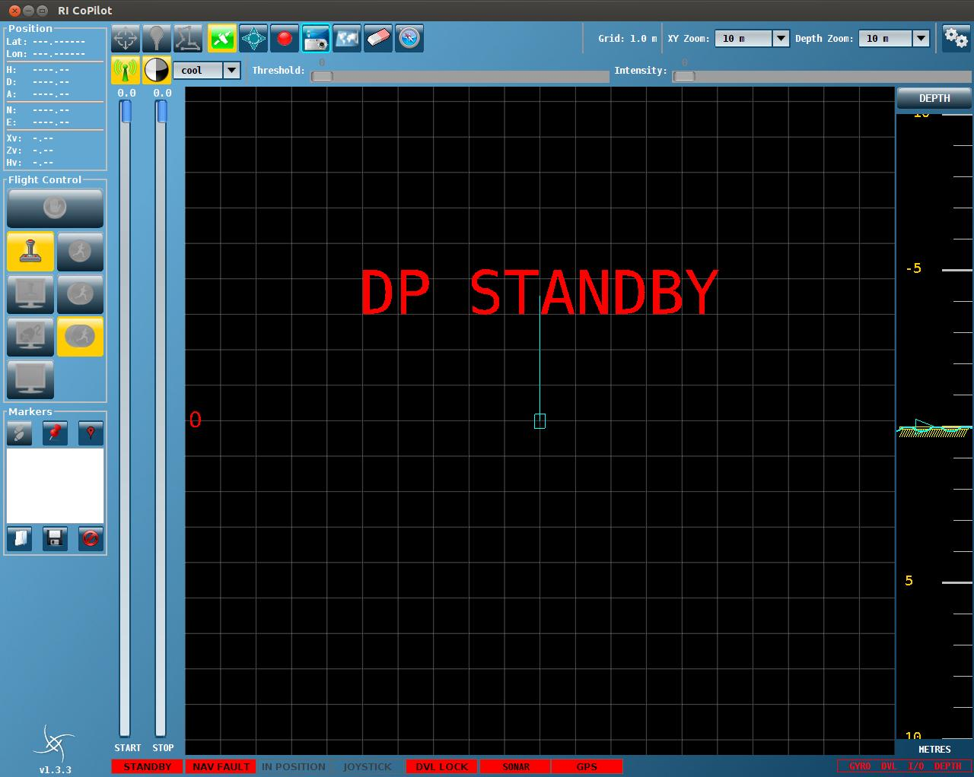

Figure 1: Screen capture of UI version 1.3.3

Changes for that version are minors:

1. JOYSTICK INDICATOR C:\Users\benprivat\AppData\Local\Microsoft\Windows\Temporary Internet Files\Content.Word\2014-04-14_T09-09-37-680Z.JPEG:

When hovering mouse over the JOYSTICK indicator, the tool tip now displays joystick demands in the range -100% to +100% if in use.

1. MARKER SCHEME

Two types of markers are available in CoPilot, Local (North East when no GPS) and Global (Lat Lon when GPS data is available).

The marker colour scheme is now linked to the NAVIGATION status indicator.

If the indicator shows NAV LOCAL (YELLOW) markers will be displayed yellow. (Either added manually or loaded from file). This is the default behaviour.

If the indicator shows NAV GLOBAL (GREEN) markers will be displayed green. Therefore yellow markers (if any) will turn GREEN and have their latitude and longitude position updated.

Loading from existing file:

* if CoPilot is in NAV LOCAL only Local markers will be loaded. If Global markers were present they will not be loaded.
* if CoPilot is in NAV GLOBAL both Local and Global markers will be loaded. Local markers will be converted.

1. GRID MODE button C:\Users\benprivat\AppData\Local\Microsoft\Windows\Temporary Internet Files\Content.Word\2014-04-14_T09-09-37-680Z.JPEG (beta feature)

It is a toggle button.

1. Not toggled, the GRID reference is North UP as standard and it is the default mode
2. Toggled, two modes are available
   1. Fixed heading, operator to input heading for grid to rotate
   2. Follow ROV heading, grid follows the ROV heading
3. GPS INDICATOR

Added to tooltip: EPE 1-sigma (Estimated position error) in metres

<http://edu-observatory.org/gps/gps_accuracy.html>