



SeeTrack CoPilot

Troubleshooting & FAQ

Table of Contents

1 Introduction 4

2 Troubleshooting 4

2.1 General Issues 4

2.1.1 The unit does not start up 4

2.1.2 The USB ports do not work 4

2.2 Pilot Interface Issues 4

2.2.1 The performance of the system has been degraded 4

2.2.2 I have connected my sensors to the SeeTrack CoPilot unit but the alarm remains there 5

2.2.3 Navigation Chart Messages 5

2.2.4 Status Indicators Display 6

2.2.5 Module Alarms Display 7

2.3 Sensor Troubleshooting 8

3 Frequently Asked Questions 10

*3.1* General 10

3.2 Pilot Interface 12

**Table of Figures**

Figure 1 - SERIAL TOOL ICON 8

Figure 2 - SERIAL TOOL MAIN MENU 9

Figure 3 - PORT SETUP DIALOG 9

|  |
| --- |
| **Distribution:**  **CUSTOMER** |

**Revision History**

|  |  |  |
| --- | --- | --- |
| **Revision** | **Date** | **Comment** |
| **01** | April 2007 | Ross Hall – Document Created |
| **02** | Jan 2009 | Emma Macphail – Updating Document |
| **03** | Jul 2010 | Nicole Irvine – Updating Document |
| **04** | Oct 2010 | Nicole Irvine – Editorial Checking |
| **05** | Dec 2013 | Lewis Deacon – Updating Entire Document |
| **06** | Jan 2014 | Nicole Irvine – Updating Branding |

Authors: Benjamin Privat

This document is commercial in confidence. If you have received it in error, please contact:

SeeByte

Registered in Scotland Number: SC194014

Registered Office: Orchard Brae House, Edinburgh, EH4 2HS

VAT Registration Number: 783656681

Tel: +44 (0) 131 447 4200

Fax: +44 (0) 131 447 4911

[www.seebyte.com](http://www.seebyte.com)

# Introduction

This guide provides the user with useful information regarding the use of SeeTrack CoPilot. It is divided into two parts:

***Troubleshooting –*** This section covers most of the information that the user may require in the event of a fault occurring within SeeTrack CoPilot.

***FAQ –*** This section improves the user’s knowledge of SeeTrack CoPilot and may help to answer questions to any issues the user is experiencing.

**Note**: If you are still experiencing any technical issues after reading this guide, please contact SeeByte Limited’s (SeeByte) technical support.

# Troubleshooting

## General Issues

### The unit does not start up

* Make sure the **Main Power Switches** at the rear of the unit are set to **position 1**.
* Make sure the SeeTrack CoPilot hardware unit is connected to **AC** mains.

### The USB ports do not work

* Check that the SeeTrack CoPilot Hardware Unit is powered up correctly.
* Check that all cables are correctly and firmly connected to their appropriate sockets.
* Check that the connected USB peripheral is not exceeding the 500mA current limit on each USB port.

## Pilot Interface Issues

### The performance of the system has been degraded

* Check that there is no alarm or faulty status in the Pilot Interface.
* Check that the sensor configuration is appropriate for the vehicle and the offsets of the sensors are correct.

### I have connected my sensors to the SeeTrack CoPilot unit but the alarm remains there

* Check that the driver configuration is correct:
* Select Preferences → System → Sensor Driver
* Check that the sensor driver is enabled, otherwise add it.
* Check that the format is correct.
* Check that the port number is correct (use SeeTrack CoPilot User Manuals to find out ports numbering).
* Check that the serial settings are correct.
* Check the number of messages received is not 0.

### Navigation Chart Messages

|  |  |  |
| --- | --- | --- |
| NAVIGATION CHART MESSAGES | | |
| MESSAGES | POSSIBLE CAUSE | POSSIBLE SOLUTION |
| DP STANDBY | The DP system is Off. | If the vehicle is out of range, fly back into range. |
| The DP system has failed. | If the DP is failing, press the emergency stop button, check the alarm panel and refer to 0 for troubleshooting information. |
| EMERGENCY STOP | The pilot cut the DP system off by pressing the emergency stop button. | Release the emergency stop button. |

### Status Indicators Display

|  |  |  |
| --- | --- | --- |
| STATUS INDICATORS DISPLAYED | | |
| MESSAGES | POSSIBLE CAUSE | POSSIBLE SOLUTION |
| STANDBY (RED) | The DP system is turned Off, this can occur if the ROV is not in working range or a critical error was detected. | In this situation SeeTrack CoPilot changes into MANUAL mode and the pilot has full control. |
| DP (GREEN) | The DP system is turned ON. | No action is required. |
| IN POSITION (GREEN) | The ROV is within the tolerance range of its target position. | No action is required. |
| NAV GLOBAL (GREEN) | The navigation system is operating correctly, and the global position is accurate. | No action is required. |
| NAV LOCAL  (YELLOW) | The global position may have a degree of imprecision – but it is still compatible with effective ROV operation. | The DP system can still work correctly. If you want to operate in known coordinates, provide a position in latitude and longitude using the External Position Fix button to change the vehicles position. |
| NAV FAULT  (RED) | The navigation system has failed. Only the MANUAL flight mode is accessible. | Check if there is any message displayed. Please refer to section 2.2.3 – .  Restart SeeTrack CoPilot. |
| JOYSTICK  (GREEN) | SeeTrack CoPilot has detected commands from the joystick. | This indicator appears as soon as the joystick is moved. This indicator is not displayed if the joystick is released (i.e. in CRUISE mode, SeeTrack CoPilot doesn’t enable the joystick). |
| DVL LOCK  (RED) | The DVL cannot get a good fix on the seabed. | Check DVL.  Check the DVL driver configuration is correct by accessing the Drivers Configuration menu item (Preferences → System → Sensor Driver). |
| The DVL is faulty. |
| The seabed is out of range. |
| DVL  (GREEN) | The DVL is operating normally. | No action is required. |
| SONAR  (RED) | The sonar is not connected to the system. | Connect the sonar to SeeTrack CoPilot if available. |
|  |
| The sonar has failed. | Check the sonar connections.  Use the RESET SONAR COMMS button to reset the sonar.  Check the sonar using the manufacturer software. |
|  |
| EXTERNAL POSITION (GPS, UBSL...)  (RED) | The External position sensor is not connected to SeeTrack CoPilot. | Ensure that the sensor is correctly plugged in.  Check the driver configuration for the sensor (Preferences → System → Sensor Driver). |

### Module Alarms Display

|  |  |  |
| --- | --- | --- |
| MODULE ALARMS DISPLAYED (RED) | | |
| MESSAGES | POSSIBLE CAUSE | POSSIBLE SOLUTION |
| DVL | SeeTrack CoPilot has failed. | Press Emergency Stop button. |
| Sensor has failed. |
| Sensor not plugged in properly. | Make sure that sensor is well plugged into right com port. |
| Driver has not been configured properly. | Check the settings and status of the driver by accessing the Drivers Configuration menu item (Preferences → System → Sensor Driver). |
| Serial to Ethernet device has failed. | Check cabling.  Check serial to Ethernet device.  Check raw sensor data.  Power cycle the sensor.  Restart SeeTrack CoPilot. |
| NAVIGATION | SeeTrack CoPilot has failed. | UDuring operation:  Press Emergency Stop button. |
| UPre-operation:  Make sure that navigation sensors are well plugged into right com port and the drivers are properly configured. |
| ROV is not in operating range. | Fly the ROV back to the operating range. |
| AUTOPOS | SeeTrack CoPilot has failed. | UDuring operation:  Press Emergency Stop button |
| UPre-operation:  Make sure that navigation sensors are well plugged into right com port. |
| Restart SeeTrack CoPilot. |
| I/O | SeeTrack CoPilot has failed. | Press Emergency Stop button. |
| Restart SeeTrack CoPilot. |
| Interface Box (IB) not plugged in properly. | UMake sure that IB is well connected to the SeeTrack CoPilot hardware unit. |
| DEPTH | SeeTrack CoPilot has failed. | UPress Emergency Stop button. |
| Restart SeeTrack CoPilot. |
| Sensor not plugged in properly. | Make sure that sensor is well plugged into right com port. |
| Sensor has failed. | Check the ROV status output to ensure the sensor has not failed. |
| Serial to Ethernet device has failed. | Check the serial to Ethernet device. |
| Driver has not been configured properly. | Check the settings and status of the driver by accessing the Drivers Configuration menu item (Preferences → System → Sensor Driver). |
| GYRO | SeeTrack CoPilot has failed. | Press Emergency Stop button. |
| Restart SeeTrack CoPilot. |
| Sensor not plugged in properly. | Make sure that sensor is well plugged into right com port. |
| Sensor has failed. | Check the ROV heading readout to ensure the sensor is working. |
| Driver has not been configured properly. | Check the settings and status of the driver by accessing the Drivers Configuration menu item (Preferences → System → Sensor Driver). |
| External Position (GPS, USBL ...) | SeeTrack CoPilot has failed. | Press Emergency Stop button. |
| Restart SeeTrack CoPilot. |
| Sensor has failed. | Make sure that sensor is well plugged into right com port. |
| Sensor not plugged in properly. | Check ROV status display to verify the sensor is operational. |
| Driver has not been configured properly. | Check the settings and status of the driver by accessing the Drivers Configuration menu item (Preferences → System → Sensor Driver). |
| UDP | Network issue | Contact SeeByte |
| SONAR | Sensor has failed | Make sure that the sensor is well plugged into the right port. |
| Sensor not plugged in properly | Check ROV status display to verify that the sensor is operational |
| Driver has not been properly configured | Check the settings and status of the driver by accessing the Drivers Configuration menu item (Preferences → System → Sensor Driver). |

**Caution**: If the ROV stops responding, cut the DP system off immediately by pressing the emergency stop button.

## Sensor Troubleshooting

Provided with SeeTrack CoPilot is the serial tool which can be used to help debug serial settings to ensure that you are receiving data from the sensor. To use the tool right click → open on the icon.

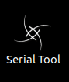

Figure 1 - SERIAL TOOL ICON

This will cause a terminal window to open which has some on screen instructions, first of all press enter, the user is then displayed with 3 more options as shown in Figure 2.

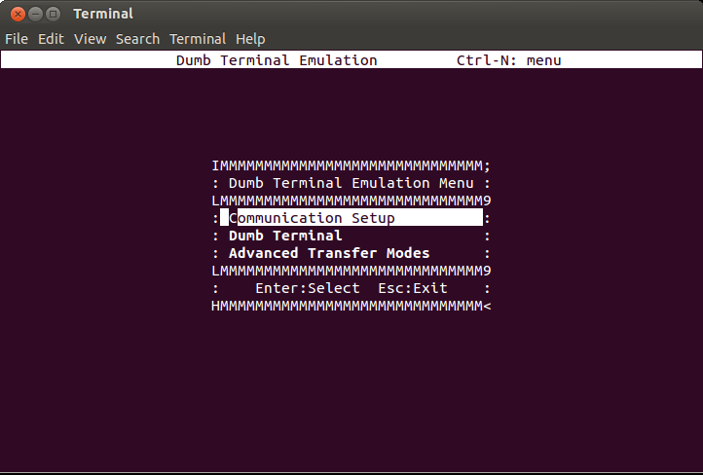

Figure 2 - SERIAL TOOL MAIN MENU

The first option Communication setup allows the user to setup the port to check for sensor data.

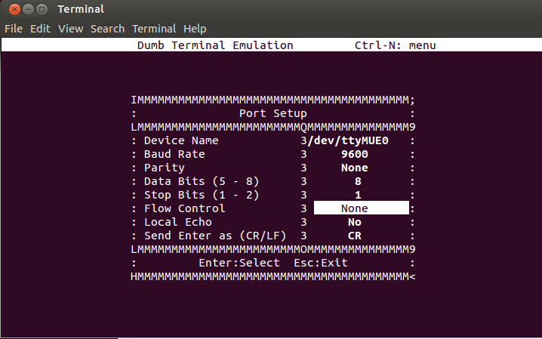

Figure 3 - PORT SETUP DIALOG

From this screen the user should change the Device name to the port they wish to test, the device name can be set as follow:

* /dev/ttyMUE0 which is port 1
* /dev/ttyMUE1 which is port 2
* /dev/ttyMUE2 which is port 3
* /dev/ttyMUE3 which is port 4

After setting the device name to the correct port of the sensor then the user must change the 'Flow Control' to None and then press Escape key to return to the previous menu, from here select option 2 'Dumb Terminal'.

If there is data being received from the sensor and that the port setup is correct the user should see the data being displayed on the terminal window.

NOTE**Note**: If there is no data being received, ensure that the sensor is correctly plugged in, that the serial cable is properly wired and that the port setup information is correct.

# Frequently Asked Questions

## General

**Q: What is the difference between the terms autoposition, station-keeping and dynamic positioning?**

***A:*** There is no difference. These terms are defined as the ability to maintain a vehicle fixed relative to a moving target or fixed point. Unlike SeeTrack CoPilot, other ROV station-keeping systems available in the market do not actually offer the ability to maintain a position relative to a target.

**Q: What do you mean by turn-key and retro-fittable? How easy is it really to fit to an ROV?**

***A:*** It is easy. To install the system the user must connect the navigation sensors and the ROV joystick. Installing the ROV joystick is critical and the most time-consuming aspect of the job, but with the right preparation it can be done in a matter of hours. Once the system has been installed it must be tuned. With the new auto-tune routines the pilot can tune the ROV in less than two hours.

**Q: Once installed, how can I verify the system’s performance?**

***A***: It’s easy. SeeTrack CoPilot can be used to store position requests and the actual ROV position, making performance analysis easy.

**Q: What happens when the Doppler loses bottom-lock?**

***A***: The ROV continues operating, but performance will be slightly compromised. The navigation system inside SeeTrack CoPilot is capable of dealing with irregular and infrequent Doppler outages. However, if the Doppler loses lock completely SeeTrack CoPilot will revert to MANUAL mode.

**Q: What information does the pilot interface display?**

***A***: The SeeTrack CoPilot system provides:

* **heading, depth and altitude information**
* **status of the ROV:** 
  + active, monitoring or on standby;
  + in position or moving; and
  + flight mode (MANUAL, AUTOFLY, etc.)
* **warnings:** 
  + prolonged loss of DVL lock;
  + automated responses to loss of Doppler lock;
  + alerting of sensor failure or disconnection;
  + information to aid remote technical support;
* **position of waypoint on the screen;**
* **sonar overlay** (if sonar is connected); **and**
* **chart overlay** (if compatible chart is loaded).

**Q: When using the chart overlay feature, how does the ROV know its global position?**

***A***: When using the chart overlay, the ROV will take an external fix at launch. The ROV will then dead-reckon until the pilot manually commands another fix.

**Note**: SeeByte envisages that the pilot will request a fix every half-hour to one hour, depending on the type of work being carried out. This process can be automated when an external position sensor is connected to SeeTrack CoPilot.

**Q: What provision is there for acceptance testing to prove that the ROV meets the specification?**

***A***: The first ROV of a new class will perform an in-water field acceptance trial in a harbour (not offshore); this will require support from the customer.

The acceptance will demonstrate all of the different flight modes.

For later ROVs of a supported class, in-water testing will not be carried out. The SeeByte installation engineer will check that sensors are installed correctly and linked to the SeeTrack CoPilot hardware unit, and that the unit has correct control of thrusters.

**Note:** If further in-water FATs are required by the customer for every installation then an extra cost may be incurred. Offshore trials will incur extra costs.

**Q: What level of documentation is provided with SeeTrack CoPilot?**

***A***: The following documentation is provided with SeeTrack CoPilot:

* A comprehensive set of manuals in digital form;
* A Factory test and acceptance certificate;
* A Trouble-shooting guide

**Q: How can I report a bug within SeeTrack or an error in the documentation, or submit a feature request for a future version of the product?**

***A***: You can submit bug reports, documentation errors, and feature requests by emailing [offshore.support@seebyte.com](mailto:offshore.support@seebyte.com) SeeByte software engineers review these reports and do their best to address these requests in the next product release cycle.

## Pilot Interface

**Q: Why does the main display stop moving when the DP system is in standby?**

***A***: The movement is produced by receiving updates from the DP navigation system. When the DP system goes into standby mode the navigation system is shut down to prevent large position errors. As a result there is no feedback for the pilot interface to display the ROV position or heading.

**Q: Why does the water column display continue to function when the DP system is in standby with the navigation turned off?**

***A***: The water column display can receive feedback from multiple sources. When the navigation system is running it accepts the depth and altitude readings from the navigation system. When the navigation is not running it displays the raw sensor data received from the ROV.

**Q: Why does the ROV appear to jump to a different position when the navigation is updated?**

***A***: The navigation is a dead-reckoning system. Periodically the dead-reckoned position must be updated with a fix from a separate system. The updated position results in the ROV’s current position being re-calculated and causes a small jump in the dead-reckoned position which is displayed on the screen.

**Q: Why does the Navigation Status indicator display a warning?**

***A:*** The navigation system requires a real-world position from an external fix. If these are unavailable the navigation global position (latitude and longitude) may have a degree of imprecision – but the DP system can still work correctly. If you want to operate in known world coordinates, provide a position in latitude and longitude using the External Position Fix button which will open the Update Global Reference window where the user can update the latitude and longitude.

**Q: Why are some of the buttons disabled?**

***A:*** When the DP system is in STANDBY, only MANUAL mode is enabled, so the rest of mode buttons are not accessible to the user.

**Q: In AUTOFLY mode, how do I know where to click to fly to a certain distance from the current position?**

***A:*** The pilot interface provides several tools to help users measure distance on the chart. Both the navigation chart display and water column display have a zoom scale and a grid. These can be altered by selecting the appropriate buttons at the top of the navigation chart display.

Also, by selecting the menu item **Preferences → Features → Range & Bearing**, the range and heading information from the ROV to the cursor is displayed on the navigation chart.

**Q: In AUTOHOVER and AUTOFLY modes, why does the pilot interface generate a ‘HOVER’ command’ when I have not completely released the joystick?**

***A:*** The menu item **Preferences →** **System → Joystick Calibration** allows the user to synchronise the settings of the joystick currently being used with SeeTrack CoPilot. This dialogue box also contains an option to adjust the deadband settings of the joystick.

**Q: Why does the ‘Not a Valid Chart File’ error message appear when I attempt to open a chart?**

***A:*** Remember that the chart file format supported by SeeTrack CoPilot is a DXF chart which must be AutoCAD® format 14. The coordinate system must also be the UTM coordinate system using the WGS84 reference ellipsoid and must not exceed the boundaries of the relevant UTM zone.

**Q: Why can't I see the chart I just loaded?**

***A:*** Remember to update the vehicles position using the 'Set Vehicle Position' button when loading the chart; it may be that the vehicle is not at the correct location therefore you will not be able to see your chart.

***A:*** Remember to zoom out using the zoom controls.

**Q: When in Survey Plan mode what is the difference between the Pause and the Stop button?**

***A:*** The pause button allows the user to pause the mission at the current point which then allows the user to play the mission from where it paused. The stop button acts differently to the pause button as when it is pressed the mission is stopped completely and pressing the play button will cause the vehicle to start the path from the first initial way point.

**Q: Where do my mission files and marker lists get saved too?**

***A:*** All data is saved to a data directory. A shortcut on the Desktop is available to navigate to the data folder (Link To Data). Missions are saved to the Mission folder and marker lists to the Marker folder. The data folder also contains subfolders such as screenshot, navigation, sonar and chart.

**Q: Is it better to use Depth or Altitude when in Cruise flight mode?**

***A:*** Altitude mode is recommended to avoid flying into the seabed.

**Q: What do the threshold and intensity sliders do?**

***A:*** The threshold slider increases and decreases the threshold value, by decreasing the threshold more background noise will be displayed in the image, increasing the threshold will suppress background noise, increasing the contrast of the image.

The intensity slider affects the brightness of the image. This is similar to brightness controls on a camera. Setting the intensity too low or too high will make the image dim or blow out respectively, making image details difficult to see.

**Automated settings are recommended.**

**Q: Is it possible to add a marker without using the add marker button?**

***A:*** Yes. Markers can be added two other ways; firstly a marker can be added at the vehicles current position by pressing the Mark Current Location button. Secondly a marker can be added by holding down the control (CTRL) key and left clicking on the grid display.

**Q: Why doesn't my overall water depth update when I enter a new value and press the OK button?**

***A:*** The manual update to the overall water depth can only be applied when CoPilot is in offline mode, to enable offline mode go to Preferences → Features → Enable Offline Planning.

**Q: Can I quickly delete mission waypoints when planning a mission?**

***A:*** Yes. Holding the control (Ctrl) key and pressing Z key will delete the last waypoint added.