# C:\Users\tom.glebas\Documents\videoray\www\required\images\logo.pngCoPilot Sonar

# Installation and Removal of the CoPilot Sonar Stabilizing Fin

BlueView V Series (small head)

## Installation

1. Remove the weight pods from the side of the sonar by removing the two screws. 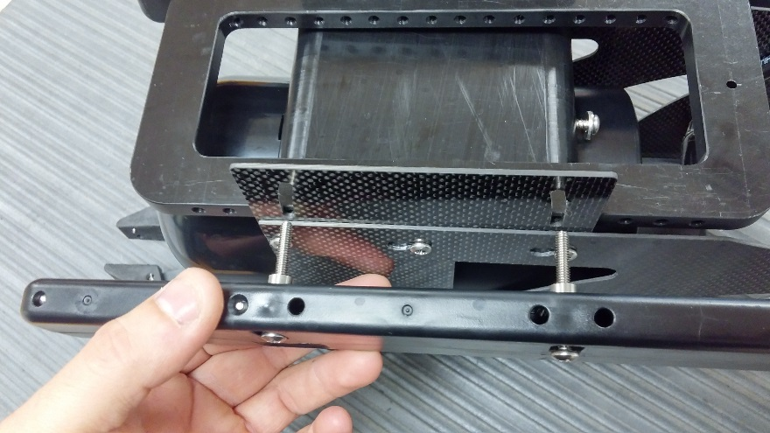
2. Loosen, but do not remove, the three top screws on the side plates. 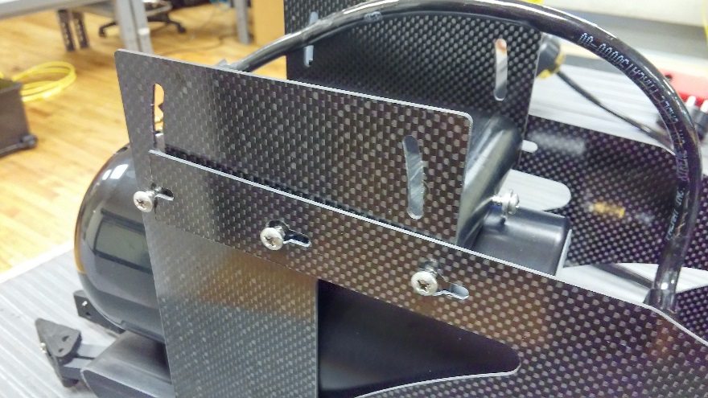
3. Remove the rear bottom screw on the side plates.
4. Slightly spread the sides of the fin and slide it over the sonar mount from the rear. 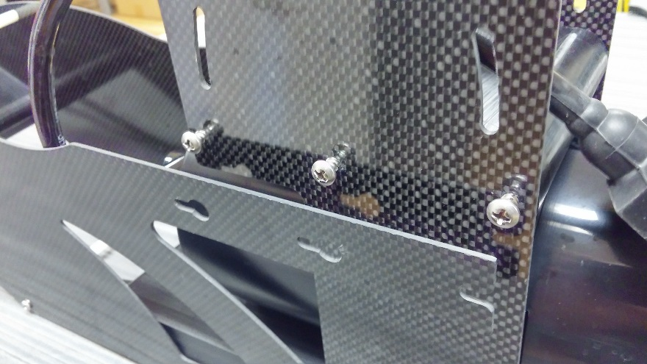
5. Align the holes with the screw heads so the fins can slip over the screws.
6. Slide the fins forward so the screws engage into the keyhole slots. 
7. Tighten all of the screws – do not overtighten the screws.
8. Reinstall and tighten the front bottom screw– do not overtighten the screw. 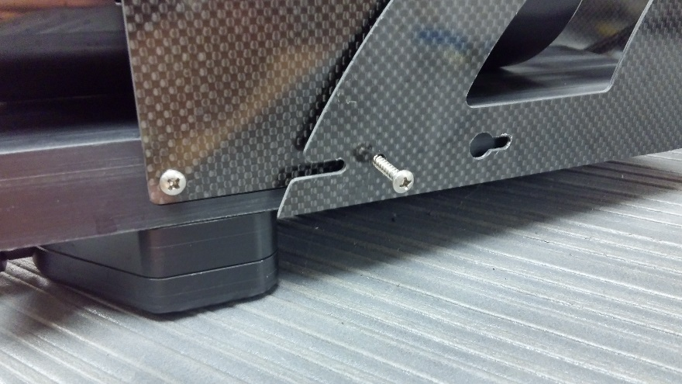
9. Reinstall the weight pods– do not overtighten the screws.

Installed configuration (some equipment shown is optional):

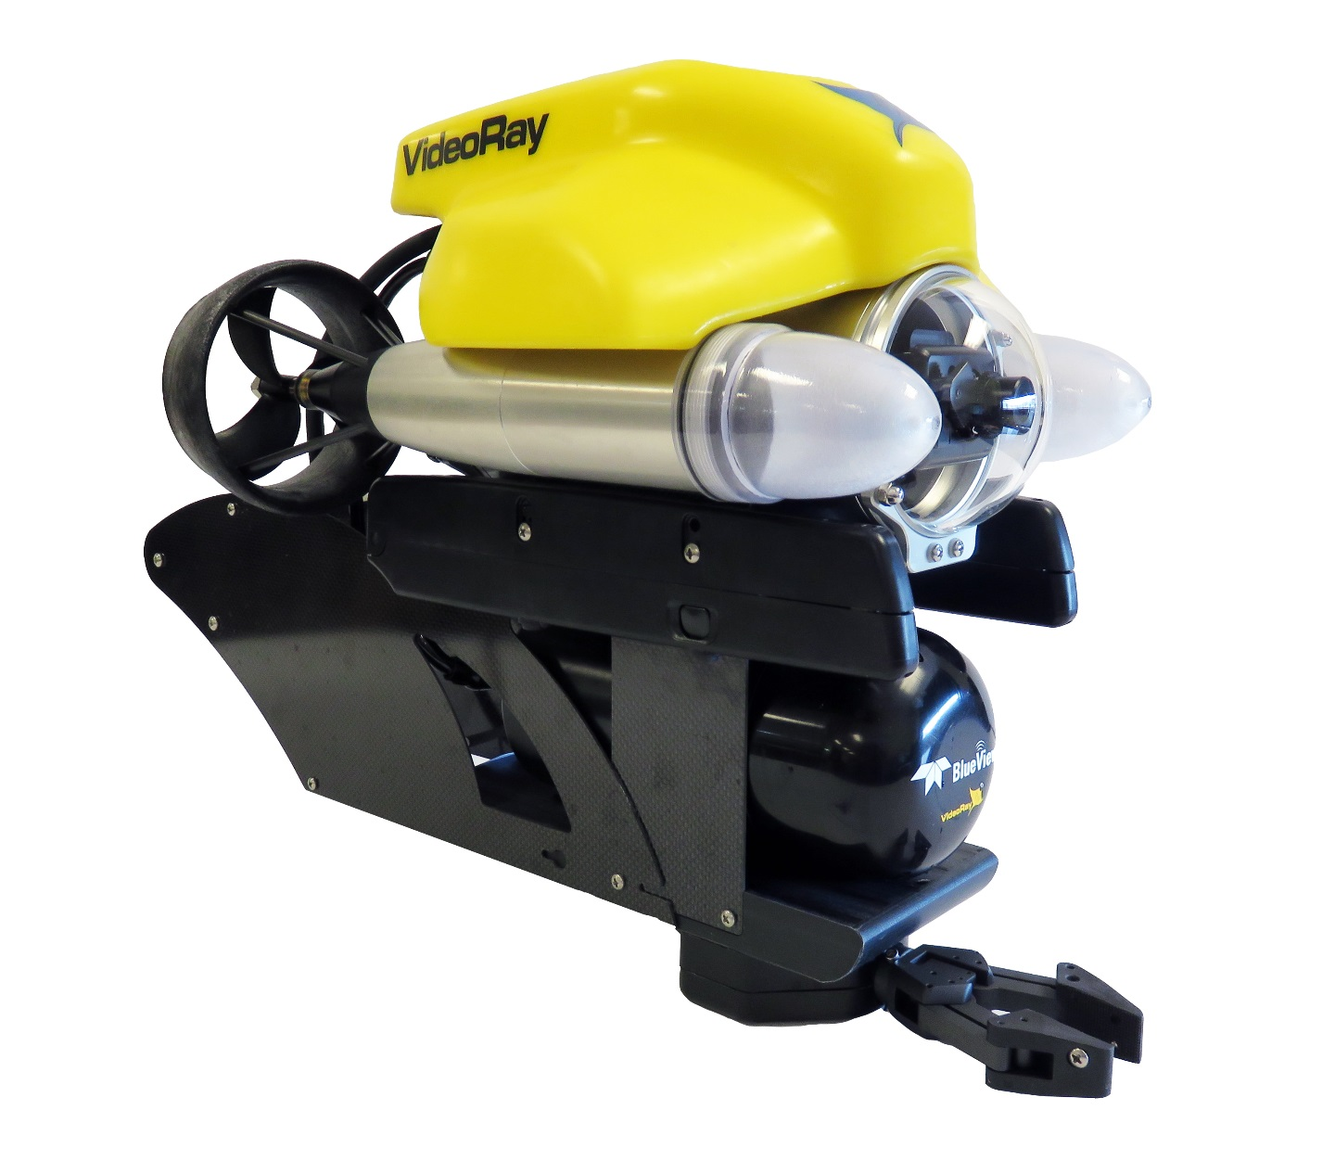

## Removal

(see photos from installation procedures)

1. Remove the weight pods from the side of the sonar by removing the two screws.
2. Remove the rear bottom screw on the fin / side plates.
3. Loosen, but do not remove, the three top screws on the fin / side plates.
4. Slide the fins rearward so the screws disengage from the keyhole slots.
5. Align the holes with the screw heads so the fins can slip over the screw heads.
6. Slightly spread the sides of the fin and slide it over the sonar mount from the rear.
7. Tighten all of the screws– do not overtighten the screws.
8. Reinstall and tighten the front bottom screw– do not overtighten the screw.
9. Reinstall the weight pods– do not overtighten the screws.