A black computer tower

Description generated with high confidence

A picture containing transport

Description generated with high confidence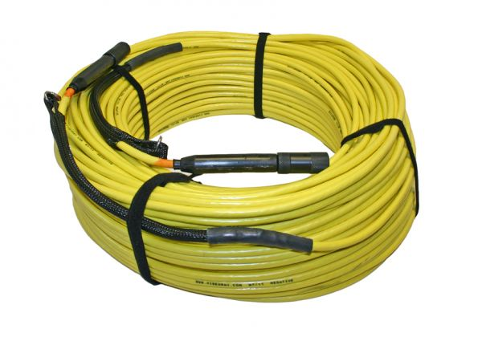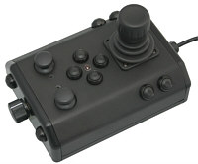

100-240 V AC 50, 60 Hz

Power Source (3 kW min)