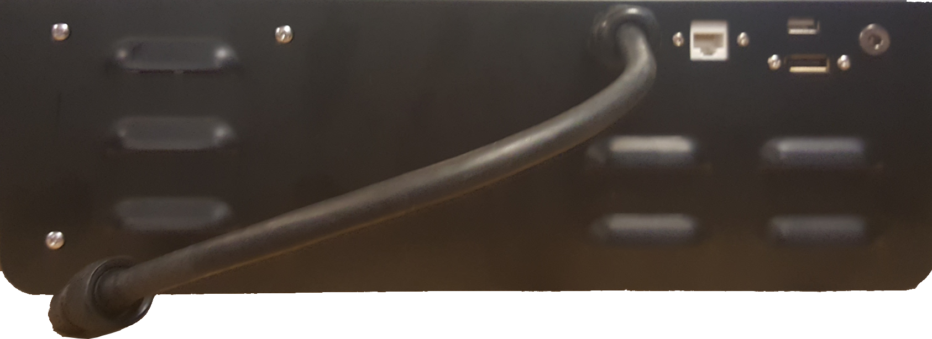

DisplayPort

Monitor Power

USB Port

ROV Tether Connection

Ethernet Port