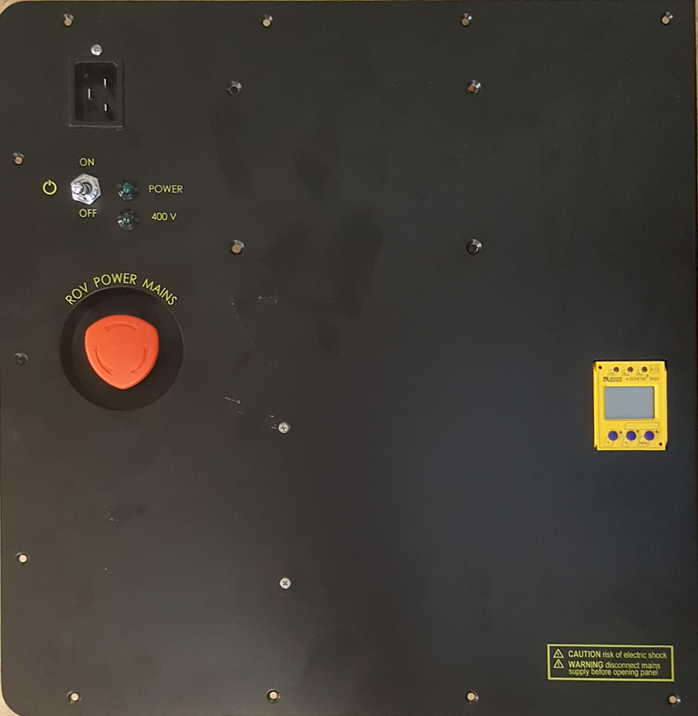

Mains Power Switch and Power Indicators

Power Cord

ROV Power Switch / Emergency Stop

Cord

LIM (Line Insulation Monitor)