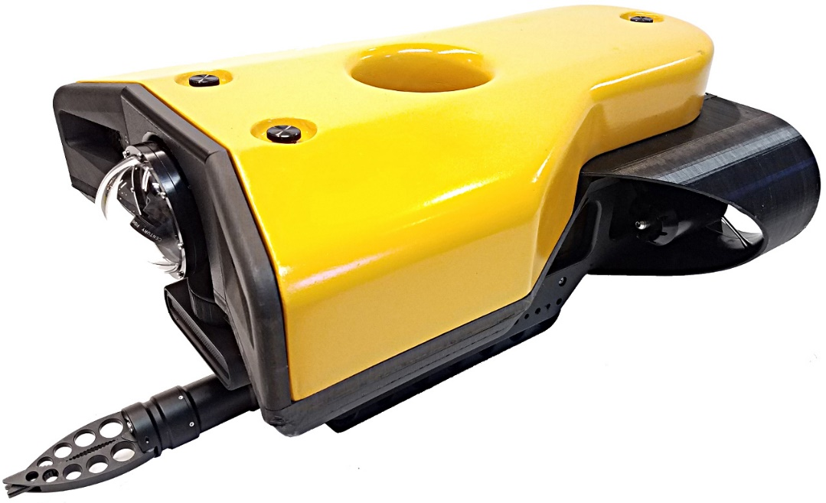

**Dive**

**Starboard side**

**Pitch**

**Sway**

**Heave**

**Stern / Aft**

**Port side**

**Roll**

**Surge**

**Surface**

**Yaw**

**Bow / Fore**