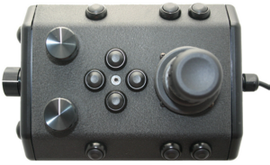

Pitch Down

Pitch Up

Left

Twist

For

Yaw

Right

Snapshot

Forward

Back

Zero Pitch/Roll

Focus Out

Focus In

Tilt Down

Tilt Up

Depth

Record

Reserved

Lights

Manip Rotate

Manip Close

Manip Open