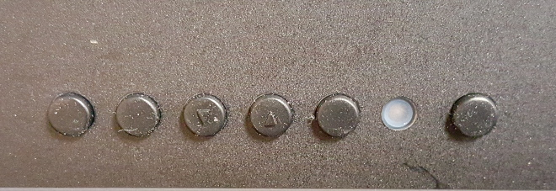

Power

Menu

Decrease

Source

Hotkey

Exit

Power LED

Increase

Down (Auto)