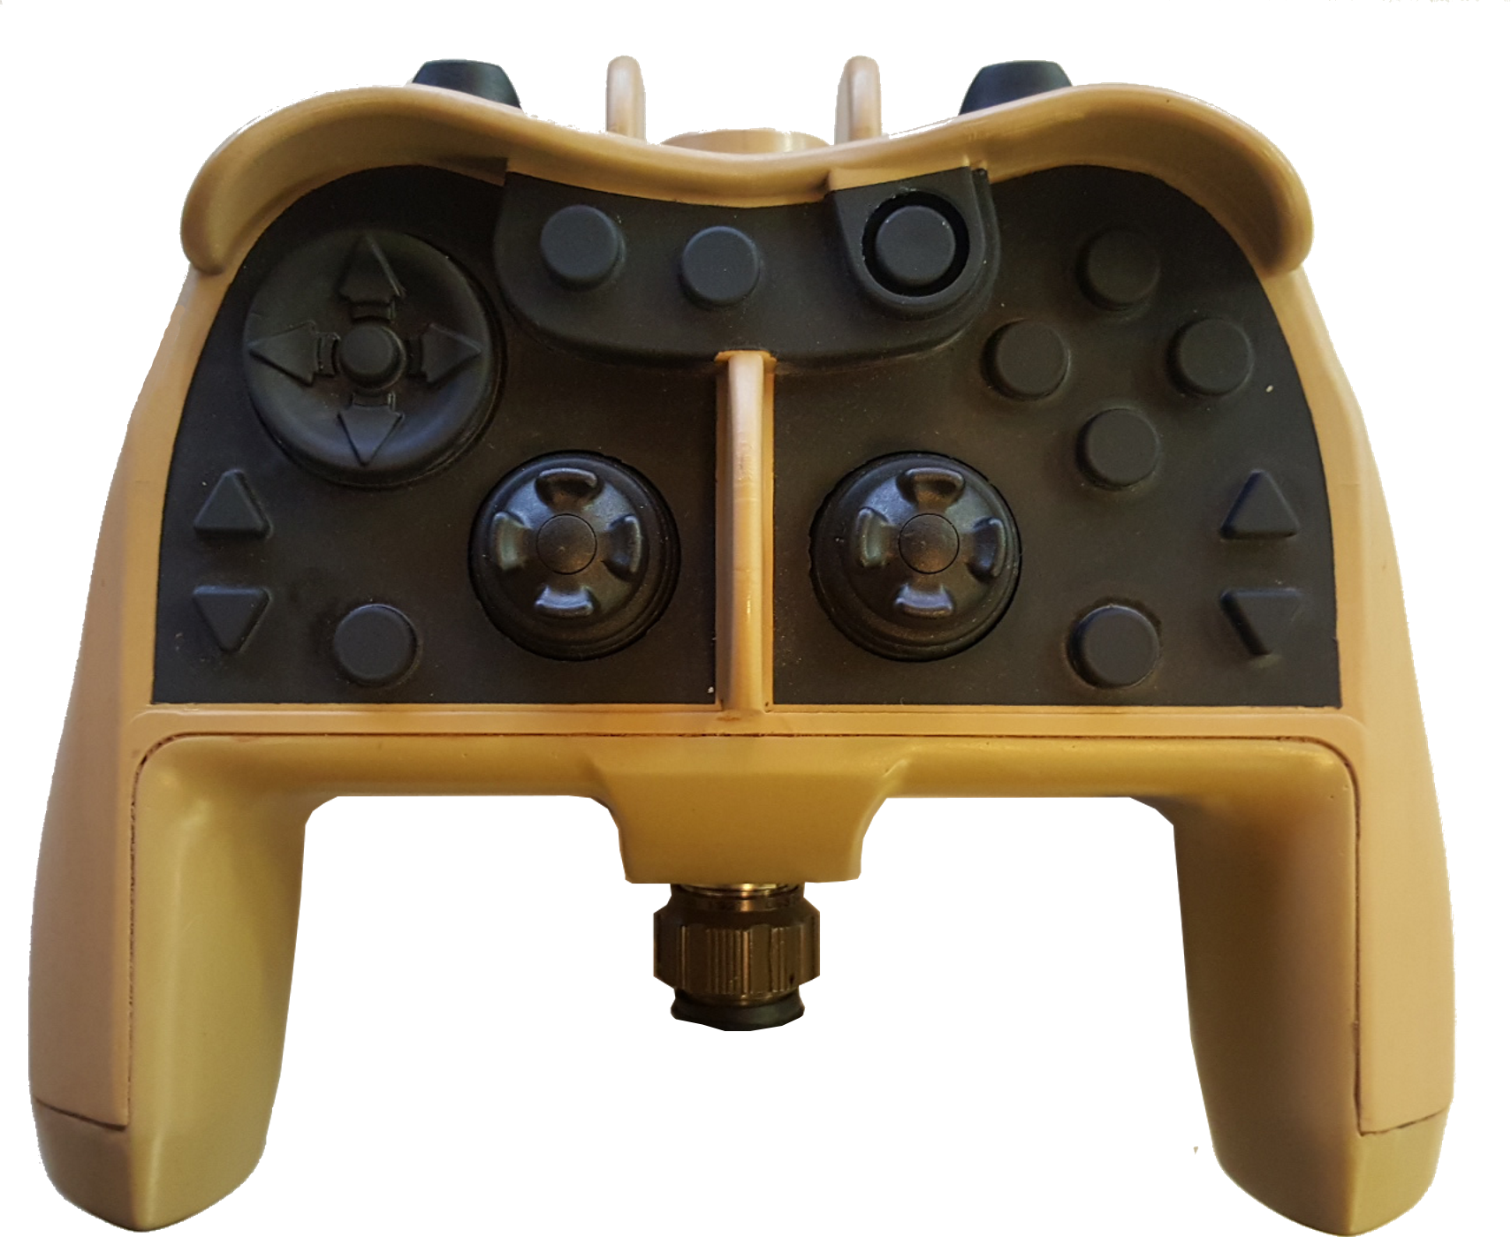

Forward

Left Right

Reverse

Surface

Manip CCW Manip CW

Dive

Tilt Up

Focus In Snapshot Focus Out

Tilt Down

Manipulator

Camera Select

Lights Bright

Help Record

Lights Dim

Auto Depth Auto Heading

Open

Close