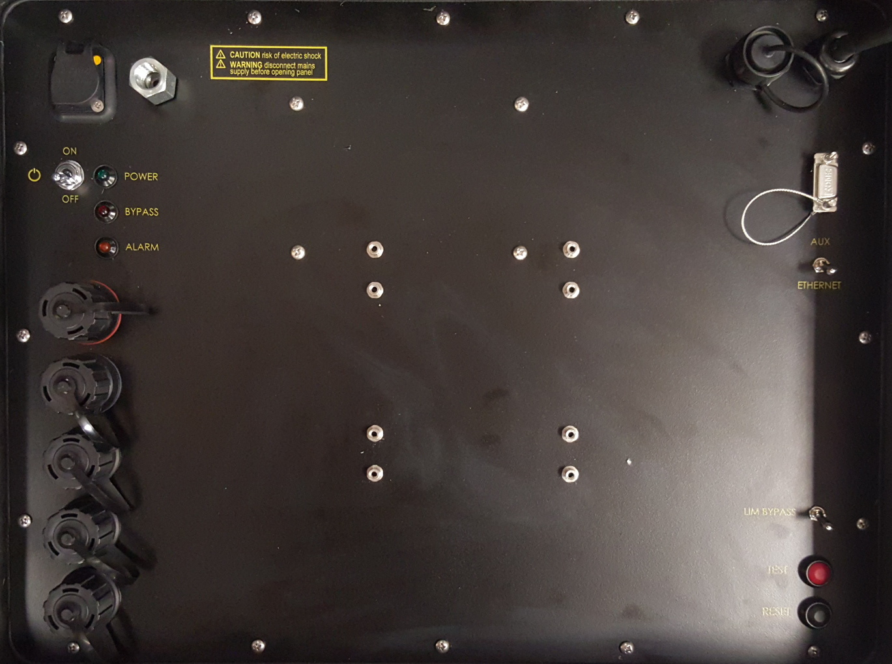

AUX Port

Tether Connection to ROV

LIM Alarm Indicator

USB Connection to Computer

Ethernet Modem Connection (Option)

USB Port

USB Port

USB Port

AUX Selector Switch

(Option)

Monitor Power

(12 Volt DV)

Power On Indicator

Power Cord Socket

Computer Power Socket

Power On/Off Switch

LIM Bypass Indicator

LIM Test Button

LIM Reset Button

LIM Bypass Switch