LECTURE
Wx Component
wxPython is a popular GUI toolkit for creating desktop applications in Python. It provides a wide range of components that you can use to build interactive user interfaces. Here are some of the possibilities:
- Windows and Dialogs: wxPython allows you to create windows and dialogs for your application, including main application windows, popup windows, message boxes, and file dialogs.
- Buttons and Controls: You can use various types of buttons and controls such as push buttons, toggle buttons, checkboxes, radio buttons, sliders, spin controls, and combo boxes to provide user interaction and input.
- Text Input: wxPython provides text input components like text fields, multiline text areas, and password fields for users to enter and edit text.
- Lists and Tables: You can use list boxes, choice lists, and combo boxes to present a list of options for users to select from. Additionally, wxPython provides table controls for displaying tabular data and allowing users to interact with it.
- Menus and Toolbars: You can create menus and toolbars with various menu items and toolbar buttons to provide easy access to application functionality.
- Trees and Notebooks: wxPython supports tree controls for displaying hierarchical data structures and notebook controls for creating multiple tabbed views within a single window.
- Graphics and Drawing: You can use the built-in support for graphics and drawing to create custom graphical elements such as lines, shapes, and images.
- Drag and Drop: wxPython provides drag-and-drop support, allowing users to drag items between different components or within the application.
- Event Handling: You can respond to user actions and events by binding event handlers to various components and events, such as button clicks, menu selections, and keyboard input.
- Custom Components: If the built-in components do not meet your requirements, you can create custom components by subclassing existing ones or by creating your own from scratch.

Here's an example of creating a custom component in wxPython by subclassing an existing component. Let's say we want to create a custom button with a special appearance and behavior. We'll create a class called CustomButton that inherits from wx.Button:
import wx

class CustomButton(wx.Button):
def __init__(self, parent, label):
super().__init__(parent, label=label)

# Set custom appearance or behavior
self.SetBackgroundColour(wx.Colour(255, 0, 0)) # Red background color
self.SetForegroundColour(wx.Colour(255, 255, 255)) # White text color
self.Bind(wx.EVT_BUTTON, self.on_button_click)

def on_button_click(self, event):
# Custom behavior when the button is clicked
print("Custom button clicked!")
event.Skip() # Allow event propagation to other event handlers
In this example, CustomButton is a subclass of wx.Button. In the constructor, we call the superclass constructor using super().__init__(parent, label=label) to initialize the button with the given parent and label.
We then set custom appearance and behavior for our button. In this case, we set the background color to red and the text color to white using SetBackgroundColour and SetForegroundColour, respectively. We also bind the wx.EVT_BUTTON event to the on_button_click method, which will be called when the button is clicked.
Inside the on_button_click method, we define the custom behavior for when the button is clicked. In this example, it simply prints a message to the console. We also call event.Skip() to allow the event to propagate to other event handlers that might be bound to the button.
Now, you can use your custom button in your application like any other wx.Button:

import wx

app = wx.App()
frame = wx.Frame(None, title="Custom Button Example")
panel = wx.Panel(frame)

custom_button = CustomButton(panel, label="Click Me")
sizer = wx.BoxSizer(wx.HORIZONTAL)
sizer.Add(custom_button, 0, wx.ALL, 10)
panel.SetSizerAndFit(sizer)

frame.Show()
app.MainLoop()
Combining the previous:

import wx

class CustomButton(wx.Button):
def __init__(self, parent, label):
super().__init__(parent, label=label)

# Set custom appearance or behavior
self.SetBackgroundColour(wx.Colour(255, 0, 0)) # Red background color
self.SetForegroundColour(wx.Colour(255, 255, 255)) # White text color
self.Bind(wx.EVT_BUTTON, self.on_button_click)

def on_button_click(self, event):
# Custom behavior when the button is clicked
print("Custom button clicked!")
event.Skip() # Allow event propagation to other event handlers

app = wx.App()
frame = wx.Frame(None, title="Custom Button Example")
panel = wx.Panel(frame)

custom_button = CustomButton(panel, label="Click Me")
sizer = wx.BoxSizer(wx.HORIZONTAL)
sizer.Add(custom_button, 0, wx.ALL, 10)
panel.SetSizerAndFit(sizer)

frame.Show()
app.MainLoop()

In this example, we create an instance of CustomButton and add it to a panel using a sizer. When you run the application, you should see a button with a red background and white text. When you click the button, it will print "Custom button clicked!" to the console.
This is just a basic example, but it demonstrates how you can create a custom component in wxPython by subclassing an existing component and adding your own custom appearance and behavior.

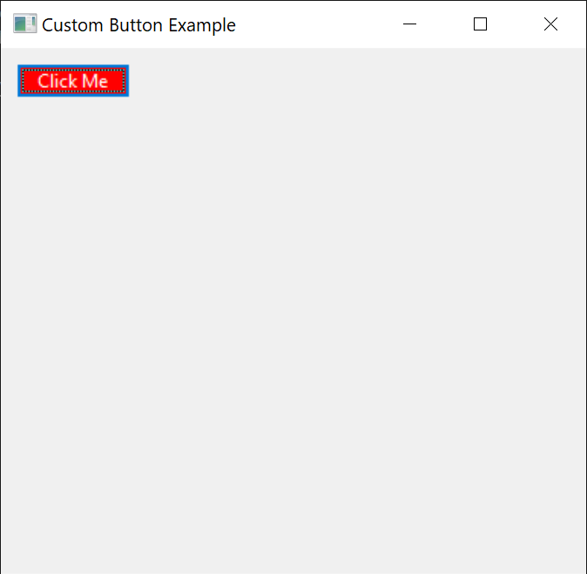

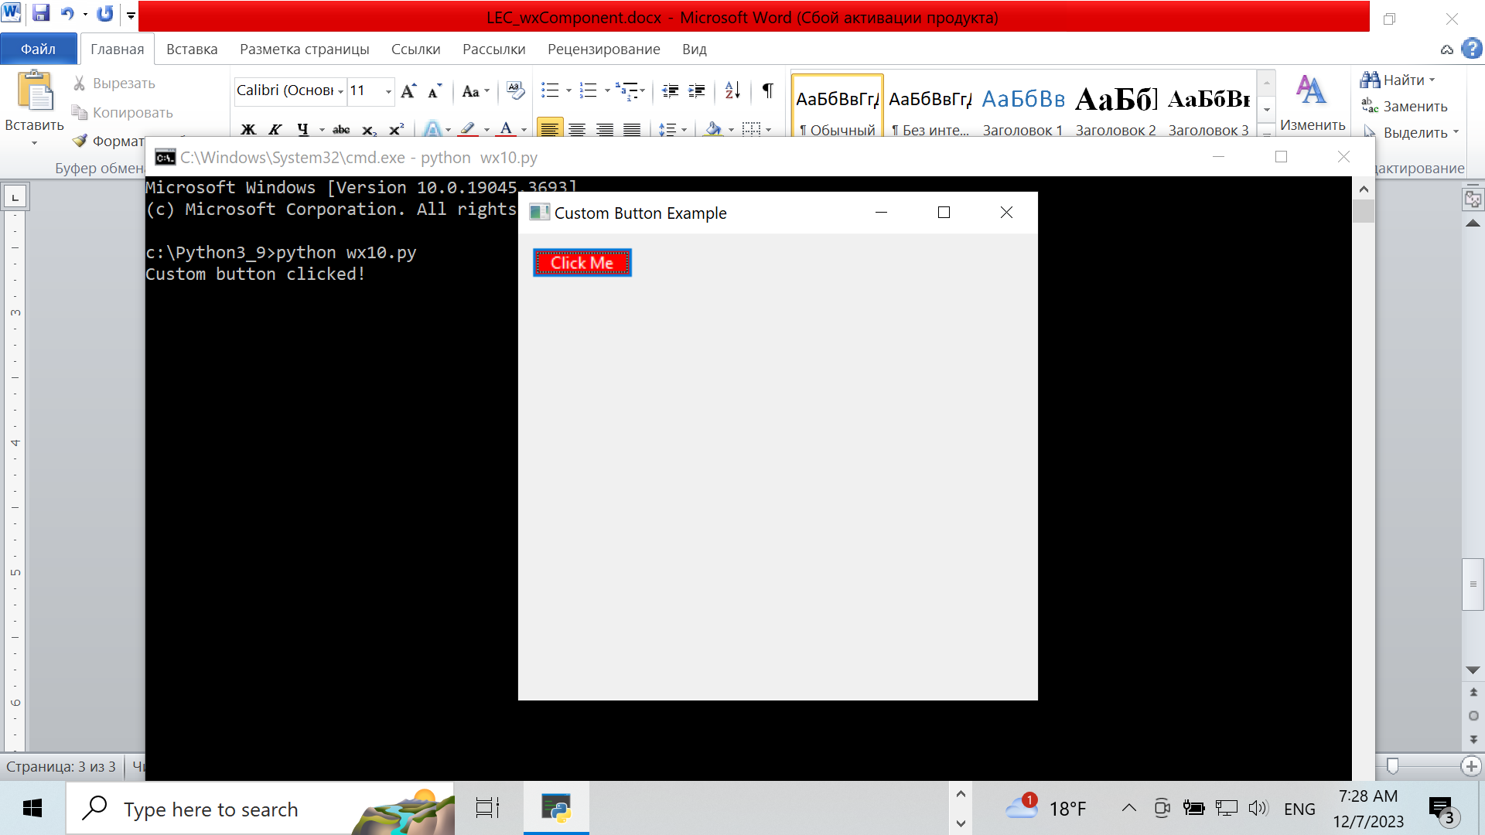

Here's an example of using the multiline text area component (wx.TextCtrl) in wxPython:

import wx

class MyFrame(wx.Frame):
def __init__(self):
super().__init__(None, title="Multiline Text Area Example")

panel = wx.Panel(self)
sizer = wx.BoxSizer(wx.VERTICAL)

self.text_ctrl = wx.TextCtrl(panel, style=wx.TE_MULTILINE)
sizer.Add(self.text_ctrl, proportion=1, flag=wx.EXPAND|wx.ALL, border=10)

button = wx.Button(panel, label="Get Text")
button.Bind(wx.EVT_BUTTON, self.on_button_click)
sizer.Add(button, flag=wx.ALL, border=10)

panel.SetSizerAndFit(sizer)

def on_button_click(self, event):
text = self.text_ctrl.GetValue()
wx.MessageBox(f"Entered Text:\n{text}", "Text Display", wx.OK | wx.ICON_INFORMATION)

app = wx.App()
frame = MyFrame()
frame.Show()
app.MainLoop()
In this example, we create a custom frame (MyFrame) that contains a panel and a vertical sizer. Inside the sizer, we add a wx.TextCtrl component with the wx.TE_MULTILINE style, which allows for multiple lines of text input.
We also add a button to the sizer, which is bound to the on_button_click method. When the button is clicked, the on_button_click method is executed. It retrieves the text entered in the multiline text area using GetValue() and displays it in a message box using wx.MessageBox.
When you run the application, you'll see a window with a multiline text area and a button. You can enter multiple lines of text in the text area. When you click the button, a message box will appear displaying the entered text.
Feel free to modify this example to suit your specific needs. You can add additional components, customize the appearance, or extend the functionality as per your requirements.
import wx

class MyFrame(wx.Frame):
def __init__(self):
super().__init__(None, title="Multiline Text Area Example")

panel = wx.Panel(self)
sizer = wx.BoxSizer(wx.VERTICAL)

self.text_ctrl = wx.TextCtrl(panel, style=wx.TE_MULTILINE)
sizer.Add(self.text_ctrl, proportion=1, flag=wx.EXPAND|wx.ALL, border=10)

button = wx.Button(panel, label="Get Text")
button.Bind(wx.EVT_BUTTON, self.on_button_click)
sizer.Add(button, flag=wx.ALL, border=10)

panel.SetSizerAndFit(sizer)

def on_button_click(self, event):
text = self.text_ctrl.GetValue()
wx.MessageBox(f"Entered Text:\n{text}", "Text Display", wx.OK | wx.ICON_INFORMATION)

app = wx.App()
frame = MyFrame()
frame.Show()
app.MainLoop()

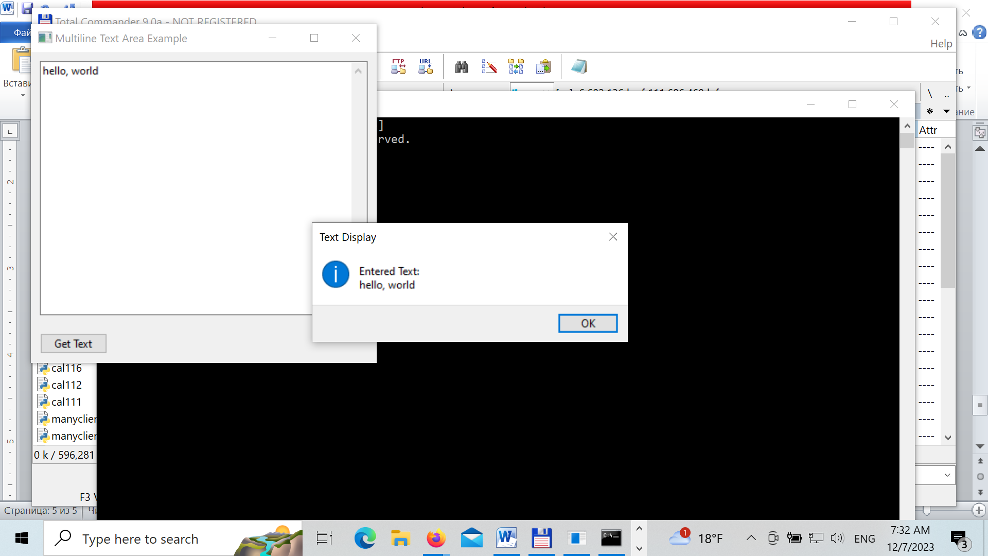
Combine both:
import wx

class CustomButton(wx.Button):
def __init__(self, parent, label):
super().__init__(parent, label=label)

# Set custom appearance or behavior
self.SetBackgroundColour(wx.Colour(255, 0, 0)) # Red background color
self.SetForegroundColour(wx.Colour(255, 255, 255)) # White text color
self.Bind(wx.EVT_BUTTON, self.on_button_click)

def on_button_click(self, event):
# Custom behavior when the button is clicked
print("Custom button clicked!")
event.Skip() # Allow event propagation to other event handlers

def on_button_click(self, event):
text = self.text_ctrl.GetValue()
wx.MessageBox(f"Entered Text:\n{text}", "Text Display", wx.OK | wx.ICON_INFORMATION)

class MyFrame(wx.Frame):
def __init__(self):
super().__init__(None, title="Multiline Text Area Example")

panel = wx.Panel(self)
sizer = wx.BoxSizer(wx.VERTICAL)

self.text_ctrl = wx.TextCtrl(panel, style=wx.TE_MULTILINE)
sizer.Add(self.text_ctrl, proportion=1, flag=wx.EXPAND|wx.ALL, border=10)

button = CustomButton(panel, label="Click Me")
button.Bind(wx.EVT_BUTTON, self.on_button_click2)
sizer.Add(button, flag=wx.ALL, border=10)

panel.SetSizerAndFit(sizer)

def on_button_click2(self, event):
text = self.text_ctrl.GetValue()
wx.MessageBox(f"Entered Text:\n{text}", "Text Display", wx.OK | wx.ICON_INFORMATION)

app = wx.App()
frame = MyFrame()
frame.Show()
app.MainLoop()

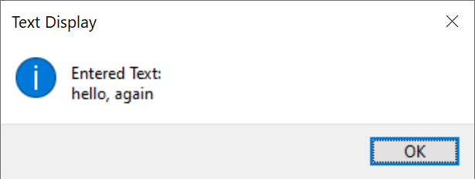

Other components

Here's an example of using a toolbar in wxPython:
import wx

class MyFrame(wx.Frame):
def __init__(self):
super().__init__(None, title="Toolbar Panel Example")

panel = wx.Panel(self)
main_sizer = wx.BoxSizer(wx.VERTICAL)

toolbar_panel = wx.Panel(panel)
toolbar_sizer = wx.BoxSizer(wx.HORIZONTAL)

toolbar = wx.ToolBar(toolbar_panel)
toolbar.AddTool(wx.ID_NEW, "New", wx.Bitmap("1.png"))
toolbar.AddTool(wx.ID_OPEN, "Open", wx.Bitmap("2.png"))
toolbar.AddTool(wx.ID_SAVE, "Save", wx.Bitmap("3.png"))
toolbar.Realize()

toolbar_sizer.Add(toolbar, proportion=1, flag=wx.EXPAND)
toolbar_panel.SetSizer(toolbar_sizer)

main_sizer.Add(toolbar_panel, proportion=0, flag=wx.EXPAND)
panel.SetSizerAndFit(main_sizer)

self.Bind(wx.EVT_TOOL, self.on_toolbar_click)

def on_toolbar_click(self, event):
toolbar_id = event.GetId()

if toolbar_id == wx.ID_NEW:
print("New button clicked!")
elif toolbar_id == wx.ID_OPEN:
print("Open button clicked!")
elif toolbar_id == wx.ID_SAVE:
print("Save button clicked!")

app = wx.App()
frame = MyFrame()
frame.Show()
app.MainLoop()

In this example, we create a custom frame (MyFrame) that contains a panel and a vertical sizer. Inside the sizer, we add a toolbar using self.CreateToolBar().
We then add three tools to the toolbar using the AddTool method. Each tool is identified by a unique ID (wx.ID_NEW, wx.ID_OPEN, wx.ID_SAVE), and we provide a label and a bitmap image for each tool.
Next, we call Realize() to finalize the toolbar creation.
The toolbar is added to the sizer, and the sizer is set on the panel.
We bind the wx.EVT_TOOL event to the on_toolbar_click method, which is called when a toolbar tool is clicked. Inside the event handler, we determine which tool was clicked based on the tool's ID, and we perform the corresponding action.
In this example, we simply print a message to the console for each tool when it is clicked.
Make sure to replace the filenames in wx.Bitmap with the actual path to the images you want to use for the toolbar icons.
When you run the application, you'll see a window with a toolbar containing the specified tools. When you click a tool, the corresponding message will be printed to the console.
You can customize this example by adding more tools, changing the icons, or extending the functionality of the toolbar to suit your needs.
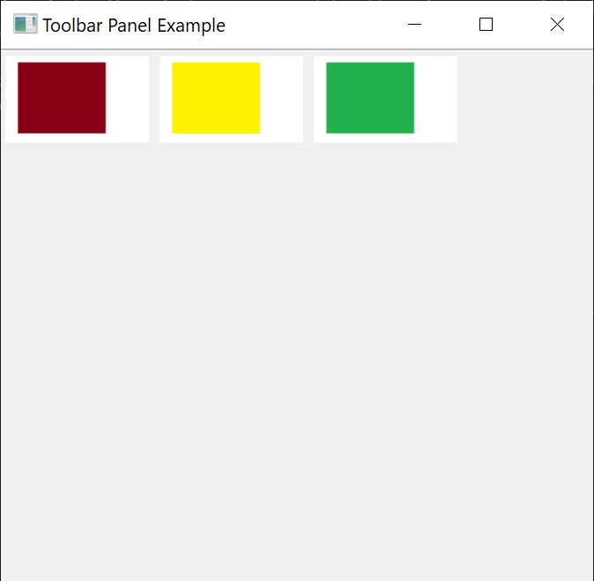

Open WEbNavigator as ActiveX

import win32com.client

def main():
# Create an instance of Internet Explorer's WebBrowser control
ie = win32com.client.Dispatch("InternetExplorer.Application")

# Make the browser window visible
ie.Visible = True

# Navigate to a website
ie.Navigate("https://www.google.com")

# Wait for the page to load
while ie.ReadyState != 4:
pass

# ie.Quit()

if __name__ == "__main__":
main()
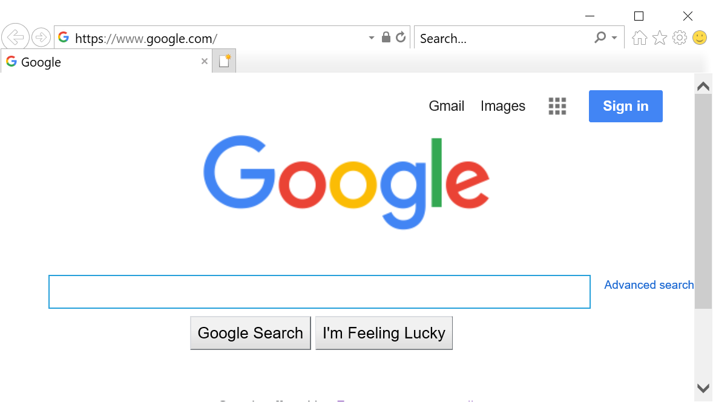

To open an HTML site using wxPython, you can use the wx.html2 module, which provides a web view component. Here's an example of how to open an HTML site using wxPython:

import wx
import wx.html2 as webview

class MyFrame(wx.Frame):
def __init__(self, parent):
wx.Frame.__init__(self, parent, title="HTML Viewer", size=(800, 600))

# Create a web view component
self.browser = webview.WebView.New(self)

# Load the HTML site
self.browser.LoadURL("https://www.google.com")

# Show the frame
self.Show()

if __name__ == "__main__":
app = wx.App()
frame = MyFrame(None)
app.MainLoop()
In this example, we create a custom MyFrame class that inherits from wx.Frame. Inside the frame's constructor, we create a web view component using webview.WebView.New(). We then load the desired HTML site using LoadURL(), passing in the URL of the site.
When you run this code, it will open a wxPython application window displaying the HTML site specified by the URL.
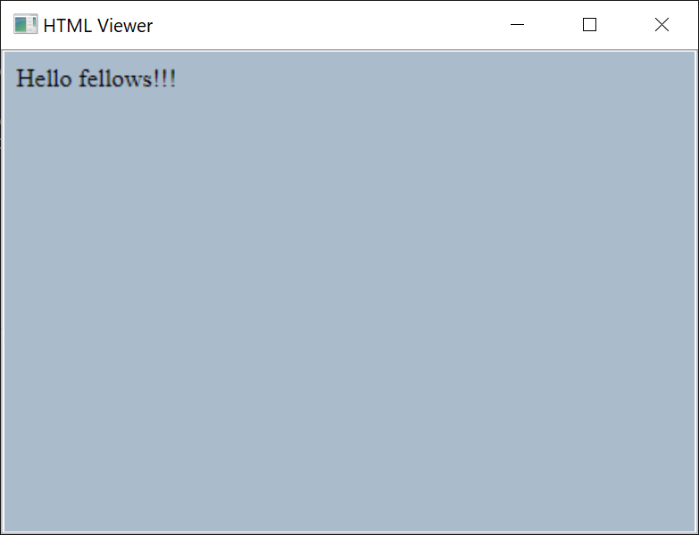

The code is here
import wx
import wx.html2 as webview

class MyFrame(wx.Frame):
def __init__(self, parent):
wx.Frame.__init__(self, parent, title="HTML Viewer", size=(800, 600))

# Create a web view component
self.browser = webview.WebView.New(self)

# Load the HTML site
self.browser.LoadURL("file:///c://Python3_9/my.html")

# Show the frame
self.Show()

if __name__ == "__main__":
app = wx.App()
frame = MyFrame(None)
app.MainLoop()

To play music from an HTML site using wxPython, you can utilize the wx.html2 module to display the HTML site and interact with the JavaScript code on the page. Here's an example of how you can play music from an HTML site using wxPython:
<html>
<body bgcolor=#aabbcc>
<audio controls>
<source src="sun.mp3" type="audio/mp3">
Your browser does not support the audio tag.
</audio>
</body>
</html>

import wx
import wx.html2 as webview

class MyFrame(wx.Frame):
def __init__(self, parent):
wx.Frame.__init__(self, parent, title="HTML Music Player", size=(800, 600))

# Create a web view component
self.browser = webview.WebView.New(self)

# Bind an event handler for when the page finishes loading
self.browser.Bind(webview.EVT_WEBVIEW_LOADED, self.on_page_loaded)

# Load the HTML site
self.browser.LoadURL("music.html")

# Show the frame
self.Show()

def on_page_loaded(self, event):
# Execute JavaScript code to play the music
self.browser.RunScript("document.getElementById('audio').play();")

if __name__ == "__main__":
app = wx.App()
frame = MyFrame(None)
app.MainLoop()

import wx
import wx.html2 as webview
import webbrowser

html_content = '''
<!DOCTYPE html>
<html>
<body bgcolor=#aabbcc>
<audio controls>
<source src="sun.mp3" type="audio/mp3">
Your browser does not support the audio tag.
</audio>
</body>
</html>
'''
webbrowser.open('my3.html')

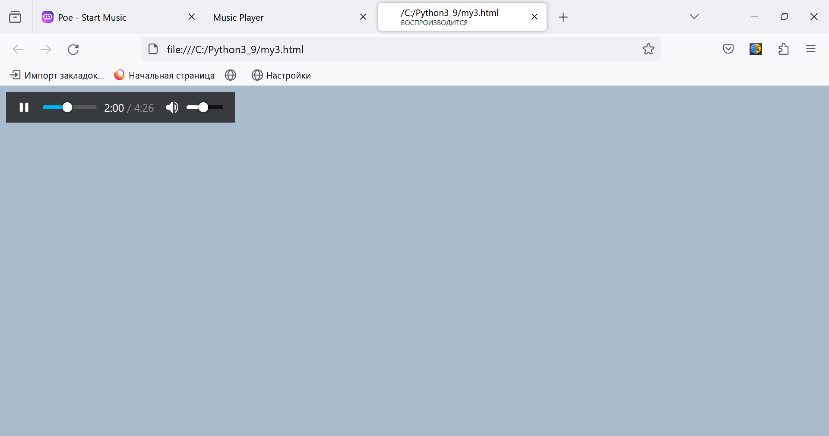

import wx
import wx.media
import time
import threading
import wx
import wx.html2
import pygame
import time

class MyFrame(wx.Frame):
def __init__(self, *args, **kw):
super(MyFrame, self).__init__(*args, **kw)

self.panel = wx.Panel(self)
self.toolbar = self.CreateToolBar()

# Устанавливаем размер изображений кнопок на панели инструментов
image_size = (32, 32)
self.toolbar.SetToolBitmapSize(image_size)

self.music_button = self.toolbar.AddTool(wx.ID_ANY, "Play Music", wx.Bitmap("music_icon.png"))
self.Bind(wx.EVT_TOOL, self.on_music_button_click, self.music_button)

self.timer_button = self.toolbar.AddTool(wx.ID_ANY, "Start Timer", wx.Bitmap("timer_icon.png"))
self.Bind(wx.EVT_TOOL, self.on_timer_button_click, self.timer_button)

self.toolbar.Realize()

self.media_player = wx.media.MediaCtrl(self.panel)
self.timer_thread = None

self.Bind(wx.EVT_CLOSE, self.on_close)

def on_music_button_click(self, event):
# Инициализация Pygame
pygame.mixer.init()

# Загрузка и воспроизведение аудиофайла
pygame.mixer.music.load("C:/Users/kbelo/OneDrive/Desktop/TKP/lab14/Ludovico Einaudi-Una Mattina.mp3")
pygame.mixer.music.play()

# Подождать, пока музыка не закончится
while pygame.mixer.music.get_busy():
time.sleep(1)

def on_timer_button_click(self, event):
if self.timer_thread and self.timer_thread.is_alive():
wx.MessageBox("Timer is already running", "Warning", wx.OK | wx.ICON_WARNING)
else:
self.timer_thread = threading.Thread(target=self.start_timer)
self.timer_thread.start()

def start_timer(self):
for i in range(5, 0, -1):
time.sleep(1)
print(f"Time left: {i} seconds")

print("Timer complete!")

def on_close(self, event):
if self.timer_thread and self.timer_thread.is_alive():
wx.MessageBox("Please stop the timer before closing the application", "Warning", wx.OK | wx.ICON_WARNING)
else:
self.Destroy()

if __name__ == "__main__":
app = wx.App(False)
frame = MyFrame(None, title="wxPython Toolbar Example", size=(400, 300))
frame.Show()
app.MainLoop()

