LABORATORY WORK REFLECTION
Goal
To study reflection mechanism
Short theory
Reflection, in the context of programming, refers to the ability of a program to examine and modify its own structure, behavior, or state at runtime. It allows a program to introspect and manipulate its elements such as classes, objects, methods, properties, and attributes dynamically.

Here's an example of how you can use reflection in Python:
class MyClass:
def __init__(self):
self.my_attribute = 42

def my_method(self):
return "Hello, reflection!"

# Create an instance of MyClass
obj = MyClass()

# Accessing attribute using reflection
attribute_name = "my_attribute"
attribute_value = getattr(obj, attribute_name)
print(attribute_value) # Output: 42

# Invoking method using reflection
method_name = "my_method"
method = getattr(obj, method_name)
result = method()
print(result) # Output: Hello, reflection!

In the example above, we define a class MyClass with an attribute my_attribute and a method my_method. We then create an instance of MyClass called obj.

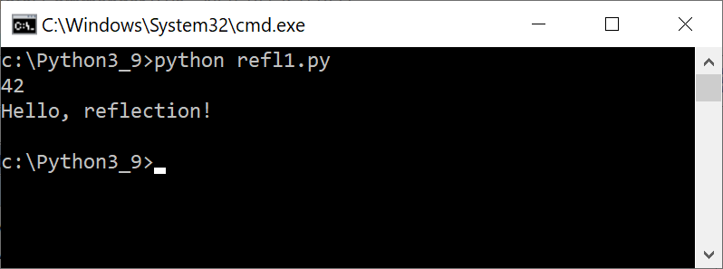

Using reflection, we can dynamically access the attribute my_attribute and retrieve its value using the getattr() function. Similarly, we can access the method my_method using getattr() and then invoke it as a regular function.
The output of the code will be:
42
Hello, reflection!
This demonstrates how reflection allows us to inspect and manipulate attributes and methods of an object dynamically at runtime.

To use reflection with external classes in Python, you can follow these steps:
- Import the necessary modules: Begin by importing the required modules or packages that contain the classes you want to reflect upon. For example, if you have an external module named external_module that contains the class you want to reflect upon, you would import it using import external_module.
- Access the class: Once you have imported the module, you can access the class using dot notation. For example, if the class you want to reflect upon is named ExternalClass within the external_module, you can access it as external_module.ExternalClass.
- Use reflection methods: Python provides various reflection methods to inspect and manipulate classes and objects. Some commonly used reflection methods include getattr(), setattr(), hasattr(), dir(), and type().
  - getattr() allows you to retrieve attributes or methods of an object based on their names. You can use it to access properties, methods, or other attributes of the external class.
  - setattr() allows you to set attributes or methods of an object dynamically.
  - hasattr() checks if an object has a specific attribute or method.
  - dir() returns a list of all the attributes and methods of an object.
  - type() returns the type or class of an object.
Here's an example that demonstrates the use of reflection with an external class time:
import time

# Access the external class
external_class = time.time

# Instantiate an object of the external class
obj = external_class()
time_tuple = time.localtime(obj)[0:5]

# Print the tuple
print(time_tuple)
print("done")

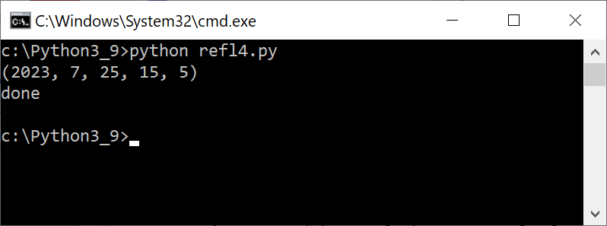

Here's an example that demonstrates the usage of dir():

class MyClass:
def __init__(self):
self.x = 10
self.y = 20

def my_method(self):
return self.x + self.y

# Create an instance of MyClass
obj = MyClass()

# Get the list of attributes and methods of the object using dir()
object_attributes = dir(obj)

# Print the list of attributes and methods
for attribute in object_attributes:
print(attribute)

In this example, we define a class called MyClass with two attributes (x and y) and a method (my_method). We then create an instance of MyClass called obj. By calling dir(obj), we obtain a list of attributes and methods associated with the obj object. Finally, we iterate through the list and print each attribute.

To add a new method to a class with parameters using reflection in Python, you can use the Types.MethodType class from the types module. :

import types

class MyClass:
def existing_method(self):
print("Existing method called.")

def new_method(self, param1, param2):
print("New method called.")
print("param1:", param1)
print("param2:", param2)

# Instantiate an object of the class
obj = MyClass()

# Add the new method to the class
new_method_name = "new_method"
setattr(MyClass, new_method_name, types.MethodType(new_method, obj))

# Call the new method
getattr(obj, new_method_name)("Value 1", "Value 2")

In this example, we define a class MyClass with an existing method called existing_method. We want to add a new method, new_method, which takes two parameters.
We import the type module and define the new_method function. We then use setattr to dynamically add a new_method to the MyClass class. Types.MethodType is used to create a bound method from new_method by passing None as the instance argument and MyClass as the class argument.

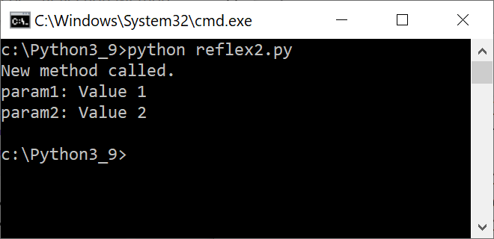

This demonstrates how reflection allows us to dynamically change an object's attributes and methods at runtime.

Here's an example that demonstrates how to modify an object using reflection in Python:
class MyClass:
def __init__(self):
self.my_attribute = 42

def my_method(self):
return "Hello, reflection!"

obj = MyClass()

# Modifying attribute using reflection
attribute_name = "my_attribute"
setattr(obj, attribute_name, 100)
print(obj.my_attribute) # Output: 100

# Modifying method using reflection
method_name = "my_method"
new_method = lambda self: "Modified method"
setattr(obj.__class__, method_name, new_method)
result = obj.my_method()
print(result) # Output: Modified method

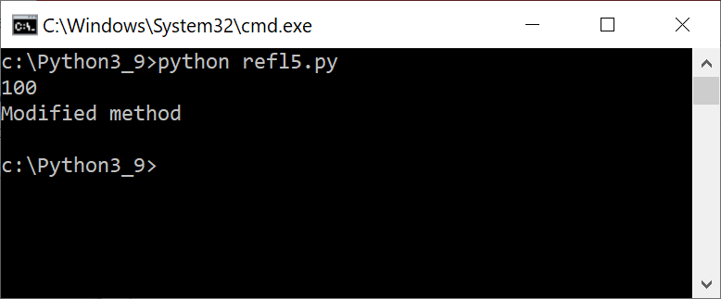

In this example, we have a class MyClass with an attribute my_attribute and a method my_method. We create an instance of MyClass called obj.
Using reflection, we modify the attribute my_attribute using the setattr() function. We pass the object obj, the attribute name as a string, and the new value. After modification, we access the modified attribute obj.my_attribute and print its value.
Similarly, we modify the method my_method using setattr(). We access the class of the object (obj.__class__), pass the method name as a string, and assign a new method (a lambda function in this case). We then invoke the modified method obj.my_method() and print the result.
This demonstrates how reflection allows us to dynamically modify attributes and methods of an object at runtime.
Below we place an example of how to create a new object using reflection in Python:

class MyClass:
def __init__(self, arg1, arg2):
self.arg1 = arg1
self.arg2 = arg2
def my_method(self):
print("Hello, world!")

# Create a new object using reflection
my_class = MyClass.__new__(MyClass)

# Initialize the object with arguments using reflection
MyClass.__init__(my_class, "argument 1", "argument 2")

# Call a method on the object using reflection
method = getattr(my_class, "my_method")
method()

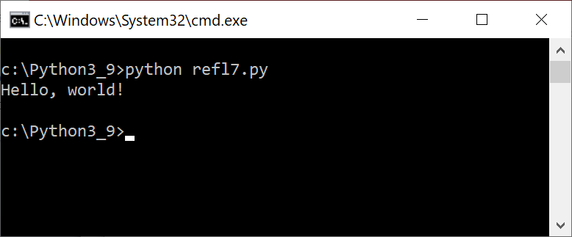

In this example, we define a class MyClass with an __init__ method that takes two arguments arg1 and arg2, and a my_method method that simply prints "Hello, world!".
To create a new object of MyClass using reflection, we call the __new__ method on MyClass. We then initialize the object using __init__ method by passing in the necessary arguments. Finally, we call the my_method method on the object using the getattr method to retrieve the method by name and then call it using regular function call syntax.
It is possible to create a class dynamically at runtime in Python using the type() function.

Here's a simple example of dynamically creating a class:

# Define class attributes
class_attrs = {
'name': 'Person',
'age': 25,
'get_name': lambda self: self.name,
'get_age': lambda self: self.age
}

# Create class dynamically
Person = type('Person', (object,), class_attrs)

# Instantiate an object of the dynamically created class
p = Person()

# Call methods defined in the class
print(p.get_name()) # 'Person'
print(p.get_age()) # 25

In this example, we define the attributes of the class in a dictionary class_attrs, which includes the name of the class, its age, and two lambda functions that return the name and age of the object. Then we use the type() function to create the class dynamically by passing in the name of the class, the base classes (in this case, just object), and the class attributes. Finally, we instantiate an object of the dynamically created class and call its methods.
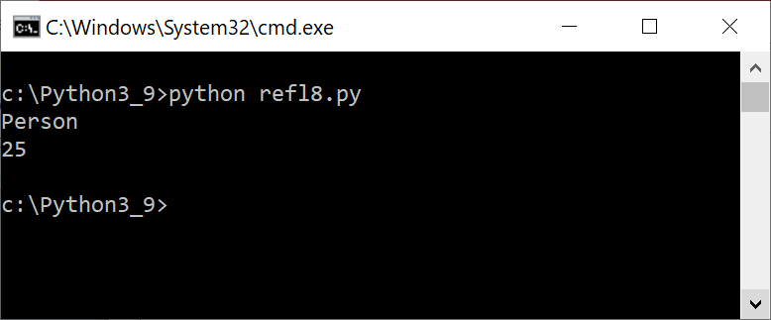

TASK
- Create dynamically a calls Student with fields: name and group and one method greet() which displays message: Hello, from <student name>
- Use reflection technique to display the field names and method specification (signature) in the class Student – test, if reflection works with Dynamically created classes. If not – show how it works with stationary classes
- Demonstrate adding new method in run-time to object and running it
- Show Java-Python interaction by sending method from Java program to python script.

