TOTAL POINTS- 32 POINTS

-70 MINUTES-

Student Performance Challenge

Questions and Answers

Easy -identification

Medium -

Hard- analysis

PART 1

- How many rows are present in the dataset? (1mrk) 1000 rows

- What is the mean and minimum writing score for Student Exam performance? (1mrk)

68.05 , 10.00

- What is the mean and minimum reading score for Reading Score performance? ( 1 mrk )

69.16 , 17.00

- What is the most and least frequent race/ethnicity of Students within the Dataset?

Group C , group A

- What is the missing value distribution within column features of the dataset? ( 1 mrk )

Non-Existent (0.0%) NAN-Value distribution.

6.

List the following columns with only numerical data within Dataset? (2 mrk)

Math_Score, Reading Score, Writing Score

- List the following minimum scores in maths, reading and writing respectively? ( 2 mrk )

Math_Score =0 , Reading_Score = 17 , Writing_Score = 10

- List the following columns with only categorical data within the Dataset? ( 2mrk)

Gender, Race/Ethnicity, Parental_Level_of_Education, Lunch, Test_Preparation_Course.

9. List the following, students’ lunch distribution by their Gender? ( 2mrk)

Gender | Lunch | Count
Female | standard | 329
 | Free/reduced | 189
Male | standard | 316
 | Free/reduced | 166

- List the following, students’ parental level education distribution by their Gender? (2 mrk)

Gender | Parental_Level_of_Education | Count
Female | some college | 118
 | associate college | 116
 | high school | 94
 | Some high school | 91

 | bachelor ‘s degree | 63
 | master’s degree | 36
Female | some college | 108
 | Associate’s degree | 106
 | high school | 102
 | some high school | 88
 | bachelor’s degree | 55
 | master’s degree | 23

- List the following students’ lunch , parental level education by their gender? Infer any insights on analysis generated. ( 2 mrk )

Gender |  | Parental_Level_of_Education | Preparation | Count
 |  | Test | Course
Female |  | Some college | none | 76
 |  | associate’s degree | none | 74
 |  | high school | none | 65
 |  | some high school | none | 56
 |  | Bachelor’s Degree | none | 41
 |  | Master’s Degree | none | 22
 |  |  |  | S
 |  | some college | completed | 42
 |  | associate’s degree | completed | 42
 |  | High school | completed | 29
 |  | some high school | completed | 35
 |  | Bachelor’s Degree | completed | 22
 |  | Master’s Degree | completed | 14
Male |  | some college | none | 73

Gender |  | Parental_Level_of_Education | Preparation | Count
 |  | Test | Course
Female |  | Some college | none | 76
 |  | associate’s degree | none | 74
 |  | high school | none | 65
 |  | some high school | none | 56
 |  | Bachelor’s Degree | none | 41
 |  | Master’s Degree | none | 22
 |  |  |  | S
 |  | some college | completed | 42
 |  | associate’s degree | completed | 42
 |  | High school | completed | 29
 |  | some high school | completed | 35
 |  | Bachelor’s Degree | completed | 22
 |  | Master’s Degree | completed | 14
 |  | associate’s degree | none | 66
 |  | High school | none | 75
 |  | some high school | none | 46
 |  | bachelor’s degree | none | 31
 |  | master’s degree | none | 17
 |  |  |  | D
 |  | some college | completed | 35
 |  | associate’s degree | completed | 40
 |  | high school | completed | 27
 |  | Some high school | completed | 42
 |  | bachelor’s degree | completed | 24
 |  | master’s Degree | completed | 6

Part 2

- Create a bar plot showcasing the gender distribution of Student Performance in Exams? (2 mrk )
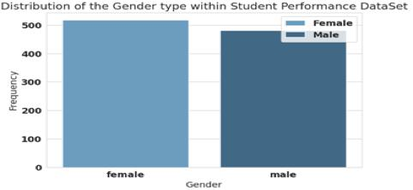

- Create a pie chart showcasing the distribution of diverse race/ethnicity grouping within the Student Performance Dataset? ( 2 mrk)

(i)
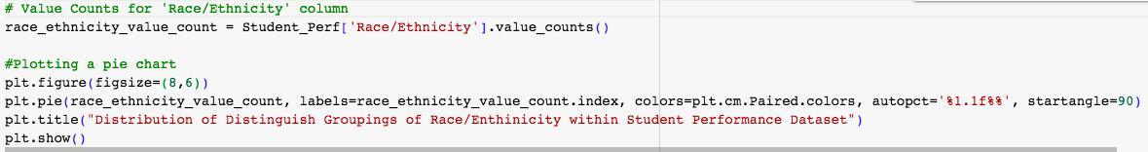
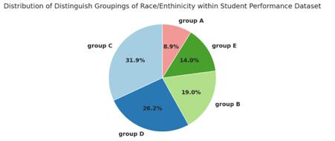

- Create a graph illustrating the evaluation distribution of successful students passing their Maths, Writing and Reading subjects? (2 mrk)

  - Determine the evaluation of successful students who passed all the their subjects Maths, Writing and Reading accordingly. ( 3mrk)
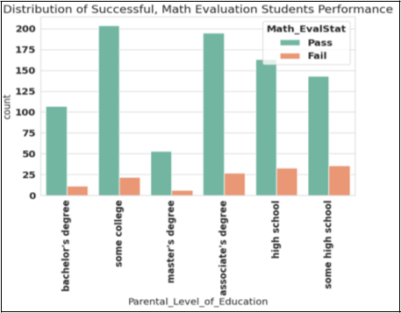
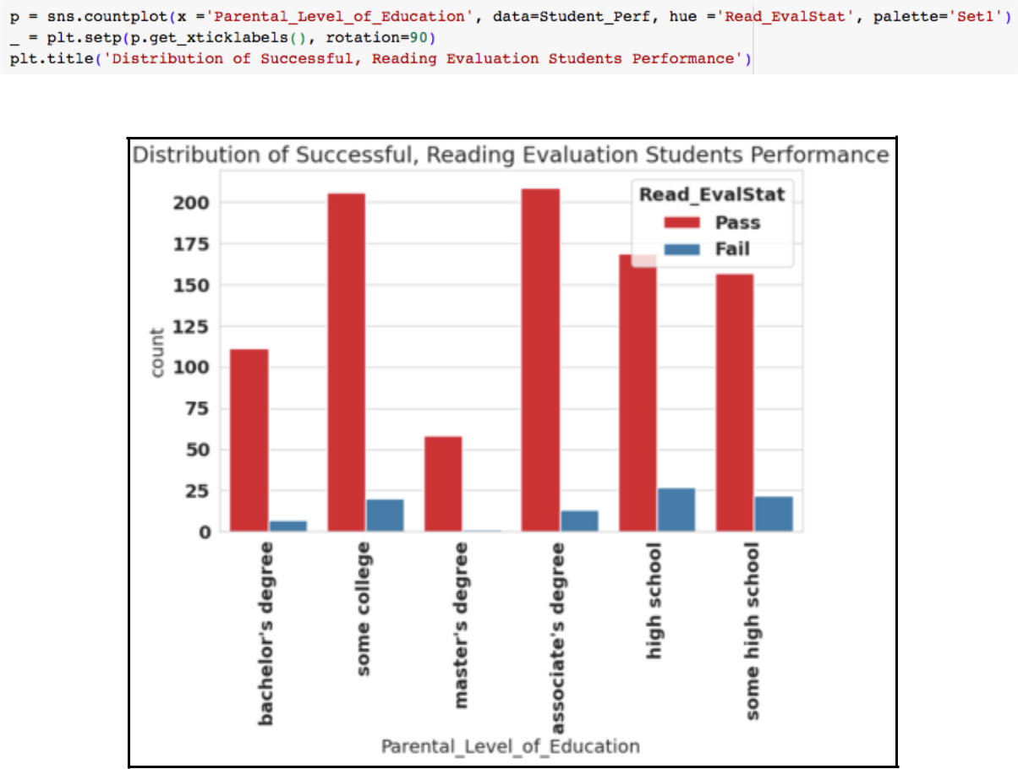
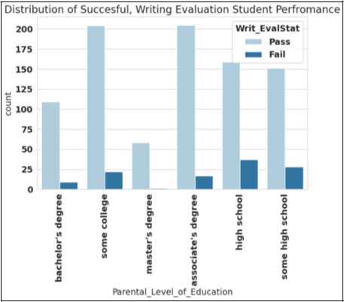

(i)
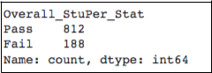

- Create a graph illustrating the student categorised parental distribution of Education by their Race/Ethnicity. ( 2 mrk)
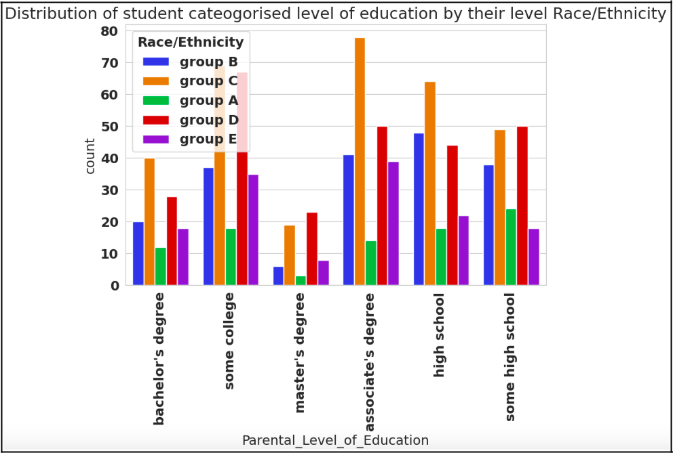

- Comment on the importance of k-means cluster analysis, its crucial features/ highlights on the graph below and overall application. [ 3mrk]
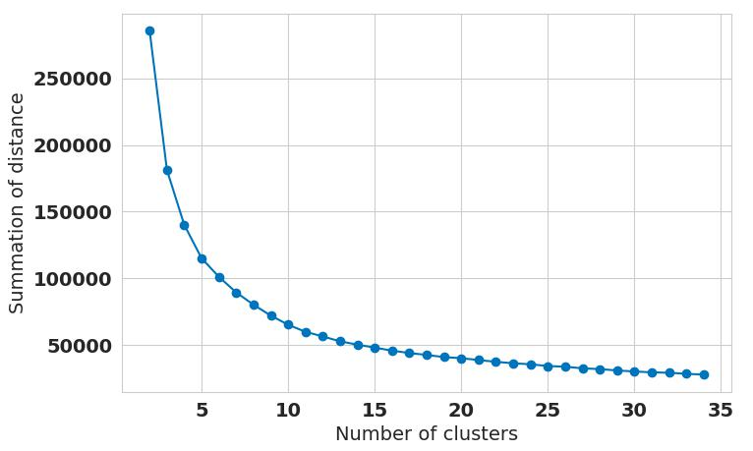

Background:

Label Encoding:

Label Encoding permits the execution for algorithms to interpret and comprehend the data by giving each category within a variable a distinct number. It must be noted that variables which reflect distinct categories such as e.g.product types, colours known as categorical variables. Therefore label encoding is suitable for ordinal data as evidently observed with the correlation relationship between Student Test Subject Performance and their Lunch respectively. [ Note: Lunch is distinctly categorised into standard , free/reduced also Test Subject Evaluation ( Maths, Reading, Writing) ] .

Cluster Analysis:

In general Cluster analysis has extensive wide range of applications of various fields including marketing, biology, finance and social sciences:

- Detect anomalies in financial transactions, ii) Classify social media users into different categories based on their interest and behaviours, iii) Identify genetic markers with specific diseases.

Specifically in regards K-means Clustering:

- K-means clustering method proceeds in grouping data points into predetermined number( k ) of clusters based on their distance to the centroid of each cluster.

- This specialised iterative algorithm focuses on minimising the sum of squared distances between data points and their assigned cluster centroids. Its evaluation metrics WCSS quantifies the sum of squared distance between each data point and the centroid of its respective cluster[: indicates proximity of grouped data point around their cluster centre.

PinPointing the Elbow Point:

- This is the associated k-value optimal number of clusters for your dataset capturing ideal data pattern. This is evident as WCSS is optimal/favourable in relation to pattern trend distribution. We can decipher that the k-value is cautious at the k=8 cluster as referred to as Elbow Point.

- Beyond this point, adding more clusters may not provide substantial improvements in capturing data patterns, and the WCSS tends to decrease at a gentler rate.

- Bonus Round
