**Current Version: 5.3.2**

1. **What is the differences between Bootstrap3 and Bootstrap4 ?**

|  |  |  |  |
| --- | --- | --- | --- |
| **S.No.** | **Component** | **Bootstrap 3** | **Bootstrap 4** |
| **1** | **Grid System** | **4 tier grid system (xs, sm, md, lg)** | **5 tier grid system (xs, sm, md, lg, xl)** |
| **2** | **CSS Unit** | **px** | **rem** |
| **3** | **Font Size** | **default font size is 14px** | **default font size is 16px** |
| **4** | **Dropdown Structure** | **Created with <ul> and <li>** | **Created with <ul> or <div>** |
| **5** | **Tables** | **To make responsive table we use *.table-responsive* class in parent <div> tag** | **To make responsive table we use  *.table-responsive* class in <table> tag** |
| **6** | **Glyphicons** | **Supported** | **Not Supported** |
| **7** | **Form Control Size** | **Increase or decrease size of an input field by using  *.input-sm* and *.input-lg* classes** | **Increase or decrease size of an input field by using *form-control-sm*  and *.form-control-lg* classes.** |
| **8** | **Button Sizes** | **The *.btn-xs* class is available** | **Available only *.btn-sm* and *.btn-lg* classes and dropped the *.btn-xs* class** |
| **9** | **Responsive image** | .img-responsive class is used in bootstrap 3 | .img-fluid class is used in bootstrap 4. |
| **10** | **Image alignment** | pull-left, .pull-right and .center-block class is used in bootstrap 3 | .pull-*-left, .pull-*-right, .text-*-right, .text-*-left and .text-*-center are used in bootstrap 4 . |
| **11** | **Buttons group** | btn-group-justified and .btn-group-xs class is used in bootstrap 3 | btn-group-justified and .btn-group-xs class is not used in bootstrap 3 |
| **10** | **Checkboxes and Radio Buttons** | **Displays the checkboxes and radio buttons by using *.radio*, *.radio-inline*, *.checkbox*, or *.checkbox-inline* classes** | **Displays the checkboxes and radio buttons by using *.form-check*, *.form-check-label*, *.form-check-input*, or *.form-check-inline* classes** |
|  |  |  |  |
|  |  |  |  |
|  |  |  |  |
|  |  |  |  |
|  |  |  |  |
| **9** | **Help Text** | **Display the help text by using *.help-block* class** | **Display the help text by using *.form-text* class** |
| **14** | **Dividers** | **Use the *.divider* class in the li element** | **Use the *.dropdown-divider* class in the div element** |
| **25** | **Fixed Navbars** | **Fix the navbar to top or bottom by using *.navbar-fixed-top* and *.navbar-fixed-bottom* classes** | **Fix the navbar to top or bottom by using *.fixed-top* and *.fixed-bottom* classes** |
| **16** | **Pagers** | **Align the pages by using *.previous* and *.next* classes** | **Not supported** |
| **17** | **Jumbotron Full Width** | **It does not uses *.jumbotron-fluid* class on full-width jumbotrons** | **It uses *.jumbotron-fluid* class for full-width jumbotrons** |
| **10** | **CSS source files** | **LESS** | **SCSS** |

1. **What are the differences among pixel, em and rem ?**

**pixel:**  font size is fixed.

**em:** it is depend on parent tag.

<style>

.divtag{

font-size:16px;

}

.ptag { font-size:2em; /*1em=16px;*/

}

</style>

<div class="divtag">

<p class="ptag">This is p tag testing of EM.</p>

</div>

Note: Font size of p tage will be 32px, because font-size of it’s parent tag is 16px.

**rem:** it is depend on root.

<style>

:root{

font-size:55px;

}

**OR**

html{

font-size:55px;

}

.ptag {

font-size:1rem; /*1rem=55px;*/

}

</style>

<p class="ptag">This is p tag testing of REM.</p>

Note: Font size of p tage will be 55px, because font-size of root is 55px.

1. **What are the Bootstrap predefined classes ?**

Bootstrap Alpha/Beta hidden - *up-down migration

|  |  |
| --- | --- |
| **Bootstrap predefined classes** | **Description** |
| .d-print-none | Screen Only (Hide on print only) |
| .d-none d-print-block | Print Only (Hide on screen only) |
| .d-none d-lg-block d-print-block | Hide up to large on screen, but always show on print |
| .d-lg-none | hide on screens wider than lg |
| .d-none d-lg-block | hide on screens smaller than lg |
| .d-none .d-xl-block | Visible only on xl |
| .d-none | Hidden on all |
| .d-none .d-sm-block | Hidden only on xs |
| .d-sm-none .d-md-block | Hidden only on sm |
| .d-md-none .d-lg-block | Hidden only on md |
| .d-lg-none .d-xl-block | Hidden only on lg |
| .d-xl-none | Hidden only on xl |
| .d-block | Visible on all |
| .d-block .d-sm-none | Visible only on xs |
| .d-none .d-sm-block .d-md-none | Visible only on sm |
| .d-none .d-md-block .d-lg-none | Visible only on md |
| .d-none .d-lg-block .d-xl-none | Visible only on lg |
| .hidden-md-up |  |
| .hidden-md-down |  |
| .hidden-sm-down |  |
| .d-none | display:none; for all screen |
| .d-inline | display:inline; |
| .d-inline-block |  |
| .d-block | display:block; |
| .d-table |  |
| .d-table-cell |  |
| .d-flex |  |
| .d-inline-flex |  |
| .d-lg-block |  |
| .d-md-inline |  |
|  |  |
|  |  |
|  |  |
|  |  |

**>> For button class:**

btn btn-primary , btn btn-secondary , btn btn-success , btn btn-danger , btn btn-warning ,

btn btn-light , btn btn-dark , btn btn-link , btn btn-info

**>> For input field class:**

form-group , form-control , input-sm , input-lg , form-control-sm , form-control-lg

**>> For text-color class:**

text-primary , text-secondary , text-success , text-danger , text-warning , text-info , text-light , text-dark , text-muted ,

text-white ,

**>> For background-color class:**

bg-primary , bg-secondary , bg-success , bg-danger , bg-warning , bg-info , bg-light , bg-dark , bg-white

**>> For text-alignment class:**

text-left , text-right , text-center

text-sm-left // for small screen

text-md-left // for middle screen

text-lg-left // for large screen

text-xl-left // for extra large screen

1. **What is the Grid System ?**

A grid system is a structure that allows content to show in vertically and horizontally format.

Grid systems includes two key components: rows and columns. There are 12 colum in a row.

Example:

* Simple Grid
* Pure Grid
* Flexbox Grid
* Bootstrap
* Foundation

**>>**For equal width with spacing between rows: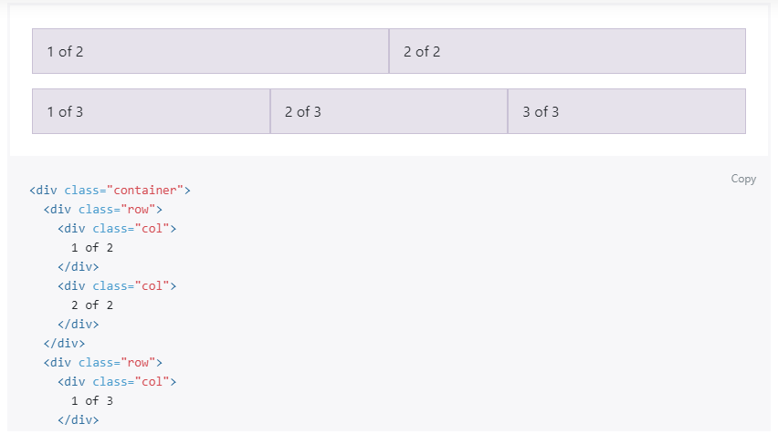

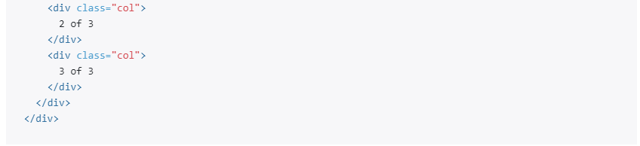

Note: It we will not mention colom size than it will auto adjuct for all screen.

**>>**For equal width with new line without spacing between row:

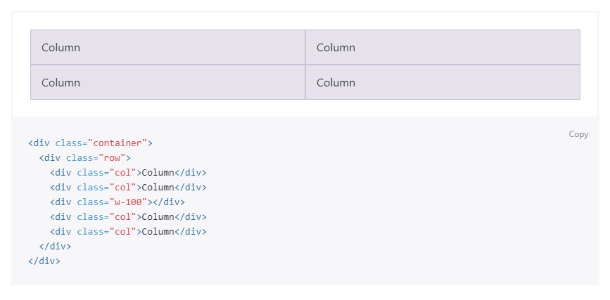

Note: class ‘.w-100’ takes width:100%, that’s why it creates new line.

**>>**Setting one column width: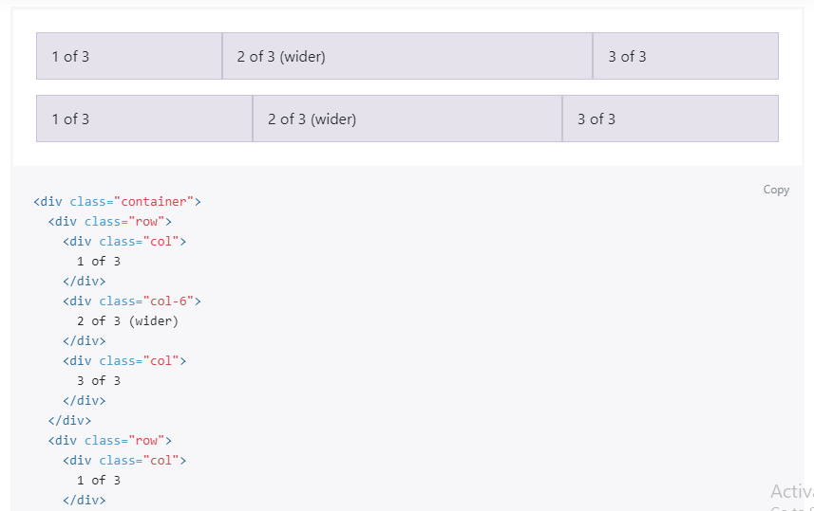

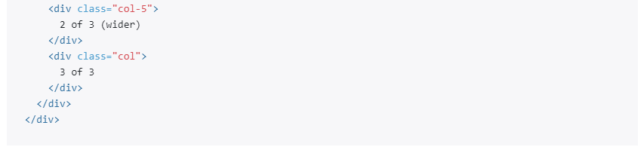

1. **What is the difference between Bootstrap4 and Bootstrap5 ?**

(upto 10Point)

| **PARAMETER** | **BOOTSTRAP 4** | **BOOTSTRAP 5** |
| --- | --- | --- |
| **Grid System** | 5 tier grid system(xs, sm, md, lg, xl). | 6 tier grid system(xs, sm, md, lg, xl, xxl). |
| **Color** | It has limited colors. | Extra colors have been added. |
| **Jquery** | It has jQuery along with all the related plugins. | Jquery is removed and it has switched to vanilla JS with some working plugins. |
| **Internet Explorer** | Bootstrap 4 supports both IE 10 and 11. | Bootstrap 5 doesn’t support IE 10 and 11. |
| **Form elements** | The look of Radio buttons and checkboxes are different in different OS and browsers. | The look of form elements does not change on different OS and browsers. |
| **Utilities API** | Utilities cannot modify in Bootstrap 4. | Utilities can modify in bootstrap 5 and also create our own utility. |
| **Vertical Classes** | Relative positioning of columns is allowed. | Relative positioning of columns is not allowed. |
| **Bootstrap Icons** | Bootstrap 4 doesn’t have its own SVG icons. | Bootstrap 5 has its own SVG icons. |
| **Jumbotron** | Bootstrap 4 supports the jumbotron. | Bootstrap 5 doesn’t support the jumbotron. |
| **Card deck** | The card deck class, used to create a set of cards with equal width and height, is available in bootstrap 4. | Card deck class has been removed in bootstrap 5. |
|  |  |  |
| **Static Site Generator** | Jekyll software is used by Bootstrap 4. | Hugo software is used by Bootstrap 5. |
| **Navbar** | We have the inline-block attribute, and the default for the dropdown-menu-dark class is a white dropdown. | The inline-block property has been removed, and the dropdown-menu-dark class now uses a black dropdown as the default. |

1. **What is Bootstrap ?**

[Bootstrap](https://getbootstrap.com/) is a open source front-end framework . It is used to create exceptional responsive designs using [HTML](https://www.edureka.co/blog/what-is-html/) and CSS. Bootstrap also have Javascript plugins, which are optional. Bootstrap is mostly used for developing mobile web applications.

**List some features of Bootstrap.**

* It is a open-source framework.
* It provides Responsive designs.
* Easy to use and fast.
* Bootstrap has Compatibility with all browsers.

1. **How many types of layout are available in Bootstrap ?**

There are two major layouts for Bootstrap:

1. **Fluid Layout-** it is used to cover entire screen width.
2. **Fixed Layout-** It is used, only for a standard screen (940px).

Both layouts are used to create a responsive design.

1. **what is lead class in bootstrap ?**

**lead** class is used to create a stand out paragraph.

Exp:

<p class="lead"> This is a lead paragraph. It stands out from regular paragraphs.</p>

Note: it will show different look. Like: font color is light, font weight is light(300).

1. **what is gutter class in bootstrap ?**

gx-0,gx-1,gx-2,gx-3,gx-4,gx-5 //for all screens, it will adjust paddinng-left and padding-right

gx-lg-0,gx-lg-1,gx-lg-2,gx-lg-3,gx-lg-4,gx-lg-5 //for large screens, it will adjust paddinng-left and padding-right, similaraly we can use md,xl,xxl screens

gy-0,gy-1,gy-2,gy-3,gy-4,gy-5 //for all screens, it will adjust margin-bottom

gy-lg-0,gy-lg-1,gy-lg-2,gy-lg-3,gy-lg-4,gy-lg-5 //for large screens, it will adjust margin-bottom on every line with in row, similaraly we can use md,xl,xxl screen

Note: it works only with bootstrap row class, we can not use separately.

1. **what is the components of bootstrap ?**

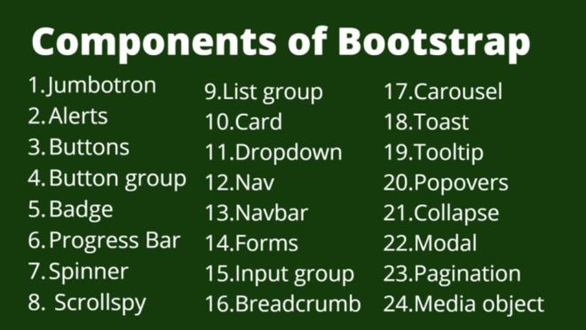

**List of components:**

1. [**Jumbotron**](https://www.geeksforgeeks.org/bootstrap-4-jumbotron/): **jumbotron** is a predefined class with some css properties like: grey background, padding(top,bottom,left,right) and border radius property. It is used to highlight a perticualr content.

.**jumbotron**

{ padding: 2rem 1rem;

margin-bottom: 2rem;

background-color: #e9ecef;

border-radius: 0.3rem;

}

1. [**Alerts**](https://www.geeksforgeeks.org/bootstrap-4-alerts/): It is a popup with a predefined message that appears after a particular action.
2. [**Buttons**](https://www.geeksforgeeks.org/bootstrap-4-buttons/): It is customized buttons that are used to perform an action in the form, dialogue box, etc. They are in multiple states, sizes and have predefined styles.
3. [**Button group**](https://www.geeksforgeeks.org/bootstrap-4-button-groups/): It is a group of buttons aligned in a single line and they can be arranged both vertically as well as horizontally.
4. [**Badge**](https://www.geeksforgeeks.org/bootstrap-4-badges/): **badge** is a predefined class which is used to heigh light a particular word,number with background .

Exp:

<span class=”badge badge-light”>Hello</span>

<span class=”badge badge-pill badge-primary”>50</span>

<span class=”badge badge-warning”>350</span>

1. [**Progress Bar**](https://www.geeksforgeeks.org/bootstrap-4-progress-bars/): It is used to show the progress of a particular operation with a custom progress bar. They have text labels, stacked bars, and animated backgrounds.
2. [**Spinner**](https://www.geeksforgeeks.org/bootstrap-4-spinners/)**(loader)**: it is a loader used to show that content is loading.

Ex:

<span class=”spinner-border”></span>

<span class=”spinner-grow”></span>

1. [**Scrollspy**](https://www.geeksforgeeks.org/bootstrap-4-scrollspy/): It keeps updating the navigation bar to the currently active link based on the scroll position in the viewport.

Exp:

Note: we can control by clicking on left tabbing and by the scroll with active link.

1. [**List group**](https://www.geeksforgeeks.org/bootstrap-4-list-groups/): it is predefined class. It is used to display an unordered list in a proper way.

Exp:

Note: To remove border, we need to add **list-group-flush** class in <ul> tag.

1. [**Card**](https://www.geeksforgeeks.org/bootstrap-4-cards/): it is a predefined class. It provides a customizable, extensible, and flexible content container.

Exp:

1. [**Dropdown**](https://www.geeksforgeeks.org/bootstrap-4-dropdowns/): We can create a dropdown button.
2. [**Navs**](https://www.geeksforgeeks.org/bootstrap-4-navs/): It is used to create a basic and simple navigation menu.

1. Text

   Description automatically generated[**Navbar**](https://www.geeksforgeeks.org/bootstrap-4-navigation-bar/): The navigation bar is the headers at the top of a website or webpage. This is a complete bar.
2. [**Forms**](https://www.geeksforgeeks.org/bootstrap-4-forms/): Forms are used to take multiple inputs at once from the user. Bootstrap has two layouts available stacked and inline.
3. [**Input groups**](https://www.geeksforgeeks.org/bootstrap-4-input-groups/): They have extended form controls by adding a button, button group or text on either side of inputs.
4. [**Breadcrumb**](https://www.geeksforgeeks.org/bootstrap-badges-and-breadcrumbs/): It is pre-defined class. It is used to show path of any file including separator.

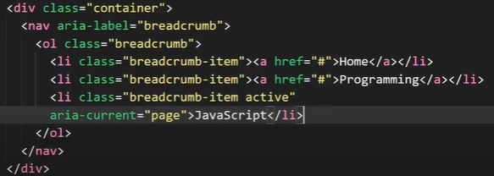

1. [**Carousel**](https://www.geeksforgeeks.org/bootstrap-4-carousel/)**(Slider)**: It is a slide show of image or text content built with CSS 3D and JavaScript.
2. [**Toast**](https://www.geeksforgeeks.org/bootstrap-4-toast/): It is same as modal box. It displays a message for a small amount of time, a few seconds.
3. [**Tooltip**](https://www.geeksforgeeks.org/bootstrap-4-tooltip/): It provides small information about the element/link when the mouse hovers over the element.
4. [**Popovers**](https://www.geeksforgeeks.org/bootstrap-4-popover/): It displays extra information about the element/link when clicked on it. It is same as modal box.
5. [**Collapse**](https://www.geeksforgeeks.org/bootstrap-4-collapse/): It is a JavaScript plugin that is used to show or hide the content.
6. [**Modal**](https://www.geeksforgeeks.org/bootstrap-4-modal/): It is a small popup window positioned over the actual window.
7. [**Pagination**](https://www.geeksforgeeks.org/bootstrap-4-pagination/): It is used to easily navigate between different pages, a large block of connected links is used for making them accessible.
8. [**Media Object**](https://www.geeksforgeeks.org/bootstrap-4-media-objects/)**:** The Media object is used for repetitive and complex components like tweets or blogs. The images or videos are placed/aligned to the left or the right of the content.

