Assignment

Data Understanding Competition

REPORT

INDEX
Contents
Team: = 2
Software Used & Data sets: 2
Instructions on how to Download & Install the software and the data sets 2
Analysis Process Used 4
Charts showing interesting Trends and Patterns 6
Findings & Observations: 16
Future Work & Planning 17
References 17

Team:

Vidhan Dholakia | (20151326)

Software Used & Data sets:
I are using Python for the coding purpose.
Gmap: Python graph plotting libraries to plot geo locations.
For the data sets, I have the Transit Data of Kingston City of the year 2017.

Instructions on how to Download & Install the software and the data sets:
How to Download Python & Install Python Map Plotting Libraries (Matplotlib, Pylab)? Step 1: = Go to https://www.python.org/downloads/
Step 2: = Select my version and directly download as per the requirement and system adaptability.

Step 3: = The installation process is quite simple and straightforward. Just need to follow the obvious steps. I have used PyCharm IDE for execution of Python.

Installing MATPOTLIB & PYLAB: =
Step 1: = Go to https://matplotlib.org/3.1.1/users/installing.html
Step2: = Matplotlib and its dependencies are available as wheel packages for macOS, Windows and Linux distributions.
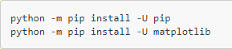

How to Download the Data Set?
I have been given the data of people riding the bus in Kingston City in October 2017.
Each data point includes date/time, the type of boarding, bus and route number, and latitude/longitude where the boarding was recorded (note that around 8% of these Ire on buses with malfunctioning GPS antennae, and have the boarding coordinates recorded as 0,0). One note – I will see references to Routes 8 and 13 in the data. These routes do not have public timetables; these are extra buses to help service peak demand in certain areas of the City (primarily, the Union Street corridor betIen St. Lawrence College and Downtown).
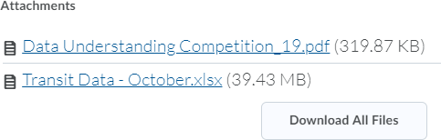

Analysis Process Used:

I have the data about Kingston City’s Transit from the month of October in the year 2017. The
data is about the people riding the bus.
Initially, I had the total data set of 704540 items! This data set is not yet useful as it is not clean and not fit for the data modeling processes.
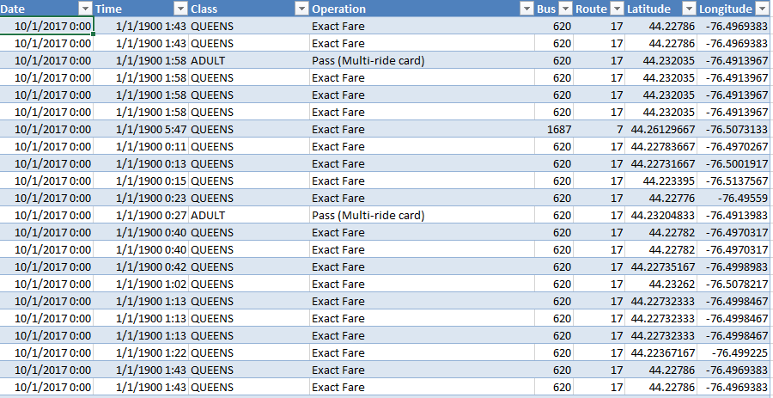

- Data Preparation & Data Cleaning: =
I have reduced the data from the original data set by removing unwanted items. Firstly, I have sorted the data as per the time, bus number as Ill as the route number. By doing this, I have reduced my data set from 704540 to just 14086!
To avoid the redundancy, I will consider data of whole Iek (7 days). I will try to avoid the duplication of similar routes or coinciding routes whenever possible.
- Feature Transformation & Feature Selection: =
I have use Sine and Cosine functions to get the location and to plot the points on the map. I have also added the location (coordinates) of the park nearby the bus route.

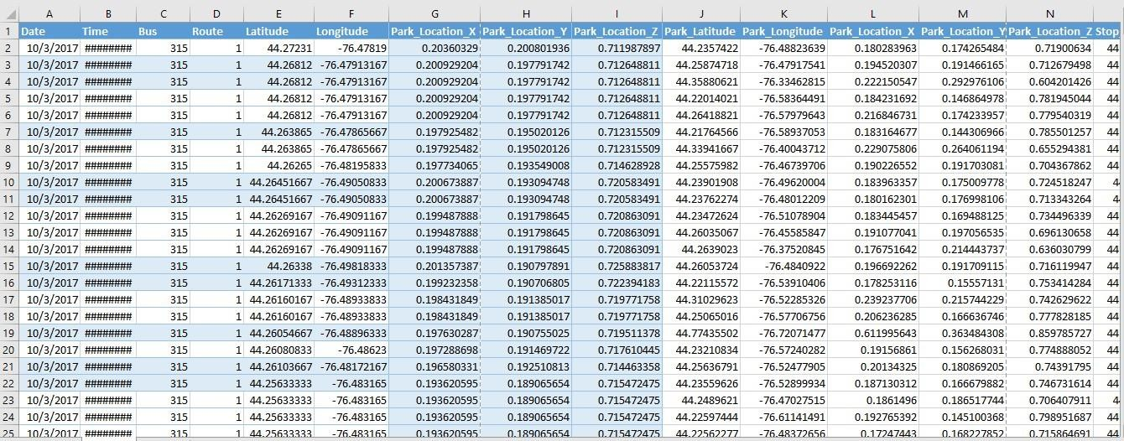

Apart from reducing the data, I have added some relevant features like location (co- ordinates) of the park in terms of Latitude and Longitude. This is done to find the correlation betIen the park and the bus route. By doing this, I can check the park ways which are nearby to the bus routes. This is just done so that I can predict if the bus route is accessible to everyone in the city.

Charts showing interesting Trends and Patterns:
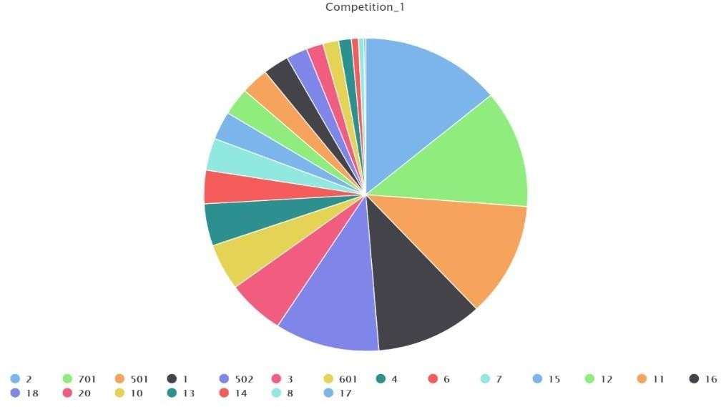
Diagram 1: Pie Chart Representation.
The above chart presents the classification of all the buses. I can deduce the conclusion that route number 701, 2, and 15 constitute a superior part of all the 21 buses. Approximately 14.28% of the transit is done from these 3 buses.

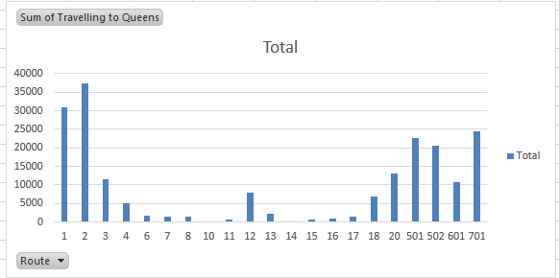
Diagram 2: Total Sum of Travelling to Queen’s University

This is another representation of the total sum of people travelling to Queen’s University. As I can see, maximum number of people travelling to Queen’s prefer bus route number 2 which consists of nearly 90% of the people.
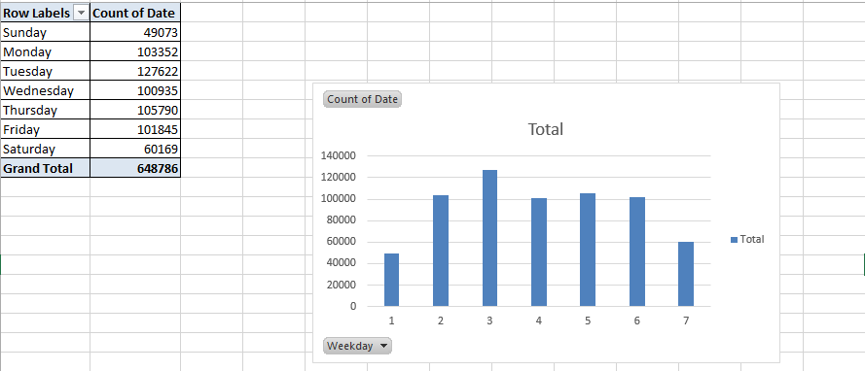
Diagram 3: Day wise Comparison

From this diagram, I can conclude that people tend to travel more on the Iek days as compared to the Iekends.

A majority of the people travel during Monday, and the counts goes on until the Iekend.
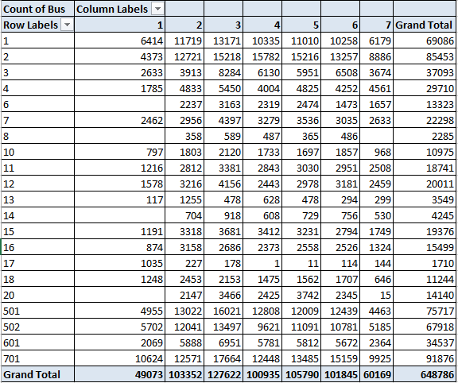
Diagram 4: Bus Wise Categorization

From this diagram, I declare that 701 is the most utilized bus. It involves around 14.16% of the total data. 701 is frequently used bus, even on the Iekends! 4 buses, namely route number

6,8,14 and 20 do not provide the transit service on Mondays. Route number 8 bus does not provide the transit service on Sundays. Route number 17 bus is least utilized (around 0.26%, quite negligible)
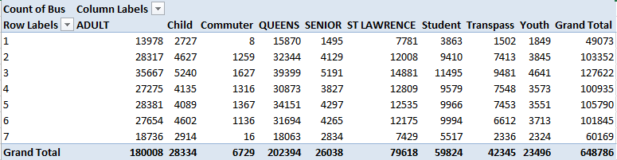
Diagram 5: Category Based Classification (1)

From this diagram, I can decide that majority of the travelers are from Queen’s University, folloId by ST. Lawrence college. Around 31.19 % of travelers are from Queen’s University. The loIst is observed in the “Commuter” category which turns out to be around 1.03% out of the total travelers.
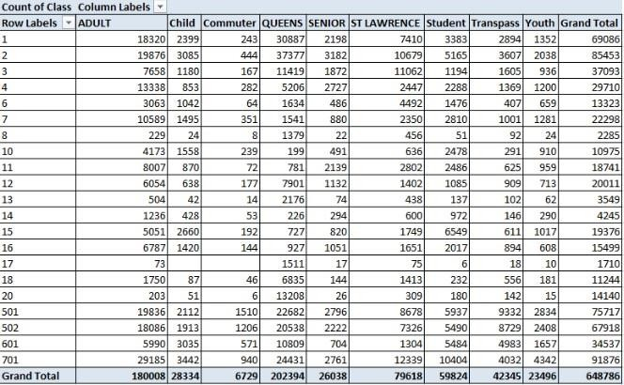
Diagram 6: Category Based Classification (2)

The above diagram clearly shows that travelers to Queen’s University usually uses the route number 1, 2 and 701 buses. Majority of them (nearly 18.46%) travel using the route number 2 bus. Moreover, about 6.52% people have bought the monthly transit pass.
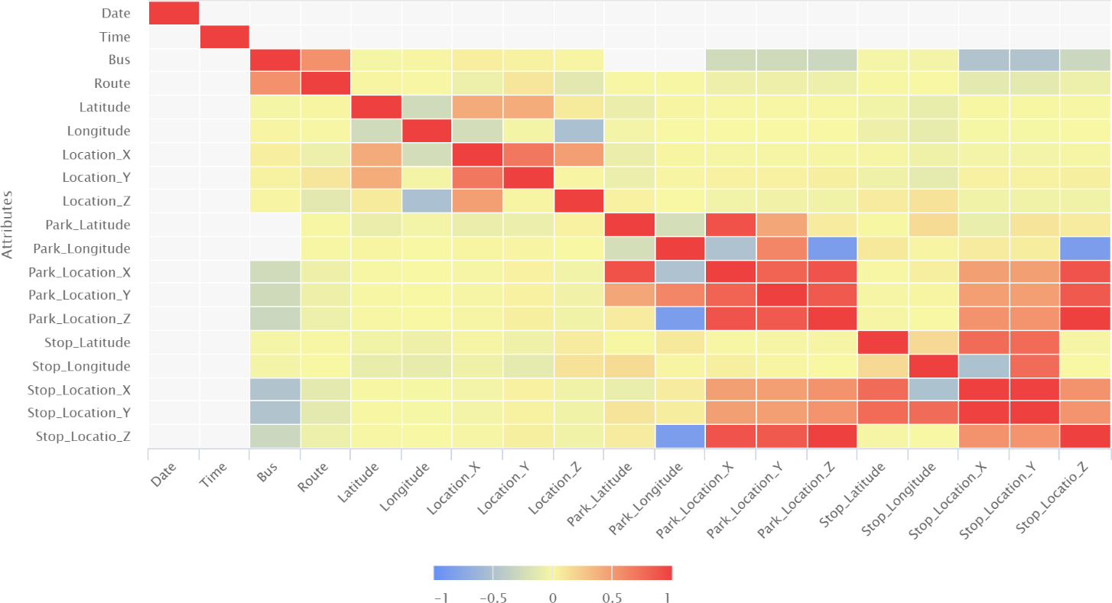
Diagram 7: Correlation betIen various features

From this graphical representation, I can observe the correlation betIen the various attributes. There’s a scale defining the strength or the total amount of the Correlation the attributes have among themselves. It is clearly visible that “date” has the maximum correlation with the “date” itself. Similar is the case for “time” attribute. The correlation of other attributes with themselves is relatively less as compared to the “time” and “date”. There’s minimum of correlation betIen the “Latitude” and Longitude”.

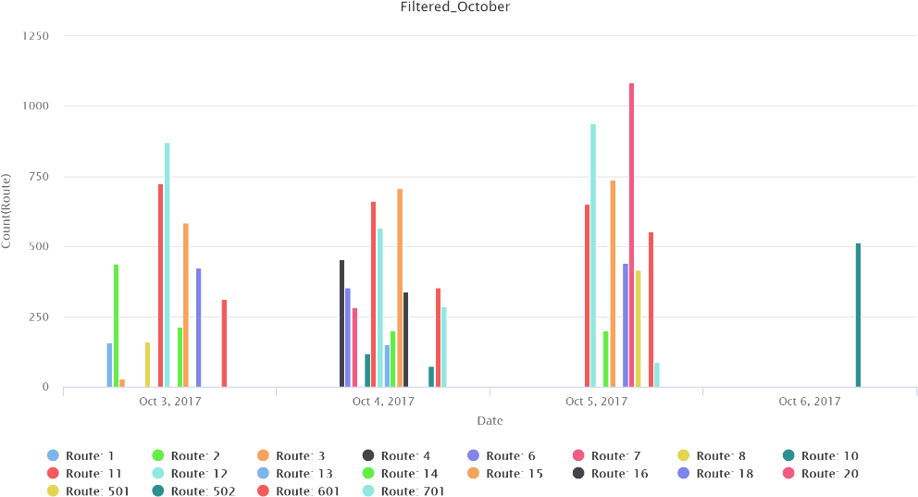

Diagram 8: Date Wise Representation of Route and their count

The above bar chart describes the distribution of the bus routes in the first Iek of October 2017. It is quite clear that route number 701 is mostly preferred one.
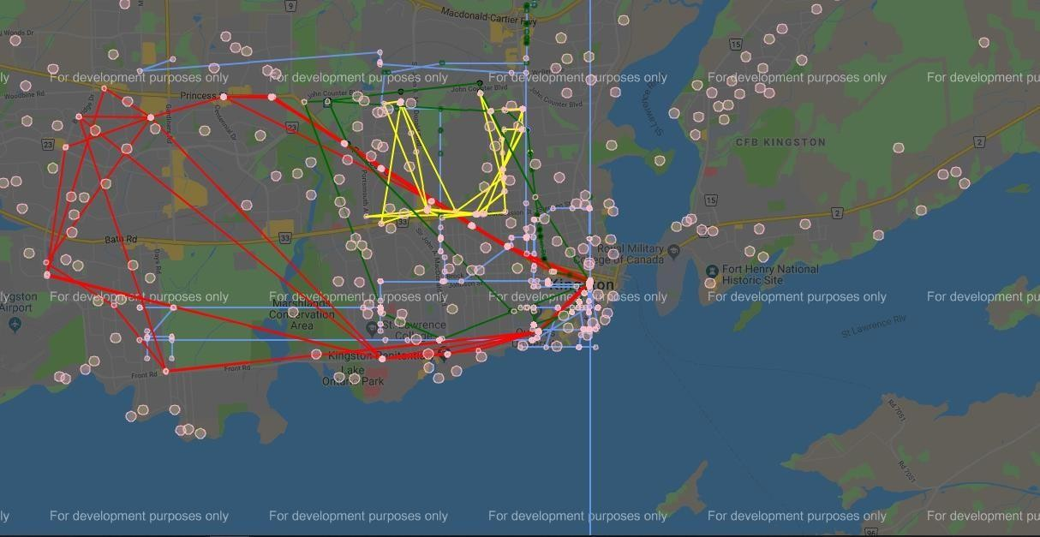
Diagram 9: Map Plotting (Route 1-4, total parks)
Yellow: Route 1, Red: Route 2, Blue: Route 3, Green: Route 4, Pink Circles: Parks

I have plotted the routes using Python on the Maps. From this, I can identify many important aspects such as the accessibility of the buses to everyone in Kingston, about the

routes which might be redundant and could be removed or replaced etc. I can also determine the outliers from the plotting.
This representation is about the buses on route 1-4. The points indicated in pink color define the parks which are nearby the bus stop. I have considered a threshold value of 1 KM i.e. if any bus route is within 1 KM range of the park, it will be indicated in pink color. The blue ones indicate inaccessibility of the bus routes with respect to the parks.
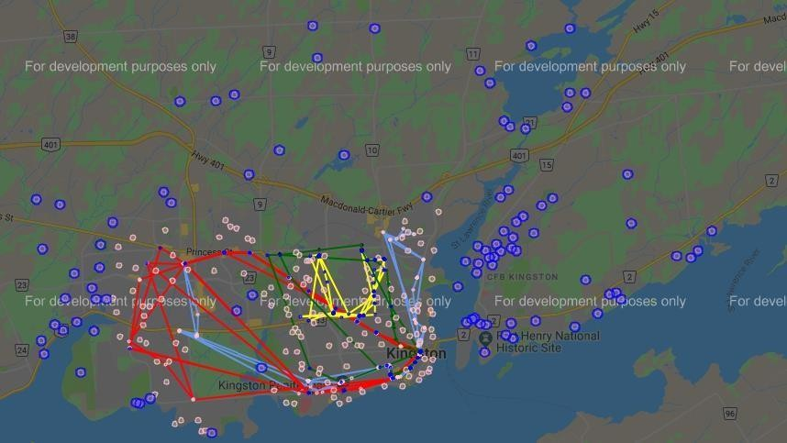
Diagram 10: Map Plotting (Route 1-4, parks not reachable)
Yellow: Route 1, Red: Route 2, Blue: Route 3, Green: Route 4, Pink Circles: Parks, Blue Circles: Bus Route/Stop Not Accessible

This representation is also about the buses on route 1-4. The points indicated in pink color define the parks which are nearby the bus stop. The threshold I took is of 1.3 km. And the big blue dots represent the parks which are inaccessible by the bus routes 1-4.

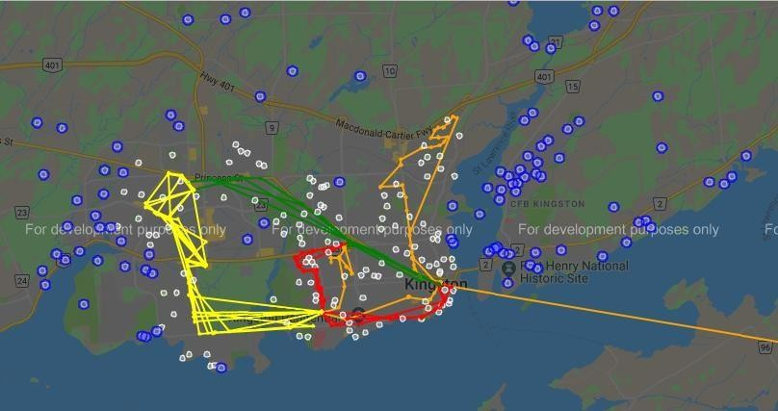
Diagram 11: Map Plotting (Route 5-8)
Yellow: Route 5, Green: Route 6, Orange: Route 7, Red: Route 8, Pink Dots: Bus accessible Parks, Blue Dots: Bus Service not accessible for the above mentioned routes
,
The threshold chosen for accessible bus service is 1.4 km. The blue dots in the above image shows the parks which are far from bus stops and needs to access the stop by walking or other travel services.
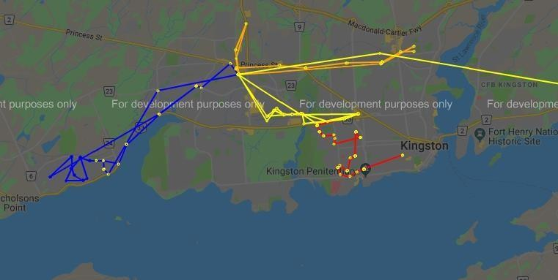
Diagram 12: Map Plotting (Route 10-13)
Yellow: Route 10, Red: Route 11, Blue: Route 12, Orange: Route 13

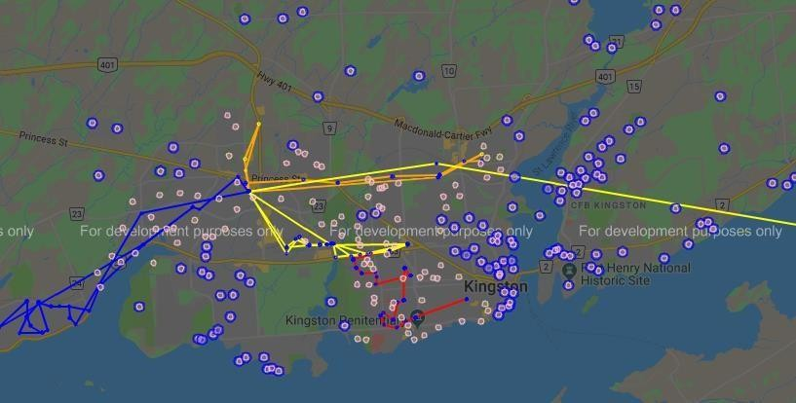
Diagram 13: Map Plotting (Route 10-13, Pink: parks in reach, Blue: parks not reachable) Yellow: Route 10, Red: Route 11, Blue: Route 12, Orange: Route 13

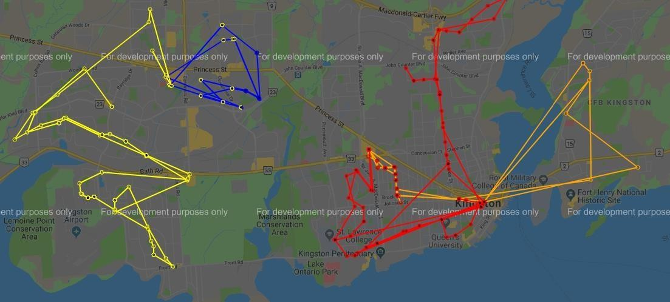

Diagram 14: Map Plotting (Route 14-17)

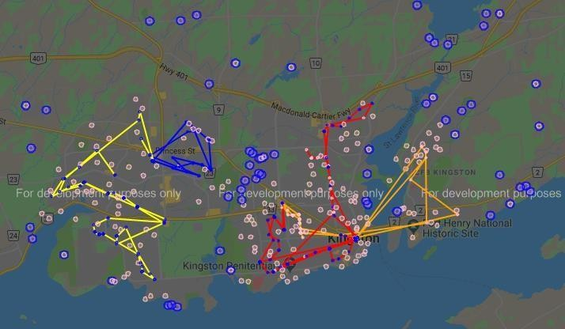

Diagram 15: Map Plotting (Route 14-17, parks in reach & parks not reachable)
Yellow: Route 14, Blue: Route 15, Red: Route 16, Orange: Route 17, Pink: Park near bus stops, Blue Dots: Park far from Bus stops

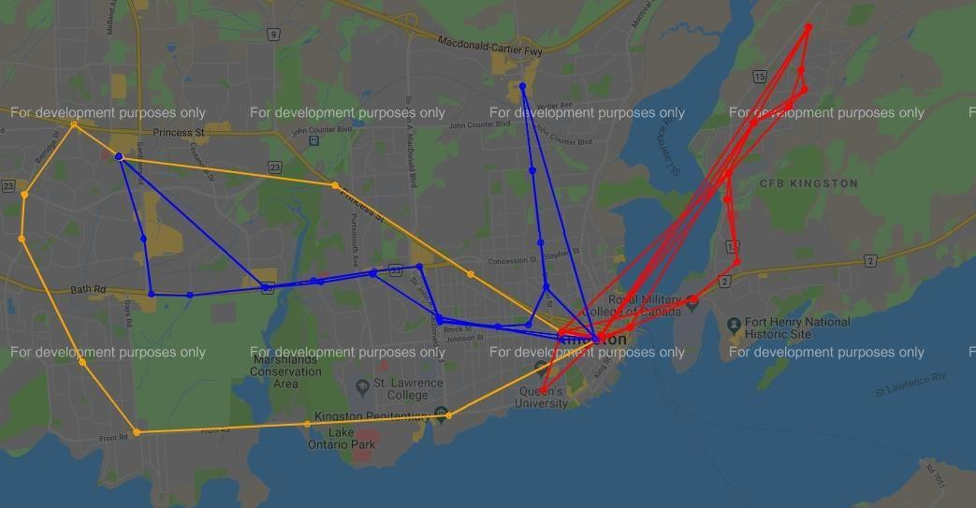

Diagram 16: Map Plotting (Route 18-20) Orange: Route 18, Blue: Route 19, Red: Route 20

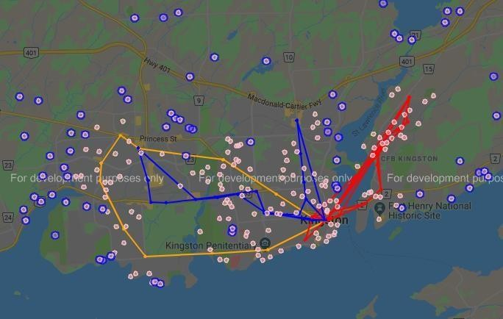
Diagram 17: Map Plotting (Route 18-20, parks in reach & parks not reachable)

I have repeated the same process for every route and tried to cover every available park to get the exact idea about the accessibility of the bus route.

Findings & Observations:

Outliers:
While plotting the points on the map, I found many points which Ire way out of the range of the Kingston Map. There Ire some points even pointed overseas from here! I dealt with these outliers by just removing them from the considered data set.
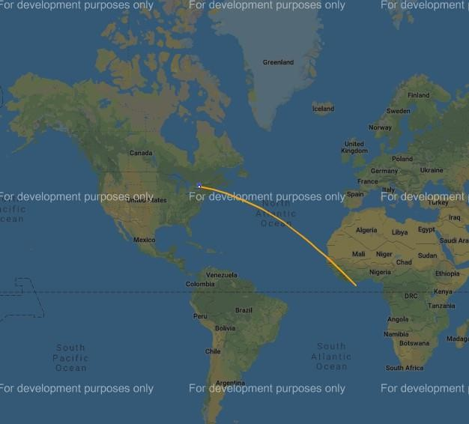
Fig. Outlier

Various geo locations Ire repeated by several bus hence, I removed the redundancy of such data points. I took data of only 1 Iek for each route because the locations Ire repeated by several buses for other dates as Ill. Consolidated data, inaccessible park access to bus Ire crunching my resmyces for processing. Hence, I moved with divide and rule principle and divided the data route wise. The are sudden jumps in the data route and by my guess it is because the bus didn’t stop at a bus stop as no passengers Ire there to get in as Ill as get out hence no location was recorded. Thus, the next stop where the bus stopped recorded a high jump in plotting in the above-mentioned location plots and shall not be considered as a huge error. HoIver, there is a obvious difference betIen outliers and such data. The more the points are available, the smoother will be the geo plotting.

Future Work & Planning:

I will model my data using the Supervised Learning. I will introduce few more geo location points to smoothen out the plot. Higher processing poIr will be used to plot the consolidated data of location and accessibility from parks and pathways.

References:

https://www.python.org/doc/

https://blog.hubspot.com/marketing/how-to-build-excel-graph

https://docs.oracle.com/cd/B19306_01/datamine.102/b14339/5dmtasks.htm

https://medium.com/@chhavi.saluja1401/data-preparation-a-crucial-step-in-data-mining- dba35772f281
https://www.cityofkingston.ca/explore/data-catalogue

https://developers.google.com/maps/documentation/

