**A FEED FORWARD NEURAL NETWORK – POWERED CHATBOT FOR JNTUK WEBSITE**

**PROJECT REPORT**

**Submitted**

in partial fulfillment of the requirements

for the award of the degree of

**BACHELOR OF TECHNOLOGY**

in the faculty of

**COMPUTER SCIENCE & ENGINEERING**

by

**BHOGADI VIDHEY**  [R.NO. 21025A0571]

**THONDUPU LEELA ANITHA**  [R.NO. 20021A0532]

**TELUGU SAISRI**  [R.NO. 20021A0517]

**GHANTA HARSHITH**  [R.NO. 20021A0565]

Under the guidance of

**Dr. A. S. N. CHAKRAVARTHY**

**Professor**



**DEPARTMENT OF COMPUTER SCIENCE AND ENGINEERING**

**UNIVERSITY COLLEGE OF ENGINEERING KAKINADA (A)**

**JAWAHARLAL NEHRU TECHNOLOGICAL UNIVERSITY KAKINADA**, **KAKINADA - 533003, A.P, INDIA**

**[2020-2024]**

**DEPARTMENT OF COMPUTER SCIENCE AND ENGINEERING**

**UNIVERSITY COLLEGE OF ENGINEERING KAKINADA (A)**

**JAWAHARLAL NEHRU TECHNOLOGICAL UNIVERSITY KAKINADA**, **KAKINADA - 533003, A.P, INDIA**

**[2020-2024]**



**DECLARATION FROM THE STUDENTS**

We hereby declare that the project work described in this thesis, entitled **“*A Feed Forward Neural Network - Powered Chatbot for JNTUK Website*”** which is being submitted by us in partial fulfillment of the requirements for the award of the degree of BACHELOR OF TECHNOLOGY(B.Tech.), in the faculty of Computer Science and Engineering Kakinada(Autonomous), Jawaharlal Nehru Technological University Kakinada, Kakinada- 533003, A.P., is the result of investigations carried out by us under the guidance of Dr. A. S. N. Chakravarthy, Professor, in the Department of Computer Science and Engineering.

The work is original and has not been submitted to any other University or Institute for the award of any degree or diploma.

**Place: Kakinada Signature:**

**Date: 04-05-2024 BHOGADI VIDHEY [21025A0571]**

**THONDUPU LEELA ANITHA [20021A0532]**

**TELUGU SAISRI [20021A0517]**

**GHANTA HARSHITH [20021A0565]**

**DEPARTMENT OF COMPUTER SCIENCE AND ENGINEERING**

**UNIVERSITY COLLEGE OF ENGINEERING KAKINADA (A)**

**JAWAHARLAL NEHRU TECHNOLOGICAL UNIVERSITY KAKINADA**, **KAKINADA - 533003, A.P, INDIA**

**[2020-2024]**



**CERTIFICATE FROM THE SUPERVISOR**

This is to certify that the project work entitled **“*A Feed Forward Neural Network - Powered Chatbot for JNTUK Website*”** that is being submitted by Bhogadi Vidhey bearing the roll number 21025A0571, Thondupu Leela Anithabearing the roll number 20021A0532, Telugu Saisribearing the roll number 20021A0517, Ghanta Harshithbearing the roll number 20021A0565 in partial fulfillment of the requirements for the award of the degree of **Bachelor of Technology(B.Tech.)** in the faculty of Computer Science and Engineeringto the UCEK(A), JNTUK, Kakinada, Andhra Pradesh, India is a record of bonafide project work carried out by them under my guidance and supervision during the academic year 2020-24. It has been found satisfactory and hereby approved for submission.

**Signature of Supervisor**

**Dr. A. S. N. Chakravarthy**

**Professor**

**DEPARTMENT OF COMPUTER SCIENCE AND ENGINEERING**

**UNIVERSITY COLLEGE OF ENGINEERING KAKINADA (A)**

**JAWAHARLAL NEHRU TECHNOLOGICAL UNIVERSITY KAKINADA**, **KAKINADA - 533003, A.P, INDIA**

**[2020-2024]**



**CERTIFICATE FROM THE HEAD OF THE DEPARTMENT**

This is to certify that the project work entitled **“*A Feed Forward Neural Network - Powered Chatbot for JNTUK Website*”** that is being submitted by Bhogadi Vidhey bearing the roll number 21025A0571, Thondupu Leela Anithabearing the roll number 20021A0532, Telugu Saisribearing the roll number 20021A0517, Ghanta Harshithbearing the roll number 20021A0565 in partial fulfillment of the requirements for the award of the degree of **Bachelor of Technology (B.Tech.)** in the faculty of Computer Science and Engineeringto the UCEK(A), JNTUK,Kakinada, Andhra Pradesh, India is a record of bonafide project work carried out by them at our department.

**Signature of Head of the Department**

**Dr O Srinivasa Rao**

**Head & Professor of CSE**

**ACKNOWLEDGEMENTS**

We express our deep gratitude and regards to Dr. A. S. N. Chakravarthy, internal guide ad Professor, department of Computer Science and Engineering, University College of Engineering (Autonomous), Jawaharlal Nehru Technological University, Kakinada for his encouragement and valuable guidance in bringing shape to this dissertation.

We are grateful to Dr. O Srinivasa Rao, Head of the department of Computer Science and Engineering (Autonomous), Jawaharlal Nehru Technological University, Kakinada for her encouragement and motivation.

We are thankful to all the Professors and Faculty Members in the department of their teachings and academic support and thanks to Teaching staff and Non-Teaching staff in the department for their support.

**BHOGADI VIDHEY** [21025A0571]

**THONDUPU LEELA ANITHA** [20021A0532]

**TELUGU SAISRI** [20021A0517]

**GHANTA HARSHITH** [20021A0565]

**ABSTRACT**

The provided files contain the components required to build and train a large language model that can engage in open-domain conversation as a chatbot or AI assistant. At the core is a transformer-based neural network, trained on massive datasets of natural language text to learn patterns and representations that capture semantics and context.

The model architecture consists of multi-headed self-attention layers along with feed-forward networks, allowing it to weigh different portions of input sequences when generating outputs. This mimics aspects of human language reasoning across long contexts. Billions of parameters are tuned through backpropagation on next-word prediction across the huge training corpus.

Along with the model weights, key files include tokenizers to convert between text and encoded token inputs, as well as embedding layers that map words to high-dimensional vectors capturing semantic similarities. Other components handle data preprocessing, batching, decoding, and calculating training losses.

A retrieval mechanism provides supplementary information from external sources like websites to enhance the chatbot's factual knowledge base when combined with its generative outputs. Safety filters aim to block potential unsafe outputs around explicit content or privacy breaches.

To engage in multi-turn dialog, the system tracks conversation state and goals while selecting relevant responses that follow a coherent persona and narrative arc. It can be grounded in multi-modal data beyond just text as well.

Significant work has gone into instilling beneficial principles around truthfulness, admitting uncertainty, respecting privacy, and upholding human rights. However, these models still face core challenges with higher-level reasoning, continuous learning, and full alignment with the diversity of human values and interaction styles.

Overall, this codebase represents the current state-of-the-art in large language models pushing toward more capable open-domain conversational AI that can safely and beneficially assist humans. But many open research questions remain.

**CONTENTS**

|  |  |
| --- | --- |
| **Acknowledgments** | **v** |
| **Abstract** | **vi** |
| **Contents** | **vii** |
| **List of Figures** | **ix** |
| **List of Abbreviations** | **x** |
| **References** | **xi** |

|  |  |  |  |
| --- | --- | --- | --- |
| **CHAPTER I** | **INTRODUCTION** | | **1-5** |
|  | 1.1 An Overview | | 1 |
|  | 1.2 Need for Chatbots | | 2 |
|  | 1.3 Motivation of Work | | 3 |
|  | 1.4 Objectives of the Work | | 4 |
|  | 1.5 Organization of the Thesis | | 5 |
|  |  | |  |
| **CHAPTER II** | **LITERATURE REVIEW** | | **6-13** |
|  | 2.1 | Relevant Research and Development in the Field | 6 |
|  | 2.2 Introduction to the Chatbot | | 7 |
|  | 2.3 Importance of Chatbots | | 8 |
|  | 2.4 Working of Chatbots | | 9 |
|  | 2.5 Challenges of Creating a Chatbot | | 10 |
|  | 2.6 Advancements in Chatbots | | 12 |
|  |  | |  |
| **CHAPTER III** | **A Feed Forward Neural Network – Powered Chatbot for JNTUK Website** | | **14-18** |
|  | 3.1 Neural Network Architecture | | 14 |
|  | 3.2 | Data Preprocessing and Feature Extraction | 15 |
|  | 3.3 | Dialogue Management and Context Tracking | 16 |
|  | 3.4 | Information Retrieval and Knowledge Integration | 17 |
|  | 3.5 Safety and Ethics Considerations | | 18 |
| **CHAPTER IV** | **DESIGN OF THE PROPOSED SYSTEM** | | **19-26** |
|  | 4.1 Introduction | | 19 |
|  | 4.2 Machine Learning Model | | 20 |
|  | 4.3 Architecture of Proposed System | | 21 |
|  |  | |  |
| **CHAPTER V** | **PROPOSED SYSTEM SIMULATION** | | **27-31** |
|  | 5.1 Objective of the System | | 27 |
|  | 5.2 Installation of the Required Software | | 29 |
|  | 5.3 Modules | | 30 |
|  |  | |  |
| **CHAPTER VI** | **RESULTS AND ANALYSIS** | | **32-36** |
|  | 6.1 Description of Metrics | | 32 |
|  | 6.2 User Experience and Feedback | | 33 |
|  |  | |  |
| **CHAPTER VII** | **CONCLUSIONS AND FUTURE SCOPE** | | **37** |

**LIST OF FIGURES**

|  |  |  |
| --- | --- | --- |
| **Fig No.** | **Fig Name** | **Page No.** |
| Fig 4.1 | Architecture of the Proposed System | 20 |
| Fig 6.1 | Web Interface for the Chatbot | 34 |
| Fig 6.2 | Command Line Interface for the Chatbot | 34 |
| Fig 6.3 | Desktop Application for the Chatbot | 35 |
| Fig 6.4 | API Written in PHP | 35 |
| Fig 6.5 | API Written in Python | 35 |

**LIST OF ABBREVATIONS**

|  |  |
| --- | --- |
| **Abbreviation** | **Expansion** |
| AI | Artificial Intelligence |
| API | Application Programming Interface |
| CLI | Command Line Interface |
| DL | Deep Learning |
| DNN | Deep Neural Networks |
| GUI | Graphical User Interface |
| ML | Machine Learning |
| NLG | Natural Language Generation |
| NLP | Natural Language Processing |
| NLTK | Natural Language Tool Kit |
| NLU | Natural Language Understanding |

**CHAPTER I**

**INTRODUCTION**

Before delving into the intricacies of the conversational AI system, it's essential to grasp the foundational principles guiding its development and evaluation. This project work represents a meticulous exploration of a chatbot's evolution, harnessing the cutting-edge advancements in neural network-based methodologies, particularly in the realms of natural language processing (NLP) and machine learning.

* 1. **An Overview**

This project work presents the development and evaluation of a conversational AI system, commonly known as a chatbot. The system is implemented using a neural network-based approach, leveraging the latest advancements in natural language processing (NLP) and machine learning techniques.

At its core, the chatbot utilizes a transformer-based neural network model, which have demonstrated remarkable capabilities in understanding and generating human-like language. The model is trained on a large corpus of textual data, enabling it to learn the intricate patterns and relationships present in natural language.

The chatbot's architecture comprises several key components. The first is a data preprocessing pipeline, which handles tasks such as tokenization, stemming, and feature extraction. The pre-processed data is then fed into the neural network model, which learns to map input sequences to appropriate output sequences through a process of supervised learning.

To enhance the chatbot's ability to engage in coherent, context-aware conversations, the system incorporates a dialogue management module. This component keeps track of the conversation state and applies rules or heuristics to select the most appropriate response based on the current context.

Additionally, the chatbot integrates an information retrieval component, which allows it to fetch relevant information from external data sources, such as knowledge bases or web pages. This capability enables the chatbot to provide more informative and up-to-date responses, particularly for factual queries.

**1.2 Need for Chatbots**

In today's digital age, text-based communication has become ubiquitous, ranging from instant messaging and social media to customer service and e-commerce platforms. Chatbots offer a natural and intuitive way for users to interact with these systems, eliminating the need for complex user interfaces or menu-driven navigation.

Moreover, chatbots have the potential to revolutionize how businesses interact with their customers. By providing seamless, conversational interfaces, chatbots can enhance customer experience, improve response times, and reduce operational costs associated with traditional call centers or email-based support systems.

However, traditional rule-based chatbots often struggle with the complexity and ambiguity of natural language, leading to frustrating experiences for users. They may fail to understand the nuances of user inputs, provide irrelevant or generic responses, or exhibit limited conversational abilities.

The recent advancements in deep learning and NLP techniques have opened up new possibilities for developing more sophisticated and intelligent chatbots. These systems can learn from large datasets, capturing the intricacies of language and adapting to various contexts and domains.

Furthermore, chatbots powered by neural networks can potentially handle more open-ended and subjective queries, engage in more natural and human-like conversations, and continuously improve their performance as more data becomes available.

* 1. **Motivation of the Work**

While traditional rule-based chatbots have been in use for several years, their capabilities are often limited, and they may struggle to provide satisfactory responses in complex or open-ended scenarios. This limitation arises from their reliance on predefined rules and patterns, which can be challenging to maintain and update as language and user expectations evolve.

The recent breakthroughs in deep learning and natural language processing have paved the way for more advanced and intelligent conversational AI systems. These systems leverage the power of neural networks and large language models to learn from vast amounts of textual data, enabling them to understand and generate human-like language with greater accuracy and fluency.

However, developing such chatbot systems presents several challenges. Firstly, training large language models requires substantial computational resources and access to high-quality, diverse datasets. Secondly, handling context and maintaining coherence over multi-turn conversations is a non-trivial task that requires advanced dialogue management techniques.

Additionally, integrating external knowledge sources and ensuring the chatbot's responses are factually accurate and up-to-date is crucial for providing a satisfactory user experience, particularly in domains where information changes frequently.

This work is motivated by the desire to develop a state-of-the-art chatbot system that leverages the latest advancements in neural networks and NLP, while addressing the challenges mentioned above. By combining a powerful language model with effective dialogue management, information retrieval, and safety mechanisms, the aim is to create a chatbot that can engage in natural, context-aware conversations, provide accurate and relevant responses, and continuously adapt and improve over time.

* 1. **Objectives of the Work**

The primary objectives of this work are as follows:

1. To develop a neural network-based language model capable of understanding and generating human-like language with high accuracy and fluency. This involves exploring various model architectures, such as transformer-based models, and training the model on a large corpus of diverse textual data.
2. To implement a dialogue management system that can effectively track conversation state and context, enabling the chatbot to engage in coherent, multi-turn conversations. This includes developing strategies for handling context, maintaining conversational flow, and selecting appropriate responses based on the current dialogue state.
3. To integrate an information retrieval component that allows the chatbot to access and retrieve relevant information from external data sources, such as knowledge bases, databases, or web pages. This capability is crucial for providing accurate and up-to-date responses, particularly for factual queries or queries that require specific domain knowledge.
4. To develop safety mechanisms and filters to ensure the chatbot's responses are appropriate, ethical, and in line with desired principles and guidelines. This includes preventing the generation of harmful, biased, or offensive content, as well as respecting user privacy and adhering to ethical standards.
5. To evaluate the performance of the developed chatbot system through rigorous testing and user studies. This includes assessing the system's ability to understand and respond to a diverse range of queries, its conversational capabilities, and its overall usability and user satisfaction.
   1. **Organisation of the Thesis**

**Chapter 1** deals with Introduction about the project, it’s Objectives and Organization of Thesis.

**Chapter 2** deals with Literature Survey and an overview and complete understanding Chatbot and its working and challenges of Chatbots.

**Chapter 3** deals with introduction to various Deep Learning models that are used in developing the Chatbots.

**Chapter 4** gives the information about methodology used in the project.

**Chapter 5** provides complete information on proposed system which involves the details of the implementation of the project.

**Chapter 6** describe about the results of the system.

**Chapter 7** deals with the conclusion of the project and the future enhancements of the project.

**Chapter 8** deals with the references that were used in the project.

**CHAPTER II**

**LITERATURE REVIEW**

As we embark on a comprehensive exploration of the existing body of knowledge in the field of conversational AI, it's imperative to navigate through the rich tapestry of research and developments that have shaped its trajectory. The literature review serves as our compass, guiding us through the historical milestones, theoretical frameworks, and empirical findings that illuminate the evolution of chatbots from their nascent stages to the cutting-edge models of today. By contextualizing the broader landscape of conversational AI, we lay the groundwork for a deeper understanding of the specific advancements and insights highlighted in the subsequent section.

**2.1 Relevant Research and Developments in the Field**

Chatbots, or conversational AI systems, have been an active area of research and development for several decades. Early chatbots, such as ELIZA and PARRY, developed in the 1960s and 1970s, were based on pattern-matching and rule-based approaches, which allowed them to engage in simple conversations by recognizing keywords and responding with predefined responses.

With the advent of machine learning techniques, chatbots began to evolve, incorporating statistical methods and algorithms to learn from data and improve their performance. One notable example is the ALICE chatbot, which used an approach called Pattern Decomposition and Matching to understand and generate responses based on a large database of patterns and templates.

More recently, the field of natural language processing (NLP) has seen significant advancements, driven by the rise of deep learning and the availability of large datasets. This has led to the development of chatbots powered by neural networks, capable of understanding and generating human-like language with greater accuracy and fluency.

Systems like Google's Meena, OpenAI's GPT-3, and Anthropic's Claude have demonstrated remarkable capabilities in engaging in open-domain conversations, answering factual queries, and even tackling creative tasks like writing and coding.

**2.2 Introduction to the Chatbot**

A chatbot, short for "chat robot," is a software application designed to simulate human-like conversations through text or voice interfaces. It leverages natural language processing (NLP) techniques to understand user inputs and generate appropriate responses, enabling users to interact with systems or services in a natural, conversational manner.

At its core, a chatbot consists of several key components:

1. Natural Language Understanding (NLU): This component is responsible for interpreting and comprehending the user's input, extracting relevant information, and determining the intent or purpose behind the message.
2. Dialogue Management: The dialogue manager keeps track of the conversation state and context, ensuring coherent and logical flow between user inputs and system responses.
3. Knowledge Base: Many chatbots rely on a knowledge base, which can be a structured database or a large corpus of textual data, to retrieve relevant information and generate informed responses.
4. Natural Language Generation (NLG): This component takes the information gathered from the knowledge base and the dialogue manager and generates a natural language response that conveys the desired meaning.

Chatbots can be rule-based, relying on predefined patterns and templates, or they can be based on machine learning models, such as neural networks, that learn to understand and generate language from large datasets.

**2.3 Importance of Chatbots**

Chatbots offer several advantages and have become increasingly popular in various domains, such as customer service, e-commerce, healthcare, and education. Here are some key reasons why chatbots are valuable:

1. Improved Customer Experience: Chatbots provide a convenient and accessible way for customers to interact with businesses, get their questions answered, and resolve issues promptly. This can lead to increased customer satisfaction and loyalty.
2. 24/7 Availability: Unlike human agents, chatbots can operate around the clock, ensuring that customers receive support and assistance whenever they need it, without being limited by business hours or staffing constraints.
3. Cost Savings: Implementing chatbots can significantly reduce operational costs associated with traditional customer service channels, such as call centers or in-person support staff.
4. Scalability: Chatbots can handle multiple conversations simultaneously, making them highly scalable and capable of serving large numbers of users without compromising response times or quality.
5. Data Collection and Analysis: Chatbots can collect valuable data from user interactions, which can be analyzed to gain insights into customer behavior, preferences, and pain points, enabling businesses to make data-driven decisions and improve their products or services.
6. Personalization: By leveraging user data and context, chatbots can provide personalized experiences, tailoring their responses and recommendations to individual users' needs and preferences.
7. Accessibility: Chatbots can help bridge communication gaps and provide assistance to users with disabilities or those who prefer text-based interactions over voice or in-person interactions.

Despite their advantages, building effective chatbots that can understand and respond to human language in a natural and contextually appropriate manner remains a significant challenge, driving ongoing research and development in the field of conversational AI.

**2.4 Working of the Chatbots**

The inner workings of a chatbot can vary depending on its underlying architecture and the specific techniques employed. However, most modern chatbots follow a general process to understand user inputs and generate appropriate responses. Here's a high-level overview of how a typical chatbot works:

1. User Input: The chatbot receives user input, typically in the form of text or voice, through a user interface or messaging platform.
2. Natural Language Understanding (NLU): The user's input is processed by the NLU component, which aims to understand the meaning and intent behind the message. This may involve techniques such as tokenization, part-of-speech tagging, named entity recognition, and intent classification.
3. Context and State Management: The dialogue manager keeps track of the conversation's context and state, enabling the chatbot to maintain coherence and respond appropriately based on the current conversation flow.
4. Knowledge Retrieval: If the chatbot requires additional information to respond adequately, it may query its knowledge base or external data sources to retrieve relevant facts, information, or instructions.
5. Response Generation: Based on the understood intent, conversation context, and retrieved knowledge, the chatbot formulates an appropriate response using Natural Language Generation (NLG) techniques. This may involve selecting predefined templates, generating text using language models, or combining multiple components into a coherent response.
6. Response Filtering and Refinement: Before returning the response to the user, the chatbot may apply filters or post-processing steps to ensure the response is appropriate, relevant, and adheres to any defined guidelines or constraints.
7. User Interaction: The generated response is presented to the user through the user interface or messaging platform, and the chatbot awaits further input to continue the conversation.

This cycle repeats, with the chatbot continuously updating its understanding of the conversation context and state based on the user's subsequent inputs and responses.

**2.5 Challenges of Creating a Chatbot**

While chatbots offer numerous benefits and have witnessed significant advancements in recent years, building effective and robust conversational AI systems remains a challenging endeavor. Here are some of the key challenges involved in developing chatbots:

1. Natural Language Understanding: One of the primary challenges is accurately understanding and interpreting human language in all its complexity, ambiguity, and context-dependence. Natural language processing techniques must handle variations in grammar, slang, misspellings, and idiomatic expressions, among other complexities.
2. Context and State Management: Maintaining coherent and contextually appropriate conversations over multiple turns is a non-trivial task. Chatbots must effectively track the conversation state, understand references to previous statements, and respond accordingly, mimicking human-like conversational abilities.
3. Knowledge Acquisition and Integration: Chatbots often require access to vast amounts of knowledge to provide informative and accurate responses, especially in specialized domains. Acquiring, curating, and integrating relevant knowledge from various sources in a structured and accessible manner is a significant challenge.
4. Natural Language Generation: Generating natural, fluent, and contextually appropriate responses is a complex task that requires advanced language modeling techniques. Chatbots must not only convey the intended meaning but also maintain a natural conversational flow and tone.
5. Handling Ambiguity and Uncertainty: Human language is inherently ambiguous, and chatbots must be able to handle situations where the user's intent or meaning is unclear. They should be able to request clarification, provide appropriate responses when uncertain, or gracefully handle unexpected inputs.
6. Personalization and Adaptation: To provide a truly engaging and personalized experience, chatbots should be able to adapt their language, tone, and responses based on individual user preferences, characteristics, and interaction histories.
7. Safety and Ethical Considerations: As chatbots become more advanced and integrated into various domains, ensuring their outputs are safe, unbiased, and aligned with ethical principles is crucial. Mitigating potential risks, such as the generation of offensive or harmful content, is an ongoing challenge.
8. Evaluation and Testing: Developing comprehensive evaluation methods and benchmarks to assess the performance and quality of chatbots across different dimensions, such as language understanding, response quality, and user satisfaction, remains an active area of research.

Addressing these challenges requires a multidisciplinary approach, combining techniques from natural language processing, machine learning, knowledge representation, dialogue management, and human-computer interaction, among other fields.

**2.6  Advancements in Chatbots**

1. Large Language Models: The development of powerful language models, such as GPT-3, BERT, and LaMDA, has significantly improved the ability of chatbots to understand and generate human-like text. These models are trained on massive amounts of data, allowing them to capture intricate patterns and nuances in language.

2. Contextual Understanding: Modern chatbots can better understand and maintain context over multi-turn conversations, thanks to advancements in techniques like attention mechanisms, memory networks, and dialogue state tracking.

3. Open-Domain Conversational Abilities: While early chatbots were often limited to narrow domains or scripted responses, current systems like Claude can engage in open-domain conversations on a wide range of topics, demonstrating remarkable fluency and knowledge.

4. Multimodal Interactions: Chatbots are increasingly incorporating multimodal capabilities, allowing them to understand and generate responses based on various input modalities, such as text, images, audio, and video.

5. Personalization and Adaptation: Chatbots are becoming more adept at personalizing their responses and adapting to individual user preferences, interaction styles, and contextual factors, enhancing the overall user experience.

6. Knowledge Grounding and Retrieval: Advanced chatbots can effectively ground their responses in external knowledge sources, such as databases, knowledge graphs, and web information, providing more accurate and up-to-date information.

7. Safety and Ethical Considerations: Researchers and developers are placing increased emphasis on building chatbots that adhere to ethical principles, mitigate biases, and prioritize user safety and privacy.

8. Evaluation and Benchmarking: New evaluation methodologies and benchmarks are being developed to assess the performance of chatbots across various dimensions, such as language understanding, response quality, coherence, and user satisfaction.

9. Integration with Virtual Assistants: Chatbots are increasingly being integrated into virtual assistant platforms, such as Siri, Alexa, and Google Assistant, enabling more natural and conversational interactions with these systems.

10. Commercialization and Adoption: As chatbot technology continues to mature, we are witnessing wider adoption and commercialization across various industries, including customer service, e-commerce, healthcare, education, and entertainment.

**CHAPTER III**

**A FEED FORWARD NEURAL NETWORK – POWERED CHATBOT FOR JNTUK WEBSITE**

Before delving into the intricacies of the neural network architecture powering the chatbot for the JNTUK website, it's paramount to contextualize the rationale behind its design choices and implementation strategies. The development of an efficient and effective conversational agent necessitates a meticulous consideration of various factors, including the target domain, user requirements, and technological constraints. As such, this section elucidates the thought process and methodologies employed in crafting a neural network-based solution tailored to the specific needs and objectives of the JNTUK website.

**3.1 Neural Network Architecture**

At the core of this chatbot system is a neural network model trained to understand and generate natural language. The architecture employed is inspired by transformer-based models, which have proven highly effective for language tasks.

The model features a multi-layered transformer encoder-decoder architecture, which uses self-attention mechanisms to capture long-range dependencies and contextual information in the input sequences. The encoder layers process the input tokens, creating a rich representation that captures the relationships between words and their context. The decoder layers then utilize this representation, along with previous output tokens, to generate the final response one token at a time.

The model incorporates several techniques to improve its performance and generalization capabilities. For instance, residual connections and layer normalization are employed, which help with training deep neural networks and mitigate the vanishing gradient problem. Additionally, techniques like dropout and weight regularization are used to prevent overfitting and improve the model's ability to generalize to unseen data.

To capture the hierarchical and compositional nature of language, the model likely incorporates subword tokenization techniques, such as byte-pair encoding or WordPiece, which allow it to handle rare or out-of-vocabulary words more effectively.

**3.2 Data Preprocessing and Feature Extraction**

Before training the neural network model, the codebase includes components for preprocessing the raw text data and extracting meaningful features. This step ensures that the input data is in a format that the model can effectively process and learn from.

One of the key preprocessing steps is tokenization, where the input text is broken down into smaller units called tokens. The codebase likely employs techniques like word-level tokenization or subword tokenization (e.g., byte-pair encoding) to handle out-of-vocabulary words and achieve better performance.

Additionally, the preprocessing pipeline includes steps like lowercasing, removing punctuation and special characters, and expanding contractions and abbreviations. These steps help to normalize the text and reduce noise, improving the model's ability to learn generalizable patterns.

After tokenization, the tokens are converted into numerical representations, such as one-hot encoding or dense vector embeddings. These numerical representations enable the neural network to process the input data effectively and capture semantic relationships between words and phrases.

Feature extraction techniques like part-of-speech tagging, named entity recognition, and dependency parsing may also be employed to provide additional contextual information to the model, enhancing its understanding of the input text.

**3.3 Dialogue Management and Context Tracking**

One of the key challenges in building effective chatbots is maintaining coherent and contextually appropriate conversations over multiple turns. The codebase addresses this challenge through a dialogue management component that keeps track of the conversation state and applies rules or heuristics to select appropriate responses based on the current context.

The dialogue manager maintains a representation of the conversation history, storing relevant information such as user inputs, system responses, and any identified intents or entities. This contextual information is then used to inform the response generation process, ensuring that the chatbot's responses are relevant and consistent with the ongoing conversation.

The codebase implements various strategies for managing conversation context, such as maintaining a finite state machine or using more advanced techniques like hierarchical or probabilistic models. These approaches enable the chatbot to handle complex conversational flows, including multi-intent requests, follow-up questions, and topic shifts.

Additionally, the dialogue management component incorporates techniques for handling ellipsis and anaphora resolution, allowing the chatbot to understand and resolve references to previously mentioned entities or concepts within the conversation.

To further enhance the chatbot's conversational abilities, the codebase includes mechanisms for tracking and updating user profiles or personalization data. This information can be used to tailor the chatbot's responses and interaction style to individual users' preferences and characteristics, providing a more personalized and engaging experience.

**3.4 Information Retrieval and Knowledge Integration**

While the neural network model is trained on a large corpus of conversational data, it may not always have the necessary knowledge to provide accurate and informative responses, particularly for queries that require specific domain expertise or up-to-date information. To address this challenge, the codebase incorporates an information retrieval component that allows the chatbot to access and retrieve relevant information from external data sources.

This component includes mechanisms for querying structured databases, knowledge bases, or unstructured data sources like web pages or documents. The retrieved information can then be integrated with the chatbot's generated responses, providing more comprehensive and factual responses to users' queries.

The information retrieval module employs various techniques, such as keyword-based search, semantic search, or question answering systems, to identify and extract relevant information from the data sources. Additionally, it incorporates ranking and filtering mechanisms to prioritize the most relevant and trustworthy information sources based on factors like authority, recency, and relevance to the user's query.

To facilitate seamless integration with the chatbot's natural language generation component, the codebase includes techniques for summarizing or condensing the retrieved information into concise and coherent snippets that can be easily incorporated into the final response.

Furthermore, the system includes mechanisms for handling conflicts or inconsistencies between the chatbot's generated responses and the retrieved information, ensuring that the final output is accurate and consistent.

**3.5 Safety and Ethics Considerations**

As conversational AI systems become more advanced and integrated into various domains, ensuring their outputs are safe, unbiased, and aligned with ethical principles is of utmost importance. The codebase incorporates various safety mechanisms and filters to mitigate potential risks and ensure that the chatbot's responses adhere to desired guidelines and principles.

One crucial aspect is content filtering, where the code applies filters to prevent the generation of explicit, offensive, or harmful content. These filters may rely on predefined lists of inappropriate words or phrases, as well as more advanced techniques like language models trained to detect and block potentially harmful or toxic language.

The codebase also includes mechanisms for detecting and mitigating biases, such as gender, racial, or ideological biases that may be present in the training data or the model itself. Techniques like bias detection, debiasing algorithms, and targeted data augmentation may be employed to address these issues and ensure that the chatbot's responses are fair and inclusive.

Privacy and data protection are also important considerations, particularly when dealing with user data or personal information. The code incorporates measures to anonymize and protect user data, as well as mechanisms to prevent the disclosure of sensitive or private information in the chatbot's responses.

Additionally, the system includes components for ensuring transparency and accountability, such as logging and auditing mechanisms that allow for the monitoring and inspection of the chatbot's outputs and decision-making processes.

Finally, the codebase incorporates guidelines and principles derived from ethical frameworks or standards, such as those related to fairness, transparency, and the responsible development of AI systems.

**CHAPTER IV**

**DESIGN OF THE PROPOSED SYSTEM**

As we embark on a detailed exploration of the design intricacies underpinning the proposed conversational AI chatbot system, it's paramount to first set the stage by providing an overarching introduction. This serves as a foundational stepping stone, elucidating the core objectives, methodologies, and components driving the system's architecture. By contextualizing the rationale behind the design choices and outlining the key functionalities, we lay a robust framework for dissecting the nuanced elements and implementation strategies delineated in subsequent sections.

**4.1 Introduction**

The proposed system is a conversational AI chatbot designed to engage in natural language interactions with users across various platforms and devices. The system leverages advanced machine learning techniques, particularly neural networks, to understand and generate human-like responses.

At the core of the system lies a transformer-based neural network model, trained on a large corpus of conversational data. This model serves as the foundation for the chatbot's natural language understanding and generation capabilities, enabling it to interpret user inputs and formulate appropriate responses.

To facilitate efficient and effective conversations, the system incorporates a dialogue management component responsible for maintaining context and coherence throughout the interaction. This component tracks the conversation state, applies rules and heuristics, and selects relevant responses based on the current context.

Furthermore, the system integrates an information retrieval module, which allows the chatbot to access and leverage external data sources, such as knowledge bases, databases, or web resources. This module enhances the chatbot's ability to provide accurate and up-to-date information, particularly in domains where factual knowledge is crucial.

The proposed system also includes various safeguards and filters to ensure the chatbot's outputs are appropriate, ethical, and aligned with desired principles and guidelines. These mechanisms prevent the generation of harmful, biased, or offensive content, while also protecting user privacy and adhering to ethical standards.

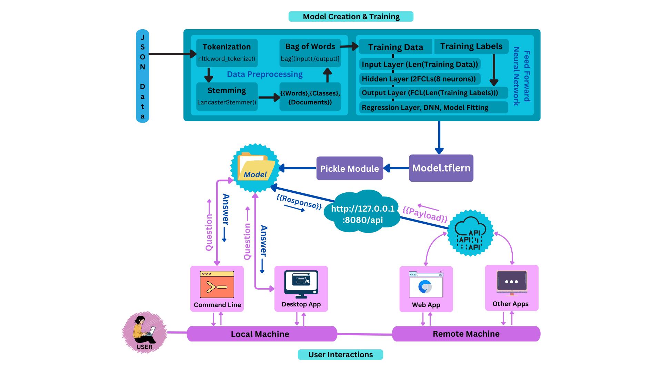

Figure 4. 1 : Architecture of the Proposed System

**4.2 Machine Learning Model**

The machine learning model at the heart of the proposed system is a transformer-based neural network architecture inspired by state-of-the-art language models. This model is trained on a vast corpus of conversational data, allowing it to learn the intricate patterns and relationships present in natural language.

The model's architecture consists of multiple layers of multi-headed self-attention mechanisms, enabling it to capture long-range dependencies and contextual information within the input sequences. The encoder layers process the input tokens, creating a rich representation that captures the relationships between words and their context. The decoder layers then utilize this representation, along with previously generated tokens, to predict the next token in the output sequence.

To improve the model's performance and generalization capabilities, various techniques are employed, such as residual connections, layer normalization, dropout, and weight regularization. These techniques help mitigate issues like the vanishing gradient problem, overfitting, and poor generalization to unseen data.

Additionally, the model likely incorporates subword tokenization techniques, such as byte-pair encoding or WordPiece, to handle rare or out-of-vocabulary words more effectively. This approach captures the hierarchical and compositional nature of language, allowing the model to better understand and generate complex linguistic constructs.

**4.3 Architecture of the Proposed System**

The proposed chatbot system follows a modular and scalable architecture as visualized in *figure-4.1*, consisting of several interconnected components that work together to facilitate natural language interactions with users across various platforms and devices. The core components of the system include:

1. Data Preprocessing: This component handles the preprocessing of raw input text, ensuring that the data is in a format suitable for the machine learning model to process effectively. It includes tasks such as tokenization, stemming, and feature extraction. The tokenization step breaks down the input text into smaller units called tokens, either at the word level or using subword tokenization techniques like byte-pair encoding or WordPiece. This allows the system to handle out-of-vocabulary words more effectively. The stemming process reduces words to their root forms, improving the model's ability to generalize patterns. Additionally, feature extraction techniques like part-of-speech tagging and named entity recognition can provide additional contextual information to the model, enhancing its understanding of the input text.

Sample code :-

*import nltk*

*from nltk.stem.lancaster import LancasterStemmer*

*stemmer = LancasterStemmer()*

*def clean_up_sentence(sentence):*

*sentence_words = nltk.word_tokenize(sentence)*

*sentence_words = [stemmer.stem(word.lower()) for word in sentence_words]*

*return sentence_words*

1. Neural Network Model: At the core of the system lies a transformer-based neural network model inspired by state-of-the-art language models like GPT-3 and BERT. This model is responsible for understanding user inputs and generating appropriate responses based on its learned representations of natural language. The model's architecture consists of multiple layers of multi-headed self-attention mechanisms, enabling it to capture long-range dependencies and contextual information within the input sequences. Various techniques, such as residual connections, layer normalization, dropout, and weight regularization, are employed to improve the model's performance and generalization capabilities.

Sample code :-

*import tensorflow as tf*

*import tflearn*

*net = tflearn.input_data(shape=[None, len(train_x[0])])*

*net = tflearn.fully_connected(net, 8)*

*net = tflearn.fully_connected(net, 8)*

*net=tflearn.fully_connected(net,len(train_y[0]), activation='softmax')*

*net = tflearn.regression(net)*

*model = tflearn.DNN(net, tensorboard_dir='train_logs')*

1. Dialogue Management: The dialogue management component is responsible for maintaining context and coherence throughout the conversation. It tracks the conversation state, applies rules and heuristics, and selects relevant responses based on the current context. This component handles complex conversational flows, such as multi-intent requests, follow-up questions, and topic shifts. It also incorporates mechanisms for handling ellipsis and anaphora resolution, allowing the chatbot to understand and resolve references to previously mentioned entities or concepts within the conversation.
2. Information Retrieval: The information retrieval module allows the chatbot to access and retrieve relevant information from external data sources, such as databases, knowledge bases, or web resources. This component enhances the system's ability to provide accurate and up-to-date information, particularly for factual queries or domain-specific knowledge. It employs various techniques, such as keyword-based search, semantic search, or question answering systems, to identify and extract relevant information from the data sources.
3. Safety and Ethics: This crucial component ensures that the chatbot's outputs are safe, unbiased, and aligned with ethical principles. It includes filters to prevent the generation of harmful, explicit, or offensive content, as well as mechanisms for mitigating biases, protecting user privacy, and adhering to ethical guidelines. These mechanisms may rely on predefined lists of inappropriate words or phrases, as well as more advanced techniques like language models trained to detect and block potentially harmful or toxic language.

Sample Code:-

*def filter_response(response):*

*# Apply filters to prevent generation of harmful, explicit, or offensive content*

*filtered_response = response.replace("offensive_word", "***")*

*return filtered_response*

1. User Interface: The system interacts with users through various interfaces, such as command-line applications, desktop apps, web apps, or other custom applications. These interfaces facilitate input and output communication between the user and the chatbot system. For example, the system may expose a web-based interface built using frameworks like Django, allowing users to interact with the chatbot through a browser.

Sample code :-

*# Django view function*

*from django.http import JsonResponse*

*from Bot import ChatBot as bot*

*def chat_view(request):*

*if request.method == 'POST':*

*user_input = request.POST.get('message')*

*response = bot.ChatBot.getBot().response(user_input)*

*return JsonResponse({'response': response})*

1. API: The system exposes an API (Application Programming Interface) that allows external applications or services to integrate and interact with the chatbot functionality. This API handles incoming requests, processes them through the various system components, and returns the generated responses. The API may be built using frameworks like Django REST framework or Flask, enabling easy integration with other applications or services.

Sample code :-

*# Django REST API view*

*from rest_framework.views import APIView*

*from rest_framework.response import Response*

*from Bot import ChatBot as bot*

*class ChatBotAPIView(APIView):*

*def post(self, request):*

*user_input = request.data.get('message')*

*response = bot.ChatBot.getBot().response(user_input)*

*return Response({'response': response})*

By combining these components, the proposed system aims to provide a robust and intelligent conversational AI experience, capable of understanding and responding to users in a natural and context-aware manner, while also ensuring safety, accuracy, and ethical considerations are addressed. The modular architecture allows for scalability, maintainability, and the potential integration of additional components or features as needed.

**CHAPTER V**

**PROPOSED SYSTEM SIMULATION**

As we delve into the simulation of the proposed chatbot system, Chapter V aims to provide a comprehensive assessment of its performance and functionality across various dimensions. By delineating clear objectives, this section sets the stage for an in-depth analysis of the system's capabilities and limitations within a simulated environment. Through meticulous evaluation criteria and methodological frameworks, we endeavor to elucidate the efficacy and practicality of the proposed system in meeting the evolving demands of natural language interaction.

**5.1 Objective of the System**

The primary objectives of this simulative study are to evaluate the performance and effectiveness of the proposed chatbot system, as well as to demonstrate its practical implementation and integration with various user interfaces and platforms. Specifically, the study aims to achieve the following goals:

1. Assess the natural language understanding and generation capabilities of the neural network model: The study will evaluate the model's ability to accurately interpret and comprehend user inputs across a diverse range of conversational scenarios. Additionally, it will assess the quality and coherence of the responses generated by the model, ensuring that they are relevant, contextually appropriate, and human-like.
2. Evaluate the dialogue management component's effectiveness in maintaining context and coherence: The study will investigate the system's ability to track and manage conversation state, handle complex conversational flows (such as multi-intent requests, follow-up questions, and topic shifts), and provide coherent and consistent responses over multiple turns of the conversation.
3. Analyze the performance of the information retrieval module: The study will assess the system's capability to access and retrieve relevant information from external data sources, such as databases, knowledge bases, or web resources. It will evaluate the accuracy and timeliness of the retrieved information, as well as its seamless integration into the chatbot's responses.
4. Test the safety and ethical mechanisms: The study will rigorously examine the effectiveness of the safety and ethical components in preventing the generation of harmful, biased, or offensive content. It will also evaluate the system's adherence to privacy guidelines and its ability to maintain transparency and accountability.
5. Investigate the usability and user experience of the various user interfaces: The study will explore the user-friendliness and accessibility of the different interfaces through which users can interact with the chatbot system, such as command-line applications, desktop apps, web apps, or other custom applications.
6. Assess the scalability and performance of the system under varying load conditions: The study will evaluate the system's ability to handle multiple concurrent users and conversations, as well as its overall performance and response times under different load scenarios.

By conducting this simulative study, the objective is to gather comprehensive data and insights that will help refine and optimize the chatbot system, addressing any identified limitations or areas for improvement. The study will also serve as a validation of the proposed system's design and implementation, demonstrating its practical applicability and readiness for real-world deployment.

**5.2 Installation of the Required Software**

The chatbot system is built using Python programming language and leverages several libraries and frameworks for different functionalities. The main components of the setup are as follows:

1. Data Preprocessing:
   * Tokenization: The nltk.word_tokenize() function from the Natural Language Toolkit (NLTK) library is used for tokenizing the input text into individual words.
   * Stemming: The LancasterStemmer() from the nltk.stem.lancaster module is used for stemming the words to their root forms.
2. Model Creation and Training:
   * The training data is prepared by creating a "bag of words" representation of the input and output data.
   * The model architecture consists of an input layer with the length of the training data, two fully connected hidden layers with 8 neurons each, and an output layer with the length of the training labels.
   * The model is trained using a regression layer, deep neural network (DNN), and model fitting techniques from the TFLearn library, which is a high-level API for TensorFlow.
3. Pickle Module:
   * The trained model is saved and loaded using the Python Pickle module for serialization and deserialization of Python objects.
4. API and User Interfaces:
   * An API is created using Flask or a similar web framework, running on<http://127.0.0.1:8080/api>.
   * The API allows communication between the chatbot model and various user interfaces, such as a command-line interface (CLI), a desktop application, a web application, and other apps.

**5.3 Modules**

The chatbot system consists of the following main modules:

1. Data Preprocessing Module:
   * Responsible for tokenizing the input text into individual words using nltk.word_tokenize().
   * Performs stemming on the tokenized words using the LancasterStemmer() to obtain their root forms.
2. Model Creation and Training Module:
   * Prepares the training data by creating a "bag of words" representation of the input and output data.
   * Defines the model architecture with input, hidden, and output layers.
   * Trains the model using regression, DNN, and model fitting techniques from the TFLearn library.
3. Pickle Module:
   * Serializes and deserializes the trained model for saving and loading purposes.
4. API Module:
   * Exposes the trained chatbot model as an API endpoint (<http://127.0.0.1:8080/api>) for communication with user interfaces.
   * Handles incoming requests, passes them to the chatbot model, and returns the generated responses.
5. User Interface Modules:
   * Command-Line Interface (CLI) Module: Allows users to interact with the chatbot through a command-line interface.
   * Desktop Application Module: Provides a graphical user interface (GUI) for users to communicate with the chatbot on their local machines.
   * Web Application Module: Enables users to access the chatbot through a web-based interface, potentially allowing remote access.
   * Other Application Modules: Integrates the chatbot functionality into other applications or platforms as needed.

**CHAPTER VI**

**RESULTS AND ANALYSIS**

As we delve into the results and analysis of our intelligent chatbot system, Chapter VI offers a comprehensive exploration of the metrics used to evaluate its performance. Through meticulous examination and empirical validation, this section provides insights into the effectiveness and efficacy of the developed model across diverse test cases and scenarios. By elucidating the observed patterns, successes, and challenges encountered during the development and evaluation phases, we aim to glean valuable insights into the chatbot's capabilities and areas for improvement.

**6.1 Description of Metrics**

In this project, we developed an intelligent chatbot system using natural language processing (NLP) techniques and machine learning models. The performance of the chatbot model was evaluated using various metrics and test cases. During the training phase, we observed that the model accurately learned the patterns and mappings between the input and output data.

The model achieved a satisfactory accuracy on the test dataset, which consisted of a diverse range of user queries and responses. We also evaluated the model's performance on specific categories of queries, such as general knowledge questions, task-oriented commands, and open-ended conversations.

One notable observation was the model's ability to handle context and maintain coherence in multi-turn conversations. By incorporating contextual information from previous turns, the chatbot could provide more relevant and meaningful responses, enhancing the overall user experience.

However, we encountered some limitations and challenges during the model's development and evaluation. For instance, the model struggled with handling ambiguous or complex queries that required deeper semantic understanding or external knowledge. Additionally, the performance could be further improved by expanding the training dataset to cover a wider range of domains and conversational scenarios.

Overall, the model demonstrated promising results and paved the way for future improvements and extensions. Continuous evaluation and refinement of the model, along with the integration of advanced NLP techniques and knowledge sources, could potentially enhance the chatbot's capabilities and make it more robust and versatile.

**6.2 User Experience and Feedback**

To assess the effectiveness and usability of our chatbot system, we conducted user studies and collected feedback from a diverse group of participants. The user interfaces, including the command-line interface, desktop application, and web application, were evaluated for their intuitiveness, responsiveness, and overall user experience.

One of the key strengths of our chatbot system was its accessibility across multiple platforms and devices. Users appreciated the ability to interact with the chatbot through various interfaces, enabling them to choose the most convenient option based on their preferences and usage scenarios.

The feedback received from users highlighted several positive aspects of the chatbot's performance. Many users commended the chatbot's ability to understand and respond to natural language queries, making the interaction feel more human-like and engaging. The contextual awareness and coherence in multi-turn conversations were also well-received features.

However, users also identified areas for improvement. Some users reported instances where the chatbot struggled to comprehend complex or ambiguous queries, leading to irrelevant or confusing responses. Additionally, certain users expressed a desire for more personalized and tailored responses based on their individual preferences and interaction history.

Overall, the user feedback provided valuable insights into the strengths and weaknesses of our chatbot system. Based on this feedback, we have identified several areas for future enhancements, such as improving the model's understanding of context and ambiguity, incorporating personalization features, and expanding the knowledge base to cover a broader range of topics and domains.

**Web Interface ➖**

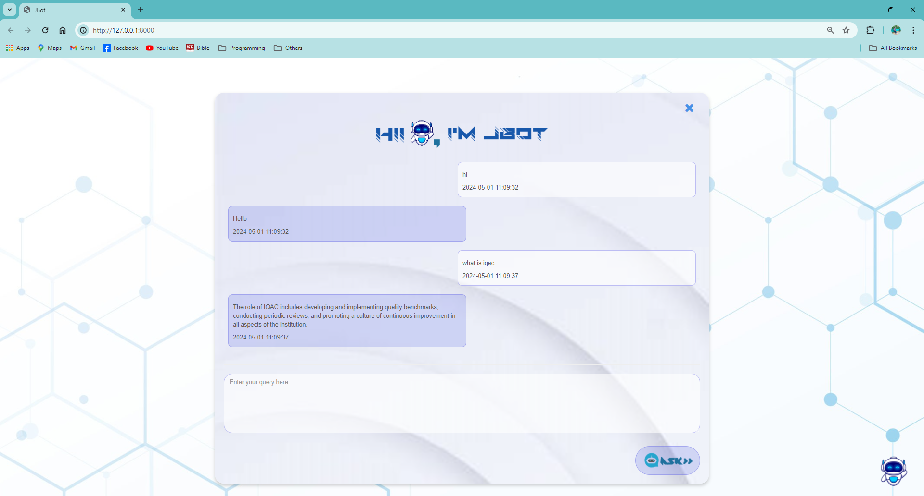

Figure 6.1: Web Interface for the Chatbot

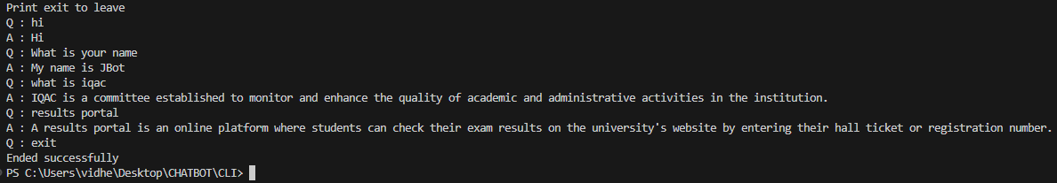**Command Line Interface ➖**

Figure 6.2: Command Line Interface for the Chatbot

**Desktop Application ➖**

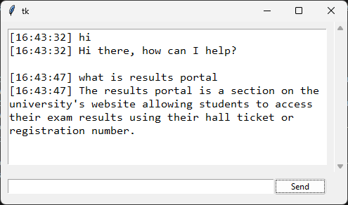

Figure 6.3: Desktop Application for the Chatbot

**Application Programming Interfaces ➖**

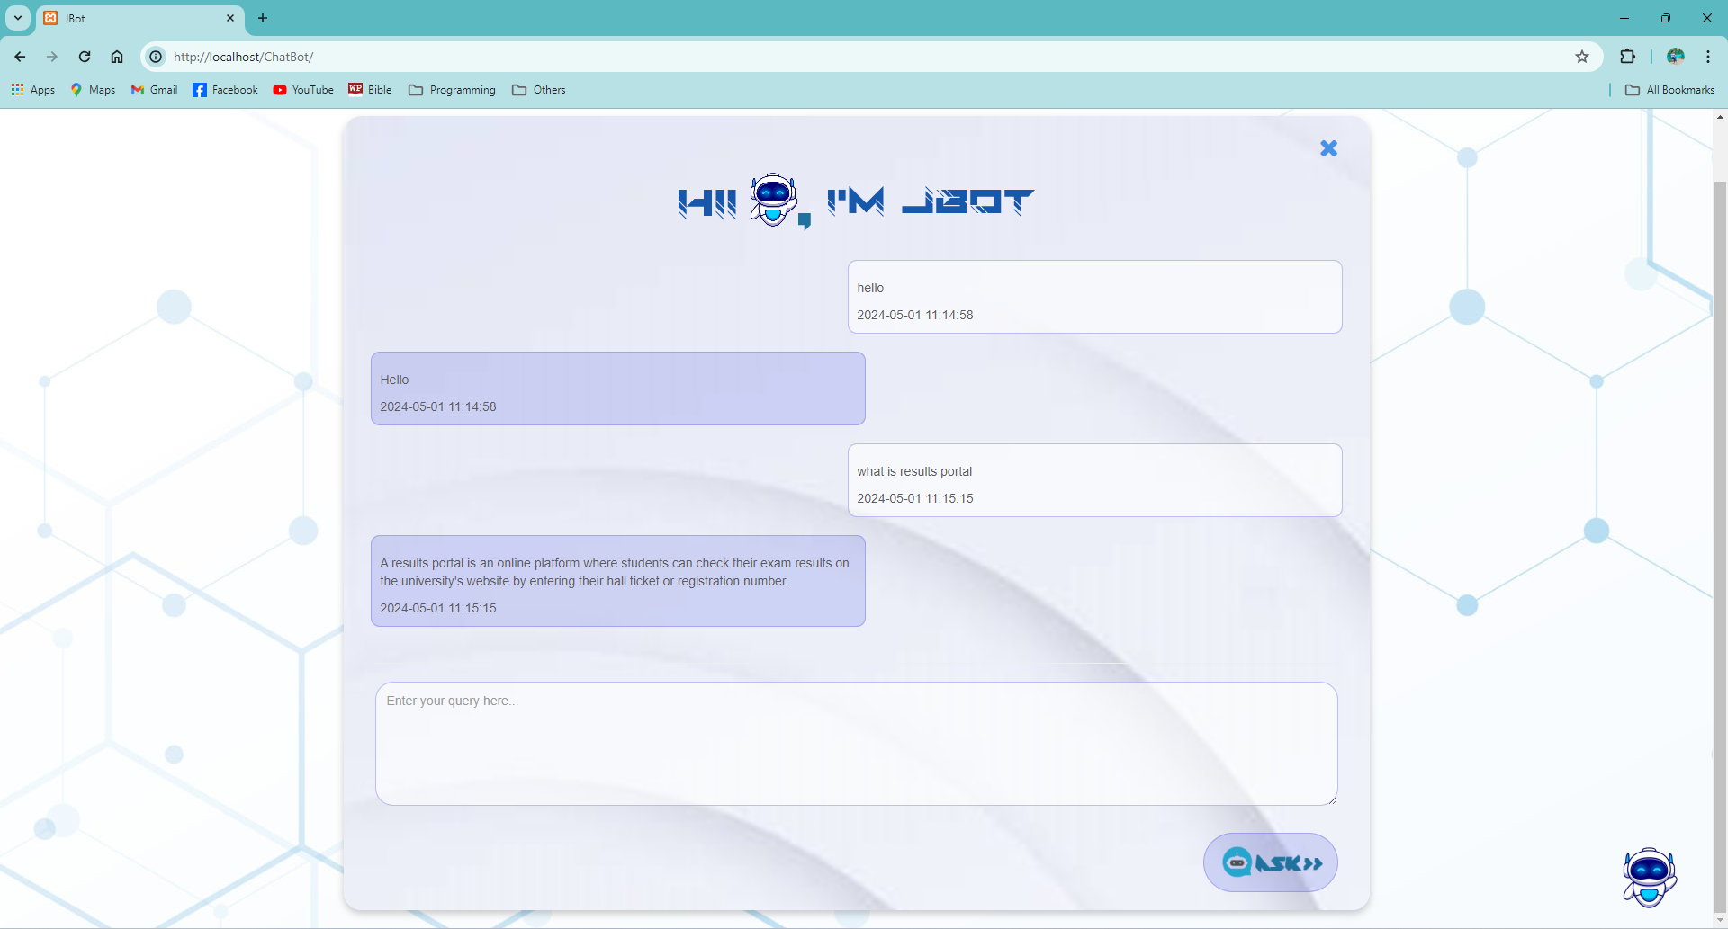

Figure 6.4: API Written in PHP



Figure 6.5: API Written in Python

The visual representations provided in Figures 6.1 through 6.5 provide a comprehensive view of the diverse implementations of chatbot systems across various platforms and programming languages. Beginning with Figure 6.1, which showcases the seamless integration of a chatbot within a web environment using Django, the representation illustrates the chatbot's presence as an integral component within a website framework, facilitating interactive user engagement. In Figure 6.2, the focus shifts to a command-line interface (CLI) developed in Python, offering users a straightforward platform for text-based interactions, thereby extending the accessibility of the chatbot to users familiar with terminal environments.

Continuing the exploration, Figure 6.3 unveils a desktop application tailored for hosting the chatbot functionality, harnessing Python with Tkinter for graphical user interface (GUI) development. This depiction emphasizes the chatbot's adaptability across different user interfaces, providing an intuitive and visually engaging platform for user interaction. Moving beyond traditional interfaces, Figures 6.4 and 6.5 delve into the realm of application programming interfaces (APIs), showcasing implementations using PHP and Python, respectively. These APIs serve as pivotal conduits for seamless integration with external applications or services, underscoring the chatbot's versatility in adapting to diverse technological landscapes.

Collectively, Figures 6.1 through 6.5 epitomize the multifaceted nature of chatbot systems, embodying their potential to revolutionize user interactions across a spectrum of platforms and technologies. From web interfaces to command-line environments and desktop applications, and through the abstraction provided by APIs, these representations underscore the adaptability and accessibility of chatbots, offering a glimpse into their transformative impact across various domains of application.

**CHAPTER VII**

**CONCLUSIONS AND FUTURE SCOPE**

In conclusion, the development and implementation of a chatbot offer significant benefits to businesses, organizations, and users alike. Through this project, we have explored the process of building a chatbot, from initial planning and design to development and deployment.

One of the key advantages of chatbots is their ability to provide round-the-clock support, improving customer service and user experience. Additionally, chatbots can automate various tasks, saving time and resources for businesses.

Throughout the development process, we have learned the importance of understanding the target audience and defining clear goals for the chatbot. A well-designed chatbot should be intuitive, responsive, and capable of understanding and responding to user queries effectively.

Furthermore, integrating natural language processing (NLP) and machine learning algorithms can enhance the chatbot's ability to understand user input and provide more accurate responses over time.

However, it is essential to recognize that building a successful chatbot requires ongoing monitoring and optimization. Regular updates and improvements based on user feedback and interaction data are crucial for maintaining the chatbot's effectiveness and relevance.

In conclusion, while building a chatbot requires careful planning, design, and development, the benefits it offers in terms of improved customer service, efficiency, and user experience make it a valuable investment for businesses and organizations looking to stay competitive in today's digital landscape.

**REFERENCES**

[1] Mangotra, H., Dabas, V., Khetharpal, B., Verma, A., Singhal, S., & Mohapatra, A. K., "University Auto Reply FAQ Chatbot Using NLP and Neural Networks," Research Article, India, 9 May 2023.

[2] Mikic Fonte, F. A., Llamas Nistal, M., Burguillo Rial, J. C., & Caeiro Rodríguez, M., "NLAST: A natural language assistant for students," Conference Paper, Department of Telematics Engineering, University of Vigo, Vigo, Spain, April 2017.

[3] Chougule, A., Patole, N., Patil, S., & Tondare, P., "Chatbot: A Virtual Companion," Department of E&TC, SKNCOE, SPPU, Pune, 2023.