Ruhee Nagulwar 111803158 Chinmay Dixit 111803169

Flight Management System

**Problem Statement:**

The project focusses on managing details of Airlines tickets, flights, bookings and customers. The purpose of the project is to build an application program to reduce the manual work for managing the ticket bookings. Such a system is secure, reliable and fast and will help the organization maintain computerized records without redundant entries.

**Introduction:**

The project will be a web application using a suitable frontend framework. The backend will interact with the database which will be a SQL-based dbms. The customers will be able to use the frontend to make registrations and keep a record of the registration and may even cancel the registration. The application will manage all the information related to Airline ticket, bookings, vendors. Only the administrator will have access to all the data. The database schema will be defined in such a way that it will be easy for the administrator to navigate.

**Functional Requirements:**

1. Each user will have the option to book a flight ticket and cancel it.
2. The user will not be able to make reservations for flights with intersecting schedules.
3. The administrator will only have access to the public details of all the users.
4. Each user will get a unique identification number which will be maintained as long as the user information resides within the database.
5. Each ticket will have a unique number that cannot be duplicated.
6. Each flight will also have a unique reference number that may also be used for tracking the current route/ destination of the flight.

**ER Diagram:**

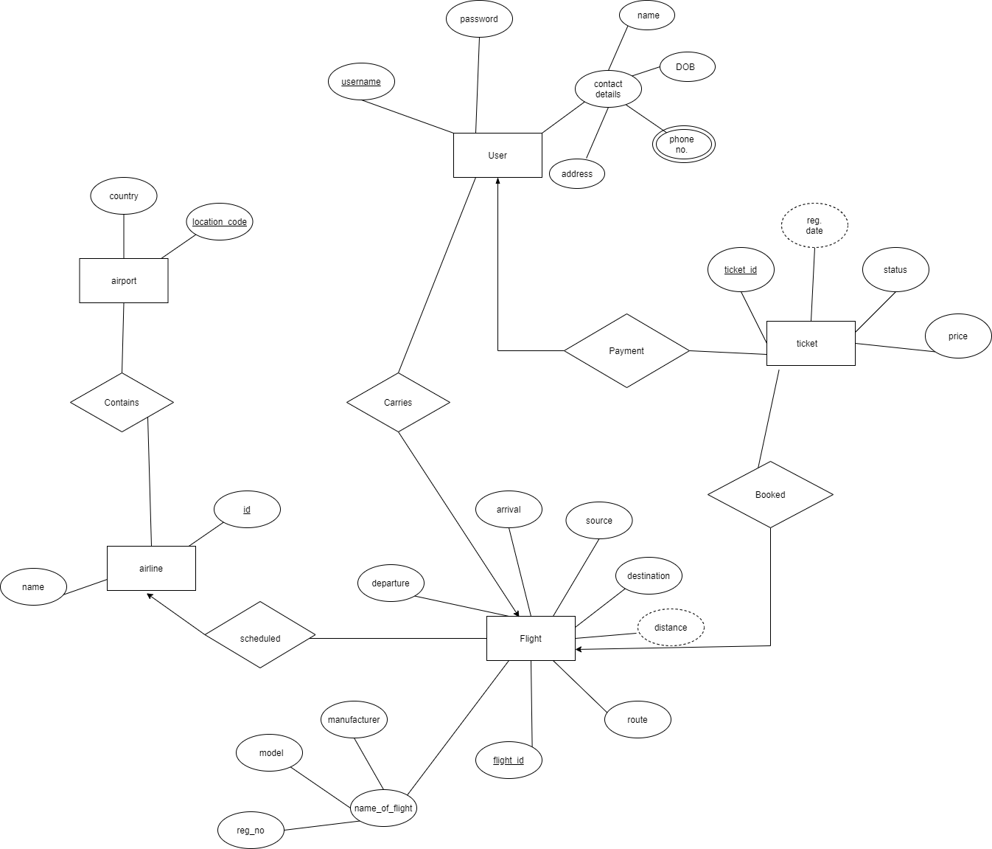

**Relational Schema:**

1. User (username, password, name, address, phone number, DOB)
2. Ticket (ticket_id, status, price)
3. Flight (flight_id, reg_no, manufacturer, model, departure, arrival, source, destination)
4. Airline (airline_id, name)
5. Airport (location_code, country)

Note: The registration date for each ticket is a derived attribute and has not been mentioned in the relational schema. Similarly, the distance of the flight is a derived attribute decided on the basis of the source, destination and the route.

**Tables obtained from ER diagram:**

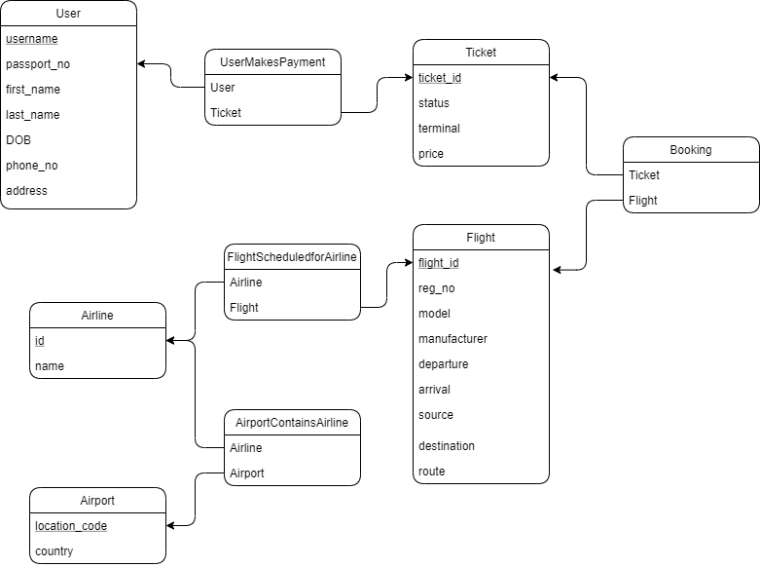

**Functional Dependencies:**

1. User: {username, passport_no, first_name, last_name, DOB, phone_no, address}

Username -> passport_no

Username -> first_name

Username -> last_name

Username -> DOB

Username -> phone_no

Username -> address

Passport_no -> first_name

Passport_no -> last_name

Passport_no -> DOB

Passport_no -> phone_no

Passport_no -> address

1NF: the table has no composite or multivalued attributes as phone_no is single valued in this case and the user identity(name, last name, DOB) has been split into individual and atomic attributes.

2NF: the table is in 2NF since there are no partial dependencies because the table contains primary key as username

3NF: There are no transitive dependencies involved

1. Ticket: {ticket_id, status, terminal, price}

Ticket_id -> status

Ticket_id -> terminal

Ticket_id -> price

1NF: no composite or multivalued attribute

2NF: no partial dependencies as ticket_id is primary key

3NF: no transitive dependencies

1. Flight: {flight_id, reg_no, manufacturer, model, departure, arrival, source, destination, route}

All attributes will be functionally dependent on flight_id and reg_no

Table is in 1NF, 2NF and 3NF.

1. Airline {id, name}

Id -> name

1. Airport {location_code, country}

Location_code -> country