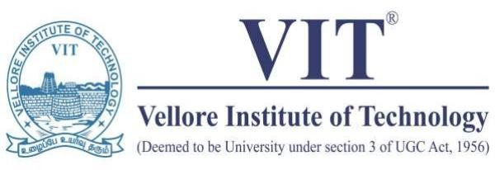

**FALL SEMESTER- 2022 REVIEW-3**

**CLOUD COMPUTING- SWE4002**

**TEAM MEMBERS VAISHALI G - 19MIS0009 VIDHYA R - 19MIS0035 SNEHA K - 19MIS0043**

**SUBMITTED TO Dr. VANI M P**

**TITLE: BUILDING A PLASMA DONOR APP WITH AWS**

# ABSTRACT:

Cloud computing has the pressing need for computing as the best use and as an optimal utility, structured with the current trends in mind, and has the potential to be a huge leap forward in the IT industry. Developers with innovative ideas don’t have to fear not spending expensive resources on a service that doesn’t meet demands and expectations. Cloud computing is like a panacea to overcome obstacles. In a cloud computing environment, all data resides on a set of network resources and can be accessed through virtual machines.

When we look through the Software applications that are being created and stored in the AWS cloud, this might have seemed impossible, not so long ago. But as of now, cloud computing is ruling the IT industry whether private or public makes easily accessible and scalable and AWS is one of the top cloud service providers in the market.

# PROBLEM DEFINITION:

During the COVID 19 crisis, the requirement of plasma became high and the donor count being low. Saving the donor information and helping the need by notifying the current donors would be a helping hand. In regard to the problem faced, an application is to be built which would take the donor details store it and inform them upon a request.

Serverless computing is the current trend of software application development. Micro services are a popular new approach for building maintainable, scalable, cloud-based applications. AWS is the perfect platform for hosting micro- services. In this project we will be building a plasma donor app with AWS services like lambda functions, API gateway and DynamoDB.

# LITERATURE REVIEW:

* **A Review of E- Training and Development Practices Implemented by Government for Healthcare Sector and their Impact during COVID 19 (With Special Reference to Uttarakhand)**

The abrupt global spread of the Corona virus disease, also known as Covid 19, has had a significant impact. The healthcare industry as a whole was particularly devastated. The world views the covid crisis as the most dangerous and tragic event since World War II as of June 2022, when the World Health Organization documented 6320599 deaths from the epidemic. Since the study is specifically focused on the state of Uttarakhand, we are all familiar with its topographical and climatic characteristics. The harsh weather conditions even make the health sector more vulnerable to disaster, as more than 70% of the state is hilly. State Covid 19 data from an authorized Uttarakhand government website were analyzed for the study. National Skill Development Corporation(NSDA) and the Ministry of Skill Development & Entrepreneurship. The Covid 19 not only presented a major issue to the government, but it also caused every business organization and policy maker to reevaluate the knowledge, skills, and expertise of their staff in order to deal with such unanticipated circumstances. In Uttarakhand state, there is always a manpower deficit in hospitals, but Covid 19 makes it more vulnerable and forces the entire Indian government to consider the kinds of training programs that aid the people in overcoming these circumstances.

# * A Novel Blockchain-Based Model for Blood Donation System

The ability to efficiently retrieve donor-to-consumer data is a limitation of Pakistan's current blood management or control systems. Blood is wasted since there is no communication system in place to request additional blood from a region if it is needed elsewhere. There have been instances where blood tainted with diseases like HIV has been used for transfusion due to a lack of accessibility and adequate blood quality testing. To deal with these issues, the paper suggests a ledger blood management system. Following the blood, the trail has been depicted as a supply-chain management issue. The suggested solution, based on the Hyperledger fabric model, adds greater traceability toward the blood

transfusion process by tracking the blood stream and donating to a single platform for transferring blood and the problem that arises among blood types. By offering an integrated system for transmitting lifeblood and the object extracted across lifeblood banks, it also aids in reducing unnecessary blood wastage. For ease of use and increased security, a web application is also created for network access. This application uses the Key Value System (KVS) system to establish a block chain hyperbaric ledger system.

# * Demography and blood donation trends in Saudi Arabia: A nationwide retrospective, cross-sectional study

Blood banks frequently have a shortage of blood due to a lack of donors, which has prompted officials to use social media to reach out to the public on behalf of patients who urgently require blood transfusions.

Globally, there has been an increase in the use of e-platforms to facilitate blood donation by providing a reliable information system that enables donors and facilitating centers to interact effectively and cooperate with one another easily. The blood bank's bloodstock information as well as test results for donors and medical assistants will be included in this study which enables the programme to automatically update patient vitals so that doctors may monitor patients remotely and deliver the best treatment possible.

# * The effect of motivational strategy on voluntary plasma donation, a field trial

Plasma protein treatments (PPTs) are a class of drugs that are separated from human plasma. A significant volume of human plasma is needed to produce enough PPTs. WHO underlined that giving whole blood and blood components should always be voluntary and gratuitous. Therefore, encouraging plasma donation is essential. In this investigation, we assessed the moderating effects of blood donation history on plasma donation as well as the influence of social media on encouraging blood donors to donate plasma unreimbursed.

# * Multistep screening and selection of COVID‐19 convalescent plasma donors at the early stage of the SARS‐CoV‐2 pandemic: A retrospective analysis

In February 2020, the COVID-19 epidemic spread to Bavaria. Almost around the same time, Chinese doctors released accounts of the first successful therapies using plasma from COVID-19 convalescent donors. With these positive developments in sight, we made the decision to set up production of anti-SARS CoV2 antibody-containing plasma from COVID-19 convalescent donors at our facility. Here, we present our donor selection procedure, which was created from scratch to help us deal with the intense resonance after our social media appeal for donations.

# ARCHITECTURE DIAGRAM:

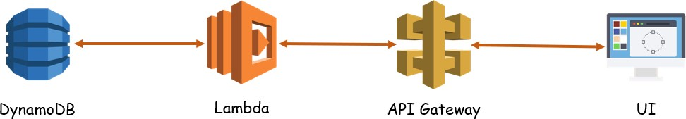

**MODULE DESCRIPTION:**



Create a flask

application

Create a

database

Deploy the

application

Create APIs

AWS

# SIGN IN TO AWS CONSOLE

Use your AWS account email address and password to sign in to the AWS Console or if you are new user sign up using valid credentials.

# CREATE A DATABASE

we will use Amazon RDS to create a MySQL DB Instance with db.t2. micro DB instance class, 20 GB of storage, and automated backups enabled with a retention period of one day. As a reminder, all of this is free tier eligible.

# CREATE APIS TO

* + Push the registration data into database.
  + Fetch the data upon login.
  + Display the stats of different blood groups.
  + Upon request, take the required blood group and return the details

# CREATE AN APPLICATION

* + Registration page
  + Login page
  + Stats page to display the count
  + Request page
  + Test it

# DEPLOY THE APPLICATION

* + Create an EC2 instance.
  + Deploy the app.

# USE CASE DIAGRAM:

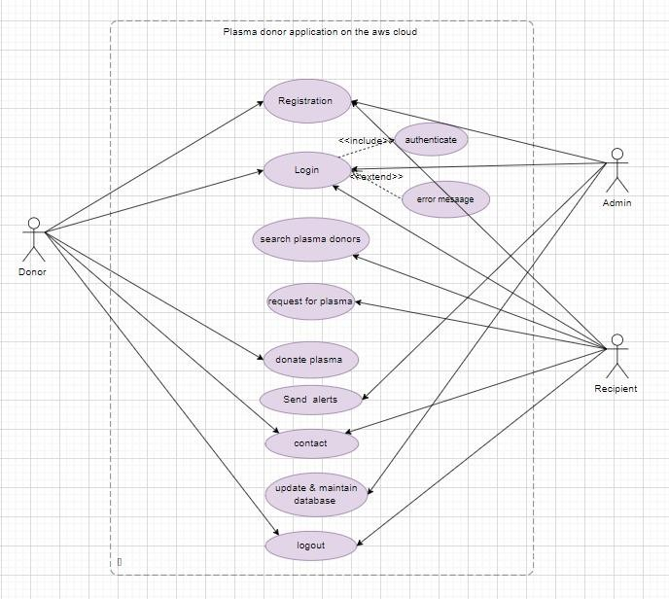

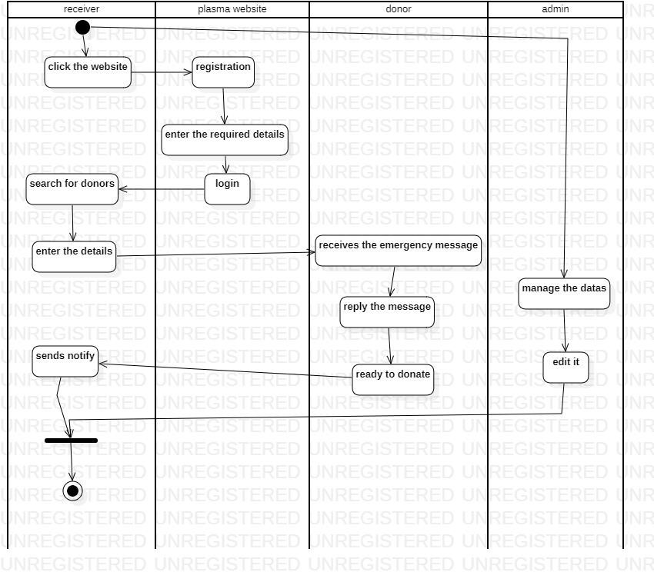**ACTIVITY DIAGRAM:**

# AWS SCREENSHOTS:

**CREATING A DATABASE IN DYNAMODB**

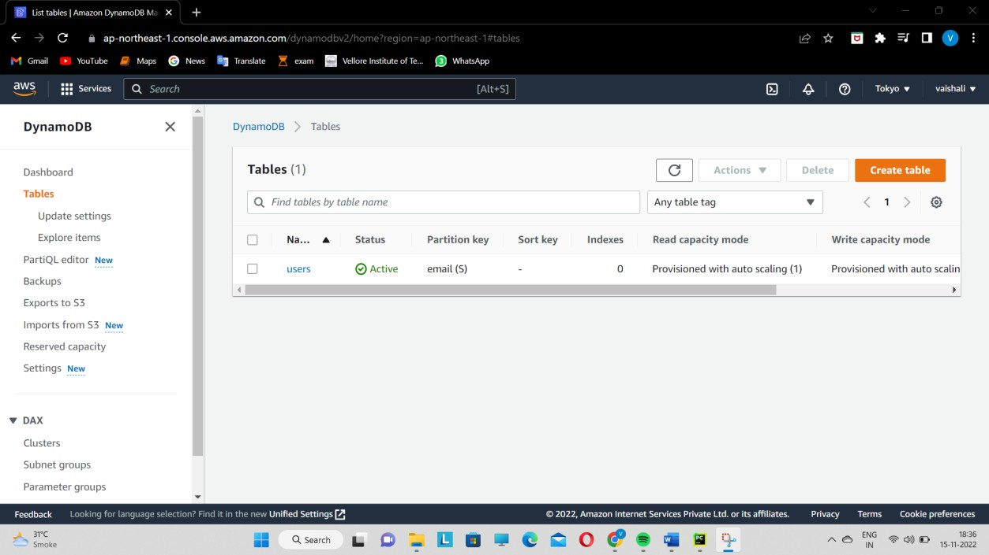

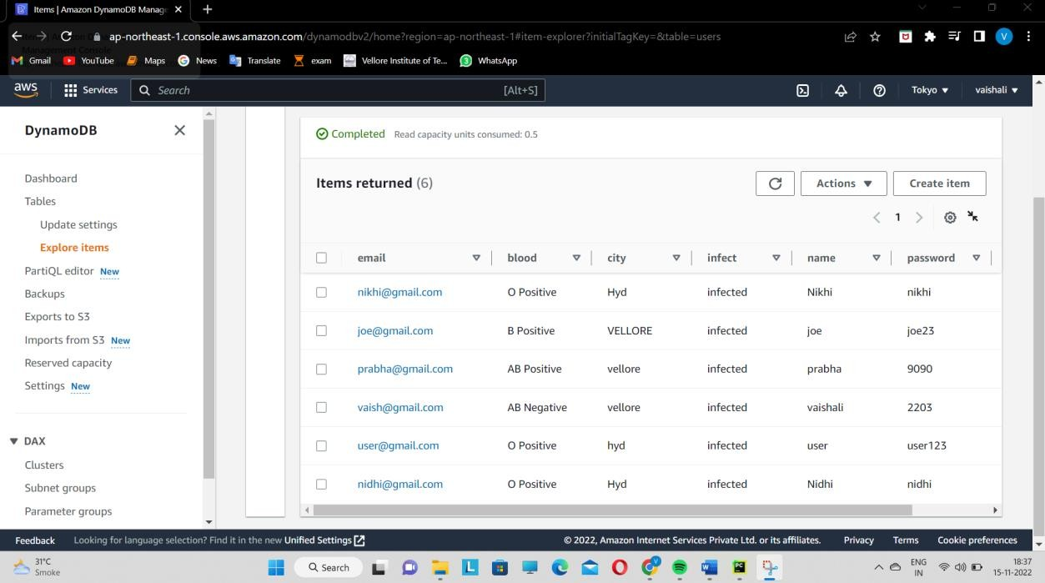

# Creating LAMBDA functions

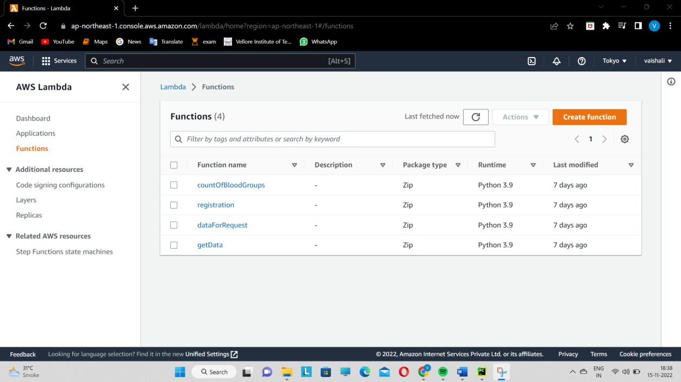

**REGISTERATION FUNCTION**

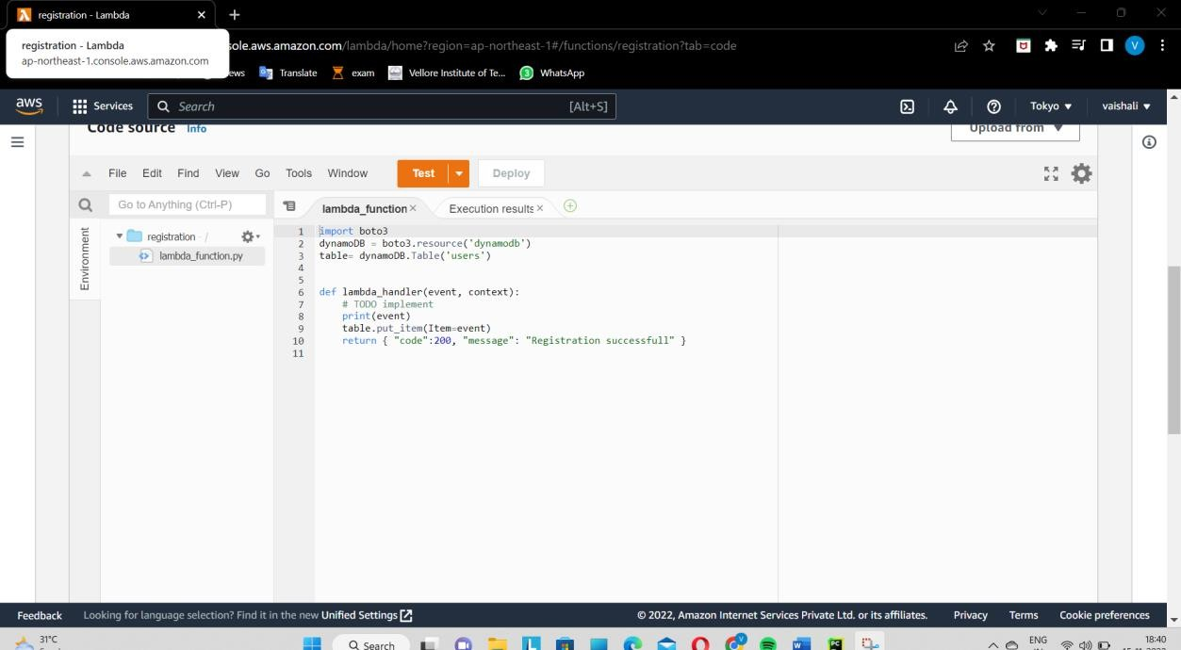

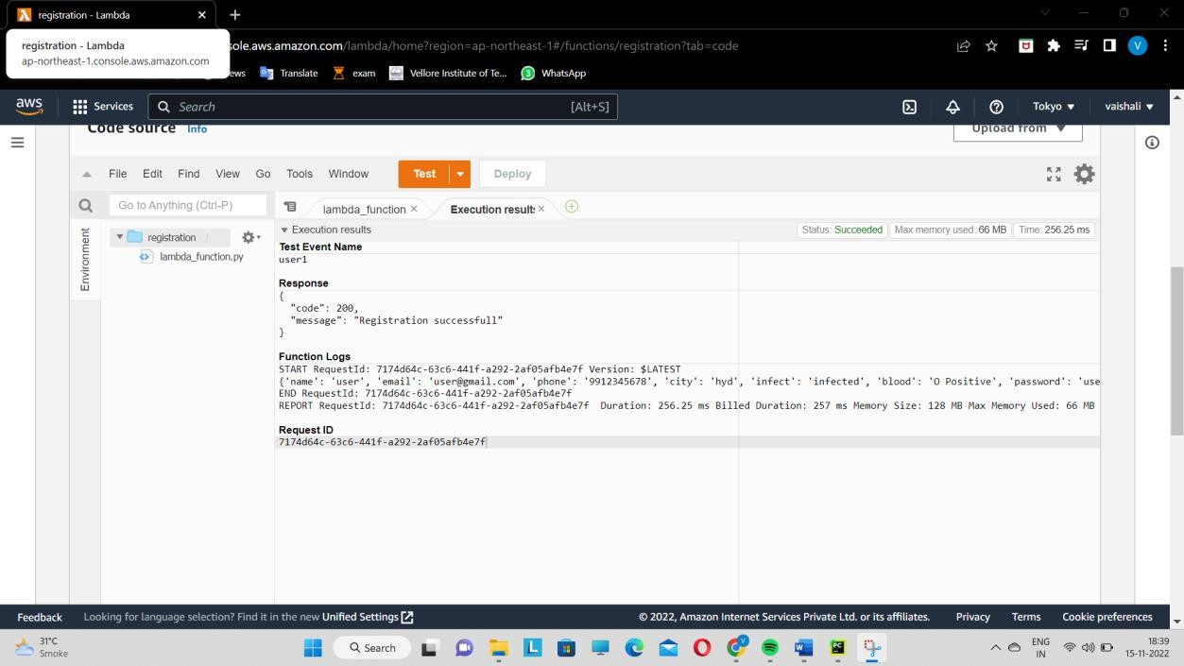

# GETDATA FUNCTION

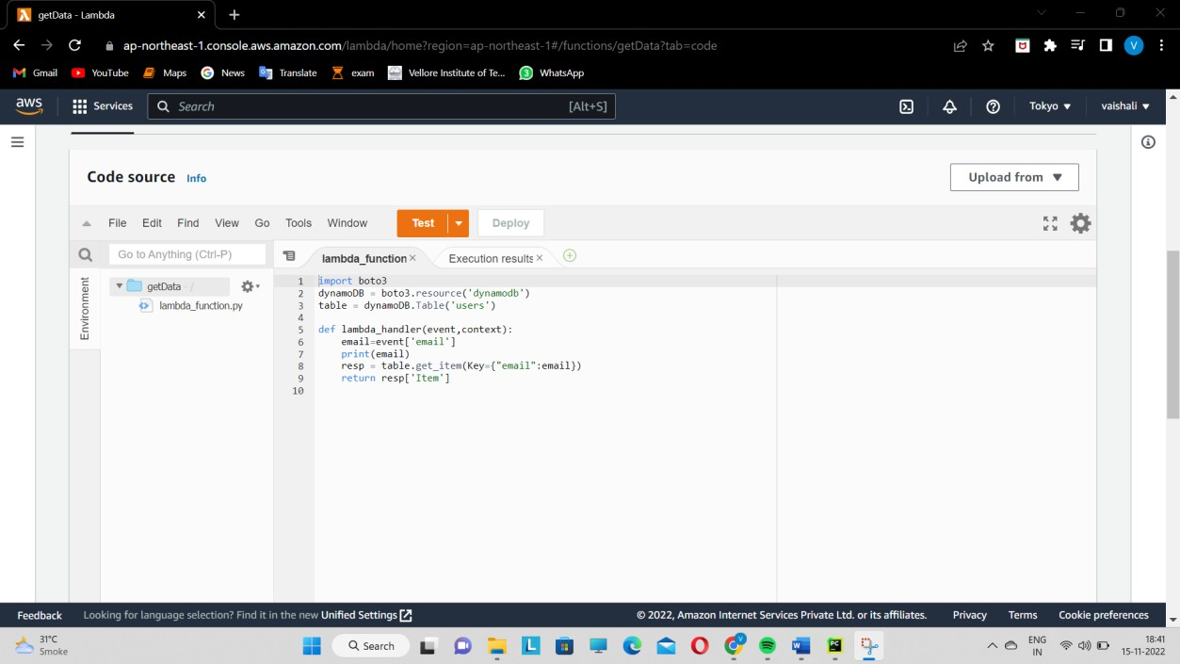

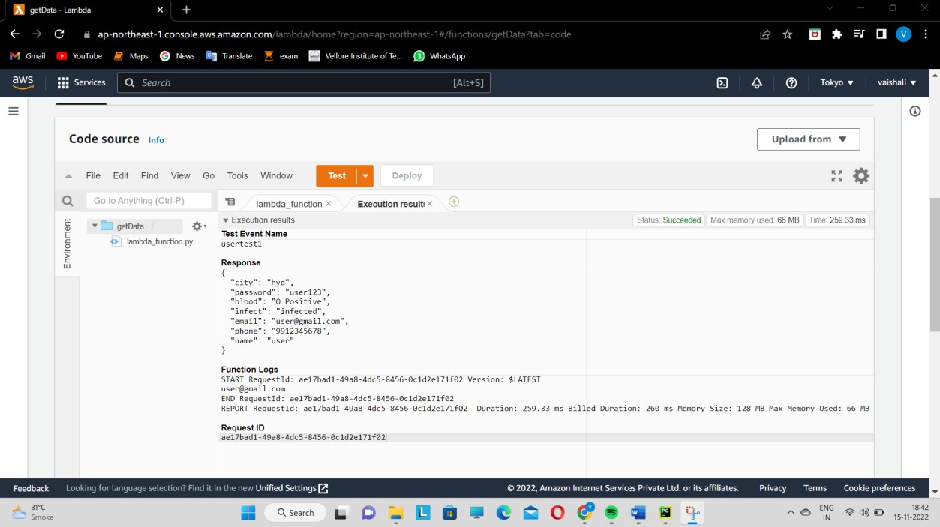

**COUNTOFBLOODGROUPS FUNCTION**

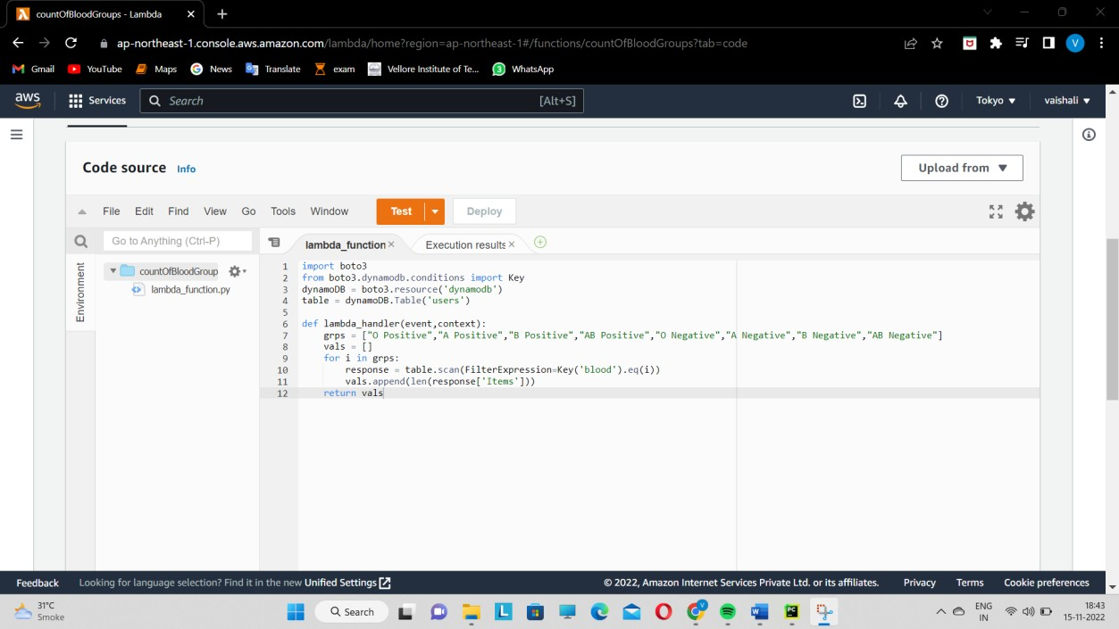

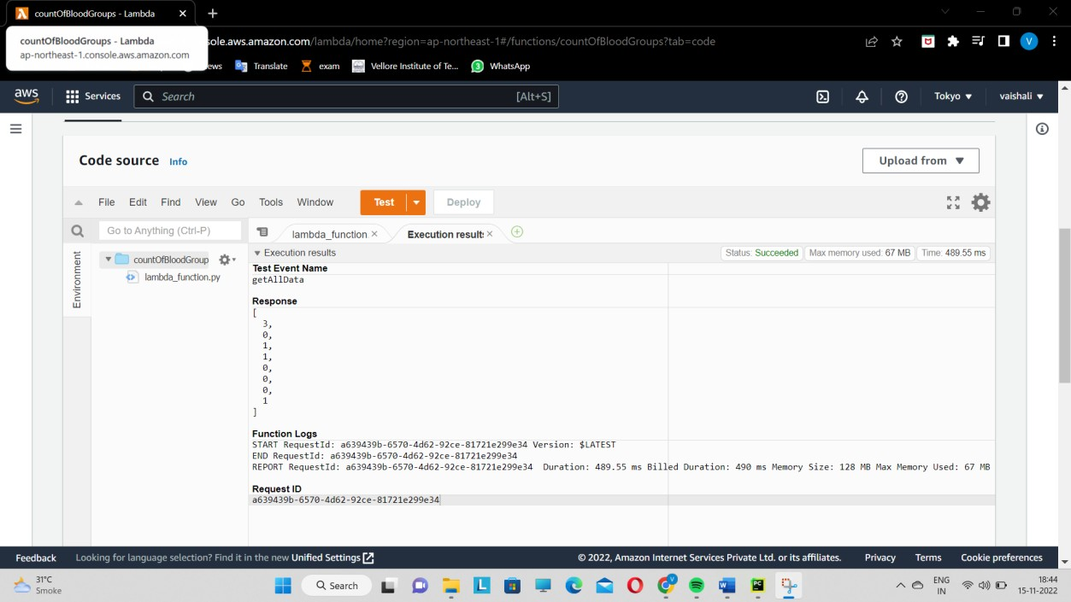

# DATAFORREQUEST FUNCTION

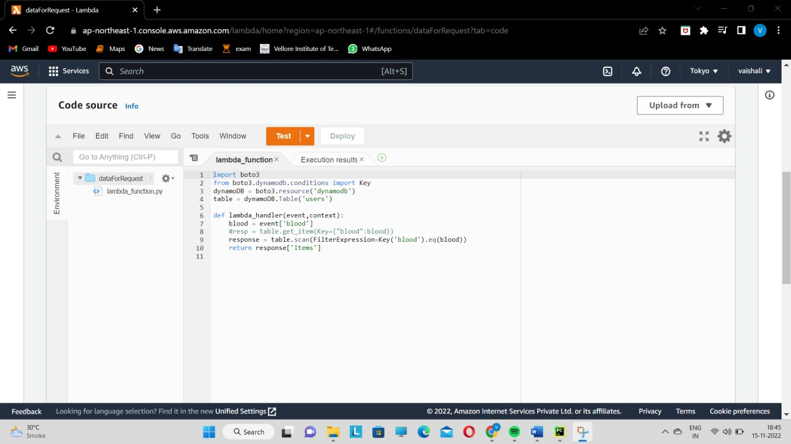

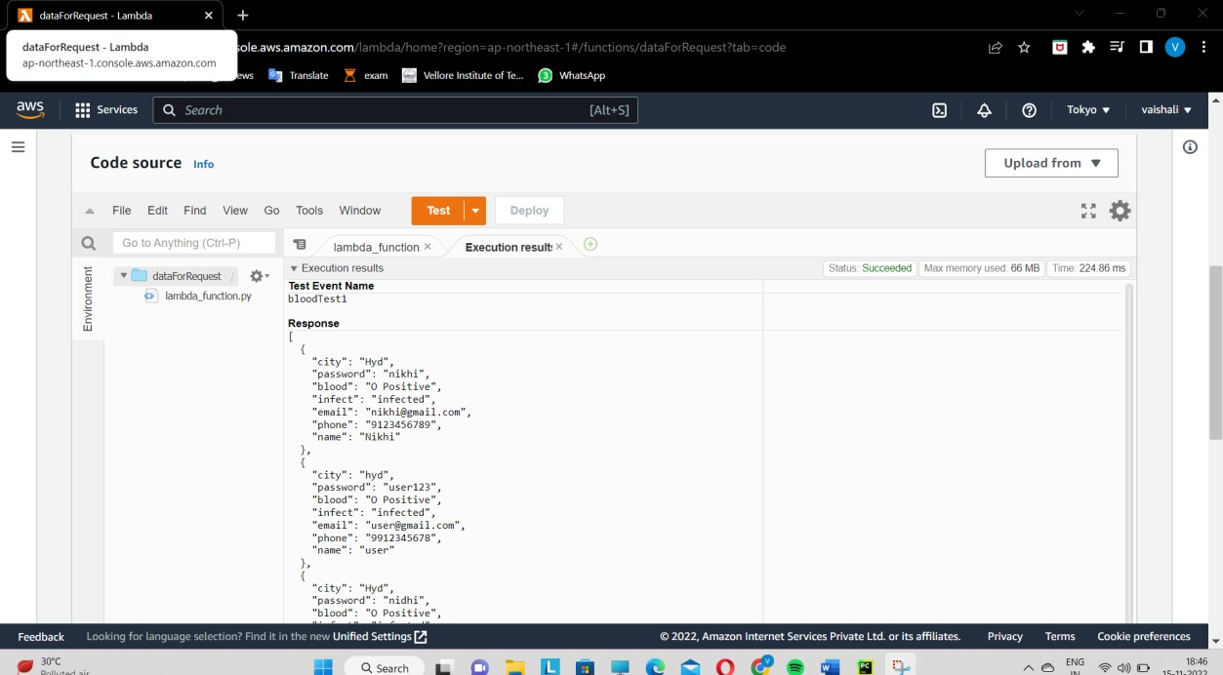

**API**

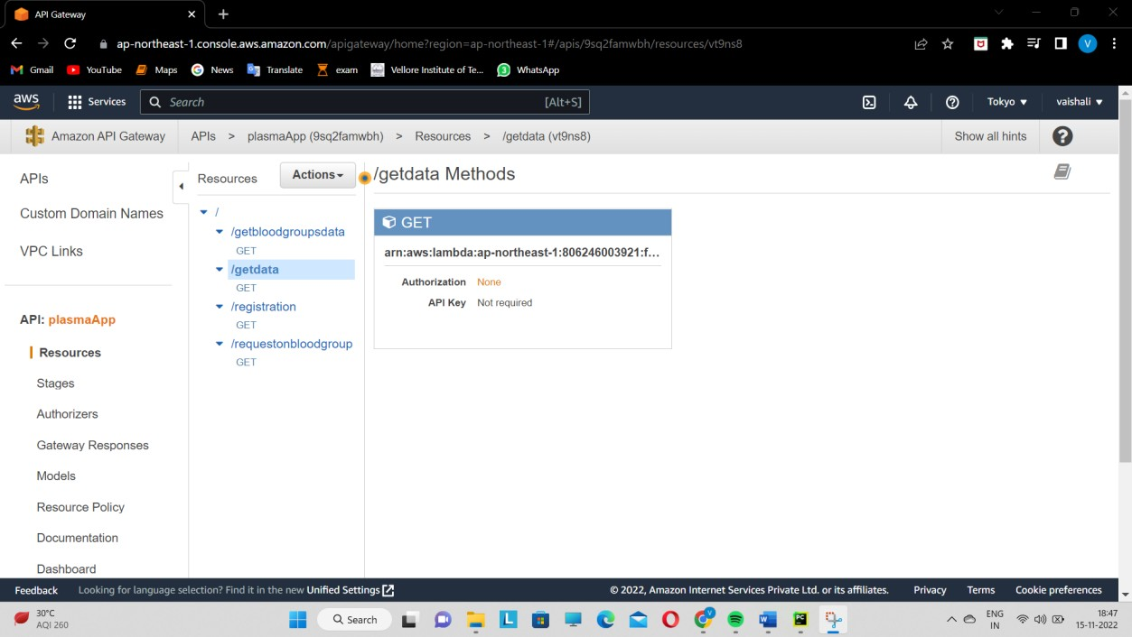

# DEPLOYING API GATEWAYS

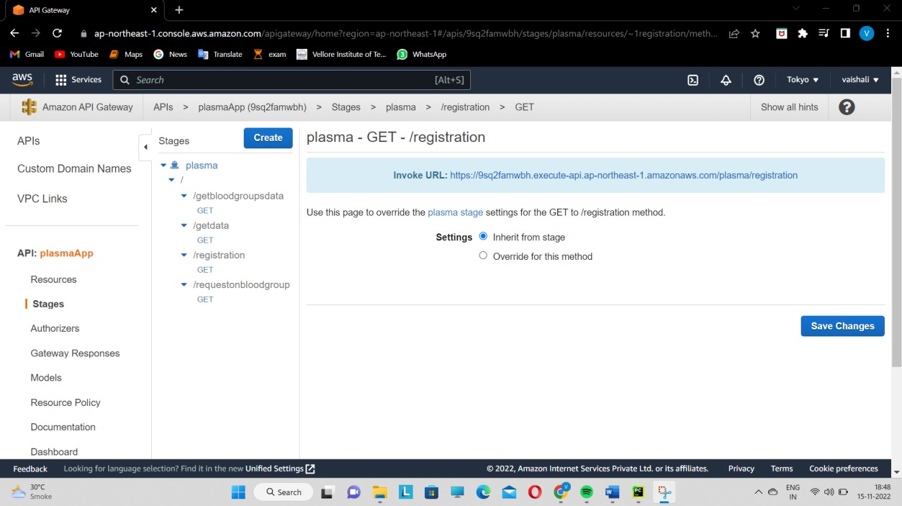

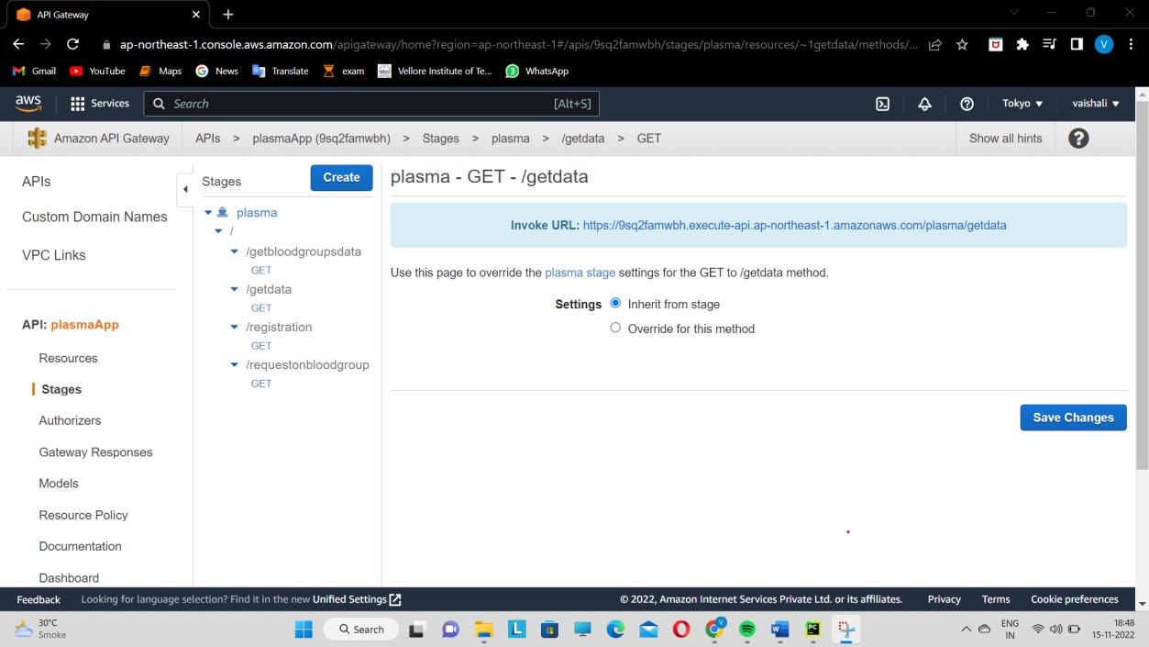

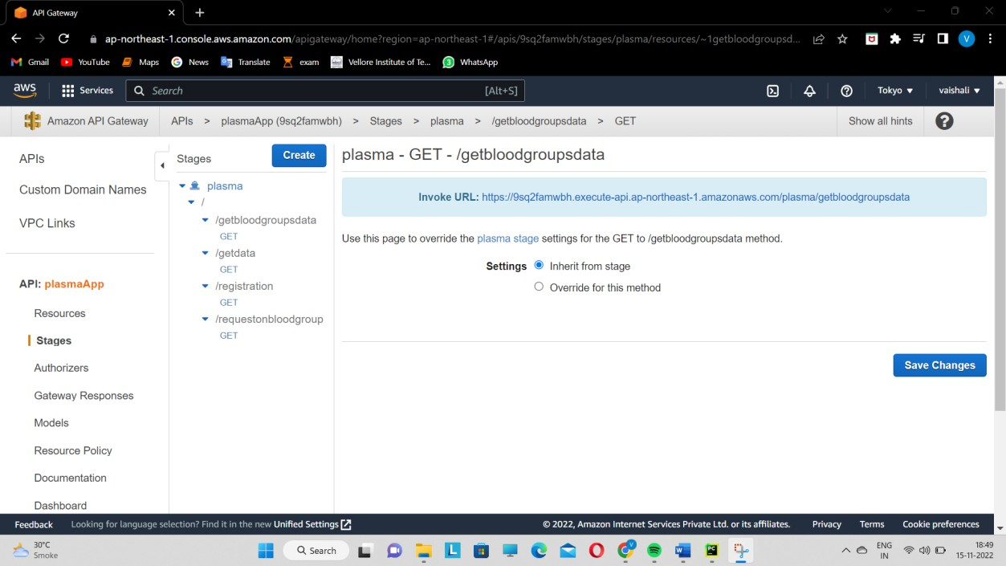

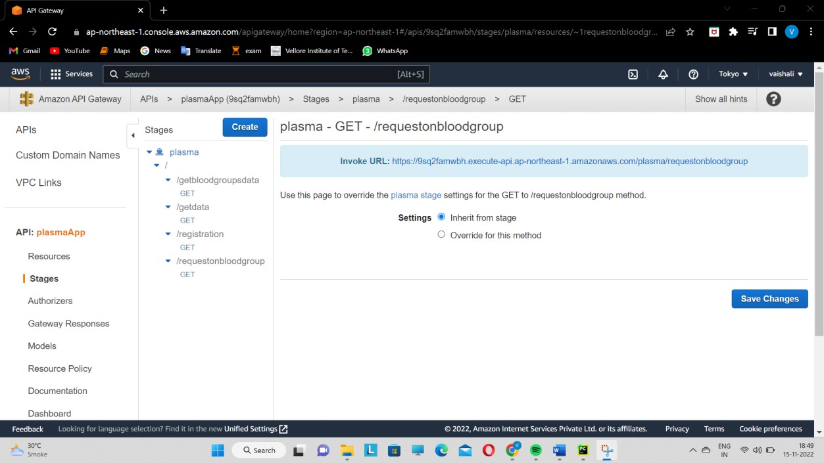

**APPLICATION SCREENSHOTS:**

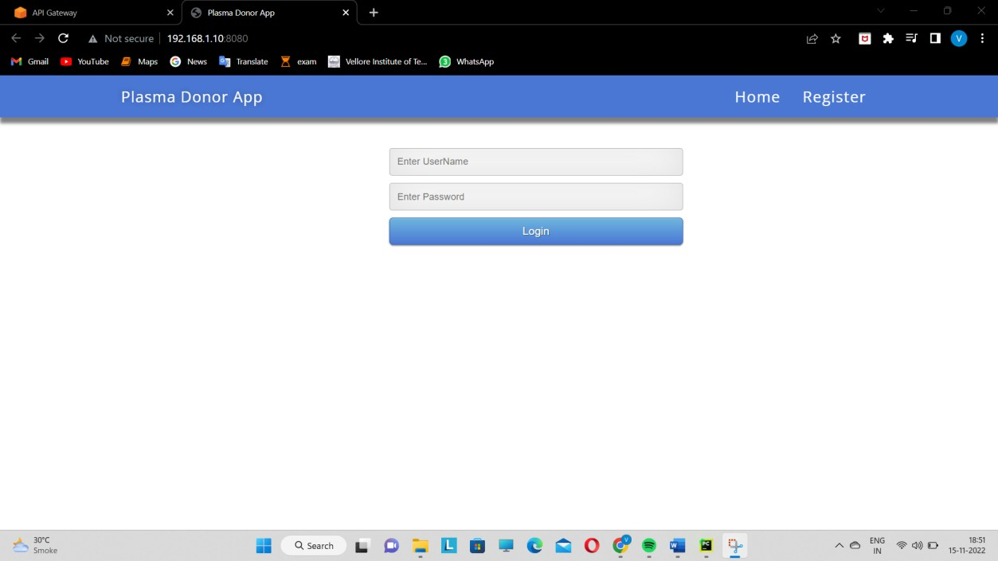

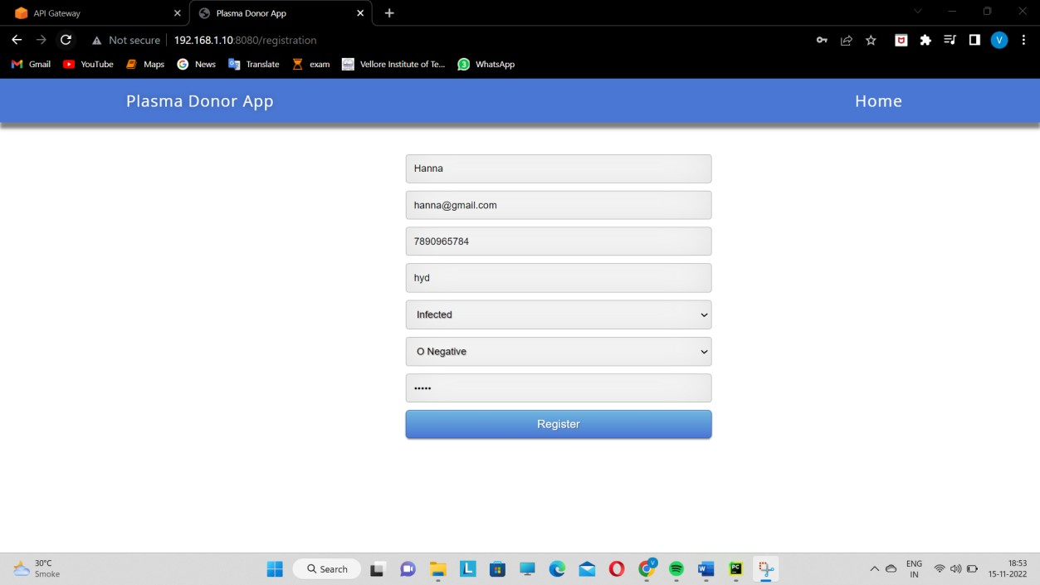

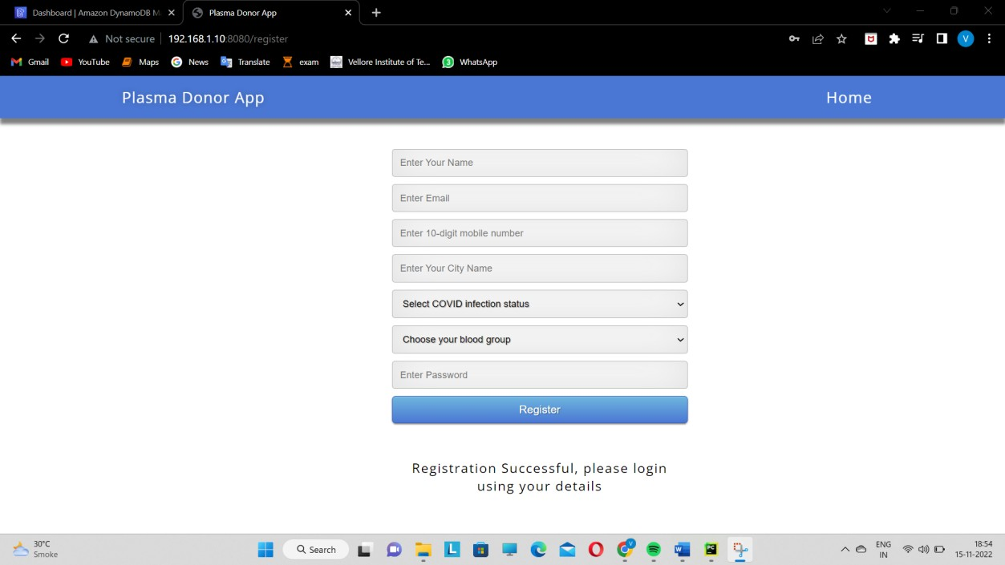

# As you can see details have been updated in the database.

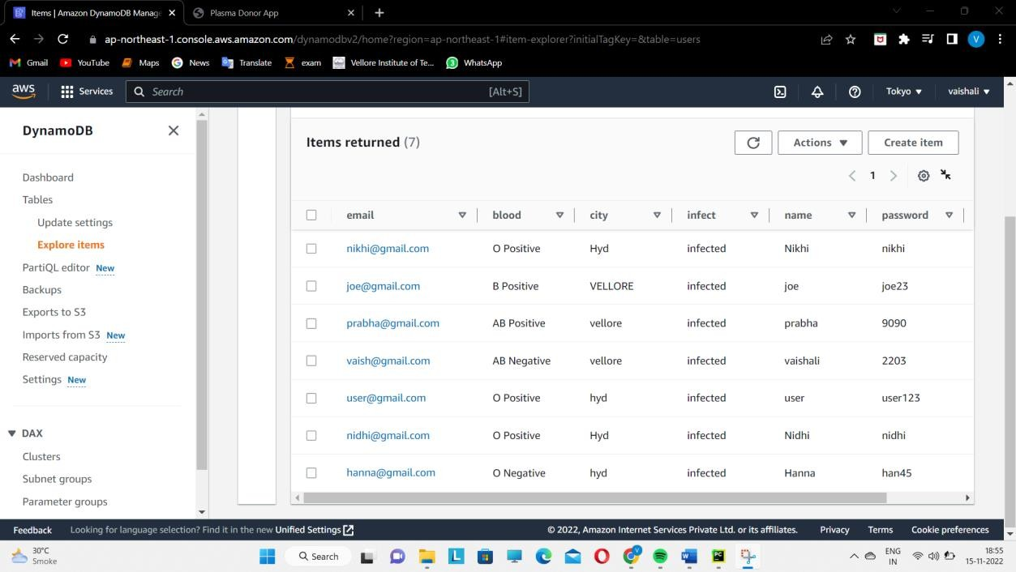

**Log in**

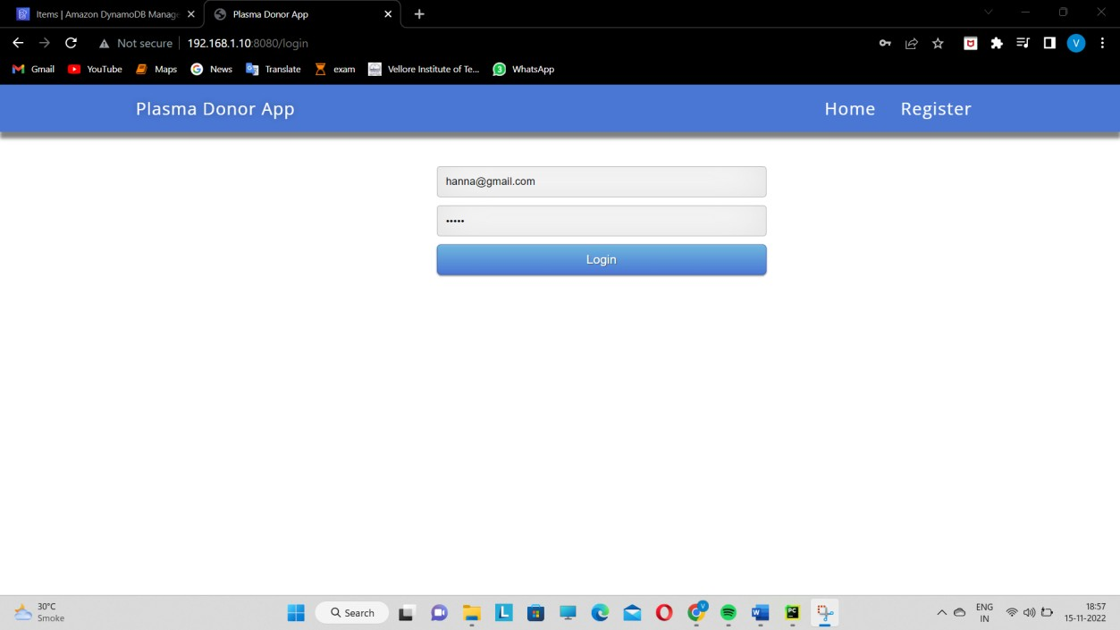

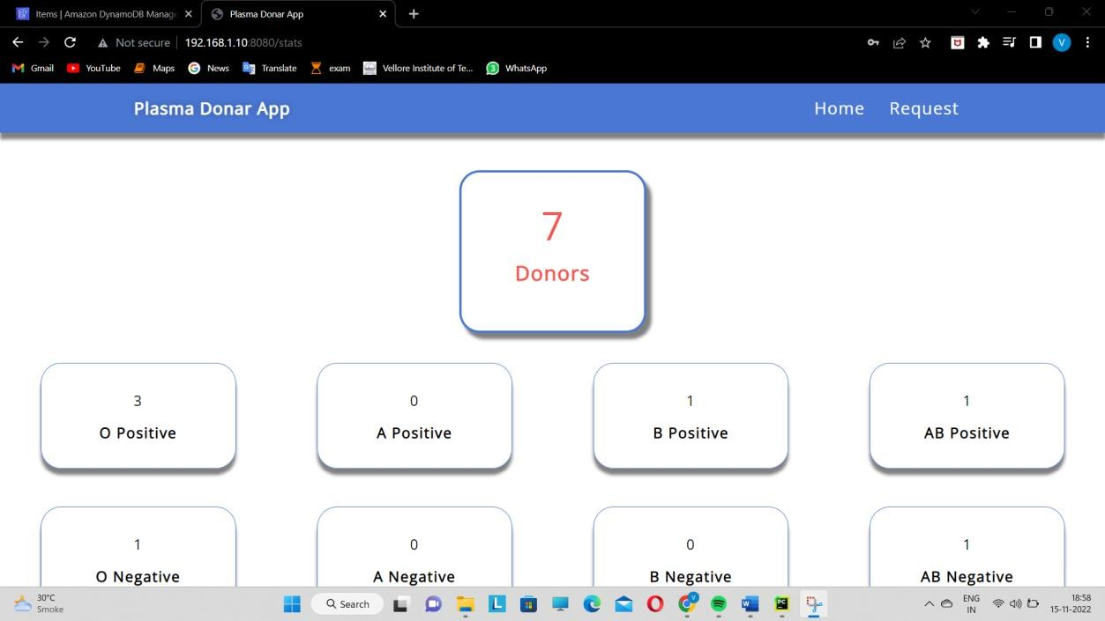

# REQUEST

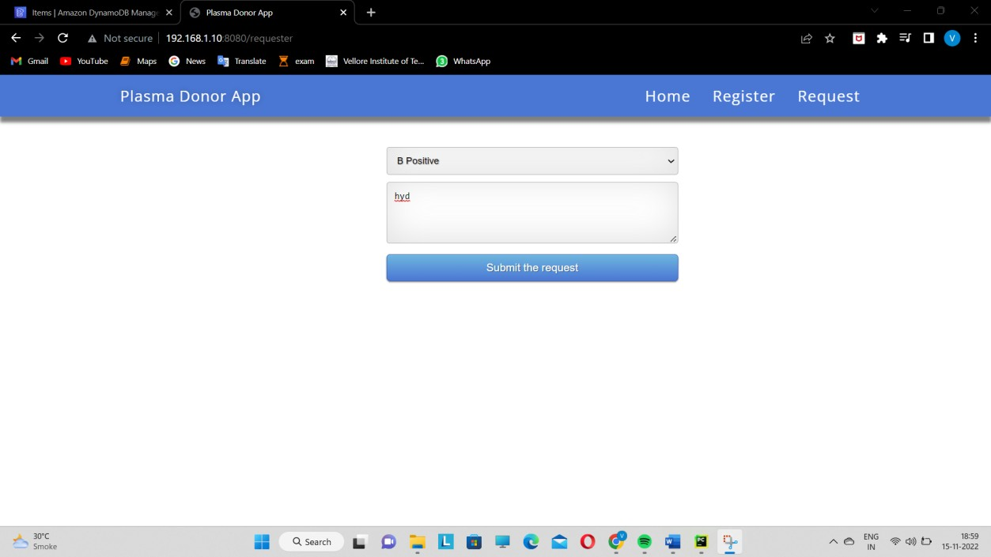

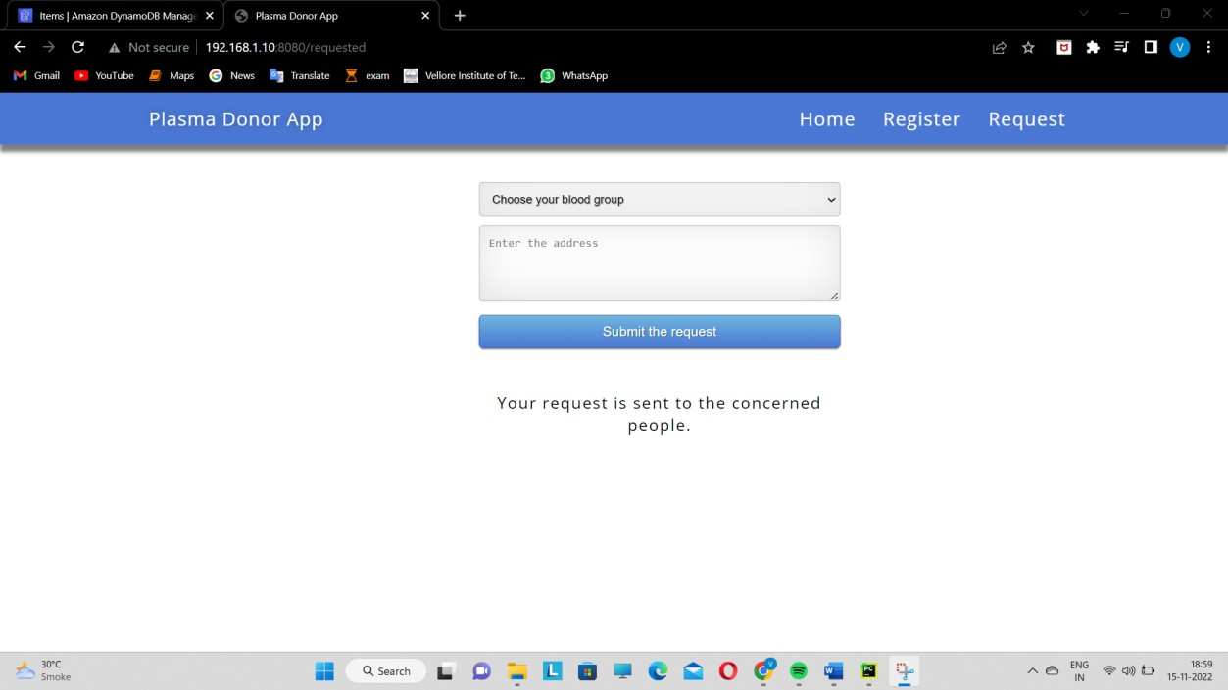

**ANALYSIS:**

**ADVANTAGES:**

* Easy to find plasma donors
* Easy to tack donors and acceptors number
* Availability of specific blood group donors
* Easy to manage

**DISADVANTAGES:**

* If in the wrong hands, privacy issues arise.
* Black marketing of plasma via some organization can also be done
* Lack of reliability in information’s provided by donors

# CONCLUSION:

When someone starts the app, we ask them to sign up with their name, email and basic information covid infection status, blood group, contact details which will be proved helpful in plasma donation. We maintain these records on our dashboard with blood groups and with the no. of donors available. Where the other users can also login and see the donor’s availability. Those in need can contact these available donors via their contact details.

# FUTURE WORK:

We can improve the user interface of the application and increase the size of the database. We can also check number of successful plasma donation and patient’s recovery. We can also increase database to store worldwide information. Using the information, we can find out the percentage of population recovered from covid19 and whether they are getting infected again or not and how long their immunity lasts. While the vaccination we can also maintain database and notify people when there is vaccine available in their locality.