**ASE STUDY:- ATM MACHINE AND SYSTEM**

**Class Diagram for ATM Machine**

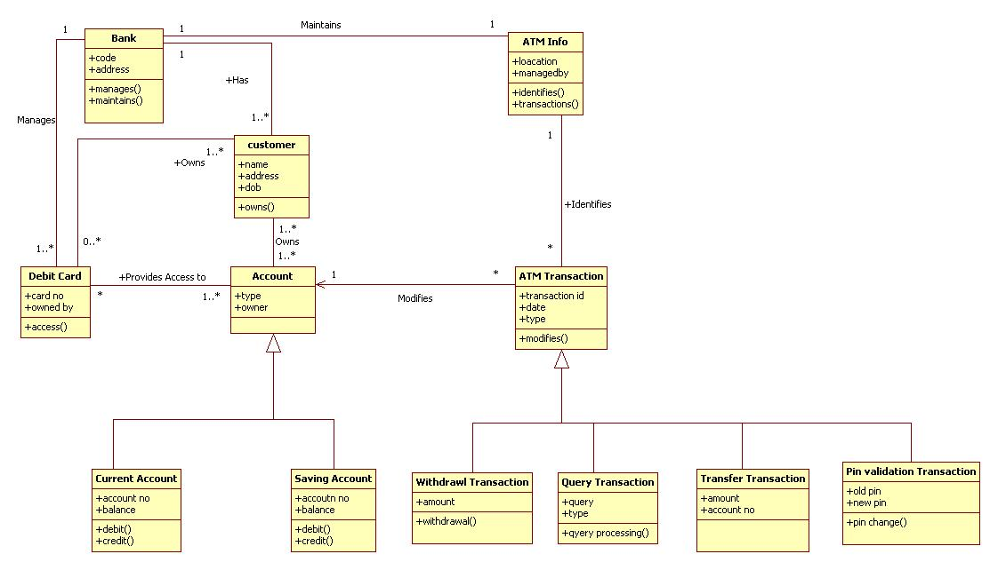

**Use Case Diagram ATM Machine**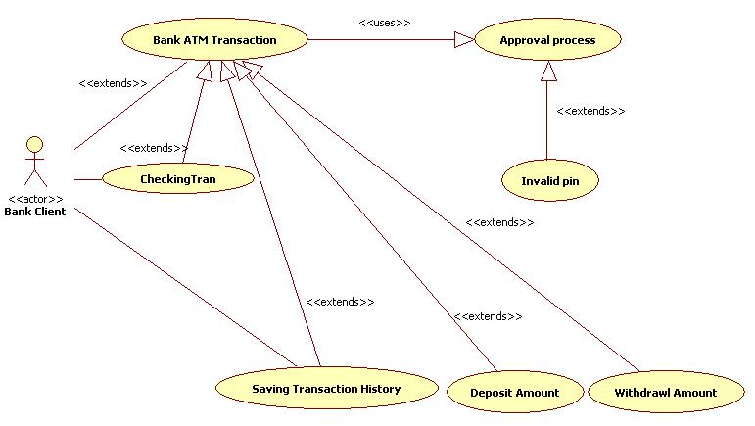

**Activity Diagram for ATM Machine 1**

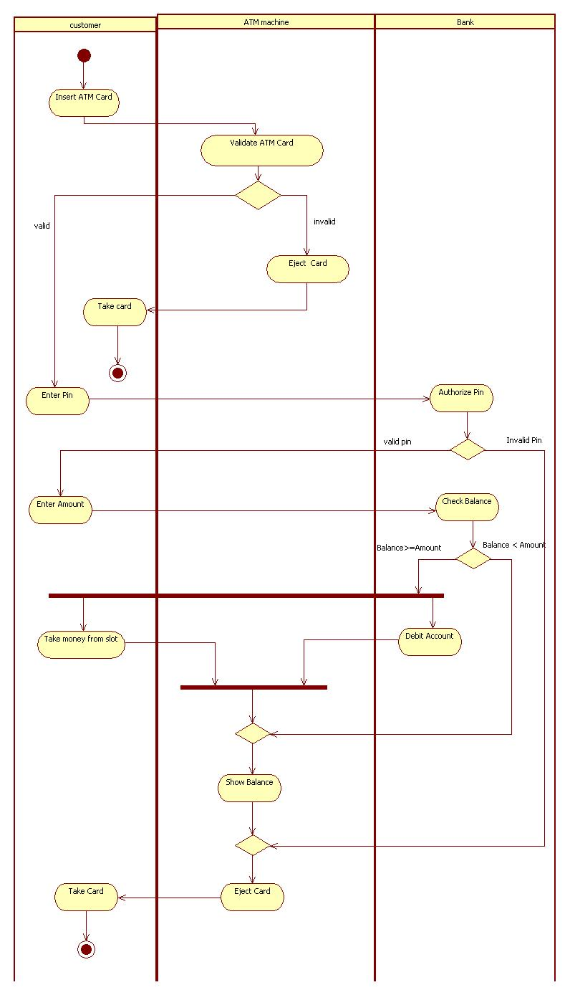

**Activity Diagram for ATM Machine 2**

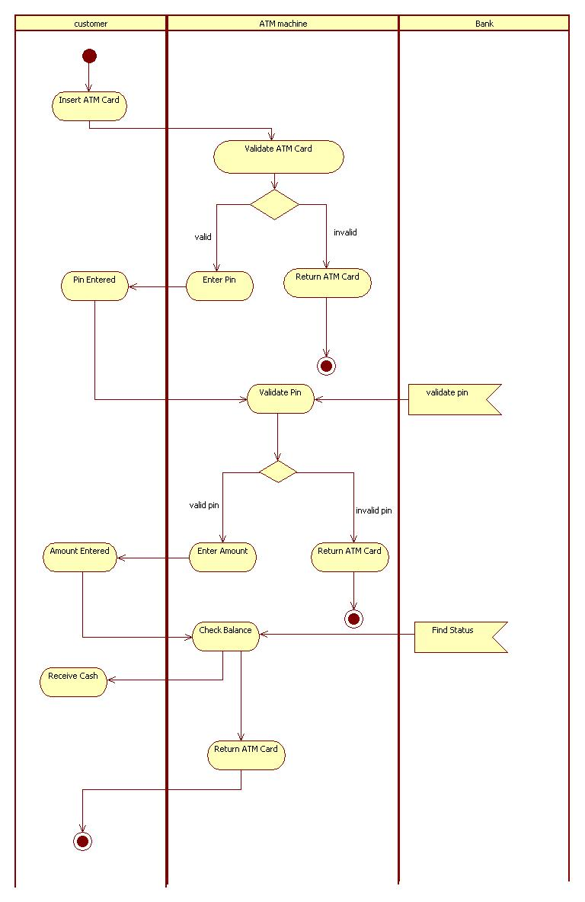

**Activity Diagram for Overall ATM Machine:-**

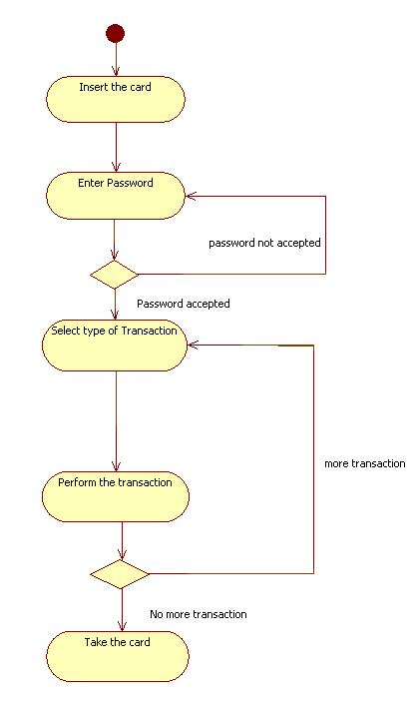

**Activity Diagram Verify Password ATM Machine:-**

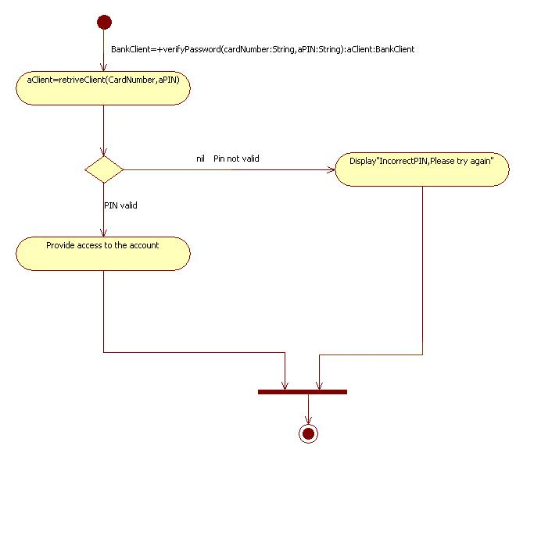

**Sequence Diagram for ATM Machine :-**

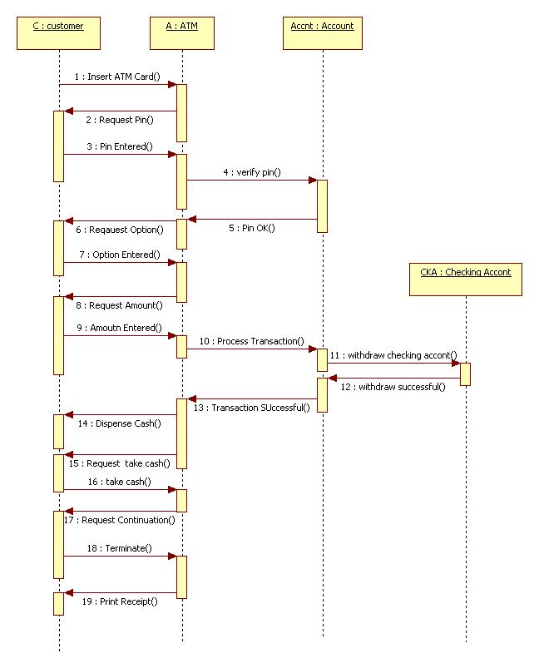

**Sequence Diagram for Invalid Pin ATM Machine:-**

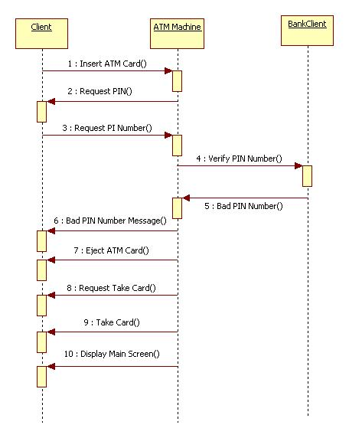

**Sequence Diagram ATM withdrawal:-**

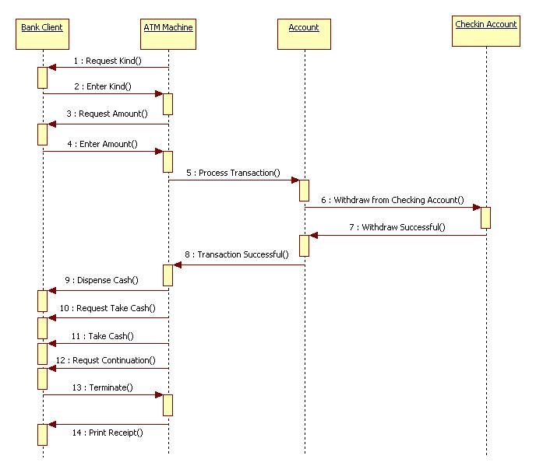

**Collaboration Diagram For ATM machine:-**

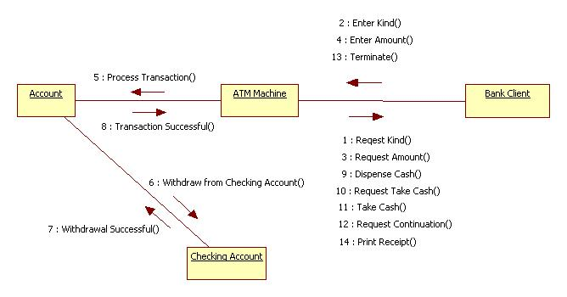

**Collaboration Diagram for ATM withdrawal :-**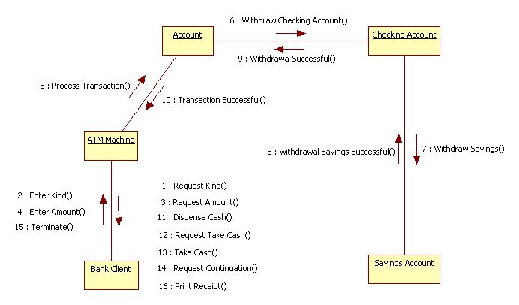

**State Diagram for One Transaction ATM machine:-**

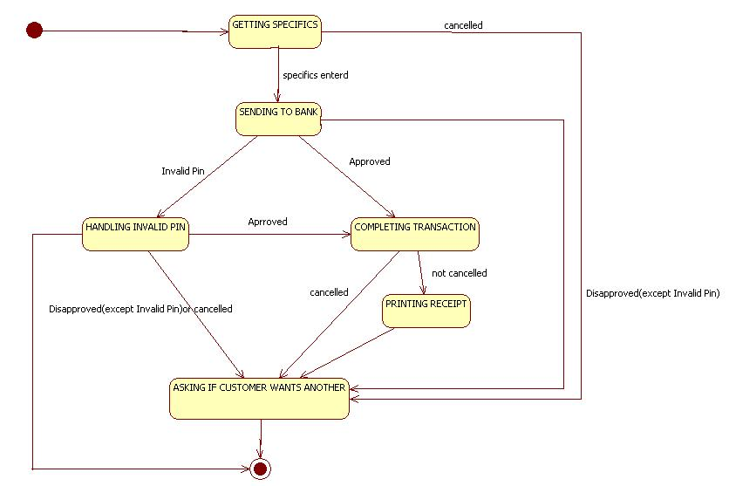

**State Diagram one Session ATM Machine:-**

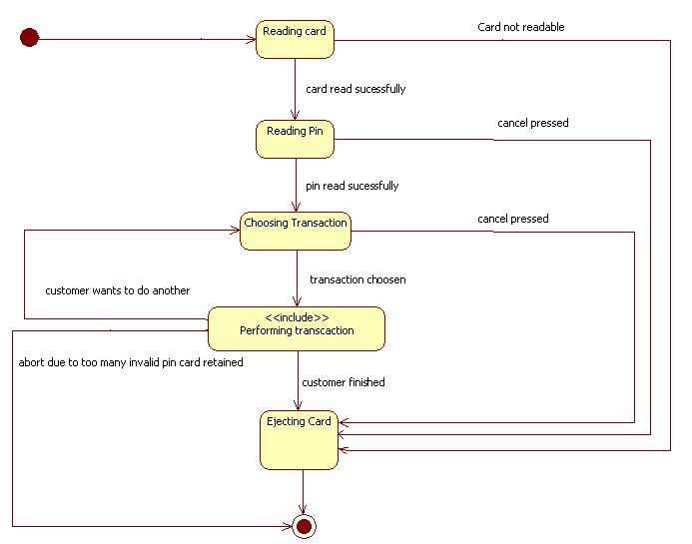

**Component Diagram ATM Machine:-**

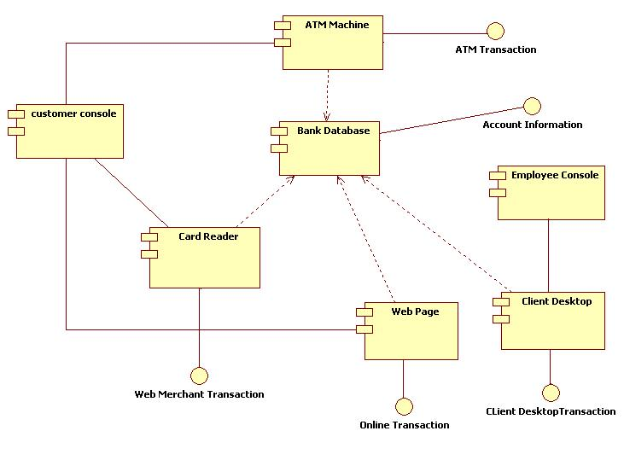

**Deployment Diagram ATM Machine :-**

