**CASE STUDY: Library Management System.**

**Use Case Diagram:- Library Management System**

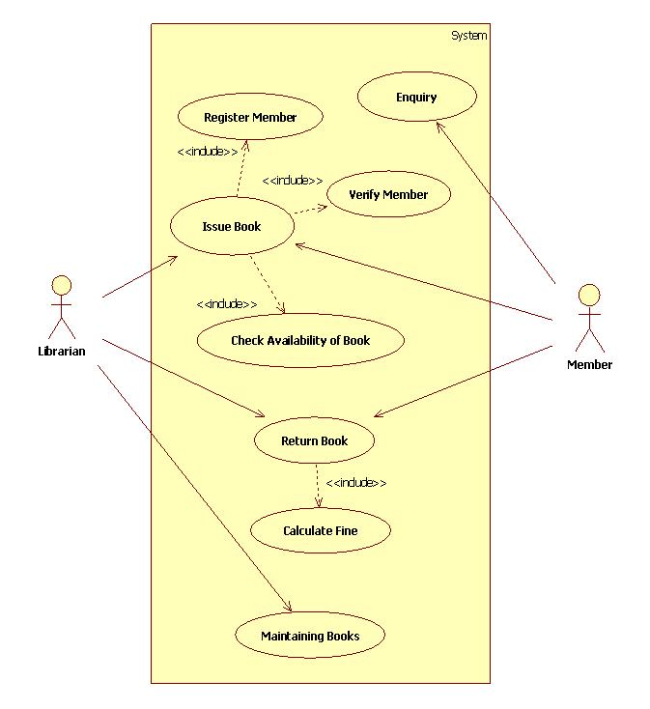

**Activity Diagram for Issue Book in Library :-**

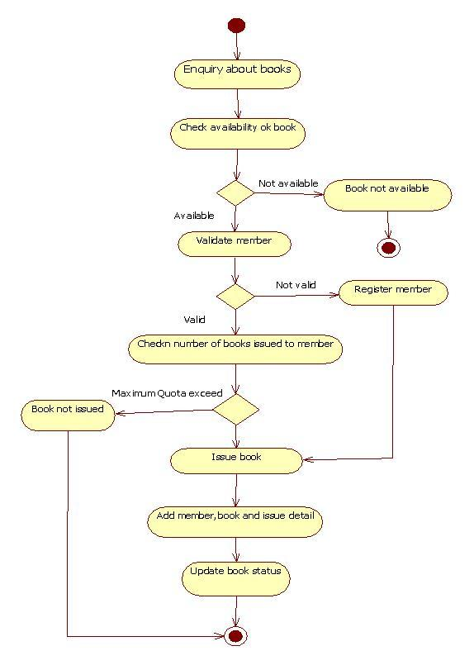

**Activity Diagram for Return Book in Library:-**

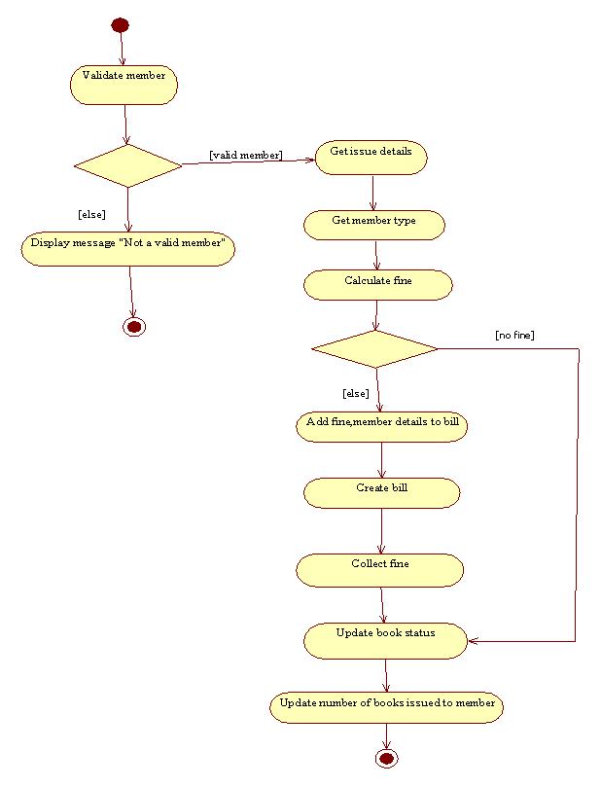

**Class Diagram for Library System:-**

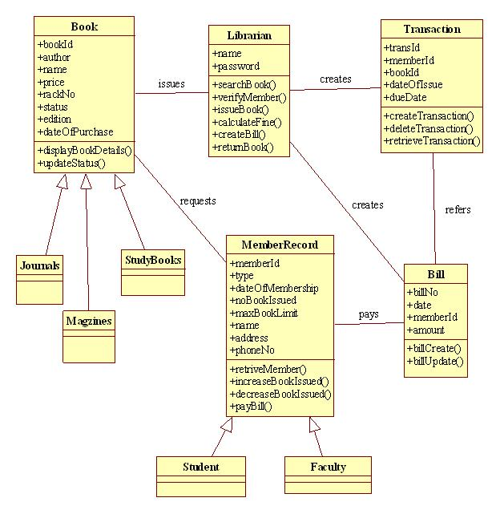

State diagram for Book:

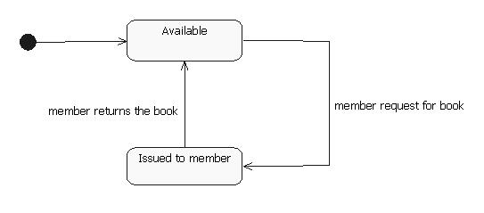

State diagram for Librarian:

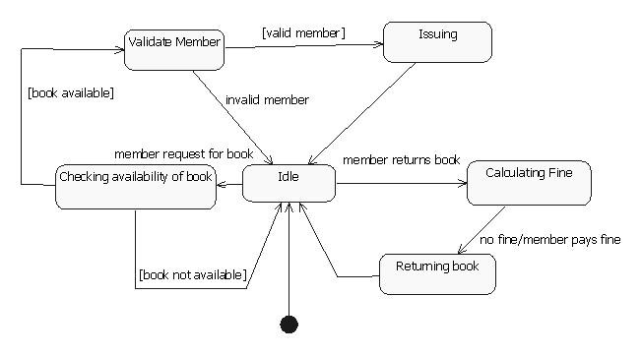

Collaboration diagram for issuing Book:

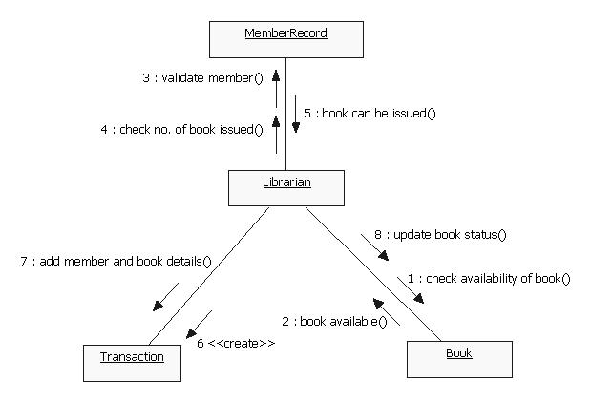

Collaboration diagram for returning Book:

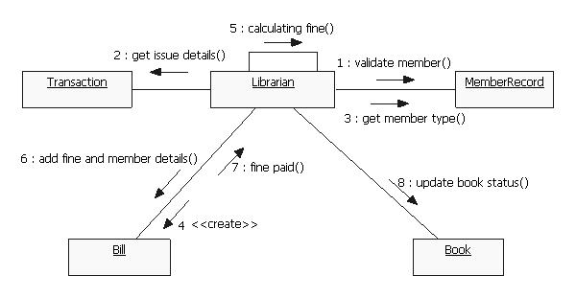

Sequence diagram for issuing book:

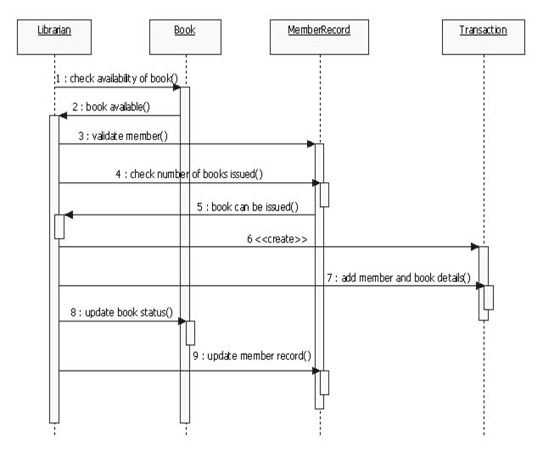

Sequence diagram for returning book:

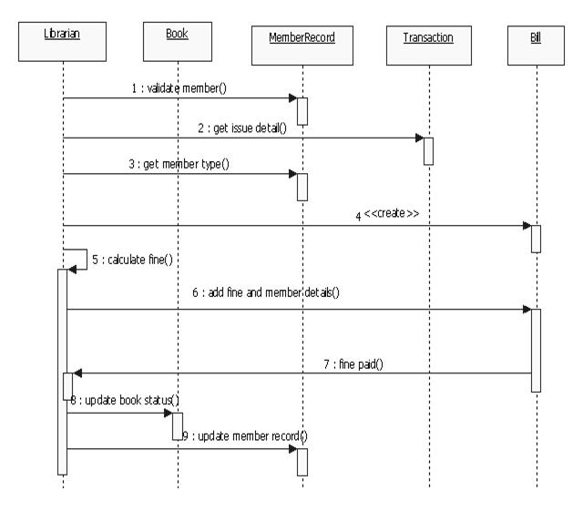

Component diagram for Library Management System:

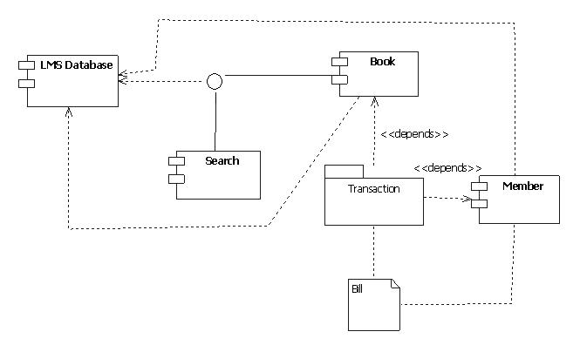

**Deployment Diagram for Library management system:-**

[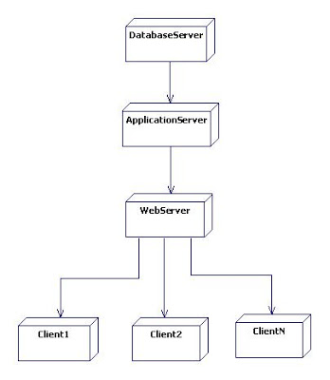](http://4.bp.blogspot.com/-7OQ7xLXBIuo/T26v4Ja_AeI/AAAAAAAAAM0/B3t8eaSGJ_4/s1600/uml+deployment+diagram+for+library+mgmt.JPG)