|  |  |  |
| --- | --- | --- |
| **SRNO** | **TITLE** | **PAGE NUMBER** |
| **1** | **INTRODUCTION** | **4** |
|  | **1.1 ORGANIZATION PROFILE** | **4** |
|  | **1.2 SYSTEM DETAILS** | **4** |
|  | **1.2.1 CURRENT SYSTEM** | **4** |
|  | **1.2.2 PROPOSED SYSTEM** | **4** |
|  | **1.3 SCOPE** | **5** |
|  | **1.4 OBJECTIVE** | **5** |
| **2** | **REQUIREMENT GATHERING** | **6** |
|  | **2.1 STAKEHOLDER** | **6** |
|  | **2.2 REQUIREMENT GATHERING TECHINIQUE USED** | **7** |
|  | **2.4 PROJECT DEFINATION** | **8** |
| **3** | **PROJECT MANAGEMENT AND PLANNING** | **8** |
|  | **3.1 FEASIBLITY STUDY** | **9** |
|  | **3.1.1 TECHNICAL STUDY** | **9** |
|  | **3.1.2 ECONOMICAL STUDY** | **9** |
|  | **3.1.3 OPERATIONAL STUDY** | **10** |
|  | **3.2 HARDWARE SOFTWARE REQUIREMENT** | **10** |
|  | **3.3.1 WORK BREAKDOWN STRUCTURE** | **11** |
|  | **3.3.2 GANNT CHART** | **11** |
|  | **3.4 PROCESS MODEL** | **11** |
| **4** | **ANALYSIS AND DESIGN** | **13** |
|  | **4.1 UML DIAGRAM** | **13** |
|  | **4.2 SYSTEM FLOW DIAGRAM** | **22** |
|  | **4.3 DATA DICTIONARY** | **24** |
|  | **4.4 USER INTERFACE** | **31** |
| **5** | **SUMMARY** | **40** |
|  | **5.1 ASSUMPTION** | **40** |
|  | **5.2 LIMITATIONS** | **40** |
|  | **5.3 CONCLUSION** | **40** |
|  | **5.4 FUTURE SCOPE** | **40** |
|  | **BIBLIOGRAPHY** | **41** |

**Project title: Progress Report Generation**

**(By Semester:- 5th of T.Y. M.Sc(2018-19)**

|  |  |
| --- | --- |
| **Student Name** | **Roll No** |
| 1. **Nikita Gupta** | **3030** |
| 1. **Hetvee Shah** | **3061** |
| 1. **Vidhi Shah** | **3070** |

**Project Guide:**

**Name of Company/Institutuin: Maths Academy**

**Date of Submission:**

**Submitted to K.S.School Of Business Management**

**M.Sc In Computer Application and International Technology**

**Acknowledgment**

The success and the final outcome of this project required a lot of guidance and assistance from many people and we are extremely fortunate to have got this all for our project work. Whatever we have done is only due to such guidance and assistance and we would not forget to thank them.

We respect and thankful to K.S.School of Business Management for giving us an opportunity to do the project work and providing us all support ad guidance which make us completes the project on time. We are extremely thankful to project guide for providing such a nice support and guidance through she had busy schedule.

We would like to express our grateful towards Course coordinator Department and our project for their kind co-operation and encouragement , which helped us in this project.

|  |
| --- |
| **CHAPTER 1:**  **INTRODUCTION** |

* 1. **ORGANISATIONAL PROFILE:**

**NAME :** MATHS ACADEMY

**ADDRESS :** 31 SANGATHAN SOCIETY

OPPOSITE SUNRISE PARK NEAR HIMALAYA MALL

DRIVING ROAD,

AHMEDABAD,

INDIA 380061

**CONTACT :** 093270 70815

**ABOUT :**



* **MATHS ACADEMY** is an institute which provides coaching for all the subjects of classes 8th to 12th.
* This institute is specialist in CBSE board only.
* The teaching staff over here are highly experienced,result oriented and has proven track records of delivering top rankers from various CBSE schools of Ahmedabad over a decade.
* This institute provide large variety of learning environment and learning spaces.
* The institute endeavour to inculcate three important principles – Discipline, Dedication and Determination – popularly known as 3D's among our students.
* The institute strive to instil a spirit of excellence and self-confidence in each and every student. It is known for its quality mentoring, skilled teaching methodology, authenticity and sheer dedication.
* Year after year they have brought excellent results in all the subjects for students in classes 8th to 12th of C.B.S.E. This has led to a strong brand equity among students and their guardians.
* The students develop excellent time management skills and build basic fundamentals after studying from our institute. This enables them to bear the rigors of preparation for their competitive examinations.

**1.2 SYSTEM DETAIL**

**1.2.1 Current System:**

Currently no such system exists for Maths Academy.Currently they are keeping records manually of each student.

* + 1. **Proposed System:**
* Progress report of student result analysis and time table generation .This project is mainly to reduce manual work.
* In progress report of student generates the report according to student roll-no,batchwise,standardwise,attendance details and marks.
* Record can be edited as per requirements.
* Time table generation will generate time table without overlapping any details like subject details,faculty details,batch details and time slots.It may possible that two classes are allocated to same classrooms to manage such things.A lot of human power is wasted so this software is used to overcome such type of conflicts.
* In attendance management module both the entries and view of student attendance details can be done.All the details are taken from excel sheet,details will be checked and after that it will be added to database and message will be displayed.
* Management can send SMS to one student, to a group or to whole batch.
* Transparency in the institute.
* Keep all the records at one place and easy to maintain and update the record.
* Defines course details like course streams .
* Get details of every test student wise, batch wise and date wise.
  1. **SCOPE**
* The scope of our system is very vast. It includes:efficiency of the institution,securing benefits in school through practical measures, co-ordination of educational programmes,sound educational planning,good direction,efficient and systematic execution.
* It provides close collaboration and sense of sharing responsibilities,organized purpose and dynamic approach.
* Any organization plays vital role in the life of human being.It plays different functions like brings efficiency,guide people to receive right direction from right teachers,enables the pupil to get profit from their learning,bring co-ordination of the student-teacher-parents-society.
* It provides well-defined policies and programs,favorable teaching learning situation,growth and development of students,make use of appropriate materials,arrangement of activities and efforts for attainment of the objectives
  1. **OBJECTIVE**

Now let us tell you about some main points of our objective of the system.

* + - 1. Provide registration channel to new users
* **Record-Keeping:-**
* The first objective of this system is to maintain the data of all the student and teacher in database.
* It maintains the personnel detail as well as the academic report of the student.
* It maintains student fee record and dues record.
* Teacher personnel record are also stored in the software.
* To have centralized control over the records of students, faculty and monitor changes in it.
* **Computerization:-**
  + All the details regarding institute,whether it is small or big,will be computerized .
  + No redundant data-as this system will be centralized,the chances of the duplicate data in the system are close to nil.
* **Automation:-**
* The automation feature of this system will mitigate the task of writing the papers for example,there is no need to write report card of the students on the paper.
* It is simply can be done online on the system,and can be forwarded to the students and there parents.
* **Easy interaction:-**
* In today’s rush hour of the life,it is difficult for a parent to go the institute of his/her child every time when teacher calls
* By this system it will be easier for a parent and teacher to be in touch everyday

|  |
| --- |
| **CHAPTER 2:**  PROPOSED SYSTEM REQUIREMENT GATHERING |

**2.1 STAKEHOLDERS OF SYSTEM**

**Stakeholders** can be defined as “anyone who has an interest in system to be built”.Stakeholders may include individuals and group of people who have some direct interest in success and welfare of educational system.This includes all parties that are directly affected by the success or failure of an educational system as well as those indirectly affected.

Following are the stakeholders of our system.

* Parents
* Faculties
* Administrators
* Professionals

1. **PARENTS:**

* Parents influence the implementation of the curriculum by playing a vital role in monitoring the lessons taught at institute,filling the gap between their children and institute administration by providing various resources which are not available in institute.
* Teachers often take help of parents for monitoring the social and behavioral development of a child especially for special educational needs.

1. **FACULTIES:**

* Faculties,as front line educators are at the heart of learning.Through their frequent contact with students they can better understand students learning needs.Faculty manages:
* Share their experiences in and advice on curriculum development,classroom instruction,student activity and educational enrichment.
* Provide professional expertise for improvement of student learning;and
* Serve as important link between parent and faculty.

1. **ADMINISTRATORS:**

* Administrators,who monitor the implementation of the curriculum,play a vital role in structuring and developing the institute and student.
* They are responsible for purchasing of learning material which are essential for curriculum implementation.
* They are usually informed by faculties,students about the success of their curriculum.

1. **PROFESSIONALS:**

* Phsycologist and social workers are known for their contribution towards special institutes and their children.
* This stakeholders provide useful options for dealing with students of foreign origin or those with disabilities.

Government and professional regulation commission are other stakeholders providing a licence to graduate of different institutes.

**2.2 REQUIREMENT GATHERING TECHNIQUES USED**

Requirement elicitation is the process to find out the requirements for a proposed system by communicating with student,faculties,admin and other who have stake in the system development.

There are various ways to discover requirements:

1. **Interviews :**

* Interviews are strong medium to collect requirements. Organizations may conduct several types of interviews such as:
  + Structured(closed) Interviews
  + Non-structured(open) Interviews
  + Oral Interviews
  + Written Interviews
  + One-to-one Interviews
  + Group Interviews

1. **Surveys :**

* Organizations may conduct surveys among various stakeholders by querying about their expectation and requirements from the upcoming system.

1. **Questionnaires :**

* A document with pre-defined set of objectives questions and respective options is handed over to all stakeholder to answer, which are collected and then compiled.
* A shortcoming of this technique is, if an option for some issue is not mentioned in the questionnaire, the issue might be left unattended.

1. **Task Analysis :**

* Team of engineers and developers may analyse the operation for which the new system is required. If the client already has some software to perform certain operation, it is studied and requirements of proposed system are collected.

1. **Domain Analysis :**

* Every software falls into some domain category. The expert people in the domain can be a great help to analyse general and specific requirements.

1. **Brainstorming :**
   * An informal debate is held among various stakeholders and all their inputs are recorded for further requirements analysis.
2. **Prototyping :**
   * Prototyping is building user interface without adding detail functionality for user to interpret the features of intended software product. It helps giving better idea of requirements.
   * The prototype is shown to the client and the feedback is noted. The client feedback serves as an input for requirement gathering.
3. **Observation :**
   * Team of experts visit the client’s organization or workplace. They observe the actual working of the existing installed systems. They observe the workflow at client’s end and how execution problems are dealt.
   * The team itself draws some conclusions which aid to form requirements expected from the software.

For our system we have used **Questionnaires**:

1.How your Front Page should look like?

Ans: It should provide Graphical user interface, extremely efficient

Systematic, sophisticated and yet automated system.

2.What is your current system for handling routine activities of your Institute?

Ans: Currently their is no such system but all the data’s of the

Institute are handled manually.

3.What problems you are facing with manual system?

Ans: It is time consuming and error prone. Hard to make changes Involves large amount of paper

work and keeping it safe. And the retrieval of information is difficult

4.What features you require in the system for institute?

Ans: To provide proper registration to new users, to make the Information accessible to admin in just

one click , to have Centralized control over the records of students, faculty and Monitor changes

in the records..

5.How skilled are the teachers?

Ans:They Know How To Learn The Application And Have overall knowledge..

**2.3 PROJECT DEFINATION**

Traditionally managing all the student data manually requires lot of human power and there by it leads to tedious task.Hence, our system resolves such kind of issues.Believe it or not the phase of education is changing or challenging rapidly with the growing and advance technology.

This software is very useful for students,parents,faculties as well as admins.In current system all the activities are done manually which consumes lot of time and it is less efficient.It has been developed with an idea of “Technology alone isn’t going to improve student achievements but it is the combination of faculties who are working along with the technology to render and engage students.”It provides common platform for student-faculties-parents for complete guidance and attention on their child.

We introduce a new software product for handling activities that are taking place inside the institute. It is a software product to automate and log on to day to day activities and to provide instantaneous information required in effective manner. The automation part involves data capture and maintenance of details in the institute.

|  |
| --- |
| **CHAPTER 3:**  **SYSTEM MANAGEMENT AND PLANNING** |

**3.1 FEASIBILITY STUDY**

A feasibility study is carried out to select the best system that needs performance requirements.

The main aim of the feasibility study activities to determine whether it would be financially and technically feasible to develop the system.The feasibility study activity involves the analysis of the problem and collection of all the relevant information related to the system such as different types of data to be input in the system,the process require to carried out on this data,the output that is require to be produced by the system as well as various constraints of the system.

**3.1.1 TECHNICAL FEASIBILITY**

The technical feasibility study compares the level of technology available in the software development firm and level of technology required for the development of the system. Here, the level of technology consist of programming language , the software resources other software tools etc. Internet is required to run the system. The main concern it to specify the equipments and the software to satisfy the user requirements.

Our system consists of :-

* The facility to produce output in given time.
* Response time under certain condition.
* Facility to communicate data to distant location.
* It just require window operating system and the normal browser to use our system.
* In examining the technical feasibility, the configuration of the system is given more importance than the actual hardware.

So that we can easily say that our system is technically feasible.

This system is technically feasible as it doesn’t required any other additional hardware or software to be installed and can easily workable with normal hardware and software.

**3.1.2 ECONOMIC FEASIBILITY**

The economic feasibility study evaluate the cost of software development against the ultimate income or benefits gets from the developed systems.There must be scope for profit after the successful completion of the project.

Economic analysis is the most frequently used technique for evaluating the effectiveness of a proposed system. More commonly known as Cost / Benefit analysis, the procedure is to determine the benefits and savings that are expected from a proposed system and compare them with costs.

* Our system is not much costly to develop.
* It is easy to use and understand thereby there is no need to appoint any operator to use the system.
* Organization is ready to invest in proposed system because it is being developed in latest technology and will be very easy for the users to view the information of the system.

The system being developed is economic with respect to institution point of view. It is cost effective in the sense that has eliminated the paper work completely. The system is also time effective because the calculations are automated which are made at the end of the month or as per the user requirement.

The result obtained contains minimum errors and are highly accurate as the data is required.

**3.1.3 OPERATIONAL FEASIBILITY**

Operational feasibility is the measure of how well a proposed system solves the problem,and take the advantage of opportunities identified during scope definition and how it satisfies the requirements identified during the requirements analysis phase of system development.

**3.2 HARDWARE-SOFTWARE REQUIREMENT**

**Software Requirement**

**Hardware Requirement**

**3.3 SYSTEM PLANNING**

**3.3.1 System BreakDown Structure**

**3.3.2 GANNT Chart**

|  |  |  |  |  |  |
| --- | --- | --- | --- | --- | --- |
| **Activities** | **July** | **August** | **September** | **October** | **November** |
| **Project Scope** |  |  |  |  |  |
| **Research** |  |  |  |  |  |
| **Requirement Gathering** |  |  |  |  |  |
| **Analysis** |  |  |  |  |  |
| **Designing** |  |  |  |  |  |

**3.4 PROCESS MODEL**

We would be following the incremental model because the nature of the system as the requirements are not complete.Many features can be added after the development of the system that serves the main purpose.The hardware we use is little expensive for prototyping so we go iteration by iteration and develop the final product.

*INCREMENTAL MODEL*

* This model is more flexible-less costly to change scope and requirements
* It is easier to test and debug during a smaller iteration.
* In this model user can respond to each built.
* We can get our users respond and can change according to their requirements. Rather than other model here users have exact idea about their proposed system. In other models users get their system at last so we can’t know whether our customer is satisfied or not. Here we’re constantly in touch with user. This model provides higher user satisfaction.
* Lower initial delivery cost.
* Easier to manage risk because risky pieces are identified and handled during each iteration.

**Why it is suitable for our system?**

* **Requirements for the system are clear.**
* **New technologies is being used.**
* **There is need to get the project in the market quickly.**

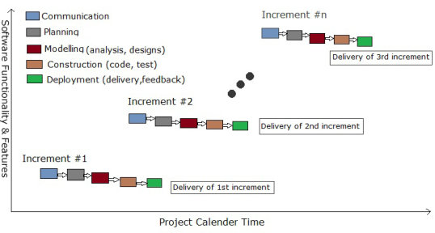

In our system at every stage we are incrementing our system

First we designed for the common functionality of the user or student like their personal details, subjects and batches.

As the project progresses ahead we further added the functionality of notice , assignments, daily work to be embedded in the system.

As sms and emails about students results, test schedule, holidays have also been developed for the same.

In each and every stage we are incrementing our system to make it more ease of use and user friendly .

We have also developed back up of our previous data and it generates result of the entire month for the particular student.

|  |
| --- |
| **CHAPTER-4**  **SYSTEM ANALYSIS AND DESIGN** |

**4.1 UML/DFD**

**USECASE FACULTY::**

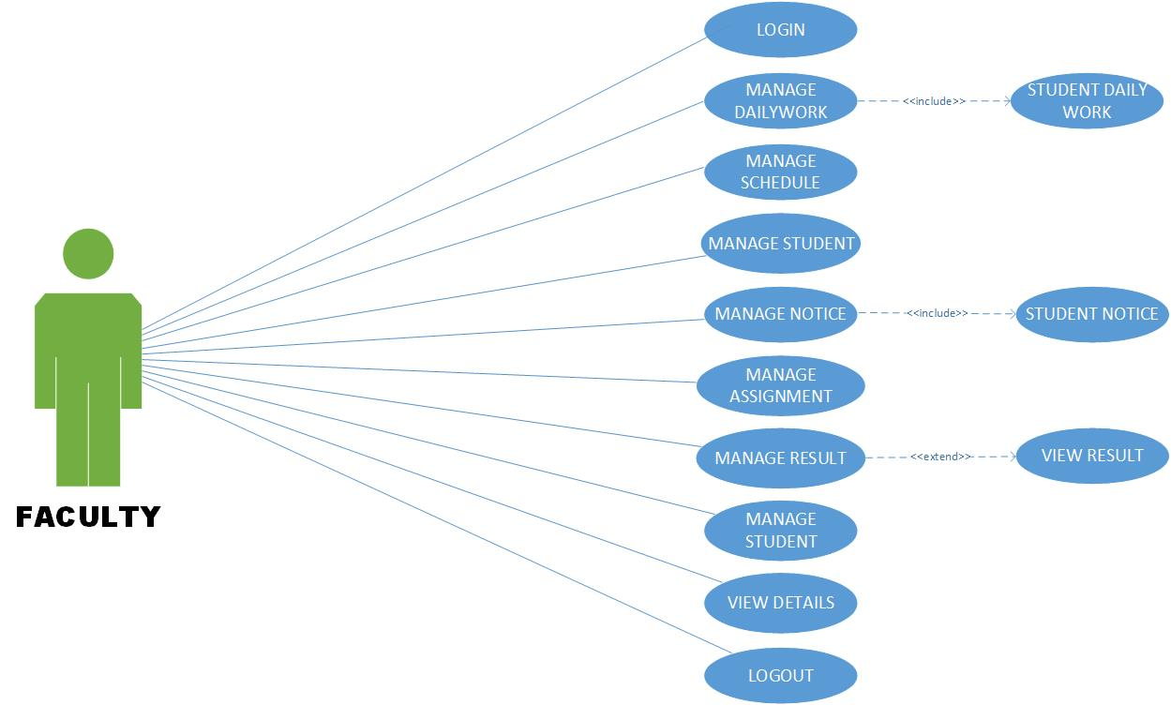

**USECASE STUDENT::**

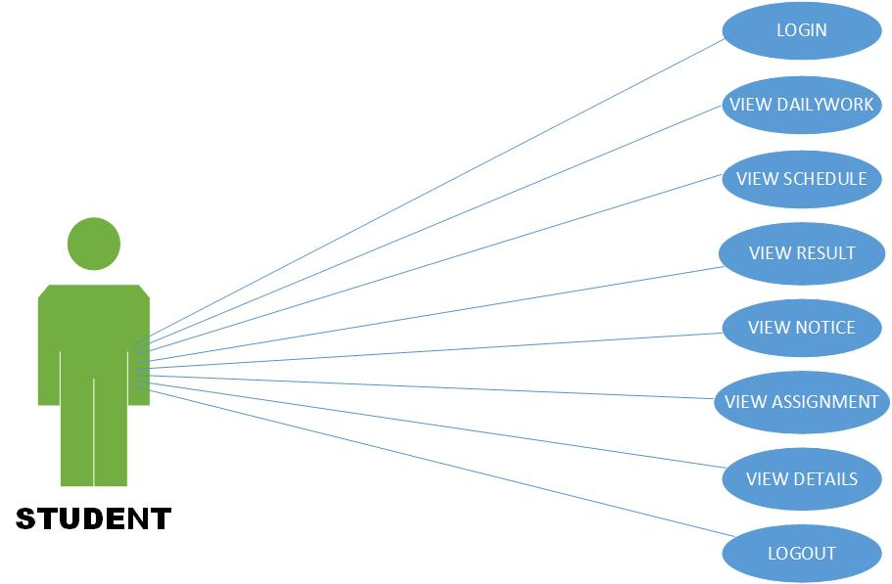

**COMMON USECASE::**

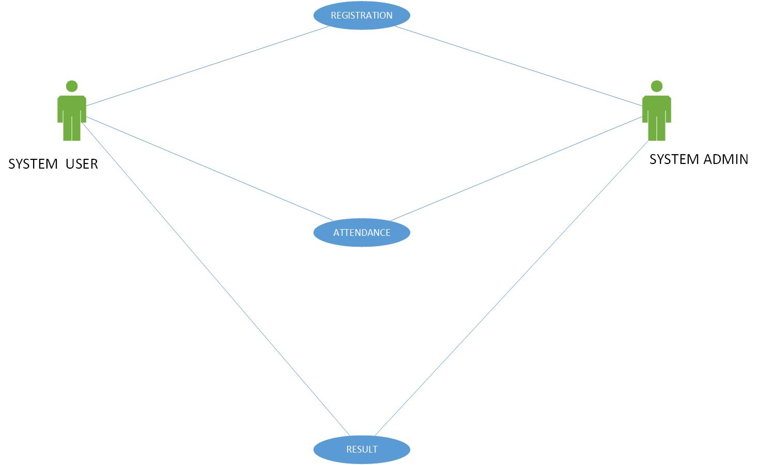

**SEQUENCE ADMIN::**

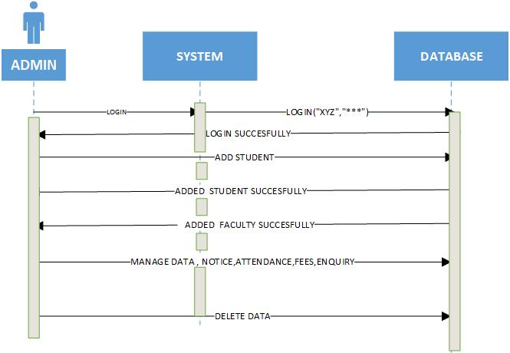

**SEQUENCE DIAGRAM:-**



**SEQUENCE FACULTY:**

Untitled Diagram.png

**ACTIVITY DIAGRAM::**

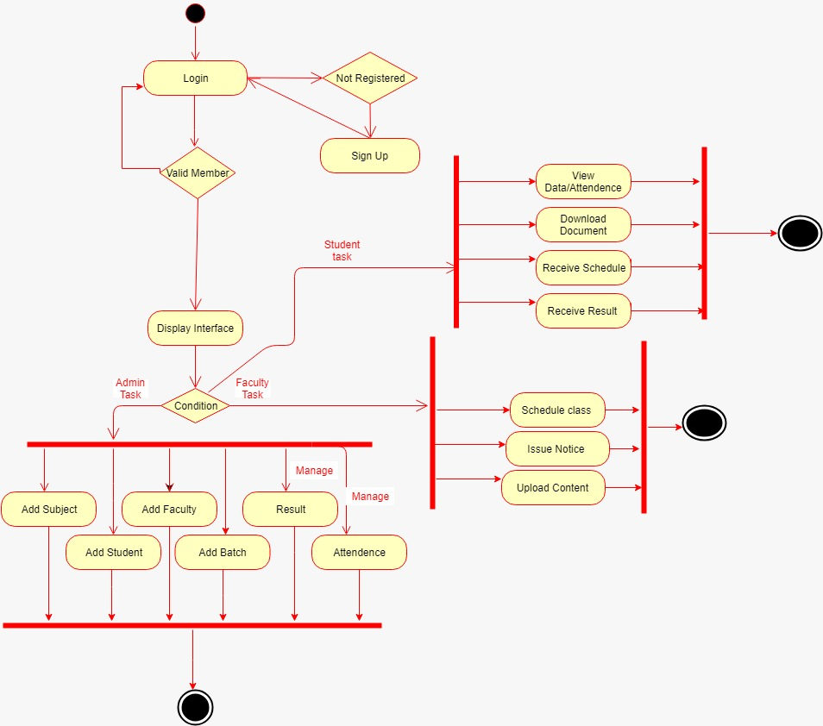

**CLASS DIAGRAM::**

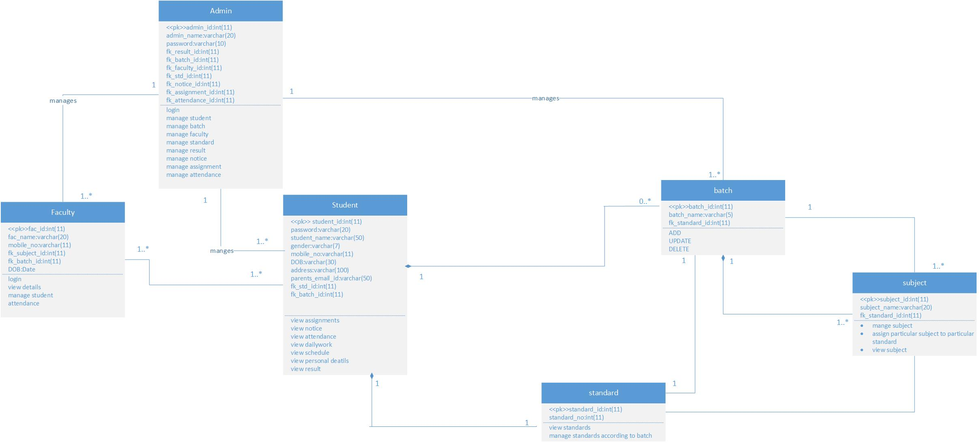

**STUDENT STATE DIAGRAM::**



**ADMIN STATEDIAGRAM::AdminState.png**

**4.2 SYSTEMFLOW DIAGRAM::**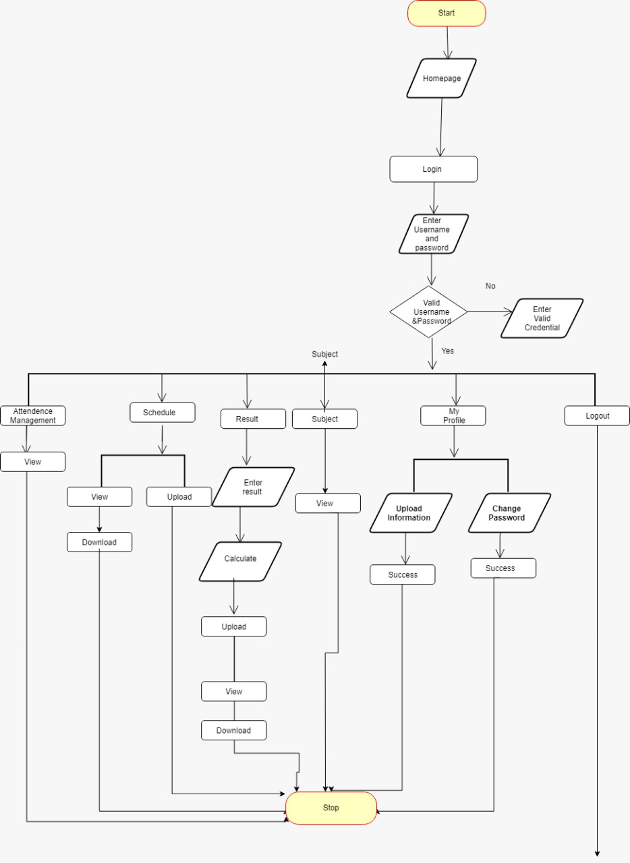

**DEPLOYMENT DIAGRAM**

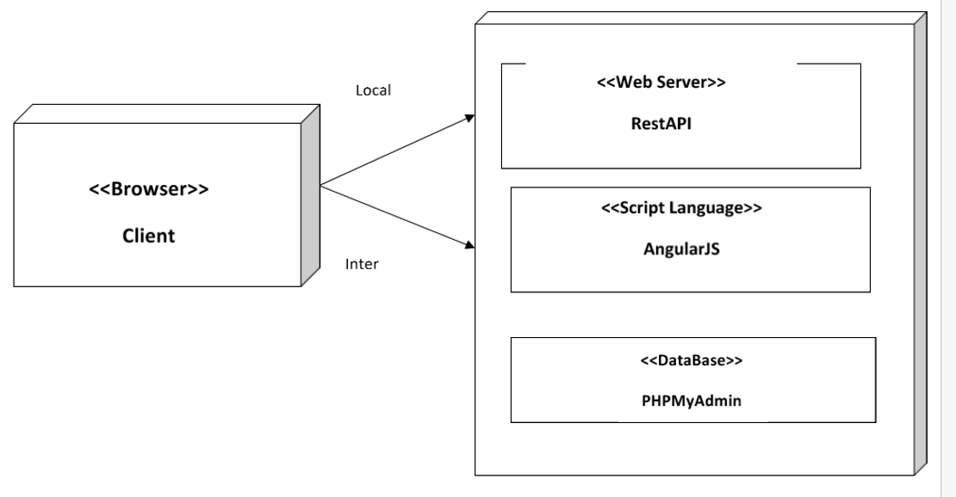

**4.3 DATA-DICTIONARY**

**BATCH**

|  |  |  |  |  |
| --- | --- | --- | --- | --- |
| **FIELD** | **DATA TYPE** | **CONSTRAINS** | **REMARK** | **DECSCRIPTION** |
| batch_id | INTEGER(11) | PRIMARY KEY | AUTO INCREMENT | Batch Id which defines particular batch |
| batch_name | VARCHAR(50) | - | - | Name Of the batch |
| fk_standard_id | INTEGER(11) | FOREIGN KEY | - | Reference of the standard ID of standard table |

**RESULT**

|  |  |  |  |  |
| --- | --- | --- | --- | --- |
| **FIELD** | **DATA TYPE** | **CONSTRAINS** | **REMARK** | **DESCRIPTION** |
| res_id | INTEGER(11) | PRIMARY KEY | AUTO INCREMENT | ID that identifies result of particular student |
| fk_student_id | INTEGER(11) | FOREIGN KEY | - | Refrence of the student ID of student table |
| fk_batch_id | INTEGER(11) | FOREIGN KEY | - | Reference of the Batch ID of Batch Table |
| fk_standard_id | INTEGER(11) | FOREIGN KEY | - | Reference of the Standard ID of Standard Table |
| res_status | VARCHAR(20) | - | - | RESULT STATUS defines whether student is present or absent |
| remarks | VARCHAR(50) | - | - |  |
| Fk_exam_attid | INTEGER(11) | FOREIGN KEY | - | Reference of exam attendance ID from exam attendance table |
| fk_subject_id | INTEGER(11) | - | - | Reference of the subject ID of Subject table |
| Grade | STRING(20) | - | - | Garde obtained by student |
| Total | INTEGER(11) | - | - | Total marks obtained by student |

**ATTENDANCE**

|  |  |  |  |  |
| --- | --- | --- | --- | --- |
| **FIELD** | **DATA TYPE** | **CONSTRAINS** | **REMARKS** | **DESCRIPTION** |
| attendance_id | INTEGER(11) | PRIMARY KEY | AUTO INCREMENT | Attendance ID which identifies attendance of particular Student |
| fk_student_id | INTEGER(11) | FOREIGN KEY | - | Reference of student ID of student table |
| fk_batch_id | INTEGER(11) | FOREIGN KEY | - | Reference of Batch ID of batch table |
| attendance_date | DATE | - | - | Attendance date of particular day |
| Attendance_status | VARCHAR(20) | - | - | Attendance status defines whether student is present or absent |
| fk_faculty_id | INTEGER(11) | FOREIGN KEY | - | Reference of faculty ID of faculty table |

**ASSIGNMENT**

|  |  |  |  |  |
| --- | --- | --- | --- | --- |
| **FIELD** | **DATA TYPE** | **CONSTRAINS** | **REMARKS** | **DECSRIPTION** |
| assignment_id | INTEGER(11) | PRIMARY KEY | AUTO INCREMENT | Assignment ID which identifies particular assignment |
| assignment_title | VARCHAR(50) | - | - | Heading of the assignment |
| Image | VARCHAR(50) | - | - | Image of the assignment subject wise |
| fk_subject_id | INTEGER(11) | FOREIGN KEY | - | Reference of the Subject ID of Subject Table |
| fk_standard_id | INTEGER(11) | FOREIGN KEY | - | Reference of the Standard ID of Standard Table |
| fk_batch_id | INTEGER(11) | FOREIGN KEY | - | Reference of the Batch Table |

**FACULTY**

|  |  |  |  |  |
| --- | --- | --- | --- | --- |
| **FIELD** | **DATA TYPE** | **CONSTARINS** | **REMARKS** | **DESCRIPTION** |
| faculty_id | INTEGER(11) | PRIMARY KEY | AUTO INCREMENT | Faculty ID identifies particular faculty |
| faculty_name | VARCHAR(30) | - | - | Name of the faculty |
| mobile_no | INTEGER(11) | - | - | Mobile Number of the faculty |
| fk_subject_id | INTEGER(11) | - | - | Reference of the Subject Id of Subject Table |
| fk_batch_id | INTEGER(11) | - | - | Reference of the Batch Id of the Batch Table |
| qualification | VARCHAR(50) | - | - | Qualification of the faculty |
| DOB | DATE | - | - | Date of birth of the faculty |
| experience | INTEGER(11) | - | - | Experience of faculty in particular institute for appropriate subject |

**STANDARD**

|  |  |  |  |  |
| --- | --- | --- | --- | --- |
| **FIELD** | **DATA TYPE** | **CONSTRAINS** | **REMARKS** | **DECRIPTION** |
| standard_id | INTEGER(11) | PRIMARY KEY | AUTO INCREMENT | ID for the particular standard |
| standard_no | INTEGER(11) | - | - | Particular standard |

**SCHEDULE**

|  |  |  |  |  |
| --- | --- | --- | --- | --- |
| **FIELD** | **DATA TYPE** | **CONSTRAINS** | **REMARKS** | **DESCRIPTION** |
| schedule_id | INTEGER(11) | PRIMARY KEY | AUTO INCREMENT | Schedule ID which identifies particular Schedule for particular day |
| schedule_date | DATE | - | - | Date which identifies schedule for particular day |
| fk_faculty_id | INTEGER(11) | FOREIGN KEY | - | Reference of the Faculty ID of faculty table which identifies which faculty posted particular schedule for srudents |
| fk_subject_id | INTEGER(11) | FOREIGN KEY | - | Reference of the Subject ID of Subject Table |
| fk_batch_id | INTEGER(11) | FOREIGN KEY | - | Reference of Batch ID of the Batch Table |
| Course | VARCHAR(100) | - | - | Corse defines how much course in appropriate subject |

**SUBJECT**

|  |  |  |  |  |
| --- | --- | --- | --- | --- |
| **FIELD** | **DATA TYPE** | **CONSTRAINS** | **REMARKS** | **DESCRIPTION** |
| subject_id | INTEGER(11) | PRIMARY KEY | AUTO INCREMENT | Unique ID for particular subject |
| subject_name | VARCHAR(20) | - | - | Appropriate name of subject |
| fk_standard_id | INTEGER(11) | FOREIGN KEY | - | Reference of Standard ID of Standard Table |
| fk_faculty_id | INTEGER(11) | FOREIGN KEY | - | Reference of Faculty ID of Faculty Table |

**STUDENT**

|  |  |  |  |  |
| --- | --- | --- | --- | --- |
| **FIELD** | **DATA TYPE** | **CONSTRAINS** | **REMARKS** | **DESCRIPTION** |
| student_id | INTEGER(11) | PRIMARY KEY | AUTO INCREMENT | ID of particular student |
| student_name | VARCHAR(30) | - | - | Name of the student |
| password | VARCHAR(10) | - | - | Password of the student for login |
| Gender | VARCHAR(10) | - | - | It defines whether student is male or female |
| mobile_number | INTEGER(11) | - | - | Mobile number of student’s parent |
| DOB | DATE | - | - | Date of birth of the student |
| Address | VARCHAR(100) | - | - | Address of the student |
| parent_email_id | VARCHAR(20) | - | - | Email-ID of the parent for giving student’s information |
| fk_standard_id | INTEGER(11) | FOREIGN KEY | - | Reference of the Standard ID of the Standard Table |
| fk_batch_id | INTEGER(11) | FOREIGN KEY | - | Reference of the Batch ID of the Batch Table |

**LOGIN**

|  |  |  |  |  |
| --- | --- | --- | --- | --- |
| **FIELD** | **DATA TYPE** | **CONSTRAINS** | **REMARKS** | **DESCRIPTION** |
| login_id | INTEGER(11) | PRIMARY KEY | AUTO INCREMENT | Unique ID for Login |
| Password | VARCHAR(10) | - | - | Appropriate password for login |
| Type | VARCHAR(10) | - | - | Login type whether he is faculty/student/admin |

**NOTICE**

|  |  |  |  |  |
| --- | --- | --- | --- | --- |
| **FIELD** | **DATA TYPE** | **CONSTARINS** | **REMARKS** | **DESCRIPTION** |
| notice_id | INTEGER(11) | PRIMARY KEY | AUTO INCREMENT | Unique ID for the appropriate notice |
| notice_name | VARCHAR(30) | - | - | Defines name of the notice |
| notice_description | VARCHAR(100) | - | - | Defines details of the notice |
| notice_date | DATE | - | - | Date of the notice |
| fk_batch_id | INTEGER(11) | FOREIGN KEY | - | Reference of the Batch ID of Batch Table |
| fk_standard_id | INTEGER(11) | FOREIGN KEY | - | Reference of the Standard ID of Standard Table |
| fk_faculty_id | INTEGER(11) | FOREIGN KEY | - | Reference of Faculty ID from Faculty Table |
| fk_subject_id | INTEGER(11) | FOREIGN KEY | - | Reference of Subject ID of Subject table |

**DAILYWORK**

|  |  |  |  |  |
| --- | --- | --- | --- | --- |
| **FIELD** | **DATA TYPE** | **CONSTRAINS** | **REMARKS** | **DESCRIPTION** |
| dailywork_id | INTEGER(11) | PRIMARY KEY | AUTO INCREMENT | Unique ID for daily work |
| dailywork_date | DATE | - | - | Date of the daily work for particular day |
| Image | VARCHAR(50) | - | - | Image of the daily work |
| Title | VARCHAR(20) | - | - | Title for daily work |
| fk_standard_id | INTEGER(11) | FOREIGN KEY | - | Reference of Standard ID of Standard Table |
| fk_subject_id | INTEGER(11) | FOREIGN KEY | - | Reference of Subject ID of Subject Table |
| fk_batch_id | INTEGER(11) | FOREIGN KEY | - | Reference of Batch ID of Batch Table |

**EXAM**

|  |  |  |  |  |
| --- | --- | --- | --- | --- |
| **FIELD** | **DATA TYPE** | **CONSTRAINS** | **REMARKS** | **DESCRIPTION** |
| exam_id | INTEGER(11) | PRIMARY KEY | AUTO INCREMENT | Unique ID for Exam table |
| exam_date | DATE | - | - | Appropriate exam date |
| exam_time | VARCHAR(10) | - | - | Timing for exam |
| fk_subject_id | INTEGER(11) | - | - | Reference of subject ID from subject table |
| fk_batch_id | INTEGER(11) | - | - | Reference of batch ID from batch table |

**EXAM ATTENDANCE**

|  |  |  |  |  |
| --- | --- | --- | --- | --- |
| **FIELD** | **DATA TYPE** | **CONSTRAINS** | **REMARKS** | **DESCRIPTION** |
| exam_attid | INTEGER(11) | PRIMARY KEY | AUTO INCREMENT | Unique ID for Exam Attendance table |
| status | VARCHAR(8) | - | - | Student status for absent/present |
| fk_exam_id | INTEGER(11) | - | - | Reference of exam ID from exam table |
| fk_student_id | INTEGER(11) | - | - | Reference of student ID from student table |

**4.4 USER INTERFACE**

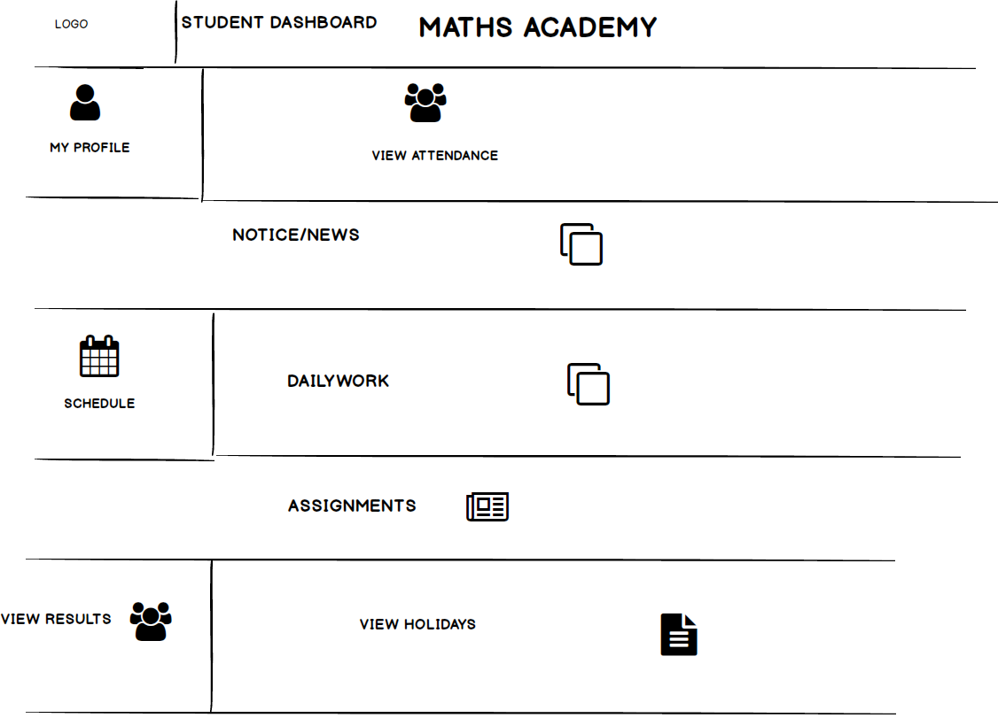

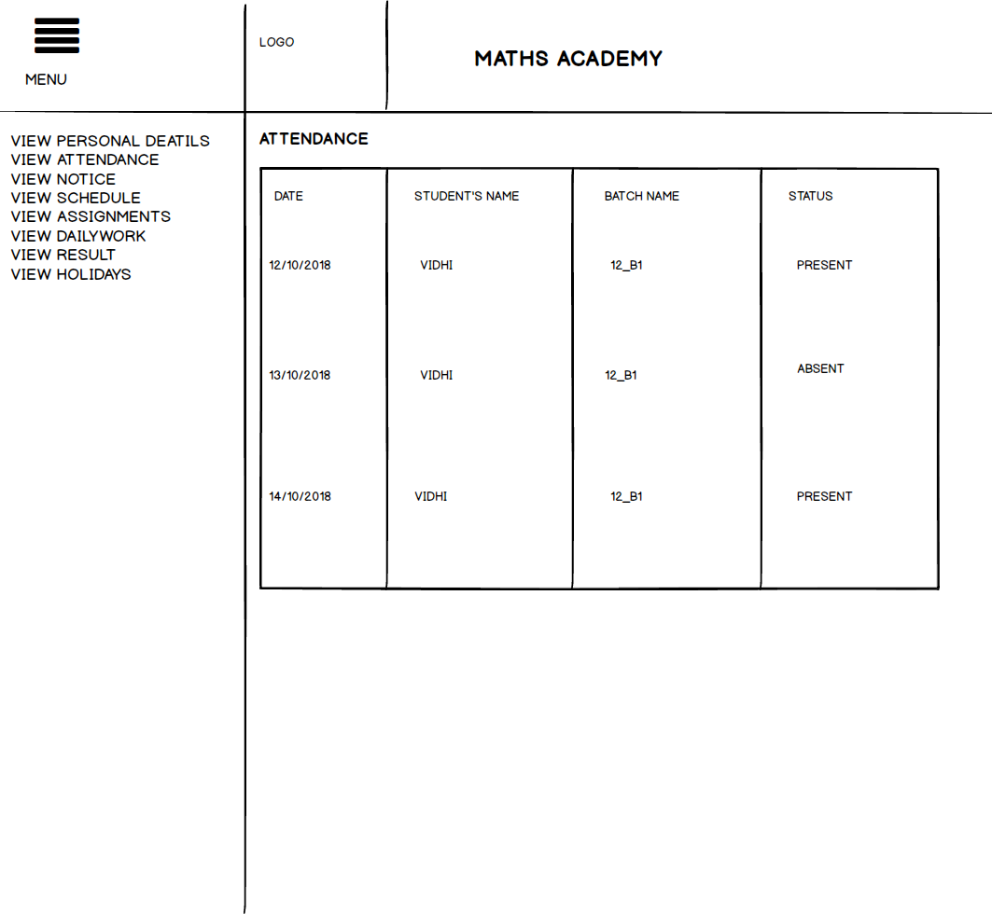

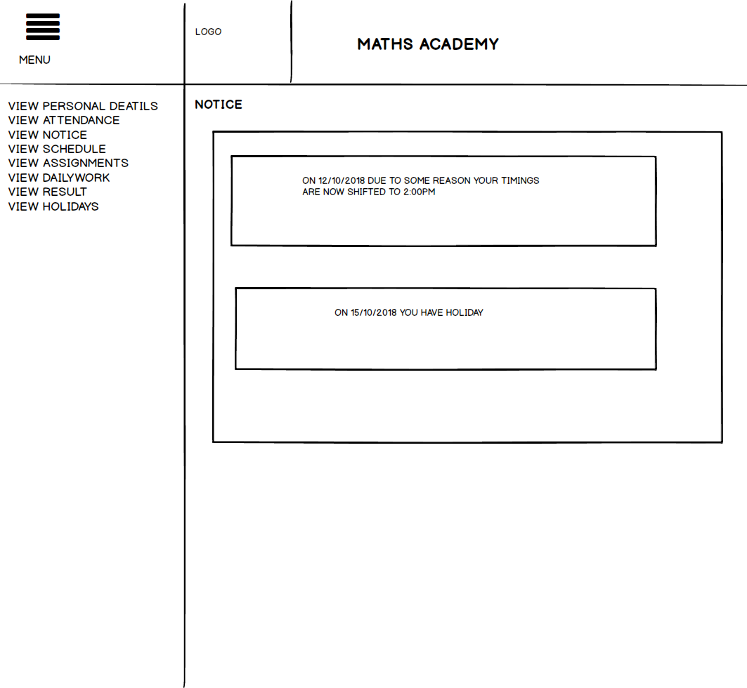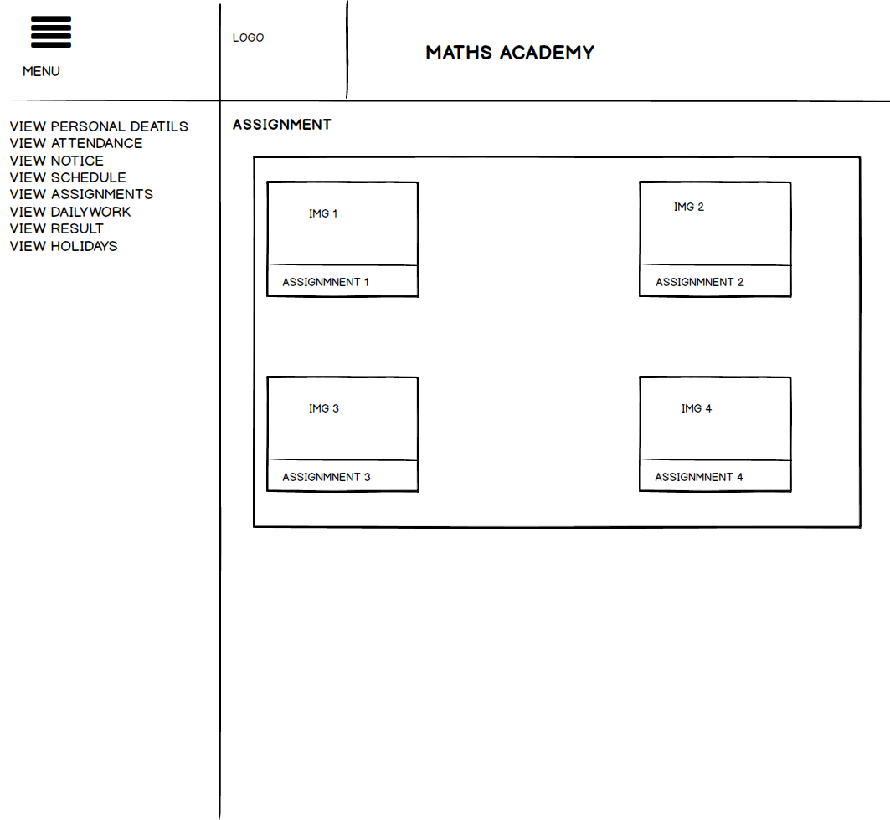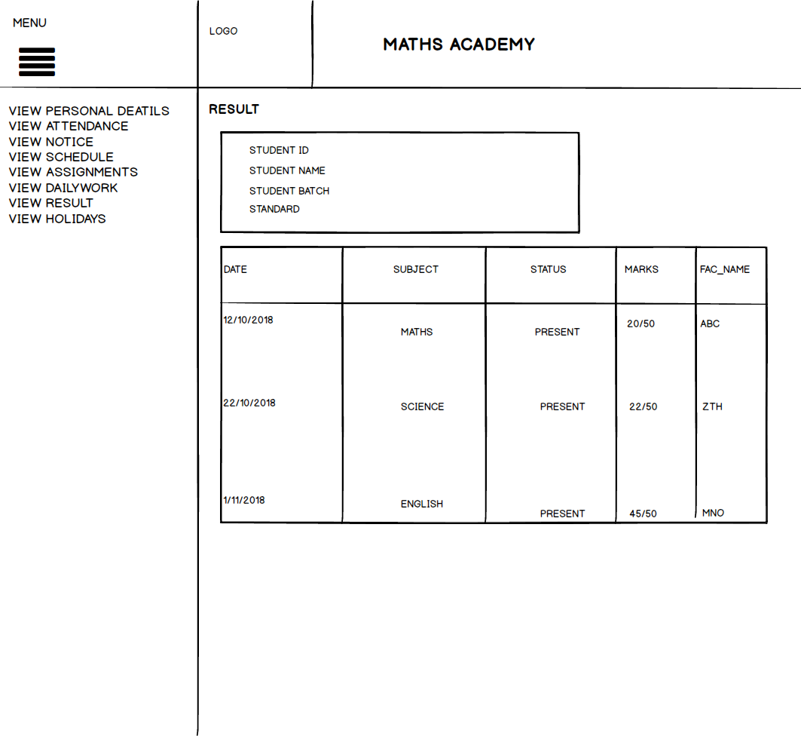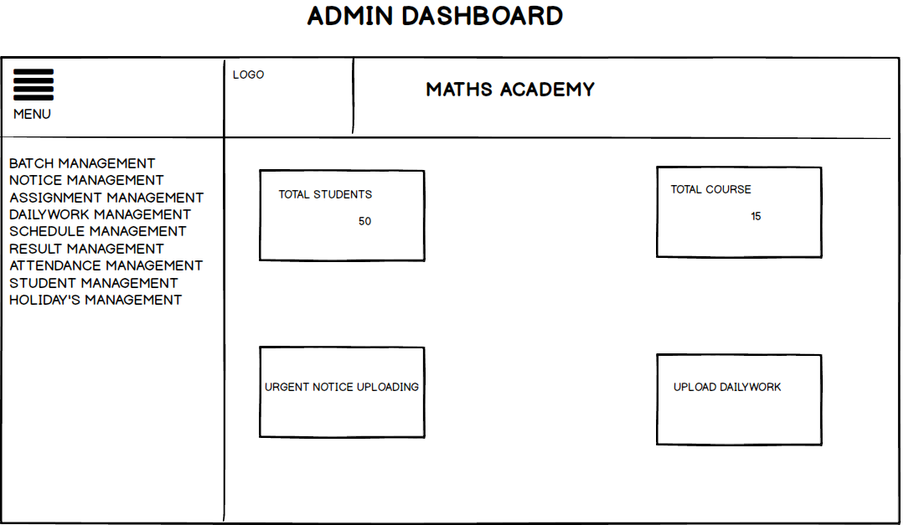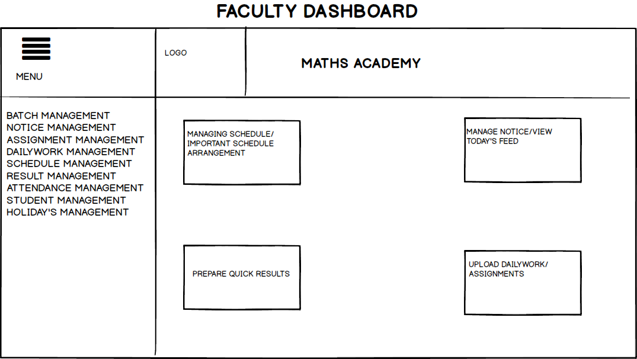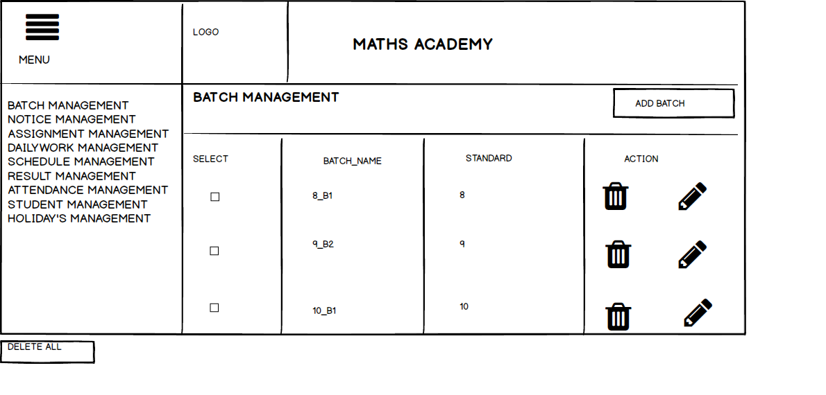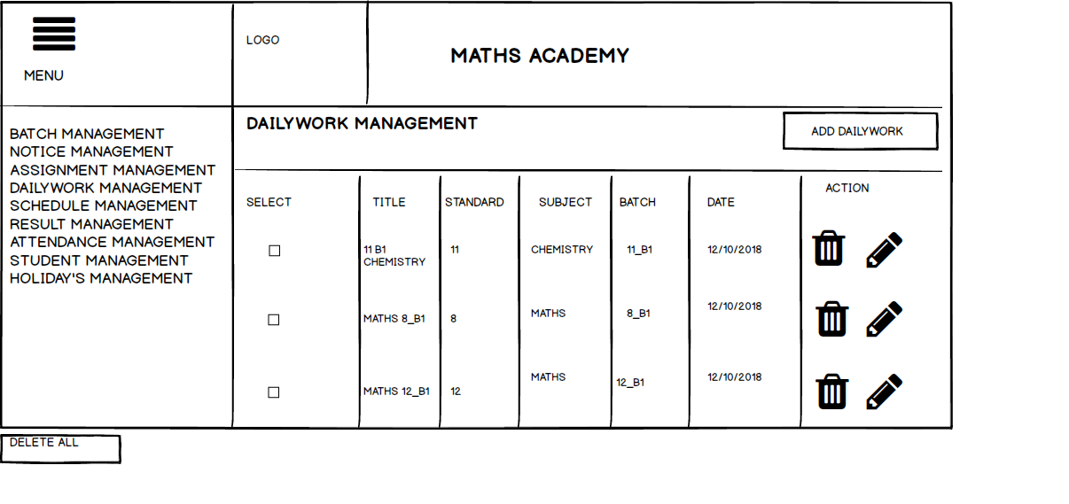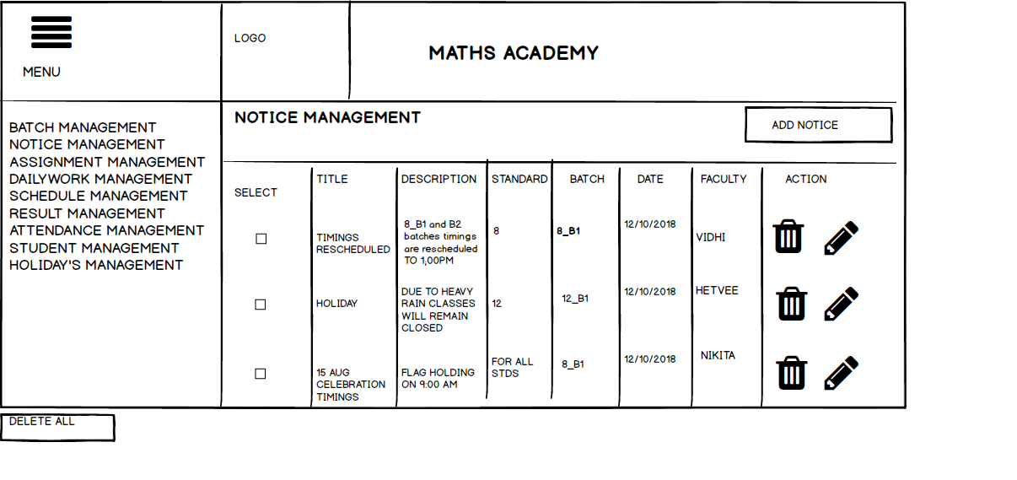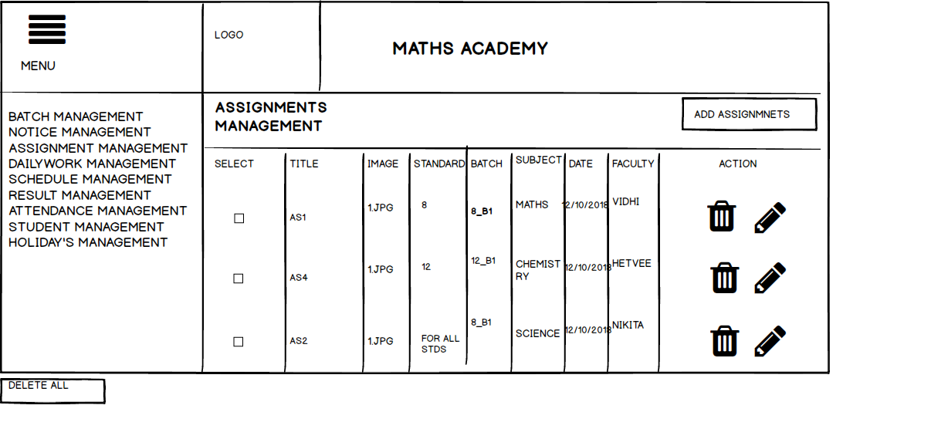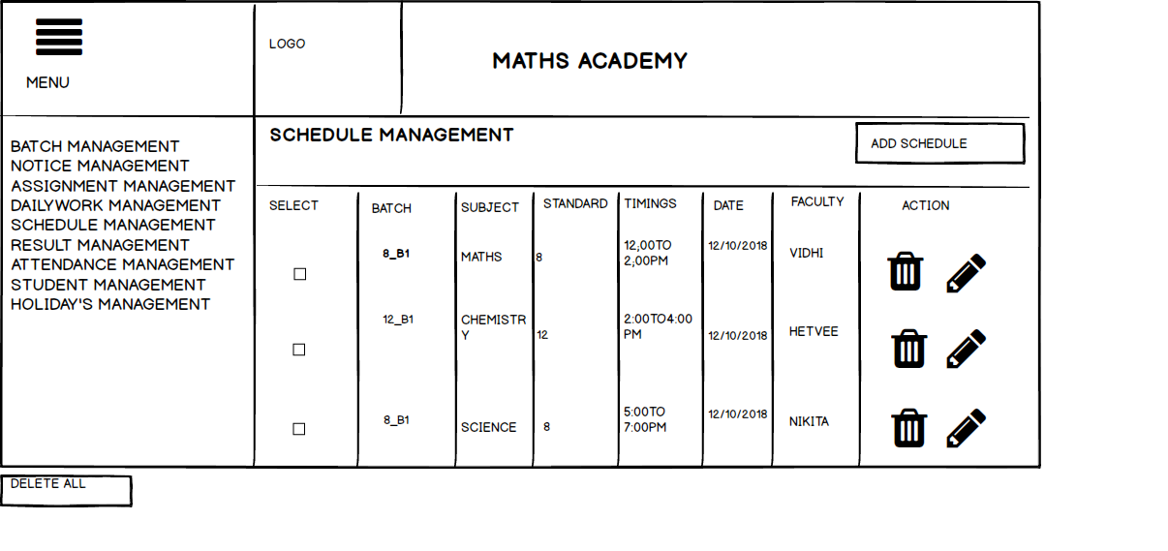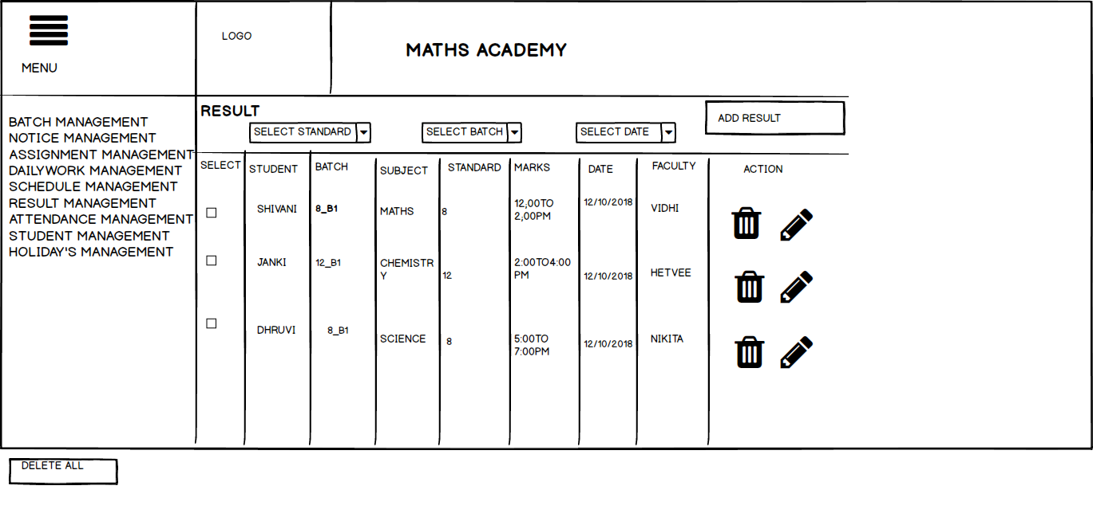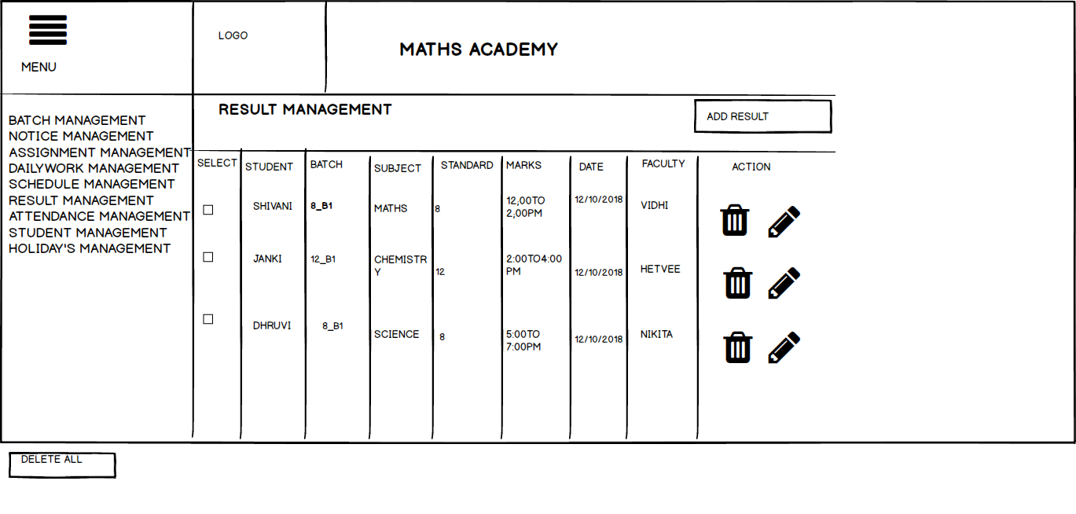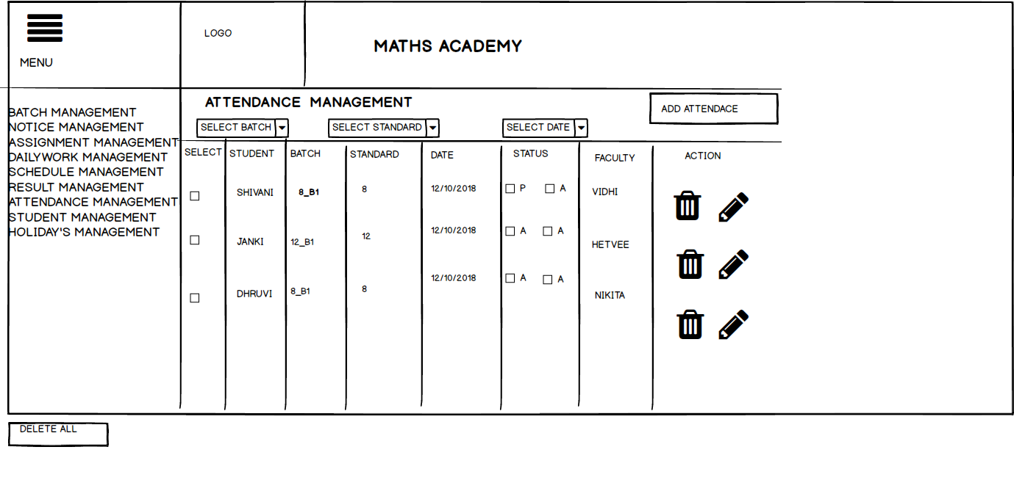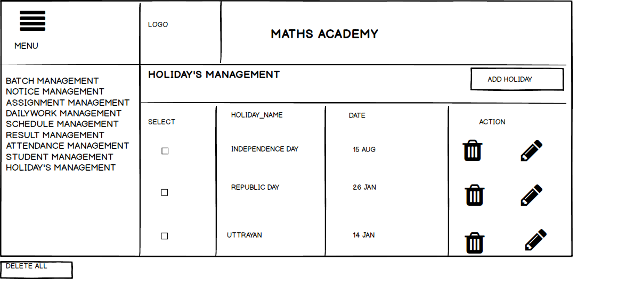

|  |
| --- |
| **CHAPTER 5:**  **SUMMARY** |

# 

# **5.1 ASSUMPTION:**

* One should remember their ID and Password while login in the system.
* He has the primary knowledge of the system.
* He is able to run the system properly.
* It is assumed that services will be provided 24x7x365.
* He/she is having knowledge about what is community.
* Implement the backup mechanism for taking backup of codebase and database on regular basis on different servers.

# **5.2 LIMITATIONS:**

* User must be the member of any community to create the event.
* If the user does not have knowledge about the system then he might get confuse between them.
* User can add members who are the registered user of their for the system.
* If the user might not be able to deal with English language then user might not able to understand the system efficiently.
* As it is also designed for mobile , on smartphones there is no hover state and typing on touch screen is slow and error prone and it results in reduced context. This tends to make it more difficult for user to understand the overview of the system.

# **5.3 CONCLUSION:**

Main concern for developing this system was to aware normal people like us about the new concepts . MNC like TCS. Accenture are using this kind of system for better communication between their employees. But most of us are not aware of this. It is useful in every field whether it is related to IT or Non-IT field. Students like us can have our collection and communities so that we can also share our new ideas/concepts/videos/images with each other so fast and so easily. Even Non-IT people like housewives can also use this system.

We know we might have made some mistakes knowingly or unknowingly. But all the suggestions regarding to this system are always welcome.

Several user friendly coding has been acquired. This system shall provide to be a powerful system in satisfying all the requirements of the institution.

The objective of the system is to provide a frame work that enables user to make reasonable estimates made within a limited time frame at the beginning of the software and should be updated regularly as the project progress.

# **5.4 FUTURE SCOPE:**

Although we have put lot of efforts to make the software flexible but limitations cannot be ruled out. Though the software presents a broad range of options to its users.

In a nutshell, it can be summarized that the future scope of the project circles around maintain information regarding :

* We can give advance software for Report generation including more facilities.
* We will host the platform for online servers to make it accessible.

The above mentioned points are the enhancement which can be done to increase the applicability and usage of this project.

# **5.5 BIBLIOGRAPHY:**

* SOFTWARE ENGINEERING a practitioner’s Approach Seventh Edition by Roger S. Pressman.
* <https://angular.io/>
* <https://ionicframework.com/>
* <https://www.w3schools.com/css/default.asp>
* <https://www.w3schools.com/html/default.asp>