Data Visualization Topics
Assignment 3: Dashboard using Power BI.
CST2106_10
Professor: Prableen Singh

Author: Vidhi Tripathi
Student Id: 041057189

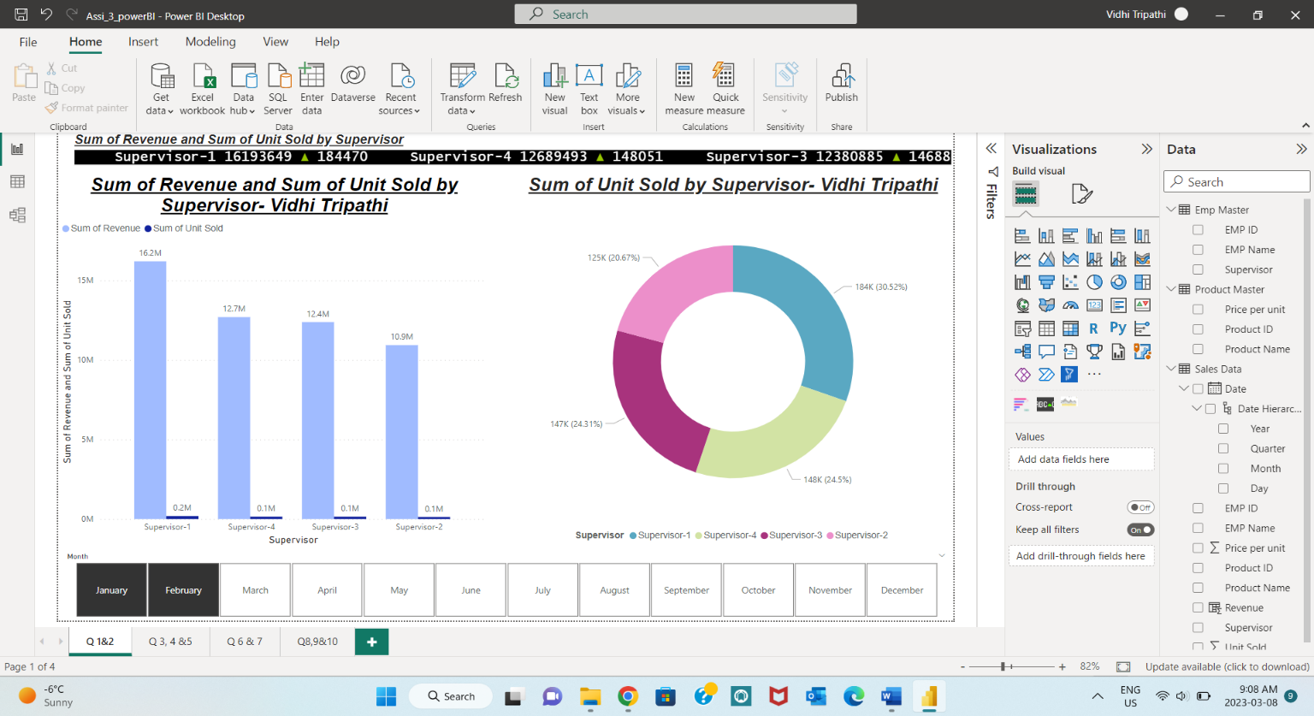
- Revenue and Units sold by each supervisor in January and February 2019

Ans 1:
First clustered column chart represents the revenue and the unit sold by each supervisor. For the very first two month of the year 2019 supervisor 1 sold 184K unit and generated $16.2 million revenues. Supervisor 2, 3, and 4 generated $ $12.7 million, $12.4 million, $10.9 million revenue respectively. At very bottom slicer for month which gives the value specifically of January and February 2019.

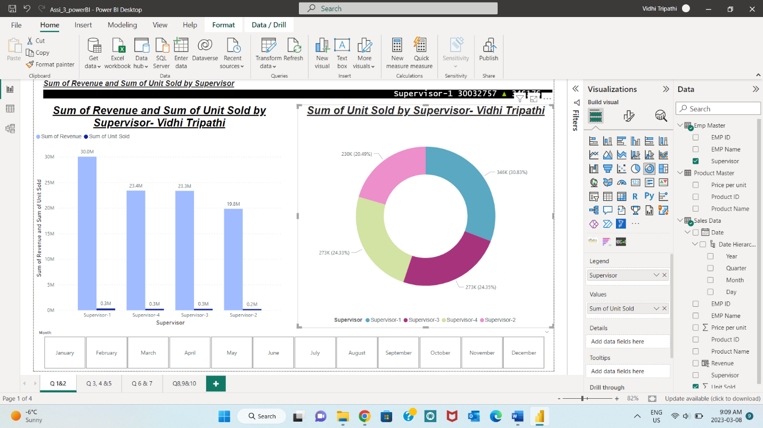
2.) Total units sold by each Supervisor

Ans 2:
Here right side of the chart area, Donut chart shows the unit sold by each supervisor with percentage of it. The highest unit sold by supervisor-1 was 30.83% and rest of supervisor have nearly equal amount. Additionally, we can find unit sold by each supervisor for each month with the help of slicer below.

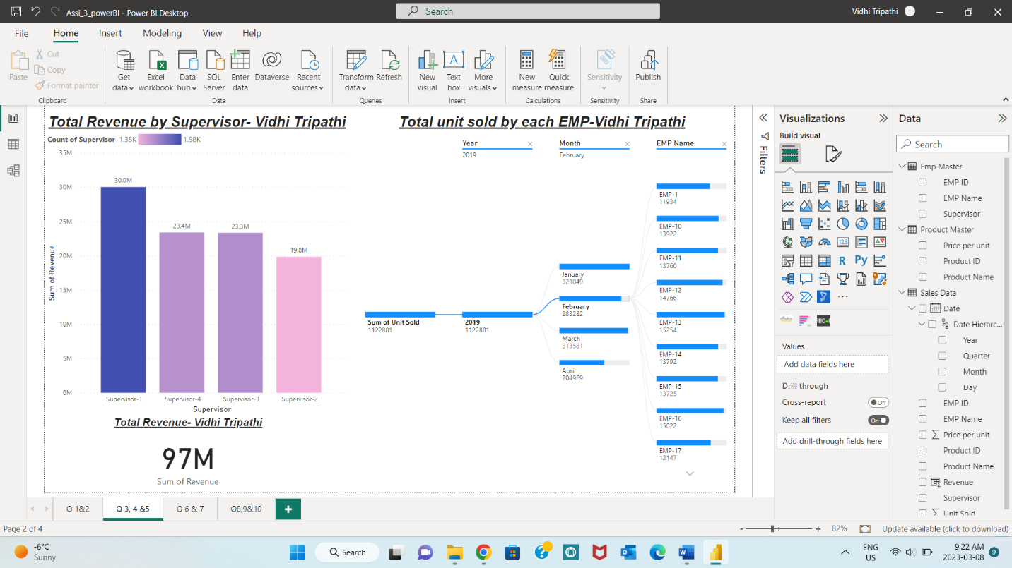
3.) Total revenue generated by each Supervisor
Ans 3:
Left side stacked column chart display the total revenue by each supervisor. From total revenue ($97 million) of 2019 the highest revenue generated by supervisor 1, it was $ 30 million, supervisor 2 make $20 million whereas 3 and 4 have same made same amount $23.5 million.
4.) Total Revenue
Ans 4:
Here in above graph the bottom left card represents the total value of the revenue which is 97 million.
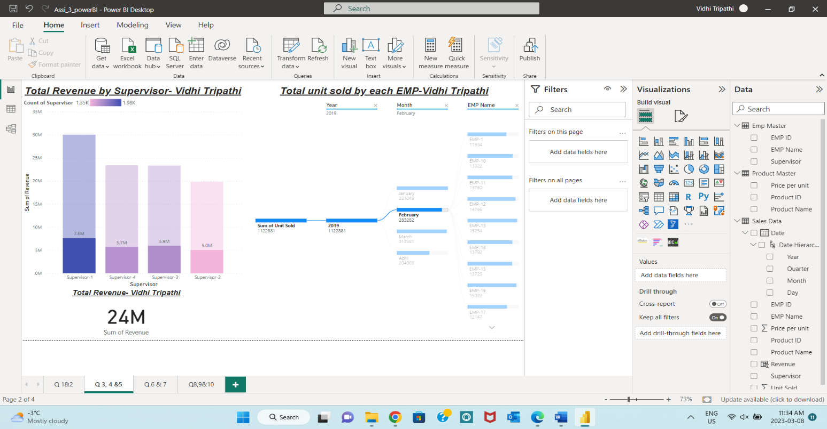
5.) Total units sold by each EMP in February 2019
Ans 5:
Right hand side, decomposition tree visualization helps to find total unit sold by every employee by selecting nodes step by step. Such as here we want total unit sold by each employee in February 2019 sum of unit sold-> Year here 2019-> Month here February-> employee. 1 million unit were sold by all employee in 2019, during February total unit sold is 1122881 units.

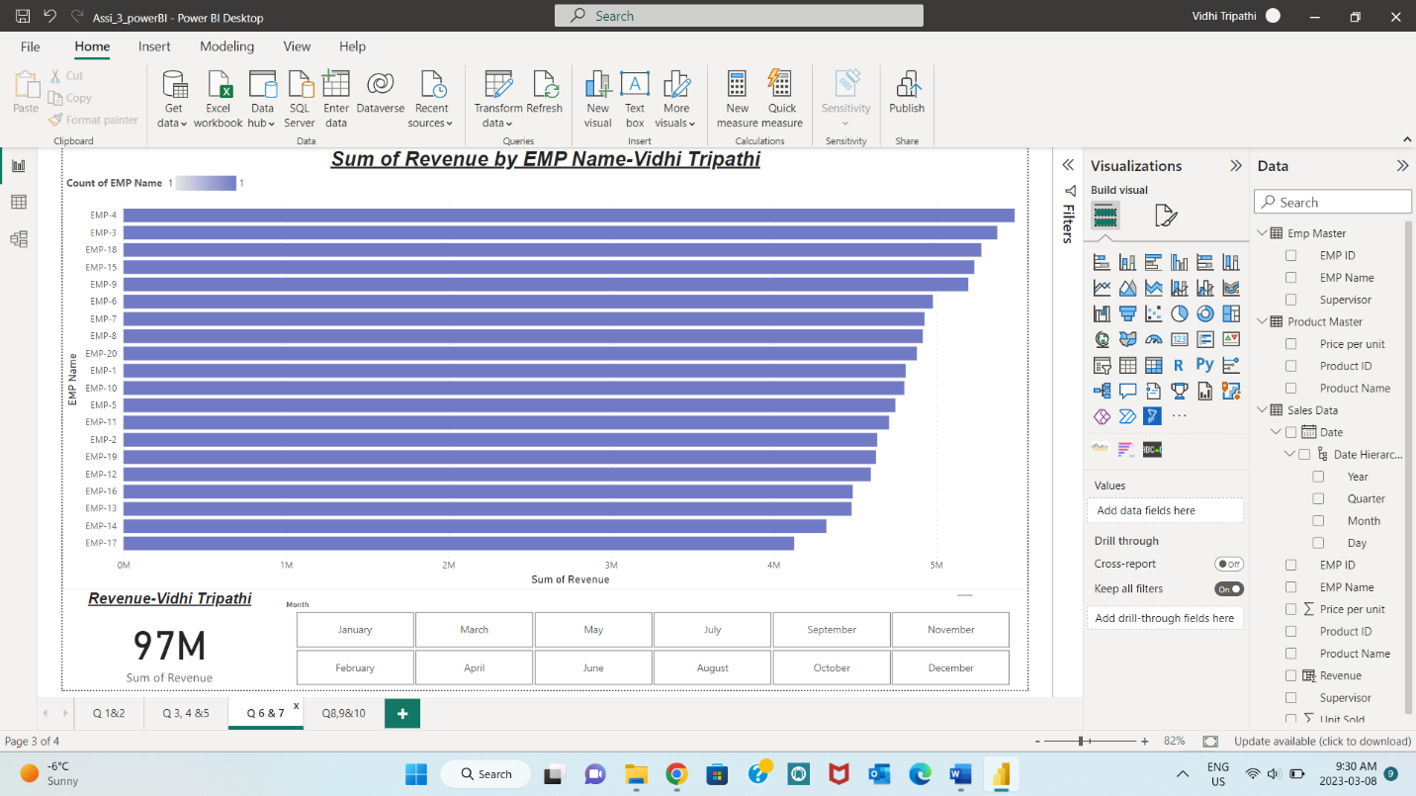
6.) Revenue by EMP Name:
Ans 6:
The clustered bar chart represents the sum of revenue by employee name. Where, sum of revenue having scale of millions and with the help of slicer below one can easily find revenue for each employee for various months. We can clearly seen that EMP- 4 has highest revenue nearly 5 million and lowest by EMP-17 around 4 million.
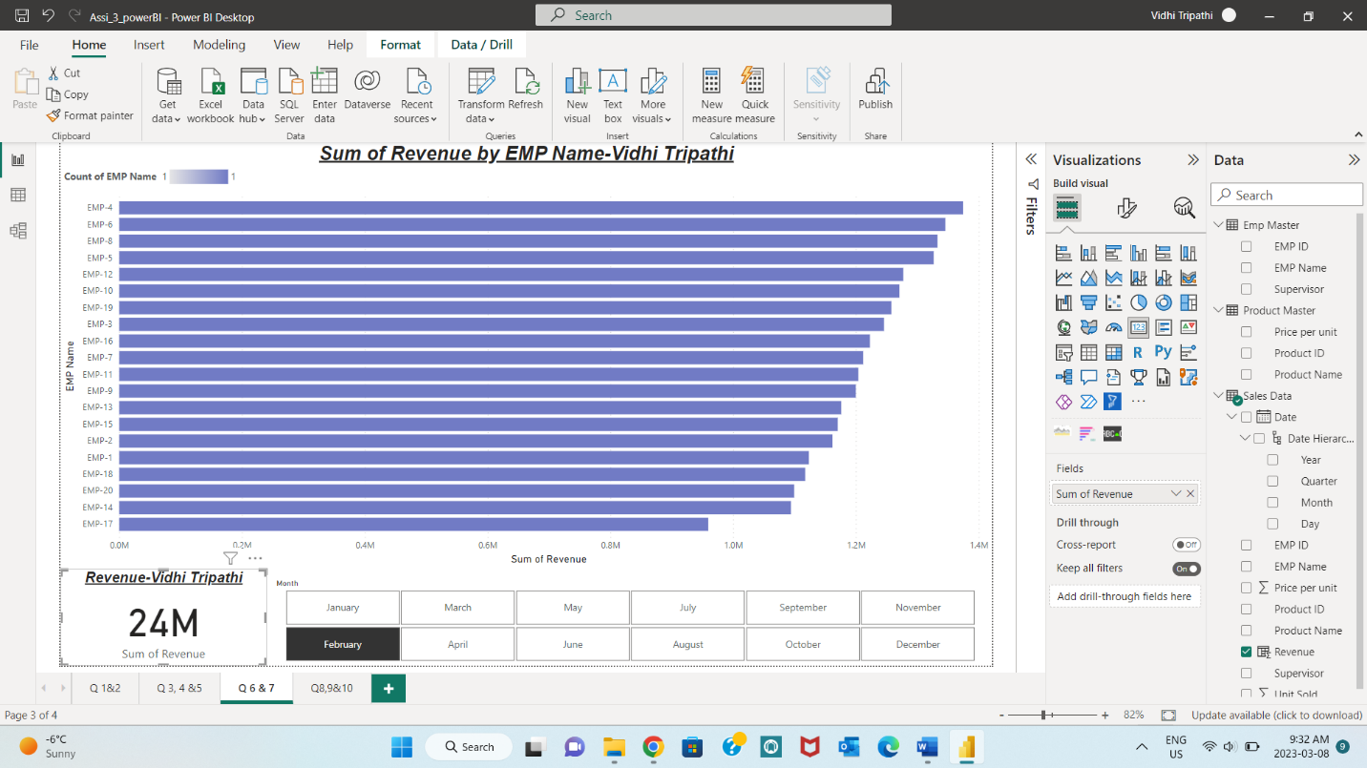
7.) Revenue generated in the February 2019
Ans 7:
AT the bottom left card represent the revenue generated in February 2019 which is $24 millions and by selecting on any bar from bar chart it will gives the total revenue of employee for respected month.
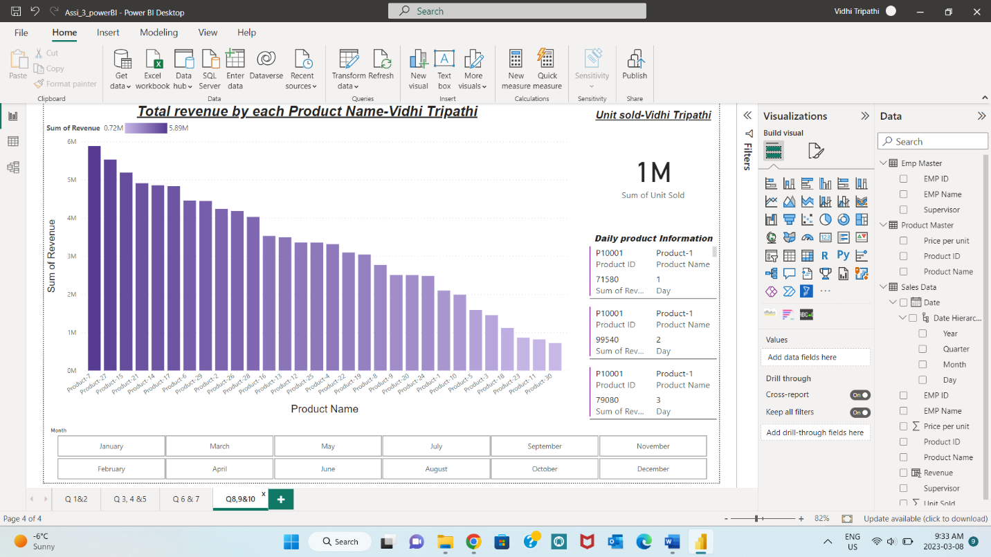
8.) Total revenue generated by every product
Ans 8:
Stacked column chart gives the product name on X axis and revenue on Y. The detail information about product such as product ID, name and revenue generated by the multivalued card. Maximum revenue made by product -7 and product-30 made minimum revenue in 2019. Here, by using slicer we can find the monthly revenue generated by each product. On top of that, slicer and multivalued card offers the information for each day of the month for product.

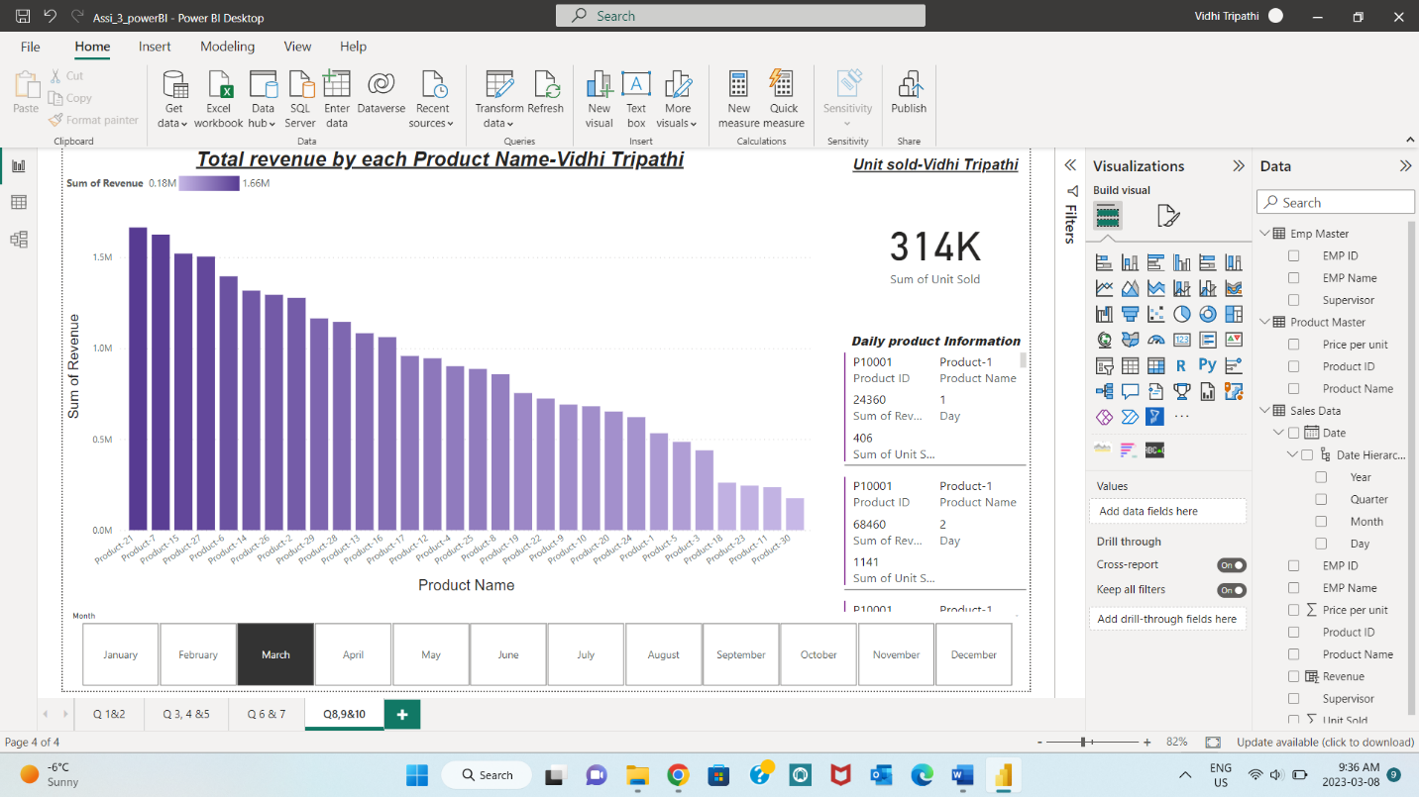
9.) Units sold in March 2019
Ans 9: card represent the unit sold and by selecting on slicer, unit sold in March 2019 gives the value 314K. Also, from multivalued card we can find the detail analysis of it.
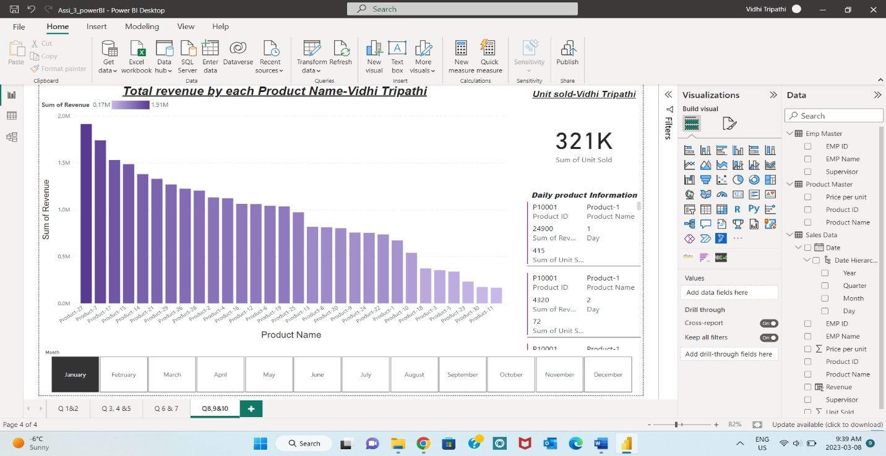
10.) Which product generated the highest revenue in January 2019?

Ans 10:
By using slicer select on January 2019 one can find the revenue for the each product. It is clearly seen that darker bar in the chart represent the highest revenue in January 2019 generated by product 27. Which is nearly 2 million or by turn on labels we get the exact value $1.91M.
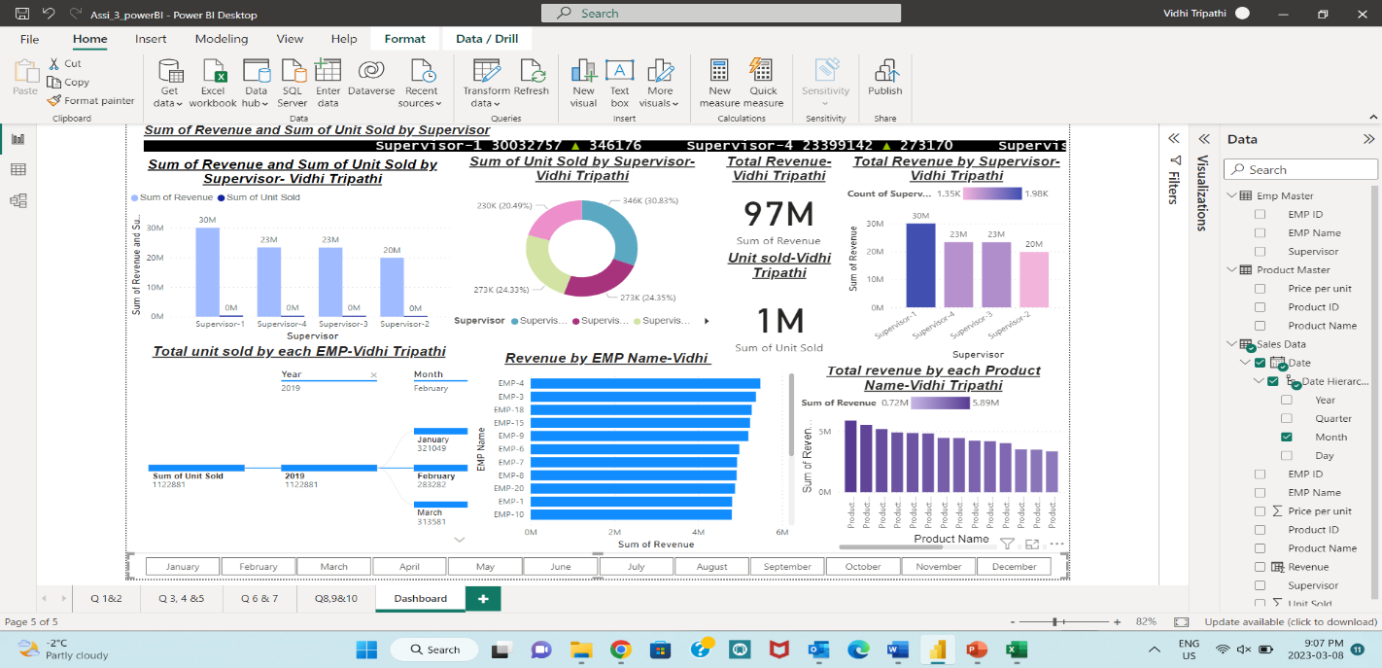
- Dashboard

Here above image represents the combination of all graphs called as a dashboard which is interactive in terms of finding particular information for particular variable in the data and get all answers from one page.

References:
Algonquin college Brightspace course material.

