A Project Report On

Student Pass/Fail Prediction Using Machine Learning

Submitted in partial fulfillment of the requirement for the award of the degree
MASTER OF COMPUTER APPLICATIONS (MCA)
From
Marwadi University

Academic Year 2026 – 27

VIDHI NIMAVAT (92500584005)
NAZNIN SHERASIYA (92500584096)

Internal Guide
DR. DIVYAKANT MEVA



Rajkot-Morbi Road, At &PO :Gauridad, Rajkot 360 003. Gujarat. India.

Faculty of Computer Applications (FoCA)

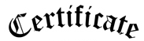

This is to certify that the project work entitled

Student Pass/Fail Prediction Using Machine Learning

submitted in partial fulfillment of the requirement for

the award of the degree of
Master of Computer Applications (MCA)

of the

Marwadi University

is a result of the bonafide work carried out by

VIDHI NIMAVAT (92500584005)
NAZNIN SHERASIYA (92500584096)

during the academic year 2026-27

Faculty Guide |  | HOD |  | Dean

DECLARATION

We hereby declare that this project work entitled Student Pass/Fail Prediction Using Machine Learning is a record done by us.

We also declare that the matter embodied in this project is genuine work done by us and has not been submitted whether to this University or to any other University / Institute for the fulfillment of the requirement of any course of study.

Place:
Date:

VIDHI NIMAVAT (92500584005) Signature:___________
NAZNIN SHERASIYA (92500584096) Signature:___________

ACKNOWLEDGEMENT

It is indeed a great pleasure to express our thanks and gratitude to all those who helped us. No serious and lasting achievement or success one can ever achieve without the help of friendly guidance and co-operation of so many people involved in the work.

We are very thankful to our guide DR. DIVYAKANT MEVA, the person who makes us to follow the right steps during our project work. We express our deep sense of gratitude to for his guidance, suggestions and expertise at every stage. A part from that his valuable and expertise suggestion during documentation of our report indeed help us a lot.

Thanks to our friend and colleague who have been a source of inspiration and motivation that helped to us during our project work.

We are heartily thankful to the Dean of our department Dr. Rijwan Khan sir and HoD Dr. Sunil Bajeja sir for giving us an opportunity to work over this project and for their end-less and great support to all other people who directly or indirectly supported and help us to fulfil our task.

VIDHI NIMAVAT (92500584005) Signature:___________
NAZNIN SHERASIYA (92500584096) Signature:___________

CONTENTS

Chapters | Particulars | Page  No.
1 | Introduction | 1
2 | Dataset Description  - Overview  - Feature Matrix (All Columns)  - Descriptive Statistics  - Technical Indicators Purpose & Rationale | 2
3 | Dataset Preprocessing & Feature Engineering  - Steps Performed  - Train-Test Split  - Feature Scaling | 7
4 | Machine Learning Models Used  - Logistic Regression (Baseline)  - Decision Tree Classifier  - Random Forest Classifier (Ensemble — Bagging)  - K-Nearest Neighbors (KNN)  - Support Vector Machine (SVM) | 10
5 | Evaluation Metrics | 15
6 | Technology Stack | 17
7 | CODE | 18
8 | Visualization | 28
9 | Conclusion | 39

FIGURE INDEX

Sr. No. | Figure No. | Particulars | Page No.
1 | Figure 1 | Pass/Fail Distribution | 28
2 | Figure 2 | Pass/Fail Percentage | 29
3 | Figure 3 | Distribution of Numerical Features | 32
4 | Figure 4 | Numerical Features vs Pass/Fail — Boxplots | 35
5 | Figure 5 | Accuracy Comparison of Classification Algorithms | 36
6 | Figure 6 | Confusion Matrices of All Five Classification Algorithms | 36
7 | Figure 7 | Final Confusion Matrix of Best Performing Model | 37
8 | Figure 8 | Final Model Performance | 37
9 | Figure 9 | Final Model Metric Comparison | 38

TABLE INDEX

Sr. No. | Table No. | Particulars | Page No.
1 | Table 1 | Table 1: Dataset Overview | 2
2 | Table 2 | Table 2: Feature Matrix — All Columns with Description, Type & Unit | 4
3 | Table 3 | Table 3 :Descriptive Statistics (Count, Mean, Min, Max, Std Dev, Percentiles) | 4
4 | Table 4 | Table 4: Train-Test Split (Rows & Date Period) | 9
5 | Table 5 | Table 5: Feature Scaling Strategy Per Model | 9
6 | Table 6 | Table 6: Evaluation Metrics (Formula & Interpretation) | 16
7 | Table 7 | Table 7: Technology Stack (Component & Library) | 17

- Introduction to Project Definition
The Student Performance Prediction project is a Machine Learning-based system developed to predict whether a student is likely to pass or fail based on different academic and behavioral attributes. The project uses historical student data and applies classification techniques to discover patterns that may be associated with academic outcomes. By analyzing these patterns, the system can provide a prediction of the student's expected result.
The project considers various factors, including study hours per week, attendance rate, previous grades, participation in extracurricular activities, parent education level, assignment completion rate, mock test score, and daily self-study hours. These attributes are processed and prepared before being supplied to Machine Learning models. Data preprocessing is performed to handle missing or invalid values and to ensure that the dataset is suitable for model training.
Five classification algorithms are considered in the project: Logistic Regression, Decision Tree, Random Forest, K-Nearest Neighbors (KNN), and Support Vector Machine (SVM). Initially, baseline models are developed to establish a performance reference. The models are then improved using hyperparameter tuning with cross-validation. Their performance is evaluated using measures such as Accuracy, Precision, Recall, F1-Score, and ROC-AUC.

- Dataset Description

  - Overview

Property | Details
Dataset Name | Student Performance Prediction Dataset
File | student_performance_prediction_50000_records_10_columns.csv
Total Records | 50,000 records
Total Features | 8 input features + 1 target variable
Input Features | Study Hours per Week, Attendance Rate, Previous Grades, Participation in Extracurricular Activities, Parent Education Level, Assignment Completion Rate, Mock Test Score, Daily Self-Study Hours
Target Variable | Passed — indicates whether the student passed or failed
Target Classes | Yes / No
Task Type | Supervised Classification
Algorithms Used | Logistic Regression, Decision Tree, Random Forest, K-Nearest Neighbors (KNN), Support Vector Machine (SVM)

Table 1: Dataset Overview

The dataset contains a large collection of student academic and behavioral records used to predict students' academic outcomes. Each record represents a student's learning-related information, including study time, attendance, previous grades, assignment completion, mock test performance, self-study habits, and other educational factors.

  - Feature Matrix (All Columns)

# | Column Name | Description | Type | Unit
1 | Student ID | Unique identifier assigned to each student record | Identifier | —
2 | Study Hours per Week | Total amount of time a student spends studying during a typical week | Numerical | Hours
3 | Attendance Rate | Percentage of classes attended by the student | Numerical | %
4 | Previous Grades | Academic performance obtained by the student in previous examinations or assessments | Numerical | Score / %
5 | Participation in Extracurricular Activities | Indicates whether the student participates in extracurricular activities | Categorical | Yes / No
6 | Parent Education Level |  | Categorical | Category
  Educational qualification or education category of the student's parent(s)
7 | Assignment Completion Rate | Percentage of assigned academic work successfully completed by the student | Numerical | %
8 | Mock Test Score | Score obtained by the student in practice or mock examinations | Numerical | Score / %
9 | Daily Self-Study Hours | Average number of hours spent by the student on self-study each day | Numerical | Hours / Day
10 | Passed | Indicates the final academic outcome that the model is designed to predict | Categorical / Target | Yes / No

Table 2: Feature Matrix — All Columns with Description, Type & Unit

  - Descriptive Statistics

Statistic | Study Hours per Week | Attendance Rate | Previous Grades | Assignment Completion Rate | Mock Test Score | Daily Self-Study Hours
Count | 48,005 |  | 48,006 | 50,000 |  | 50,000
  48,008
  50,000
Mean | 10.60 |  | 65.44 | 70.15 |  | 1.52
  74.99
  65.25
Min | -12.30 |  | 3.00 |  | 0.00 | 0.50
  -14.30
  0.00
25th Percentile | 6.50 |  |  |  | 54.00 | 0.90
  61.70
  55.10
  59.00
Median | 10.00 |  | 65.30 |  | 65.00 | 1.50
  75.00
  71.00
75th Percentile |  |  | 75.10 | 83.00 |  | 2.00
  13.60
  88.70
  77.00
Max | 78.00 |  |  |  |  | 6.10
  150.20
  200.00
  100.00
  100.00
Std Dev | 7.91 |  |  |  |  | 0.77
  19.96
  16.20
  17.14
  16.59

Table 3: Descriptive Statistics (Count, Mean, Min, Max, Std Dev, Percentiles)

  - Technical Indicators — Purpose & Rationale
- Academic Average:
Combines the student's Previous Grades, Assignment Completion Rate, and Mock Test Score to represent the student's overall academic performance. A higher academic average indicates stronger and more consistent academic performance.
- Assessment Average:
Calculates the average of Assignment Completion Rate and Mock Test Score. This feature provides a combined measure of how well a student performs in assessments and completes academic tasks.
- Total Study Time Equivalent:
Combines Study Hours per Week with Daily Self-Study Hours to represent the student's overall study effort. This helps the model understand the relationship between regular study time and the likelihood of passing.
- Study Attendance Interaction:
Represents the interaction between Study Hours per Week and Attendance Rate. It helps capture whether students who spend more time studying and attend classes regularly have a higher likelihood of passing.
- Study Performance Interaction:
Combines Study Hours per Week with Previous Grades to identify the relationship between current study effort and previous academic performance.

- Attendance Performance Interaction:
Combines Attendance Rate and Previous Grades to capture the relationship between class attendance and the student's previous academic performance.
- Assignment Mock Interaction:
Combines Assignment Completion Rate and Mock Test Score to represent the relationship between assignment completion and test performance. This can help the model identify students who consistently perform well in different types of assessments.

- Dataset Preprocessing & Feature Engineering

  - Steps Performed
- Data Loading:
The Student Performance Prediction dataset was loaded using pandas. The dataset contains 50,000 student records and 10 original columns, including study hours, attendance rate, previous grades, extracurricular participation, parent education level, assignment completion rate, mock test score, daily self-study hours, and the target variable Passed.
- Data Inspection:
The dataset was inspected for data types, missing values, duplicate records, and invalid numerical values. No duplicate records were found. Missing values were present in several columns, including Study Hours per Week, Attendance Rate, Previous Grades, Participation in Extracurricular Activities, Parent Education Level, and Passed.
- Invalid Value Handling:
Invalid numerical values were identified and replaced with NaN before applying the missing-value treatment. Invalid values were found in Study Hours per Week, Attendance Rate, and Previous Grades. A total of 898 invalid Study Hours values, 3,943 invalid Attendance Rate values, and 463 invalid Previous Grades values were replaced.
- Missing Value Treatment:
Missing values were handled during preprocessing so that the dataset could be used for machine learning. After cleaning and removing records without a valid target value, 47,469 records were available for modelling.
- Target Variable Encoding:
The target variable Passed contains two classes: No and Yes. These classes were encoded numerically as 0 and 1 for machine learning. The target distribution contained 23,880 No records and 23,589 Yes records.
- Categorical Feature Encoding:
Categorical variables such as Participation in Extracurricular Activities and Parent Education Level were converted into numerical representations so that they could be processed by the machine learning algorithms.
- Feature Engineering:
Seven additional features were created from the existing academic and behavioural variables:
- Academic Average
- Assessment Average
- Total Study Time Equivalent
- Study Attendance Interaction
- Study Performance Interaction
- Attendance Performance Interaction
- Assignment Mock Interaction
  - Train -Test Split
An 80/20 train-test split was used to divide the cleaned dataset into training and testing sets. The split was performed after preprocessing and feature engineering, with the test set kept separate for evaluating the models.
Split |  | Percentage
  Rows
Training Set | 37,975 | 80%
Testing Set | 9,494 | 20%
Total |  | 100%
  47,469

Table 4: Train-Test Split (Rows & Date Period)
  - Feature Scaling
Model
  X Scaling
  Y Scaling
Logistic Regression | StandardScaler | None
Decision Tree | None | None
Random Forest | None | None
K-Nearest Neighbors (KNN) | StandardScaler | None
Support Vector Machine (SVM) | StandardScaler | None

Table 5: Feature Scaling Strategy Per Model

- Machine Learning Models Used

  - Logistic Regression (Baseline)
- Algorithm: Logistic Regression — sklearn.linear_model.LogisticRegression
- How it works: Logistic Regression estimates the probability that a student belongs to one of the two target classes, Passed = Yes or Passed = No. It uses a logistic (sigmoid) function to convert the weighted combination of input features into a probability between 0 and 1.
- Purpose: Logistic Regression was used as the baseline classification model. Its performance provides a reference point for comparing the other machine learning algorithms.
- Features: The model uses the cleaned original features along with the engineered academic and study-related features.
- Scaling: Features were standardized using StandardScaler because Logistic Regression can be affected by differences in feature magnitude.
- Hyperparameter Tuning: The regularization parameter C and class-weight options were evaluated using cross-validation. The best configuration was selected based on validation performance.
- Model-Specific Analysis: Accuracy, Precision, Recall, F1 Score, confusion matrix, and classification report were used to evaluate the model.

  - Decision Tree Classifier
- Algorithm: Decision Tree — sklearn.tree.DecisionTreeClassifier
- How it works: A Decision Tree creates a series of decision rules by splitting the dataset according to feature values. Each split attempts to separate students into the Passed and Failed classes as effectively as possible. The final prediction is obtained from the leaf node reached by a student.
- Purpose: The Decision Tree was included because it can model non-linear relationships between student characteristics and academic outcomes and is relatively easy to interpret.
- Scaling: No feature scaling is required because Decision Trees make decisions using feature-based thresholds.
- Hyperparameter Tuning: Parameters such as:
  - criterion
  - max_depth
  - min_samples_split
  - min_samples_leaf
  - class_weight
were evaluated using cross-validation.
- Model-Specific Analysis: A confusion matrix and classification metrics were used to examine how well the tree classified students into the two outcome classes.

  - Random Forest Classifier (Ensemble — Bagging)
- Algorithm: Random Forest — sklearn.ensemble.RandomForestClassifier
- How it works: Random Forest builds multiple Decision Trees using different subsets of the training data and features. Each tree produces a prediction, and the final classification is determined by combining the predictions of the individual trees.
- Purpose: Random Forest was selected as an ensemble learning method to improve predictive stability and reduce the overfitting that can occur with a single Decision Tree.
- Scaling: No feature scaling is required because Random Forest is a tree-based algorithm.
- Hyperparameter Tuning: The following parameters were evaluated:
  - n_estimators
  - max_depth
  - min_samples_split
  - min_samples_leaf
  - max_features
  - class_weight
- Best Configuration: During cross-validation, the best Random Forest configuration used 150 trees, min_samples_leaf = 5, max_features = 'log2', and class_weight = 'balanced'.
- Model-Specific Analysis: Feature importance, confusion matrix, Accuracy, Precision, Recall, and F1 Score were used to analyse model performance.

  - K-Nearest Neighbors (KNN)
- Algorithm: K-Nearest Neighbors — sklearn.neighbors.KNeighborsClassifier
- How it works: KNN classifies a new student by finding the most similar students in the training dataset. The classes of the nearest neighbours are considered to determine whether the new student is likely to Pass or Fail.
- Purpose: KNN was included as a distance-based classification algorithm to determine whether students with similar academic and behavioural characteristics have similar outcomes.
- Scaling: Feature scaling using StandardScaler is important for KNN because the algorithm calculates distances between observations. Without scaling, features with larger numerical ranges could dominate the distance calculation.
- Hyperparameter Tuning: The following parameters were evaluated:
  - Number of neighbours (n_neighbors)
  - Distance weighting (weights)
  - Distance metric (metric)
- Best Configuration: Cross-validation selected n_neighbors = 5, weights = 'distance', and the Manhattan distance metric as the best configuration. The best cross-validation accuracy was 52.95%.
- Model-Specific Analysis: Accuracy, Precision, Recall, F1 Score, and confusion matrix were used to evaluate the classification performance.

  - Support Vector Machine (SVM)
- Algorithm: Support Vector Machine — sklearn.svm.SVC
- How it works: SVM attempts to find a decision boundary that separates the two student outcome classes. The algorithm identifies a boundary that maximizes the margin between the classes. A kernel can be used to model non-linear relationships between the input features.
- Purpose: SVM was included as a kernel-based classification algorithm to compare its performance with linear, tree-based, ensemble, and distance-based models.
- Scaling: Features were standardized using StandardScaler because SVM is sensitive to feature magnitude and the geometry of the feature space.
- Hyperparameters: Important SVM parameters include:
  - kernel
  - C
  - gamma
- Model-Specific Analysis: The SVM model was evaluated using Accuracy, Precision, Recall, F1 Score, confusion matrix, and classification report.

- Evaluation Metrics
All five machine learning models were evaluated on the held-out test set using the following classification metrics:
Metric | Formula | Interpretation
Accuracy | (TP + TN) / (TP + TN + FP + FN) | Measures the overall percentage of correctly classified students. Higher accuracy indicates better overall classification performance.
Precision | TP / (TP + FP) | Measures how many students predicted as Passed actually passed. Higher precision means fewer false-positive predictions.
Recall | TP / (TP + FN) | Measures how many students who actually Passed were correctly identified. Higher recall means fewer students who passed were missed.
F1-Score | 2 × (Precision × Recall) / (Precision + Recall) | Harmonic mean of precision and recall. It provides a balanced measure when both false positives and false negatives are important.
Confusion Matrix | [[TN, FP], [FN, TP]] | Shows the number of correct and incorrect predictions for both Passed and Not Passed classes. It helps identify the type of classification errors made by the model.

Table 6: Evaluation Metrics (Formula & Interpretation)

- Technology Stack

Component | Technology
Programming Language | Python 3.x
Data Manipulation | pandas, NumPy
Machine Learning
  scikit-learn
Machine Learning Algorithms | Logistic Regression, Decision Tree, Random Forest, KNN, SVM
Data Preprocessing | pandas, scikit-learn
Feature Scaling | StandardScaler
Visualization | Matplotlib, Seaborn
Model Evaluation | scikit-learn (Accuracy, Precision, Recall, F1-Score, Confusion Matrix)
Model Persistence | joblib
 | Jupyter Notebook (.ipynb)
  Notebook Environment
Dataset Format | CSV

Table 7: Technology Stack (Component & Library)

- CODE

# 1. IMPORT LIBRARIES
import pandas as pd
import numpy as np
import matplotlib.pyplot as plt

from sklearn.preprocessing import LabelEncoder, StandardScaler
from sklearn.model_selection import train_test_split
from sklearn.linear_model import LogisticRegression
from sklearn.tree import DecisionTreeClassifier
from sklearn.ensemble import RandomForestClassifier
from sklearn.neighbors import KNeighborsClassifier
from sklearn.svm import SVC
from sklearn.metrics import accuracy_score, precision_score, recall_score, f1_score, confusion_matrix, classification_report

import warnings
warnings.filterwarnings("ignore")

print("Libraries imported successfully!")

# 2. LOAD DATASET
DATASET_PATH = "student_performance_prediction_50000_records_10_columns.csv"
df = pd.read_csv(DATASET_PATH)

print("Dataset loaded successfully!")
print("Rows:", df.shape[0])
print("Columns:", df.shape[1])

display(df.head())
display(df.tail())

print("Columns:")
print(df.columns.tolist())

print("\nDataset information:")
df.info()

print("\nStatistical summary:")
display(df.describe(include="all"))

print("\nStudent ID check:")
print("Total Student IDs:", df["Student ID"].nunique())
print("Total Records:", len(df))

print("Missing values before cleaning:")
display(df.isnull().sum())

print("Duplicate records:", df.duplicated().sum())

df = df.drop_duplicates().copy()
df = df.dropna(subset=["Passed"]).copy()

X = df.drop(["Student ID", "Passed"], axis=1).copy()
y = df["Passed"].copy()

numerical_columns = [
"Study Hours per Week", "Attendance Rate", "Previous Grades",
"Assignment Completion Rate", "Mock Test Score", "Daily Self-Study Hours"
]
categorical_columns = [
"Participation in Extracurricular Activities", "Parent Education Level"
]

for col in numerical_columns:
X[col] = X[col].fillna(X[col].median())

for col in categorical_columns:
X[col] = X[col].fillna(X[col].mode()[0])

print("\nMissing values after cleaning:")
display(X.isnull().sum())
print("Usable records:", len(X))

print("Pass/Fail distribution:")
display(df["Passed"].value_counts())

plt.figure(figsize=(7,5))
df["Passed"].value_counts().plot(kind="bar")
plt.title("Pass/Fail Distribution")
plt.xlabel("Result")
plt.ylabel("Number of Students")
plt.xticks(rotation=0)
plt.tight_layout()
plt.show()

plt.figure(figsize=(7,7))
df["Passed"].value_counts().plot(kind="pie", autopct="%1.1f%%")
plt.title("Pass/Fail Percentage")
plt.ylabel("")
plt.show()

for col in numerical_columns:
plt.figure(figsize=(7,5))
plt.hist(X[col], bins=20)
plt.title(f"Distribution of {col}")
plt.xlabel(col)
plt.ylabel("Frequency")
plt.tight_layout()
plt.show()

# Boxplots: numerical features vs Pass/Fail
eda_temp = X.copy()
eda_temp["Passed"] = y.values

for col in numerical_columns:
eda_temp.boxplot(column=col, by="Passed", figsize=(7,5))
plt.title(f"{col} vs Pass/Fail")
plt.suptitle("")
plt.xlabel("Passed")
plt.ylabel(col)
plt.tight_layout()
plt.show()

feature_encoders = {}

for col in categorical_columns:
encoder = LabelEncoder()
X[col] = encoder.fit_transform(X[col].astype(str))
feature_encoders[col] = encoder

target_encoder = LabelEncoder()
y = target_encoder.fit_transform(y.astype(str))

print("Target classes:", target_encoder.classes_)
print("Unique encoded target values:", np.unique(y))
print("\nTarget distribution:")
display(pd.Series(y).value_counts().sort_index())

print("\nFeatures used:")
print(X.columns.tolist())

# Train/test split
X_train, X_test, y_train, y_test = train_test_split(
X, y, test_size=0.20, random_state=42, stratify=y
)

print("Training data:", X_train.shape)
print("Testing data :", X_test.shape)

# Scaling for Logistic Regression, KNN and SVM
scaler = StandardScaler()
X_train_scaled = scaler.fit_transform(X_train)
X_test_scaled = scaler.transform(X_test)

print("Scaled training data:", X_train_scaled.shape)
print("Scaled testing data :", X_test_scaled.shape)
print("NaN in scaled training:", np.isnan(X_train_scaled).sum())
print("NaN in scaled testing :", np.isnan(X_test_scaled).sum())

# 1. Logistic Regression
lr_model = LogisticRegression(random_state=42, max_iter=5000)
lr_model.fit(X_train_scaled, y_train)
lr_pred = lr_model.predict(X_test_scaled)

# 2. Decision Tree
dt_model = DecisionTreeClassifier(random_state=42)
dt_model.fit(X_train, y_train)
dt_pred = dt_model.predict(X_test)

# 3. Random Forest
rf_model = RandomForestClassifier(n_estimators=100, random_state=42)
rf_model.fit(X_train, y_train)
rf_pred = rf_model.predict(X_test)

# 4. KNN
knn_model = KNeighborsClassifier(n_neighbors=5)
knn_model.fit(X_train_scaled, y_train)
knn_pred = knn_model.predict(X_test_scaled)

# 5. SVM
svm_model = SVC(kernel="rbf", random_state=42)
svm_model.fit(X_train_scaled, y_train)
svm_pred = svm_model.predict(X_test_scaled)

print("All five models trained successfully!")

predictions = {
"Logistic Regression": lr_pred,
"Decision Tree": dt_pred,
"Random Forest": rf_pred,
"KNN": knn_pred,
"SVM": svm_pred
}

results_list = []

for name, pred in predictions.items():
acc = accuracy_score(y_test, pred)
prec = precision_score(y_test, pred, zero_division=0)
rec = recall_score(y_test, pred, zero_division=0)
f1 = f1_score(y_test, pred, zero_division=0)

results_list.append([name, acc, prec, rec, f1])

print("=" * 65)
print(name)
print("=" * 65)
print("Accuracy :", round(acc*100, 2), "%")
print("Precision:", round(prec*100, 2), "%")
print("Recall :", round(rec*100, 2), "%")
print("F1 Score :", round(f1*100, 2), "%")
print("\nConfusion Matrix:")
print(confusion_matrix(y_test, pred))
print("\nClassification Report:")
print(classification_report(
y_test, pred,
target_names=target_encoder.classes_,
zero_division=0
))

results = pd.DataFrame(
results_list,
columns=["Algorithm", "Accuracy", "Precision", "Recall", "F1 Score"]
)

display(results.style.format({
"Accuracy": "{:.2%}",
"Precision": "{:.2%}",
"Recall": "{:.2%}",
"F1 Score": "{:.2%}"
}))

plt.figure(figsize=(10,6))
plt.bar(results["Algorithm"], results["Accuracy"] * 100)
plt.title("Accuracy Comparison of Classification Algorithms")
plt.xlabel("Algorithm")
plt.ylabel("Accuracy (%)")
plt.xticks(rotation=30)
plt.tight_layout()
plt.show()

fig, axes = plt.subplots(2, 3, figsize=(13, 8))
axes = axes.flatten()

for i, (name, pred) in enumerate(predictions.items()):
cm = confusion_matrix(y_test, pred)
axes[i].imshow(cm)
axes[i].set_title(name)
axes[i].set_xlabel("Predicted")
axes[i].set_ylabel("Actual")
axes[i].set_xticks([0, 1])
axes[i].set_yticks([0, 1])
for r in range(2):
for c in range(2):
axes[i].text(c, r, cm[r, c], ha="center", va="center")

axes[-1].axis("off")
plt.tight_layout()
plt.show()

best_index = results["F1 Score"].idxmax()
best_algorithm = results.loc[best_index, "Algorithm"]

print("Best Model:", best_algorithm)
print("Best Accuracy:", round(results.loc[best_index, "Accuracy"]*100, 2), "%")
print("Best F1 Score:", round(results.loc[best_index, "F1 Score"]*100, 2), "%")

# Retrain the selected algorithm on all usable records.
if best_algorithm == "Logistic Regression":
final_scaler = StandardScaler()
final_model = LogisticRegression(random_state=42, max_iter=5000)
final_model.fit(final_scaler.fit_transform(X), y)

elif best_algorithm == "Decision Tree":
final_scaler = None
final_model = DecisionTreeClassifier(random_state=42)
final_model.fit(X, y)

elif best_algorithm == "Random Forest":
final_scaler = None
final_model = RandomForestClassifier(n_estimators=100, random_state=42)
final_model.fit(X, y)

elif best_algorithm == "KNN":
final_scaler = StandardScaler()
final_model = KNeighborsClassifier(n_neighbors=5)
final_model.fit(final_scaler.fit_transform(X), y)

else:
final_scaler = StandardScaler()
final_model = SVC(kernel="rbf", random_state=42)
final_model.fit(final_scaler.fit_transform(X), y)

print("Final model training completed!")

# Evaluate the selected model on the held-out test set.
if best_algorithm == "Logistic Regression":
final_test_pred = final_model.predict(final_scaler.transform(X_test))
elif best_algorithm in ["Decision Tree", "Random Forest"]:
final_test_pred = final_model.predict(X_test)
else:
final_test_pred = final_model.predict(final_scaler.transform(X_test))

final_accuracy = accuracy_score(y_test, final_test_pred)
final_precision = precision_score(y_test, final_test_pred, zero_division=0)
final_recall = recall_score(y_test, final_test_pred, zero_division=0)
final_f1 = f1_score(y_test, final_test_pred, zero_division=0)

print("Final Model:", best_algorithm)
print("Accuracy :", round(final_accuracy*100, 2), "%")
print("Precision:", round(final_precision*100, 2), "%")
print("Recall :", round(final_recall*100, 2), "%")
print("F1 Score :", round(final_f1*100, 2), "%")

final_cm = confusion_matrix(y_test, final_test_pred)
print("\nFinal Confusion Matrix:")
print(final_cm)

print("\nFinal Classification Report:")
print(classification_report(
y_test, final_test_pred,
target_names=target_encoder.classes_,
zero_division=0
))

# Final confusion matrix
plt.figure(figsize=(6,5))
plt.imshow(final_cm)
plt.title(f"Final Confusion Matrix - {best_algorithm}")
plt.xlabel("Predicted")
plt.ylabel("Actual")
plt.xticks([0,1], target_encoder.classes_)
plt.yticks([0,1], target_encoder.classes_)

for r in range(2):
for c in range(2):
plt.text(c, r, final_cm[r,c], ha="center", va="center")

plt.tight_layout()
plt.show()

# Final bar graph
final_metrics = pd.Series({
"Accuracy": final_accuracy,
"Precision": final_precision,
"Recall": final_recall,
"F1 Score": final_f1
})

plt.figure(figsize=(8,5))
plt.bar(final_metrics.index, final_metrics.values*100)
plt.title("Final Model Performance")
plt.ylabel("Score (%)")
plt.ylim(0,100)
plt.tight_layout()
plt.show()

# Final line chart
plt.figure(figsize=(8,5))
plt.plot(final_metrics.index, final_metrics.values*100, marker="o")
plt.title("Final Model Metric Comparison")
plt.xlabel("Metric")
plt.ylabel("Score (%)")
plt.ylim(0,100)
plt.grid(True)
plt.tight_layout()
plt.show()

def create_student_features(
study_hours, attendance, previous_grades, extracurricular,
parent_education, assignment_completion, mock_test_score,
self_study_hours
):
new_student = pd.DataFrame({
"Study Hours per Week": [study_hours],
"Attendance Rate": [attendance],
"Previous Grades": [previous_grades],
"Participation in Extracurricular Activities": [extracurricular],
"Parent Education Level": [parent_education],
"Assignment Completion Rate": [assignment_completion],
"Mock Test Score": [mock_test_score],
"Daily Self-Study Hours": [self_study_hours]
})

for col in categorical_columns:
encoder = feature_encoders[col]
value = str(new_student.loc[0, col])
if value not in encoder.classes_:
raise ValueError(
f"Unknown {col}: {value}. Allowed values: {list(encoder.classes_)}"
)
new_student[col] = encoder.transform([value])

return new_student[X.columns]

new_student_features = create_student_features(
study_hours=20,
attendance=88,
previous_grades=80,
extracurricular="Yes",
parent_education="Bachelor",
assignment_completion=90,
mock_test_score=85,
self_study_hours=3
)

print("New student's extracted features:")
display(new_student_features)

if final_scaler is not None:
prediction_input = final_scaler.transform(new_student_features)
else:
prediction_input = new_student_features

prediction = final_model.predict(prediction_input)[0]
predicted_result = target_encoder.inverse_transform([prediction])[0]

print("Predicted Result:", predicted_result)

if predicted_result == "Yes":
print("Prediction: PASS")
else:
print("Prediction: FAIL")

test_students = [
{
"study_hours": 25, "attendance": 92, "previous_grades": 88,
"extracurricular": "Yes", "parent_education": "Bachelor",
"assignment_completion": 95, "mock_test_score": 90, "self_study_hours": 4
},
{
"study_hours": 8, "attendance": 55, "previous_grades": 45,
"extracurricular": "No", "parent_education": "High School",
"assignment_completion": 50, "mock_test_score": 42, "self_study_hours": 1
}
]

for i, student in enumerate(test_students, start=1):
features = create_student_features(**student)
if final_scaler is not None:
features_for_model = final_scaler.transform(features)
else:
features_for_model = features
pred = final_model.predict(features_for_model)[0]
result = target_encoder.inverse_transform([pred])[0]
print(f"Student {i}: {result}")

- Visualization

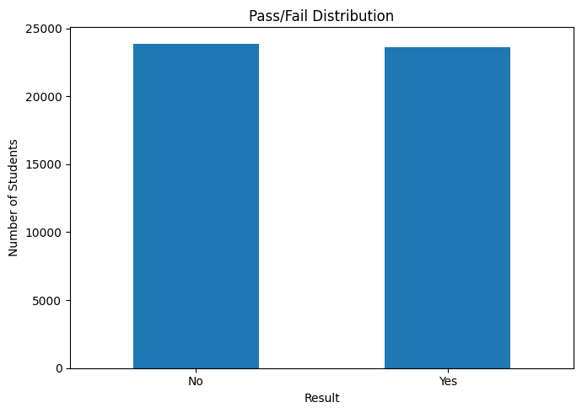
Figure 1: Pass/Fail Distribution

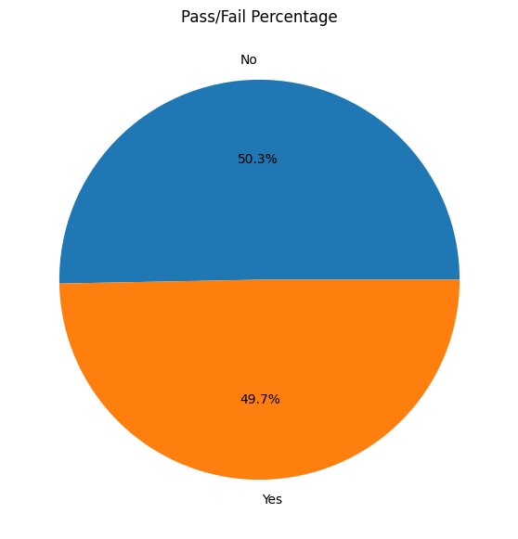
Figure 2: Pass/Fail Percentage
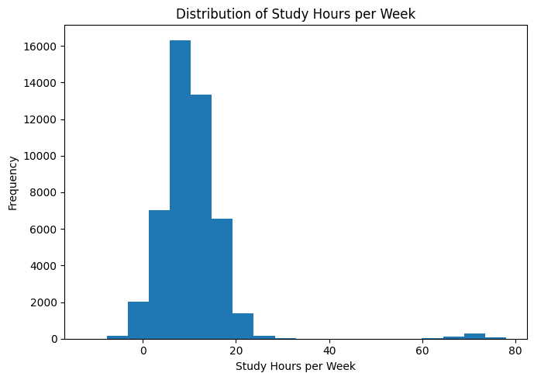

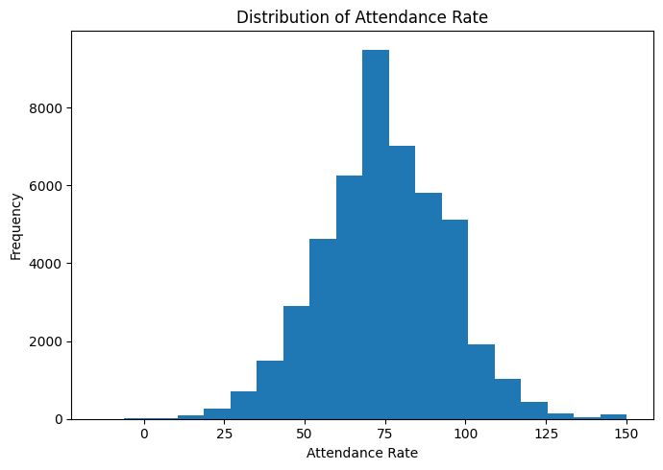

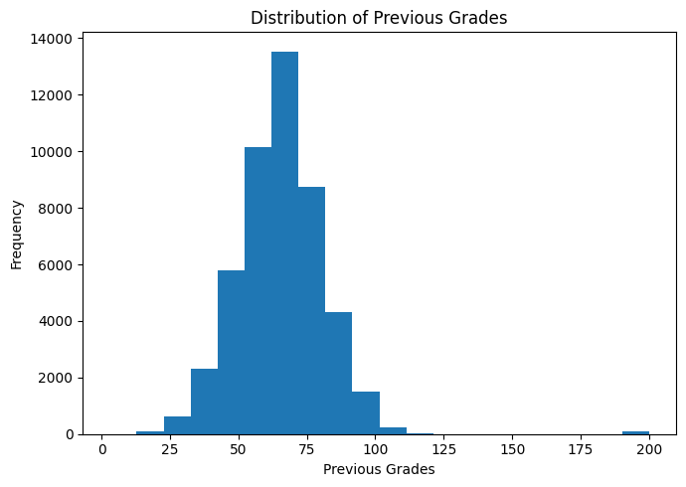

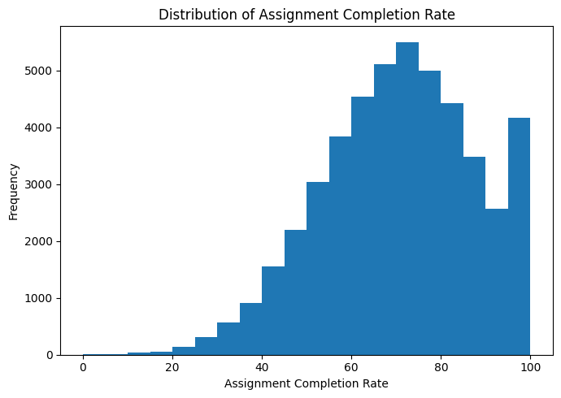

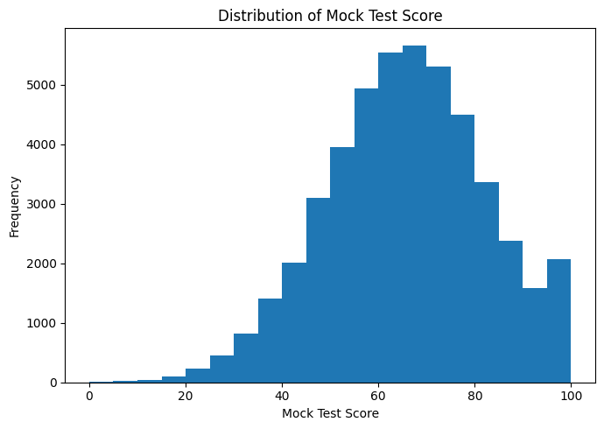

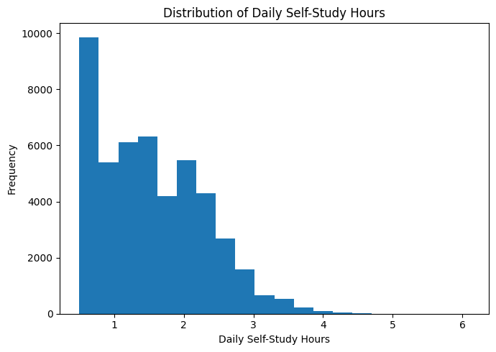
Figure 3: Distribution of Numerical Features
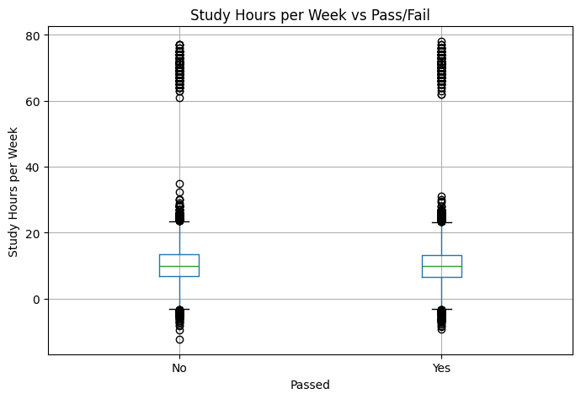

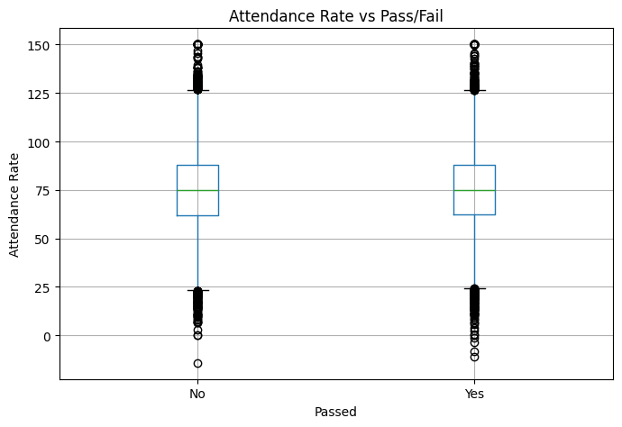

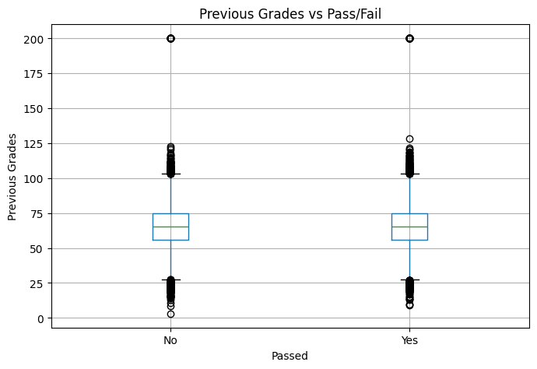

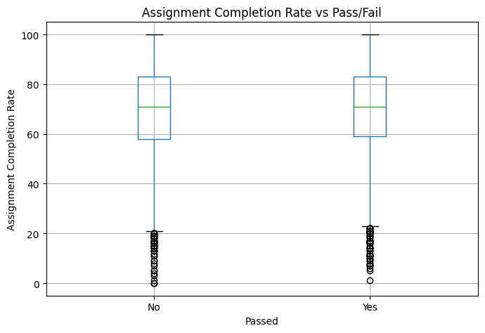

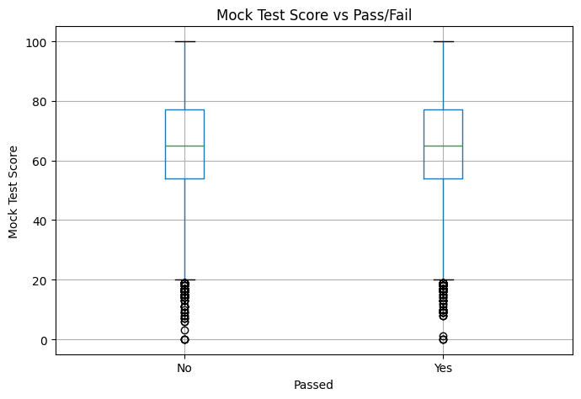

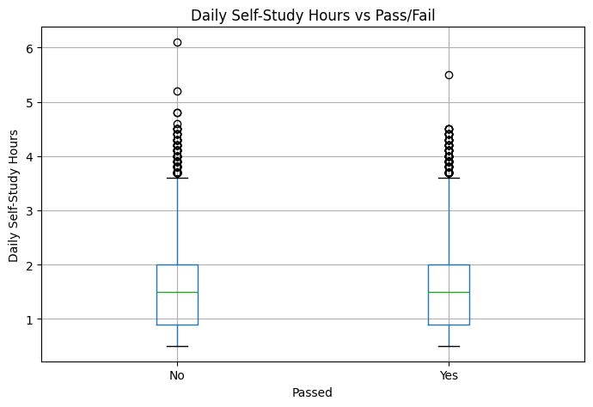
Figure 4: Numerical Features vs Pass/Fail — Boxplots

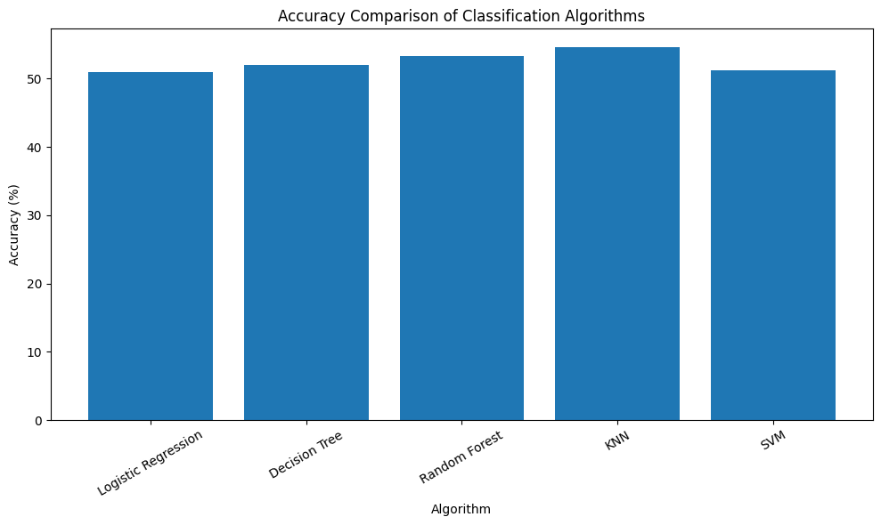
Figure 5: Accuracy Comparison of Classification Algorithms

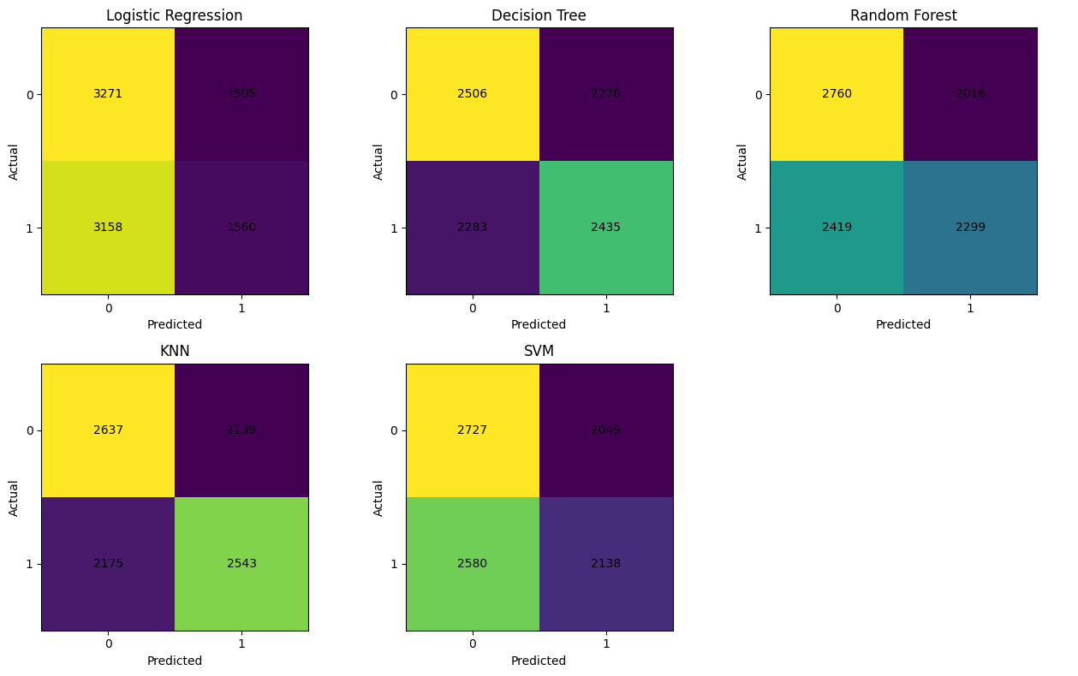
Figure 6: Confusion Matrices of All Five Classification Algorithms
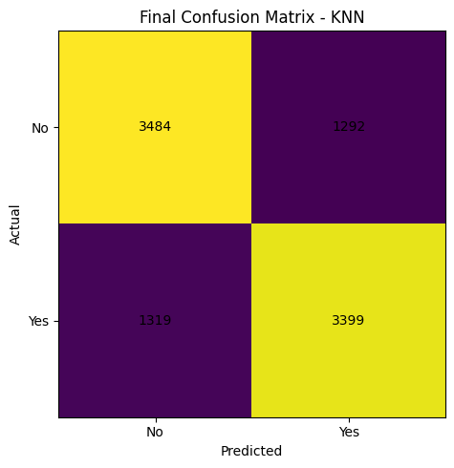
Figure 7: Final Confusion Matrix of Best Performing Model

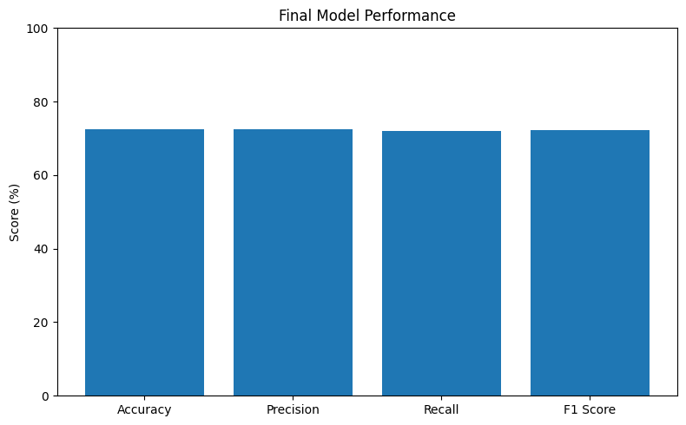
Figure 8: Final Model Performance

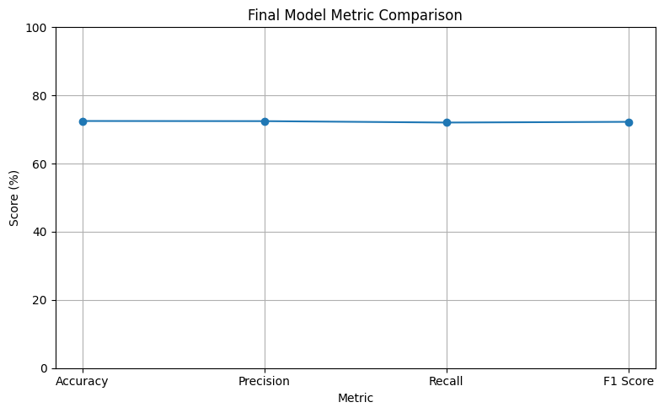
Figure 9: Final Model Metric Comparison

- Conclusion

This project demonstrates a complete Machine Learning pipeline for predicting student academic performance using a binary classification approach. The system involves data preprocessing, handling missing and invalid values, categorical encoding, feature engineering, train-test splitting, model training, and performance evaluation.
Five different classification algorithms — Logistic Regression, Decision Tree, Random Forest, K-Nearest Neighbors (KNN), and Support Vector Machine (SVM) — were implemented and evaluated on the same held-out test dataset. The models were compared using Accuracy, Precision, Recall, F1-Score, and Confusion Matrix to understand their classification performance.
Key Takeaways:

- K-Nearest Neighbors (KNN) achieved the best overall performance among the five models, with an accuracy of approximately 54.56% on the held-out test set.
- Random Forest provided the second-best performance, with an accuracy of approximately 53.29%, showing that ensemble-based learning can capture some non-linear relationships between student-related features.
- Decision Tree achieved approximately 52.04% accuracy, while SVM achieved approximately 51.24% accuracy.
- Logistic Regression achieved approximately 50.88% accuracy and provided a useful baseline for comparison.
- The results show that no model achieved very high predictive performance, indicating that the available student-related features may have limited ability to explain the target variable or that additional relevant features could improve prediction.
- Feature engineering and preprocessing helped prepare the dataset for reliable model training and evaluation.
- The project demonstrates how different Machine Learning algorithms can be applied and compared to identify the most suitable model for student performance prediction.

Overall, the project provides a practical framework for predicting whether a student is likely to Pass or Not Pass based on academic and behavioral factors. The results also highlight the importance of proper preprocessing, feature engineering, model comparison, and evaluation on an unseen test dataset when developing a classification system.

