**SOMAIYA VIDYAVIHAR**

Padmabhushan (Late) Shri. K. J. Somaiya, an entrepreneur and philanthropist, established Somaiya Vidyavihar for imparting value-based education to today’s youth. It is one of the largest private educational campuses in Mumbai. He had the vision and grit to achieve his dreams single-mindedly. (Late) Dr. Shri. S. K. Somaiya was a great visionary who further developed campus with more than 34 institutions. The Somaiya Vidyavihar offers school education, diplomas and under graduate/post graduate degree programs in various disciplines.

**ABOUT KJSCE**

K.J Somaiya College of Engineering (KJSCE) established in 1983 is an Autonomous College Affiliated to University of Mumbai and has permanent affiliation to the University of Mumbai. Presently institute offers five undergraduate courses Computer, Electronics, E&TC, Information Technology and Mechanical Engineering which are provisionally accredited up to November 2016. The institute also offers post graduate courses in Mechanical, Electronics, E&TC, IT, and Computer Engineering.

**THEME**

K. J. Somaiya College of Engineering and the ISTE Student Chapter – KJSCE is organizing **PRAKALPA 17** on 31st. March & 1st. April, 2017. The competition is being organized since 2006 and has since been gaining increasing popularity among the students from various colleges across the state.

**I) Paper Presentation on Artificial Intelligence on 31st. March 2017**

The theme of this year’s Prakalpa is **Artificial Intelligence-Innovation towards Future**. Papers are invited from students based on any one of the following categories. Send the paper via e-mail only for scrutiny in standard two column IEEE format. In covering letter of e-mail quote your **affiliation and the category.** A **maximum of 4 students** can be present in a group

1. **Machine Learning**
2. **Computer Vision**
3. **Natural Language processing**
4. **Artificial Neural Networks**
5. **Data Mining**
6. **Evolutionary Algorithm**

**II) Technical Quiz competition on 31st. March 2017.**

This year a technical quiz is being introduced for students from all branches. The quiz will be conducted in 2 rounds, with both being held on the same day. The first round will be the elimination round where students from each branch will be asked questions with respect to their branch itself. The top 2 teams from each branch qualify for the final round. The final round will have teams facing questions which will be based on the latest as well as on the technical developments which revolutionized the lives of humans. **A maximum of 3 students can be present in a team**. The team with the maximum points in the final round will be declared the winner. The decision of the organizer will be final in this regard. All rights are reserved with organizers to disqualify entry at any level.

**III) Theme Based Project Competition on 1st. April 2017**

The **PRAKALPA 17** will have separate section of theme based working project competition. The theme is **Artificial intelligence-Innovation towards Future**. The participants are requested to send separate entries via e-mail for this theme based project competition. A **maximum of 4 students** can be present in a group

IV) Working Model/Project Exhibition/Competition on 1st. April 2017

This competition is open to **all students from** **FE to BE students for all** **engineering colleges**. Send the synopsis of project in any diverse field via e-mail for scrutiny. For the evaluation of this competition there will be separate category for FE/SE/TE and BE, each with software and hardware based projects. Please mention year and type of project (software/hardware) in e-mail clearly while sending synopsis. **Same group with multiple entries on same topic/project/theme in all competitions is not permitted.** A **maximum of 4 students** can be present in a group

PRIZES

Cash prizes for winners and participation certificate for all participants will be given. All rights are reserved with the organizers.

**I) Conference on Artificial Intelligence**

Cash prizes: 1st .prize Rs.3500, 2nd prize Rs.2000.

**II) Technical Quiz**

Cash prizes: 1st prize Rs.1500, 2nd prize Rs.1000.

**III) Theme Based Project Competition**

Cash prizes: 1st prize Rs.4000, 2nd prize Rs.3000 and 3rd prize Rs.2000.

IV) Project exhibition/competition

Cash prizes: 1st prize Rs. 4000, 2nd prize Rs.3000 and 3rd prize Rs.2000 and consolation prize Rs. 500 in each category. The projects will be classified into different categories (all rights reserved with organizers)

**SCHEDULE**

**I) Conference on Artificial Intelligence**

* Date of conference: March 31, 2017 (Friday)
* Last date for sending paper via e-mail in standard two column format (A4 size paper, 12 font size, Times New Roman) on or before March 20,2017

**II) Technical Quiz**

* Date of competition: March 31, 2017 (Friday)
* Last date of entry: on or before March 20,2017

**III) Theme Based Project Competition**

* Date of theme based project competition: April 1 , 2017 (Saturday)
* Submission of synopsis via e-mail in standard one column format (A4 size paper, 12 font size, Times New Roman) on or before March 20,2017

IV) Project Exhibition/Competition

* Date of project exhibition / competition: April 1, 2017 (Saturday)
* Submission of synopsis via e-mail in standard one column for project exhibition on or before March 20,2017

**Competitions will start at 9.30 a.m. sharp. Participants may plan for return journey after 7.00 p.m.**

**Prize distribution ceremony on both days will be at 5.30 p.m.**

|  |  |
| --- | --- |
| Patrons **Dr. Shubha Pandit,** Principal  **Prof. A. S. Thosar,** Vice Principal  **Dr. N. R. Gilke,** Vice Principal  **Advisors**  **Dr. R. G. Karandikar**  **Prof. M. S. Marathe**  **Prof. A. S. Phadke**  **Prof. A. S. Desai**  **Convener**  **Prof. Bhushan Pradhan,**  **Prof. Sujata Pathak**  **Faculty Advisors,**  **ISTE Students’ Chapter, KJSCE**  **Organizing Committee**  **Prof. S. S. Kulkarni**  Head, EXTC Dept.  **Prof. Lekha Das**  Head, ETRX Dept.  **Prof. H. N. Bharathi**  Head, Computer Dept.  **Prof. Sangeeta Nagpure**  Head, IT Dept. | **Dr. Siddappa Bhosnoor**  **Head, Mechanical Dept.**  **Prof. S. R. Chawde,**  Head, S&H Dept.  **Prof. S.S. Hanumante,**  Dean (SA)  **Steering Committee**  **Dr. Kashinath Patil**  **Dr. Ramesh Lekurwale**  **Prof Irfan Siddavatam**  **Prof. Rajnarsimha**  **Prof. Kavita Kelkar**  **Prof. J. M. Kundargi**  **Prof. Makarand Kulkarni**  **Sis. Nisha Mishra**  Chairperson, ISTE Students’ Chapter  **Sis Trishala Pawar**  Treasurer , ISTE Students’ Chapter  **Sis.Rutuja Malani,**  **Bro.Ruchit Makwana**  **Bro.Abhishek Gadhave**  **Sis.Jawahirani Kiran**  **Bro.Anurag Pandya**  **Bro.Jigar Panchal** |

Entry fees:

* For KJSCE students: ₹ 500/- per team.
* For Non-KJSCE students: ₹ 700/- per team.
* For Technical quiz: ₹ 150/- per team.
* Payment of registration fee should be done on the day of competition.

Registration procedure:

* The link for the registration is available on [www.iste-kjsce.org](http://www.iste-kjsce.org)
* Fill the Google form by clicking on the link and submit it with details of the entire team (only one form to be submitted per team).
* A confirmation email will be sent within few days.

Note:

* Food coupons will be provided on Prakalpa day to each member of the team.
* The competitions will be judged by professionals from esteemed institutions and various industries.
* For any queries WhatsApp on +918976704985,+918879207275 or send an e-mail to [*prakalpa2017@gmail.com*](mailto:prakalpa2017@gmail.com)
* For brochure/entry form : e-mail to [prakalpa2017@gmail.com](mailto:prakalpa2017@gmail.com) or visit [www.iste-kjsce.org](http://www.iste-kjsce.org) or contact on +918976704985, +918879207275

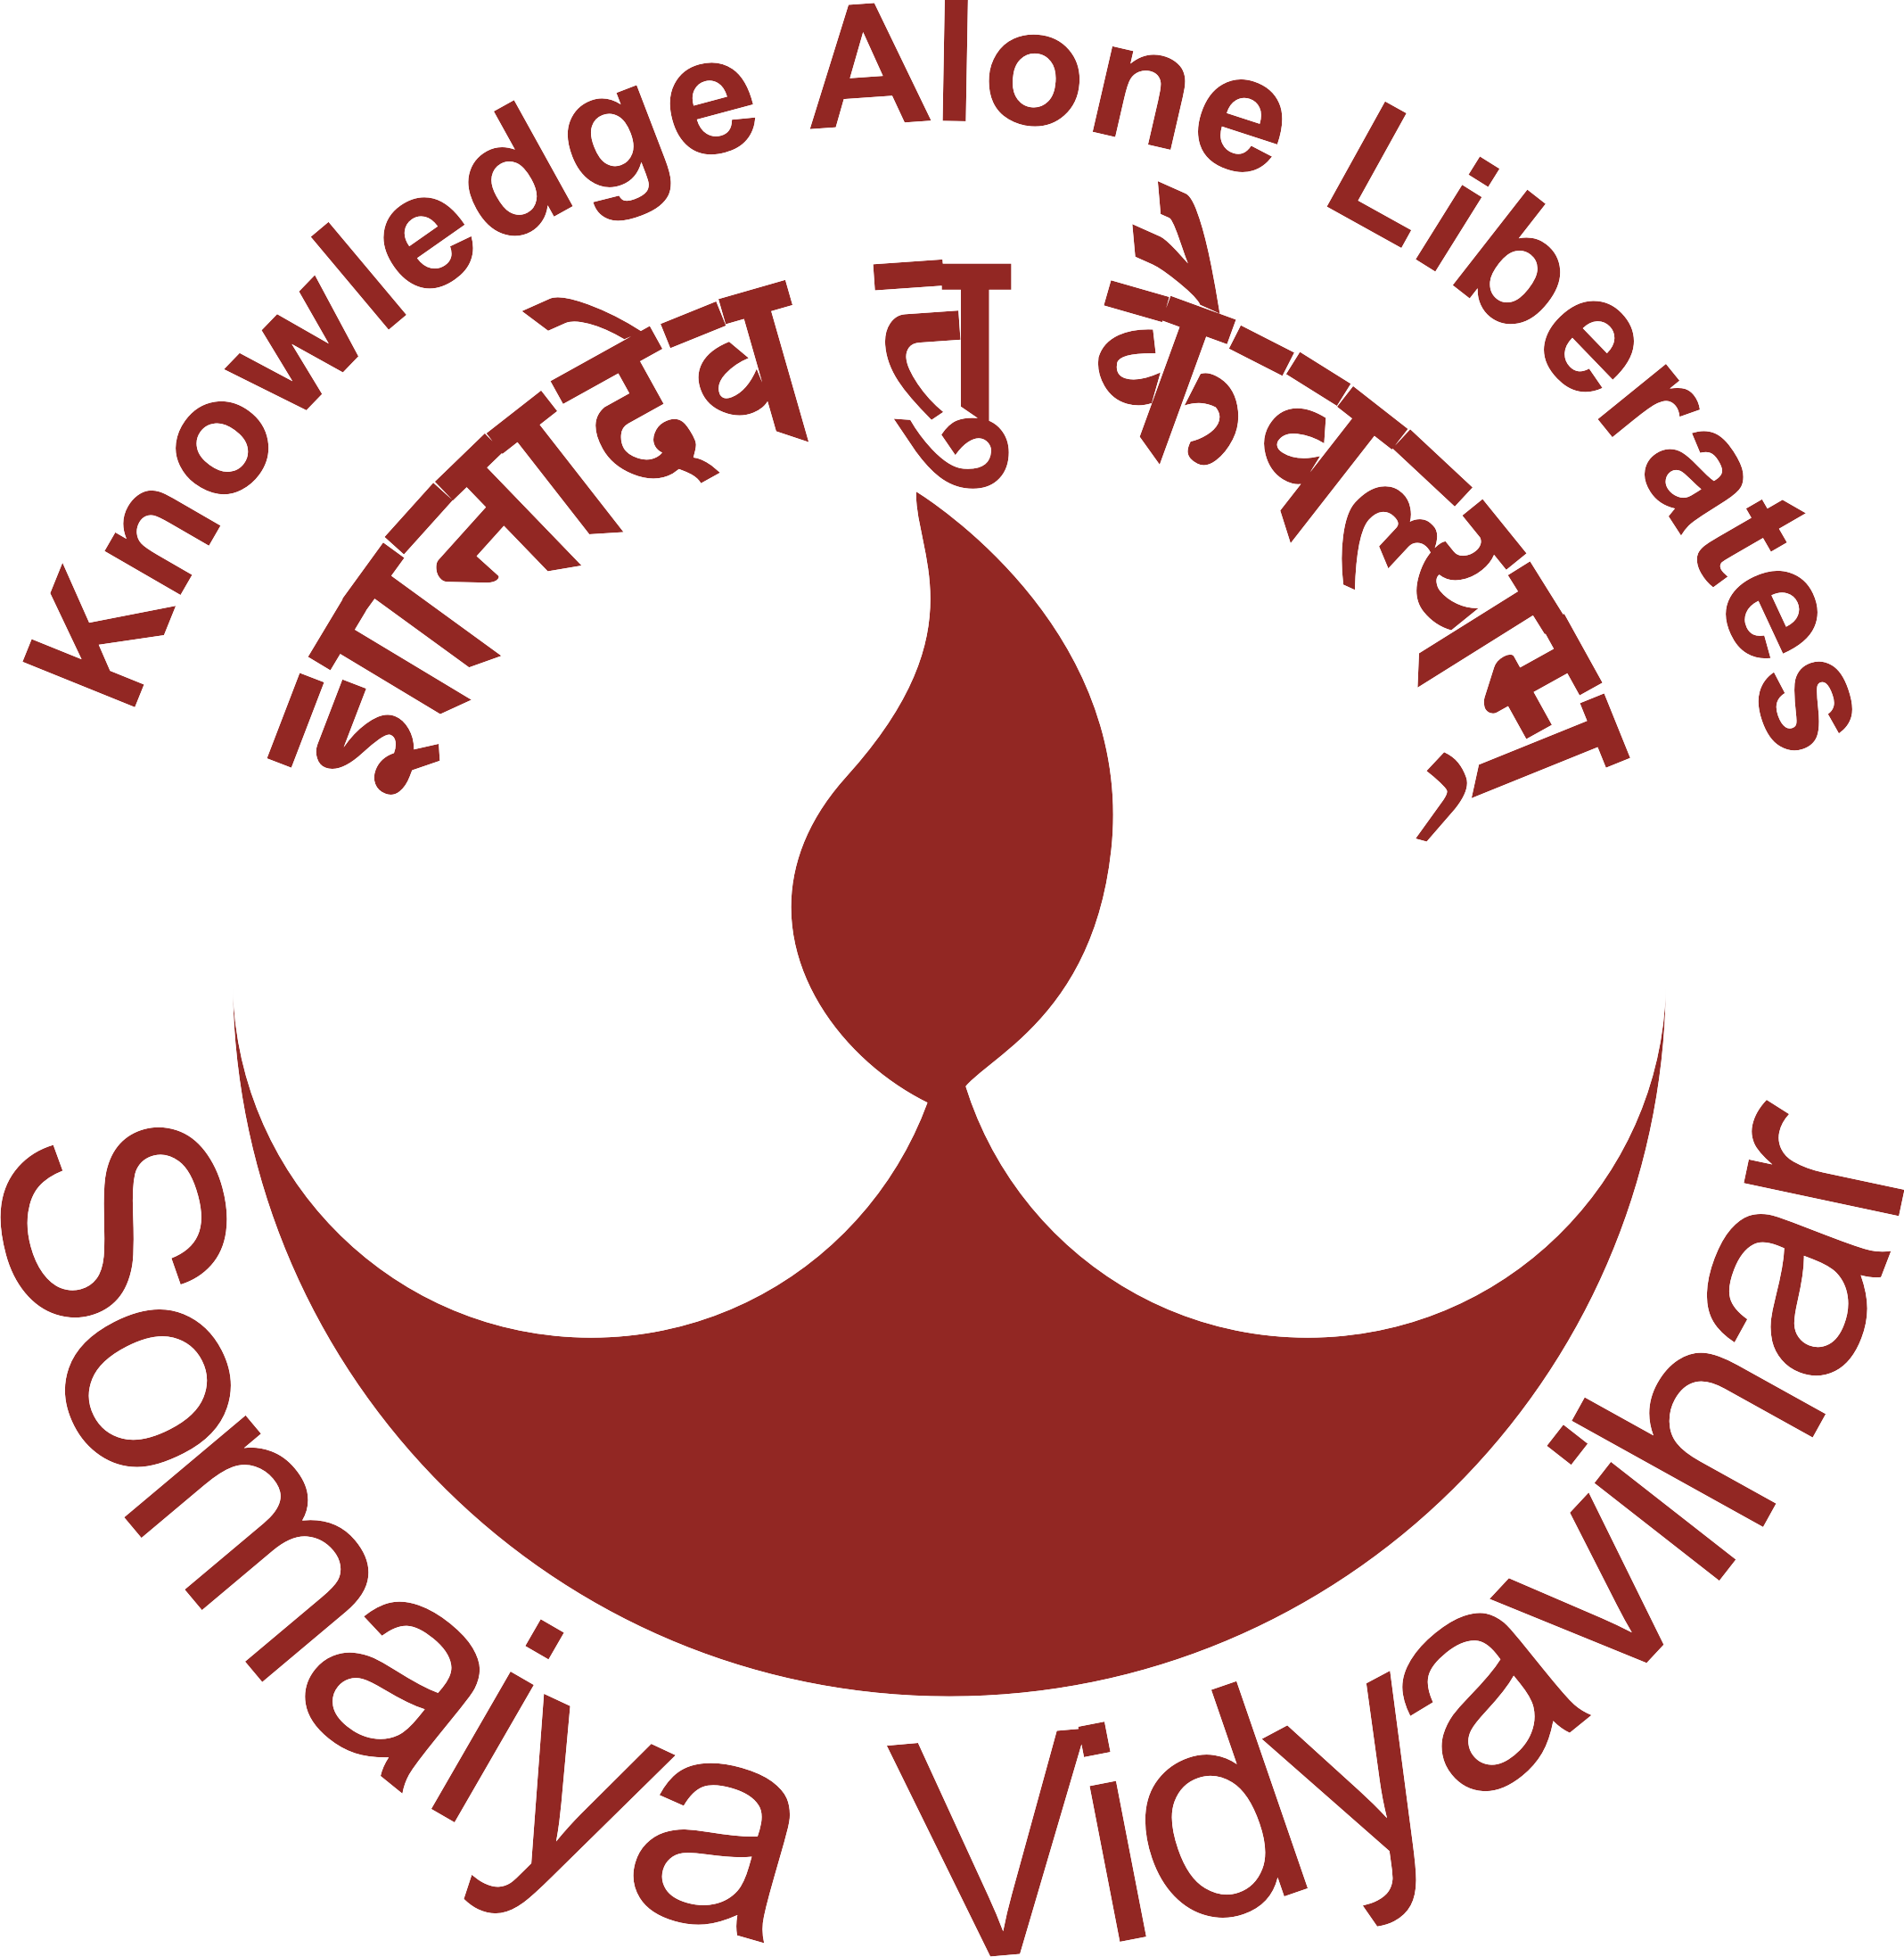

**K. J. Somaiya College of Engineering, Mumbai-77**

**(Autonomous College Affiliated to University of Mumbai)**

**Presents**

PRAKALPA 2017

**State Level Conference and Working Model Exhibition**

March 31 & April 01, 2017

**Organized by**

**ISTE Students’ Chapter KJSCE (MH-60)**



Contact

**Convener, Prakalpa 2017**

**K. J. Somaiya College of Engineering**

**Vidyavihar, Mumbai - 400 077**

**www.somaiya.edu/vidyavihar/kjsce**

[prakalpa2017@gmail.com](mailto:prakalpa2017@gmail.com)

www.iste-kjsce.org