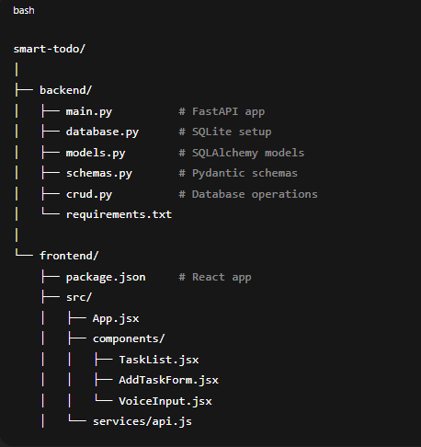
PS C:\Users\HP VICTUS\OneDrive\Desktop\Projects\Smart-to-do\frontend> npm start
PS C:\Users\HP VICTUS\OneDrive\Desktop\Projects\Smart-to-do\backend> uvicorn main:app --reload

venv\Scripts\activate
.\venv\Scripts\Activate.ps1
uvicorn main:app --reload

backend: cd backend
python -m venv venv
venv\Scripts\activate # Windows
pip install -r requirements.txt
frontend: cd frontend
npm install
npm start

History tab, after done remove it from tasks

