RESUME
SUJAL GUPTA  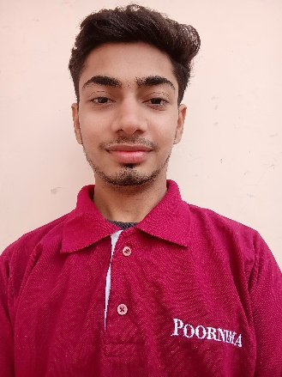  E-mail : 2023pceecsujal029@poornima.org  Contact No: +91-7230824524  Present Address: Poornima college of engineering, Sitapura, Jaipur  Permanent Address: Tijara, Alwar, Rajasthan  Personal Information:  - Name: Sujal Gupta  - Father’s Name: Govind Gupta  - Date of Birth :05/10/2004  - Nationality: Indian  - Languages known: English  And Hindi.  Interest  - Solving real life problems using technology  - Learning new things  Date: 23 December, 2025 | OBJECTIVE:  Interested in using new technologies to tackle real-world challenges through research. I am eager to apply my technical skills and creative problem-solving abilities to contribute to innovative projects.  QUALIFICATION:  - Matriculation from Ajeet Public School (Tijara) with 86% {March,2020}  - Senior Secondary from Ajeet Public School (Tijara) with 65% {March,2022}  AWARDS AND ACHIEVEMENTS:  “Special Forces Defense Glove” project achievements  - 1st position in Technovation organized by Poornima College of Engineering, Jaipur.  - 2nd position in Aadhar organized by Poornima college of engineering for Technical Competition.  - 1st position in Apogee Technical fest of BITS PILANI for Technical Competition.  - 1st position in Model presentation in MNIT Jaipur  - 2nd position in IISF 2024 at IIT Guwahati.  - 2nd position in Abhivyakti Science Fare.  - 1st position in Tek-Connect 2024.  - 2nd position in ICI Fest, SKIT Jaipur.  Other achievements  - 3rd position in WISE for Women Empowerment Poster Competition.  - Participation in Sustain-a-thone organized by Indian Oil  TECHNICAL SKILLS:  - 3D printing  - 3D Designing  - PCB designing  - IoT (Arduino, ESP)  PAPER PUBLICATIONS:  - Published research paper on “Special forces defense glove”, in STM Journals in the domain of Recent trends in sensor Research and Technology  INDUSTRIAL PRACTICAL TRAININGS:  - 15 Days Summer Internship on Python ML from Promo Daddy.  - 30 Days internship at CSIR CEERI, Jaipur in Industrial IoT.  - 45 Days Summer Internship in IoT domain from Seldom Technologies.  PROJECTS:  - Electronics and IOT Project on “Specials forces defense glove”.  - A glove “IOT thought translation glove” made for speech impaired people which help them to communicate easily like normal people.  - “A security system” which passes electricity in air .  - ^{“IoT Smart Glove” for Army.}  Declaration  I hereby declare that the information furnished above is true to the best of my knowledge and belief.  Signature  