**Name: Vidhi Gulhane**

**Roll No: 17 (D10B) IT**

Q1} To write a c program to implement Paging technique for memory management.

#include <stdio.h>

#include <stdlib.h>

#define PAGE_SIZE 1024

#define NUM_FRAMES 4

#define NUM_PAGES 8

int page_table[NUM_PAGES];

void initialize_page_table() {

for (int i = 0; i < NUM_PAGES; i++) {

page_table[i] = -1; }}

void display_page_table() {

printf("\nPage Table:\n");

for (int i = 0; i < NUM_PAGES; i++) {

printf("Page %d -> Frame %d\n", i, page_table[i]);}

printf("\n");}

int main() {

initialize_page_table();

int logical_memory[NUM_PAGES][PAGE_SIZE];

int physical_memory[NUM_FRAMES][PAGE_SIZE];

for (int i = 0; i < NUM_PAGES; i++) {

int page_number = rand() % NUM_PAGES;

if (page_table[page_number] == -1) {

int frame_to_replace = i % NUM_FRAMES;

printf("Page %d is not in memory. Loading into Frame %d\n", page_number, frame_to_replace);

for (int j = 0; j < PAGE_SIZE; j++) {

physical_memory[frame_to_replace][j] = logical_memory[page_number][j];}

page_table[page_number] = frame_to_replace;}}

display_page_table();

return 0;}

**Output:**

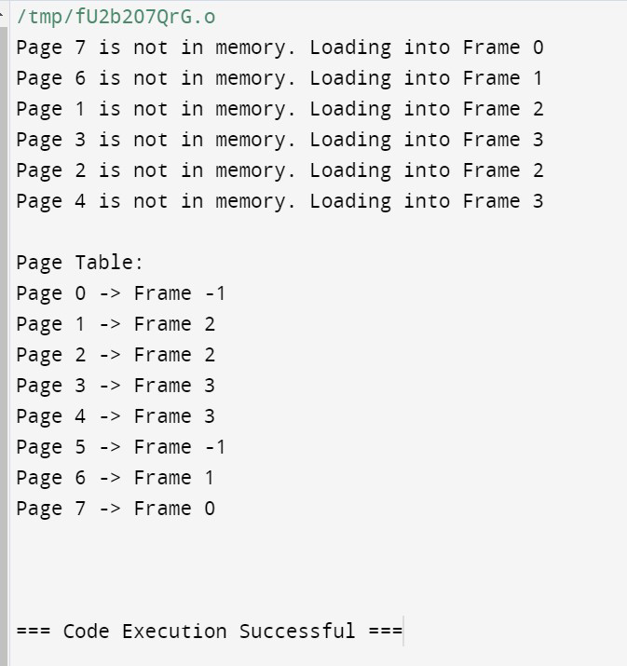

**Q2} Implement various disk scheduling algorithms like SCAN, and C-SCAN in C/Python/Java.**

**SCAN**

#include <stdio.h>

#include <stdlib.h>

#include <string.h>

#define size 10

#define disk_size 200

int comp(const void * l, const void * n) {

return (*(int*)l - *(int*)n);

}

void SCAN(int arr[], int head, char* dn){

int seek_num = 0;

int dt, cur_track;

int leftside[size], rightside[size];

int seek_seq[size + 3];

int m_scan = 0, s_scan = 0;

if (strcmp(dn, "leftside") == 0)

leftside[m_scan++] = 0;

else if (strcmp(dn, "rightside") == 0)

rightside[s_scan++] = disk_size - 1;

for (int p_s = 0; p_s < size; p_s++) {

if (arr[p_s] < head)

leftside[m_scan++] = arr[p_s];

if (arr[p_s] > head)

rightside[s_scan++] = arr[p_s];

}

qsort(leftside, m_scan, sizeof(int), comp);

qsort(rightside, s_scan, sizeof(int), comp);

int go = 2;

int ind = 0;

while (go--) {

if (strcmp(dn, "leftside") == 0) {

for (int p_s = m_scan - 1; p_s >= 0; p_s--) {

cur_track = leftside[p_s];

seek_seq[ind++] = cur_track;

dt = abs(cur_track - head);

seek_num += dt;

head = cur_track;

}

dn = "rightside";

}

else if (strcmp(dn, "rightside") == 0) {

for (int p_s = 0; p_s < s_scan; p_s++) {

cur_track = rightside[p_s];

seek_seq[ind++] = cur_track;

dt = abs(cur_track - head);

seek_num += dt;

head = cur_track;

}

dn = "leftside";

}

}

printf("Num of seek process = %d", seek_num);

printf("Sequence is");

for (int p_s = 0; p_s < ind; p_s++) {

printf("%d", seek_seq[p_s]);

}

}

int main(){

int arr[size] = { 126, 90, 14, 50, 25, 42, 51, 78, 102, 100 };

int head = 42;

char dn[] = "leftside";

SCAN(arr, head, dn);

return 0;}

Output:

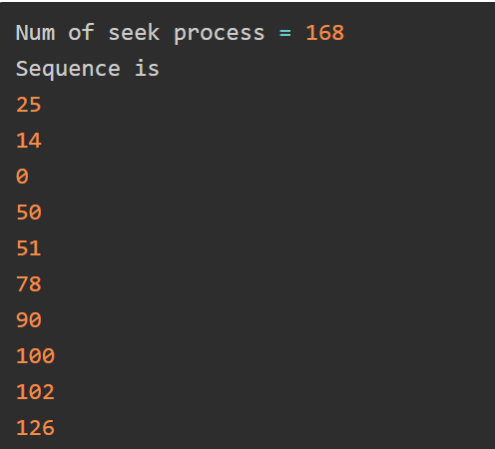

**C-SCAN:**

size = 8

disk_size = 200

def CSCAN(arr, head):

seek_count = 0

distance = 0

cur_track = 0

left = []

right = []

seek_sequence = []

left.append(0)

right.append(disk_size - 1)

for i in range(size):

if (arr[i] < head):

left.append(arr[i])

if (arr[i] > head):

right.append(arr[i])

left.sort()

right.sort()

for i in range(len(right)):

cur_track = right[i]

seek_sequence.append(cur_track)

distance = abs(cur_track - head)

seek_count += distance

head = cur_track

head = 0

seek_count += (disk_size - 1)

for i in range(len(left)):

cur_track = left[i]

seek_sequence.append(cur_track)

distance = abs(cur_track - head)

seek_count += distance

head = cur_track

print("Total number of seek operations =",

seek_count)

print("Seek Sequence is")

print(*seek_sequence, sep="\n")

arr = [176, 79, 34, 60,

92, 11, 41, 114]

head = 50

print("Initial position of head:", head)

CSCAN(arr, head)

