NVISION

Java miniproject using swing

// some comment

Ms. Nidhee Kamble  
Ms. Vidhi Rambhia **Project duration:** 5th November 2018 – 12th November 2018

Contents

Abstract 1

Softwares Used 3

Software and Code 4

Use and Demo 7

Future Scope 20

Bug Reports and Challenges 22

Bibliography 24

# Abstract

### // one-line summary

## motivation

// edit

## PUrpose

// edit.

// some shit

# Software Used

## Source code

* Backend: Java (JDK v1.8)
* Frontend: Java (Swing)

## EXECUTION

* IDE: Eclipse (v2018-09)
* Command Prompt on Windows 10

The references used for the project are listed under the *Bibliography* header in this document.

# Software and Code

## GITHUB REPOSITORY

The project can be found at: <https://github.com/VidhiRambhia/JAVA_project.git>

The main directory consists of:

* **.git** (folder)
* **.metadata** (folder)
* **.recommenders (**folder)
* **Final_Project** (folder) – Main implementation:

1. src (folder) – Has all the images, .java, and .class files
2. bin (folder) – Contains post-compilation elements
3. NVision – Documentation of the project

* **BackUp** (Python file)
* **Code of Conduct** (MD file) – Lays out the GitHub etiquette concerning the project
* **README** (MD file) – An overview of the GitHub repository

The application can be run by running the file FirstPage.java in either Command Prompt or an IDE (preferably the same as was used while designing).

## EXISTING FEATURES

### The application, as of on 13th November 2018, works with the following facets fully implemented:

* **Main screen**  
  Introduces the application. Offers the user to either take a quiz or list down tasks for the day.
* **An Interactive Quiz Session**There are four subjects, that have a set questionnaire:

1. Java
2. DLD
3. Data Structures
4. EVS

The questions may be bookmarked for reference. Such questions may be revisited once till the quiz is submitted.

At the end of the session, the user gets to know his final score. Thus helping him stay up-to-date with his academic curriculum.

* **To-Do List**Three tasks can be listed. Once a task is marked as done, it is cleared and a new task may be added in its place. The cycle continues as long as the user operates on this keeping the frame open.

Frames for To-Do Lists for multiple users can be generated with each run. All such frames function independently of each other.

# Use and Demo

The application opens on the Navigator Page. ‘Take a quiz’ and ‘List today’s tasks’, on clicking, redirect to the quiz menu and To-Do List respectively.

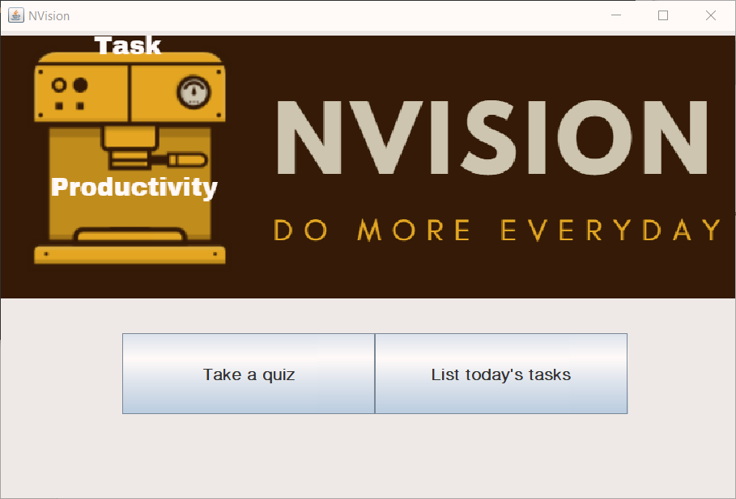

On selecting the second option, a prompt for entering a name is displayed. The name so entered appears as the header on the list of the new To-Do List. An empty To-Do List looks like this:

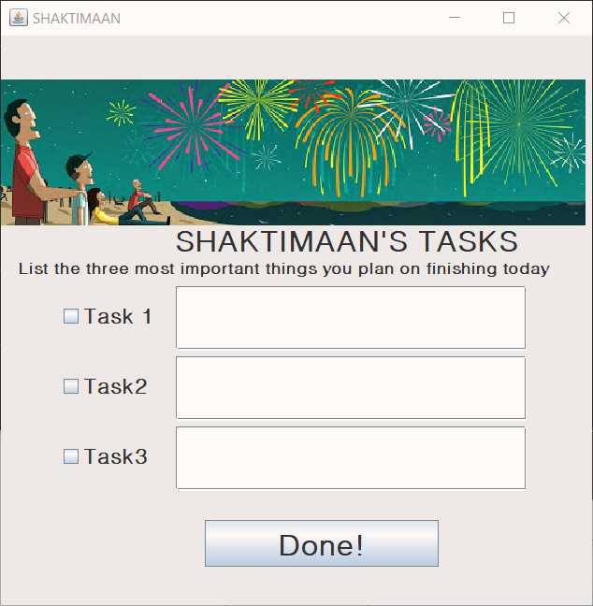

While running in an IDE or even using Windows cmd or Linux Terminal, multiple lists can be generated. The tasks in the list are tracked according to their completion independently for different lists.

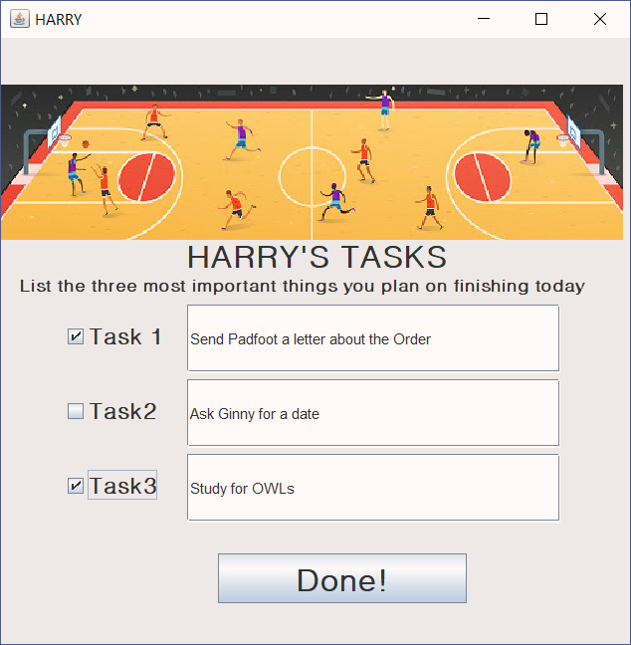 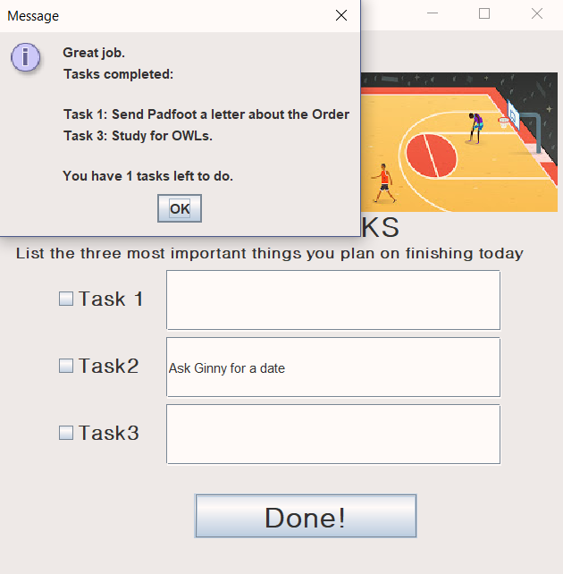

A task one marked as done, is cleared. A reminder is displayed on clicking on ‘Done!’. New asks may be added.

On selecting the option for the quiz from the Navigation Page, the following frame appears:  
  
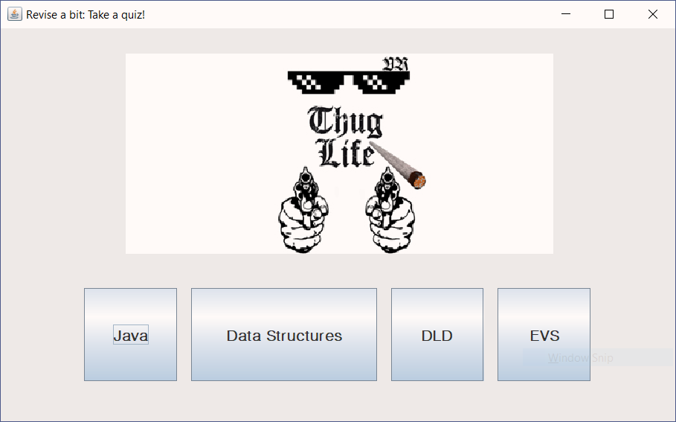

Questions are displayed according to the subject selected:

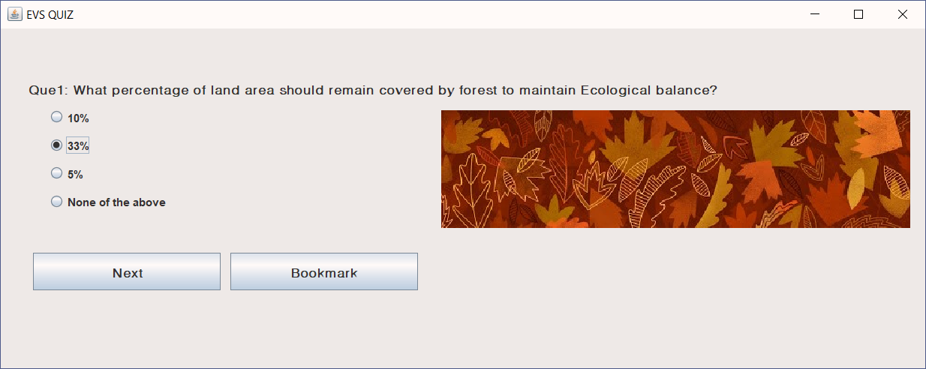

The bookmarked questions may be visited once again by clicking on the ‘Bookmark[number]’ button. The button appears only if a question has been previously labelled accordingly by the user:

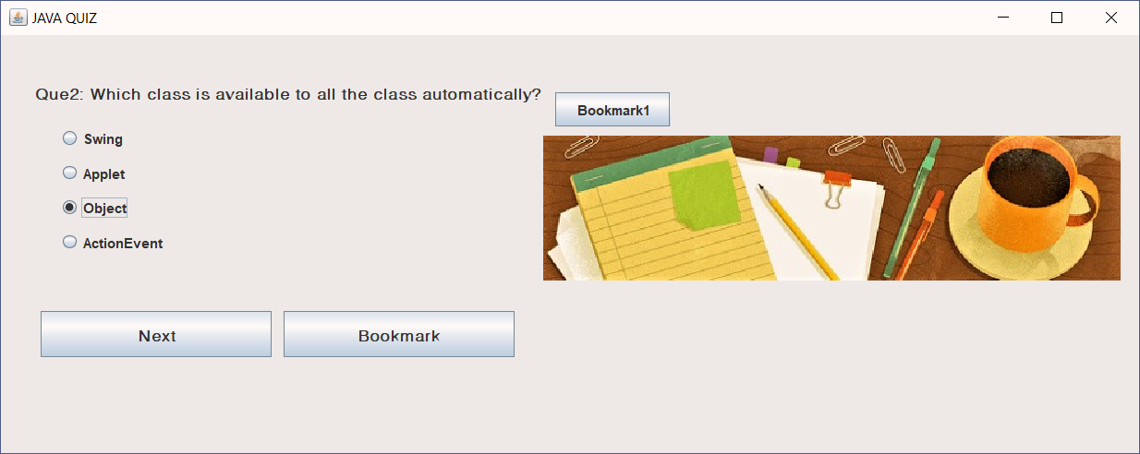

After reaching the final question, the result is displayed in a message prompt that is flashed on clicking on ‘Result’:

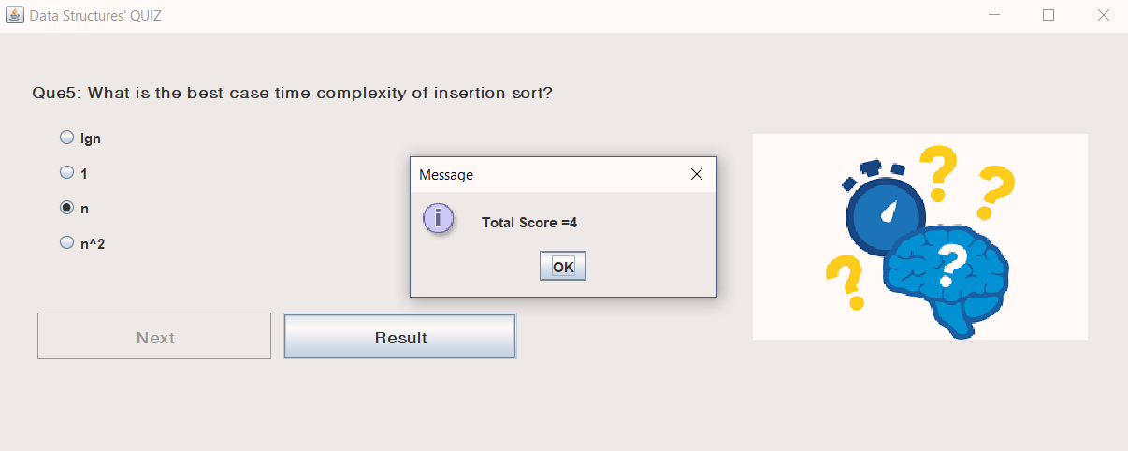

# Future Scope

## release

// add

## Basic modifications

* Swing shapes the core of this project. However, in today’s time, versatile frameworks and libraries have been successful in overcoming limitations of the traditional Swing. Such frameworks may be incorporated in future either by integrating them with the existing module, if possible, or by replacing it.
* // Daalde kuch

## FEATURE ADDITIONS

* **At present, the questionnaire in the quiz session consists of a limited set of questions for prototype demonstration purpose. However, in future, after deployment, a provision can be made for accepting scholarly contributions from all over the world and thus helping our users to enrich their repository of knowledge in subjects of their choice.**
* // To Do ka daalde kuch

# Bug Reports and Challenges

## Viewing experience

* Nvision makes the best use of Swing to give its users a simple and aesthectic interface.
* For this, the developers have ensured that every button the application has, has been described aptly so as to avoid any kind of ambiguity for its users
* Appropriate messages are displayed at all times, thus keeping the user updated at all times with his quiz score, tasks completed,etc.

## avoiding errors

The current version Nvision is totally bug-free.

# Bibliography

resources referred

|  |  |  |  |
| --- | --- | --- | --- |
| NAME | referred for | link |  |
| Stackoverflow Stackexchange | Resolution of errors | <https://stackoverflow.com/>  <https://stackexchange.com/> |  |
| java T point | Swing Basics | <https://www.javatpoint.com/java-swing> |  |
| Tutorials Point | <https://www.tutorialspoint.com/swing/> |  |

Java Mini Project, Semester 3, Year 2018-19

Subject in-charge: Professor Chitra Sahu,  
  
Veermata Jijabai Technological Institute,  
  
Matunga, Mumbai.

**NVision**

