E-COMMERCE SALES AND
CUSTOMER INSIGHTS DASHBOARD
PROJECT REPORT

Submitted By
VIDHI SONI
Course
B.Tech – Information Technology
Semester
7th Semester
Project Domain
Data Analytics / Business Intelligence
Technologies Used
Python | Pandas | Matplotlib | Streamlit

ABSTRACT
The E-Commerce Sales and Customer Insights Dashboard is a data analytics and business intelligence project designed to analyze e-commerce transaction data and present useful business information through an interactive dashboard. The project uses a dataset containing 3,500 transactions with attributes such as Order Date, Product Name, Category, Region, Quantity, Sales, and Profit.
Python and Pandas are used for data loading, cleaning, grouping, aggregation, and KPI calculation. Matplotlib is used for analytical visualization, while Streamlit is used to create an interactive dashboard interface. The analysis focuses on total sales, total profit, total orders, average order value, category performance, regional performance, product performance, and monthly sales trends.
The final dashboard converts raw transaction data into understandable visual information and summarizes the major findings as business insights and recommendations.

TABLE OF CONTENTS
1. Introduction
2. Problem Statement
3. Objectives
4. Scope of the Project
5. Dataset Description
6. Tools and Technologies
7. Methodology
8. System / Dashboard Design
9. Implementation
10. Key Performance Indicators
11. Analysis and Results
12. Dashboard Description
13. Key Insights
14. Business Recommendations
15. Limitations
16. Future Scope
17. Conclusion
18. References

1. INTRODUCTION
E-commerce businesses generate a large amount of transaction data through customer orders and sales activities. This data contains information about products, categories, regions, quantities, sales values, profits, and dates. Raw transaction records are difficult to interpret directly, so data analysis and visualization are required to identify meaningful patterns and trends.
The E-Commerce Sales and Customer Insights Dashboard is developed to transform e-commerce transaction data into useful business information. The project uses Python-based data analytics techniques and an interactive Streamlit dashboard to present key business metrics and visualizations.
The project follows the analytics flow: Raw Data → Data Analysis → Visualization → Insights → Recommendations. The dashboard provides an overview of sales and profit performance and allows the results to be interpreted from product, category, regional, and time-based perspectives.
The main purpose is not only to display charts, but to transform transaction data into clear, understandable, and actionable business insights.

2. PROBLEM STATEMENT
E-commerce transaction datasets contain valuable information, but raw records alone do not clearly show which categories, products, or regions are performing well. Manual inspection of thousands of transactions can make it difficult to identify trends and compare performance.
The problem addressed by this project is to develop a simple and understandable analytics dashboard that processes e-commerce transaction data, calculates important KPIs, visualizes sales and profit performance, identifies major trends, and presents actionable business insights.

3. OBJECTIVES
- Analyze overall sales performance.
- Calculate important Key Performance Indicators (KPIs).
- Identify high-performing product categories.
- Compare sales and profit across regions.
- Identify top-selling and most profitable products.
- Analyze monthly sales trends.
- Present results through clear visualizations.
- Generate business insights and practical recommendations.

4. SCOPE OF THE PROJECT
The scope is limited to the analysis of the provided e-commerce transaction dataset. The project focuses on descriptive and diagnostic business analytics rather than complex predictive modeling.
- Sales and profit analysis.
- Category-level performance.
- Regional performance.
- Product-level sales and profit.
- Monthly sales trend analysis.
- Interactive dashboard presentation.
- Business insight and recommendation generation.
Detailed customer demographic analysis is not included because the dataset does not contain customer demographic attributes.

5. DATASET DESCRIPTION
The project uses an e-commerce sales dataset containing 3,500 transaction records and 7 main columns. The data covers orders from January 2022 to December 2024.
Column | Description | Data Type
Order Date | Date on which the order was recorded | Date
Product Name | Name of the product sold | Text
Category | Product category | Text
Region | Sales region | Text
Quantity | Number of units sold | Numeric
Sales | Sales value of the transaction | Numeric
Profit | Profit generated by the transaction | Numeric

5.1 Data Quality Check
The dataset was checked for missing values and basic structure before analysis. It contains 3,500 rows and 7 columns, and the missing-value check returned zero missing values for all seven columns.

6. TOOLS AND TECHNOLOGIES
Technology | Purpose
Python | Main programming language used for data processing and dashboard development.
Pandas | Data loading, processing, grouping, aggregation, and KPI calculations.
Matplotlib | Analytical charts and visualization.
Streamlit | Interactive web-based dashboard.
Visual Studio Code | Development environment.
CSV | Data storage format.

7. METHODOLOGY
The project follows a structured data analytics workflow that converts raw records into meaningful business information.
Data Loading: The CSV dataset is loaded into a Pandas DataFrame.
Data Inspection: Rows, dimensions, column names, and missing values are checked.
Data Preparation: Order Date is converted to datetime format.
KPI Calculation: Total sales, profit, quantity, orders, and average order value are calculated.
Data Aggregation: Sales and profit are grouped by category, region, product, and month.
Visualization: Bar and line charts communicate analytical results.
Dashboard Development: Streamlit presents KPIs, charts, and insights.
Insight Generation: Results are interpreted to identify performance patterns and possible actions.

8. SYSTEM / DASHBOARD DESIGN
The dashboard is organized to present information in a logical order. KPI cards provide a high-level overview, followed by detailed sales, profit, and product analysis. The final section summarizes insights and recommendations.
- Executive Overview – Total Sales, Total Profit, Total Orders, and Average Order Value.
- Sales Analysis – Sales by Category, Sales by Region, and Monthly Sales Trend.
- Profit Analysis – Profit by Category and Profit by Region.
- Product Analysis – Sales by Product and Profit by Product.
- Key Insights & Recommendations – Summary of findings and suggested actions.
CSV Dataset → Pandas → Analysis → KPIs & Aggregation → Charts → Streamlit Dashboard → Insights

9. IMPLEMENTATION
The implementation uses Python for analysis and Streamlit for the dashboard. Pandas loads the CSV file, performs grouping and aggregation, and calculates KPIs. The dashboard loads the dataset and displays the resulting analysis through Streamlit components.

9.1 Dataset Loading
The dataset is loaded using Pandas read_csv(). The project file is “ecommerce_sales_data (2).csv”.

9.2 KPI Calculation
Total Sales is calculated by summing the Sales column. Total Profit is calculated by summing Profit. Total Orders are represented by the number of transaction records. Average Order Value is Total Sales divided by Total Orders.

9.3 Grouped Analysis
The groupby operation is used to calculate sales and profit totals for categories, regions, and products. Monthly sales are calculated after converting Order Date to datetime format.

9.4 Dashboard Development
Streamlit provides the web interface. KPI cards are displayed using columns and metric components. Bar charts are used for categorical comparisons and a line chart is used for the monthly sales trend.

10. KEY PERFORMANCE INDICATORS
KPI | Value
Total Sales | ₹10,667,881
Total Profit | ₹1,844,665.21
Total Quantity Sold | 17,261
Total Orders | 3,500
Average Order Value | ₹3,047.97
These KPIs provide a concise overview of the dataset's overall sales and profitability performance.

11. ANALYSIS AND RESULTS

11.1 Sales by Category
Category | Total Sales
Accessories | ₹4,247,591
Electronics | ₹5,326,074
Office | ₹1,094,216
Electronics records the highest total sales among the three categories.

11.2 Sales by Region
Region | Total Sales
East | ₹2,675,110
North | ₹2,488,773
South | ₹2,659,548
West | ₹2,844,450
West records the highest total sales among the four regions.

11.3 Profit by Category
Category | Total Profit
Accessories | ₹736,084.74
Electronics | ₹923,185.59
Office | ₹185,394.88
Electronics generates the highest total profit among the categories.

11.4 Profit by Region
Region | Total Profit
East | ₹464,888.46
North | ₹426,314.75
South | ₹458,103.27
West | ₹495,358.73
West generates the highest total profit among the four regions.

11.5 Product Performance
Product | Sales
Camera | ₹1,177,381
Headphones | ₹988,638
Keyboard | ₹1,024,507
Laptop | ₹1,005,873
Monitor | ₹1,160,048
Mouse | ₹1,074,398
Printer | ₹1,094,216
Smartphone | ₹1,069,681
Smartwatch | ₹1,049,211
Tablet | ₹1,023,928
Camera has the highest sales value among the listed products. Camera also has the highest product-level profit, with total profit of ₹207,630.99.

11.6 Monthly Sales Trend
Monthly sales were calculated for January 2022 through December 2024. A line chart is used in the dashboard so that changes in sales over time can be visually inspected. The project uses descriptive analysis rather than forecasting.

12. DASHBOARD DESCRIPTION
The final dashboard is implemented using Streamlit and presents the analysis in a single interactive web page. The dashboard moves from high-level KPIs to detailed analysis and finally to insights and recommendations.

12.1 Executive Overview Screenshot
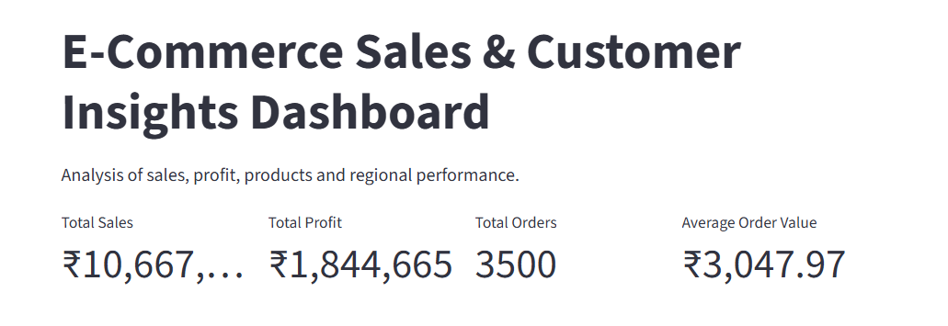
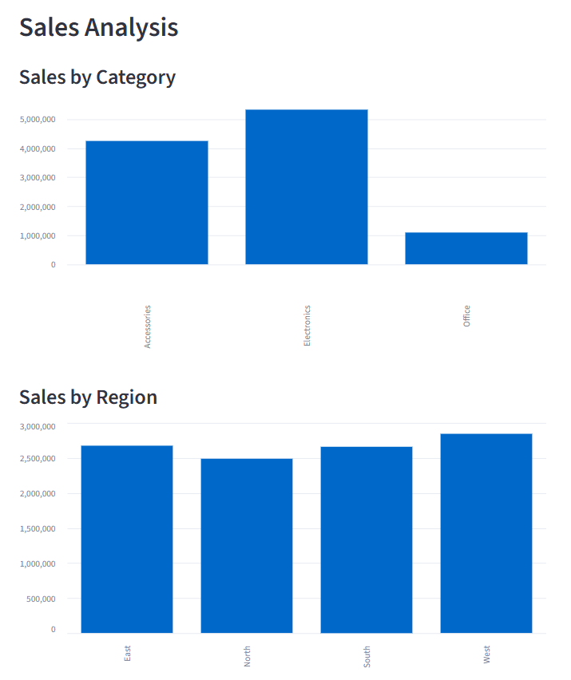

12.2 Sales and Profit Analysis Screenshot
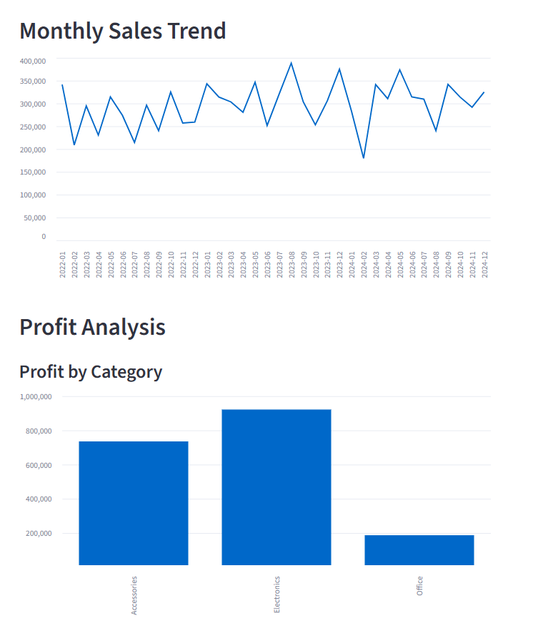
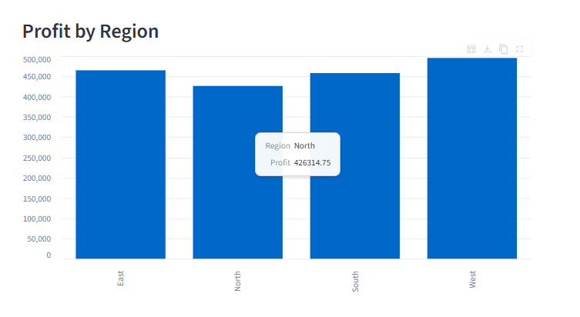

12.3 Product Analysis and Insights Screenshot
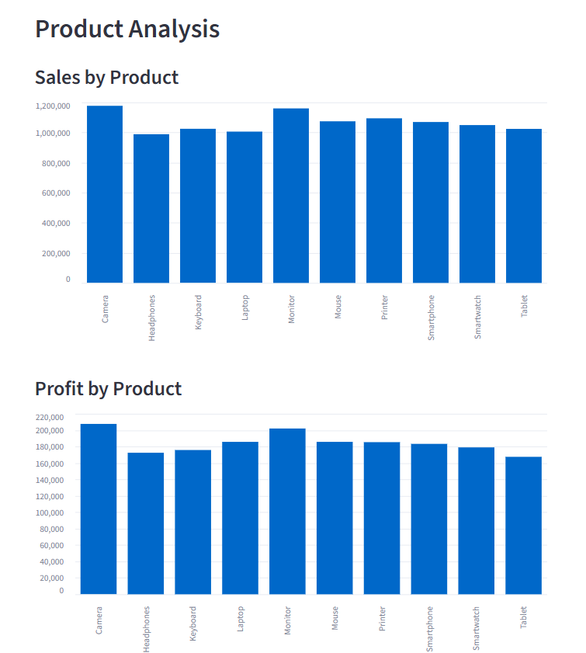
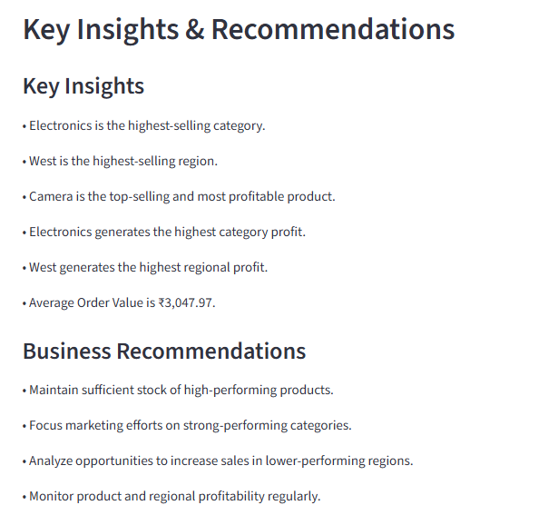

13. KEY INSIGHTS
- Electronics is the highest-selling category with total sales of ₹5,326,074.
- West is the highest-selling region with total sales of ₹2,844,450.
- Camera is the top-selling product with sales of ₹1,177,381.
- Camera is also the most profitable product with profit of ₹207,630.99.
- Electronics generates the highest category profit of ₹923,185.59.
- West generates the highest regional profit of ₹495,358.73.
- The overall average order value is ₹3,047.97.
- The dataset contains no missing values in the seven analyzed columns.

14. BUSINESS RECOMMENDATIONS
- Maintain sufficient stock of high-performing products such as Camera.
- Continue monitoring Electronics because it contributes the highest category sales and profit.
- Study successful sales patterns in the West region and evaluate whether similar practices can be applied in other regions.
- Review lower-performing categories and regions to identify opportunities for improvement.
- Monitor monthly sales trends regularly to support inventory and marketing planning.
- Track both sales and profit rather than sales alone so that business decisions consider profitability.

15. LIMITATIONS
- The project is based on a single transaction dataset.
- The dataset does not provide detailed customer demographic information.
- The dashboard focuses mainly on descriptive and diagnostic analysis.
- No sales forecasting or predictive model is included in the current version.
- Recommendations are based on the available dataset and should be reviewed with additional business information before operational decisions.

16. FUTURE SCOPE
- Add customer-level attributes when suitable data is available.
- Add interactive filters for date, region, category, and product.
- Add sales forecasting using suitable time-series or machine-learning methods.
- Add customer segmentation when customer-level data is available.
- Connect the dashboard to a live database.
- Deploy the Streamlit dashboard online for controlled access.
- Add automated report generation and scheduled business summaries.

17. CONCLUSION
The E-Commerce Sales and Customer Insights Dashboard demonstrates how raw e-commerce transaction data can be converted into meaningful business information using data analytics and visualization techniques.
The project calculates important KPIs and analyzes sales and profit by category, region, product, and month. The Streamlit dashboard presents these results in an accessible format and summarizes the main findings as business insights and recommendations.
The project demonstrates the complete analytics cycle from data loading and inspection to analysis, visualization, interpretation, and decision support.

18. REFERENCES
- Python Documentation – https://docs.python.org/
- Pandas Documentation – https://pandas.pydata.org/docs/
- Matplotlib Documentation – https://matplotlib.org/stable/
- Streamlit Documentation – https://docs.streamlit.io/
- Kaggle – https://www.kaggle.com/

