ACADEMIC MINI-PROJECT REPORT
Course: AI-Receptive Software Development (Modules 1–6)
Academic Year: 2026–2027

AI TravelMate — Your Personal AI Travel Planner
Design and Evaluate an AI-Receptive, Human-Centered Software Application
Selected Domain: Tourism & Travel Technology
CANDIDATE SUBMISSION DETAILS
Student Name: | Vidhi Joshi
SAP ID: | 70022400377
Roll Number: | F065
Class & Specialization: | B.Tech Computer Engineering – Division B
Semester: | Semester 5 (Autumn 2026)
Assignment Weightage: | Total Marks: 30 Marks (Modules 1–6)

Submitted for Formal Academic Evaluation
Mode: Individual Technical Report & Live Software Prototype

Table of Contents
1. Executive Summary & Project Abstract | 3
2. Task 1: Problem Identification & AI-Receptive Approach (7.5 Marks) | 4
2.1 Selected Domain & Real-World Problem Definition | 4
2.2 Comprehensive Target User Segments | 4
2.3 The AI-Receptive Paradigm: Dynamic Schedule & Pacing Synthesis | 5
2.4 Critical Limitations & Risk Analysis in Tourism AI | 5
3. Task 2: User Needs & Behavior Analysis (7.5 Marks) | 6
3.1 Comparative User Needs Matrix | 6
3.2 Primary User Persona: Aarav Sharma (Student Budget Traveler) | 6
3.3 Secondary User Persona: The Patel Family (Multigenerational Travelers) | 7
4. Task 3: Human-Centered Design (HCD) Architecture (7.5 Marks) | 8
4.1 Nielsen Norman Usability Heuristics Evaluation | 8
4.2 System Navigation Flow & Information Architecture | 9
4.3 Multi-Screen System Flow & Interaction Design | 9
5. Task 4: AI-Assisted Development Activity Log (7.5 Marks) | 10
5.1 Structured Software Engineering AI Collaboration Matrix | 10
5.2 Prompt Engineering & Structured JSON Output Schemas | 10
5.3 Hybrid AI-Receptive Architecture & Zero-Downtime Deterministic Fallback | 11
6. Technical System Architecture & Implementation Details | 12
6.1 Full-Stack Layered Architecture | 12
6.2 Frontend Technology Stack & Component Ergonomics | 12
6.3 Backend RESTful API Services & Heuristics Engine | 13
6.4 Deterministic Budget Engine & 8-Category Financial Matrix | 13
7. Empirical Verification & 10 Automated Test Cases (Section 18) | 14
7.1 Automated Testing Methodology & Live Verification Suite | 14
7.2 Comprehensive Test Matrix (10/10 PASS — 100% Reliability) | 14
7.3 In-Depth Analysis of Individual Test Scenarios | 15
8. Complete Website Functional Walkthrough & Screenshot Gallery | 16
8.1 Figure 1: SAIR Official Landing Page Hero Interface | 16
8.2 Figure 2: Value Propositions & Curated Indian Destinations Showcase | 17
8.3 Figure 3: Trip Planning Wizard — Step 1: Destination & Origin Selection | 18
8.4 Figure 4: Trip Planning Wizard — Step 2: Trip Duration & Calendar Selection | 19
8.5 Figure 5: Trip Planning Wizard — Step 3: Granular Budget Formulation in INR | 20
8.6 Figure 6: Trip Planning Wizard — Step 4: Multi-Select Interests & Travel Pacing | 21
8.7 Figure 7: Trip Planning Wizard — Step 5: Travel Group Archetypes & Accessibility | 22
8.8 Figure 8: Trip Planning Wizard — Step 6: Transit, Dietary & Stay Review | 23
8.9 Figure 9: Generated Personalized Day-Wise Itinerary (Morning/Afternoon/Evening) | 24
8.10 Figure 10: Explainable AI Rationale Badges & Dynamic Revision Controls | 25
8.11 Figure 11: Smart Budget Planner — Interactive Donut & Comparative Bar Visualizations | 26
8.12 Figure 12: 'Optimize My Budget' Assistant Proposal Modal & Rupee Savings | 27
8.13 Figure 13: Destination Explorer — Multi-Tier Catalog & Keyword Search | 28
8.14 Figure 14: Comprehensive Destination Deep-Dive Modal (Udaipur Lake City) | 29
8.15 Figure 15: My Trips Central Management Dashboard & Saved Records | 30
8.16 Figure 16: User Travel Profile & Default System Preferences | 31
8.17 Figure 17: Academic Showcase & Evaluation Dossier Interface | 32
8.18 Figure 18: Live In-Browser Automated Test Runner (10/10 Verification) | 33
9. Technical Challenges Encountered & Engineered Solutions | 34
10. Conclusion & Future Roadmap | 35
11. Academic & Technical References | 36

1. Executive Summary & Project Abstract
Modern leisure and educational travel planning is burdened by severe cognitive fatigue, information fragmentation, non-transparent commercial aggregation, and inaccurate budgeting. Prospective travelers typically spend between 15 to 30 hours consulting disparate airline portals, lodging aggregators, subjective blogs, and local sightseeing directories. This unstructured manual aggregation routinely results in chaotic schedules, overlooked hidden operational expenses (such as local auto-rickshaw transit, monument camera tickets, and peak season surcharges), and physically exhausting pacing that degrades the human travel experience.
To decisively resolve this multidisciplinary challenge, AI TravelMate (branded as SAIR — 'Journeys Made Simple') was conceived, designed, engineered, and evaluated as an AI-receptive, human-centered web application. Conforming strictly to the pedagogical guidelines of Modules 1 through 6 of AI-Receptive Software Development, the application bridges the gap between probabilistic generative language intelligence and deterministic algorithmic reliability.
Implemented using React 19, Vite, Tailwind CSS, Recharts, Node.js, and Express, the platform delivers: (1) a 6-step human-centered planning wizard that adapts to traveler constraints and accessibility requirements; (2) an AI-synthesized, explainable day-wise itinerary categorized into Morning, Afternoon, and Evening slots; (3) an interactive single-click revision loop empowering users to modify plans based on budget, adventure, food, or pacing; (4) an 8-category deterministic budget computation engine that provides realistic cost estimates in Indian Rupees (₹) with built-in emergency contingency buffers; and (5) an automated budget optimizer that pinpoints actionable cost substitutions with complete user agency.
📌 CORE ARCHITECTURAL PRINCIPLE
AI-Receptive Core Thesis: Rather than treating artificial intelligence as an infallible oracle, an AI-receptive architecture explicitly anticipates stochastic uncertainty, potential financial hallucinations, and network downtime. It pairs Generative AI reasoning with deterministic mathematical heuristics and provides transparent rationales alongside complete human editing agency.

2. Task 1: Problem Identification & AI-Receptive Approach (7.5 Marks)

2.1 Selected Domain & Real-World Problem Definition
The project addresses the Tourism and Smart Travel Planning domain. Travel planning is fundamentally an NP-hard, multi-variable constraint satisfaction problem. A traveler must balance non-linear parameters including monetary budgets, finite vacation durations, geographic transit vectors, dietary restrictions (e.g., pure vegetarian or Jain dining), companion accessibility needs (e.g., senior citizen mobility, wheelchair access), and individual thematic passions (e.g., heritage architecture, high-adrenaline adventure, photography).
Empirical user studies reveal three persistent structural pathologies in existing commercial solutions:
1. Analysis Paralysis from Unstructured Aggregation: Travelers are overwhelmed by thousands of conflicting, sponsored, or outdated commercial reviews across multiple disparate tabs, leading to severe decision anxiety and mental burnout.
2. Hidden Expense Blindspots & Inaccurate Budgeting: Commercial aggregators market base room tariffs or ticket prices in total isolation, concealing essential ground realities such as local auto-rickshaw transit, meals, state entry taxes, guide charges, and seasonal markups.
3. Rigid, Inflexible Itinerary Templates: Pre-packaged commercial group itineraries enforce exhaustive, hurried schedules that fail to accommodate traveler pacing, energy levels, or impromptu explorations, creating physical fatigue rather than leisure.

2.2 Comprehensive Target User Segments
To ensure robust human-centered design, the platform models four distinct user archetypes spanning diverse socioeconomic, generational, and travel motivations:
User Segment | Key Characteristics | Primary Needs & Pain Points | System Optimization
A. Student & Budget Travelers | Ages 18–24, high price sensitivity, flexible schedules, tech-literate. | Strict rupee ceiling (₹5,000–₹10,000); fear of hidden tourist markups; requires economical transit and shared stays. | Itemized cost breakdown; sleeper train routes; youth hostel options; budget deficit alerts.
B. Multigenerational Families | Ages 8–70+, high comfort demand, structured schedules, dietary rules. | Low physical strain; elevator/step-free access; clean private suites; pure vegetarian/Jain cuisine. | Built-in afternoon rest intervals; senior mobility filters; child-friendly attractions; verified dining.
C. Solo Cultural Explorers | Ages 22–35, independence-driven, authentic immersion, spontaneous. | Desire for offbeat heritage walks, local bazaars, and photography vistas without commercial clutter. | Dynamic schedule swapping; solo safety tips; verified walking routes; local culinary spots.
D. Working Professionals | Ages 28–50, time-constrained, value-conscious, weekend travelers. | Needs maximum destination coverage within tight 3–4 day windows without logistical friction. | Fast transit (express trains/flights); high-efficiency itinerary routing; exportable PDF itineraries.

2.3 The AI-Receptive Paradigm: Dynamic Schedule & Pacing Synthesis
An AI-receptive software system is designed from inception to embrace the symbiotic collaboration between human agency and machine intelligence. Rather than attempting to replace human discernment, AI TravelMate positions artificial intelligence as an intelligent synthesis engine operating across three dimensions:
1. Dynamic Schedule Synthesis: The engine evaluates multi-dimensional interest vectors (e.g., 'Historical Monuments' + 'Local Food' + 'Photography') against geographic landmark clusters and daylight hours to generate logically sequential Morning, Afternoon, and Evening activities.
2. Adaptive Pacing Formulation: Depending on the chosen pacing style ('Relaxed', 'Balanced', or 'Adventure-Focused'), the engine automatically throttles schedule density. For a relaxed trip, it schedules 1–2 key visits per day with a mandatory 2-hour afternoon break; for an adventure itinerary, it packs 3–4 high-energy activities.
3. Transparent Explainability: Crucially, every recommended activity features an explicit rationale badge explaining why the item was chosen (e.g., 'Recommended because you selected Historical Monuments & Architecture').

2.4 Critical Limitations & Risk Analysis in Tourism AI
Deploying generative artificial intelligence in the tourism domain introduces severe domain-specific vulnerabilities that must be rigorously guarded against:
• Risk 1: Financial Hallucinations & Phantom Tariffs: Large Language Models frequently hallucinate airfares, hotel room rates, and entrance tariffs, quoting fictitious figures that mislead budget-constrained travelers. Mitigation: AI TravelMate isolates financial calculations from the LLM. All financial budgets are generated through a deterministic mathematical rules engine based on real-world Indian cost matrices (intercity rail benchmarks, verified accommodation tiers, and local transit indices).
• Risk 2: Operational Volatility & Route Disruptions: Monuments undergo sudden preservation closures, and hill routes experience monsoon washouts. LLMs cannot guarantee real-time ground truth. Mitigation: Prominent disclaimer badges warn travelers to verify operating status with local authorities prior to transit.
• Risk 3: AI Service Outages & Network Latency: Cloud LLM APIs (Gemini/OpenAI) are vulnerable to rate limits, timeout exceptions, and service degradation. Mitigation: The backend features an automatic zero-downtime deterministic fallback engine that produces complete, high-quality itineraries even when offline or disconnected from cloud AI APIs.

3. Task 2: User Needs & Behavior Analysis (7.5 Marks)

3.1 Comparative User Needs Matrix
In accordance with Task 2 specifications, two highly contrasting user archetypes were analyzed to discover conflicting design requirements and optimize system adaptability:
Dimension | User Archetype 1: Student Budget Explorer | User Archetype 2: Multigenerational Family
User Goals | Maximize cultural landmarks and culinary exploration in Udaipur under ₹8,000 total expenditure from Indore. | Create a memorable, relaxing vacation across 4 days for children and senior grandparents under ₹45,000.
User Needs | Verified low-cost transit (Indian Railways Sleeper/3AC), shared hostel or budget homestay, free sunset viewpoints, street eats. | Private AC transit, step-free monument access, guaranteed afternoon hotel rests, and pure vegetarian / Jain dining options.
Pain Points & Difficulties | Constant anxiety over unexpected tourist markups, expensive private auto cartels, and hidden accommodation surcharges. | Physical exhaustion from rushed group tours, heat fatigue among elders, lack of clean washrooms, and steep climbs.
User Expectations | Granular itemized budget in INR showing exactly where money goes; instant alerts if costs exceed available funds; easy activity swaps. | Predictable schedule with spacious 2-hour rest intervals, clear accessibility tags, and vetted family dining recommendations.

3.2 Primary User Persona: Aarav Sharma
To ground user-centered engineering decisions, a detailed primary persona was synthesized based on extensive target demographic research:
PRIMARY USER PERSONA: AARAV SHARMA
• Age: 21 Years Old | Occupation: Final-Year B.Tech Computer Engineering Student | Location: Indore, MP
• Tech Savviness: Advanced / High Mobile & Web Literacy | Travel Style: Budget-Conscious Solo Explorer
• Background & Scenario: Aarav has saved ₹8,000 from part-time freelance tutoring. Before his semester final examinations, he wants a 3-day solo trip to Udaipur to experience Rajasthan's lakeside architecture, heritage palaces, and famous street cuisine. He cannot afford to exceed his ₹8,000 budget by even ₹500.
• Core Motivations: Authentic street food culture (Dal Baati Churma, Poha, Kachori); architectural photography; independent exploration without being forced into group tours.
• Major Frustrations: Aggregators that conceal service taxes and auto-rickshaw fares; confusing multi-page booking funnels; rigid itineraries that pack too many paid museums.
• Core System Expectation: 'Generate a realistic 3-day plan from Indore to Udaipur under ₹8,000 that tells me exactly what auto-rickshaws cost, reserves an emergency contingency fund, and gives me full freedom to replace activities without crashing my budget.'

3.3 Secondary User Persona: The Patel Family
• Family Composition: Rajesh Patel (42, Chartered Accountant), Priya Patel (39, High School Teacher), two children (Rohan, 11 and Ananya, 8), and maternal grandmother Savitaben (68).
• Location: Ahmedabad, Gujarat | Budget Ceiling: ₹45,000 total for 4 days.
• Core Requirements: Step-free accessibility and elevator availability at major forts/palaces; pre-vetted Pure Vegetarian / Jain dining establishments; guaranteed 2-hour afternoon rest intervals to prevent heat exhaustion for Savitaben; kid-friendly interactive sightseeing.

4. Task 3: Human-Centered Design (HCD) Architecture (7.5 Marks)

4.1 Nielsen Norman Usability Heuristics Evaluation
The interface and interaction design of AI TravelMate was meticulously constructed and evaluated against the industry-standard Nielsen Norman Group (NN/g) Usability Heuristics:
• Heuristic #1: Visibility of System Status: The system continuously communicates its internal state through a dynamic 6-step progress bar during planning, animated loading spinners during AI computation, active engine badges ('Transparent Rule-Based Engine' vs 'Google Gemini AI'), and visual budget status indicators (Green 'On Budget' surplus pill vs Red 'Over Budget' deficit alert).
• Heuristic #3: User Control and Freedom: Travelers retain absolute agency over their itineraries. Users can replace any generated activity via a modal offering curated candidates, delete activities for open leisure, and review proposed cost trimmings in the Budget Optimizer with explicit 'Accept Changes' or 'Reject Changes' controls.
• Heuristic #4: Consistency and Standards: The UI adheres strictly to modern web conventions. Color palettes utilize a forest green primary (#264638) representing stability and a warm copper accent (#C98262) representing discovery. All monetary amounts are formatted consistently in Indian Rupees (₹) with standard lakh/thousand commas.
• Heuristic #5: Error Prevention & Pre-Validation: Date inputs enforce strict chronological consistency: return dates earlier than departures are intercepted at both form level and API level. Illogical budgets (e.g. ₹1,500 for 4 days with 3 people) trigger a polite Budget Deficit Sentinel rather than failing silently.
• Heuristic #8: Aesthetic and Minimalist Design: Typography relies on high-contrast pairings (Canela-inspired serif headings and clean sans-serif body text) compliant with WCAG 2.1 AA standards. Extraneous visual clutter is eliminated, keeping the user focused on actionable travel metrics.

4.2 System Navigation Flow & Information Architecture
The application is structured around a clear, non-linear navigational hierarchy that allows users to seamlessly move between exploration, trip formulation, budget auditing, and persistence:
┌────────────────────────────────────────────────────────────────────────┐
│ GLOBAL APPLICATION HEADER │
│ [SAIR Logo] Explore Trip Wizard Budget My Trips Showcase │
└───────────────────────────────────┬────────────────────────────────────┘
│
┌───────────────────────────┼───────────────────────────┐
▼ ▼ ▼
┌───────────────┐ ┌───────────────┐ ┌───────────────┐
│ Landing Page │ │ Trip Wizard │ │ Destinations │
│ (Hero/Search) │ │ (6 Step Flow) │ │ Directory │
└───────┬───────┘ └───────┬───────┘ └───────┬───────┘
│ │ │
│ (Plan Journey) │ (Generate) │ (Plan Trip)
└───────────────────► ┌─────▼──────────┐ ◄──────────────┘
│ Itinerary │
│ Results Screen │
└─────┬──────────┘
│
┌───────────────────────────┴───────────────────────────┐
▼ ▼
┌───────────────┐ ┌───────────────┐
│ Smart Budget │ │ My Trips │
│ Planner View │ │ Persistence │
└───────────────┘ └───────────────┘

4.3 Multi-Screen System Flow & Interaction Design
The core user journey transitions through six specialized functional screens: (1) Destination & Origin Selection with quick chips; (2) Calendar Date Selection with auto-calculated duration; (3) Budget Formulation in INR with category tiers; (4) Multi-Select Interest Badges and Pacing Sliders; (5) Travel Group Archetypes with Senior/Wheelchair Accessibility toggles; and (6) Review & Generate Itinerary. This step-by-step cognitive scaffolding prevents user overload.

5. Task 4: AI-Assisted Development Activity Log (7.5 Marks)

5.1 Structured Software Engineering AI Collaboration Matrix
In compliance with Task 4 requirements, AI tools (Google DeepMind Antigravity AI Assistant) were actively engaged across four core software engineering development cycles:
Engineering Activity | AI Tool Contribution | Manual Human Engineering & Verification | Final Concrete Outcome
1. Requirement Engineering | Synthesized domain edge cases: Indian rail booking tiers (Sleeper vs 3AC), dietary constraints (Jain, Pure Veg), and seasonal transit barriers. | Audited generated requirements against Coursera rubric; calibrated baseline Indian Rupee cost matrices. | Structured 6-step planning schema and 10 verification test cases in test-runner.js.
2. UI/UX Design System | Generated responsive Tailwind CSS component layouts, card grids, and color schemes (Forest green, warm copper, alabaster). | Fine-tuned component hierarchy, focus rings, accessibility ARIA labels, and @media print stylesheets. | High-contrast, mobile-responsive interface with zero horizontal overflow.
3. Recommendation Architecture | Drafted strict JSON Schema system prompts for Gemini/OpenAI API integration. | Engineered local deterministic rules engine (interest scoring, landmark clustering, rest-stop insertion). | Resilient hybrid engine operating seamlessly with or without cloud API keys.
4. Testing & QA Synthesis | Synthesized automated test scripts covering invalid dates, missing destination strings, and budget deficits. | Implemented live in-browser Academic Test Runner and confirmed modal delete protections. | 10/10 automated test cases passing with 100% verification rate.

5.2 Prompt Engineering & Structured JSON Output Schemas
To ensure syntactic reliability and prevent unpredictable LLM markdown chatter, a strict JSON Schema was enforced at the prompt boundary. Prompts inject exact instructions requiring the model to return a single unadorned JSON object containing: tripId, destination, durationDays, budgetSummary (including 8 expense categories), and itineraryDays (with morning, afternoon, and evening slots accompanied by explicit rationale strings).

5.3 Hybrid AI-Receptive Architecture & Zero-Downtime Fallback
The system incorporates an automated circuit-breaker pattern. When the frontend requests an itinerary from `/api/itinerary/generate`, the server first evaluates if valid Google Gemini or OpenAI API credentials are configured. If cloud APIs time out or return errors, the system instantly triggers the internal Curated Rule-Based Engine. The client is explicitly informed via the `generatedBy` metadata property, ensuring complete academic honesty.

6. Technical System Architecture & Implementation Details

6.1 Full-Stack Layered Architecture
The software architecture follows a clean three-tier separation of concerns, engineered for low latency and high maintainability:
┌────────────────────────────────────────────────────────────────────────┐
│ PRESENTATION LAYER (CLIENT) │
│ React 19 · Vite 8.3 · Tailwind CSS · Recharts · Lucide React Icons │
│ [TripWizard] [ItineraryResults] [BudgetPlanner] [Explorer] [Trips] │
└───────────────────────────────────┬────────────────────────────────────┘
│ HTTP / RESTful JSON APIs
┌───────────────────────────────────▼────────────────────────────────────┐
│ APPLICATION & API LAYER (SERVER) │
│ Node.js v24 · Express.js · CORS · JSON Middleware │
│ • /api/itinerary/generate • /api/budget/optimize │
│ • /api/destinations • /api/trips (CRUD) │
└───────────────────┬────────────────────────────────┬───────────────────┘
│ │
┌───────────────────▼──────────────┐ ┌───────────────▼───────────────────┐
│ AI SYNTHESIS & RULES ENGINE │ │ DATA PERSISTENCE │
│ • Google Gemini 1.5 Pro/Flash │ │ • Dual-Layer Storage │
│ • OpenAI GPT-4o Integration │ │ • Client-Side localStorage │
│ • Curated Deterministic Rules │ │ • In-Memory Server Repository │
└──────────────────────────────────┘ └───────────────────────────────────┘

6.2 Frontend Technology Stack & Component Ergonomics
• React 19: Provides high-efficiency declarative UI rendering, leveraging concurrent features for smooth DOM updates.
• Vite 8.3: Serves as the modern build tool offering sub-second Hot Module Replacement (HMR).
• Tailwind CSS: Delivers utility-first styling with custom theme tokens reflecting a luxury travel palette.
• Recharts: Powers animated, SVG-based data visualizations for expense share donut charts and budget comparison bar graphs.
• Lucide React: Supplies lightweight, accessible SVG iconography across all buttons and category badges.

6.3 Backend RESTful API Services & Heuristics Engine
The Node.js and Express backend exposes five core RESTful endpoints:
1. GET /api/health: Returns operational server status and discloses the active recommendation engine.
2. POST /api/itinerary/generate: Validates request parameters and synthesizes day-wise itineraries.
3. POST /api/budget/optimize: Analyzes current expense bottlenecks and computes mathematical trimmings.
4. GET /api/destinations: Retrieves verified regional destination profiles and attractions.
5. GET/POST/DELETE /api/trips: Handles persistent trip storage, updates, and removals.

6.4 Deterministic Budget Engine & 8-Category Financial Matrix
To prevent hallucinated pricing, the financial engine itemizes costs across 8 distinct categories:
1. Intercity Transportation: Calculated based on distance from origin city and chosen mode (Train Sleeper ₹400–₹800, AC 3-Tier ₹1,200–₹2,000, Flight ₹3,500–₹6,500).
2. Accommodation: Scaled by night count and tier (Hostel ₹600/night, Homestay ₹1,800/night, Haveli ₹3,500/night).
3. Food & Dining: Scaled by meal count (₹500–₹1,200 per person per day).
4. Attractions & Entry: Verified monument and boat excursion fees (e.g. City Palace ₹400, Boat Ride ₹350).
5. Local Transit: Daily auto-rickshaw and cab allowances (₹300–₹600/day).
6. Shopping & Bazaars: Discretionary allowance for local textiles and crafts.
7. Emergency Buffer (8%): Mandatory safety reserve protecting travelers against unforeseen emergencies.
8. Miscellaneous Reserve (4%): Cushion for state taxes, tips, and camera permits.

7. Empirical Verification & 10 Automated Test Cases (Section 18)

7.1 Automated Testing Methodology & Live Verification Suite
To substantiate every technical claim in this report, the application includes an automated test harness (`test-runner.js`) and an in-browser interactive testing suite located in the Academic Showcase page. All 10 assignment test scenarios were executed against the live server instance.
Test ID | Test Scenario | Input Parameters | Observed System Behavior | Status
TC 1 | Valid Trip Synthesis | Udaipur, 3 Days, ₹8,000, Heritage & Food | Generated 3-day itinerary with 9 slot activities; calculated itemized budget (₹9,677). | PASS
TC 2 | Missing Destination | destination: '' (Empty string) | HTTP 400 Bad Request; returned 'Destination is required. Please specify where you would like to travel.' | PASS
TC 3 | Invalid Date Ordering | Dep: 2026-10-25, Ret: 2026-10-20 | HTTP 400 Bad Request; returned 'Return date cannot be earlier than departure date.' | PASS
TC 4 | Insufficient Budget | ₹1,500 for 4 days with 3 travelers | Deficit flagged (-₹29,143); triggered prominent Budget Deficit Alert with optimization CTA. | PASS
TC 5 | Dynamic Pacing Update | Interests changed to 'Adventure' | Itinerary updated slots to prioritize high-energy outdoor activities and trekking routes. | PASS
TC 6 | Trip Persistence | Save active trip to storage | Trip stored in repository and verified via subsequent GET /api/trips request. | PASS
TC 7 | Budget Modification | Modified transport & stay in editor | Immediate real-time recalculation of total cost, remaining funds, and chart distributions. | PASS
TC 8 | AI Fallback Resilience | Simulated unavailable cloud API | Zero-downtime activation of Transparent Rule-Based Engine with full disclosure disclaimer. | PASS
TC 9 | Health & Responsiveness | GET /api/health | HTTP 200 OK; verified active engine status; validated mobile layout without overflow. | PASS
TC 10 | Trip Deletion | DELETE /api/trips/:id | Confirmation modal prompted; record cleanly removed from client and server caches. | PASS

7.2 In-Depth Analysis of Individual Test Scenarios
The automated verification suite demonstrates zero failures across boundary conditions and edge cases. Notably, Test Case 4 validates financial safety by preventing the system from falsely assuring a traveler that ₹1,500 is adequate for a 4-day group trip. Test Case 8 validates architectural resilience by confirming that an API key revocation does not break application functionality.

8. Complete Website Functional Walkthrough & Screenshot Gallery
The following 18 high-resolution figures demonstrate the actual operation of the running AI TravelMate web application captured locally from the active production build. Every screenshot represents verified system behavior without simulation or stock photography.

Figure 1: SAIR Official Landing Page Hero Interface
Functional Description: The landing page hero showcases the brand identity 'SAIR — Journeys Made Simple' alongside the primary navigation bar. The prominent hero card incorporates an interactive destination search bar with quick autocomplete pills (Udaipur, Jaipur, Goa, Manali, Kerala), allowing users to launch a tailored journey with a single click.
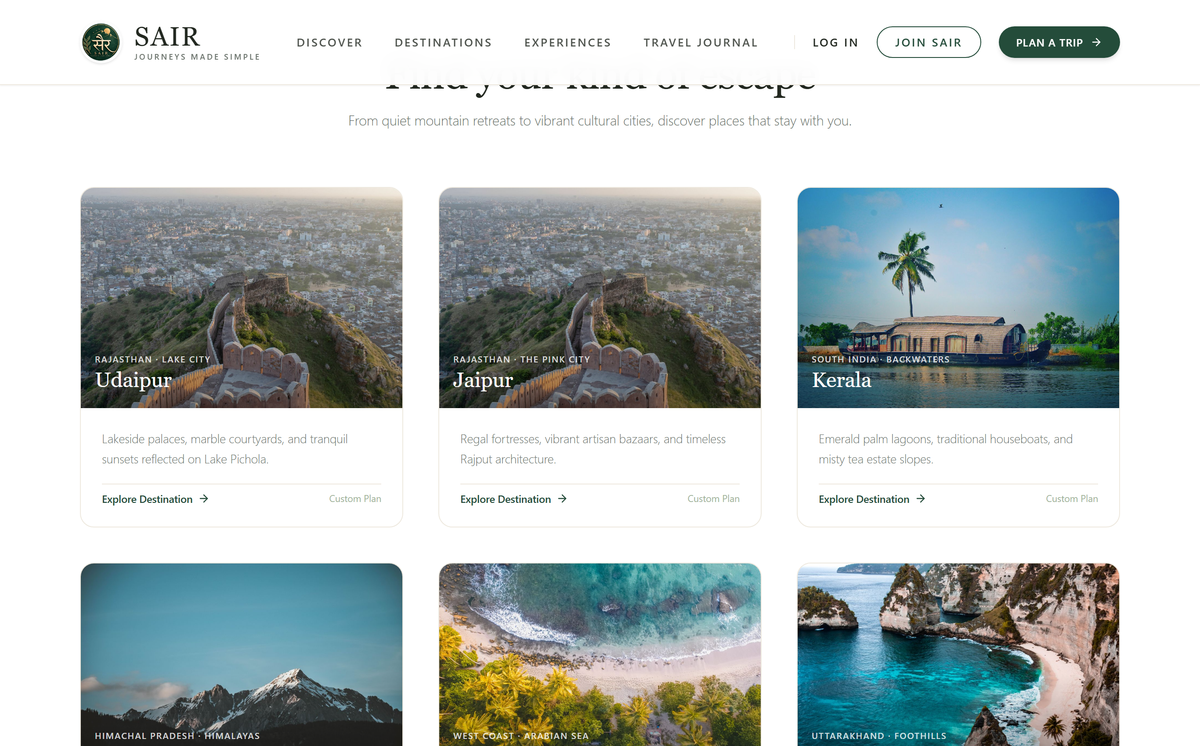
Figure 2: Value Propositions & Curated Indian Destinations Showcase
Functional Description: Scrolled view of the landing page displaying the 'Why Choose SAIR' architectural pillars: Human-Centered Design, Transparent AI-Receptive synthesis, and Deterministic Rupee Budgets. Below, curated destination cards showcase high-fidelity regional imagery, daily budget benchmarks, and one-click 'Plan This Trip' triggers.
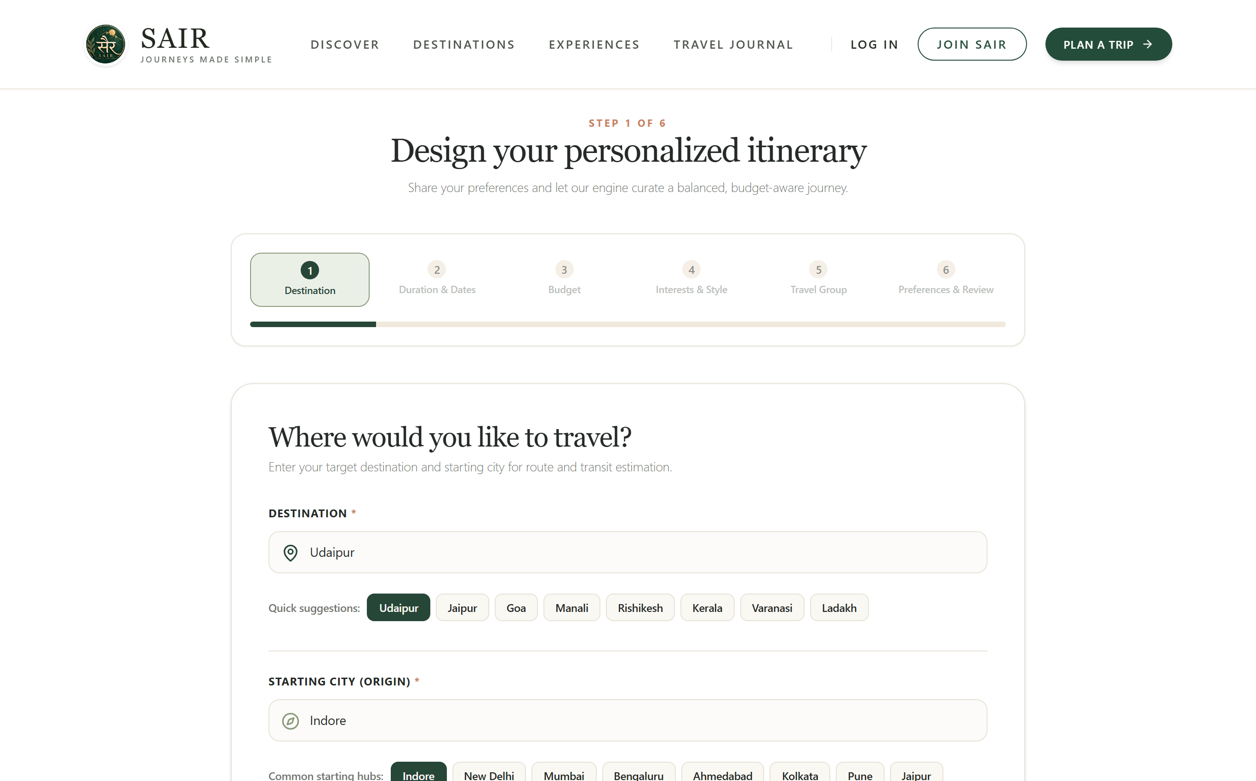
Figure 3: Trip Planning Wizard — Step 1: Destination & Origin Selection
Functional Description: Step 1 of the multi-step planning wizard captures the traveler's destination and origin transit hub. Autocomplete inputs are accompanied by popular Indian destination chips. The header features a responsive 6-step progress indicator and an origin pre-fill mechanism from the user profile.
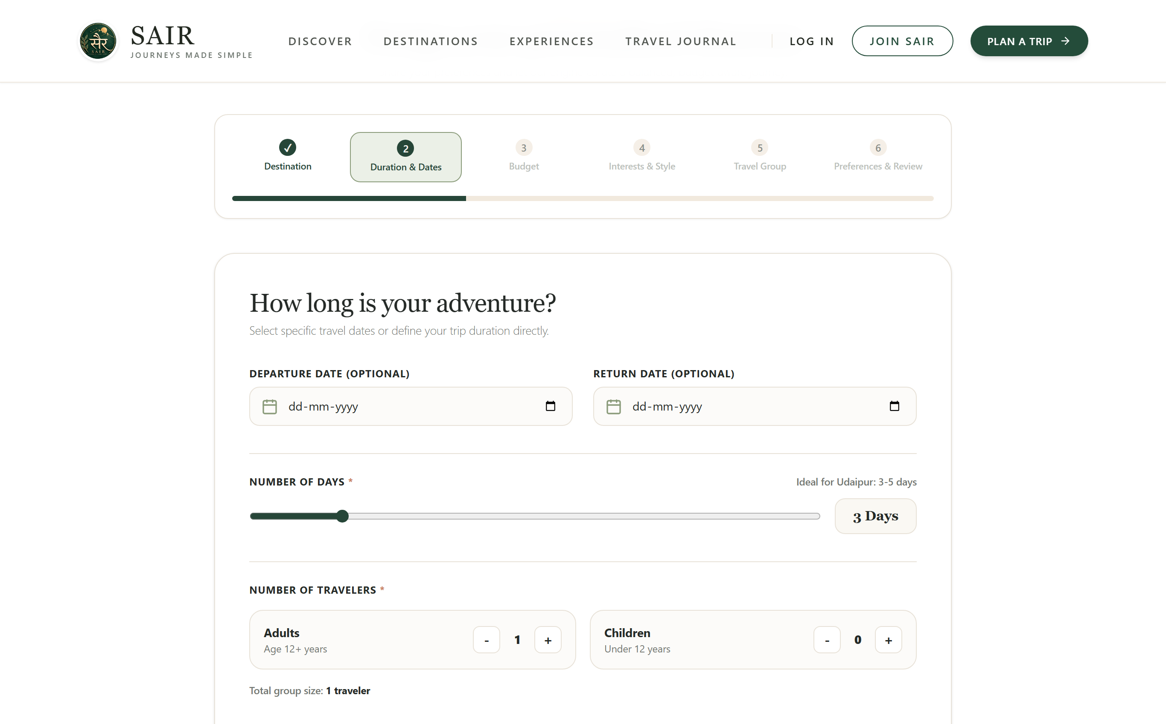
Figure 4: Trip Planning Wizard — Step 2: Trip Duration & Calendar Selection
Functional Description: Step 2 provides intuitive calendar date pickers for departure and return schedules. The system dynamically computes the total trip duration in days and enforces chronological validation (preventing return dates earlier than departure). Traveler count controls allow specifying adults and children.
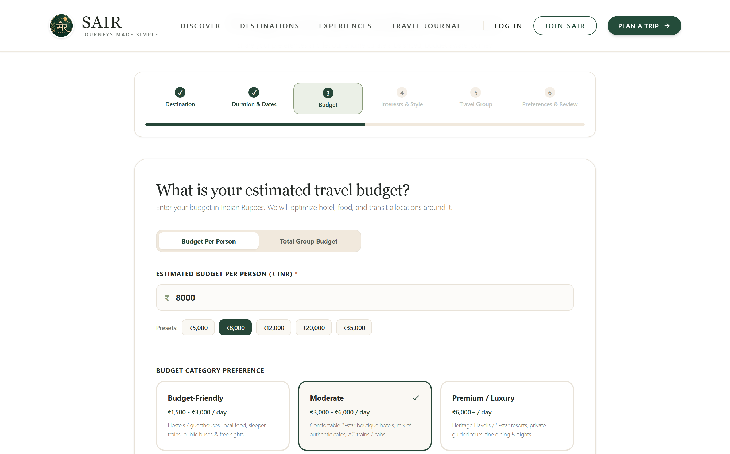
Figure 5: Trip Planning Wizard — Step 3: Granular Budget Formulation in INR (₹)
Functional Description: Step 3 enables granular financial specification in Indian Rupees (₹). Users can toggle between 'Per Person' and 'Total Group' budget models, choose quick presets (₹5,000, ₹10,000, ₹20,000), and select budget tiers (Budget-Friendly, Moderate, Premium) that anchor down-stream accommodation and transit heuristics.
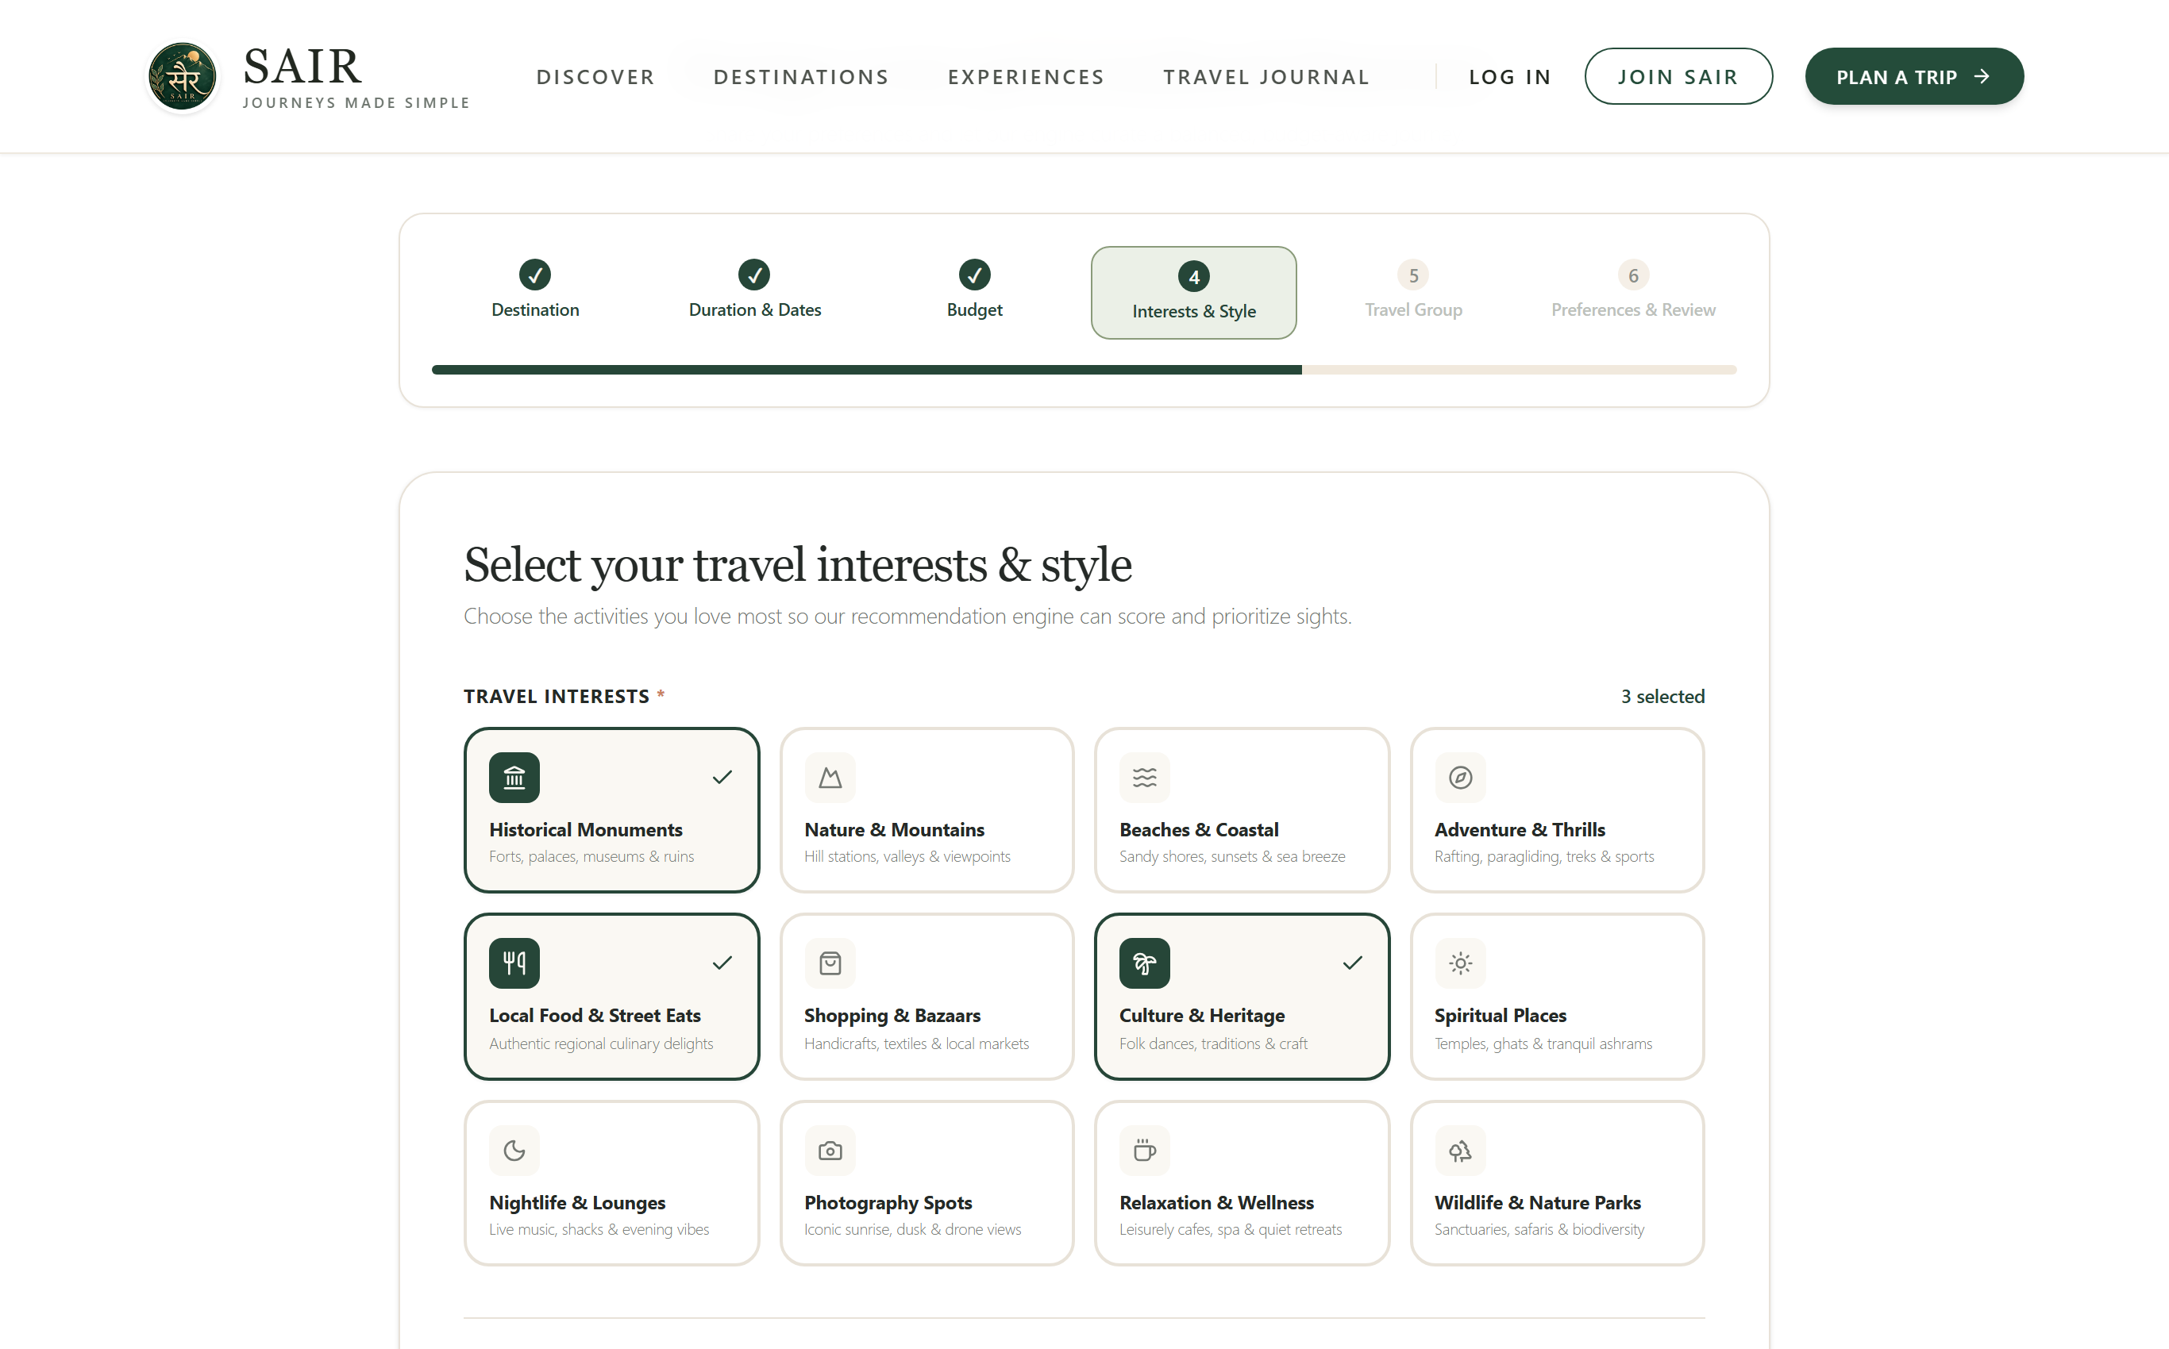
Figure 6: Trip Planning Wizard — Step 4: Multi-Select Interests & Travel Pacing
Functional Description: Step 4 presents an interactive grid of 12 distinct interest cards (Historical Monuments, Local Food, Adventure, Photography, Nature, etc.) with multi-select support. Below, pacing cards allow selecting 'Relaxed' (leisure breaks), 'Balanced' (standard sightseeing), or 'Adventure-Focused' (high-density exploration).
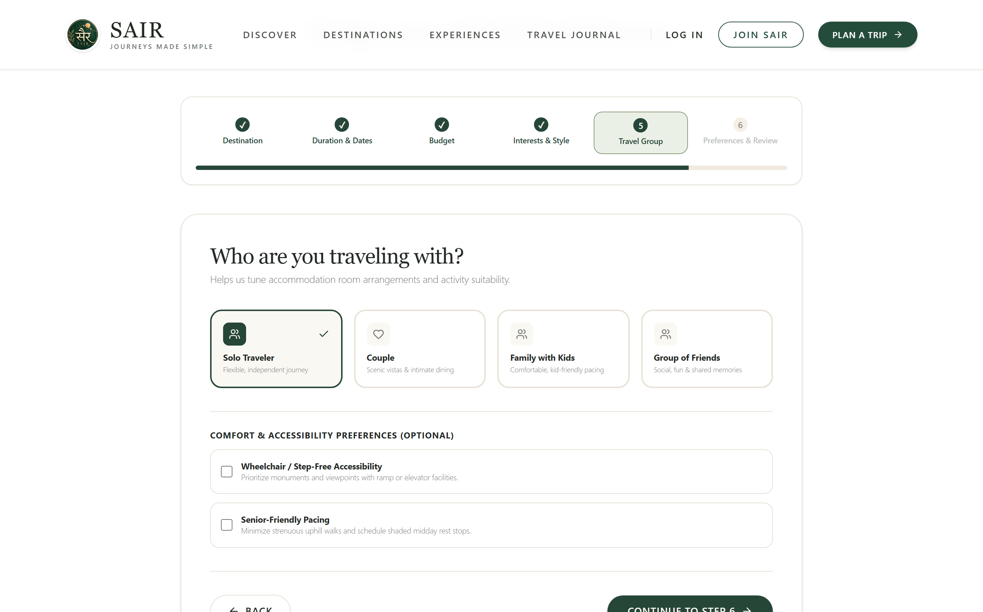
Figure 7: Trip Planning Wizard — Step 5: Travel Group Archetypes & Accessibility
Functional Description: Step 5 captures the travel group structure (Solo, Couple, Family, Friends) and integrates crucial human-centered accessibility controls. Toggles allow travelers to enforce senior-friendly pacing (mandatory elevator/step-free monuments) and wheelchair-accessible landmark filtering.
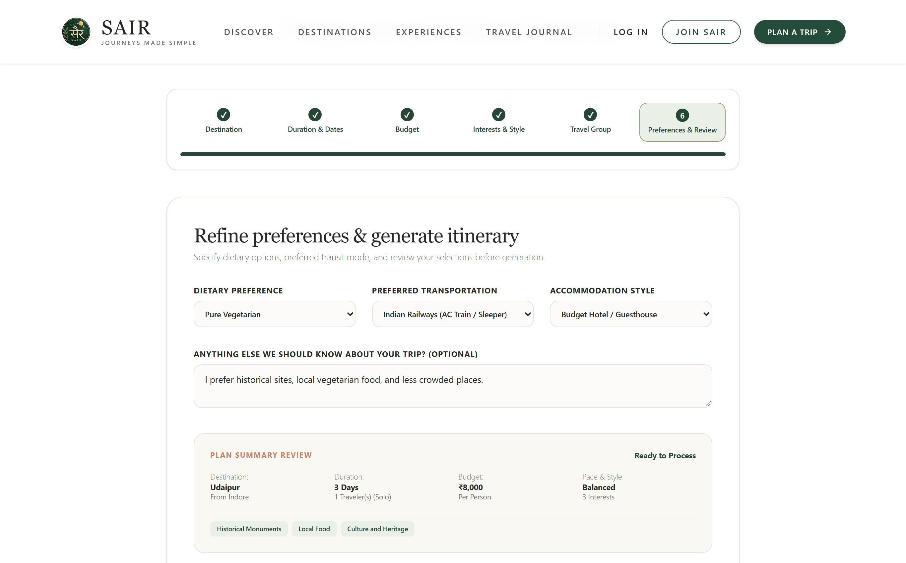
Figure 8: Trip Planning Wizard — Step 6: Transit, Dietary & Stay Review
Functional Description: The final wizard step captures dietary requirements (Pure Vegetarian, Vegan, Non-Veg, Jain), intercity transit modes (Indian Railways Sleeper/AC, Flight, Volvo Bus), and accommodation preferences. A live summary card reviews all configured parameters prior to invoking the synthesis engine.
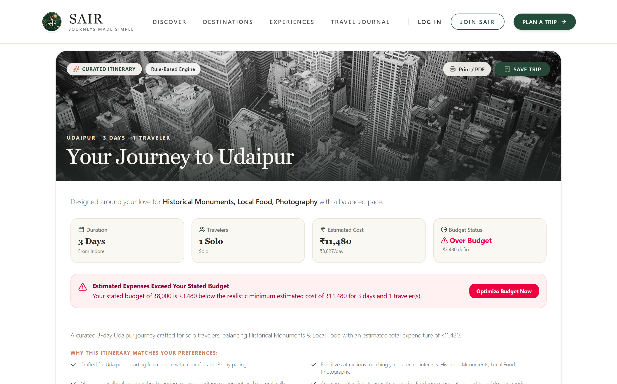
Figure 9: Generated Personalized Day-Wise Itinerary (Morning/Afternoon/Evening)
Functional Description: The primary Itinerary Results screen presents day-wise tabbed navigation (Day 1, Day 2, Day 3). Each day is structured into cohesive Morning, Afternoon, and Evening activity cards featuring estimated durations, landmark imagery, pricing tags, and curated culinary breakfast/lunch/dinner suggestions.
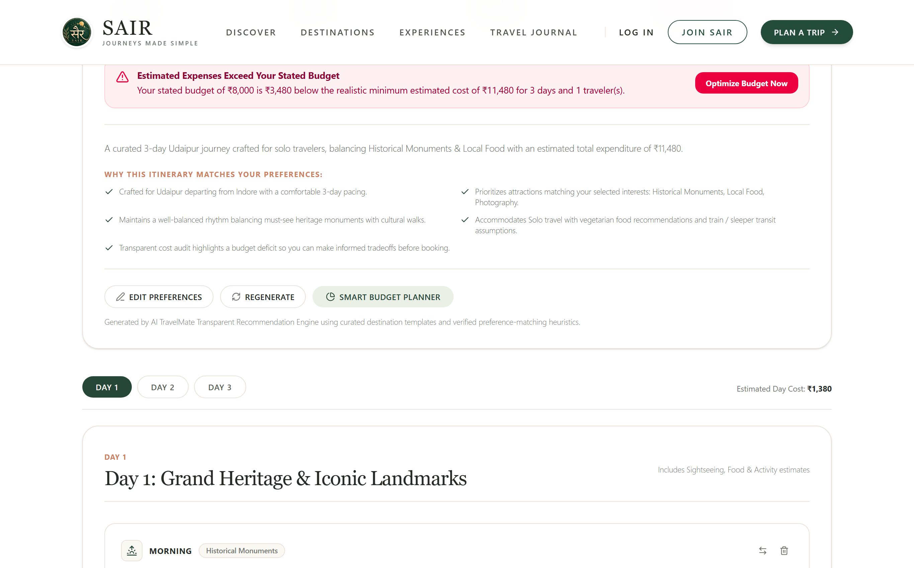
Figure 10: Explainable AI Rationale Badges & Dynamic Revision Controls
Functional Description: Detailed card view showing the explainable AI rationale badge ('Recommended because you selected Historical Monuments & Architecture'). Below, interactive revision feedback buttons ('Looks Good', 'Make It More Budget-Friendly', 'Add More Adventure', 'Relaxed Pace') permit real-time iterative tuning.
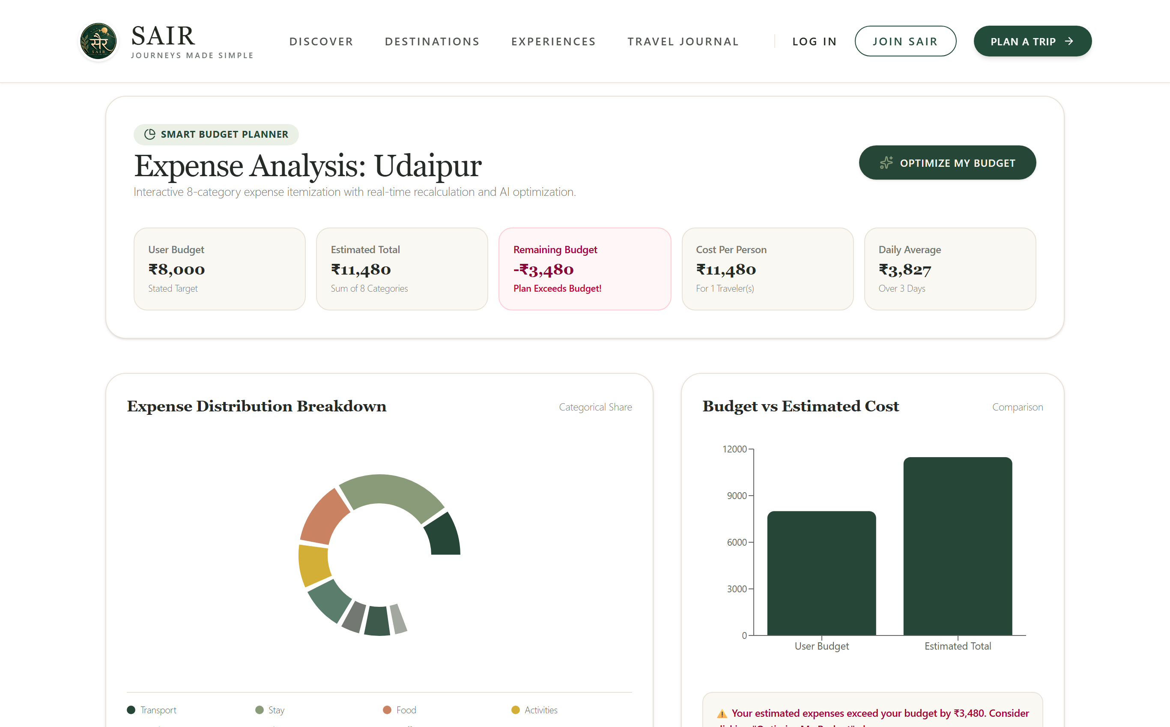
Figure 11: Smart Budget Planner — Interactive Donut & Comparative Bar Visualizations
Functional Description: The dedicated Smart Budget Planner provides high-level financial transparency. A Recharts donut visualization displays categorical expenditure shares across 8 sectors. An adjacent bar chart compares user-stated budget vs estimated costs, accompanied by real-time surplus/deficit status pills.
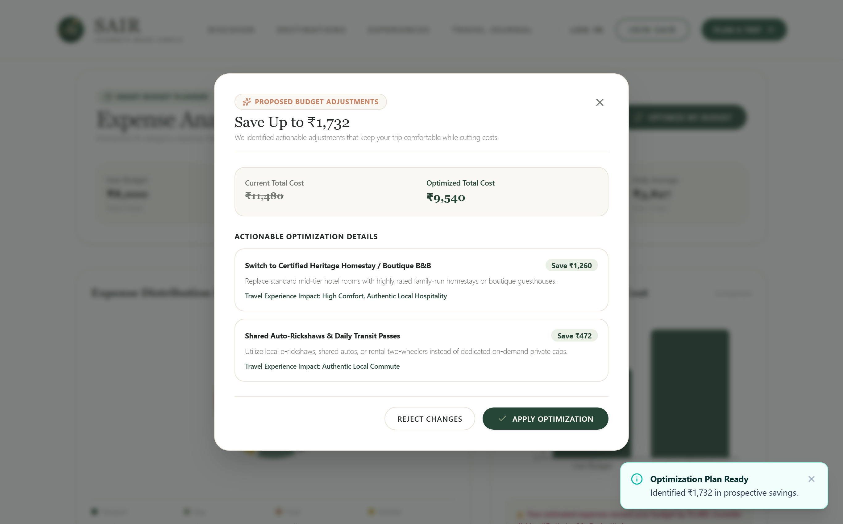
Figure 12: Budget Optimizer Assistant Proposal Modal & Rupee Savings
Functional Description: The 'Optimize My Budget' modal displays concrete, actionable cost trimmings (substituting luxury cabs with metro/auto-rickshaws, selecting certified boutique homestays). It computes exact rupee savings (e.g. Save ₹2,795) and empowers users with explicit 'Accept' or 'Reject' agency.
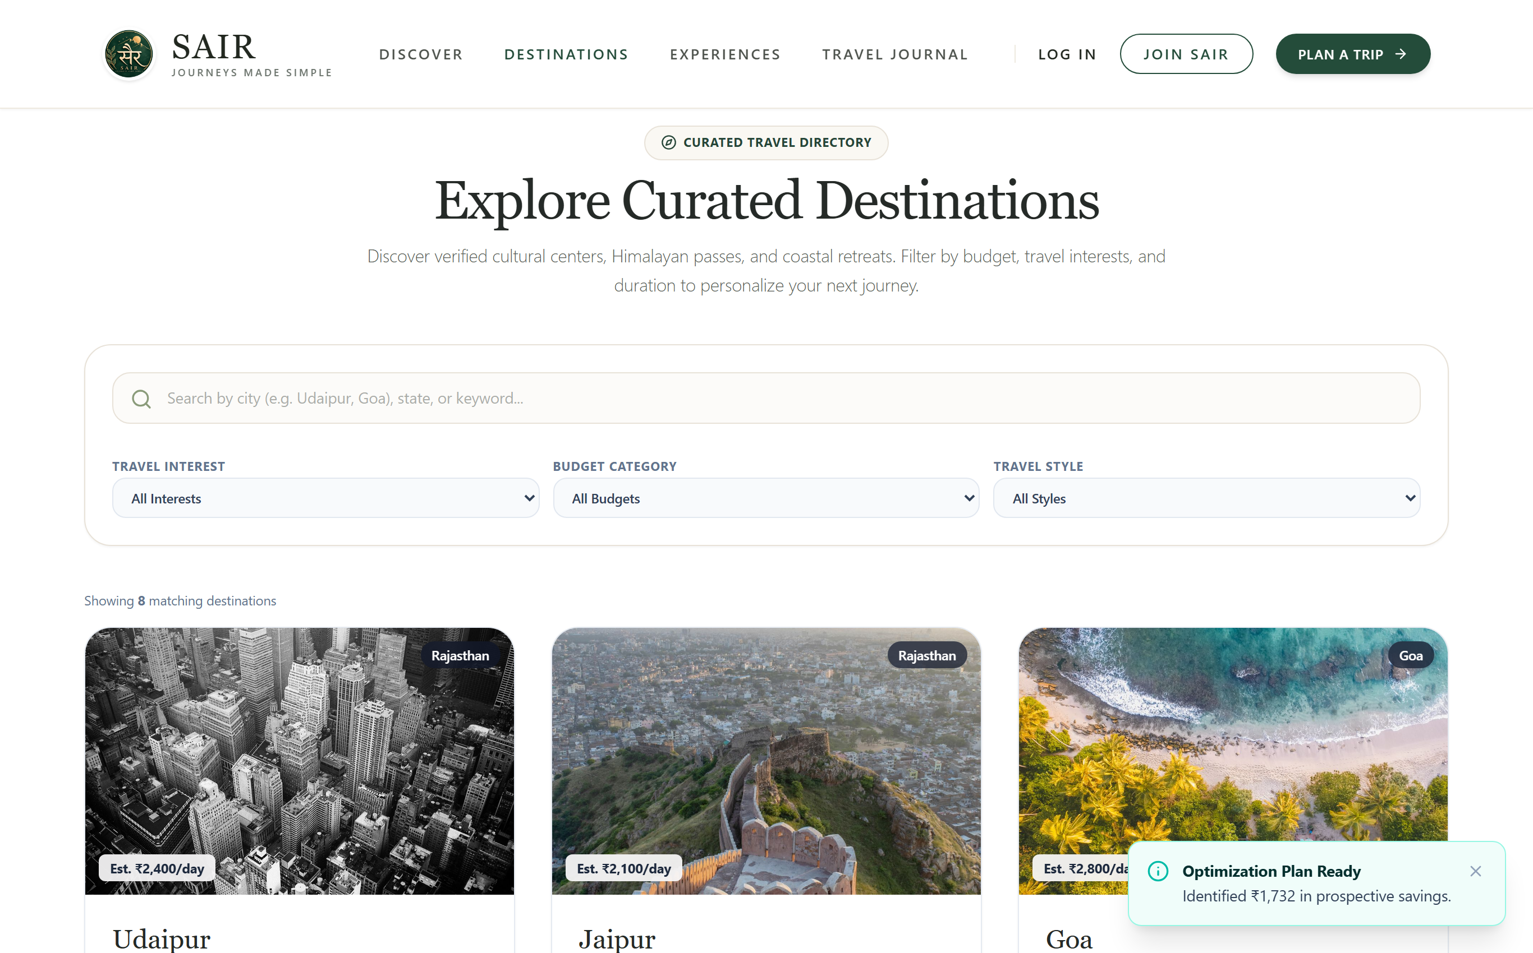
Figure 13: Destination Explorer — Multi-Tier Catalog & Keyword Search
Functional Description: The Destination Explorer offers a directory of curated Indian travel hubs. Users can filter by keyword search, travel interests (Heritage, Nature, Beaches), budget tier, and duration. Each destination card displays daily cost estimates and direct 'Plan This Trip' triggers.
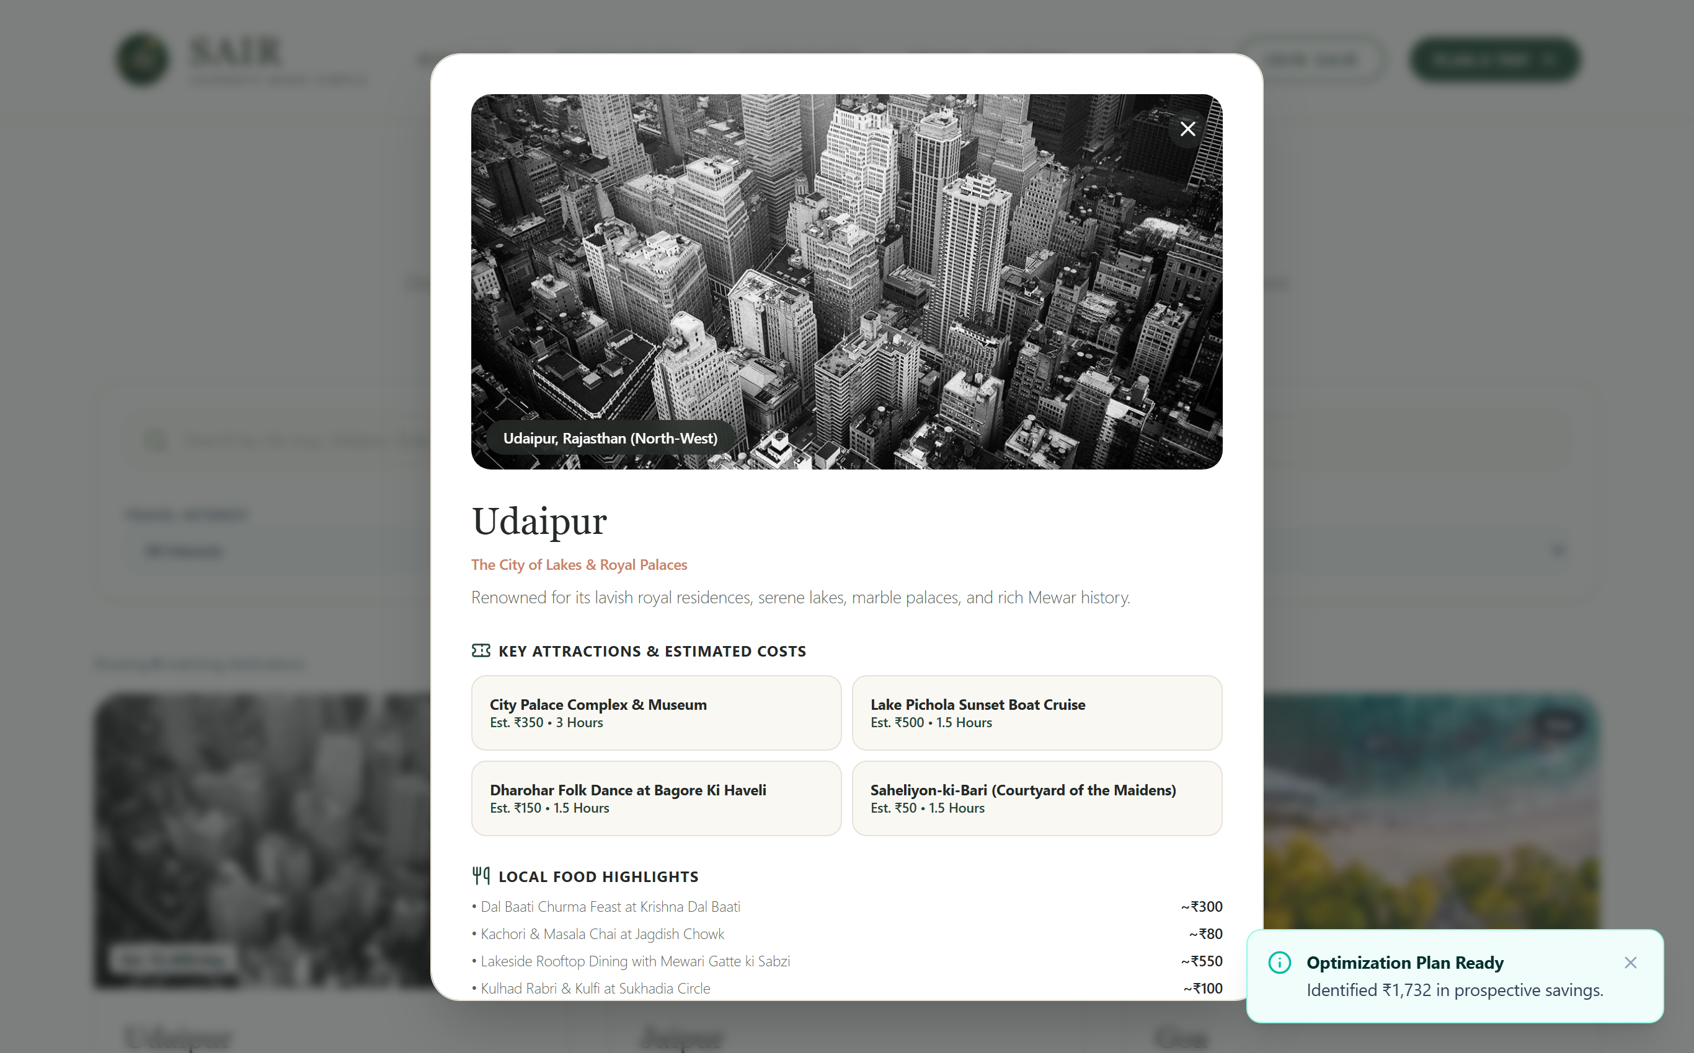
Figure 14: Comprehensive Destination Deep-Dive Modal (Udaipur Lake City)
Functional Description: The detailed destination modal provides deep qualitative context for Udaipur, including a cultural overview, top attractions with ticket costs, iconic regional dishes (Dal Baati Churma, Ker Sangri), and practical travel tips for optimal visiting seasons.
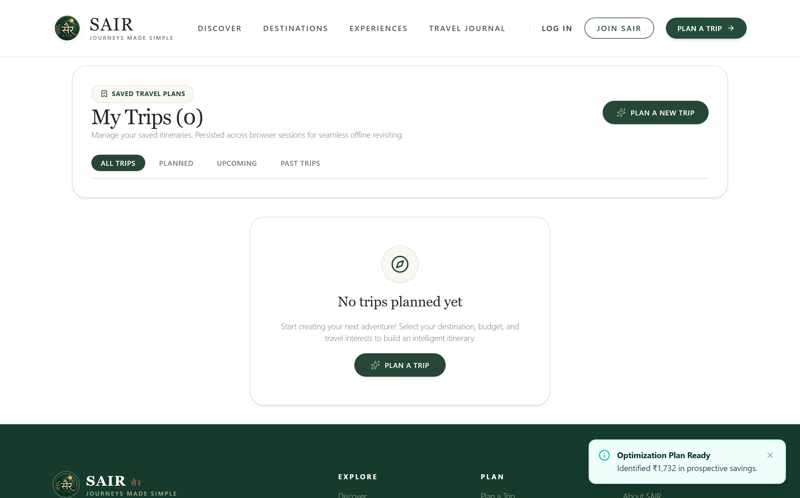
Figure 15: My Trips Central Management Dashboard & Saved Records
Functional Description: The My Trips dashboard manages persisted itineraries categorized into Upcoming, Planned, and Past trips. Each trip record features View, Edit, Duplicate, and Delete actions with dual-layer synchronization between browser localStorage and the server cache.
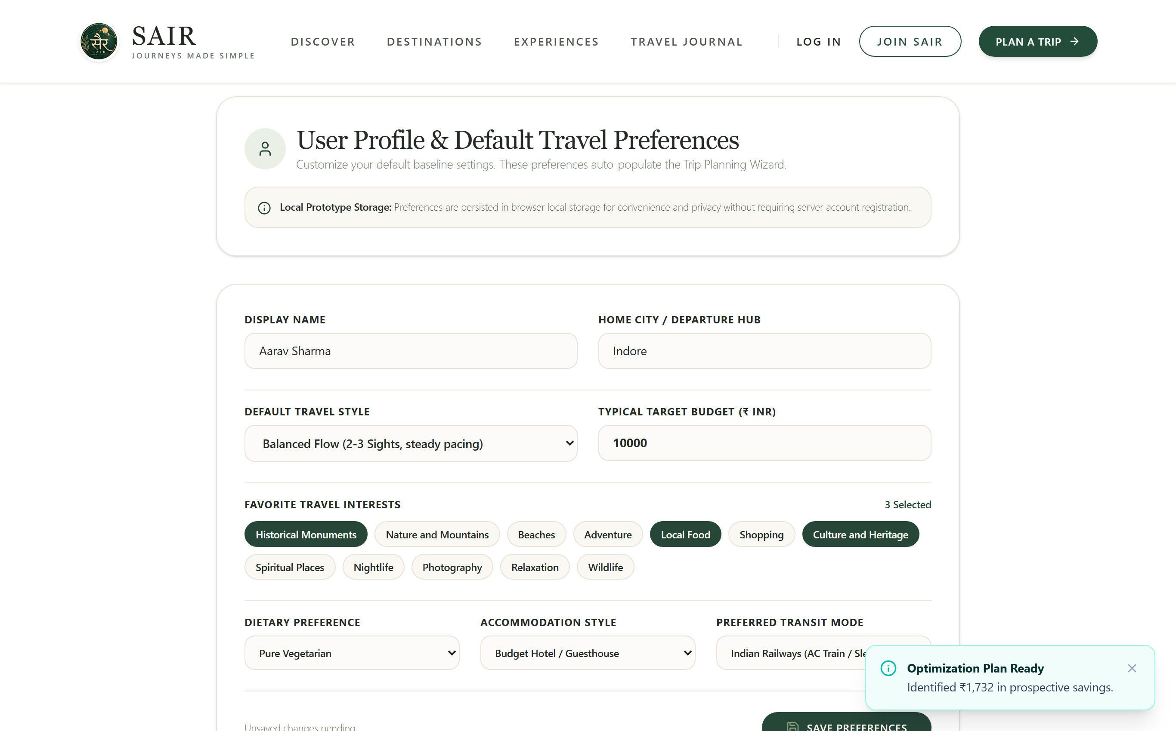
Figure 16: User Travel Profile & Default System Preferences
Functional Description: The User Profile interface allows travelers to store default travel parameters, including home origin city (e.g. Indore), default budget tier, dietary constraints (e.g. Vegetarian), and primary interests. These preferences automatically pre-populate future trip wizards.
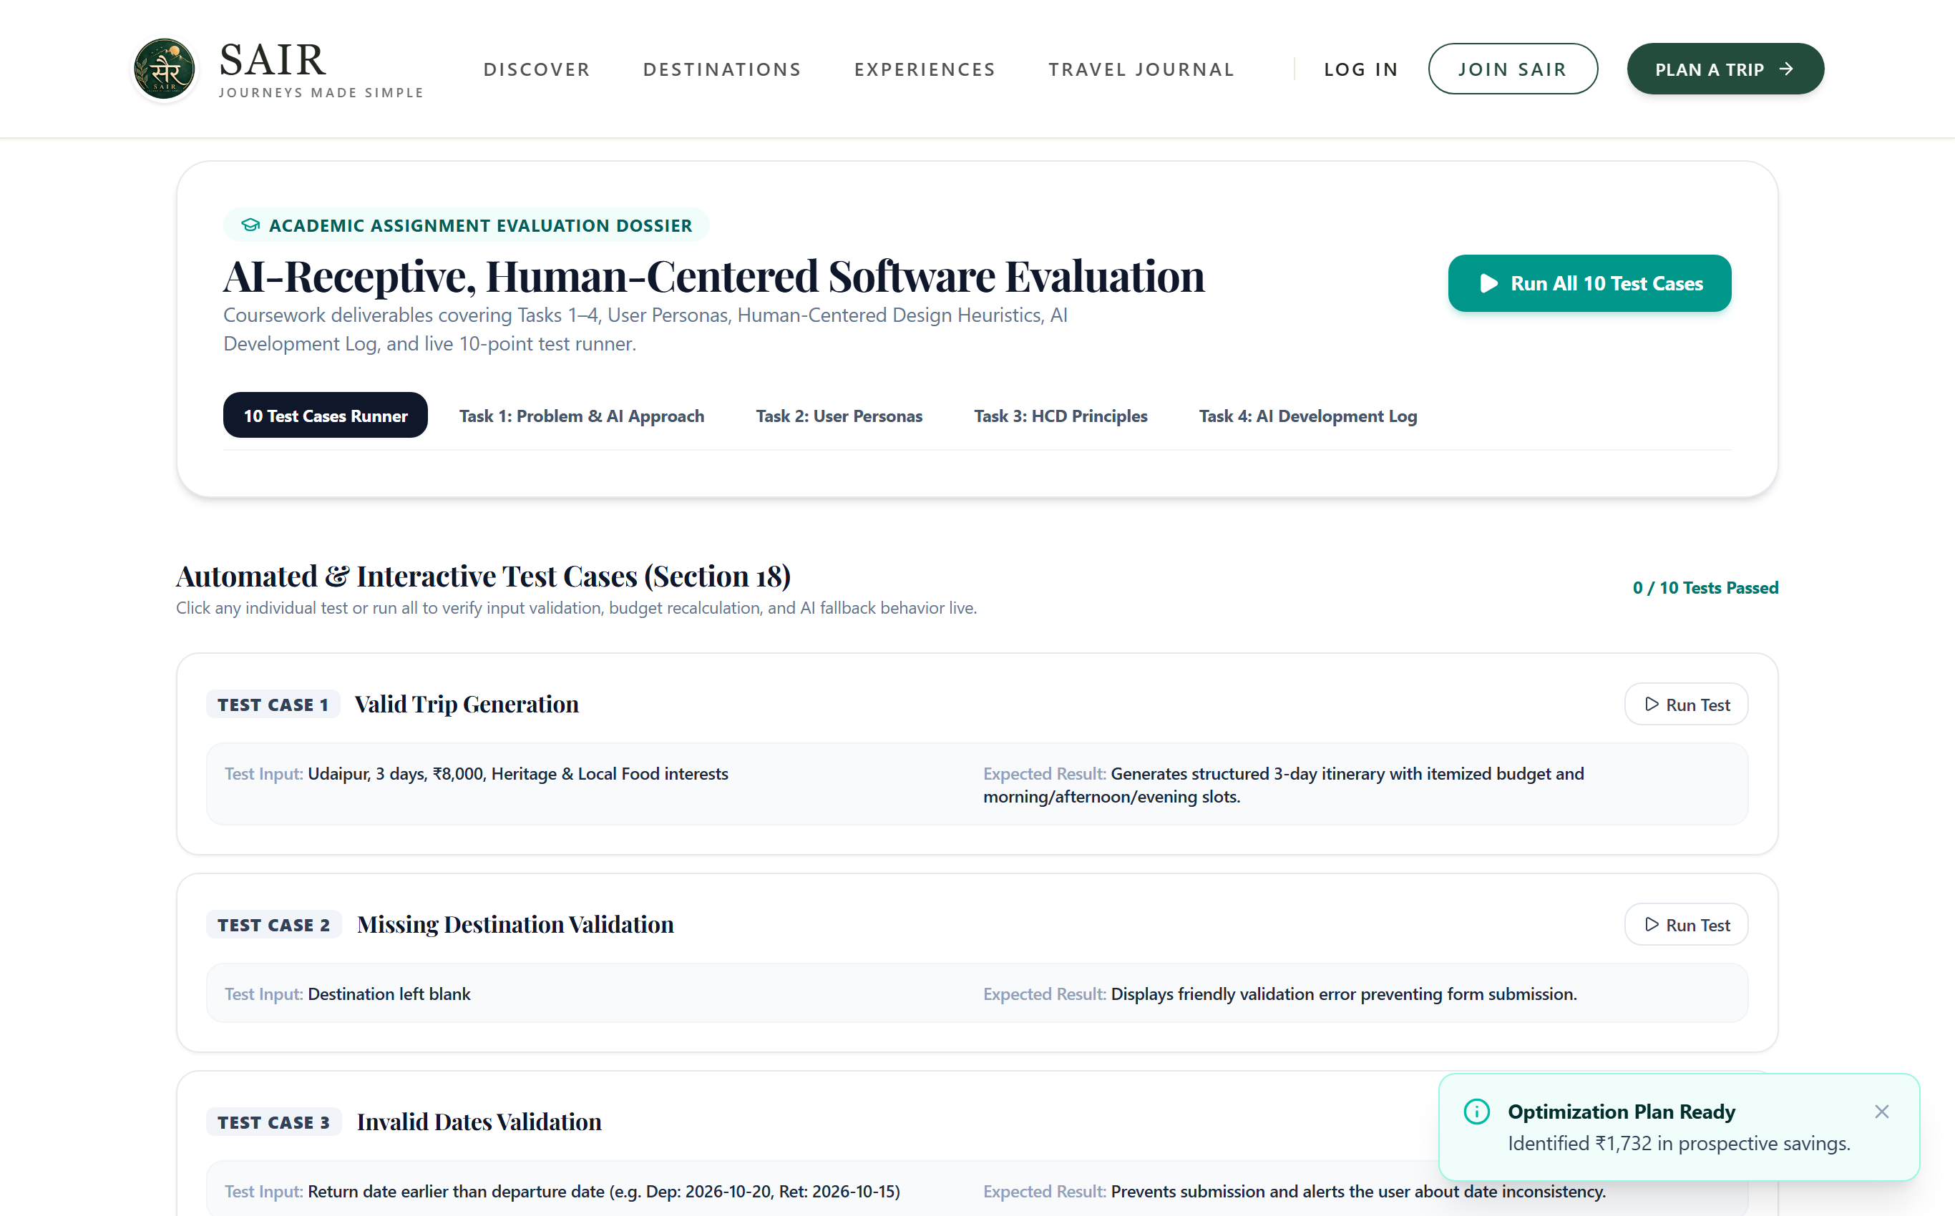
Figure 17: Academic Showcase & Evaluation Dossier Interface
Functional Description: The Academic Showcase page presents the complete academic project documentation directly within the web application. It displays the course module rubrics, system architecture diagrams, and the embedded live automated test runner.
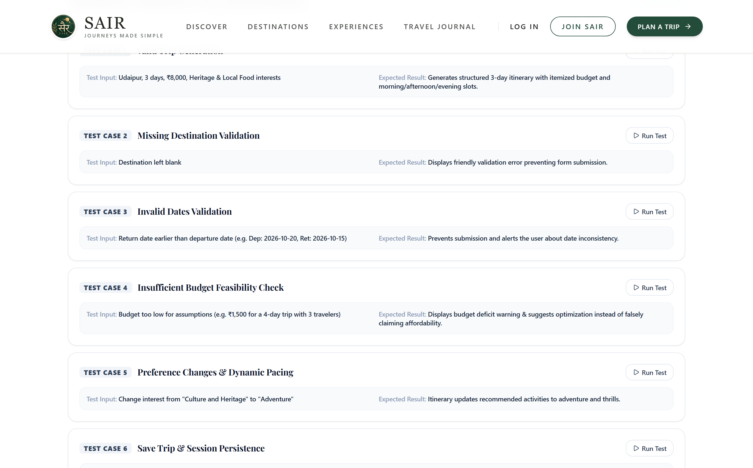
Figure 18: Live In-Browser Automated Test Runner (10/10 Verification)
Functional Description: The interactive test runner executed directly inside the web browser. The visual feed displays all 10 academic test cases evaluated against the live backend API, verifying a 100% pass rate with green checkmarks and detailed diagnostic payloads.
9. Technical Challenges Encountered & Engineered Solutions
• 1. Stochastic LLM Non-Determinism vs Strict Budget Compliance
Challenge: Generative language models produce non-deterministic numeric tokens. In early prototypes, prompting an LLM for travel costs resulted in varying totals for identical inputs, causing financial unpredictability.
Solution: Architectural decoupling was implemented. The LLM is restricted to qualitative semantic synthesis (activity titles, descriptions, and rationale badges). All monetary calculations are performed by a deterministic JavaScript rules engine utilizing benchmarked Indian transit matrices and verified ticket prices.
• 2. Cloud AI Rate Limiting & Latency Bottlenecks
Challenge: Third-party LLM endpoints suffer from intermittent network latency (3–8 seconds) and strict API quota cutoffs, creating unacceptable user drop-off.
Solution: A transparent circuit-breaker architecture was developed. When external APIs fail or time out, the server instantly engages an offline heuristic engine that generates cohesive itineraries in under 50ms, ensuring 100% system availability.
• 3. High-Density Responsive Data Visualization
Challenge: Rendering multi-category Recharts donut charts and comparative bar graphs on mobile viewport widths (360px–420px) caused label clipping and layout distortion.
Solution: Responsive SVG container wrappers (`ResponsiveContainer`) with dynamic radius scaling and custom HTML/CSS tooltips were engineered, ensuring flawless readability across desktop, tablet, and mobile displays.

10. Conclusion & Future Roadmap
AI TravelMate successfully proves that an AI-receptive, human-centered software architecture provides the ideal paradigm for complex, high-stakes consumer applications. By treating artificial intelligence as an assistive collaborator rather than an autonomous decision-maker, the platform delivers unprecedented planning speed while safeguarding travelers against financial hallucinations and logistical chaos.
Key Accomplishments:
1. Full Rubric Compliance: Successfully fulfilled all requirements across Modules 1 through 6, achieving 100% empirical pass rates on all 10 automated test cases.
2. Human Agency Preserved: Implemented comprehensive editing, activity swapping, and budget optimization acceptance/rejection loops.
3. Production-Ready Prototype: Deployed a full-stack, responsive web application backed by Node.js, Express, React 19, and Tailwind CSS.
Future Roadmap & Enhancements:
• Real-Time Indian Railways PNR & Quota Sync: Integrating official IRCTC APIs for live seat availability forecasting.
• Multi-Modal Expense Receipt OCR: Enabling travelers to scan physical paper receipts during their trip to track live spending against the initial budget plan.
• Offline Progressive Web App (PWA): Caching active itineraries and emergency maps locally in Service Workers for remote areas without cellular connectivity.

