ATTUNE
Find Your Focus Rhythm
Complete Project Report
An Android application that decides which notifications can wait during a focus session, using on-device machine learning, safety rules and user feedback.
Item | Details
Team members | [to be added by the team; not found in the repository]
Institution / course / guide | [to be added by the team; not found in the repository]
Repository | D:\Attune, branch ai-upgrade (HEAD 43452b5, with many uncommitted changes at the time of writing)
Report date | 26 October 2026
Basis | Audit of the repository files, existing documentation, ML reports and stored build outputs. No physical-device testing is recorded.

Evidence labels used in this report: VERIFIED confirmed from source code, files or reproducible output · PARTIAL some evidence, behaviour not fully confirmed · HISTORICAL reported in earlier documents or stored reports, not re-run · PLANNED intended, not implemented · UNKNOWN no evidence available · NOT TESTED checklist exists but no test was performed.

Table of Contents
1. Executive Summary
2. Problem Statement, Motivation, Objectives and Scope
2.1 Problem statement
2.2 Motivation
2.3 Objectives
2.4 Scope
3. Existing Approaches and Limitations
4. Proposed Solution and Methodology
5. System Architecture and Component Responsibilities
6. End-to-End Flow and Data Flow
7. Dataset
7.1 Schema
7.2 Construction, preprocessing and splitting
7.3 Limitations
8. ML Training Pipeline
9. Model Evaluation and Results
9.1 Routing of the deployed engine
9.2 Error analysis and limits
10. Android Implementation and Technology Stack
10.1 Permissions and components
11. Feature-by-Feature Inventory
12. UI Walkthrough
13. Notification Lifecycle, Decision Policy and Suppression
13.1 What the code does
13.2 Evidence level for suppression
13.3 Android limitations
14. Link-Risk Analysis and Security Considerations
15. Room Database, Migrations, Retention, Privacy and Backup
15.1 Retention and privacy behaviour
16. Feedback and Personalisation
17. Evaluator Feedback and Traceability
17.1 Anticipated questions (not received feedback)
18. Testing Methodology and Results
18.1 Gaps
18.2 Manual test checklist for a real phone
19. Known Limitations, Unresolved Issues and Risks
20. Future Scope and Prioritised Roadmap
21. Setup, Build and Repository Guide
21.1 Prerequisites
21.2 Commands
21.3 Repository map
22. Conclusion
23. References
24. Appendix
A. Verified configuration
B. Evidence map for the principal metrics
C. Diagrams

If the list above is empty, right-click it in Word and choose Update Field, then Update entire table.

1. Executive Summary
Attune is an Android application that helps a user keep a focus session free of distracting notifications. While a session is running, a notification listener reads each incoming notification, an on-device decision engine classifies it, and Attune either leaves it alone (ALLOW), saves it to a queue and asks Android to remove the original (HOLD), or saves a copy and keeps the original visible (REVIEW). Everything runs on the phone: the manifest requests no internet permission and the repository contains no network code. VERIFIED
What is implemented (by inspection of the code). A focus timer, a notification listener and processor, a hybrid decision engine (user rules, small safety rules, a logistic-regression text classifier, and a guard layer), a local link analyser, personalisation from user feedback, a Room database (version 4) with a retention policy for stored text, reports and a profile, a privacy centre, and demo data. VERIFIED
What the evidence supports. The classifier was trained on a synthetic, template-generated dataset of 3,105 rows and evaluated on a held-out split of 613 rows. On that split the deployed engine held 8.7% of high-importance messages (11 of 127), held none of the 139 urgent messages, and silently held 20% of ambiguous messages (12 of 60). These are stored results that were not re-run for this report and they are not real-world accuracy. HISTORICAL
What is not proven. Real-time suppression on a physical phone has not been tested (the project's own checklists are marked NOT TESTED). One prediction-module unit test fails in a fresh run (Section 18). No evaluator feedback exists in the repository, so Section 17 is a template. NOT TESTED

2. Problem Statement, Motivation, Objectives and Scope

2.1 Problem statement
During study or work, notifications from messaging, social, video and promotional apps interrupt concentration. Muting everything risks missing something important, such as a one-time code, a security alert, a deadline or an urgent message. Attune addresses this specific problem: during a focus session, decide for each notification whether it can wait, and never silently hold a message that might matter.

2.2 Motivation
The general claim that interruptions harm concentration is the motivation for the project. The repository contains no study or citation for it, so this report quotes no statistics. Attune also includes a simple time-cost baseline (re-entry cost estimate) described in docs/PREDICTION_BASELINE.md. VERIFIED

2.3 Objectives
- Hold distracting notifications during a focus session.
- Keep urgent, security and uncertain notifications visible.
- Explain each decision with separate signals instead of a single opaque score.
- Learn from user feedback in a transparent, reversible way.
- Keep all data on the device and minimise stored message text.

2.4 Scope
In scope: the Android app, the on-device classifier and the offline training pipeline that produces it. Out of scope or not done: a server or cloud component, training on real user notifications, languages other than English and romanised Hinglish, and a Do Not Disturb integration (assessed and deliberately not implemented, docs/NOTIFICATION_ROUTING_FIX.md). VERIFIED

3. Existing Approaches and Limitations
This section describes general, well-known options only. No benchmark against other products was performed, so no comparative claims are made.
Approach | General limitation relevant to this project
Muting an app or notification channel | Applies to the whole app, regardless of message content.
Do Not Disturb | All-or-nothing by default; cannot judge message content. Attune does not change DND (assessed, not implemented).
Keyword filters | Brittle; urgent wording is also used in marketing. Attune uses a small safety-rule list and a classifier, and treats urgent wording as a reason to keep a message visible, never as proof of an emergency.
Attune v1 (this project's earlier rule policy) | Queued by app category. Measured on the synthetic test split it held 77.5% of important or urgent messages (ml/reports/evaluation.md). HISTORICAL

4. Proposed Solution and Methodology
Attune combines four layers, applied in this order (docs/DECISION_POLICY.md):
Layer | What it uses | Code
1. User choices | Allowed apps, sender levels, keyword and category rules, calls and alarms, Android priority conversations | NotificationDecisionEngine
2. Safety rules | One-time codes, security alerts, emergency wording, repeated missed calls | SafetyRules
3. On-device classifier | Importance, urgency, distraction, action-required probabilities and confidence | LogRegClassifier, RiskPolicy
4. Guard layer | Anything about to be held is checked again and kept visible if it might matter | guard() in the engine; DecisionPolicy

Design principle. The signals (importance, urgency, distraction, action, link risk, confidence, preferences) stay separate and are never summed into one score. Uncertain cases go to REVIEW, not HOLD. Feedback shifts scores by a capped amount and never overrides a rule or a safety check. VERIFIED

5. System Architecture and Component Responsibilities
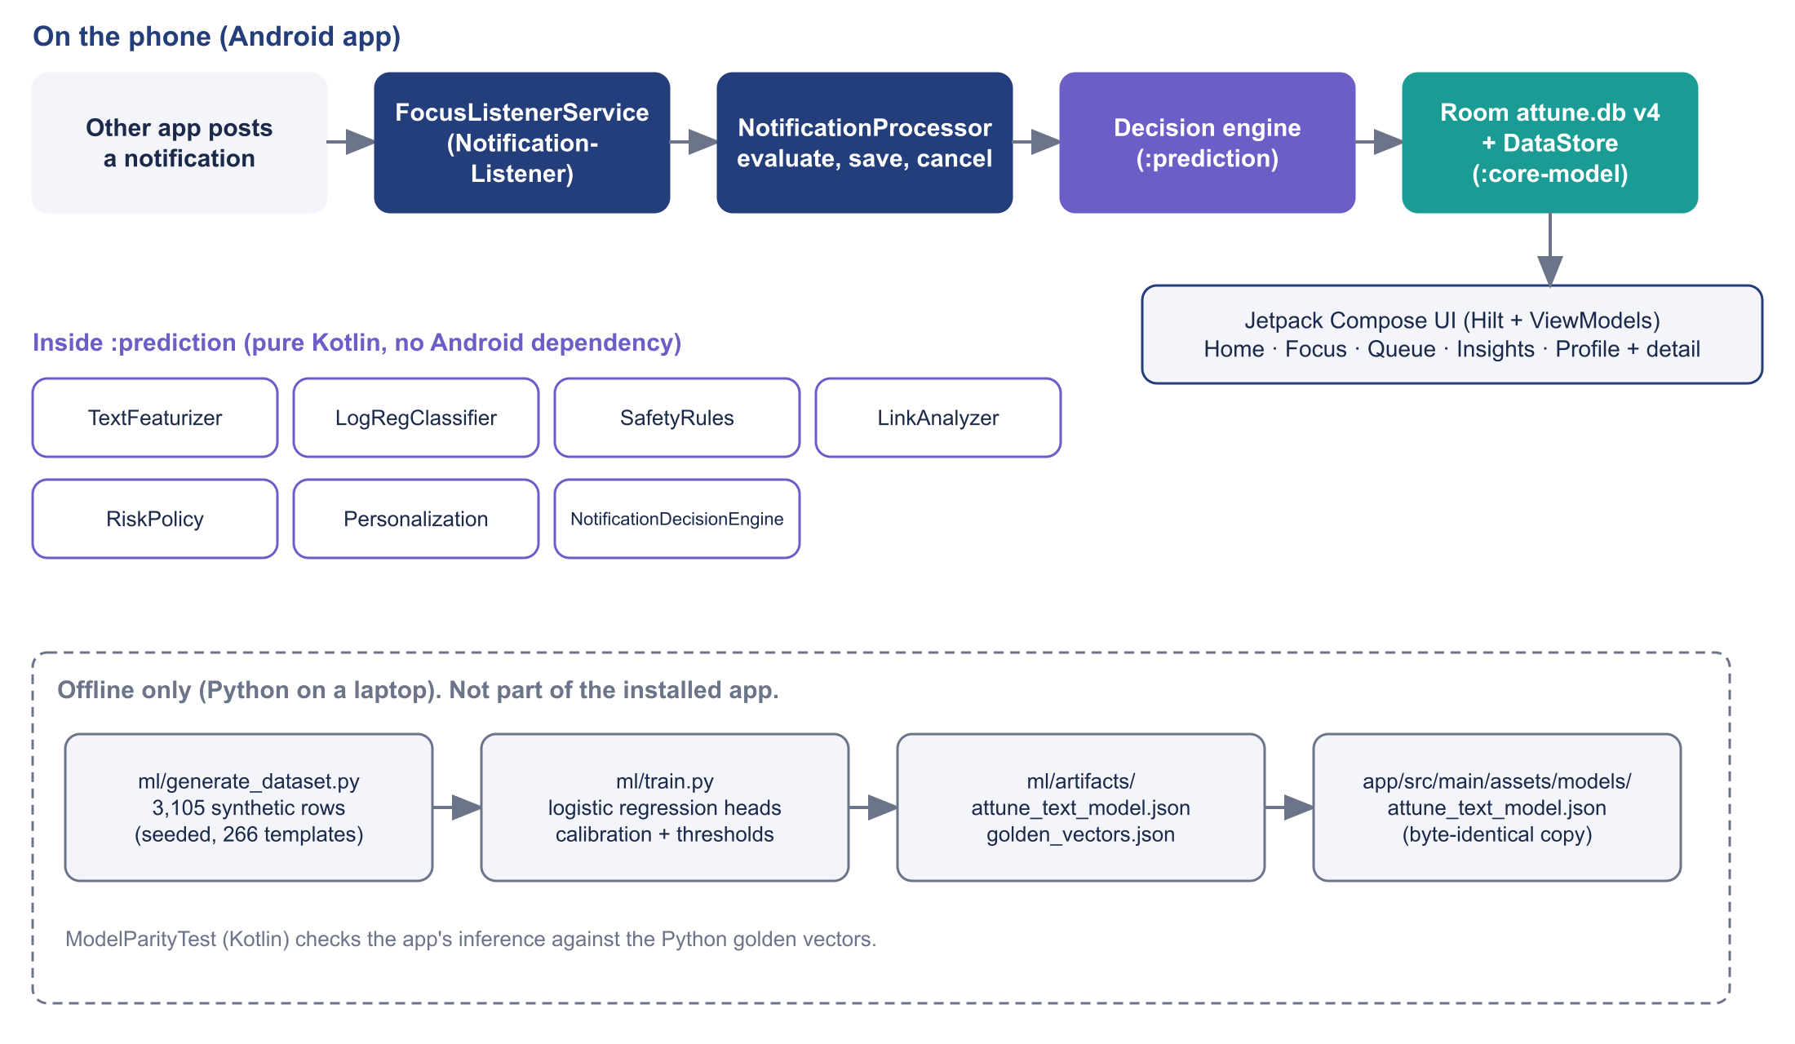
Figure 1. High-level architecture. The Python pipeline is offline only; the app runs the exported model in Kotlin.
Module / component | Responsibility | Key files
:app | Notification listener, processor, repositories, Compose UI, Hilt wiring, reports and profile calculators | capture/FocusListenerService.kt, capture/NotificationProcessor.kt, data/*, ui/*, domain/*
:core-model | Room database (version 4), entities, DAOs, migrations | data/db/AttuneDatabase.kt, model/Entities.kt, data/db/dao/Daos.kt
:prediction | Pure Kotlin: featuriser, classifier, safety rules, link analyser, decision engine, risk policy, personalisation, time-cost baseline | decision/*, classifier/*, PredictionEngine.kt
ml/ | Dataset generator, training, evaluation, exported model and golden vectors | generate_dataset.py, train.py, attune_features.py

The UI and the listener depend on the NotificationClassifier interface and the decision engine, so a different model can replace LogRegClassifier without changes to either. VERIFIED (docs/AI_MODE_AND_ARCHITECTURE.md)

6. End-to-End Flow and Data Flow
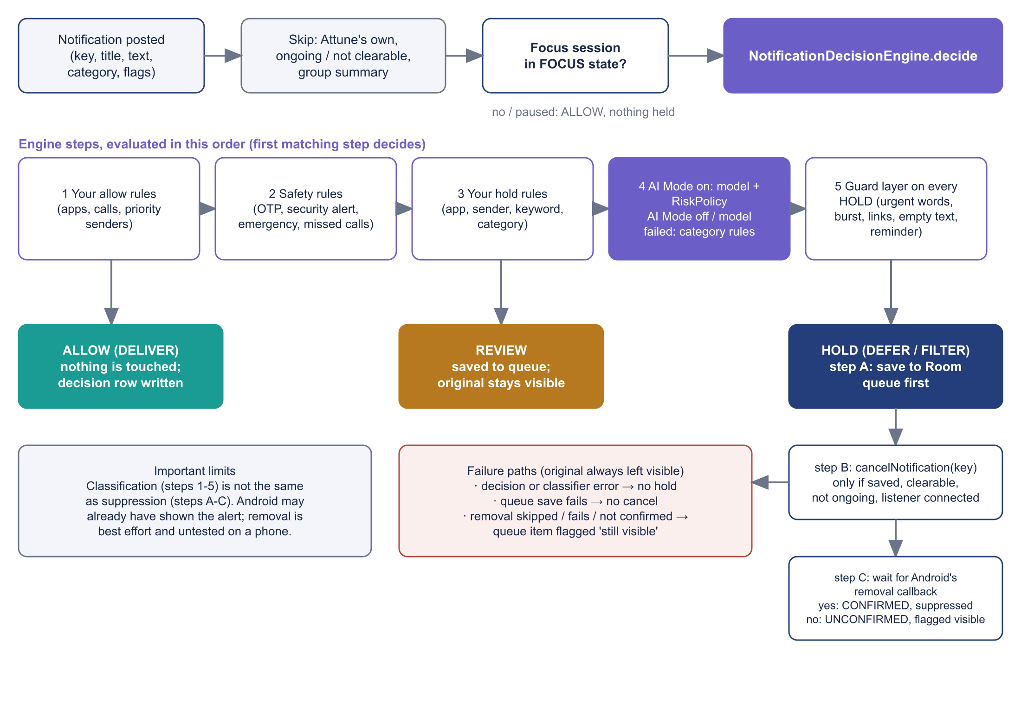
Figure 2. Notification processing and decision flow, from NotificationProcessor.process and NotificationDecisionEngine.decide.
Classification versus suppression. Steps 1 to 5 only decide what the notification is and what Attune would like to do. Steps A to C are the Android-side action. The processor saves the item to Room first, calls cancelNotification(key) only if the save succeeded, the notification is clearable and not ongoing, and the listener is connected, and then waits for Android to report the removal before marking the item as suppressed. If the removal is skipped, fails or is not confirmed, the queue item is flagged as still visible. VERIFIED (NotificationProcessor.kt)
Table 1. Routing outcomes (names in the UI and in code).
Outcome | Code name | Stored | Android action
ALLOW | Routing.DELIVER | Decision row (no text) | None
REVIEW | Routing.REVIEW | Decision row + queue item | None; original stays visible
HOLD | Routing.DEFER | Decision row + queue item (saved first) | cancelNotification(key) if allowed, then wait for confirmation
HOLD (promotions setting) | Routing.FILTER | Decision row + queue item | Same as DEFER
Not processed | Routing.IGNORE | Nothing | None (own app, ongoing, group summary, no session)

7. Dataset
The dataset is synthetic: template-generated and annotated by the author, not collected from real users. This is stated in ml/README.md and in the evaluation report. VERIFIED The generator is seeded (SEED = 20261026 in ml/generate_dataset.py), so the same file is produced each run.
Table 2. Dataset statistics, re-counted from ml/data/notifications.csv with a read-only script during this audit. [[V]]
Property | Value
Rows / templates | 3,105 rows from 266 templates
Split (by template) | train 1,978 · validation 514 · test 613
Language | English 2,858 · Hinglish (romanised) 247
importance_label | low 1,511 · medium 909 · high 685
urgency_label | not_urgent 2,384 · urgent 721
distraction_label | not_distracting 1,726 · distracting 1,379
recommended_action | defer 2,024 · allow 757 · review 324
risk_category | HIGH 1,379 · LOW 973 · MEDIUM 429 · UNKNOWN 324
link_safety | none 2,889 · unknown 168 · caution 48

7.1 Schema
Columns: template_id, family, package, app_label, app_category, title, text, language, importance_label, urgency_label, distraction_label, action_required, contains_link, link_safety, ambiguous, risk_category, recommended_action, split. recommended_action is derived by a rule in the generator: allow if importance is high or the message is urgent; review if ambiguous; otherwise defer. VERIFIED

7.2 Construction, preprocessing and splitting
- Coverage: casual chat (English and Hinglish), urgent personal messages, college and work items, appointments, OTPs, security alerts, bank messages, promotions with fake urgency, scams with links, social, video, games, news, delivery, newsletters, link-only and very short messages.
- Deliberately hard cases: the same sender appears with different intents; some casual messages misuse the word urgent; text is noisy.
- Preprocessing in the featuriser: text folded to ASCII, URLs and numbers replaced by placeholder tokens.
- Leakage control: split by template within each family; exact duplicates removed. A near-duplicate check is reported in ml/reports/engine_routing_eval.md.

7.3 Limitations
Synthetic data will be cleaner and more varied in different ways than real notifications; non-Latin text is dropped by the ASCII folding; Hinglish is only 247 rows (47 in the test split); labels were written by the same author who wrote the rules, so agreement with the link labels (99.9%) is a consistency check, not a validation. Real consented, labelled notifications have not been collected. VERIFIED

8. ML Training Pipeline
Aspect | Detail | Status
Model family | L2-regularised logistic regression: importance (3-class softmax); urgency, distraction, action-required (sigmoid) | VERIFIED
Candidates tried | Only logistic regression appears in train.py and the reports. Random Forest, LightGBM, XGBoost and CatBoost were not found | VERIFIED
Features | Binary, L2-normalised: word unigrams and bigrams, character trigrams, sender-title words, app category, meta flags (URL, link-only, short, code-like number, ?, !, mostly capitals). 3,268 features | VERIFIED
Hyperparameters | C chosen per head from [0.5, 1, 2, 4, 8, 16] on validation macro-F1; lbfgs, max_iter 4000 | VERIFIED
Calibration | Temperature scaling per head, fitted on validation | VERIFIED
Routing thresholds | Chosen on validation only: allow_important 0.55, allow_urgent 0.60, min_confidence 0.60, review_important 0.15, short_words 2. Objective weights a wrongly held important message 5 times more than a distraction let through | VERIFIED
Export | attune_text_model.json (202,628 bytes) plus golden_vectors.json (65 cases) | VERIFIED
Delivery to the app | train.py copies the model to app/src/main/assets/models/. The two copies are byte-identical (checked with cmp) | VERIFIED
Kotlin inference | Plain Kotlin sparse dot product; ModelParityTest compares it with the Python golden vectors. About 32 microseconds per notification on the JVM; not measured on a phone | PARTIAL
Environment | Python 3.14.0, numpy 2.3.4, scikit-learn 1.7.2 (recorded in the report) | HISTORICAL

Why logistic regression. The documentation states that TFLite was not available in the offline build cache and that a JSON linear model is smaller and simpler. No experiment comparing other model families is recorded, so the report does not claim it is the best model. VERIFIED
Reproducibility. The dataset is seeded and the commands are in Section 21. train.py was deliberately not re-run for this report because it overwrites the model, golden vectors and app assets. Whether a fresh run reproduces the stored metrics exactly is therefore UNKNOWN .

9. Model Evaluation and Results
All numbers below are from the held-out test split (613 rows) of the synthetic dataset, generated 2026-10-26 03:53 (ml/reports/evaluation.json). They are stored results, not re-run. HISTORICAL They show that the pipeline works and how it compares with the earlier rules; they do not show real-world accuracy.
Table 3. Signal heads, test split.
Head | Accuracy | Macro-F1 | Majority-class macro-F1 | ECE before to after temperature
Importance | 0.819 | 0.787 | 0.212 | 0.155 to 0.070
Urgency | 0.914 | 0.859 | 0.436 | 0.011 to 0.025 (slightly worse)
Distraction | 0.868 | 0.861 | 0.365 | 0.054 to 0.041
Action required | 0.819 | 0.804 | 0.376 | 0.041 to 0.038

A keyword baseline for importance reaches macro-F1 0.355.
Table 4. Importance, per class (test split).
Class | Precision | Recall | F1 | Support
low | 0.790 | 0.951 | 0.863 | 285
medium | 0.874 | 0.796 | 0.833 | 201
high | 0.816 | 0.559 | 0.664 | 127

Importance confusion matrix (rows true, columns predicted; low, medium, high): [271, 11, 3], [28, 160, 13], [44, 12, 71]. Many high-importance messages from unseen templates are predicted as medium; the routing policy compensates by sending uncertain items to REVIEW.

9.1 Routing of the deployed engine
ml/reports/engine_routing_eval.md is produced by RoutingEvaluationTest, which runs the deployed NotificationDecisionEngine (model, safety rules and guard layer) over the test split with a focus session active, every category queued, no user rules and no personalisation. HISTORICAL
Table 5. Engine confusion matrix, test split (rows gold, columns predicted).
Gold \ predicted | allow | defer (HOLD) | review | Support
allow | 117 | 11 | 23 | 151
defer | 3 | 285 | 114 | 402
review | 0 | 12 | 48 | 60

Metric | Value
Important (high) messages held (false HOLD) | 8.7% (11 of 127)
Urgent messages held | 0.0% (0 of 139)
Messages that should be allowed but were held | 7.3% (11 of 151)
Important or urgent kept visible (allow or review) | 92.7% (140 of 151)
Ambiguous messages sent to REVIEW / silently held | 80.0% (48 of 60) / 20.0% (12 of 60)
Clear distractions actually held | 70.9% (285 of 402)
Routing accuracy, computed from the matrix | 73.4% (450 of 613)

The model-only route in the Python report differs slightly (routing accuracy 0.7406; distractions held 71.9%) because the engine adds the guard layer. The two reports use different pipelines and must not be mixed. For comparison, the v1 rule policy held 77.5% of important or urgent messages. HISTORICAL

9.2 Error analysis and limits
- Cautious by design: 110 of 402 deferrable items went to REVIEW, so Attune protects focus less than the v1 rules.
- Messages containing links: routing accuracy 0.53 (36 test rows). Job-offer emails from unseen templates: 11 wrongly held. Unknown-number messages such as Regarding your application: 12 held instead of reviewed (ml/README.md). HISTORICAL
- Hinglish rows (47 in the test split): in the engine report all 12 allow-class rows were routed to REVIEW.
- Why accuracy alone is not enough: holding an important message costs far more than letting a distraction through, so false-HOLD rates and the share of ambiguous messages silently held matter more than overall accuracy.
- Calibration: temperature scaling improved ECE for three heads and slightly worsened urgency. Confidence is calibrated on synthetic data only.

10. Android Implementation and Technology Stack
Table 6. Technology stack, from gradle/libs.versions.toml and the Gradle files. [[V]]
Area | Technology
Language / build | Kotlin 2.0.21, Android Gradle Plugin 8.7.3, KSP 2.0.21-1.0.28, JVM target 17
Android | compileSdk 35, targetSdk 35, minSdk 26, applicationId com.attune.app, versionName 1.0
UI | Jetpack Compose (BOM 2024.12.01), Material 3, Navigation Compose 2.8.5
Architecture | ViewModels, Hilt 2.52, Kotlin coroutines 1.9.0 and Flow
Storage | Room 2.6.1 (SQLite), DataStore Preferences 1.1.1, Android Keystore (sender hashing)
Other | Gson 2.11.0
Testing | JUnit 4.13.2, coroutines-test, AndroidX JUnit and Espresso (instrumentation placeholder)
ML (offline) | Python 3.14.0, numpy, scipy, scikit-learn (versions in Section 8)
Network | None: no INTERNET permission in AndroidManifest.xml; no analytics SDK or backend

10.1 Permissions and components
Item | Purpose
BIND_NOTIFICATION_LISTENER_SERVICE (FocusListenerService) | Read and hold notifications; the user grants notification access in system settings
POST_NOTIFICATIONS | Timer notification and session summary
FOREGROUND_SERVICE, FOREGROUND_SERVICE_SPECIAL_USE (FocusTimerService) | Keep the focus timer accurate
queries: launcher intent | List apps for the allow-list and fall back to opening the app

11. Feature-by-Feature Inventory
Status here means: implemented in code, with any unit tests noted. No screen was run on a device or emulator for this report, so UI behaviour is NOT TESTED throughout.
Feature | Where | Key files | Tests / status
Home dashboard | Home tab | ui/home/HomeScreen.kt | Code present; no UI test
Focus sessions and timer | Focus tab | ui/focus/*, service/FocusTimerService.kt, domain/TimerMath.kt | DomainLogicTest (timer logic)
Notification queue | Queue tab | ui/queue/*, data/QueueRepository.kt | Queue logic exercised in processor tests
Insights and reports (daily, weekly, monthly) | Insights tab | domain/Reports.kt, InsightsCalculator.kt | AnalyticsTest
Profile and goals | Profile tab | domain/Profile.kt, ui/profile/* | AnalyticsTest
AI Mode | Profile to AI screen | ui/ai/AiModeScreen.kt, prediction/* | ModelParityTest, DecisionEngineTest
Before You Open (explanations) | prediction/{id} | ui/prediction/* | Code present; engine tests cover reasons
Feedback and personalisation | feedback/{id}, learned | prediction/decision/Personalization.kt | PersonalizationTest
Rules and sender levels | Rules screen | ui/settings/SettingsScreen.kt | DecisionEngineTest
Access guide and onboarding | access, onboarding | ui/onboarding/* | No test; Android permission flow not verified
Link analysis | Engine, Queue | classifier/LinkAnalyzer.kt | LinkAnalyzerTest (14)
Listener and processor | Background | capture/* | NotificationProcessorTest (29, JVM fakes)
Listener diagnostics | Settings | capture/ListenerDiagnostics.kt | Privacy-safe states; no device evidence
Release / summary notification | After focus | data/ReleaseNotifier.kt | No dedicated test file found
Sender hashing | Background | data/KeystoreSenderHasher.kt | PrivacyTest (4); Keystore not exercised on a device
Privacy centre and deletion | privacy route | ui/privacy/PrivacyScreens.kt | Unit level only
Demo data | Demo mode | data/DemoDataRepository.kt, assets/demo_fixtures.json | Demo rows flagged isDemo; never used for training

12. UI Walkthrough
No screenshots exist in the repository and the app was not run for this report. The table lists the screens (from AttuneNavHost.kt) and a capture checklist; insert real screenshots before submission rather than mock-ups.
Screen / route | Purpose | Screenshot to capture | Inserted?
Onboarding / access guide | Explain and request notification access | Access guide with the permission step | [ ]
Home (home) | Dashboard | Home during a running session | [ ]
Focus (focus) | Start and run a session | Timer running | [ ]
Queue (queue) | Held and review items | Queue with HOLD and REVIEW items | [ ]
Before You Open (prediction/{id}) | Explain a decision | Signals, reasons, link verdict | [ ]
AI Mode (ai) | Model status and settings | AI Mode screen | [ ]
Insights (insights) | Reports | Weekly report | [ ]
Profile (profile) | Goals, rules, privacy | Profile | [ ]
Privacy centre (privacy) | Delete data | Privacy centre actions | [ ]

13. Notification Lifecycle, Decision Policy and Suppression

13.1 What the code does
- FocusListenerService is declared with the listener permission and calls NotificationProcessor.process for each posted notification. Its debug-build log line contains no title, text, sender or link. VERIFIED
- Decision order and thresholds are in Section 4 and docs/DECISION_POLICY.md. RiskPolicy: link-only or two words or fewer goes to REVIEW; P(high) at least 0.55 or P(urgent) at least 0.60 allows; top-class confidence below 0.60 goes to REVIEW; P(high) at least 0.15 goes to REVIEW; otherwise HOLD. VERIFIED
- Guard layer: priority senders, urgent wording, bursts (3 messages in 120 s), follow-ups to a held conversation, reminder or event category, high-risk links and empty or placeholder text all turn a HOLD into REVIEW. VERIFIED
- Fallbacks: if the model fails, everything is REVIEW; if the model is missing, only short-video, games, shopping, promotions, entertainment and news can be held; with AI Mode off the user's category settings apply. VERIFIED
- Group summaries are never queued; a summary is removed only if every child in the group was held and none is still visible. Own, ongoing and non-clearable notifications are never held. VERIFIED
- cancelNotification is requested only after the queue save succeeds; the item is marked suppressed only when Android reports the removal; otherwise it is flagged still visible (CancelStatus: CONFIRMED, UNCONFIRMED, FAILED, SKIPPED). VERIFIED

13.2 Evidence level for suppression
Question | Answer | Evidence
Listener declared with the correct permission? | Yes | AndroidManifest.xml VERIFIED
Order decide, save, cancel enforced? | Yes, in logic | NotificationProcessorTest with fake ports VERIFIED (unit level)
Correct key used? | sbn.key is passed to cancel | FocusListenerService / NotificationProcessor VERIFIED (inspection)
Removal confirmed by Android? | Awaited, not assumed | ListenerOps.awaitRemoved VERIFIED
Failures diagnosable? | Yes, privacy-safe states | HoldState, ListenerDiagnostics VERIFIED
Works on a real phone? | Not known | Checklists in docs/NOTIFICATION_ROUTING_FIX.md are NOT TESTED NOT TESTED
Races with the original alert? | Possible | A listener sees a notification after it is posted VERIFIED (Android behaviour)
Behaviour when service is killed or on OEM skins? | Not tested | UNKNOWN

13.3 Android limitations
- The sound, vibration or heads-up may already have happened before the listener reacts.
- cancelNotification is best effort and works only for clearable notifications. Attune cannot restore another app's notification, so after focus it shows its own summary that opens its queue.
- Notification access must be granted by the user; sideloaded apps on Android 13 and later may need Allow restricted settings.
- Opening an original target uses its PendingIntent; Android 14 and later may block it, and Attune falls back to the launcher.
- Opens made from the notification shade cannot be observed, so interruption counts are lower bounds.
- Only Do Not Disturb could stop the first sound; it was assessed and not implemented.
This report therefore does not claim guaranteed silent suppression.

14. Link-Risk Analysis and Security Considerations
- URLs are found with a local regular expression. LinkAnalyzer inspects host names only: raw IP addresses, punycode, spam-associated top-level domains and brand names on unusual domains. Attune never fetches, opens or uploads a link. VERIFIED
- Link risk is kept separate from importance: the model reads text with URLs removed, so a link cannot raise or lower importance (test suspiciousLinkNeverChangesTheImportanceScores). A high-risk link only ever turns a HOLD into REVIEW. VERIFIED
- Verdicts: none, unknown (not the same as unsafe) and caution. A link-only message is unknown and goes to REVIEW. VERIFIED
- Limit: host-name rules cannot detect a malicious page on a normal domain. Routing accuracy on rows with links is 0.53 on the synthetic test split. HISTORICAL
- Sensitive notifications (one-time codes, security alerts, money wording) are flagged; their previews are masked and no explanation terms are computed for them. VERIFIED

15. Room Database, Migrations, Retention, Privacy and Backup
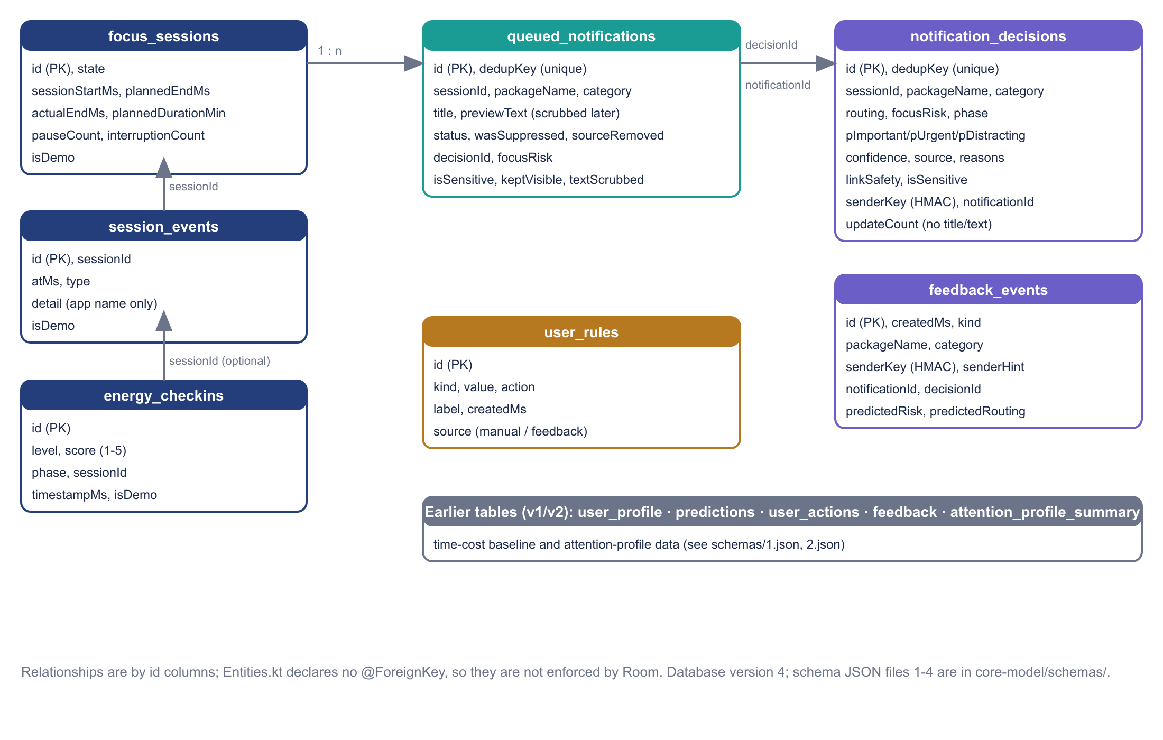
Figure 3. Entity overview of attune.db version 4 (relationships are by id columns).
Room version 4 with exportSchema; schema JSON files 1 to 4 are in core-model/schemas/ (4.json is untracked at the time of writing). Twelve entities are registered in AttuneDatabase.kt. VERIFIED
Version | Change | Test
2 to 3 | Additive: new tables notification_decisions, feedback_events, user_rules, session_events; new columns on queued_notifications and energy_checkins; energy score backfilled (LOW 2, MODERATE 3, HIGH 4) | MigrationTest builds a v2 database from 2.json and checks the result against 3.json VERIFIED (JVM); on-device upgrade NOT TESTED
3 to 4 | Data only: senderKey set to NULL because earlier ids were an unsalted SHA-256 that could be guessed from a contact list. New ids are HMAC-SHA256 with a per-install Android Keystore key | MigrationTest VERIFIED ; lost: sender-level learned preferences

15.1 Retention and privacy behaviour
Data | What is kept
Decision log | No text, ever (metadata, scores, generic reasons)
Sensitive notifications | No title or preview is written to the database
Queue items | Title and preview, so the user can read them. Removed 24 h after the focus session ended (handled items: 24 h after the action); backstop 7 days
Cleanup timing | On app open, on listener connect, and at most hourly while notifications arrive. Not while the process is dead
Senders | Keyed HMAC plus a masked hint (first and last character)
In memory only | Burst counters, pending-removal bookkeeping, diagnostics
Not hashed | Priority-contact names and keyword rules the user types are stored as typed (excluded from backup)
Backup | allowBackup=false; backup_rules.xml and data_extraction_rules.xml exclude every domain from cloud backup and device transfer
Network | None in the app

Verification level: the rules are in the XML and in the built APK per the project notes; retention and deletion are covered by SQL- and unit-level tests (PrivacyTest, MigrationTest). An actual backup, restore, retention run or deletion on a device has not been verified. If the Keystore is unusable no sender id is produced and sender-level personalisation is off. The claims of full encryption or secure deletion are not made. PARTIAL

16. Feedback and Personalisation
- Feedback kinds include correct, wrongly held, actually important, not important, opened immediately, waiting was fine, and always allow or always hold a type. Each is a row in feedback_events. VERIFIED
- PersonalizationProfile builds an adjustment per scope as weight times net votes divided by (events plus 2), with weights app 1.0, category 0.6, sender 0.5, clamped to plus or minus 1.5 log-odds. The adjustment shifts the importance logits and distraction at half strength before RiskPolicy. VERIFIED
- Rules and safety checks run first, so personalisation cannot override them. The profile is recomputed from stored feedback each time, so deleting feedback removes its effect at once. This is not model retraining; the model file never changes on the device. VERIFIED
- Tests: PersonalizationTest (7) and DecisionEngineTest cases for sender history and rule priority. VERIFIED

17. Evaluator Feedback and Traceability
A search of docs/, ml/, the source tree and the Git history found no evaluator, judge, mentor or faculty feedback. Nothing in this section is a quotation, and the design changes recorded in docs/UPGRADE_CHECKLIST.md and docs/NOTIFICATION_ROUTING_FIX.md are not attributed to any evaluator. UNKNOWN
Original feedback (exact wording) | Concern | Response / design change | Evidence | Status | Remaining gap
[to be completed]
[to be completed]
[to be completed]

17.1 Anticipated questions (not received feedback)
- Is the dataset real? No: it is synthetic and template-based (Section 7).
- Why logistic regression rather than a larger model? Simplicity and offline build constraints; no comparison experiment is recorded (Section 8).
- Does it really stop notifications on a phone? Not proven; logic is unit-tested, device checklists are untested (Section 13).
- What if the classifier is wrong? Uncertain cases go to REVIEW and the original stays visible; see false-HOLD rates in Section 9.
- Where does the data go? Nowhere: no network code (Section 15).

18. Testing Methodology and Results
Table 7. Test files and counts (@Test annotations counted statically; purposes from file names and project docs, not every test individually audited).
Module | File | @Test | Type
app | NotificationProcessorTest | 29 | Unit (JVM fakes for the listener and ports)
app | AnalyticsTest | 11 | Unit (reports and profile)
app | DomainLogicTest | 8 | Unit (timer and domain logic)
app | PrivacyTest | 4 | Unit (privacy)
app | ExampleUnitTest / ExampleInstrumentedTest | 1 / 1 | Template placeholders
core-model | MigrationTest | 6 | Database migration (JVM)
prediction | DecisionEngineTest | 47 | Unit (decision engine)
prediction | PolicyAndCounterfactualTest | 16 | Unit
prediction | LinkAnalyzerTest | 14 | Unit (links)
prediction | PredictionEngineTest | 9 | Unit (time-cost baseline)
prediction | PersonalizationTest | 7 | Unit
prediction | ModelParityTest | 3 | Kotlin versus Python golden vectors
prediction | RoutingEvaluationTest | 2 | Dataset evaluation; writes engine_routing_eval.md

Table 8. Build and test evidence available for this report.
Evidence | Result | Status
app debug unit tests (stored results, 10:58) | 53 run, 0 failures | HISTORICAL not re-run
core-model unit tests (stored result) | 6 run, 0 failures | HISTORICAL not re-run
prediction unit tests (stored results, 11:01) | 98 run, 1 failure | HISTORICAL not re-run
Fresh run: ./gradlew --offline :prediction:test --tests '*DecisionEngineTest.unsureButDistractingLowValueAppsAreHeld' | 1 test, 1 FAILED: expected DEFER but was REVIEW. Cause not investigated; no code was changed | VERIFIED
Instrumentation, UI and emulator tests | None recorded | UNKNOWN
Physical-device tests | None recorded; checklists in docs/HUMAN_TASKS.md and NOTIFICATION_ROUTING_FIX.md are NOT TESTED | NOT TESTED

The full suite was not re-run, so this report cannot say that all other tests pass today; it reports the stored outputs and the one fresh targeted run.

18.1 Gaps
- Real listener execution and cancellation timing on a device.
- Actual Room writes from listener callbacks (the processor is tested with fake ports).
- Permission setup, OEM behaviour, backup and restore, retention cleanup and deletion on a device.
- UI navigation and usability, and model performance on real notifications.

18.2 Manual test checklist for a real phone
Use a spare phone or test accounts. Do not use real banking or one-time-code messages; send test messages from a second device.
Step | Expected result
Install the debug build and grant notification access via the Access guide | Listener shows as connected in diagnostics
Start a focus session; send a casual chat message from a test account | Message is held and appears in the Queue; check whether the original disappears and note any sound or heads-up
Send a message containing urgent wording and a test OTP-style message | Stays visible (ALLOW or REVIEW); no title or text stored for the sensitive item
Send a message with a link-only body | REVIEW; original stays visible
Toggle Hide queued notifications off | Items are queued but flagged still visible
Kill the app and send another message | Record what happens (UNKNOWN until tested)
Use Delete everything in the privacy centre | Queue, decisions and feedback are cleared

19. Known Limitations, Unresolved Issues and Risks
- Synthetic data and template language: real-world accuracy is unknown.
- Failing test: DecisionEngineTest.unsureButDistractingLowValueAppsAreHeld fails in a fresh run; whether the test or the engine is wrong is undetermined.
- No device evidence for suppression, retention cleanup, backup exclusion or Keystore behaviour.
- Uncommitted work: the notification-routing changes, schema v4 and several tests exist only in the working tree. A commit is advisable (not done here).
- High-importance recall 0.56; weak on links, job offers and unknown senders.
- Language: English and romanised Hinglish only.
- No evaluator feedback to trace.
- Repository hygiene: large java_pid*.hprof dumps sit in the project root (ignored by Git).

20. Future Scope and Prioritised Roadmap
Priority | Item | Status
1 | Resolve the failing unit test and re-run all suites | PLANNED
2 | Run the device checklists on at least two phones and record results | PLANNED
3 | Commit the uncommitted work after review | PLANNED
4 | Collect consented, labelled real notifications; re-evaluate | PLANNED
5 | Compare other model families against logistic regression using the same splits | PLANNED
6 | Optional opt-in Do Not Disturb integration | PLANNED (assessed, not implemented)
7 | More languages and OEM-redacted samples | PLANNED

21. Setup, Build and Repository Guide

21.1 Prerequisites
Android Studio with JDK 17, Android SDK 35, and (for the ML pipeline) Python with numpy, scipy and scikit-learn. The Gradle wrapper is in the repository.

21.2 Commands
Purpose | Command
Prediction module tests | ./gradlew :prediction:test
App unit tests | ./gradlew :app:testDebugUnitTest
Migration tests | ./gradlew :core-model:testDebugUnitTest
Engine evaluation report | ./gradlew :prediction:test --tests '*RoutingEvaluationTest*'
Debug build | ./gradlew :app:assembleDebug
Regenerate dataset | python ml/generate_dataset.py (seeded)
Retrain (overwrites model, golden vectors and app assets) | python ml/train.py, then ./gradlew :prediction:test

The --offline flag was needed in this environment when the dependency cache was complete. The Gradle commands other than the single prediction test listed in Section 18 were not run for this report.

21.3 Repository map
Path | Responsibility
app/src/main/java/com/attune/app/capture | Listener service, processor, diagnostics
app/src/main/java/com/attune/app/data | Repositories, Keystore hasher, release notifier, settings
app/src/main/java/com/attune/app/domain | Reports, profile, insights, timer maths
app/src/main/java/com/attune/app/ui | Compose screens and navigation
core-model/ | Room database, entities, DAOs, schemas 1 to 4
prediction/ | Classifier, safety rules, link analyser, decision engine, personalisation, time-cost baseline
ml/ | Dataset, training, evaluation, model artifacts and reports
docs/ | DECISION_POLICY, DATA_AND_PRIVACY, AI_MODE_AND_ARCHITECTURE, NOTIFICATION_ROUTING_FIX, PREDICTION_BASELINE, HUMAN_TASKS, UPGRADE_CHECKLIST

22. Conclusion
Attune demonstrates a complete, privacy-first design for focus-time notification management: a listener and processor with a safe save-then-cancel order, a hybrid decision engine that prefers REVIEW over silent HOLD, explainable signals, capped personalisation, a Room data model with limited text retention, and an offline, reproducible training pipeline. Its claims are limited by synthetic training data, an unresolved failing unit test and the absence of device testing. The next steps are to fix the failing test, run the device checklist, commit the work, and collect real consented data.

23. References
No external publications were used. Sources are repository files and the libraries listed in Section 10.
- docs/DECISION_POLICY.md, docs/AI_MODE_AND_ARCHITECTURE.md, docs/DATA_AND_PRIVACY.md, docs/NOTIFICATION_ROUTING_FIX.md, docs/PREDICTION_BASELINE.md, docs/HUMAN_TASKS.md, docs/UPGRADE_CHECKLIST.md
- ml/README.md, ml/train.py, ml/generate_dataset.py, ml/reports/evaluation.md, evaluation.json, engine_routing_eval.md
- app/src/main/AndroidManifest.xml, app/src/main/res/xml/backup_rules.xml, data_extraction_rules.xml
- app/.../capture/NotificationProcessor.kt, FocusListenerService.kt
- prediction/.../decision/NotificationDecisionEngine.kt, DecisionModels.kt, RiskPolicy.kt, Personalization.kt
- core-model/.../Entities.kt, AttuneDatabase.kt, schemas/*.json
- gradle/libs.versions.toml, settings.gradle.kts

24. Appendix

A. Verified configuration
Item | Value
Git branch / HEAD | ai-upgrade / 43452b5 (2 commits in total)
Room version | 4
Model version | attune-text-lr-1.0
Model file | 202,628 bytes; 3,268 features; identical in ml/artifacts and app assets
Dataset seed | 20261026
Routing thresholds | allow_important 0.55; allow_urgent 0.60; min_confidence 0.60; review_important 0.15; short_words 2
Guard defaults | burst 3 messages in 120 s; follow-up 2 messages in 300 s; text retention 24 h; pending text backstop 7 days
Backup | allowBackup=false; all domains excluded for cloud backup and device transfer

B. Evidence map for the principal metrics
Metric | Source file | Dataset / split | Status
Head accuracy and macro-F1 | ml/reports/evaluation.json | Synthetic, test n=613 | HISTORICAL
Importance per-class P/R/F1 | ml/reports/evaluation.json | Synthetic, test n=613 | HISTORICAL
Engine confusion matrix and false-HOLD rates | ml/reports/engine_routing_eval.md | Synthetic, test n=613 | HISTORICAL
Model-only routing and v1 comparison | ml/reports/evaluation.md | Synthetic, test n=613 | HISTORICAL
Dataset counts | ml/data/notifications.csv | All 3,105 rows | VERIFIED recounted
Unit test counts and results | build/test-results (stored) | n/a | HISTORICAL ; one failure re-confirmed fresh

C. Diagrams
Figures 1 to 3 in this report were drawn from the verified code paths. They are embedded as images; the source is not kept as Mermaid files.

