
Dr. Ambedkar College, Deeksha Bhoomi, Nagpur
Department Of Commerce
2025-2026
Field Project
On
"Decent Work and Economic Growth (SDG 8): A Study of India's Progress and Challenges"
Submitted To
Rashtrasant Tukdoji Maharaj Nagpur University, Nagpur
In
Partial fulfilment of the requirements for the award of the degree
of
Bachelor Of Commerce
Submitted By
Miss. Vaidehi Gandhare
Guided By
Prof. Akhil Ramteke

Dr. Ambedkar College, Deeksha Bhoomi, Nagpur
DEPARTMENT OF COMMERCE
SESSION 2025-2026
CERTIFICATE
This project synopsis entitled "Decent Work and Economic Growth (SDG 8): A Study of India's Progress and Challenges" by VI semester students of this institute and is submitted to Rashtrasant Tukdoji Maharaj Nagpur University, Nagpur is approved in partial fulfilment of requirement for the award of degree of Bachelor of Commerce.
Miss. Vaidehi Gandhare
PROF. Akhil Ramteke
Project Guide

INDEX
Sr. No. | Headings | Page No.
1. | Introduction
2. | Objectives of the Study
3. | Research Methodology
4. | Detailed Profile of SDG 8: Decent Work and Economic Growth
5. | Impact on Employment, Productivity & Economic Growth
6. | Data Analysis & Interpretations
7. | Challenges & Risks
8. | Case Study: PM Mudra Yojana (PMMY)
9. | Findings & Recommendations
10. | Conclusion
11. | Bibliography

Review of Literature
A review of literature is an essential part of any research study. It helps in understanding previous research conducted in the field and identifies gaps that require further investigation.
The present study examines research and policy documents related to decent work, economic growth, employment generation, entrepreneurship and the Sustainable Development Goals. The review presented below summarizes important studies and frameworks developed by various scholars and institutions.
Conceptual Literature
1. Decent Work
The concept of decent work was introduced by the International Labour Organization (ILO) in 1999. It refers to productive work for women and men in conditions of freedom, equity, security and human dignity. Decent work includes:
- Opportunities for productive work and fair income
- Security in the workplace and social protection for families
- Better prospects for personal development and social integration
- Freedom to express concerns, organize and participate in decisions
- Equality of opportunity and treatment for all women and men
These elements together make employment meaningful rather than merely a source of income.
2. Economic Growth
Economic growth refers to a sustained increase in the production of goods and services in an economy over time, usually measured by the rate of growth of Gross Domestic Product (GDP) or per capita income. Growth is considered sustainable and inclusive when it:
- Creates employment opportunities for all sections of society
- Raises productivity and living standards
- Reduces poverty and inequality
- Uses natural resources efficiently without harming the environment
3. Employment and Sustainable Development
Sustainable development means meeting the needs of the present generation without compromising the ability of future generations to meet their own needs. Employment is a bridge between economic growth and human development. Decent work contributes to sustainable development by:
- Reducing poverty and income inequality
- Empowering women, youth and marginalized groups
- Increasing consumption, savings and investment
- Strengthening social stability and trust
Review of Previous Studies
Study 1
W. Arthur Lewis (1954)
Lewis, in his dual-sector model "Economic Development with Unlimited Supplies of Labour", explained how surplus labour in the traditional agricultural sector can move to the modern industrial sector, driving economic growth. The study found that:
- Surplus labour in developing countries keeps wages low in the early stages of development
- Growth of the modern sector absorbs workers and raises incomes
- Employment generation is central to long-term economic growth
Study 2
Amartya Sen (1999)
In "Development as Freedom", Sen argued that development should be judged by the expansion of real freedoms that people enjoy, and not by income alone. The study found that:
- Access to work, education, health and social security is an essential part of development
- Unemployment causes a loss of dignity and capability in addition to loss of income
- Growth must be accompanied by opportunities for people to improve their lives
Study 3
International Labour Organization (1999 onwards)
The ILO developed the Decent Work Agenda, built on four pillars: employment creation, social protection, rights at work and social dialogue. ILO reports on employment and social outlook consistently highlight that:
- A large share of workers in developing countries are in informal and vulnerable employment
- Youth and women face higher barriers in the labour market
- Quality of jobs matters as much as the number of jobs
Study 4
United Nations (2015)
The United Nations General Assembly adopted the 2030 Agenda for Sustainable Development, "Transforming our World", in September 2015. Sustainable Development Goal 8 calls for promoting sustained, inclusive and sustainable economic growth, full and productive employment and decent work for all. It sets 12 targets covering growth, productivity, entrepreneurship, youth employment, labour rights, tourism and access to financial services.
Research Gap
Most existing studies deal either with economic growth or with labour conditions separately. There is limited primary-level research on how young people in an Indian city perceive employment opportunities, wages, skill needs and awareness of government schemes in the context of SDG 8. The present study attempts to fill this gap through a survey-based analysis for the period 2020–2025.

Introduction
Work is at the heart of every economy. Through work, people earn a livelihood, develop skills, gain dignity and contribute to the growth of the nation. India, with one of the youngest populations in the world, has the potential to convert its demographic strength into economic strength, provided that growth is accompanied by good quality jobs.
In September 2015, all 193 member states of the United Nations adopted the 2030 Agenda for Sustainable Development, which contains 17 Sustainable Development Goals (SDGs). SDG 8 – Decent Work and Economic Growth aims to "promote sustained, inclusive and sustainable economic growth, full and productive employment and decent work for all". It recognizes that growth alone is not enough; the benefits of growth must reach workers in the form of fair wages, safe workplaces, social security and equal opportunity.
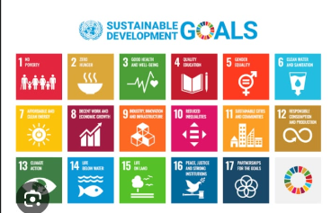
Figure: The 17 Sustainable Development Goals
Over the past decade India has taken several steps in this direction. Make in India (2014), Skill India Mission and Pradhan Mantri Mudra Yojana (2015), Startup India (2016) and the Pradhan Mantri Jan Dhan Yojana have focused on manufacturing, skills, entrepreneurship and financial inclusion. These initiatives aimed to create jobs, support small businesses and bring more people into the formal economy.
The COVID-19 pandemic in 2020 tested the Indian economy and its labour market severely. Lockdowns caused job losses, reverse migration of workers and disruption of small businesses, especially in the informal sector. At the same time, it accelerated digital work, e-commerce, gig platforms and government support measures such as the Atmanirbhar Bharat package and the Production Linked Incentive (PLI) schemes. The economy recovered strongly in the following years and India emerged as one of the fastest-growing major economies in the world.
Another major reform has been the consolidation of 29 central labour laws into four Labour Codes – on Wages, Industrial Relations, Social Security, and Occupational Safety, Health and Working Conditions – which aim to simplify compliance, extend social security and improve working conditions, including for gig and platform workers.
However, despite the growth, challenges remain. Informal employment, youth unemployment, low female participation in the workforce, skill mismatch, low wages and unsafe working conditions continue to limit the quality of growth. Addressing these challenges requires continuous investment in education and skills, support to MSMEs, effective implementation of labour laws and strong social protection.
In conclusion, achieving SDG 8 is central to India's vision of a developed nation. Growth that creates decent work for all will make the economy not only larger but also fairer and more resilient.

The Overall Plan
The progress of an economy is measured not only by how fast it grows but by how well it provides opportunities to its people. Sustainable Development Goal 8 brings these two ideas together by linking economic growth with decent work.
In India, economic growth has been supported by government initiatives such as Make in India, Skill India, Startup India and Digital India, along with rising consumption, services exports and infrastructure investment. The COVID-19 pandemic highlighted the need for secure jobs and social protection for workers.
The labour market has undergone substantial transformation due to these developments. Workers, employers and policymakers have shifted their focus toward skills, formalization, entrepreneurship and safe and fair working conditions.
1.2 Meaning of Decent Work and Economic Growth
Decent work means employment that provides fair income, security in the workplace, social protection, equal opportunity and freedom to organize and express concerns. Economic growth means a sustained rise in the output of goods and services of a country. SDG 8 requires that the two go together.
Key elements of SDG 8 include:
- Sustained per capita economic growth
- Higher productivity through technology and innovation
- Promotion of entrepreneurship and MSMEs
- Full and productive employment with equal pay for work of equal value
- Reduction in the share of youth not in employment, education or training (NEET)
- Elimination of forced labour, child labour and human trafficking
- Safe and secure working environments for all workers
- Access to banking, insurance and financial services for all
These elements together aim to make growth inclusive and sustainable.
1.3 Evolution of Decent Work and Growth Policies in India
The employment and growth policy framework in India has evolved over several decades.
Early Phase (1950–1990)
Planned development, public sector expansion and protective labour laws shaped employment, with a large share of workers remaining in agriculture.
Liberalization Period (1991 onwards)
Economic reforms opened the economy, boosted services and private enterprise and increased the growth rate.
Skill and Entrepreneurship Push (2014–2016)
Make in India, Skill India, Mudra Yojana and Startup India focused on jobs, skills and small business finance.
COVID-19 Period (2020–2021)
The pandemic disrupted jobs, especially in the informal sector, and led to relief and recovery measures.
Reform and Recovery Phase (2021–2025)
PLI schemes, e-Shram registration of unorganised workers, Labour Codes and a strong rebound in growth strengthened the focus on formal and quality jobs.
1.4 Features of Decent Work
The major features include:
- Fair Income – Wages that are adequate and paid on time.
- Security – Safe workplaces and protection against sudden loss of income.
- Equality – Equal opportunity and equal pay irrespective of gender, caste or religion.
- Rights – Freedom to form unions and take part in decisions affecting work.
- Social Protection – Health, pension and insurance benefits for workers and families.
1.5 Importance of Decent Work and Economic Growth
Decent work and growth play an important role in the economy by:
- Reducing poverty and unemployment
- Raising productivity and national income
- Improving living standards and human development
- Promoting women's and youth empowerment
- Supporting social stability and inclusive development
- Strengthening consumption, savings and investment
1.6 Benefits to the Economy
Achieving SDG 8 offers several advantages to the economy and society:
- Higher Productivity – Skilled and healthy workers produce more.
- Increased Demand – Fair incomes raise spending and boost markets.
- Wider Tax Base – Formal employment increases tax and social security contributions.
- Reduced Inequality – Opportunities reach rural, women and marginalized groups.
- Business Growth – Support to MSMEs and startups generates jobs.
1.7 Challenges in Achieving SDG 8
Despite numerous advantages, several challenges remain:
- Informal Employment – A large part of the workforce lacks contracts and social security.
- Youth Unemployment – Educated youth often struggle to find suitable jobs.
- Skill Mismatch – Training does not always match industry requirements.
- Low Female Participation – Women face social and workplace barriers.
- Low Wages and Unsafe Conditions – Especially in unorganised and gig work.
1.8 Statement of the Problem
India has recorded rapid economic growth, but the quality of employment and the distribution of benefits remain important concerns. Understanding how far growth has translated into decent work, and what young people think about jobs, wages, skills and government schemes, is important. Therefore, the present study attempts to analyze the progress of Decent Work and Economic Growth (SDG 8) in India during 2020–2025.
1.9 Objectives of the Study
- To study the concept of decent work and economic growth (SDG 8).
- To analyze the growth of the Indian economy and employment trends.
- To evaluate the impact of government initiatives on employment and entrepreneurship.
- To assess perceptions of respondents regarding employment, wages and work conditions.
- To identify challenges associated with achieving decent work.
- To provide suggestions for improving decent work and inclusive growth.
1.10 Scope of the Study
The study focuses on:
- Indian economy and labour market
- SDG 8 – Decent Work and Economic Growth
- Period 2020–2025
- Perspectives of respondents from Nagpur
- Employment, skills, entrepreneurship and work conditions
1.11 Need for the Study
The study is important because decent work and economic growth are central to India's development goals. Understanding their status helps policymakers, educational institutions, employers and young job seekers make informed decisions regarding future employment and skill initiatives.

Objectives of the Study
The progress of an economy depends on its ability to create productive and dignified work for its people. With the growing importance of the Sustainable Development Goals, it has become essential to examine decent work and economic growth from multiple perspectives. The following objectives guide the present study:
1. To Study the Concept and Progress of SDG 8 in India
- One of the primary objectives of this study is to understand the meaning, targets and indicators of SDG 8 and to examine how India has progressed towards them. This includes studying GDP growth, employment trends, productivity and the role of sectors such as agriculture, industry and services.
- The study also aims to understand the factors that contributed to this progress, including Make in India, Skill India, Startup India, Mudra Yojana, PLI schemes, labour reforms and the expansion of digital infrastructure. The impact of events such as the COVID-19 pandemic on jobs and recovery is also considered.
2. To Analyse the Impact of Government Initiatives on Employment and Entrepreneurship
- Another important objective of the study is to examine how government schemes have influenced job creation, self-employment and the growth of MSMEs. The study looks at access to credit, skill training and registration of unorganised workers.
- The study also aims to analyse the formalization of businesses, improvement in social security coverage and the role of financial inclusion in enabling entrepreneurship, especially for women and rural youth.
3. To Assess Perceptions Regarding Employment, Wages and Work Conditions
- Assessing the opinions of young people is a key objective of this study, as their expectations shape the future labour market. This objective aims to understand employment preferences, awareness of government schemes and satisfaction with wages and working conditions.
- Additionally, it considers demographic factors such as age, education and skill level in shaping attitudes towards jobs and entrepreneurship, which helps in identifying the level of confidence and awareness among respondents.
4. To Identify the Major Challenges in Achieving Decent Work
- Despite economic growth, several challenges continue to affect the quality of employment. This objective aims to identify issues such as informal work, unemployment, low wages, skill gaps, unsafe working conditions and gender inequality.
- From the policy perspective, it focuses on the need for effective implementation of labour laws, skill development programmes, social protection coverage and grievance redressal mechanisms. Identifying these challenges is essential for developing strategies for inclusive and sustainable growth.

Research Methodology
Research methodology describes the systematic procedure followed to collect, analyse and interpret data for the study. The methodology adopted for the present study is as follows:
1. Research Design
The study is descriptive and analytical in nature. It describes the status of decent work and economic growth in India and analyses the perceptions of respondents through a structured survey.
2. Sources of Data
- Primary Data – Collected through a structured questionnaire administered to respondents.
- Secondary Data – Collected from reports of the Ministry of Labour and Employment, Periodic Labour Force Survey (MoSPI), Economic Survey, NITI Aayog SDG India Index, ILO and UN publications, journals, newspapers and websites.
3. Sample Size and Sampling Method
The primary data was collected from a sample of 50 respondents from Nagpur using the convenience sampling method. The respondents include students, salaried persons, self-employed individuals and others.
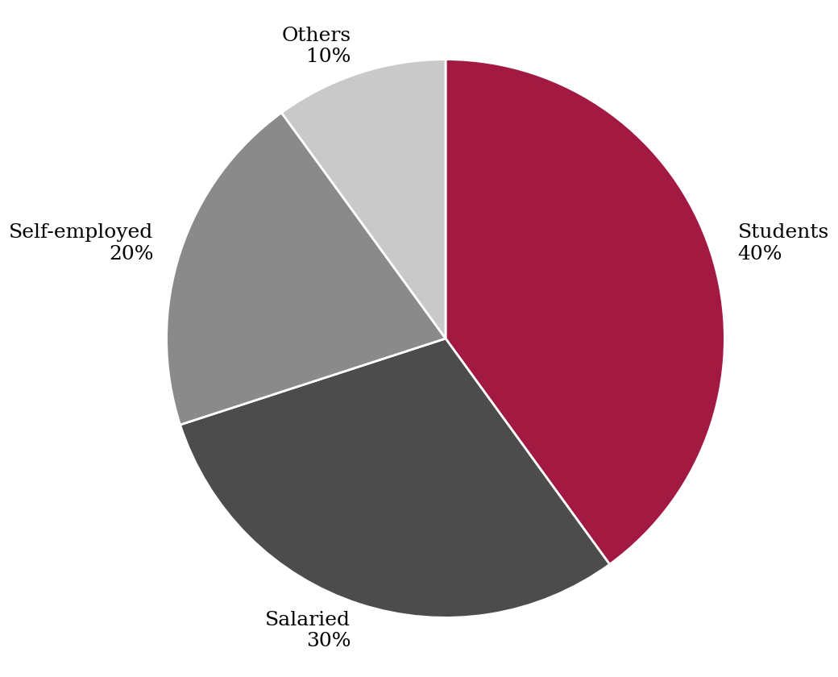
Figure: Profile of Respondents
4. Tools for Analysis
The data collected was tabulated and analysed using simple statistical tools such as frequency, percentages, tables and graphical presentation (bar chart, pie chart and donut chart).
5. Period of the Study
The study covers the period 2020–2025.
6. Limitations of the Study
- The sample size is small and limited to one city, so results cannot be generalized for the whole country.
- Responses are based on the personal opinions of respondents and may involve bias.
- Secondary data is subject to the limitations of the sources.
- The time available for the study was limited.

Deep Dive into SDG 8: Detailed Profile
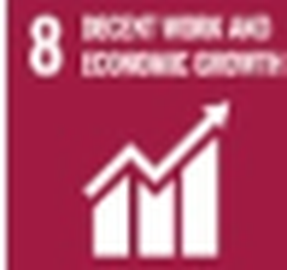
Sustainable Development Goal 8 is one of the 17 global goals adopted by the United Nations in 2015 to be achieved by 2030. It addresses economic growth, productivity, employment, labour rights and access to finance. The goal is organised into 10 outcome targets (8.1 to 8.10) and 2 means-of-implementation targets (8.a and 8.b). Each of these plays a significant role in promoting inclusive and sustainable growth.
A. Targets of SDG 8
Target | Summary
8.1 | Sustain per capita economic growth; at least 7% GDP growth per year in least developed countries.
8.2 | Achieve higher productivity through diversification, technological upgrading and innovation.
8.3 | Promote development-oriented policies supporting job creation, entrepreneurship and growth of MSMEs, including access to finance.
8.4 | Improve resource efficiency in consumption and production.
8.5 | Achieve full and productive employment and decent work for all, with equal pay for work of equal value.
8.6 | Substantially reduce the proportion of youth not in employment, education or training.
8.7 | Eradicate forced labour, modern slavery, human trafficking and child labour.
8.8 | Protect labour rights and promote safe working environments for all workers, including migrants and women.
8.9 | Promote sustainable tourism that creates jobs and promotes local culture and products.
8.10 | Strengthen domestic financial institutions to expand access to banking, insurance and financial services for all.
8.a | Increase Aid for Trade support for developing countries.
8.b | Develop and operationalize a global strategy for youth employment.

B. The Decent Work Agenda
The International Labour Organization's Decent Work Agenda is the foundation of SDG 8. It is built on four pillars which are interlinked and mutually supportive:
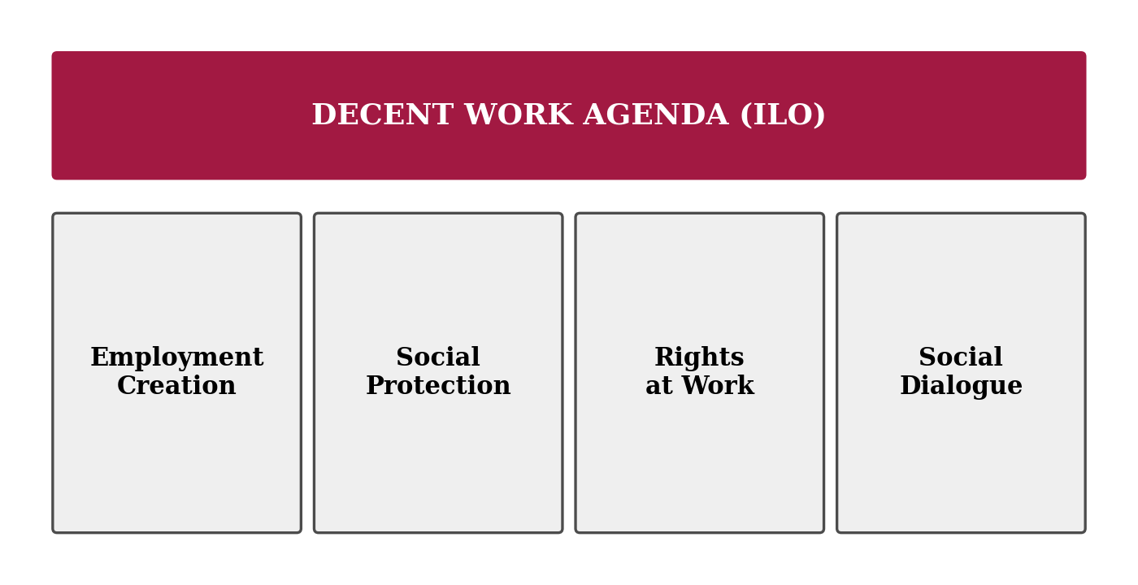
Figure: Four Pillars of the Decent Work Agenda
- Employment Creation – Promoting enterprises, skills and productive jobs for all.
- Social Protection – Providing health, pension, insurance and safety nets to workers.
- Rights at Work – Ensuring labour standards, equal treatment and elimination of forced and child labour.
- Social Dialogue – Involving workers, employers and government in decisions through tripartite consultation.
From a policy perspective, these pillars guide countries to design labour laws, social security programmes and employment schemes that make growth meaningful for workers.
C. Economic Growth and Key Indicators
Progress on SDG 8 is monitored through indicators such as:
- Annual growth rate of real GDP per capita
- Annual growth rate of real GDP per employed person (labour productivity)
- Proportion of informal employment in total employment
- Unemployment rate, by sex, age and persons with disabilities
- Proportion of youth (15–24 years) not in education, employment or training
- Occupational injuries and compliance with labour rights
- Number of commercial bank branches and ATMs per 100,000 adults and proportion of adults with an account at a financial institution
India tracks these indicators through the Periodic Labour Force Survey, national accounts and the NITI Aayog SDG India Index, which ranks states and union territories on their progress.
Conclusion
SDG 8 provides a comprehensive framework linking growth with employment quality. Its targets on productivity, entrepreneurship, youth employment, labour rights and financial inclusion together form the backbone of inclusive development. For India, achieving these targets means creating jobs that are productive, secure and fair.

Impact on Employment, Productivity & Economic Growth
The pursuit of decent work and economic growth has significantly influenced the structure of the Indian economy. By promoting enterprise, improving skills and expanding social protection, these efforts have changed how people work and earn. The major areas of impact are discussed below:
1. Employment Generation and Unemployment Trends
One of the most important outcomes has been improvement in employment indicators. According to the Periodic Labour Force Survey, the unemployment rate (usual status) declined from about 6.0% in 2017-18 to around 3–4% in recent years, and female labour force participation has risen considerably, particularly in rural areas, mainly through self-employment.
However, much of the new employment is self-employment and unpaid family work rather than regular salaried jobs. This shows that while the quantity of jobs has increased, the quality of employment requires continued attention.
2. MSMEs and Entrepreneurship
Micro, Small and Medium Enterprises (MSMEs) are the largest employment providers outside agriculture. Schemes such as Pradhan Mantri Mudra Yojana, Startup India, the Credit Guarantee Scheme and the Udyam registration portal have helped small businesses access credit, formalize and expand. Digital payments and e-commerce have further widened their market reach.
Support to MSMEs has improved self-employment opportunities, especially for women and first-generation entrepreneurs, and has strengthened local economic development.
3. Formalization and Social Protection
A large majority of Indian workers are in the informal economy, with no written contract or social security. The government has taken steps such as the e-Shram portal to register unorganised workers, the Labour Codes to extend social security to gig and platform workers, and schemes such as Ayushman Bharat, Atal Pension Yojana and the PM Suraksha Bima Yojana.
Formalization improves job security, increases the tax and contribution base and gives workers access to benefits during illness, old age or job loss.
4. Skill Development and Youth Employment
Skill India Mission, Pradhan Mantri Kaushal Vikas Yojana, apprenticeship schemes and the National Education Policy 2020 aim to align education with industry requirements. These initiatives help reduce the skill gap and improve the employability of youth. Strengthening vocational education and internships has become a priority for reducing the share of youth not in employment, education or training (NEET).
5. Productivity and Industrial Growth
Make in India and Production Linked Incentive (PLI) schemes in sectors such as electronics, pharmaceuticals, automobiles and textiles have encouraged manufacturing investment and technology adoption. Higher productivity raises wages and competitiveness and supports sustained economic growth. The services sector, particularly IT, business services and digital platforms, has remained a major driver of growth and exports.
6. Financial Inclusion and Access to Credit
Under SDG target 8.10, access to financial services is a key enabler of work and enterprise. Through Jan Dhan accounts, UPI and direct benefit transfers, millions of people have been brought into the formal financial system. Access to savings, insurance and credit enables households to invest in education and small businesses.
Conclusion
In conclusion, efforts towards decent work and economic growth have strengthened employment, entrepreneurship, formalization and inclusion. Higher growth combined with skills, finance and social protection makes development more balanced. Together, these factors highlight that decent work is not just a social objective but a strategic requirement for sustained growth in India.

CHAPTER 2: INDUSTRY PROFILE
2.1 Introduction to the Indian Economy and Labour Market
The Indian economy is one of the largest and fastest-growing economies in the world. It plays a crucial role in providing livelihoods to a population of over 1.4 billion. Over the years, the economy has undergone significant transformation due to liberalization, technological advancement and regulatory reforms. The period 2020–2025 witnessed a sharp disruption due to COVID-19 followed by a strong recovery driven by consumption, investment and services.
2.2 Structure of the Indian Economy
The Indian economy can be broadly classified into three sectors:
Primary Sector (Agriculture and Allied Activities): Provides employment to a large share of the workforce, though its contribution to GDP is comparatively smaller. Productivity and income in this sector remain low.
Secondary Sector (Industry and Manufacturing): Includes manufacturing, construction, mining and power. Programmes such as Make in India and PLI schemes aim to increase its share in output and jobs.
Tertiary Sector (Services): Includes IT, banking, trade, transport, tourism and communication. It contributes the largest share of GDP and has been the main driver of growth.
2.3 Employment Structure
Indian workers are engaged in both organised and unorganised sectors. The unorganised or informal sector includes small farmers, street vendors, construction workers, domestic workers and gig workers, who form the majority of the workforce. The organised sector includes government departments and registered companies where workers receive formal contracts and statutory benefits.
Employment is also classified as self-employed, regular wage or salaried, and casual labour. A large share of Indian workers is self-employed, often in small and low-income activities.
2.4 Institutional Ecosystem
India's decent work and growth ecosystem consists of various stakeholders:
Ministry of Labour and Employment
Responsible for labour policy and welfare. Major responsibilities include:
- Administration of labour laws and the Labour Codes
- Social security through EPFO and ESIC
- Registration of unorganised workers through e-Shram
- Employment services through the National Career Service
Ministry of Skill Development and Entrepreneurship (MSDE)
Responsible for skill training programmes such as Skill India Mission and PMKVY and for promoting apprenticeships and entrepreneurship.
Ministry of MSME and NITI Aayog
The Ministry of MSME supports small businesses through registration, credit and cluster development. NITI Aayog monitors SDG progress through the SDG India Index and guides policy.
International Organizations
The ILO and the United Nations provide technical support, standards and data for decent work and sustainable development.
2.5 Major Government Schemes
- Make in India – Promotes manufacturing and investment.
- Skill India Mission / PMKVY – Provides skill training to youth.
- Pradhan Mantri Mudra Yojana (PMMY) – Collateral-free loans to micro enterprises.
- Startup India – Supports innovation and new enterprises.
- PM Jan Dhan Yojana – Universal access to bank accounts.
- e-Shram Portal – National database of unorganised workers.
- MGNREGA and rural livelihood schemes – Support rural employment and income.
- Production Linked Incentive (PLI) Schemes – Encourage domestic manufacturing.
2.6 Growth and Employment Trends (2020–2025)
Several factors contributed to growth and job recovery during this period:
- Post-pandemic Recovery – Economic activity rebounded after 2021 with strong demand.
- Digital Economy – UPI, e-commerce, gig platforms and remote work created new opportunities.
- Infrastructure Investment – Higher public capital expenditure generated construction jobs.
- Start-up Ecosystem – India emerged as one of the largest start-up hubs in the world.
2.7 Challenges Faced
Despite significant growth, several challenges persist:
- Informality – Large share of workers lack security and social protection.
- Youth Unemployment – Educated youth face difficulty in finding suitable work.
- Skill Gap – Mismatch between training and industry needs.
- Gender Gap – Women's participation in the paid workforce remains lower than men's.
- Regional Disparity – Uneven development across states.
2.8 Future of Work in India
The future of work is expected to be shaped by:
- Artificial Intelligence and Automation
- Green Jobs and Renewable Energy
- Gig and Platform Work
- Digital Skills and Reskilling
- Manufacturing and Export Growth
- Women's Workforce Participation
These trends are expected to create new opportunities while also requiring continuous skill upgradation and strong social protection.

Data Analysis
The data analysis is based on responses collected from a sample of 50 respondents. The objective of this analysis is to understand employment preferences, awareness of government schemes and major concerns related to decent work. The findings are analysed question-wise and interpreted to draw meaningful conclusions.
1. Preferred Type of Employment
The first question aimed to identify the most preferred type of employment among respondents.
Type of Employment | Number of Respondents | Percentage
Government Job | 18 | 36%
Private Job | 15 | 30%
Self-Employment / Business | 12 | 24%
Freelance / Gig Work | 5 | 10%
Total | 50 | 100%

Interpretation:
The data indicates that government jobs are the most preferred type of employment, with 36% of respondents choosing it. This highlights the importance given to job security, fixed income and social benefits, which are key elements of decent work.
Private jobs are preferred by 30% of respondents, reflecting the attraction of growth and higher pay in the corporate sector. Self-employment is preferred by 24%, showing a growing entrepreneurial spirit among youth supported by schemes such as Mudra and Startup India. Only 10% prefer freelance or gig work, possibly due to uncertainty of income and lack of social security.
Overall, the findings reflect a continued preference for secure employment, along with rising interest in entrepreneurship.
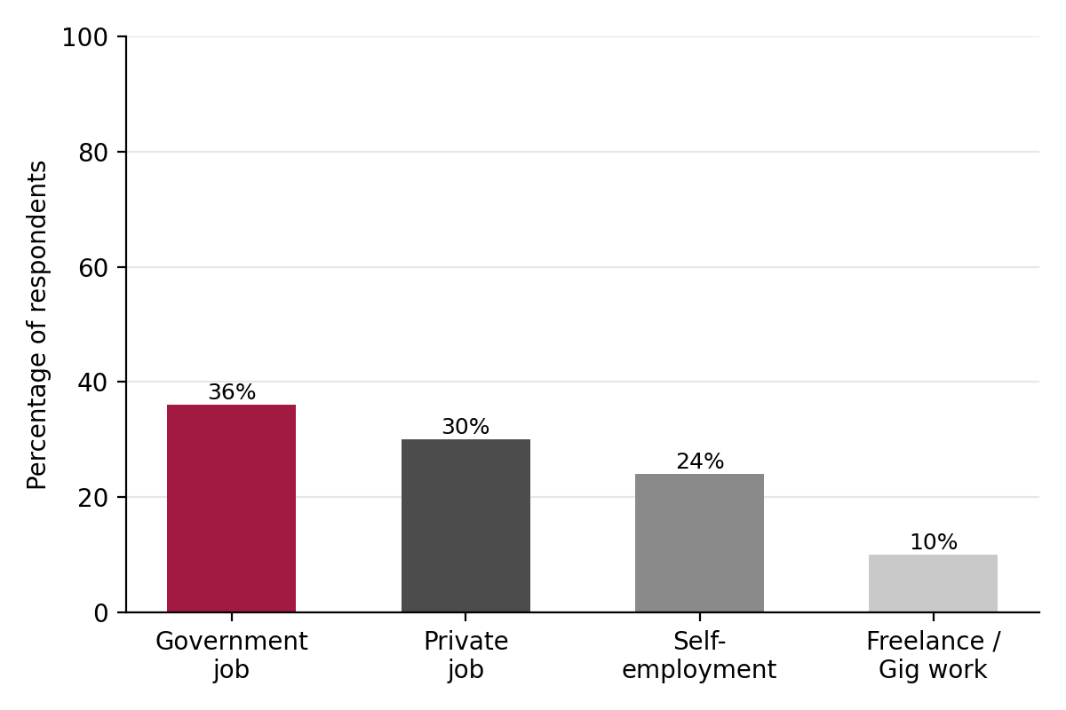
Figure: Preferred Type of Employment
2. Awareness of Government Employment and Skill Schemes
The second question focused on understanding how aware respondents are about government schemes such as Skill India, Mudra Yojana and Startup India.
Level of Awareness | Number of Respondents | Percentage
Fully Aware | 10 | 20%
Partially Aware | 25 | 50%
Not Aware | 15 | 30%
Total | 50 | 100%

Interpretation:
The analysis reveals that only 20% of respondents are fully aware of government employment and skill schemes, while 50% are partially aware. Nearly 30% are not aware at all, indicating a significant awareness gap.
This suggests that even though many schemes exist, their benefits may not reach everyone because of limited information. Stronger outreach through colleges, social media and local bodies is needed to increase participation.
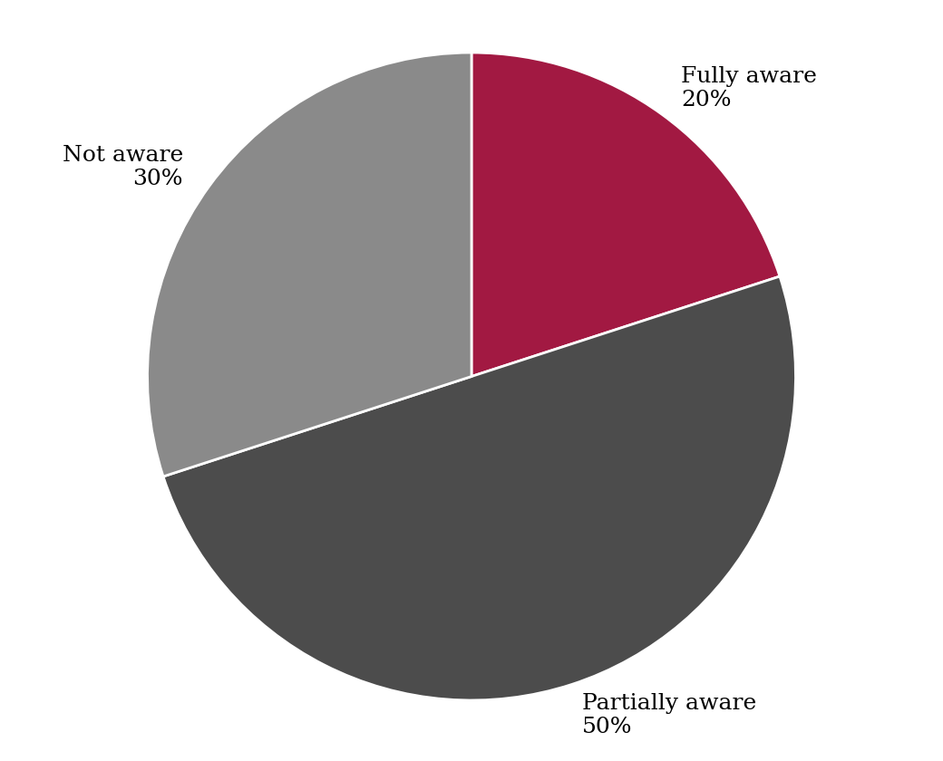
Figure: Awareness of Government Schemes
3. Major Concerns Related to Decent Work
The third question aimed to identify the primary concerns faced by respondents regarding employment and work conditions.
Major Concern | Number of Respondents | Percentage
Lack of Job Opportunities | 22 | 44%
Low Wages | 15 | 30%
Lack of Skills / Training | 8 | 16%
Unsafe Working Conditions | 5 | 10%
Total | 50 | 100%

Interpretation:
The results show that lack of job opportunities is the biggest concern, reported by 44% of respondents. This reflects the pressure faced by young job seekers in a competitive labour market.
Low wages is the second major concern, highlighted by 30% of respondents. Even when jobs are available, inadequate pay affects living standards and satisfaction. Lack of skills or training is cited by 16%, and unsafe working conditions by 10%, suggesting that skill development and workplace safety remain areas for improvement.
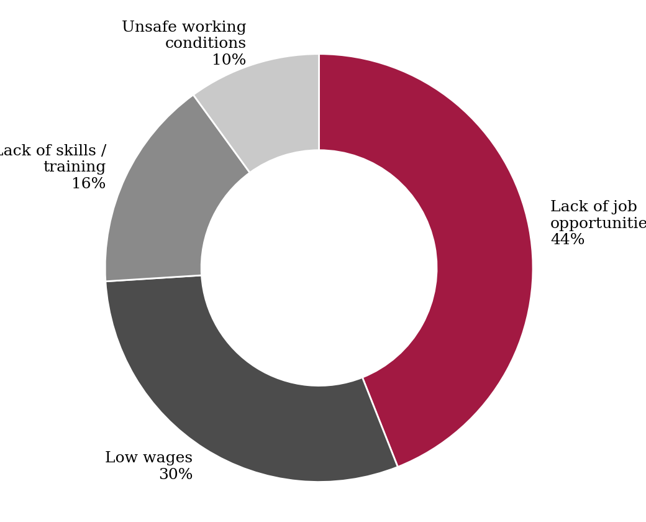
Figure: Major Concerns Related to Decent Work
Overall Findings
The data analysis clearly demonstrates a strong preference for secure employment, along with growing interest in self-employment. Limited awareness of government schemes, and concerns about job availability and wages, highlight the need for stronger skill programmes, better outreach and improved job quality.

Challenges & Risks
Despite the rapid growth of the Indian economy and several policy initiatives, a number of challenges and risks continue to hinder the achievement of decent work for all. While growth has brought opportunities and higher incomes, issues related to informality, skills, equality and workplace safety remain significant. The major challenges are discussed below.
1. Informal Employment and Lack of Social Security
One of the most serious challenges is the dominance of informal employment. A large majority of Indian workers work without written contracts, paid leave, pension or health insurance. This makes them highly vulnerable to income shocks, as seen during the COVID-19 lockdowns.
Many informal workers, including daily wage labourers, street vendors, domestic workers and gig workers, earn low and irregular incomes. Although initiatives such as e-Shram and the Labour Codes aim to extend coverage, effective registration, awareness and implementation remain challenging.
2. Youth Unemployment and Skill Mismatch
India has a young population, but many educated youth are unable to find jobs that match their qualifications. Employers often report a shortage of employable skills, while graduates complain of lack of opportunities. This mismatch results in underemployment and a high share of youth who are not in employment, education or training.
Addressing this challenge requires closer collaboration between industry and educational institutions, quality vocational training, internships and continuous reskilling in areas such as digital and green skills.
3. Gender Inequality in the Workforce
Despite recent improvements, women's participation in paid work is still lower than men's, and women often receive lower wages for similar work. Safety concerns, unpaid care responsibilities, limited mobility and social norms act as barriers. Increasing women's participation is essential for achieving higher growth and equality.
4. Low Wages and Unsafe Working Conditions
In many sectors such as construction, manufacturing, mining and agriculture, workers face low wages, long hours and inadequate safety measures. Accidents and occupational diseases often go unreported. Strong enforcement of safety standards and minimum wages is necessary to ensure dignity at work.
5. Impact of Automation and Technology
Artificial intelligence, robotics and automation may improve productivity but can also displace routine jobs. Workers without digital skills face the risk of exclusion. Gig and platform work offers flexibility but often lacks job security and benefits, creating new forms of vulnerability.
6. Regional Disparities and Economic Shocks
Growth and job opportunities are unevenly distributed across states and between rural and urban areas, leading to migration of workers in search of work. Global uncertainties, inflation, supply chain disruptions and climate change can also affect growth and employment, especially in agriculture and small businesses.
While initiatives such as skill missions, MSME support and rural employment schemes have helped reduce some of these gaps, significant efforts are still required. Improving infrastructure, promoting skills and designing inclusive policies are essential to overcome these challenges.

Case Study: PM Mudra Yojana (PMMY)
1. Background
Micro and small enterprises are the backbone of employment in India, but a large number of them, often called the "non-corporate small business sector", were unable to get formal credit. They depended on moneylenders at high interest rates because they could not offer collateral. To solve this problem, the Government of India launched the Pradhan Mantri Mudra Yojana (PMMY) on 8 April 2015 under the Micro Units Development and Refinance Agency (MUDRA).
2. Features of the Scheme
Under PMMY, collateral-free loans are provided by banks, Regional Rural Banks, small finance banks, microfinance institutions and NBFCs for non-farm income-generating activities. The loans are classified into three categories according to the stage of the business:
Category | Loan Amount | Target Group
Shishu | Up to ₹50,000 | Beginners and very small start-ups
Kishor | ₹50,001 to ₹5 lakh | Businesses that are established but need expansion
Tarun | ₹5 lakh to ₹10 lakh | Well-established businesses seeking growth

A further category, Tarun Plus, has been introduced for higher loan limits for borrowers who have successfully repaid earlier Tarun loans. MUDRA does not lend directly to individuals; it refinances lending institutions.
3. Link with SDG 8
PMMY directly supports SDG targets 8.3 and 8.10, which call for policies that encourage entrepreneurship, formalization and growth of MSMEs, and for wider access to financial services. By providing affordable credit, the scheme enables small traders, shopkeepers, artisans, food vendors, transporters and service providers to start or expand their businesses and employ others.
4. Impact
- Self-employment and job creation – Crores of loans have been sanctioned since inception, supporting micro enterprises and creating livelihoods.
- Women's empowerment – A majority of loan accounts belong to women entrepreneurs, improving their economic independence.
- Inclusion of weaker sections – Many beneficiaries belong to SC, ST and OBC categories and rural areas.
- Formalization – Borrowers enter the formal banking system, build a credit history and can access further credit.
- Growth of banks – Banks and financial institutions expand lending to a new customer base.
5. Challenges
- Risk of non-performing assets in some loan categories
- Need for proper assessment of end-use of loans
- Lack of awareness and handholding support for first-time entrepreneurs
- Need for skill and market linkage along with credit
6. Lessons Learned
The case of PMMY shows that access to credit combined with digital banking can unlock the entrepreneurial potential of millions of people. It also shows that credit alone is not enough; training, mentoring and market access are required for businesses to grow and generate decent jobs. PMMY has therefore become an important example of how a financial inclusion scheme can contribute to decent work and economic growth in India.

Findings & Recommendations
Based on the data analysis and overall study of decent work and economic growth in India, several important findings have emerged. These findings highlight current trends, perceptions and challenges in the labour market. Accordingly, suitable recommendations are suggested to strengthen job creation, skills, protection and inclusiveness.
Findings
1. Preference for Secure Employment
The study clearly reveals that government jobs and secure employment remain the most preferred among respondents. Job security, regular income and social benefits are valued highly. At the same time, a significant share of respondents is interested in self-employment, which shows the growing entrepreneurial mindset of youth.
2. Low Awareness of Government Schemes
Another key finding of the study is the awareness gap. Only one-fifth of respondents are fully aware of schemes such as Skill India, Mudra Yojana and Startup India, while nearly one-third are not aware at all. This reduces the effectiveness of these schemes, as potential beneficiaries remain unaware of the support available.
3. Concerns about Jobs and Wages
Despite economic growth, lack of job opportunities and low wages are the biggest concerns of respondents, together accounting for about three-fourths of responses. This highlights that growth must be translated into more and better quality jobs, particularly for young people.
Recommendations
1. Strengthen Skill Development and Industry Linkages
Educational institutions and training providers should work closely with industry to design courses that match market needs. Greater emphasis should be placed on internships, apprenticeships, digital skills and vocational education at the college level so that graduates are job-ready.
2. Expand Social Protection and Formalization
The government should ensure effective implementation of the Labour Codes and extend health, insurance and pension coverage to informal and gig workers. Simplified registration through portals such as e-Shram, along with awareness drives, will encourage workers to join the formal social security system.
3. Increase Awareness and Support for Entrepreneurship
Colleges, banks and local authorities should conduct regular awareness campaigns on schemes such as Skill India, Mudra Yojana and Startup India through workshops, social media and community programmes. Entrepreneurship cells, mentoring and easy access to credit and markets will help youth become job creators rather than only job seekers.
4. Promote Equal Opportunity and Safe Workplaces
Employers and regulators should ensure equal pay, safe working conditions and grievance redressal mechanisms. Policies supporting women's participation, such as safe transport, childcare facilities and flexible work, should be encouraged.

Conclusion
The study highlights the importance of Decent Work and Economic Growth (SDG 8) for India's development. The Indian economy has moved from a low-growth, agriculture-dependent structure to a faster-growing, services- and technology-driven economy. Initiatives such as Make in India, Skill India, Startup India, Mudra Yojana, e-Shram and the Labour Codes, along with events such as the COVID-19 pandemic and the digital transformation, have shaped the labour market and the way people work.
The findings of the study clearly indicate that respondents value secure and well-paid employment, while also showing growing interest in self-employment. Government schemes have expanded opportunities for entrepreneurship, financial inclusion and skill development. The study also reveals that awareness of such schemes is limited, and that lack of job opportunities and low wages are major concerns.
However, despite these advancements, challenges such as informal employment, youth unemployment, skill mismatch, gender inequality and unsafe working conditions continue to pose risks to inclusive growth. Stronger implementation of laws, better skill development and wider awareness are required to overcome these barriers.
In conclusion, decent work and economic growth are inseparable goals for India. With continuous improvements in education and skills, support to MSMEs, effective social protection and equal opportunity for all, India can move closer to achieving an inclusive, resilient and sustainable economy. The success of SDG 8 ultimately depends on ensuring that growth reaches every worker and every household.

Bibliography
1. United Nations (2015), "Transforming our World: The 2030 Agenda for Sustainable Development", General Assembly Resolution A/RES/70/1.
2. International Labour Organization, Decent Work Agenda and World Employment and Social Outlook reports (www.ilo.org).
3. Ministry of Statistics and Programme Implementation, Periodic Labour Force Survey (PLFS) Annual Reports (www.mospi.gov.in).
4. Ministry of Finance, Government of India, Economic Survey of India (various years).
5. NITI Aayog, SDG India Index and Dashboard (www.niti.gov.in).
6. Ministry of Labour and Employment, Labour Codes and e-Shram Portal (www.labour.gov.in).
7. Pradhan Mantri Mudra Yojana official portal (www.mudra.org.in).
8. Lewis, W. A. (1954), "Economic Development with Unlimited Supplies of Labour", The Manchester School.
9. Sen, A. (1999), Development as Freedom, Oxford University Press.
10. Business Standard & Economic Times articles on employment and economic growth (2024–2025).

