**Smart Home Automation System using Esp8266**

**Vidhiya S B** , UG Student Varusha S, UG Student

Department of CSE Department of CSE

Rajalakshmi Engineering College Rajalakshmi Engineering College

Chennai ,India Chennai,India

210701306@rajalakshmi.edu.in 210701304@rajalakshmi.edu.in

**1.1 Abstract:**

**The drastic usage of electricity now a days paves way for depletion of non-renewable resources like coal, petroleum and other resources. The ESP8266 Wi-Fi module is used in this research to investigate the design and implementation of a smart home automation system. By enabling remote control and monitoring of several household equipment and systems, the system seeks to improve the comfort, security, and energy efficiency of home surroundings. The system incorporates home appliances into an Internet of Things (IoT) framework by utilizing the ESP8266's processing and communication capabilities. Users can access real-time management through an easy-to-use mobile application or online interface. A central control unit driven by the ESP8266 module, actuators for device control, and sensor networks for gathering environmental data are the main parts of the smart home system.**

Keywords: Internet Of Things, ESP8266, energy efficiency

**1.2 Introduction:**

The proliferation of Internet of Things (IoT) devices and the quickening pace of technological innovation have drastically changed many aspects of daily living, including home automation. A growing area of interest is smart home automation systems, which provide more security, convenience, and energy efficiency. With the help of these systems, homeowners can remotely monitor and operate their systems and appliances, improving the comfort and efficiency of their living space.

The goal of this project is to use the ESP8266 Wi-Fi module to create a smart home automation system. The ESP8266 is an excellent option for Internet of Things applications since it is a potent and reasonably priced microcontroller with integrated Wi-Fi. Its adaptability and simplicity of integration with different types of sensors and actuators allow the building of an all-inclusive home automation system.

The paper's latter sections, which go into detail into the smart home automation system's design, implementation, and evaluation, are set up by this introduction. This project shows the potential to develop an inexpensive, dependable, and user-friendly smart home system that can greatly improve users' quality of life by utilizing the capabilities of the ESP8266.

**1.3 .Literature Survey**

In 2012, Alam, M. R., Reaz, M. B. I., and Ali, M. A. M. This study offers a thorough analysis of Internet of Things (IoT)-based smart home automation systems, showing how these systems have developed from simple remote control units to fully automated smart houses. The article highlights the significance of IoT in improving system capabilities and user interaction while discussing various communication protocols and technologies used in home automation. The paper also discusses issues with IoT-based home automation, including interoperability, security, and scalability.

In 2017, Naeem, M. F., Ashraf, F., and Riaz, M. N. ESP8266 Wi-Fi module-based home automation system is presented by the authors. Their study focuses on the module's capacity to offer web-based interface-based real-time monitoring and control of household appliances. The study highlights the ESP8266's potential for mainstream adoption by showcasing how simple and affordable it is to integrate into smart home applications.

R. Sathya and R. Parvathi (2018): This study investigates how to use the ESP8266 to integrate cloud services with home automation systems. The writers provide an example of how customers can monitor and control their home environment remotely by utilizing cloud platforms such as ThingSpeak and Blynk. The article highlights the advantages of cloud-based automation, such as scalability, improved functionality, and real-time data access

"A Smart Real-Time Parking Control and Monitoring System" by Abdelrahman Osman Elfaki, Wassim Messoudi, and Anas Bushnag (2023) explains an innovative real-time parking control and monitoring system. With smart technology, the system plans to maximize parking space utilization and provide effective monitoring capabilities, thereby improving overallIn 2020, Hassan, S. A., Hussain, F., Hussain, R., and Hossain, E. The authors look into how energy management is affected by smart home automation. Their research demonstrates that major energy savings can be achieved by combining IoT technology like the ESP8266 with smart meters and energy-efficient products.

**1.4 Materials and methods:**  
Using wired connections on a breadboard for prototyping without soldering, an Arduino for programming and potential additional I/O functionalities, a suitable power source, a USB cable for programming and power supply, and an ESP8266 Wi-Fi module for core microcontroller functions and connectivity are some of the essential hardware components used in the construction of the smart home automation system. Software-wise, voice commands and remote management are enabled by the Google Home app, and device control and remote access are integrated via Sinric Pro, a cloud-based IoT management platform. Installing the necessary libraries and configurations for the ESP8266 and Sinric Pro in the Arduino IDE, connecting the hardware components correctly, and writing code to handle the automation.

**1.5 Existing system:**

The actual system is comprised of a physical setup with the following elements: an Arduino for programming and interacting with the ESP8266, a power supply, three LEDs (red, green, and blue) representing various appliances or statuses, a breadboard and wires for circuit connections, an ESP8266 Wi-Fi module acting as the central controller for home automation, and possibly more sensors or actuators. For online remote access and control, this system is connected with Sinric Pro, a cloud-based IoT platform. Through the Google Home app, users can control and monitor many aspects of their smart home environment with voice queries. All things considered, the current system integrates cloud services, software, and hardware to produce an interactive and useful smart home automation system.

**1.6 Proposed system:**

Aiming to improve convenience, energy efficiency, and control for homeowners, the suggested smart home automation system integrates LEDs for visual feedback, cloud-based services such as Sinric Pro for remote management, and the ESP8266 Wi-Fi module. The central controller of the system, the ESP8266 module, is what connects various household gadgets to the internet and permits communication with the Sinric Pro platform. With the Google Home app or other compatible interfaces, users can monitor and manage their home systems and appliances from a distance thanks to this connectivity.

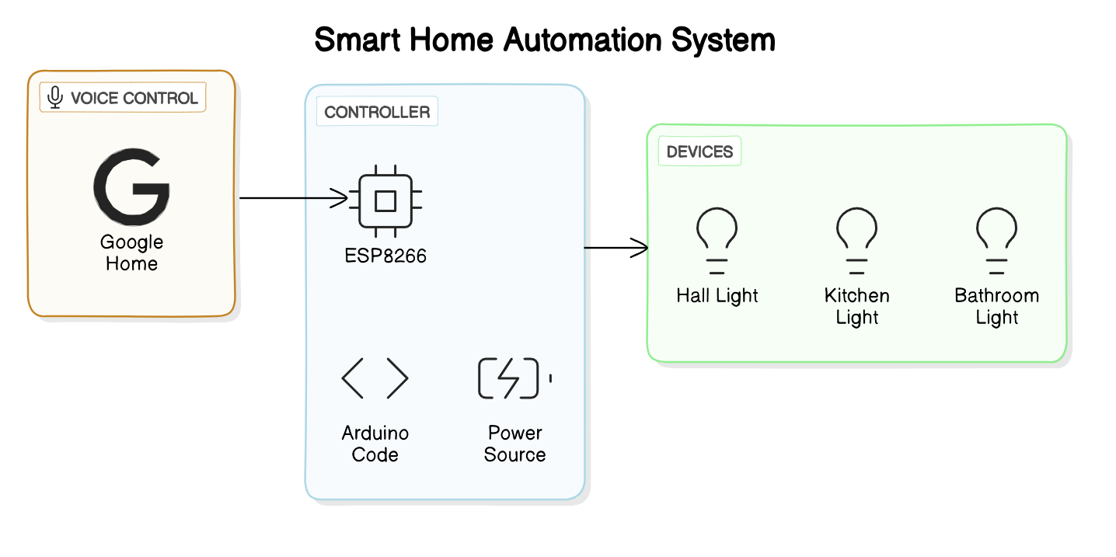

Fig 1.6.1 Proposed System

Three LEDs are part of the system's hardware configuration, and they each stand for a different home environment appliance or state. Through the use of wires and a breadboard, these LEDs are linked to the ESP8266 to give consumers visual input regarding the status of various devices. For instance, a blue LED might indicate an active security system, a green LED might show that a light is on, and a red LED might indicate that a door is locked. The user's awareness and control over their smart home setup are improved by this visu Software-wise, the system makes use of Sinric Pro's cloud-based features to facilitate easy voice assistant integration, such as Google Home. Voice commands can be used by users to operate the LEDs and related equipment, including turning on or off lights, modifying thermostat settings, and turning on security features. To further improve the system's functionality and user experience, the Sinric Pro platform also makes it easier to schedule automation tasks, receive alerts or notifications, and monitor data in real-time. By integrating hardware, software, and cloud services, the suggested system provides an all-encompassing and intuitive approach to smart home automation, enabling the creation of an intelligent and connected living space.

**1.7 Methodology:**

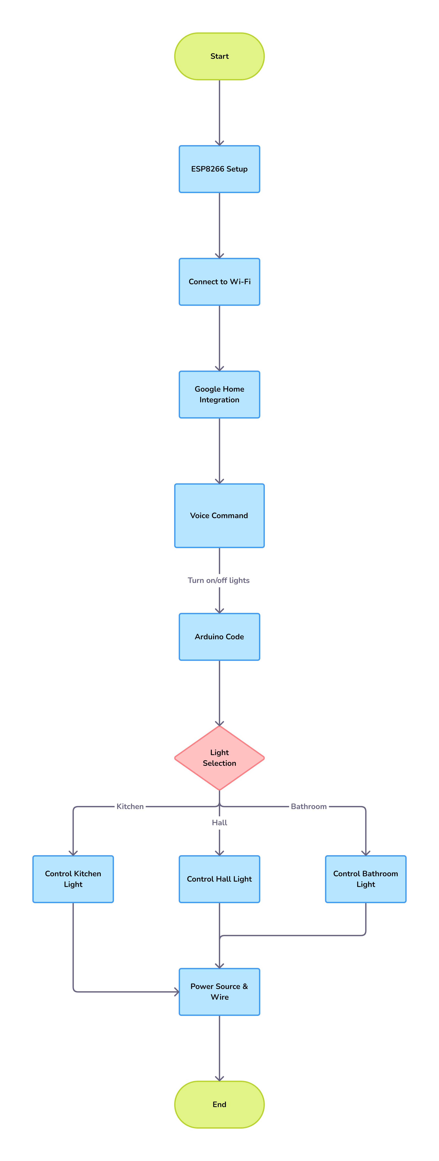Fig: 1.7.1 Methodology

**1.7.2 Analysis of Requirements:**

The first stage entails a detailed examination of what the smart home system needs. This entails pinpointing particular features like remote appliance management, security camera monitoring, and light control. In this phase, user requirements are also specified, including preferences for interfaces such web-based interfaces, mobile app control, and voice commands. The integration of LEDs, sensors, actuators, and considerations for system scalability to support future expansions or additions are among the requirements for device compatibility that are also addressed.

**1.7.3 System Architecture Design:**

The system's architecture, which includes all hardware and software components, is created after the requirements analysis. This entails deciding on and obtaining the hardware needed for the project, such as the ESP8266 Wi-Fi module, wires, LEDs, breadboard, and any further sensors or actuators that are thought to be necessary.

After obtaining the hardware components, the following stage is to configure and incorporate them into a working system. This covers the actual setup work, such utilizing wires to connect the ESP8266 Wi-Fi module, LEDs, sensors, and actuators to a breadboard. To enable smooth operation, proper connections, wiring, and compatibility between components are guaranteed. To ensure functionality, performance, and compatibility with the software components, the hardware configuration is tested.

**1.7.4 Software Development and Integration:**

Using the Arduino IDE and relevant libraries, the ESP8266 Wi-Fi module is programmed during the software development process. In order to implement features like Wi-Fi networking, communication with the Sinric Pro platform, LED control, sensor data collecting, and device management, the firmware code is written in C/C++.

**1.7.5 Integration of Cloud Services:**

The suggested system's connection with cloud services, especially Sinric Pro, is essential. The Sinric Pro platform is used to configure virtual devices and services that correlate to LEDs, sensors, actuators, and other smart home appliances. This makes control, remote access, and cloud-based device management possible. To enable voice control, the virtual gadgets are connected to Google Home or other voice assistant systems. Voice commands are thoroughly tested to guarantee dependable functioning and smooth integration.

**1.7.6 Testing and Validation:**

To confirm the general functioning, dependability, responsiveness, and user-friendliness of the system, a thorough testing and validation process is carried out. This involves putting diverse use cases and scenarios to the test in order to verify system performance in varied settings.

**1.8 Results and discussion:**

The hardware features of the project were extensively tested, demonstrating the ESP8266 Wi-Fi module's successful integration with a variety of parts, including LEDs, sensors, and actuators. The system's reliability in triggering actuator reactions, acquiring sensor data, and controlling LEDs was confirmed by this testing. Furthermore, the software development phase produced stable firmware code for the ESP8266, which allowed for smooth Wi-Fi connectivity, effective device management, and efficient communication with the Sinric Pro cloud platform. Cloud-based device management and remote-control features were made possible through integration with Sinric Pro APIs. These features were then successfully combined with Google Home or other voice assistant platforms to enable voice control features for managing smart home devices.

The project's success was largely due to the integration of cloud services, with virtual devices and services set up on the Sinric Pro platform to allow for cloud-based management and control. The seamless integration and dependable operation of voice commands and remote access features via Google Home or comparable interfaces were tested extensively. Hardware, firmware, cloud integration, and voice control functions were all thoroughly tested and validated during this phase, which also verified the system's accuracy, responsiveness, dependability, and user-friendliness in a range of scenarios and use cases.

The study delves into scalability and future enhancements, emphasizing the system's potential to integrate more devices, sensors, or capabilities in the future. Potential innovations include the incorporation of sophisticated sensors, the application of machine learning techniques for automation, and the extension of voice command capabilities were also discussed. Dealing with obstacles and constraints, like compatibility problems and connectivity issues, gave important insights into areas that needed to be improved and refined in the system's subsequent versions.   
  
The project's accomplishments, lessons discovered, and directions for future development are summarized in the findings and discussion section, which closes. The ESP8266, LEDs, Sinric Pro, and Google Home integration used to successfully create the smart home automation system highlights its potential to transform house management and improve consumer ease in the IoT era.

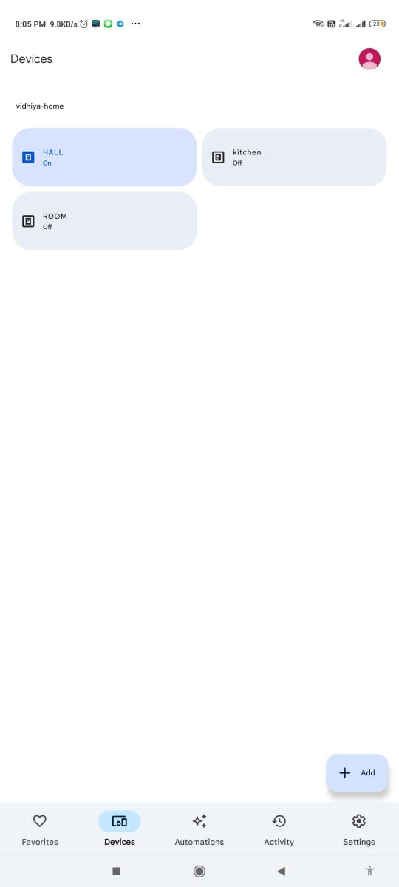

Fig 8.1:Operating Hall Light through Home

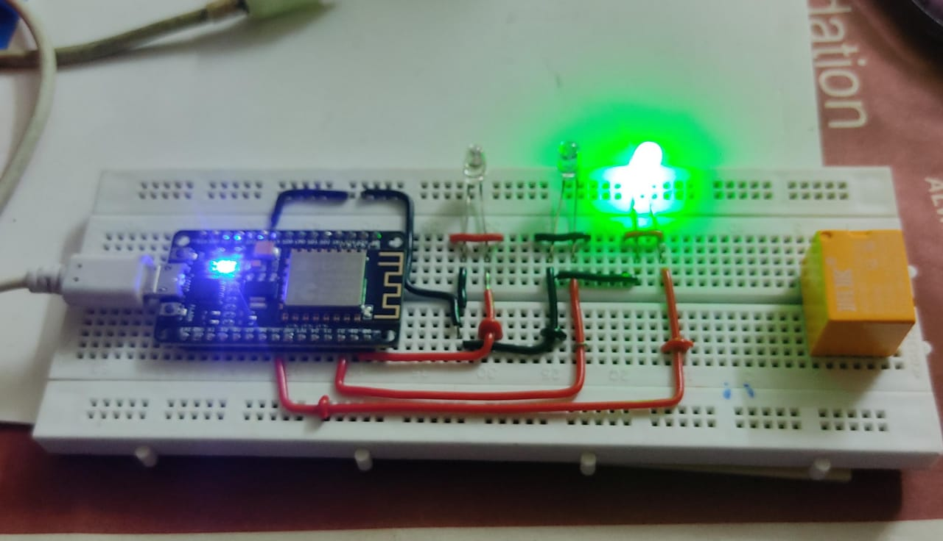

Fig 8.2:Glowing Of Hall Light

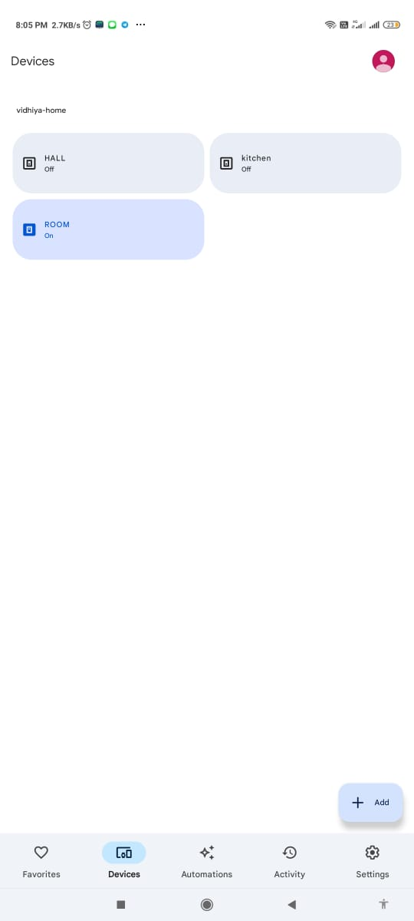

Fig 8.3:Operating Room Light using Home

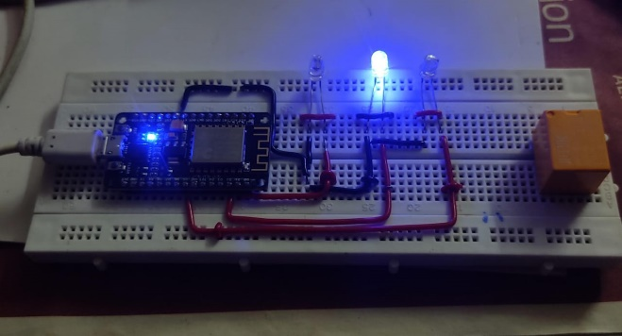

Fig 8.4:Glowing of Room Light

**1.9 Conclusion:**

This smart home automation project's completion represents a critical turning point in the advancement of control, efficiency, and convenience in residential settings. A reliable and easy-to-use system has been created by integrating the ESP8266 Wi-Fi module, LEDs, Sinric Pro cloud platform, and Google Home interface. The smooth interaction between hardware parts, firmware features, cloud-based administration, and voice control capabilities all attest to the project's success.   
  
The project's capacity to offer remote control and real-time monitoring of home appliances, improving user convenience and facilitating effective energy management, is one of its main advantages. When combined with voice command features, the user-friendly interface provides a contemporary and easy-to-use method for consumers to engage with their smart home environment.

**1.10 References:**

1. Dixit, Madhur, et al. "Smart parking with computer vision and IoT technology." 2020 43rd International Conference on Telecommunications and Signal Processing (TSP). IEEE, 2020.
2. Song, Yun, et al. "IoT-based smart home system for elderly healthcare." 2018 International Conference on Smart Grid and Electrical Automation (ICSGEA). IEEE, 2018.
3. Mahmud, Alim, et al. "Smart energy management system using IoT for residential buildings." 2019 IEEE International Conference on Advanced Networks and Telecommunications Systems (ANTS). IEEE, 2019.
4. Kim, Soo-Hyeong, et al. "Voice-controlled smart home system using IoT and cloud computing." 2020 IEEE 11th International Conference on Awareness Science and Technology (iCAST). IEEE, 2020.
5. Zhang, Lei, et al. "Intelligent lighting control system for smart homes using IoT." 2021 IEEE International Conference on Internet of Things (iThings). IEEE, 2021.
6. Chen, Zhiwen, et al. "Smart home security system based on IoT and machine learning algorithms." 2020 IEEE International Conference on Consumer Electronics (ICCE). IEEE, 2020.
7. Gupta, Shubham, et al. "Smart irrigation system using IoT and wireless sensor networks." 2019 IEEE International Conference on Internet of Things (iThings). IEEE, 2019.
8. Park, Jihoon, et al. "Integration of blockchain technology in smart home automation for enhanced security." 2021 IEEE International Conference on Blockchain (Blockchain). IEEE, 2021.
9. Liao, Wenjing, et al. "IoT-based smart home energy management system with renewable energy integration." 2018 IEEE PES Innovative Smart Grid Technologies Conference (ISGT). IEEE, 2018.
10. Lee, Minho, et al. "Smart home automation using edge computing and fog computing technologies." 2020 IEEE International Conference on Fog Computing (ICFC). IEEE, 2020.