HTML Quick-Styler
AI-Powered HTML Page Generator with IBM Granite 3.3 2B

Abstract
HTML Quick-Styler is an AI-powered web page generation platform designed to simplify and accelerate modern web development. The system utilizes the IBM Granite 3.3 2B Instruct model to automatically generate professional HTML and CSS code based on user-provided descriptions such as page title, required sections, and color preferences.
The platform analyzes user inputs and intelligently constructs a semantic HTML structure while applying modern CSS styling, responsive layouts, and visually appealing design elements. It also offers multiple predefined color palettes that ensure consistent design aesthetics across the generated webpage.
The system is implemented using Python and the Gradio framework, providing a simple and interactive interface that allows users to generate, preview, and customize web pages easily. The generated code follows modern web standards including HTML5, CSS3, responsive design principles, and accessibility guidelines.
By combining artificial intelligence with modern web design practices, HTML Quick-Styler significantly reduces the time required to create professional web pages while maintaining high-quality design and usability standards.

Introduction
Web development often requires significant time and effort to design visually appealing and responsive web pages. Developers and designers must manually write HTML structure, CSS styling, and responsive layouts while ensuring the page maintains a consistent visual theme. This process can be time-consuming, especially for beginners or for rapid prototyping.
HTML Quick-Styler is designed to solve this challenge by providing an AI-assisted web page generation system. The platform uses the IBM Granite 3.3 2B Instruct model, which is capable of understanding user instructions and generating structured HTML content with appropriate styling.
Users simply provide basic inputs such as the page title, required sections, and preferred color theme. The system then automatically creates a fully structured webpage that includes modern design elements such as hero sections, feature grids, portfolio galleries, testimonials, and contact forms.
The application is built using Python with the Gradio framework, which provides an easy-to-use interface for interacting with the system. The generated webpages follow responsive design principles so that they work properly across desktops, tablets, and mobile devices.
Overall, HTML Quick-Styler aims to make professional web development faster, easier, and more accessible to developers, designers, and non-technical users.

Architecture Overview
HTML Quick-Styler follows a modular architecture that integrates AI-based content generation with a structured HTML and CSS generation engine.
The system architecture consists of three primary layers:
1. User Interface Layer
The user interface is built using Gradio, which provides an interactive web application environment. Users can enter page details such as title, section descriptions, and color preferences through multiple interface tabs.
2. Processing Layer
This layer contains the main application logic written in Python. It includes several components such as:
- Color Palette Generator
- HTML Page Builder
- CSS Styling Engine
- Section Template Manager
These components analyze user inputs and generate structured webpage content.
AI Generation Layer
The IBM Granite 3.3 2B Instruct model processes user descriptions and assists in generating intelligent content suggestions and structured page elements.
4. Output Layer
The generated output includes:
- Complete HTML page structure
- CSS styling rules
- Responsive layout configuration
- Design elements such as animations and transitions
The final result is a production-ready webpage that can be used directly in web projects.

Technologies Used

The development of HTML Quick-Styler involves several modern technologies and frameworks.
Programming Language
- Python 3.x
Artificial Intelligence
- IBM Granite 3.3 2B Instruct Model
Web Technologies
- HTML5
- CSS3
- JavaScript
Frameworks and Tools
- Gradio (Interactive UI framework)
- Hugging Face Transformers (Model loading and inference)
- Google Colab (Cloud development environment)
Design Technologies
- Responsive Design (Media Queries)
- CSS Grid and Flexbox
- CSS Animations and Transitions

Software Requirements
The following software components are required to develop and run the HTML Quick-Styler system.
Operating System
- Windows / Linux / macOS
Development Environment
- Google Colab or Jupyter Notebook
Programming Language
- Python 3.8 or higher
Required Libraries
- Gradio
- Transformers
- Torch
- Requests
Installation command:
pip install gradio transformers torch requests
Web Browser
- Google Chrome
- Mozilla Firefox
- Microsoft Edge
- Safari
Additional Requirement
- Internet connection for accessing the AI model through Hugging Face.

Hardware Requirements
Minimum Requirements
Processor: Intel Core i3 or equivalent
RAM: 4 GB
Storage: 1 GB free space
Display Resolution: 1280 × 720
Recommended Requirements
Processor: Intel Core i5 or higher
RAM: 8 GB
Storage: 2 GB free space
Since the application runs in Google Colab, most computational tasks are handled in the cloud environment.

Project Workflow Diagram
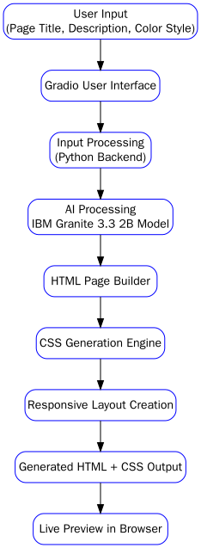
Workflow Steps:
- User provides webpage requirements through the interface.
- The system processes the input using Python backend logic.
- IBM Granite AI model assists in generating intelligent content.
- HTML Page Builder creates the webpage structure.
- CSS Engine applies styling, animations, and responsive design.
- The final webpage is generated and previewed in the browser.
Source Code
!pip install -U transformers
# Use a pipeline as a high-level helper
from transformers import pipeline
pipe = pipeline("text-generation", model="ibm-granite/granite-3.3-2b-instruct")
messages = [
{"role": "user", "content": "Who are you?"},
]
pipe(messages)
# Load model directly
from transformers import AutoTokenizer, AutoModelForCausalLM
tokenizer = AutoTokenizer.from_pretrained("ibm-granite/granite-3.3-2b-instruct")
model = AutoModelForCausalLM.from_pretrained("ibm-granite/granite-3.3-2b-instruct")
messages = [
{"role": "user", "content": "Who are you?"},
]
inputs = tokenizer.apply_chat_template(
messages,
add_generation_prompt=True,
tokenize=True,
return_dict=True,
return_tensors="pt",
).to(model.device)
outputs = model.generate(**inputs, max_new_tokens=40)
print(tokenizer.decode(outputs[0][inputs["input_ids"].shape[-1]:]))
!pip install -q gradio

import gradio as gr
import json
import re
from datetime import datetime
from typing import Tuple, Dict, List
import random

# ============================================================================
# HTML QUICK-STYLER - ADVANCED VERSION (FIXED)
# ============================================================================

class ColorPaletteGenerator:
"""Generate visually cohesive color palettes"""

@staticmethod
def generate_palette(style: str = "modern") -> Dict[str, str]:
"""Generate a cohesive color palette based on style"""

palettes = {
'modern': {
'primary': '#667eea',
'secondary': '#764ba2',
'accent': '#f093fb',
'background': '#0f172a',
'surface': '#1e293b',
'text_primary': '#f1f5f9',
'text_secondary': '#cbd5e1',
'border': '#334155'
},
'vibrant': {
'primary': '#ff6b6b',
'secondary': '#ff8e72',
'accent': '#f5576c',
'background': '#0f172a',
'surface': '#1e293b',
'text_primary': '#f1f5f9',
'text_secondary': '#cbd5e1',
'border': '#334155'
},
'ocean': {
'primary': '#0099cc',
'secondary': '#006699',
'accent': '#00ccff',
'background': '#0f172a',
'surface': '#1e293b',
'text_primary': '#f1f5f9',
'text_secondary': '#cbd5e1',
'border': '#334155'
},
'forest': {
'primary': '#27ae60',
'secondary': '#1e8449',
'accent': '#52be80',
'background': '#0f172a',
'surface': '#1e293b',
'text_primary': '#f1f5f9',
'text_secondary': '#cbd5e1',
'border': '#334155'
},
'sunset': {
'primary': '#ff8c42',
'secondary': '#ff6b35',
'accent': '#ffa751',
'background': '#0f172a',
'surface': '#1e293b',
'text_primary': '#f1f5f9',
'text_secondary': '#cbd5e1',
'border': '#334155'
},
'luxury': {
'primary': '#1a1a1a',
'secondary': '#333333',
'accent': '#FFD700',
'background': '#0f172a',
'surface': '#1e293b',
'text_primary': '#f1f5f9',
'text_secondary': '#cbd5e1',
'border': '#334155'
},
'creative': {
'primary': '#9b59b6',
'secondary': '#8e44ad',
'accent': '#e74c3c',
'background': '#0f172a',
'surface': '#1e293b',
'text_primary': '#f1f5f9',
'text_secondary': '#cbd5e1',
'border': '#334155'
},
'minimal': {
'primary': '#2c3e50',
'secondary': '#34495e',
'accent': '#3498db',
'background': '#0f172a',
'surface': '#1e293b',
'text_primary': '#f1f5f9',
'text_secondary': '#cbd5e1',
'border': '#334155'
}
}

return palettes.get(style.lower(), palettes['modern'])

class HTMLPageBuilder:
"""Build styled HTML pages from descriptions"""

@staticmethod
def extract_sections(description: str) -> List[str]:
"""Extract sections from description"""
sections = []

section_keywords = {
'hero': ['hero', 'banner', 'landing'],
'features': ['features', 'services', 'benefits'],
'about': ['about', 'team', 'company'],
'portfolio': ['portfolio', 'gallery', 'work', 'projects'],
'testimonials': ['testimonial', 'reviews', 'feedback'],
'pricing': ['pricing', 'plans', 'cost'],
'contact': ['contact', 'form', 'reach'],
'footer': ['footer', 'bottom']
}

desc_lower = description.lower()

for section_type, keywords in section_keywords.items():
for keyword in keywords:
if keyword in desc_lower:
sections.append(section_type)
break

if not sections:
sections = ['hero', 'features', 'contact', 'footer']

return sections

@staticmethod
def generate_meta_tags(title: str, description: str) -> str:
"""Generate SEO meta tags"""
meta_tags = f''' <meta charset="UTF-8">
<meta name="viewport" content="width=device-width, initial-scale=1.0">
<title>{title}</title>
<meta name="description" content="{description[:160]}">
<meta name="theme-color" content="#0f172a">
<meta property="og:title" content="{title}">
<meta property="og:description" content="{description[:160]}">
<meta property="og:type" content="website">
<meta name="twitter:card" content="summary_large_image">
<meta name="author" content="HTML Quick-Styler">'''
return meta_tags

@staticmethod
def generate_section_html(section_type: str, palette: Dict) -> str:
"""Generate HTML for specific section"""
sections = {
'hero': f''' <section class="hero">
<div class="hero-content">
<h1>Welcome to Your Site</h1>
<p>Create amazing web experiences</p>
<button class="btn btn-primary">Get Started</button>
</div>
</section>''',

'features': f''' <section class="features">
<h2>Features</h2>
<div class="features-grid">
<div class="feature-card">
<h3>Fast</h3>
<p>Lightning-quick performance</p>
</div>
<div class="feature-card">
<h3>Secure</h3>
<p>Enterprise-grade security</p>
</div>
<div class="feature-card">
<h3>Scalable</h3>
<p>Grow without limits</p>
</div>
</div>
</section>''',

'about': f''' <section class="about">
<div class="about-content">
<h2>About Us</h2>
<p>We're passionate about creating beautiful, functional websites that help your business grow.</p>
</div>
</section>''',

'portfolio': f''' <section class="portfolio">
<h2>Our Work</h2>
<div class="portfolio-grid">
<div class="portfolio-item"></div>
<div class="portfolio-item"></div>
<div class="portfolio-item"></div>
</div>
</section>''',

'testimonials': f''' <section class="testimonials">
<h2>What People Say</h2>
<div class="testimonials-grid">
<div class="testimonial">
<p>"Amazing service!"</p>
<span>- Client Name</span>
</div>
<div class="testimonial">
<p>"Highly recommended!"</p>
<span>- Happy Customer</span>
</div>
</div>
</section>''',

'pricing': f''' <section class="pricing">
<h2>Pricing Plans</h2>
<div class="pricing-grid">
<div class="pricing-card">
<h3>Starter</h3>
<p class="price">$29</p>
<ul><li>Feature 1</li><li>Feature 2</li></ul>
</div>
<div class="pricing-card featured">
<h3>Pro</h3>
<p class="price">$79</p>
<ul><li>All Starter</li><li>Feature 3</li></ul>
</div>
</div>
</section>''',

'contact': f''' <section class="contact">
<h2>Get in Touch</h2>
<form class="contact-form">
<input type="text" placeholder="Your Name" required>
<input type="email" placeholder="Your Email" required>
<textarea placeholder="Your Message" rows="5" required></textarea>
<button type="submit" class="btn btn-primary">Send Message</button>
</form>
</section>''',

'footer': f''' <footer class="footer">
<div class="footer-content">
<p>&copy; 2024 Your Company. All rights reserved.</p>
<div class="footer-links">
<a href="#privacy">Privacy</a>
<a href="#terms">Terms</a>
<a href="#contact">Contact</a>
</div>
</div>
</footer>'''
}

return sections.get(section_type, '')

@staticmethod
def generate_css(palette: Dict) -> str:
"""Generate comprehensive CSS"""
css = f''' <style>
* {{
margin: 0;
padding: 0;
box-sizing: border-box;
}}

:root {{
--primary: {palette['primary']};
--secondary: {palette['secondary']};
--accent: {palette['accent']};
--background: {palette['background']};
--surface: {palette['surface']};
--text-primary: {palette['text_primary']};
--text-secondary: {palette['text_secondary']};
--border: {palette['border']};
}}

body {{
font-family: 'Segoe UI', Tahoma, Geneva, Verdana, sans-serif;
background: linear-gradient(135deg, var(--background) 0%, var(--surface) 100%);
color: var(--text-primary);
line-height: 1.6;
min-height: 100vh;
}}

header {{
background: rgba(15, 23, 42, 0.95);
backdrop-filter: blur(10px);
padding: 1.5rem 2rem;
position: sticky;
top: 0;
z-index: 100;
border-bottom: 1px solid var(--border);
}}

header nav {{
display: flex;
justify-content: space-between;
align-items: center;
max-width: 1200px;
margin: 0 auto;
}}

header h1 {{
font-size: 1.8rem;
background: linear-gradient(135deg, var(--primary), var(--accent));
-webkit-background-clip: text;
-webkit-text-fill-color: transparent;
background-clip: text;
}}

header nav a {{
color: var(--text-secondary);
text-decoration: none;
margin: 0 1.5rem;
transition: color 0.3s ease;
}}

header nav a:hover {{
color: var(--primary);
}}

main {{
max-width: 1200px;
margin: 0 auto;
padding: 0 2rem;
}}

section {{
padding: 4rem 0;
animation: fadeIn 0.6s ease-in;
}}

@keyframes fadeIn {{
from {{
opacity: 0;
transform: translateY(20px);
}}
to {{
opacity: 1;
transform: translateY(0);
}}
}}

h1, h2, h3 {{
color: var(--text-primary);
margin-bottom: 1rem;
}}

h1 {{
font-size: 3rem;
font-weight: 700;
}}

h2 {{
font-size: 2rem;
margin-bottom: 2rem;
text-align: center;
}}

h3 {{
font-size: 1.3rem;
}}

.hero {{
background: linear-gradient(135deg, var(--primary) 0%, var(--secondary) 100%);
color: white;
padding: 6rem 0;
text-align: center;
min-height: 500px;
display: flex;
align-items: center;
justify-content: center;
}}

.hero h1 {{
color: white;
font-size: 4rem;
margin-bottom: 1rem;
animation: slideDown 0.8s ease;
}}

.hero p {{
font-size: 1.5rem;
margin-bottom: 2rem;
opacity: 0.95;
animation: slideUp 0.8s ease;
}}

@keyframes slideDown {{
from {{
opacity: 0;
transform: translateY(-30px);
}}
to {{
opacity: 1;
transform: translateY(0);
}}
}}

@keyframes slideUp {{
from {{
opacity: 0;
transform: translateY(30px);
}}
to {{
opacity: 1;
transform: translateY(0);
}}
}}

.btn {{
padding: 0.8rem 2rem;
border: none;
border-radius: 8px;
font-size: 1rem;
cursor: pointer;
transition: all 0.3s ease;
font-weight: 600;
}}

.btn-primary {{
background: var(--primary);
color: white;
box-shadow: 0 4px 15px rgba(0,0,0,0.3);
}}

.btn-primary:hover {{
transform: translateY(-2px);
box-shadow: 0 6px 20px rgba(0,0,0,0.4);
background: var(--accent);
}}

.btn-secondary {{
background: var(--secondary);
color: white;
}}

.btn-secondary:hover {{
background: var(--primary);
}}

.features-grid {{
display: grid;
grid-template-columns: repeat(auto-fit, minmax(250px, 1fr));
gap: 2rem;
}}

.feature-card {{
background: rgba(30, 41, 59, 0.8);
padding: 2rem;
border-radius: 12px;
border: 1px solid var(--border);
transition: all 0.3s ease;
backdrop-filter: blur(10px);
}}

.feature-card:hover {{
transform: translateY(-8px);
border-color: var(--primary);
box-shadow: 0 20px 40px rgba(0,0,0,0.3);
}}

.feature-card h3 {{
color: var(--primary);
margin-bottom: 0.5rem;
}}

.feature-card p {{
color: var(--text-secondary);
}}

.portfolio-grid {{
display: grid;
grid-template-columns: repeat(auto-fit, minmax(280px, 1fr));
gap: 2rem;
}}

.portfolio-item {{
aspect-ratio: 1;
background: linear-gradient(135deg, var(--primary), var(--secondary));
border-radius: 12px;
cursor: pointer;
transition: all 0.3s ease;
border: 1px solid var(--border);
}}

.portfolio-item:hover {{
transform: scale(1.05);
box-shadow: 0 20px 40px rgba(0,0,0,0.3);
}}

.about {{
text-align: center;
}}

.about-content {{
max-width: 800px;
margin: 0 auto;
}}

.about p {{
font-size: 1.1rem;
color: var(--text-secondary);
}}

.testimonials-grid {{
display: grid;
grid-template-columns: repeat(auto-fit, minmax(300px, 1fr));
gap: 2rem;
}}

.testimonial {{
background: rgba(30, 41, 59, 0.8);
padding: 2rem;
border-left: 4px solid var(--primary);
border-radius: 8px;
}}

.testimonial p {{
font-style: italic;
margin-bottom: 1rem;
color: var(--text-secondary);
}}

.testimonial span {{
font-weight: 600;
color: var(--primary);
}}

.pricing-grid {{
display: grid;
grid-template-columns: repeat(auto-fit, minmax(300px, 1fr));
gap: 2rem;
}}

.pricing-card {{
background: rgba(30, 41, 59, 0.8);
padding: 2rem;
border-radius: 12px;
border: 1px solid var(--border);
text-align: center;
transition: all 0.3s ease;
}}

.pricing-card.featured {{
border-color: var(--primary);
box-shadow: 0 20px 40px rgba(0,0,0,0.3);
transform: scale(1.05);
}}

.pricing-card .price {{
font-size: 2.5rem;
color: var(--primary);
margin: 1rem 0;
font-weight: 700;
}}

.pricing-card ul {{
list-style: none;
margin: 1.5rem 0;
text-align: left;
}}

.pricing-card li {{
padding: 0.5rem 0;
color: var(--text-secondary);
}}

.contact {{
max-width: 600px;
margin: 0 auto;
}}

.contact-form {{
display: flex;
flex-direction: column;
gap: 1.5rem;
}}

.contact-form input,
.contact-form textarea {{
padding: 1rem;
border: 1px solid var(--border);
border-radius: 8px;
background: rgba(30, 41, 59, 0.8);
color: var(--text-primary);
font-family: inherit;
font-size: 1rem;
}}

.contact-form input:focus,
.contact-form textarea:focus {{
outline: none;
border-color: var(--primary);
box-shadow: 0 0 0 3px rgba(0,0,0,0.3);
}}

.footer {{
background: rgba(15, 23, 42, 0.95);
border-top: 1px solid var(--border);
margin-top: 4rem;
padding: 3rem 0;
}}

.footer-content {{
max-width: 1200px;
margin: 0 auto;
padding: 0 2rem;
display: flex;
justify-content: space-between;
align-items: center;
flex-wrap: wrap;
gap: 2rem;
}}

.footer-links {{
display: flex;
gap: 2rem;
}}

.footer-links a {{
color: var(--text-secondary);
text-decoration: none;
transition: color 0.3s ease;
}}

.footer-links a:hover {{
color: var(--primary);
}}

@media (max-width: 768px) {{
header nav {{
flex-direction: column;
gap: 1rem;
}}

header h1 {{
font-size: 1.4rem;
}}

.hero h1 {{
font-size: 2rem;
}}

.hero p {{
font-size: 1.1rem;
}}

h2 {{
font-size: 1.5rem;
}}

main {{
padding: 0 1rem;
}}

section {{
padding: 2rem 0;
}}

.footer-content {{
flex-direction: column;
text-align: center;
}}
}}
</style>'''
return css
class HTMLGenerationEngine:
"""Main engine for HTML page generation"""
@staticmethod
def generate_page(title: str, description: str, style: str = "modern") -> Tuple[str, str]:
"""Generate complete HTML page"""
# Generate color palette
palette = ColorPaletteGenerator.generate_palette(style)

# Extract sections
sections = HTMLPageBuilder.extract_sections(description)
# Generate meta tags
meta_tags = HTMLPageBuilder.generate_meta_tags(title, description)
# Generate sections
sections_html = '\n\n'.join([
HTMLPageBuilder.generate_section_html(section, palette)
for section in sections
if HTMLPageBuilder.generate_section_html(section, palette)
])

# Generate CSS
css = HTMLPageBuilder.generate_css(palette)

# Build complete HTML
html = f'''<!DOCTYPE html>
<html lang="en">
<head>
{meta_tags}
{css}
</head>
<body>
<header>
<nav>
<h1>{title}</h1>
<div>
<a href="#features">Features</a>
<a href="#about">About</a>
<a href="#contact">Contact</a>
</div>
</nav>
</header>
<main>
{sections_html}
</main>
</body>
</html>'''
return html, palette
generation_history = []
def generate_html_page(title: str, description: str, style: str = "modern") -> Tuple[str, str, str]:
"""Generate HTML page with styling"""
if not title.strip() or not description.strip():
return "", "❌ Please provide both title and description!", ""
try:
html_output, palette = HTMLGenerationEngine.generate_page(title, description, style)
color_info = f"""
**Color Palette:**
- Primary: {palette['primary']}
- Secondary: {palette['secondary']}
- Accent: {palette['accent']}
- Background: {palette['background']}
"""
generation_history.append({
'title': title,
'description': description,
'html': html_output,
'palette': palette,
'timestamp': datetime.now().isoformat()
})
return html_output, "✅ HTML page generated successfully!", color_info
except Exception as e:
return "", f"❌ Error: {str(e)}", ""
def get_color_suggestions(style: str) -> str:
"""Get color suggestions based on style"""
palette = ColorPaletteGenerator.generate_palette(style)
palette_text = f"""
**Palette for "{style}" style:**
- Primary: {palette['primary']}
- Secondary: {palette['secondary']}
- Accent: {palette['accent']}
- Background: {palette['background']}
- Text: {palette['text_primary']}
"""
return palette_text
print("🚀 Loading HTML Quick-Styler Advanced...")
with gr.Blocks(title="HTML Quick-Styler - Advanced Edition") as demo:
gr.Markdown("""
# 🎨 HTML Quick-Styler Advanced
## Professional HTML Page Generator with Auto-Styling

**Generate production-ready HTML pages in seconds**
""")
with gr.Tabs():
# ============= TAB 1: Page Generator =============
with gr.TabItem("🎯 Generate Page"):
with gr.Row():
with gr.Column(scale=1):
gr.Markdown("### 📝 Page Details")
page_title = gr.Textbox(
label="Page Title",
value="Modern Portfolio Website",
lines=1
)
page_description = gr.Textbox(
label="Page Description & Sections",
value="Hero section with welcome message, features list with 3 items, about section, portfolio gallery, testimonials, contact form, and footer",
lines=4
)
color_style = gr.Dropdown(
["modern", "vibrant", "ocean", "forest", "sunset", "luxury", "creative", "minimal"],
value="modern",
label="🎨 Color Style"
)
generate_btn = gr.Button("✨ Generate HTML", size="lg", variant="primary")
with gr.Column(scale=1):
gr.Markdown("### 📊 Output")
html_output = gr.Code(
language="html",
label="Generated HTML/CSS",
lines=20
)
status_msg = gr.Markdown()
color_info = gr.Markdown()
generate_btn.click(
generate_html_page,
inputs=[page_title, page_description, color_style],
outputs=[html_output, status_msg, color_info]
)
# ============= TAB 2: Preview =============
with gr.TabItem("👁️ Live Preview"):
gr.Markdown("### 🔍 Preview Generated Page")
preview_button = gr.Button("🔄 Load Preview", size="lg", variant="primary")
preview_output = gr.HTML(value="<p style='text-align:center; color:#fff; padding:40px;'>No preview loaded. Generate a page first.</p>")
def show_preview(html_text):
if not html_text.strip():
return "<p style='text-align:center; color:#fff; padding:40px;'>No HTML provided</p>"
return html_text
preview_button.click(
show_preview,
inputs=[html_output],
outputs=[preview_output]
)
# ============= TAB 3: Color Palettes =============
with gr.TabItem("🎨 Color Palettes"):
gr.Markdown("### 🌈 Explore Color Schemes")
with gr.Row():
style_selector = gr.Radio(
["modern", "vibrant", "ocean", "forest", "sunset", "luxury", "creative", "minimal"],
value="modern",
label="Choose Style"
)
palette_btn = gr.Button("🎨 Get Palette", size="lg", variant="primary")
palette_display = gr.Markdown()
palette_btn.click(
get_color_suggestions,
inputs=[style_selector],
outputs=[palette_display]
)
# ============= TAB 4: Templates =============
with gr.TabItem("📋 Templates"):
gr.Markdown("### 📝 Quick Templates")
with gr.Row():
with gr.Column():
gr.Markdown("""
#### Portfolio Website
Hero, Portfolio Gallery, About, Contact, Footer
""")
portfolio_btn = gr.Button("Use Template", size="sm")
def load_portfolio():
return ("Portfolio Website",
"Hero section with welcome banner, portfolio gallery with 6 items, about section, testimonials, contact form, footer",
"modern")
portfolio_btn.click(load_portfolio, outputs=[page_title, page_description, color_style])
with gr.Column():
gr.Markdown("""
#### SaaS Landing Page
Hero, Features, Pricing, Testimonials, CTA, Footer
""")
saas_btn = gr.Button("Use Template", size="sm")
def load_saas():
return ("SaaS Product",
"Hero banner, features showcase with 3 items, pricing plans comparison, testimonials, call-to-action button, footer",
"vibrant")
saas_btn.click(load_saas, outputs=[page_title, page_description, color_style])

with gr.Column():
gr.Markdown("""
#### Company Website
Header, About, Services, Team, Contact, Footer
""")
company_btn = gr.Button("Use Template", size="sm")
def load_company():
return ("Company",
"Header with navigation, hero section, about company, services list, team members, contact form, footer",
"ocean")
company_btn.click(load_company, outputs=[page_title, page_description, color_style])
# ============= TAB 5: Guide =============
with gr.TabItem("📚 Guide"):
gr.Markdown("""
# 📖 HTML Quick-Styler Guide
## How It Works
### 1. Enter Details
- **Title:** Page name
- **Description:** Sections you want
- **Color Style:** Pick a theme
### 2. Automatic Detection
The tool recognizes these keywords:
- `hero` / `banner` → Hero Section
- `features` / `services` → Features Grid
- `about` / `team` → About Section
- `portfolio` / `gallery` → Portfolio
- `testimonial` / `reviews` → Testimonials
- `pricing` / `plans` → Pricing Plans
- `contact` / `form` → Contact Form
- `footer` → Footer
### 3. Generate & Customize
- Copy generated HTML
- Edit text and colors
- Save as .html file
- Open in browser
## Features
✅ Responsive design
✅ Modern animations
✅ SEO meta tags
✅ Professional styling
✅ Dark theme
✅ Color palettes
✅ Copy-paste ready
## Color Styles
- **Modern:** Professional blues
- **Vibrant:** Bold reds
- **Ocean:** Calm blues
- **Forest:** Natural greens
- **Sunset:** Warm oranges
- **Luxury:** Elegant blacks
- **Creative:** Purple artistic
- **Minimal:** Clean grays
""")
print("\n✅ HTML Quick-Styler Advanced Ready!\n")
demo.launch(share=True, show_error=True, show_api=False)

OUTPUT
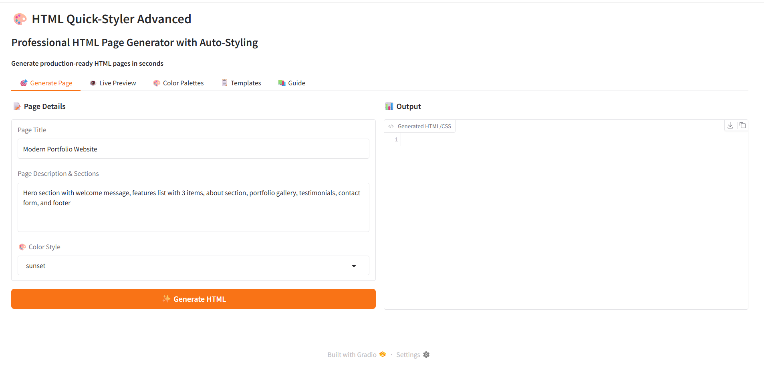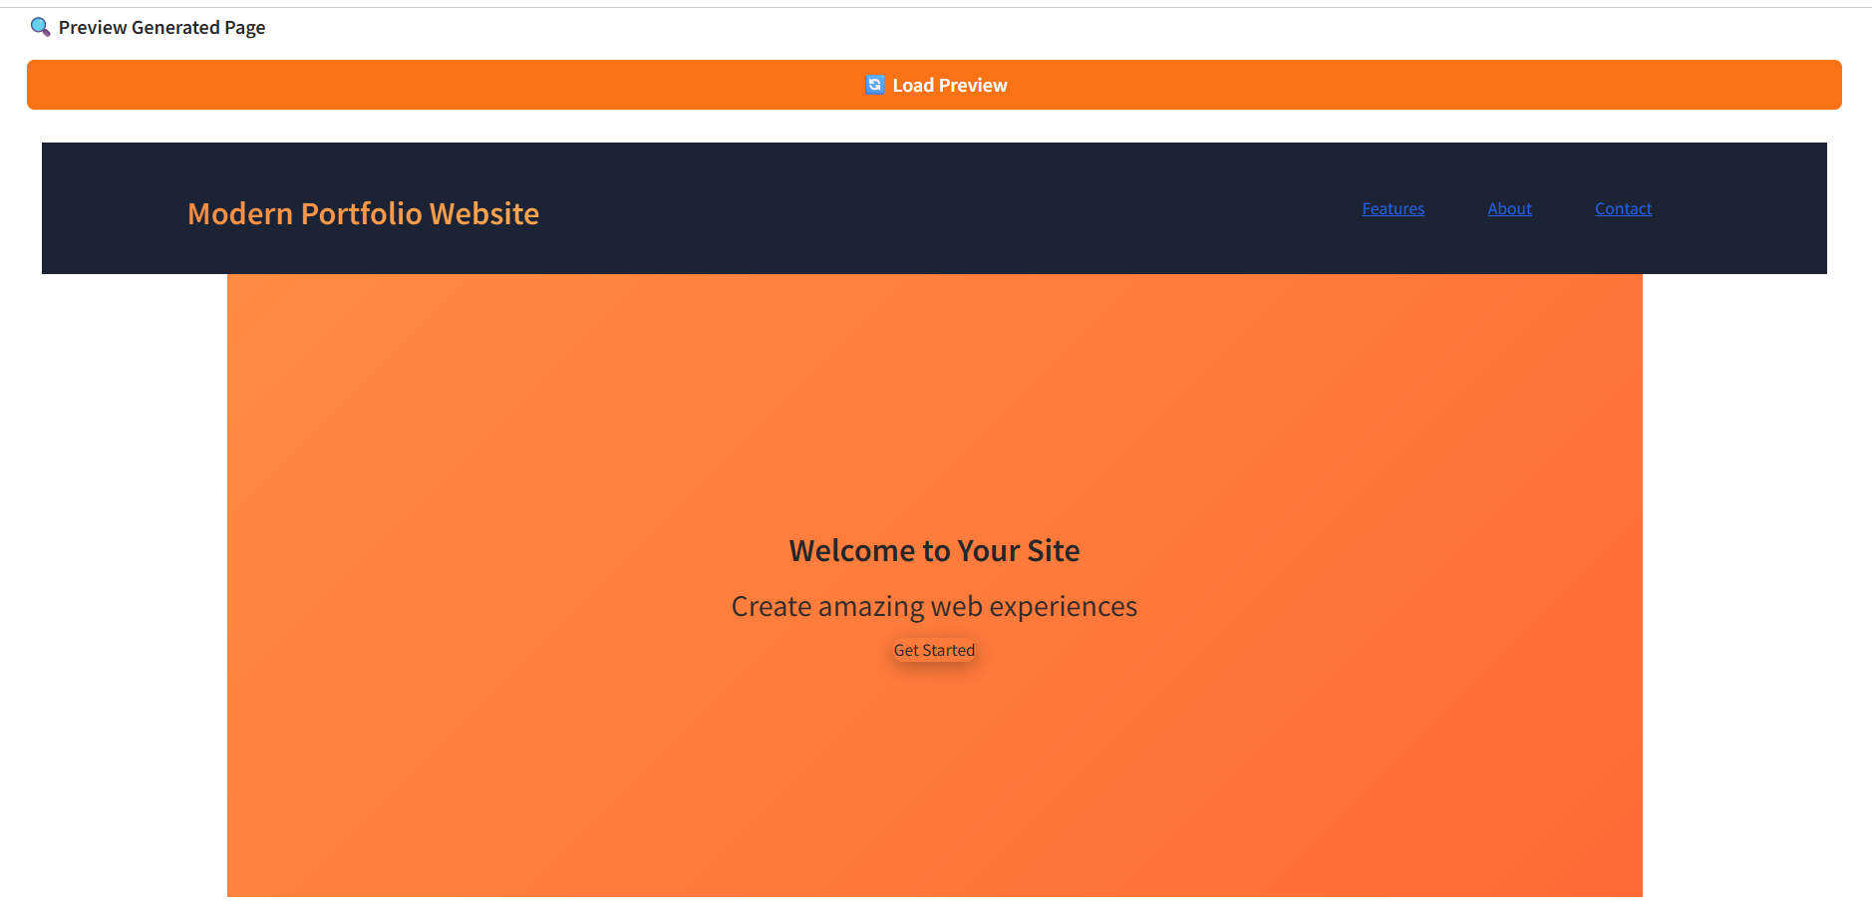

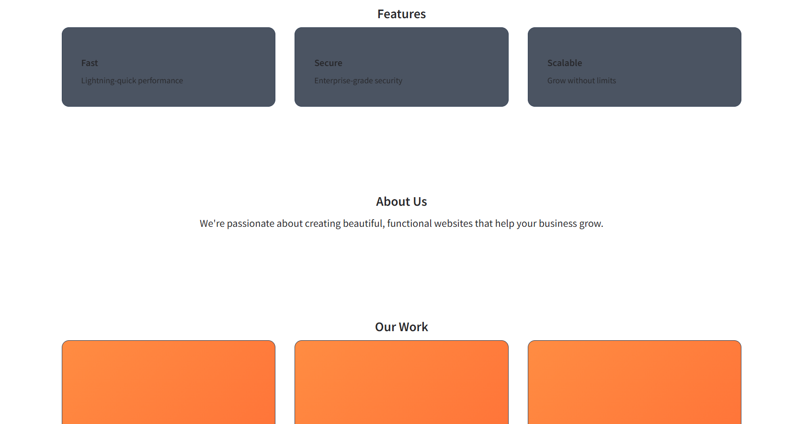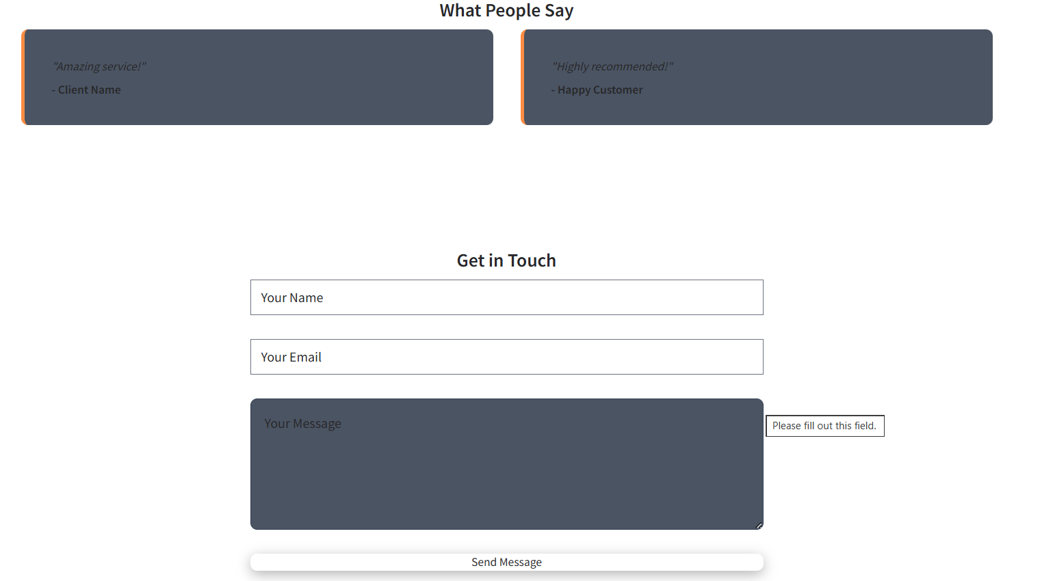

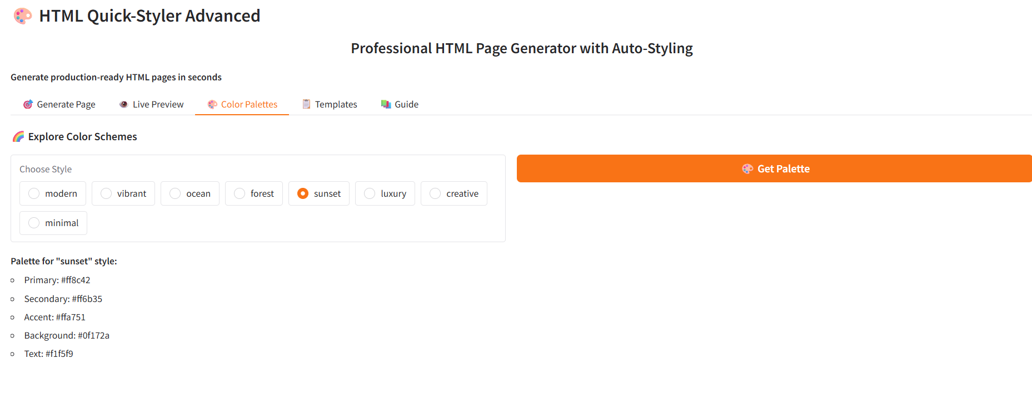
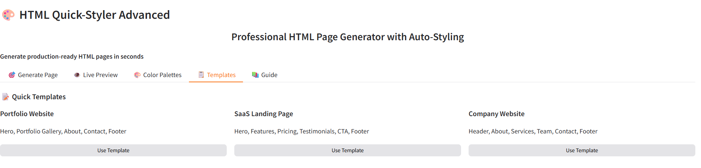

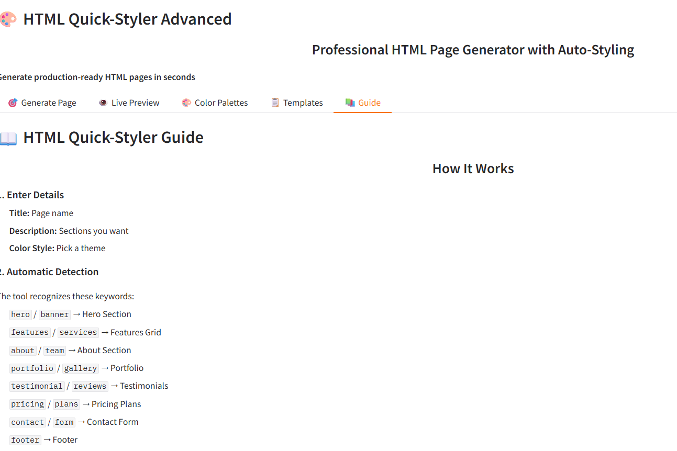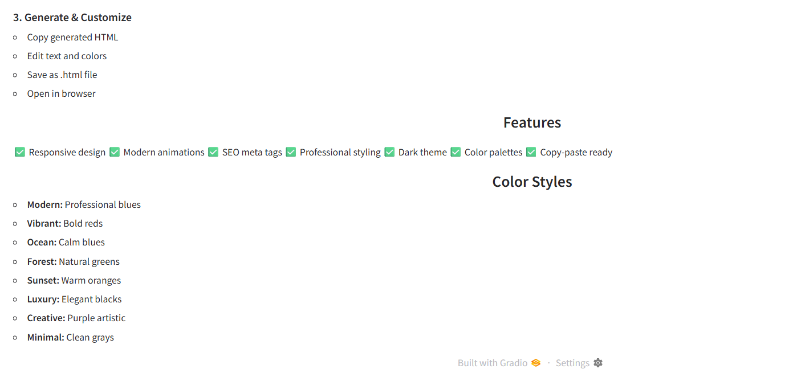

Output
The system generates a complete HTML webpage with modern CSS styling based on user input.
The output includes:
- Structured HTML sections such as hero, features, about, portfolio, and contact.
- Responsive layouts that work across mobile, tablet, and desktop devices.
- Professional design with animations and transitions.
- Multiple color palette options.
- Live preview of the generated webpage.

Conclusion
HTML Quick-Styler successfully demonstrates how artificial intelligence can simplify the web development process. By combining AI-powered content generation with automated HTML and CSS creation, the system allows users to generate professional webpages quickly and efficiently.
The project helps reduce development time while maintaining high design quality and responsive layouts. With its user-friendly interface and intelligent design generation, HTML Quick-Styler can be useful for developers, designers, and beginners who want to create websites easily.
Future improvements may include additional design templates, custom color selection, integration with web frameworks, and advanced JavaScript interactivity generation.

