**Letters and word counter**: counts the number of letters and words entered in text and give the number (count) of each in output. Each element present in the text will be considered a letter, and a group of letters with a space will be considered a word.

🡺Text editor will be there to write any text inside that.

🡺It will count the number of words and also number of letters and display on UI.

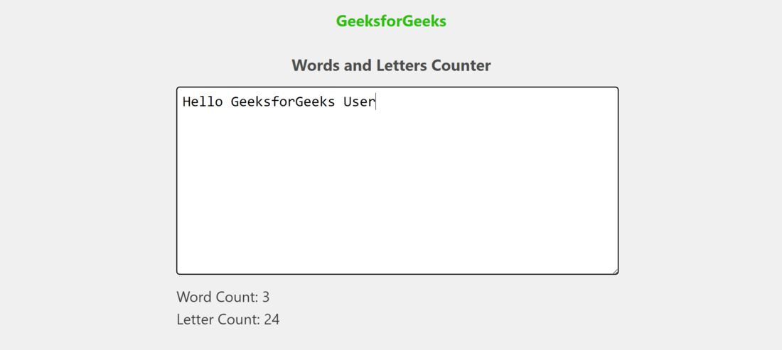

**Image Compresser:**

Users can upload image files and adjust compression quality via a slider. Upon setting the compression quality and initiating compression, users can download the compressed image locally.

🡺Upload button will be there through which we have to upload the image .

🡺we will compress the image size by using the slider .

🡺user can download the compressed image by clicking on download button.

🡺Reset button will be there which helps us to again upload the image to compress it.

🡺compress button will be there after adjusting the size we have to click on compress button which will show the message as compressed successfully.

