Live Weather Dashboard

What it does
- Search any city and see its weather
- Current conditions: temperature, feels-like, humidity, wind speed, weather condition
- Next 24 hours: temperature line chart and rain-chance bar chart
- 7-day forecast: high/low, condition and rain chance per day
- Air quality: US AQI value with its meaning (Good, Moderate, Unhealthy, …)
- City comparison: temperature of 2+ cities on one chart
- Live data with a "Last updated" time and a Refresh button
- Clear error messages (city not found, empty search, API failure/timeout); the page does not crash
- Mobile-friendly layout

API and hosting
- API: Open-Meteo — Geocoding API, Forecast API and Air Quality API. Free, no API key, so there are no secrets in the code.
- Charts: Chart.js (loaded from the jsDelivr CDN)
- Hosting: GitHub Pages
- Built with plain HTML, CSS and JavaScript in a single index.html.

How to run
Locally: download or clone the repo and open index.html in a browser (or run python -m http.server in the folder and visit http://localhost:8000). An internet connection is needed because the data is fetched live.

Screenshots
- Full dashboard:
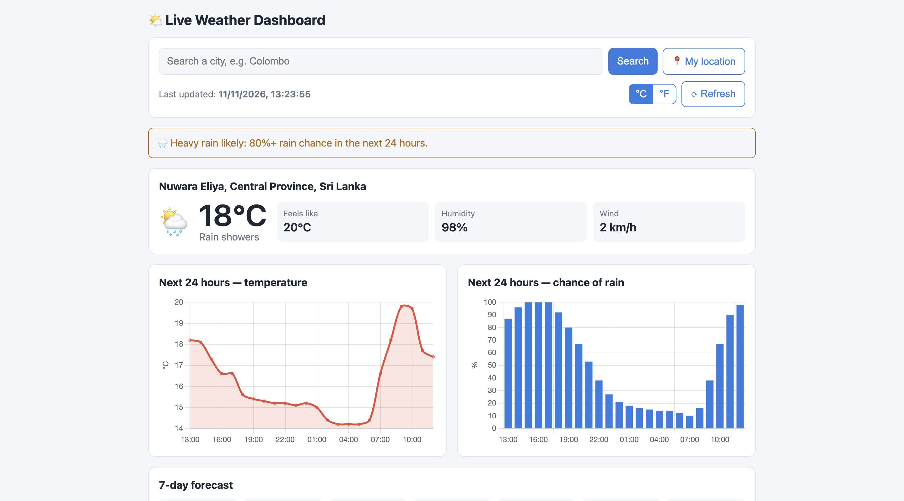
- City search result:
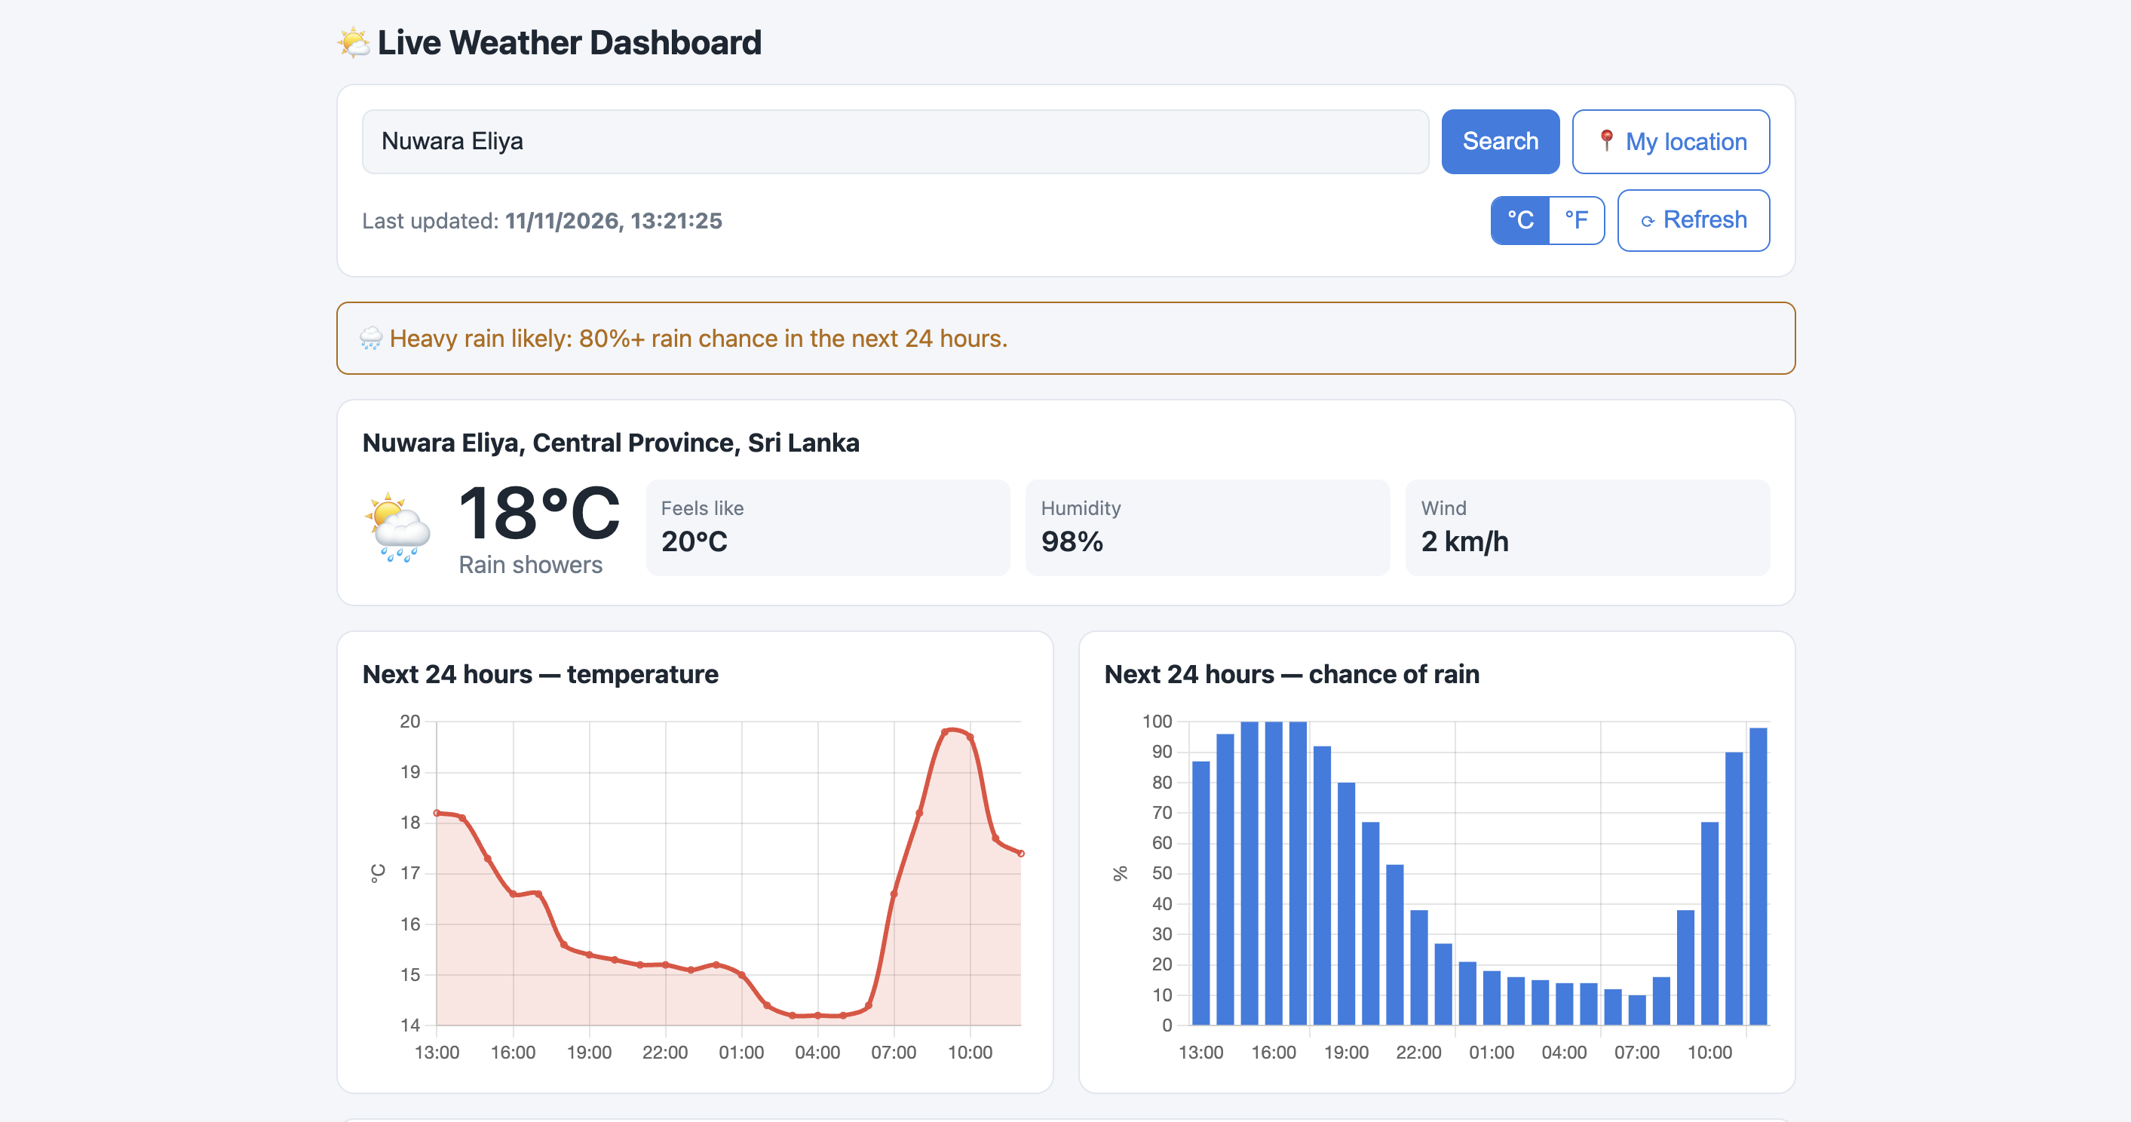
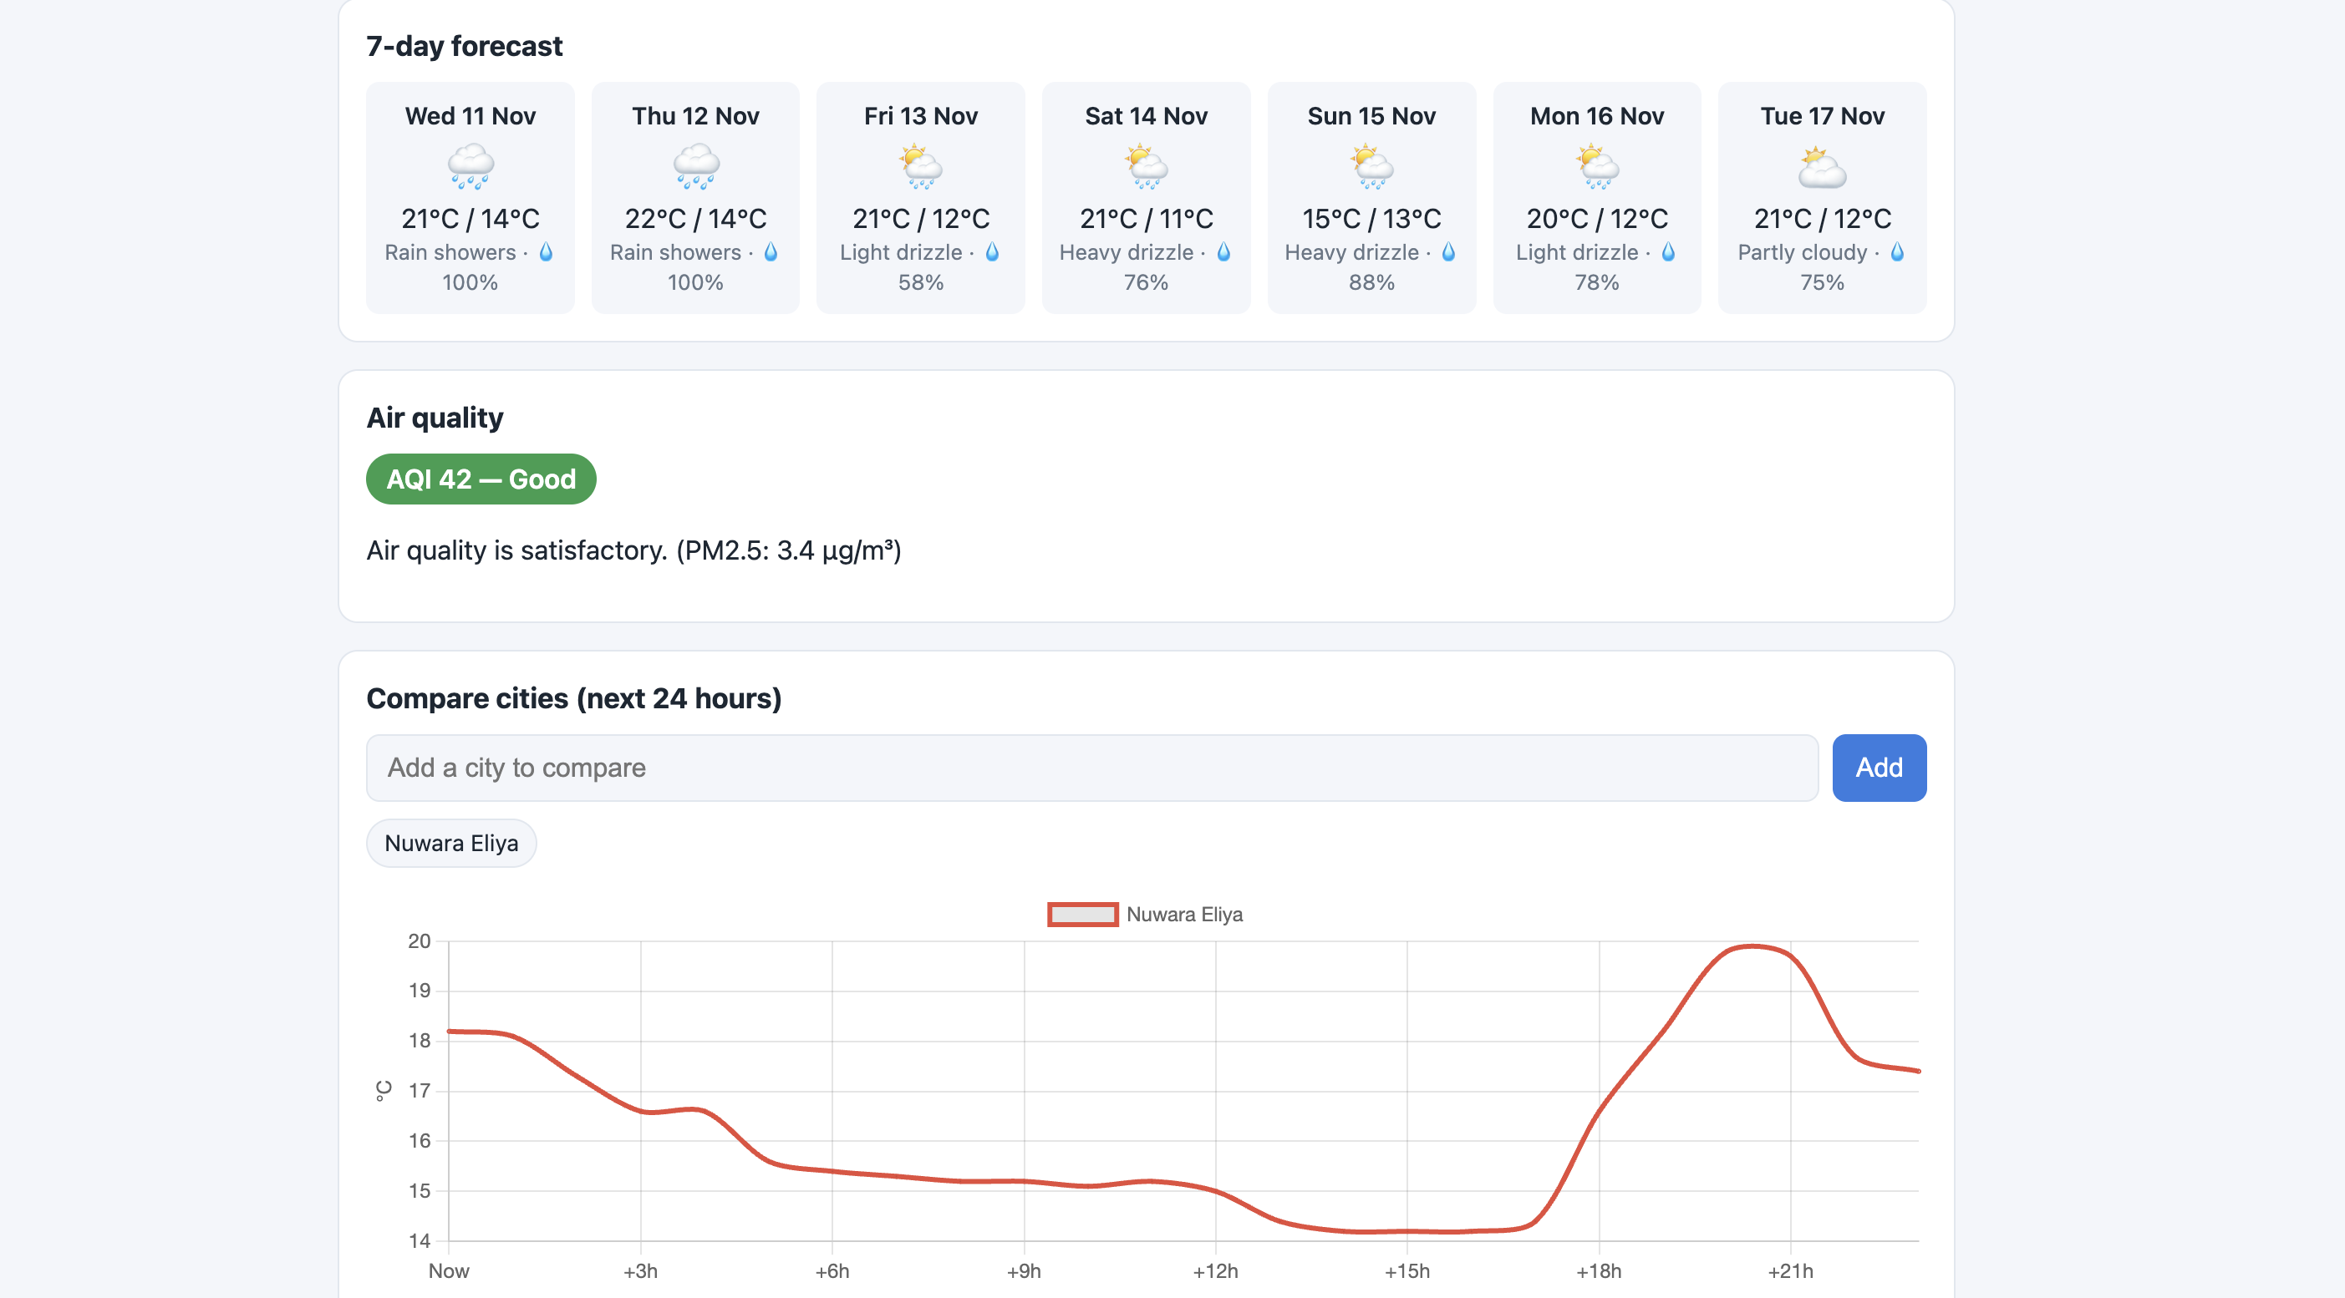

- City comparison:
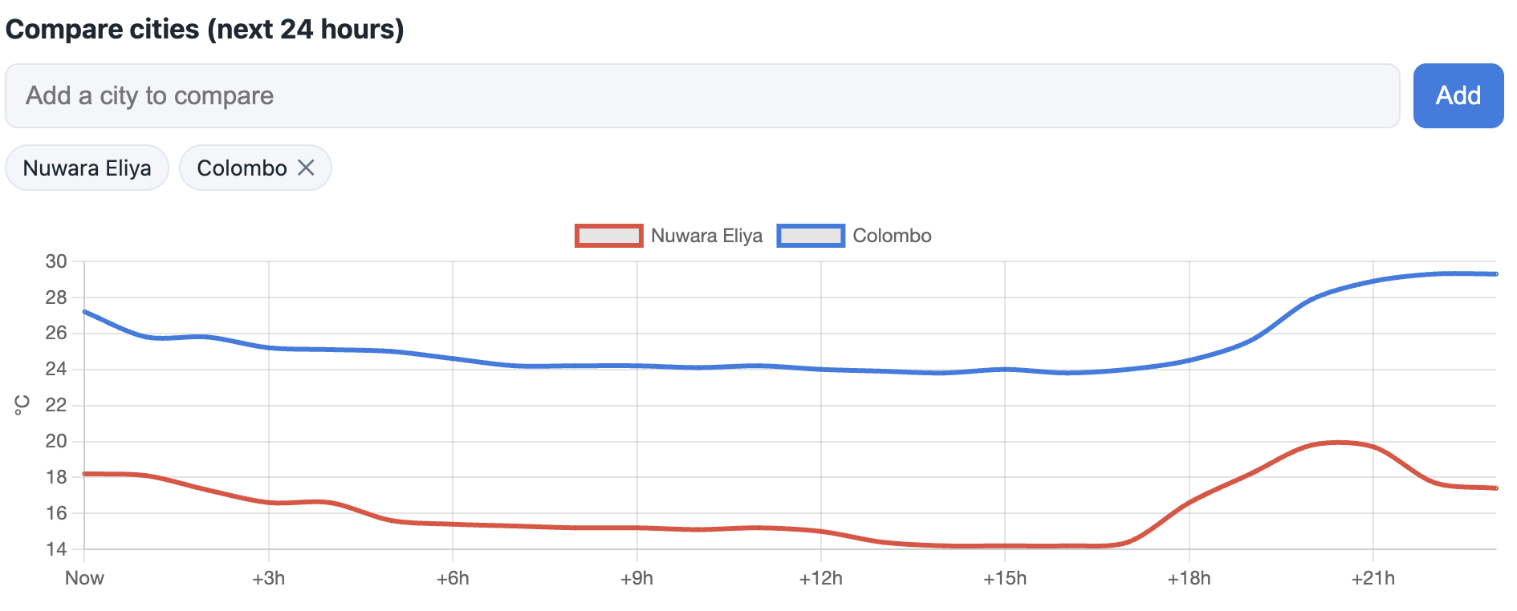

- Error message:
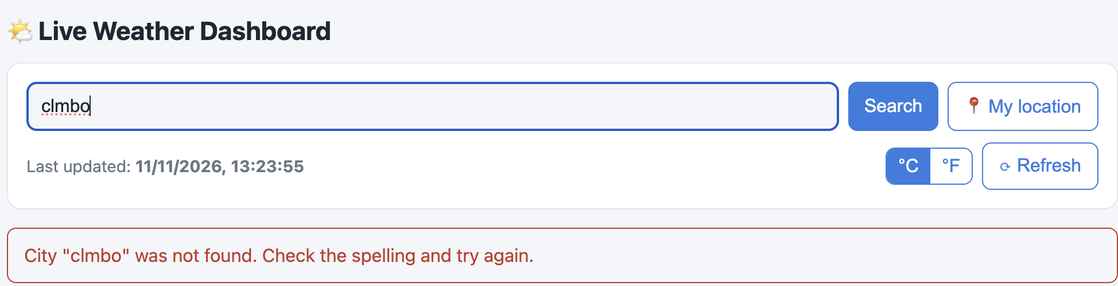
- Phone view:


