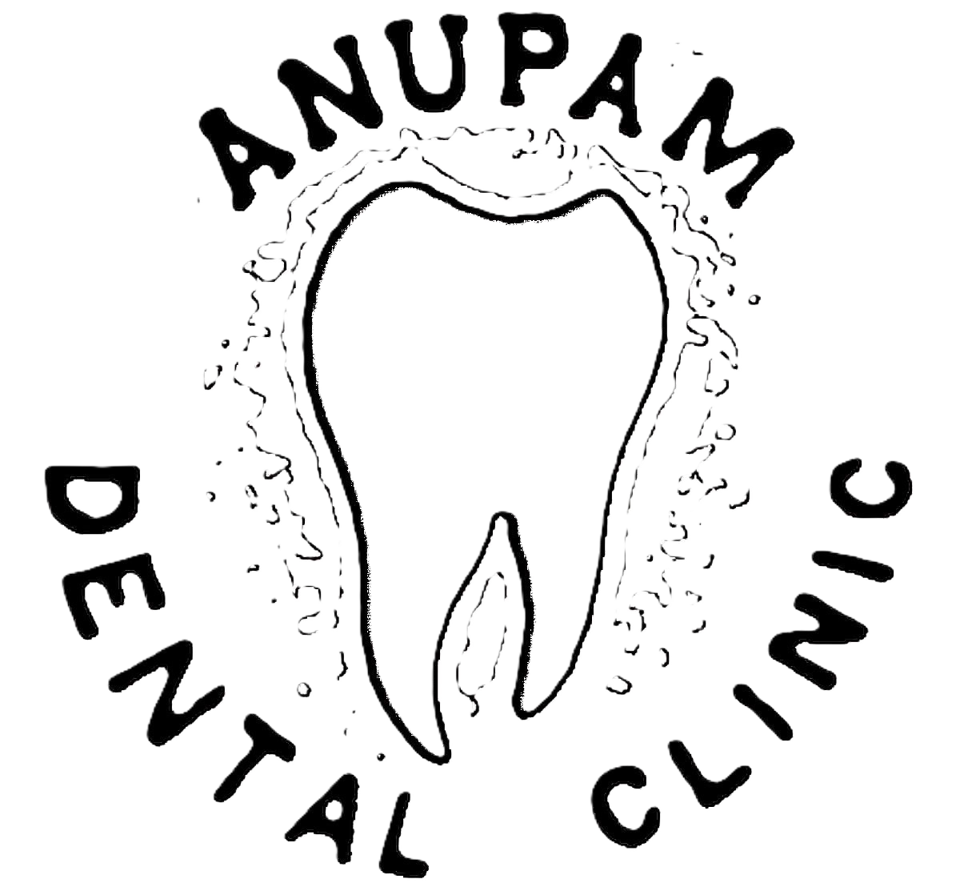 | ANUPAM DENTAL CLINICWest Gate Vaikom - 686141 | Clinic : 9446046868Resi : 9447016868

Consultants :
- Dr. Anoop Kumar. BDS
Dental Sugreon
Reg.No. 1732

Visiting :
- Dr.JUSTIN MATHEW. MDS
Oral & Maxillo Facial Surgeon
Reg.No. 5492
- Dr.KRISHNA KUMAR. MDS
Paedodontist
Reg.No. 7729
- Dr.JOSEPH J PULIKKOTTIL. MDS
Periodontist & Implantologist
Reg.No. 2418
- Dr.TERRY THOMAS. MDS
Orthodontist
Reg.No. 4807
- Dr.SHIBHU SREEDHAR. MDS
Endodontist
Reg.No. 15619-A
- Dr.RENJITH RAJ. MDS
Endodontist
Reg.No. 8171
- Dr.SIJO P MATHEW. MDS
Endodontist
Reg.No. 8982

