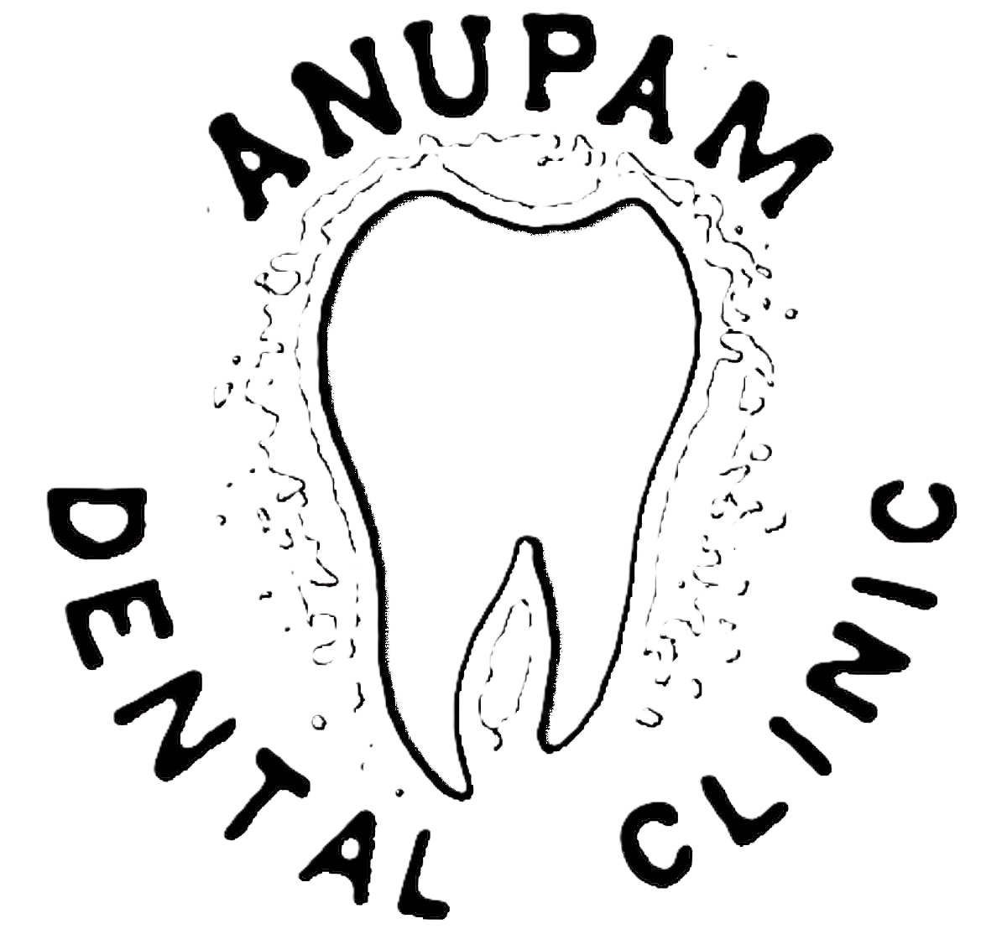 | ANUPAM DENTAL CLINIC | Clinic : 9446046868
 | West Gate Vaikom - 686141
 |  | Resi : 9447016868

Consultants :
Dr. Anoop Kumar. BDS
Dental Sugreon
Reg.No. 1732
Visiting :
Dr.JUSTIN MATHEW. MDS Oral & Maxillo Facial Surgeon Reg.No. 5492
Dr.KRISHNA KUMAR. MDS
Paedodontist
Reg.No. 7729
Dr.JOSEPH J PULIKKOTTIL. MDS Periodontist & Implantologist
Reg.No. 2418
Dr.TERRY THOMAS. MDS
Orthodontist
Reg.No. 4807
Dr.SHIBHU SREEDHAR. MDS Endodontist
Reg.No. 15619-A
Dr.RENJITH RAJ. MDS
Endodontist
Reg.No. 8171
Dr.SIJO P MATHEW. MDS
Endodontist
Reg.No. 8982
Clinic Hours : 10:00 AM to 08:00 PM, Tuesday Holiday

