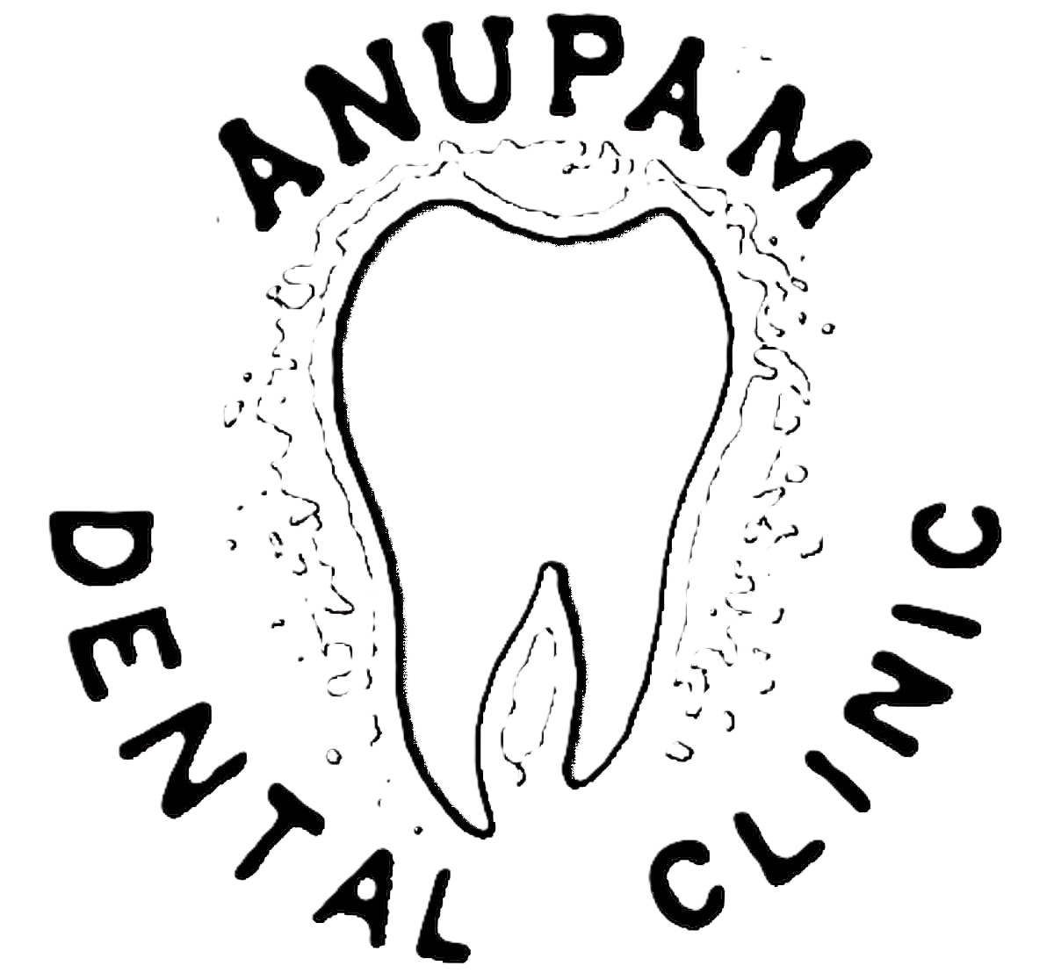 ANUPAM DENTAL CLINIC
West Gate Vaikom - 686141
Clinic : 9446046868
Resi : 9447016868
Consultants :  Dr. Anoop Kumar. BDS Dental Sugreon  Reg.No. 1732  Visiting :  Dr.JUSTIN MATHEW. MDS Oral & Maxillo Facial Surgeon Reg.No. 5492  Dr.KRISHNA KUMAR. MDS Paedodontist  Reg.No. 7729  Dr.JOSEPH J PULIKKOTTIL. MDS Periodontist & Implantologist  Reg.No. 2418  Dr.TERRY THOMAS. MDS Orthodontist  Reg.No. 4807  Dr.SHIBHU SREEDHAR. MDS Endodontist  Reg.No. 15619-A  Dr.RENJITH RAJ. MDS Endodontist  Reg.No. 8171  Dr.SIJO P MATHEW. MDS Endodontist  Reg.No. 8982 | Date :  Doctor's Notes
Clinic Hours : 10:00 AM to 08:00 PM, Tuesday Holiday

