GOVERNMENT OF KERALA

DEPARTMENT OF TECHNICAL EDUCATION

AVUKADAR KUTTY NAHA SAHIB MEMORIAL GOVERNMENT POLYTECHNIC COLLEGE, THIRURANGADI



*Community skills in Indian knowledge system report on*

**MUD CLAY BRICKS MAKING**

*In partial fulfillment for the award of*

**DIPLOMA IN COMPUTER ENGINEERING**

*Guided by,* *Submitted by,*

**BABY MANJUSHA.P AJINDAS C P 15**

**MOHAMMED SHAHEEN K.C 36**

**VIDHU PRAKASH T P 49**

**UNAIS BABU K 48**

**ABDU SHIHAD.P 4**

DEPARTMENT OF COMPUTER ENGINEERING

2022-23

**AVUKADAR KUTTY NAHA SAHIB MEMORIAL GOVERNMENT POLYTECHNIC COLLEGE, THIRURANGADI**

DEPARTMENT OF COMPUTER ENGINEERING

2022-23



**CERTIFICATE**

This is to certify that the seminar report on "MOBILE FUEL PUMB SYSTEM"was done by **VIDHU PRAKASH T P (**Reg no: **2101132377),AJINDAS C P (**Reg no: **2101132335), MOHAMMED SHAHEEN K.C (**Reg no: **2101132360)** batch of 4th semester computer engineering student in partial fulfillment of requirement of the award of diploma in computer engineering under the board of Technical Education, Kerala state during the academic year 2022-2023 under our guidance at Avukadar Kutty Naha Sahib Memorial Government Polytechnic College, Thirurangadi.

Staff in Charge Head of Section

External Examiner Internal Examiner

Place: Chelari

Date:

**ACKNOWLEDGEMENT**

I thank the God, the almighty for blessing us in making our project a successful one. The satisfaction that accompanies the successful completion of any task would be complete without the mention of people whose ceaseless cooperation made it possible. whose constant guidance and encouragement crown all efforts with success.

We hereby wish to express our sincere gratitude to **Mrs.PARVATHI.A K** principal and **Mrs.BABY MANJUSHA.P** Head of Department of computer engineering and also other staff of computer department and also friends and parents for the guidance, inspiration and constructive suggestions that were helpful for us in the preparation of the project. We also thank our colleagues who helped in successful completion of the project.

Thanking everyone once again

MOHAMMED SHAHEEN K.C

AJINDAS C P

VIDHU PRAKASH T P

**ABSTRACT**

The rise of e-commerce has led to the emergence of various online businesses that offer products and services that were previously only available in physical stores. The fuel industry is no exception, as mobile fuel pumps can now be accessed online through web-based platforms. This paper explores the concept of mobile fuel pumps available online and the benefits they offer.

The online mobile fuel pump is a web-based platform that provides customers with a way to order and pay for fuel deliveries online. The platform allows users to select the type and quantity of fuel they require, specify the location for delivery, and make payment securely through the website. Once the order is received, the mobile fuel pump is dispatched to the specified location to deliver the fuel.

The benefits of using an online mobile fuel pump include convenience, accessibility, and efficiency. Customers can order fuel from the comfort of their homes or offices, eliminating the need to travel to a fuel station. This is especially beneficial for businesses located in remote or hard-to-reach areas. Additionally, online mobile fuel pumps offer 24/7 accessibility, allowing customers to place orders at any time. This eliminates the need to wait for fuel stations to open, increasing productivity.

Online mobile fuel pumps also offer a more efficient solution to fuel delivery. The web-based platform enables customers to track their orders in real-time, giving them visibility into the delivery process. This reduces the risk of delays and ensures that the fuel is delivered on time, minimizing downtime and increasing productivity.

In conclusion, the availability of mobile fuel pumps online is a significant development in the fuel industry. It offers a more convenient, accessible, and efficient solution to fuel delivery, improving productivity and reducing downtime. As the world continues to shift towards e-commerce, the use of online mobile fuel pumps is likely to become even more widespread, making it a valuable tool for various industries.

**INDEX**

1. INTRODUCTION
2. DATA FLOW DIAGRAM
3. SYSTEM ANALYSIS
4. REQUIREMENTS AND SPECIFICATION
5. ADVANTAGES AND LIMITATIONS
6. LAYOUT
7. SYSTEM DEVELOPMENT
8. CODE
9. SYSTEM TESTING
10. CONCLUSION
11. BIBLIOGRAPHY

**INTRODUCTION**

Getting food, medicine, groceries, and electronics delivered to your doorstep is not new, we are all familiar with this concept and are actively using it. In fact, buying stuff online and getting it delivered to our place with just a few taps on our phone screens is what we all love doing.

And fuel delivery is one and the same. The only difference is that the fuel delivery app supplies the fuel at your current spot, the fuel delivery person restocks your vehicle, and you are all equipped to go.

The fuel delivery business is the buzzing topic in the industry, and so is the demand for fuel delivery app development. As it is very helpful for those who get stuck somewhere in a remote area.

Have you ever been stuck somewhere because you ran out of fuel? Or have you been in a situation where you have to line up in a long, endless line to get fuel for your vehicle?

If Yes, then you can understand how important a system like this. Delivering fuel to

customers’ spots when they have to reach their stopping place in a hurry will save them enough time as they don’t have to stand in long queues at the petrol pump station.

Furthermore, it also ensures that you travel worry-free and never get stuck on your journey because of a fuel shortage.

We can say, Mobile petrol pumb system are like Uber and OLA.

**MOBILE PETROL PUMB**

In rural areas there is no easy access to petroleum in rural areas. There are lot of farm equipments which needs fuel. The villagers have to come to city for fuel which is always time consuming activity.

This will also help to deliver petrol by ordering through the web.Sometimeswe don’t have fuel in our vehicle and stuck in the center of the road, By building this idea there will be no issue and we can enjoy the ride the project **'Mobile Petrol Pump- named as FUEL.ON '** is an innovative idea to design the mobile petrol pump to serve riders.

**DATA FLOW DIAGRAM**

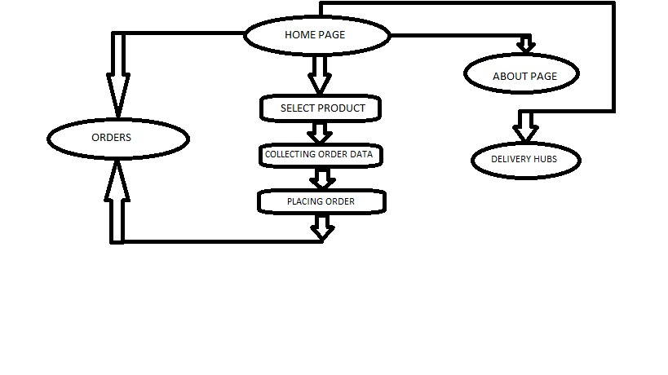

**SYSTEM ANALYSIS**

* PROGRAMMING LANGUAGE : HTML,CSS,JAVASCRIPT,PYTHON

HTML structures content on webpages, CSS styles them, JavaScript creates interactivity, and Python is versatile and used for web development, data analysis, and artificial intelligence.

* FRAMEWORK : DJANGO

Django is an excellent choice for web developers who want to build robust and scalable web applications quickly and efficiently, while following best practices and maintaining code quality.

* IDE : VISUAL STUDIO CODE

a source-code editor made by Microsoft with the Electron Framework, for Windows, Linux and macOS

* BROWSER : CHROME,MOZILLA FIREFOX,MICROSOFT EDGE

a streamlined browser built on web standards and designed for web services. It was code-named Spartan in development, a reference to the browser's lightweight structure, which is designed to make Edge functional across multiple, often mobile, device platforms. Support for inking.

* DEVELOPMENT SERVER : <http://127.0.0.1:8000/>

To run the Django development server, type the command python manage.py runserver in your terminal of the Django project and hit enter. If everything is okay with your project, Django will start running the server at localhost port 8000 (127.0. 0.1:8000) and then you have to navigate to that link in your browser

**REQUIREMENTS AND SPECIFICATIONS**

* Get the customers location :

Knowing the customers location is to deliver the fuel

* Get customers Phone number :

Knowing the customers number is a necessory requirement

* Get order details (Petrol,Diesel) :

Knowing the customers order and execute necessery actions.

* Get order quantity :

Knowing the quantity as per the customer needs

* Price per liter(Inlcuding Tax) :

Showing the price.

* Placing order :

After placing the order,Our team will out to deliver the order to the customer

**ADVANTAGES**

* It is a fast order system :

if you get in the site it is easy to order quickly

* Product switching :

It can switch the product even if you selected wrong selection

* It can access anytime:

It is a online website so it can access 24/7.

* Safer than fuel pumb:

It is more safer it reduces accidents.

**LIMITATIONS**

* One product at a time :

It can book one product at a time.

* Reliability around the world :

It can’t take order out side from india.

* Need stable internet :

sometimes we may trapped in wild jungle so we can’t order if user don’t have internet connection

**LAYOUT**

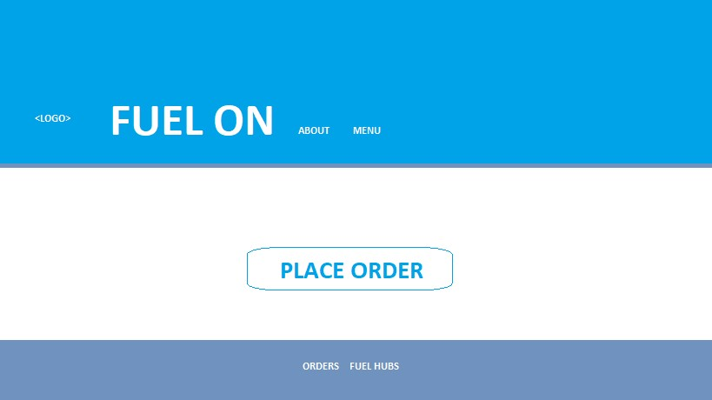

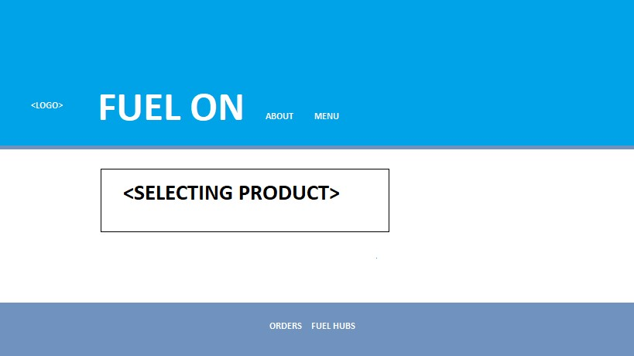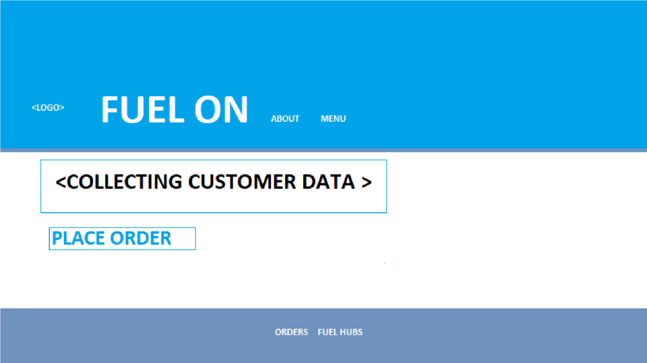

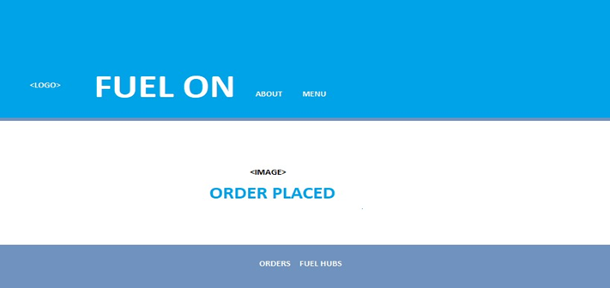

**SYSTEM DEVELOPMENT**

The system development process for the FUEL.ON mobile fuel pumb Project will follow a structured approach, including the following stages:

Planning: During the planning stage, the project team will define the project scope, objectives, and requirements. The team will also identify the key stakeholders, risks, and constraints. The project plan will be developed, outlining the timelines, milestones, and deliverables.

Design: During the design stage, the system architecture will be defined, and the software and database designs will be created. The user interface design will also be developed. The design phase will include the creation of wireframes, mockups, and prototypes.

Development: During the development stage, the system will be built according to the design specifications. The software modules will be coded, tested, and integrated. The database will be set up, and the data will be migrated from the old system. The development stage will include both front-end and back-end development.

Testing: During the testing stage, the system will be tested to ensure that it meets the functional and non-functional requirements. The testing will include unit testing, integration testing, and system testing. The user acceptance testing will also be conducted to ensure that the system meets the needs and expectations of the end-users.

Deployment: During the deployment stage, the system will be deployed on the production environment. The system will be configured, and the data will be migrated to the new system. The endusers will be trained, and the system will be launched.

Maintenance: After the system is deployed, the project team will provide ongoing maintenance and support. The system will be monitored to ensure that it is performing optimally. Any bugs or issues will be addressed promptly. The system will be updated as needed to meet the evolving needs of the users. The system development process will be iterative, and the project team will continuously evaluate and refine the system based on feedback from the end-users. The development process will be managed using agile methodologies to ensure that the project is delivered on time, within budget, and to the satisfaction of the stakeholders.

**CODE**

**PYTHON(*DJANGO FRAMEWORK*)**

**Customer app.py**

from django.apps import AppConfig

class CustomerConfig(AppConfig):

default_auto_field = 'django.db.models.BigAutoField' name = 'Customer'

**Customer models.py**

from django.db import models class Fuel(models.Model):

name = models.CharField(max_length=100,default='Petrol/diesel') Category=models.ManyToManyField('category',related_name='Name') image=models.ImageField(upload_to='menu/')

price=models.DecimalField(max_digits=5,decimal_places=2)

def __str__(self): return self.name

class category(models.Model):

name = models.CharField(max_length=100)

def __str__(self): return self.name class order_data(models.Model): customer_name = models.CharField(max_length=20) phone= models.CharField(max_length=10) category=models.CharField(max_length=10,default='') location=models.CharField(max_length=100) quantity=models.CharField(max_length=3) def __str__(self): return self.customer_name

class KeralaHub(models.Model): hub_name=models.CharField(max_length=20) hub_dist=models.CharField(max_length=20) hub_num=models.CharField(max_length=10) def __str__(self): return self.hub_name

**Customer Views.py**

from django.shortcuts import render from django.views import View from django.http import HttpResponse

from .models import Fuel,category,order_data,KeralaHub

class index(View): def get(self,request,*args,**kwargs):

return render(request,'customer/index.html')

class About(View):

def get(self,request,*args,**kwargs):

return render(request,'customer/about.html')

class hub(View): def get(self,request,*args,**kwargs): Customer=KeralaHub.objects.all()

return render(request,'customer/hub.html',{'Customer':Customer})

class Order(View): def get(self,request,*args,**kwargs):

Customer=Fuel.objects.all()

return render(request,'customer/order.html',{'Customer':Customer})

def post(self,request,*args,**kwargs):

return render(request,'customer/order_confirmation.html') class Save(View):

def post(self,request,*args,**kwargs):

if request.method=="POST":

customer_name=request.POST.get('customer_name')

phone=request.POST.get('phone') category=request.POST.get('category') location=request.POST.get('location') quantity=request.POST.get('quantity') en=order_data(customer_name=customer_name,phone=phone,location=location,quantity=qu antity,category=category)

en.save()

return render(request,'customer/save_enque.html') class OrderData(View): def get(self,request,*args,**kwargs): Customer=order_data.objects.all()

return render(request,'customer/orderdetails.html',{'Customer':Customer})

**FuelDelivery urls.py**

from django.contrib import admin from django.urls import path from django.conf import settings from django.conf.urls.static import static

from Customer.views import index,About,Order,Save,hub,OrderData from Customer import views urlpatterns = [

path('admin/', admin.site.urls), path('',index.as_view(), name='home'), path('About/',About.as_view(),name='about'), path('order/',Order.as_view(),name='order'),

path('order_confirmation/',Order.as_view(),name='order_confirmation'), path('save_enque/',Save.as_view(),name='save_enque'), path('hub/',hub.as_view(),name='hub'),

path('orderdetails/',OrderData.as_view(),name='orderdetails')

]

**HTML, CSS, JAVASCRIPT(*TEMPLATES*)**

**Base.html**

<!DOCTYPE html>

<html>

<head>

<meta charset="UTF-8">

<meta name="viewport" content="width=device-width", inital-scale=1.0, shrink-to-fit=no">

<title>FuelDeliver</title>

<link rel="stylesheet" href="https://use.fontawesome.com/releases/v5.8.2/css/all.css">

<link rel="stylesheet" href="https://fonts.googleapis.com/css?family=Roboto:300,400,500,700&display=swap">

<link href="https://cdnjs.cloudflare.com/ajax/libs/twitter-bootstrap/4.5.0/css/bootstrap.min.css" rel="stylesheet">

<link href="https://cdnjs.cloudflare.com/ajax/libs/mdbootstrap/4.19.1/css/mdb.min.css" rel="stylesheet">

<link href="https://cdn.jsdelivr.net/npm/bootstrap@5.3.0-alpha2/dist/css/bootstrap.min.css" rel="stylesheet" integrity="sha384-aFq/bzH65dt+w6FI2ooMVUpc+21e0SRygnTpmBvdBgSdnuTN7QbdgL+OapgHtvPp" crossorigin="anonymous">

<link href="out.css" rel="stylesheet">

</head>

<body>

{% include 'customer/navigation.html' %}

{% block content %}

{% endblock content %}

{% include 'customer/footer.html' %}

<!-- JQuery -->

<script type="text/javascript" src="https://cdnjs.cloudflare.com/ajax/libs/jquery/3.5.1/jquery.min.js"></script>

<!-- Bootstrap tooltips -->

<script type="text/javascript" src="https://cdnjs.cloudflare.com/ajax/libs/popper.js/1.14.4/umd/popper.min.js"></script>

<!-- Bootstrap core JavaScript -->

<script type="text/javascript" src="https://cdnjs.cloudflare.com/ajax/libs/twitter-bootstrap/4.5.0/js/bootstrap.min.js"></script>

<!-- MDB core JavaScript -->

<script type="text/javascript" src="https://cdnjs.cloudflare.com/ajax/libs/mdbootstrap/4.19.1/js/mdb.min.js"></script>

</body>

</html>

**Navigation.html**

<nav class="navbar navbar-expand-lg navbar-dark" style="background-color: rgb(0, 74, 235);">

<a class="navbar-brand" href="{% url 'home' %}" >

<img src="https://freepngimg.com/save/41398-gasoline-image-free-transparent-image-hd/512x512" width="45" alt="" class="d-inline-block align-middle mr-2">

<span class="text-uppercase font-weight-bold" style="color: mediumseagreen;">FUEL.on</span>

</a>

<button class="navbar-toggler" type="button" data-toggle="collapse" data-target="#navbarNav" aria-controls="navbarNav" aria-expanded="false" aria-label="Toggle navigation">

<span class="navbar-toggler-icon"></span>

</button>

<div class="collapse navbar-collapse" id="navbarNav" >

<ul class="navbar-nav mr-auto">

<li class="nav-item">

<a class="nav-link" href="{% url 'about' %}">About Us</span></a>

</li>

<li class="nav-item">

<a class="nav-link" href="http://127.0.0.1:8000/">Menu</a>

</li>

</ul>

<ul class="navbar-nav">

<li class="nav-item">

<a class="nav-link" style="color: rgb(255, 255, 255);" href="{% url 'order' %} "><b>Hey, Are you fuel-out!! Click-here to Place an Order!</b></a>

</li>

</ul>

</div>

</nav>

<script>

function big(x){

x.style.height = "120px";

x.style.width = "120px";

}

function normal(x){

x.style.height="60px";

x.style.width="120px";

}

</script>

**Footer.html**

<footer class="page-footer font-small indigo fixed-bottom" style="color:mediumseagreen;" >

<div class="footer text-center py-3"> <b> FUEL.On™</b>

<a href="{% url 'orderdetails' %}" class="ml-2">ORDER</a>

<a class="ml-1" href="{% url 'hub' %}">OUR HUB</a>

</div>

</footer>

**Index.html**

{% extends 'customer/base.html' %}

{% block content %}

<div class="container mb-5">

    <img src=”img.jpg”  width="400" height="200" style="margin-right: 100px;" >

    <img  src="https://cdn-icons-png.flaticon.com/512/20/20705.png"width="200" height="200" style="margin-right: 150px;">

        <img  src="https://img.freepik.com/free-icon/car_318-503384.jpg?w=2000" width="200" height="200" ">

    <div class="row justify-content-center mt-5">

        <div class="col-md-8 col-sm-12 offset-md-1 p-4 text-center" style="color: rgb(36, 36, 36);">

            <p style="color: rgb(74, 123, 212);"> FUEL.ON™ THE ENERGY YOU NEED</p>

            <h1>ONLINE FUEL ORDER & DELIVERY</h1>

        </div>

    </div>

    <div class="row justify-content-center mt-1">

        <div class="card col-md-5 col-sm-12 offset-md-1 p-4 text-center">

            <h2>Place an Order!</h2>

            <a href="{% url 'order' %}" class="btn btn-outline-primary">Order Now!</a>

            <p>NB : We are a start-up so we may get delayed as per the location you enter</p>

        </div>

    </div>

    <br>

    <div class="center" >

    <h3 align="center">Where do we serve</h3>

    <p align="center">Our services are available in Kerala for now, But soon it will be all over india  </p>

    <h3 align="center">What Our Customers Say</h3>

    <p align="center">FUEL.ON is a fuel delivery website that offers customers the convenience of ordering fuel from the comfort of their homes or offices. The website is designed to be user-friendly, with a clean and modern interface that makes it easy to navigate.

        One of the standout features of FUEL.ON is its delivery service. Customers can order fuel online and have it delivered directly to their location. This is particularly useful for businesses and individuals who may not have the time or resources to travel to a fuel station.

        Another advantage of FUEL.ON is the range of fuel types available. Customers can choose from a variety of options, including gasoline, diesel, and even biofuels. This flexibility allows customers to choose the fuel that best meets their needs, whether it's for their car or their business.

        FUEL.ON also offers competitive pricing, with transparent and upfront pricing information available on the website. This makes it easy for customers to compare prices and choose the best deal.

        Overall, FUEL.ON is a great option for those looking for a convenient and hassle-free way to order fuel. Its user-friendly interface, range of fuel types, and competitive pricing make it a standout choice in the fuel delivery market.</p>

    </div>

</div>

<br>

</div>

{% endblock content %}

**About.html**

{% extends 'customer/base.html' %}

{% block content %}

<div class="container mb-5">

    <div class="justify-content-center mt-5">

        <div class="text-center">

            <h1>About Us!</h1>

        </div>

    </div>

    <div class="justify-content-center mt-1">

        <div class="text-center">

            <p>We are FUEL.ON we server people to enhance their life routines

                </p>

            <p>Have you ever been stuck somewhere because you ran out of fuel? Or have you been in a

                situation where you have to line up in a long, endless line to get fuel for your vehicle?

                If Yes, then you can understand how important a system like this. Delivering fuel to

                customers’spots when they have to reach their stopping place in a hurry will save them

                enough time as they don’t have to stand in long queues at the petrol pump station.

                Furthermore, it also ensures that you travel worry-free and never get stuck on your journey

                because of a fuel shortage.</p>

                <h3>FOUNDERS</h3>

                <h6>AJINDAS CP</h6><h6>MOHAMMED SHAHEEN K C</h6><h6>VIDHU PRAKASH T P</h6>

        </div>

    </div>

</div>

{% endblock content %}

**Hub.html**

{% extends 'customer/base.html' %}

{% block content %}

<div class="container mb-5">

    <div class="row justify-content-center mt-1">

        <div class="col-md-12 col-sm-12 p-4">

            <form method="POST">

                <div class="pt-5">

                    {% for KeralaHub in Customer %}

                    <div class="column">

                            <div class="card" >

                                <div class="card-body">

                                  <h5 class="card-title">{{KeralaHub.hub_name}}</h5>

                                  <p class="card-text">{{KeralaHub.hub_dist}}</p>

                                  <p class="card-text">{{KeralaHub.hub_num}}</p>

                                </div>

                              </div>

                        </div>

                    </hr>

                {% endfor %}

                </div>

            </form>

        </div>

    </div>

</div>

{% endblock content %}

**Order_confirmation.html**

{% extends 'customer/base.html' %}

{% block content %}

<div class="container mb-5">

    <div class="row justify-content-center mt-1">

        <div class="col-md-12 col-sm-12 p-4">

            <form action="{% url 'save_enque' %}" method="POST">

                <label for="customer_name">Name:</label>

                <input type="text" id="customer_name" name="customer_name" required>

                <br>

                <label for="phone">Phone:</label>

                <input type="text" id="phone" name="phone" required>

                <br>

                <label for="location">location:</label>

                <textarea id="location" name="location" required></textarea>

                <br>

                <label for="category">Category:</label>

                <select id="category" name="category">

                  <option value="Petrol">Petrol</option>

                  <option value="Diesel">Diesel</option>

                </select>

                <br>

                <label for="quantity">quantity:</label>

                <input type="number" id="quantity" name="quantity" required>

                <br>

                <button type="submit">Submit</button>

              </form>

        </div>

    </div>

</div>

{% endblock content %}

**Order.html**

{% extends 'customer/base.html' %}

{% block content %}

<div class="container mb-5">

    <div class="row justify-content-center mt-1">

        <div class="col-md-12 col-sm-12 p-4">

            <form method="POST">

                <div class="pt-5">

                    {% for Fuel in Customer %}

                    <div class="column">

                            <div class="card" >

                                <img src="{{Fuel.image}}" class="card-img-top"  width="45" >

                                <div class="card-body">

                                  <h5 class="card-title">{{Fuel.name}}</h5>

                                  <p class="card-text">{{Fuel.price}}</p>

                                  <button class="btn btn-primary" href="{% url 'order_confirmation' %}" >Place Order!</button>

                                </div>

                              </div>

                        </div>

                    </hr>

                {% endfor %}

                </div>

            </form>

        </div>

    </div>

</div>

{% endblock content %}

**Order_details.html**

{% extends 'customer/base.html' %}

{% block content %}

<div class="container mb-5">

    <div class="row justify-content-center mt-1">

        <div class="col-md-12 col-sm-12 p-4">

            <h2 >PLACED ORDERS</h2>

            <form method="POST">

                <div class="pt-5">

                    {% for order_data in Customer %}

                    <div class="column">

                            <div class="card" >

                                <div class="card-body">

                                  <h5 class="card-title">Customer name : {{order_data.customer_name}}</h5>

                                  <p class="card-text"><b>Mobile No:        {{order_data.phone}}</p>

                                  <p class="card-text"><b>Item:             {{order_data.category}}</p>

                                  <p class="card-text"><b>Location:         {{order_data.location}}</p>

                                  <p class="card-text"><b>Quantity:         {{order_data.quantity}}</p>

                                </div>

                              </div>

                        </div>

                    </hr>

                {% endfor %}

                </div>

            </form>

        </div>

    </div>

</div>

{% endblock content %}

**Save_enque.html**

{% extends 'customer/base.html' %}

{% block content %}

<div class="container mb-5">

    <div class="row justify-content-center mt-1">

        <div class="col-md-12 col-sm-12 p-4">

            <div class="container mb-5">

                <div class="row justify-content-center mt-5">

                    <div class="col-md-8 col-sm-12 offset-md-1 p-4 text-center" style="color: rgb(36, 36, 36);">

                        <img src="https://www.freepnglogos.com/uploads/tick-png/image-tick-mark-icon-png-good-luck-charlie-wiki-2.png" width="200" height="200" >

                        <h1>YOUR ORDER IS PLACED</h1>

                        <a href="http://127.0.0.1:8000/" class="btn btn-outline-primary">go to home</a>

                    </div>

        </div>

    </div>

</div>

{% endblock content %}

**SYSTEM TESTING**

Unit Testing:

During the unit testing stage, the individual software

components and modules will be tested in isolation to ensure

that they are working as expected. The unit tests will be

automated and will be run each time a change is made to the

codebase.

Integration Testing:

During the integration testing stage, the individual software

components and modules will be tested together to ensure

that they integrate seamlessly and work as a cohesive system.

The integration testing will be done in a staged approach,

starting with testing the most critical components and

progressively testing the less critical components.

System Testing:

During the system testing stage, the entire system will be

tested to ensure that it meets the functional and nonfunctional requirements. The system testing will be done

using test scenarios and test cases developed based on the

requirements specification. The testing will be done in a

simulated production environment to ensure that the system

behaves as expected under normal and peak load conditions.

User Acceptance Testing:

During the user acceptance testing stage, the end-users will

test the system to ensure that it meets their needs and

expectations. The testing will be done using real-world

scenarios, and the end-users will provide feedback on the

system's usability, functionality, and performance.

Performance Testing:

During the performance testing stage, the system will be

tested to ensure that it meets the performance requirements.

The performance testing will be done under simulated peak

load conditions to ensure that the system can handle the

expected traffic and load.

Security Testing:

During the security testing stage, the system will be tested to

ensure that it is secure and free from vulnerabilities. The

security testing will include testing for common security

threats, such as cross-site scripting, SQL injection, and

authentication vulnerabilities.

**CONCLUSION**

In conclusion, In the world of electronics it is important to develop the new technology to make secure the distribution of fuel and keeping record of the same fuel with authorization of user.

Our project is one idea which can change the face of today‘s manual system of distribution and data keeping. The total central access of all these activities provide the correct approach toward security and economical need of the industries since industry itself can control distribution as well as keep the record of the same fuel from thousands of miles seated in office.

In short, this project probably can be implemented for the use of other tasks other than petrol distribution, on large scale to achieve various goals of industries

The Fuel.On mobile fuel pump is a revolutionary solution that provides convenience and flexibility to fuel up your vehicles anytime, anywhere.

With its user-friendly interface and easy-to-use website, customers can order fuel delivery on-demand and get refueled without having to visit a gas station.

This innovative technology not only saves time and effort but also reduces the carbon footprint and improves air quality by reducing the number of vehicles on the road. Overall, the Fuel.On mobile fuel pump is a game-changer for the fuel industry, providing a more efficient and eco-friendly way to fuel up your vehicles.

**BIBLIOGRAPHY**

[1]*DJANGO DOCUMENTATIONS*

*https://www.djangoproject.com/*

*Development of Django is supported by an independent foundation established as a 501(c)(3) non-profit. Like most open-source foundations, the goal of the Django Software Foundation is to promote, support, and advance its open-source project: in our case, the Django Web framework.*

[2]*BOOTSTARP LIBRARY*

https*://getbootstrap.com/*

*Bootstrap is a free and open-source CSS framework directed at responsive, mobile-first front-end web development. It contains HTML, CSS and JavaScript-based design templates for typography, forms, buttons, navigation, and other interface components.*

[3]*W3SCHOOLS*

*https://www.w3schools.com/*

*W3Schools is a freemium educational website for learning coding online. Initially released in 1998, it derives its name from the World Wide Web but is not affiliated with the W3 Consortium. W3Schools offers courses covering all aspects of web development. W3Schools also publishes free HTML templates.*

[4]*CHAT GPT AI CHATBOT*

*https://openai.com/blog/chatgpt*

*ChatGPT is an artificial intelligence chatbot developed by OpenAI and released in November 2022. It is built on top of OpenAI's GPT-3.5 and GPT-4 families of large language models and has been fine-tuned using both supervised and reinforcement learning techniques*

[5]*YOUTUBE CHANNELS*

*\*Programming with Mosh- Python tutorial - Python full course for beginners - Go from Zero to Hero with Python (includes machine learning & web development projects).*

*\*Acadaminds- Python Django Course for Beginners 2021 - Learn Django from Scratch in this 100% Free & Tutorial!*