Try selecting a mountain that matches the name Everest and the exact height of 8848 meters:

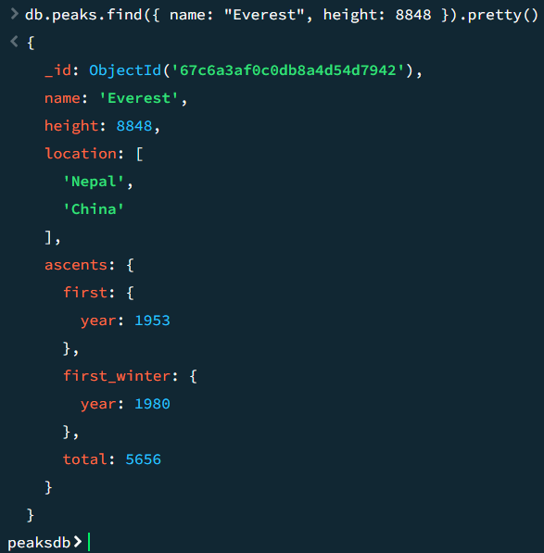

Write Query to find mountains located in both China and Nepal

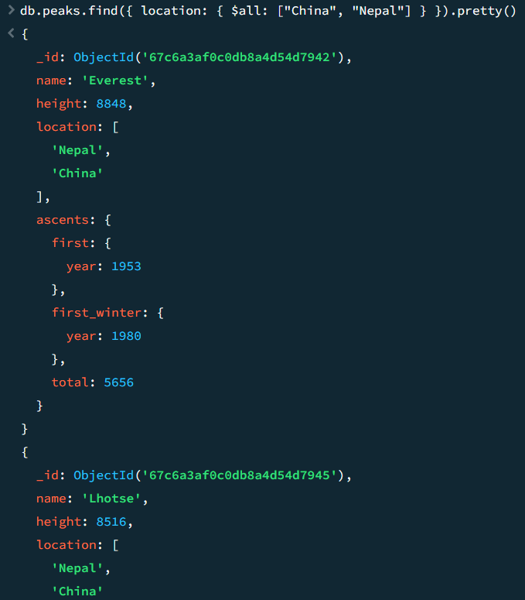

Return any documents describing mountains that were first ascended in winter only after the year 2000

Return data from each document, but will exclude the ascents and location fields

Write Queries which will retrieve only three mountain peaks from the collection

