EXPERIMENT -09
NAME: VIDHUN R
ROLL NO: 240701586

Schedule Requirements - Daily, Weekly, Monthly

Application Name: Vehicle Service Management System

Aim
To design and configure custom scheduled workflows for sending automated daily, weekly, and monthly reminders in the Vehicle Service Management System.

Procedure
Creating Daily Schedule Workflow
- Navigate to the Schedules tab under Workflow and create a new scheduled workflow.

- Set the workflow to run "Daily" at a specified start date and time (e.g., 10-Oct-2026, 18:00:00). Name it Daily_ServiceDate_Reminder_Schedule.

- Add a Deluge script action. Write a script to fetch service records where the service date is scheduled for the next day, and send an automated email reminder to the vehicle owner.

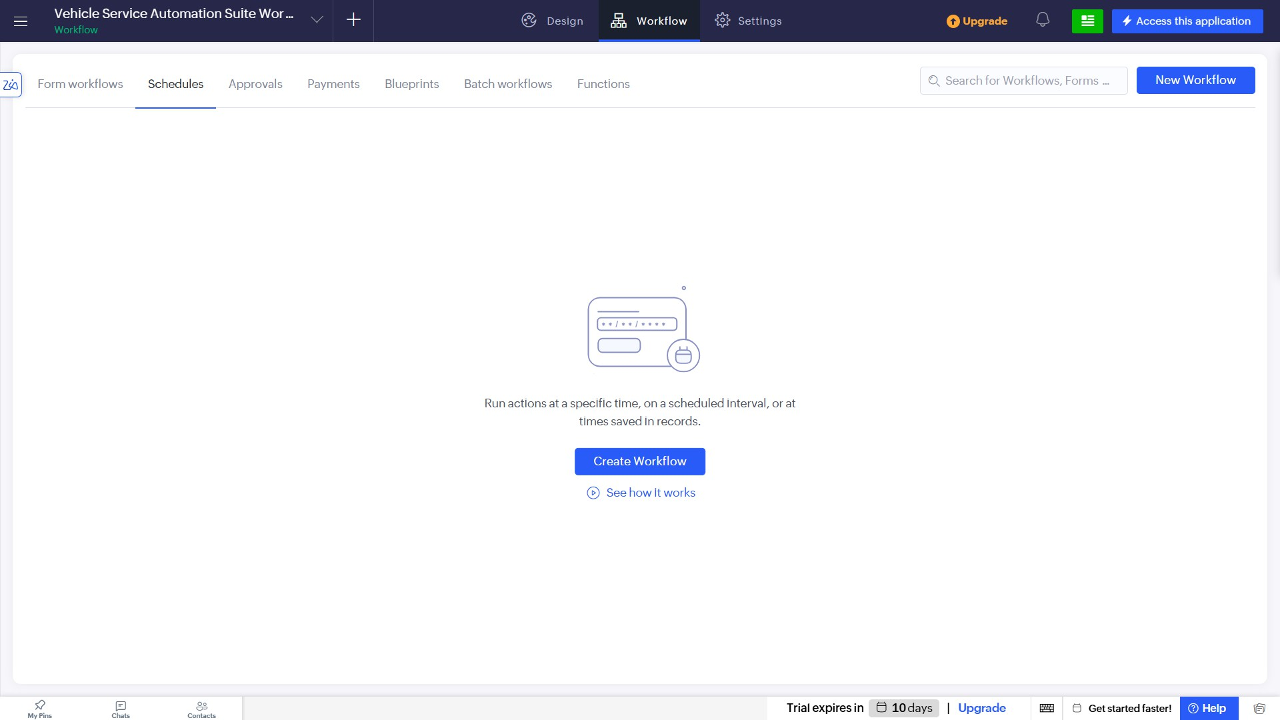
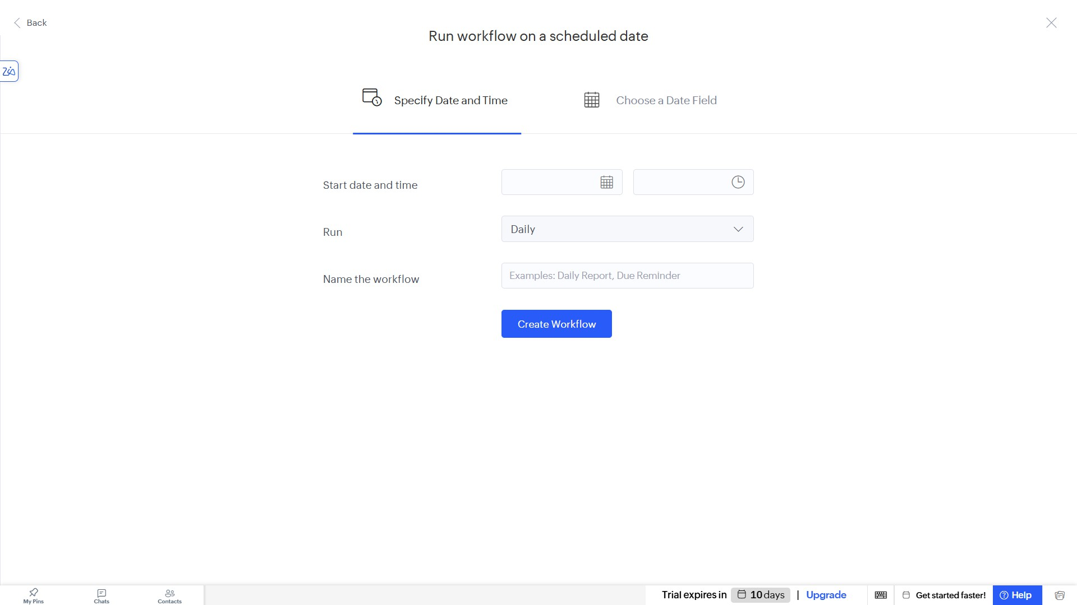

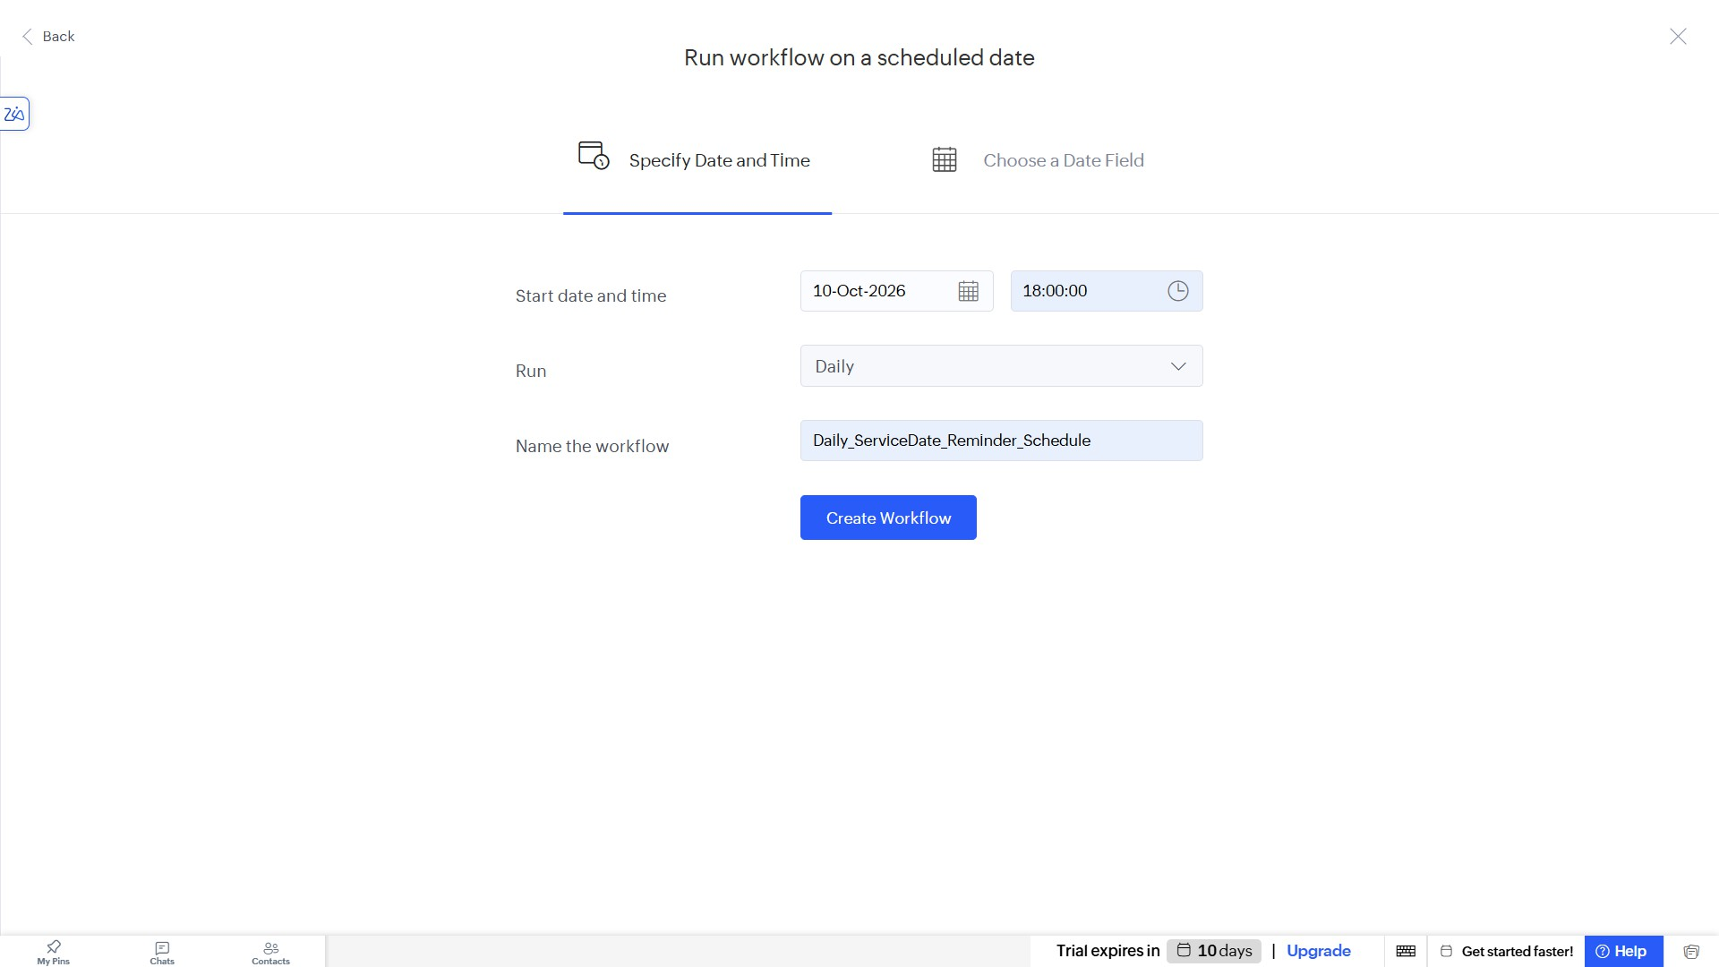
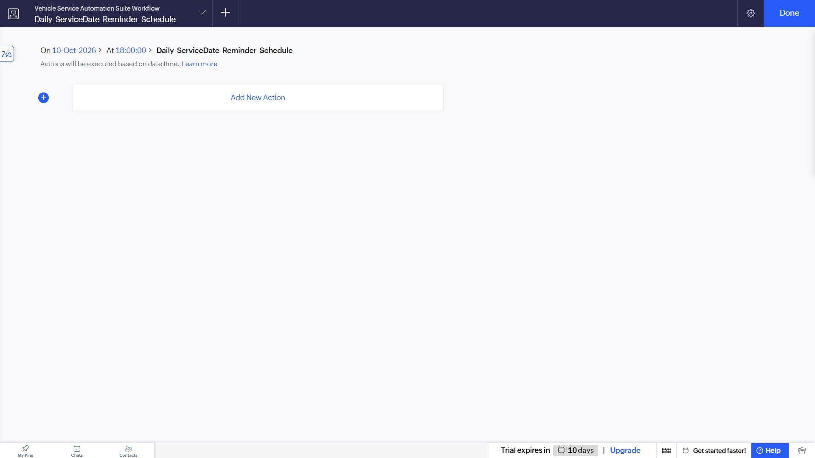

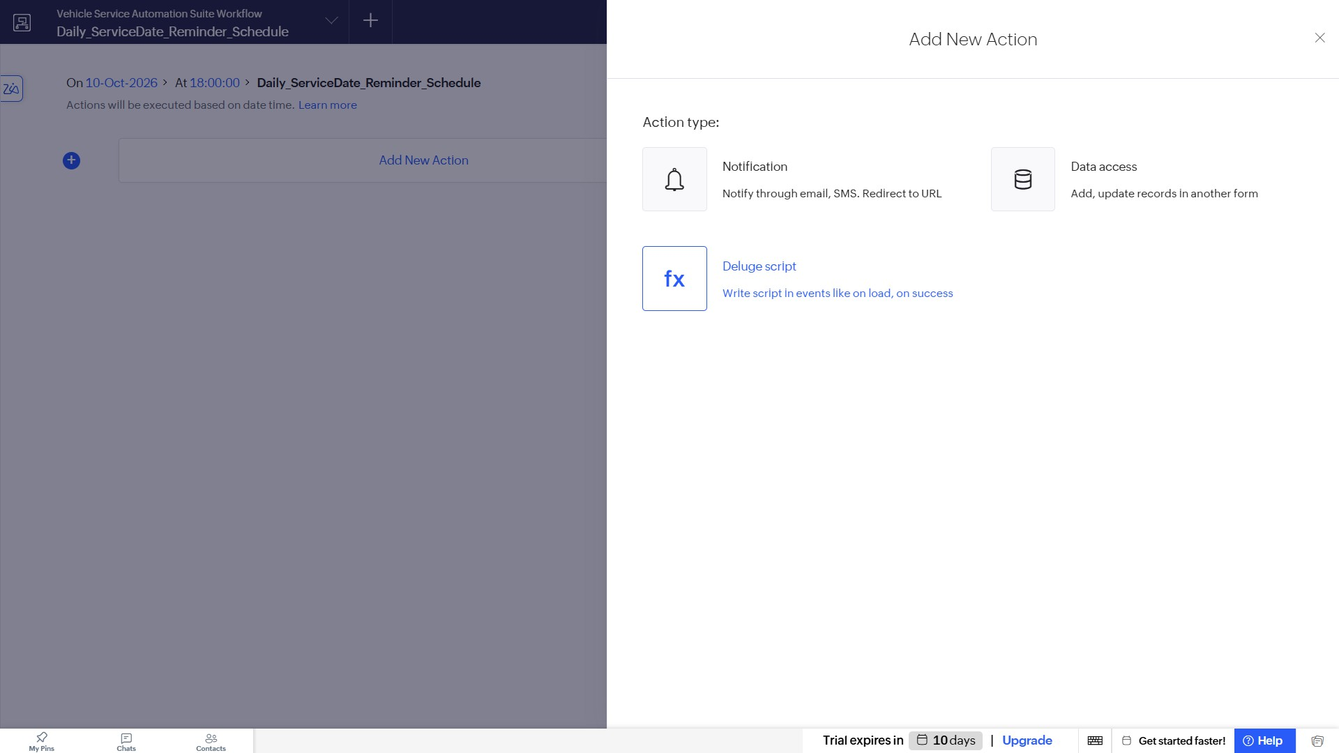
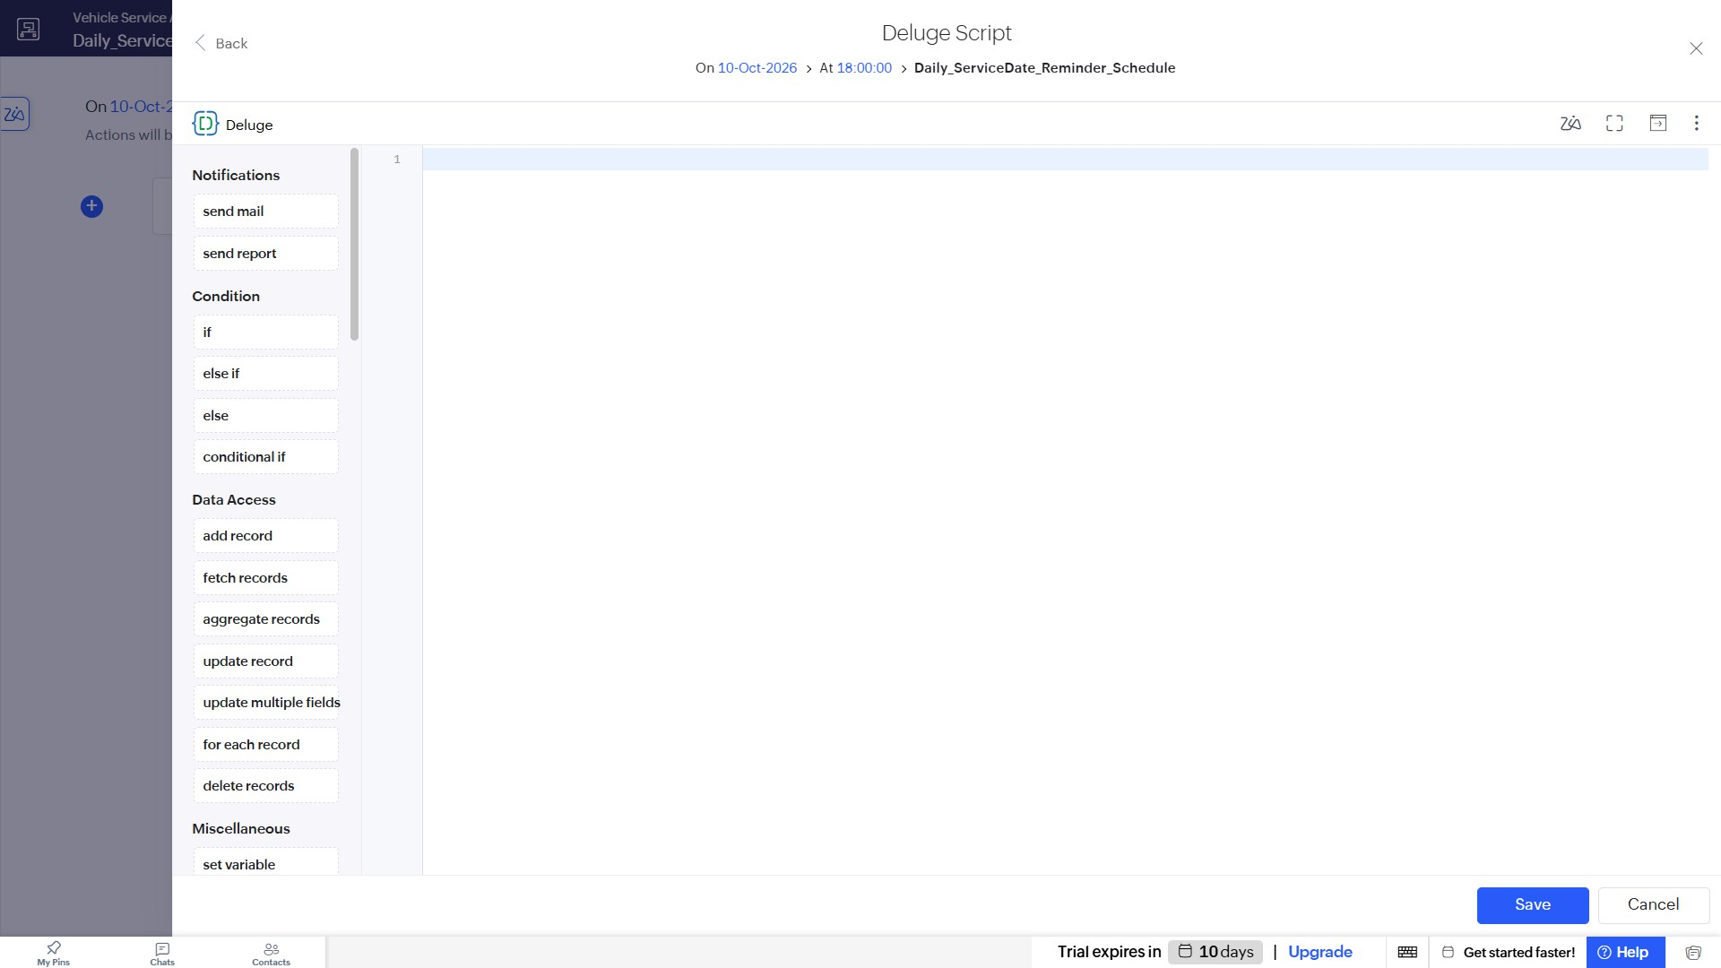

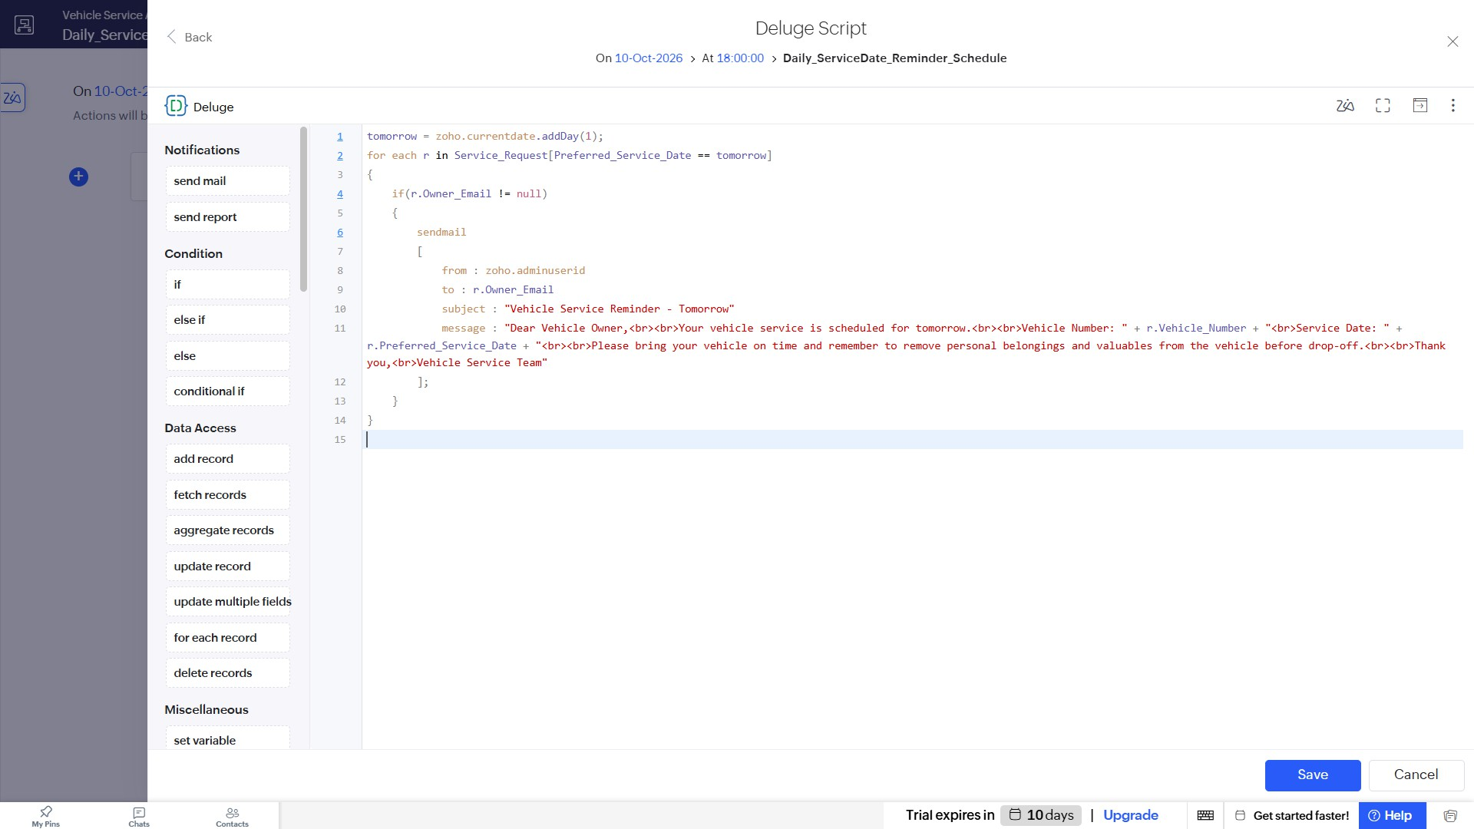
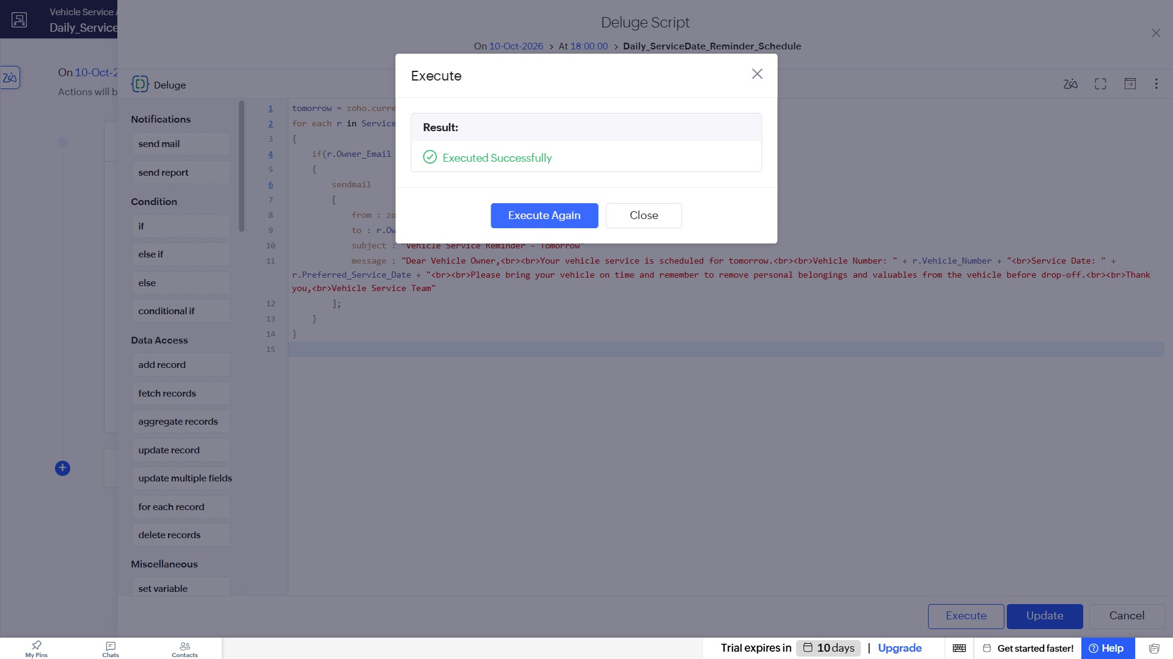

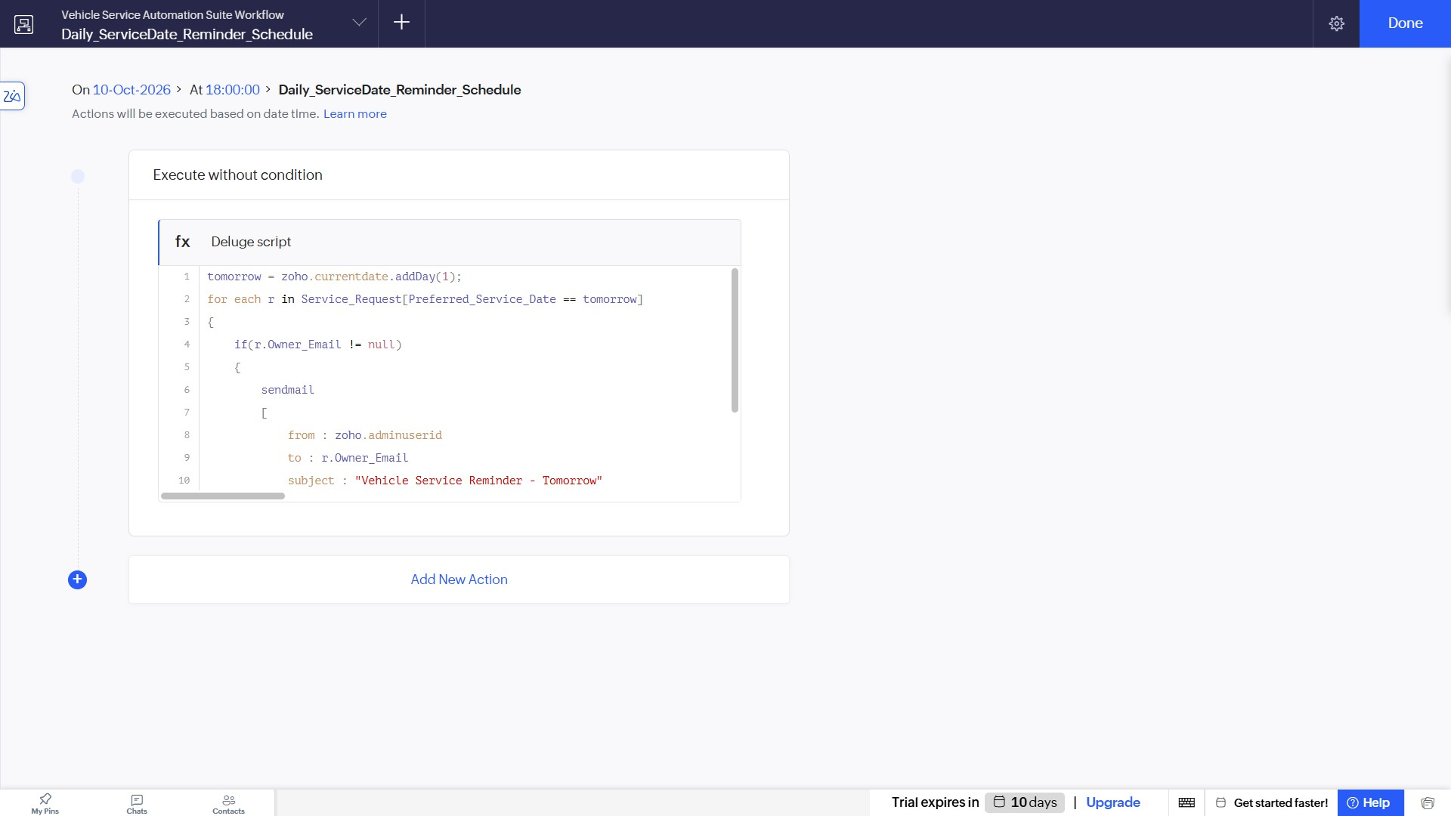
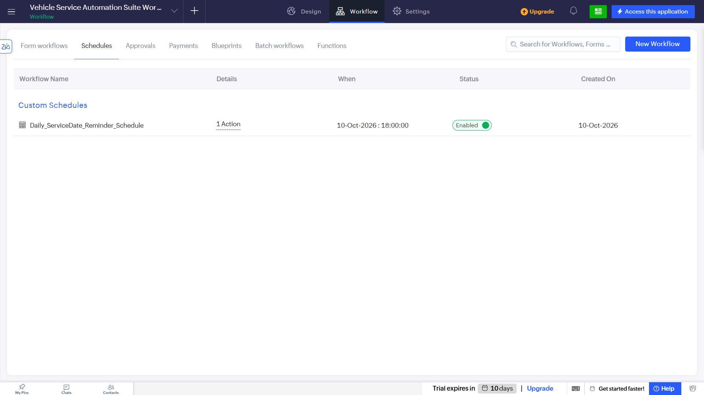

Creating Weekly Schedule Workflow
- Create a new scheduled workflow and set it to run "Weekly" starting at the designated time. Name it Weekly_Service_Reminder_Schedule.

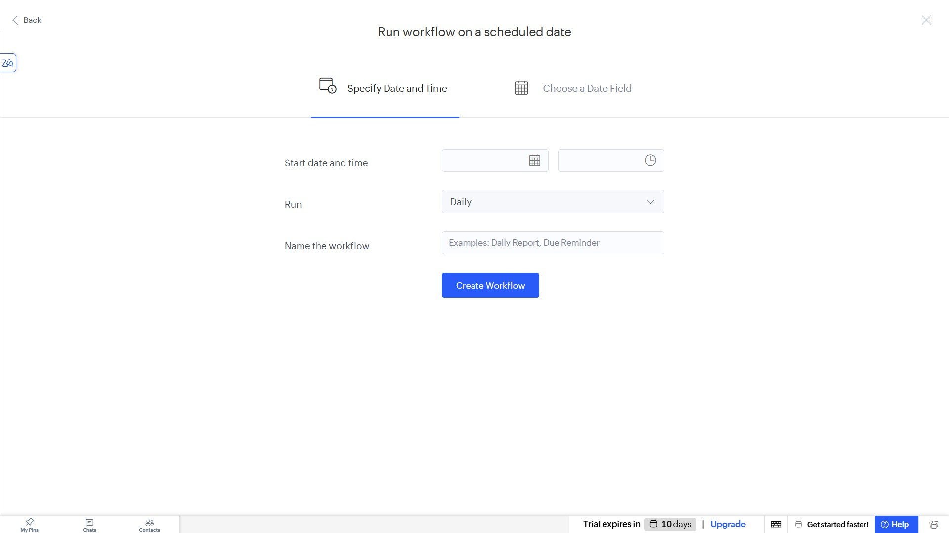
- Add a Deluge script action to evaluate records based on the Last_Service_Date (e.g., past a 6-month cutoff) and send a weekly email reminder for due service.

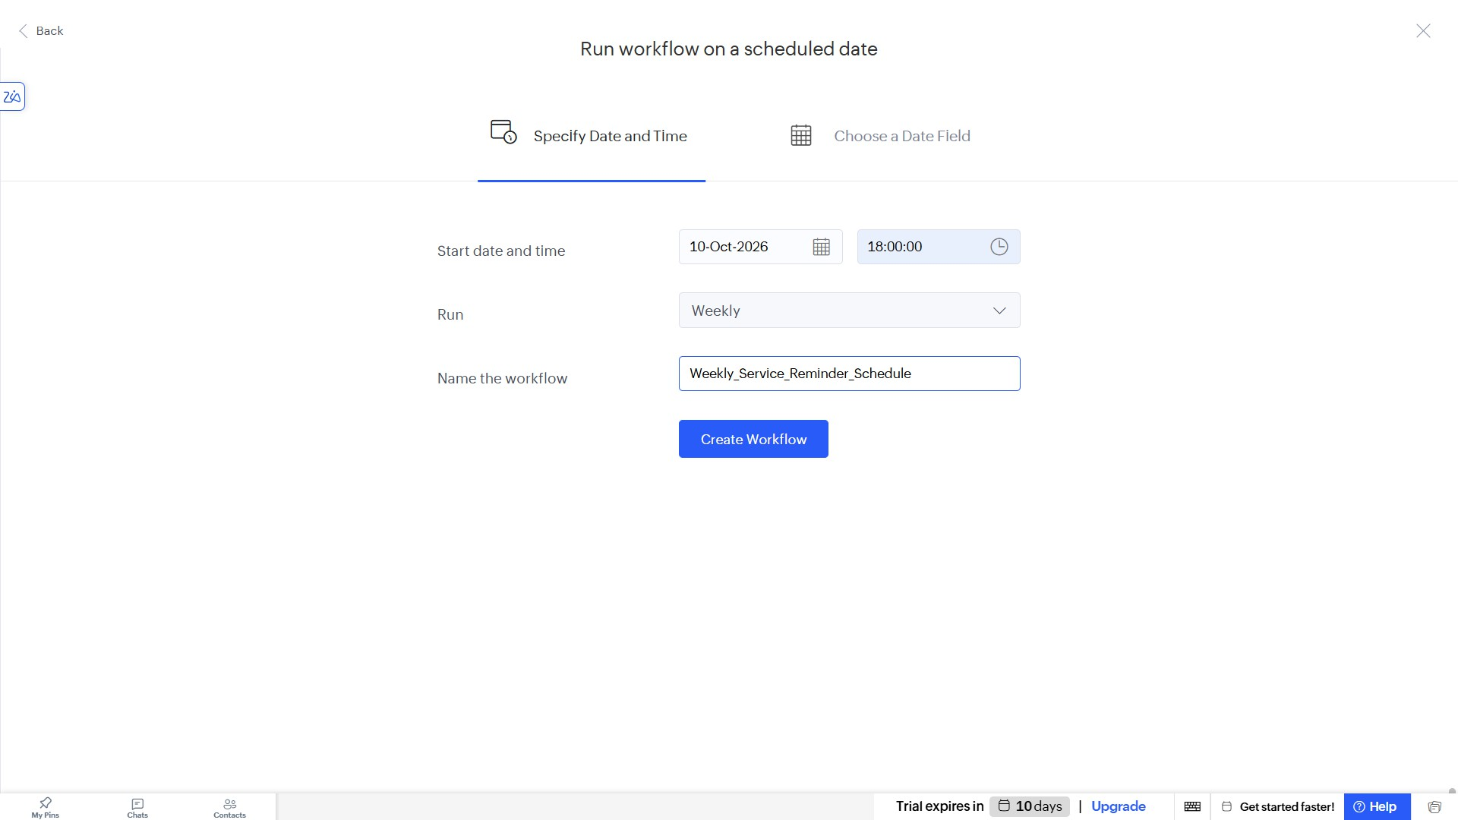
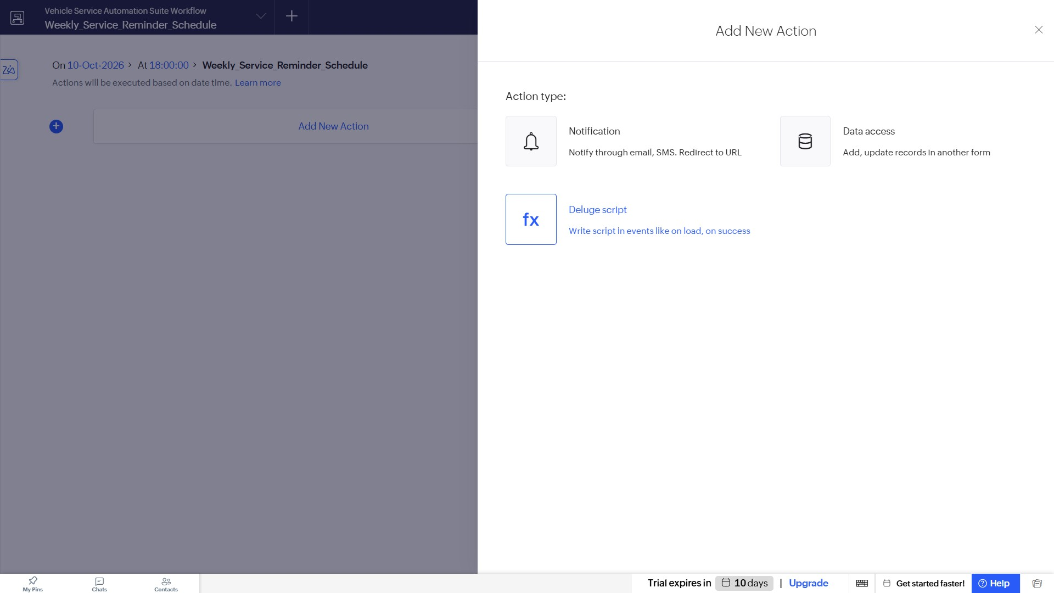

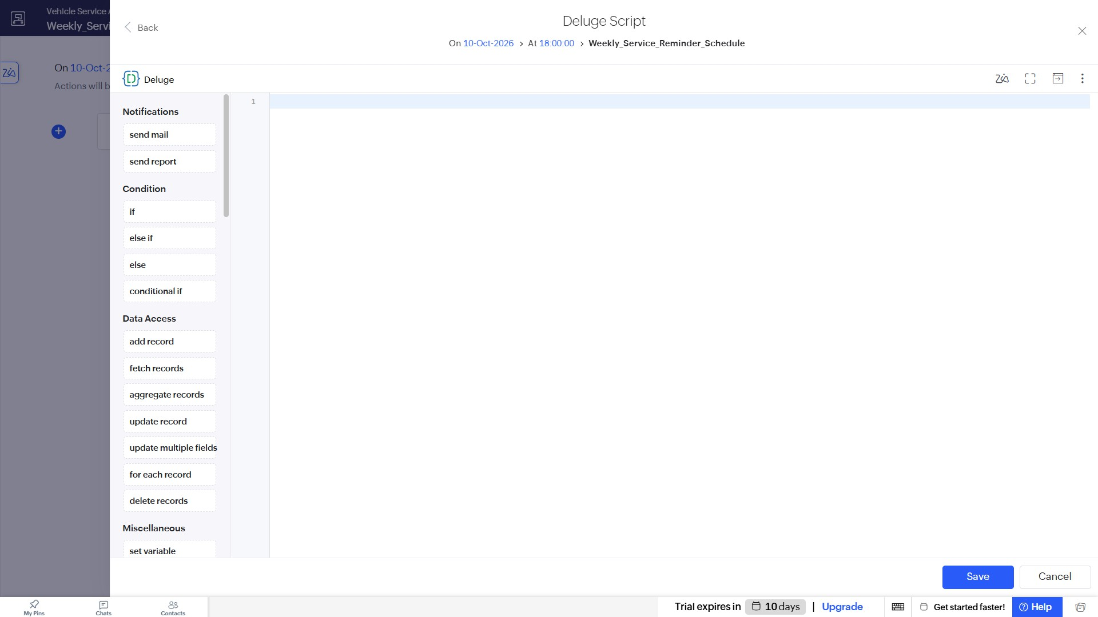
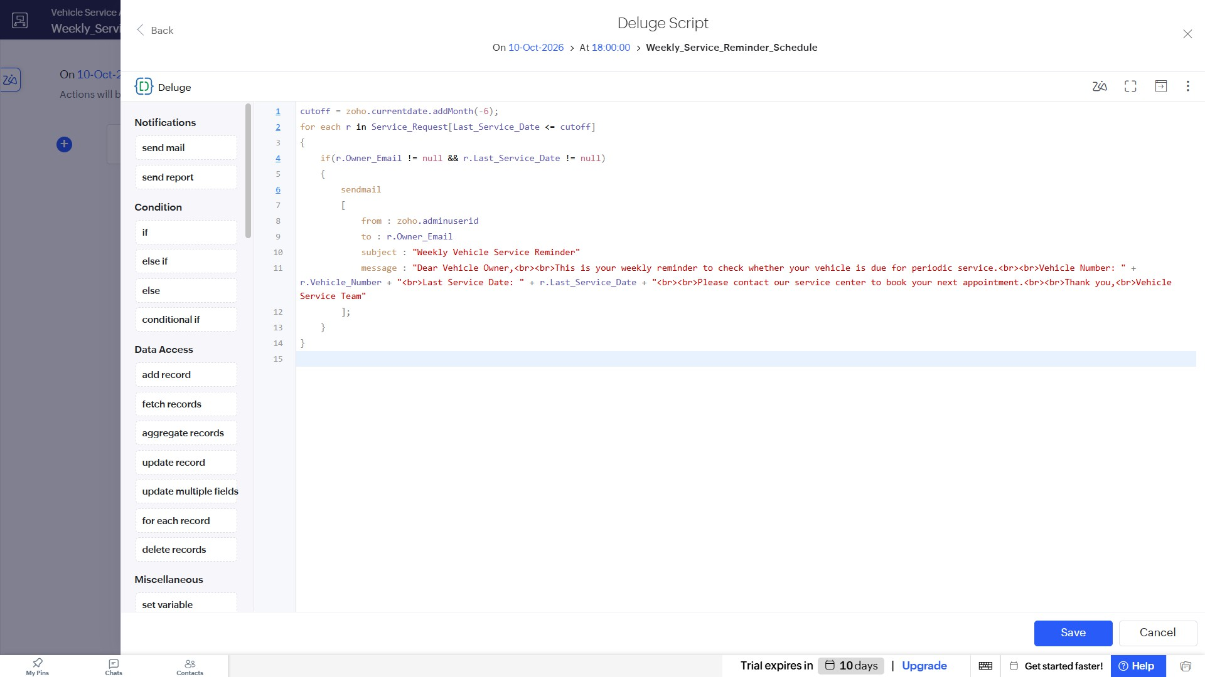

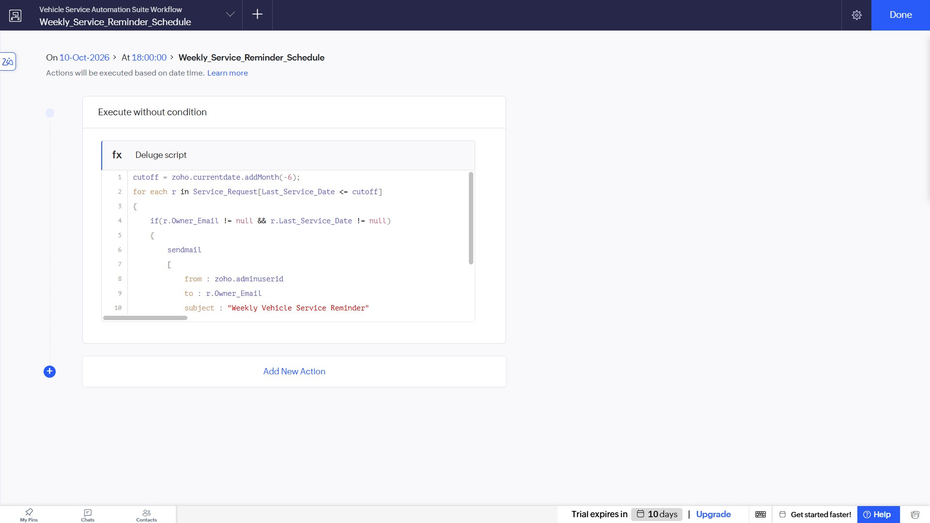
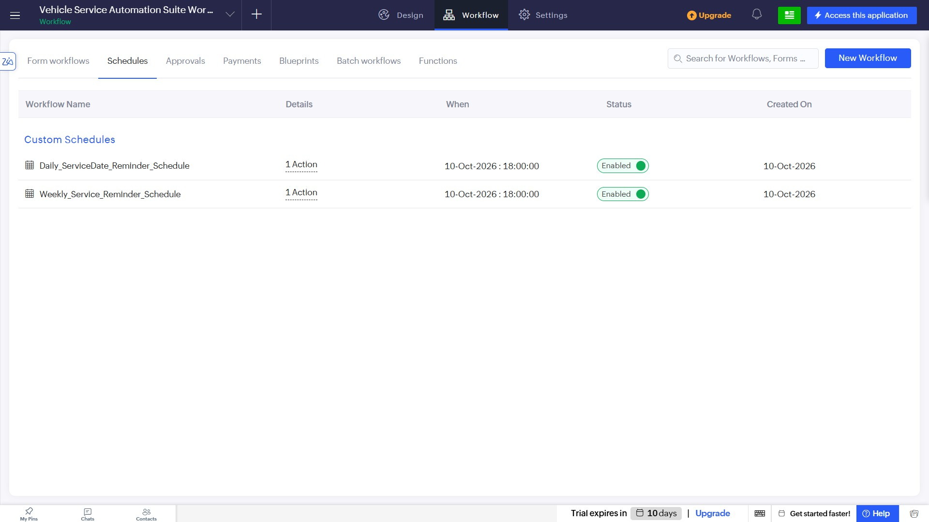

Creating Monthly Schedule Workflow
- Create another scheduled workflow and set it to run "Monthly". Name it Monthly_Service_Reminder_Schedule.

- Add a Deluge script action to check records for periodic service due dates and dispatch a monthly automated email reminder to the vehicle owners.

- Save all configurations and verify that the Daily, Weekly, and Monthly schedules are active and marked as "Enabled" in the Custom Schedules dashboard.

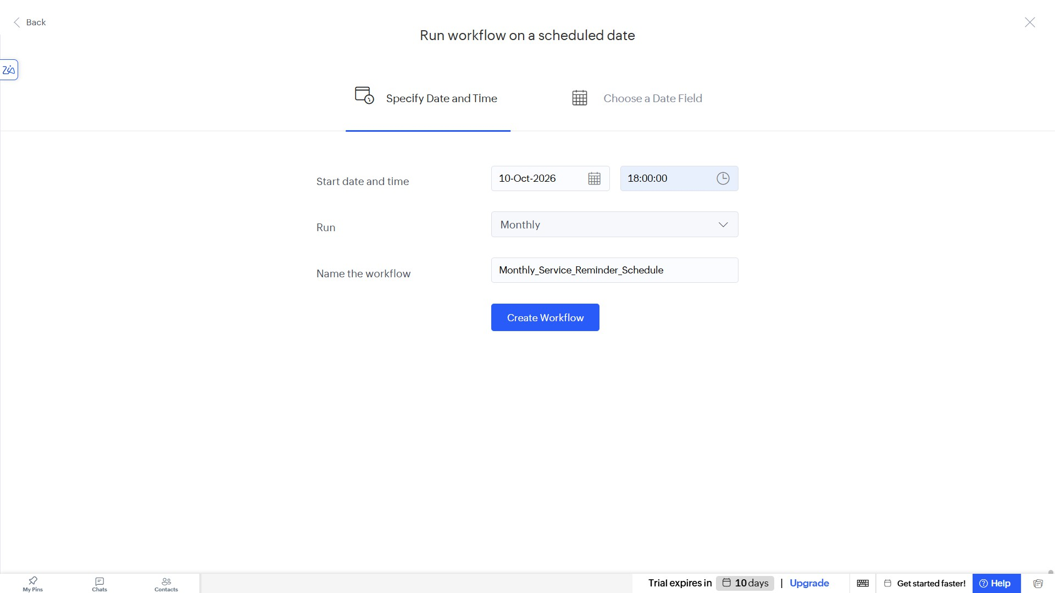
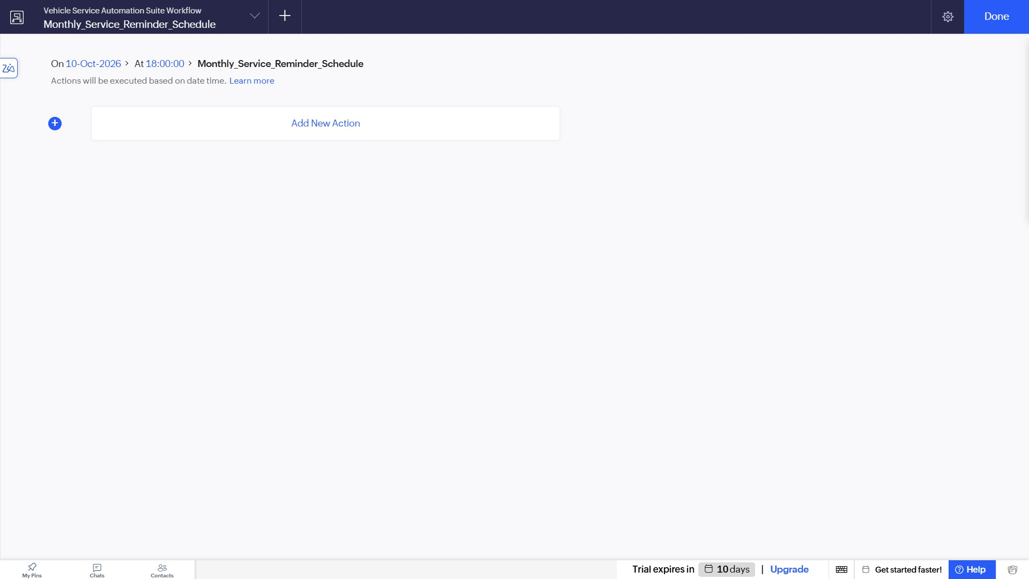

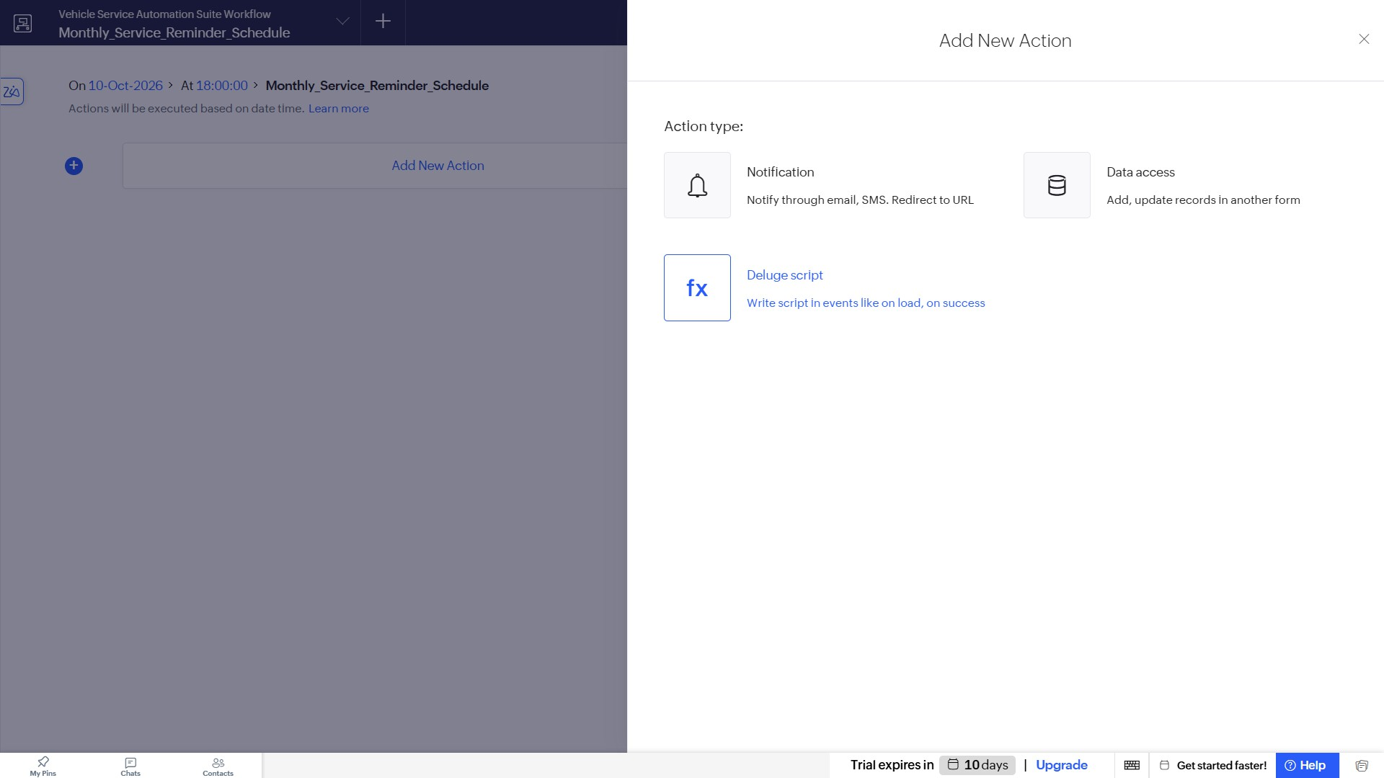
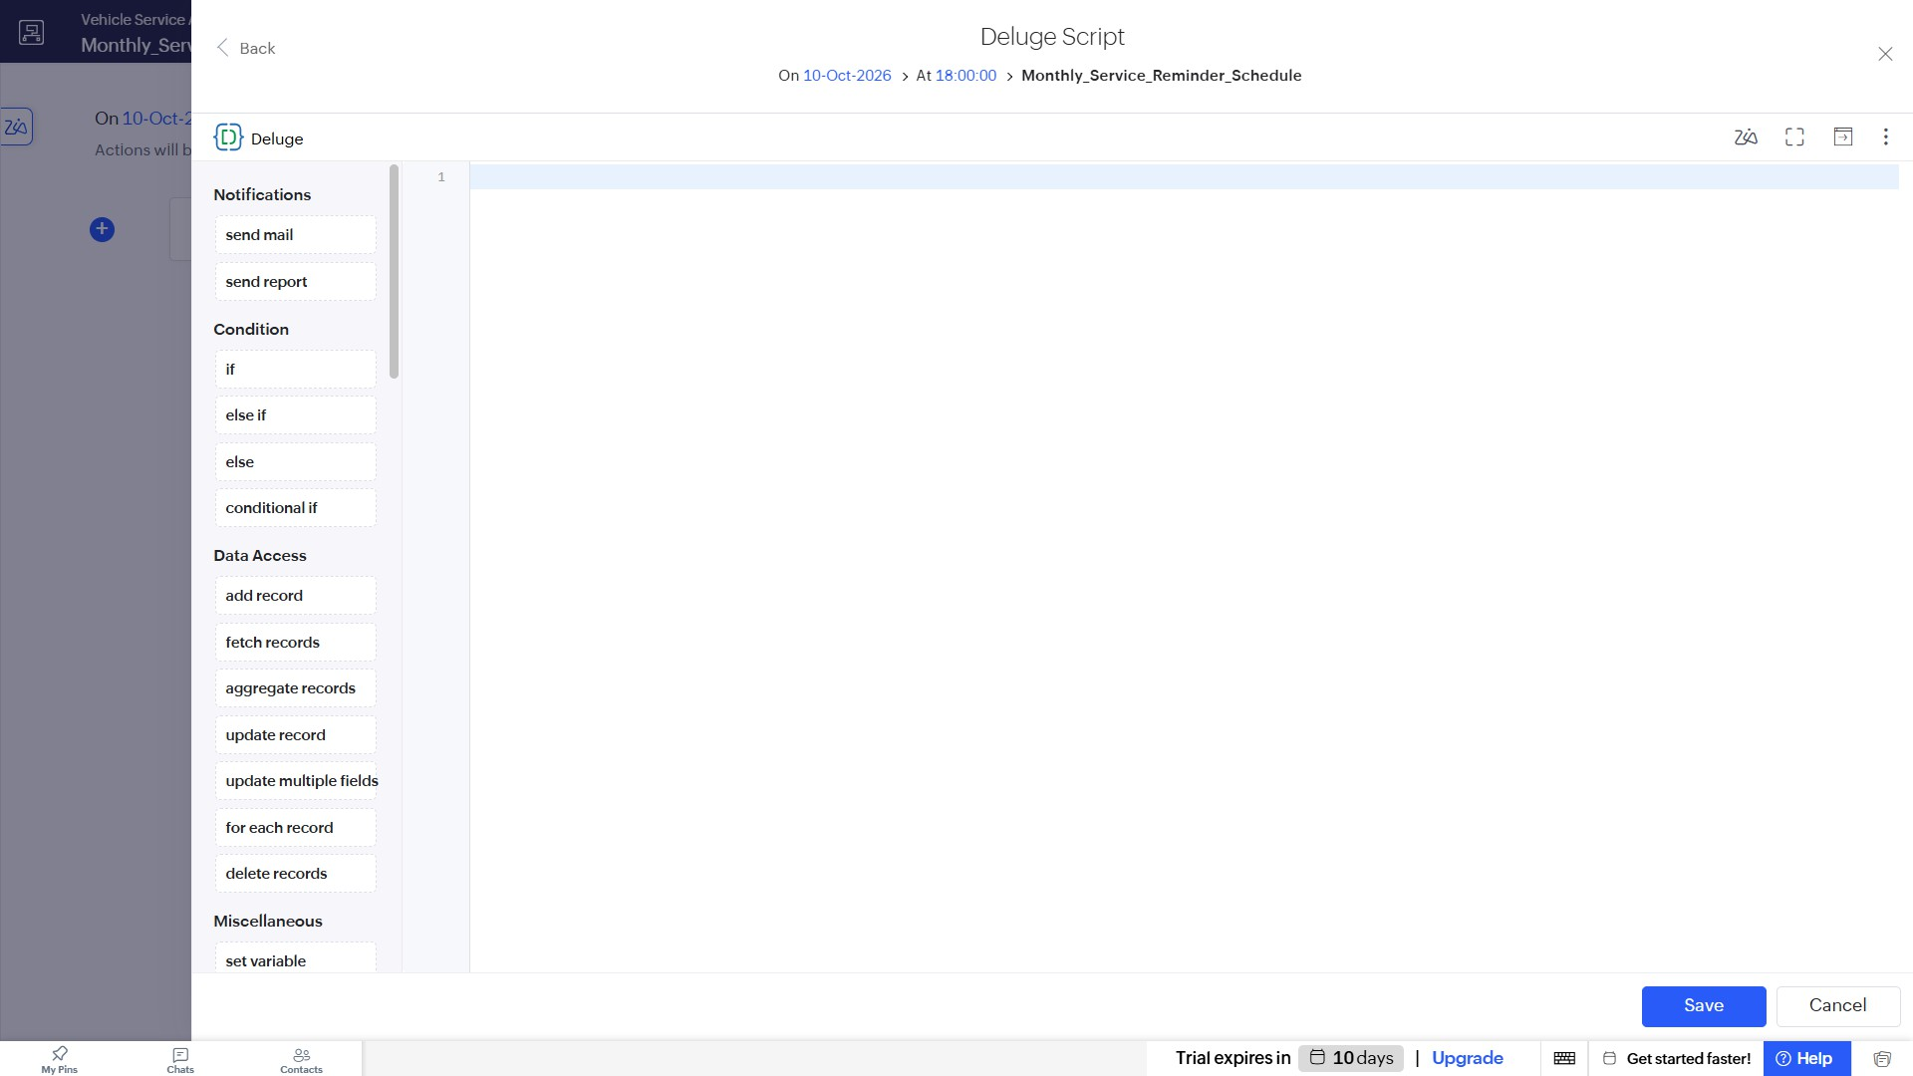

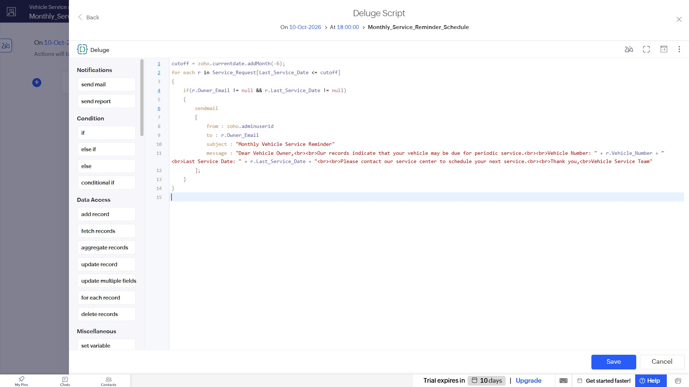
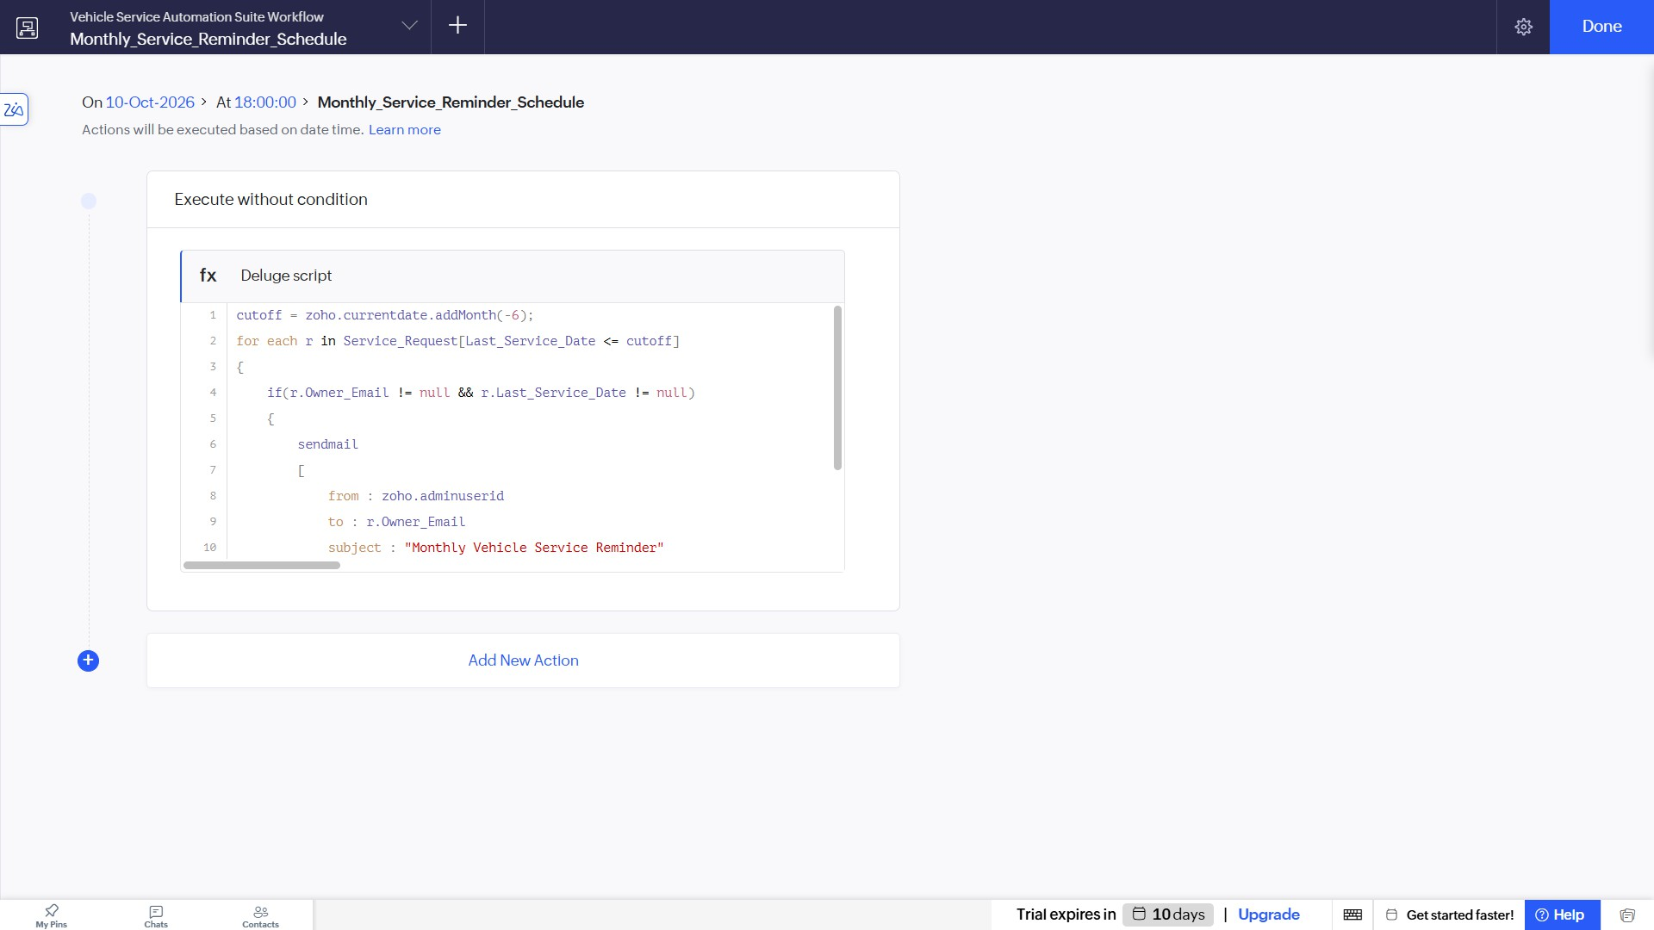

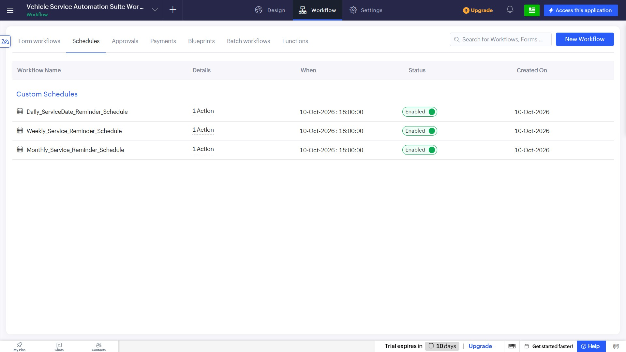
Result
The daily, weekly, and monthly scheduled workflows for sending automated service reminders within the Vehicle Service Management System were successfully created, configured with Deluge scripts, and enabled.

